DBMS ASSIGNMENT 4

Name- Arpan Agarwal Course- Btech-CS

Section- C

Roll No. 14

Univ. Rollno.- 2215000343

Write SQL Queries for the following:

**Q1. Count the total number of Student**

select count(*) as "No of Students" from student;

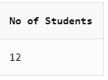

**Q2. Calculate the average GPA of all Student.**

select avg(gpa) as "average gpa" from student;

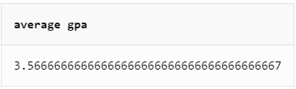

**Q3. Determine the minimum and maximum GPA. Rename the titles as ‘max_GPA’ and ‘min_GPA’ respectively**

select min(gpa) as "min_GPA",max(gpa) as "max_GPA" from student;

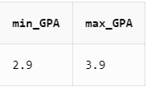

**Q4. Count the number of students having GPA greater than or equal to 3.7**

select count(*) as "no. of students" from student where gpa>=3.7;

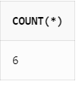

**Q5. Find Maximum, Average, Minimum, total GPA of all student**

select max(gpa),min(gpa),round(avg(gpa),3),sum(gpa) from student;

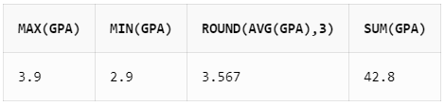

**Q6. Find total number of colleges in our Application Database.**

select count(distinct cname) as "No_of_Colleges" from apply;

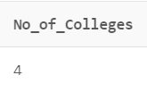

**Q7. Find how many different majors student had applied in.**

select count(distinct major) as "Total no. of colleges from apply ;

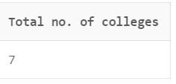

**Q8. Find total no. of Applications in our Application System’s Database.**

select count(sid) as "majors" from apply;

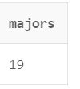

**Q9. Find average of all distinct GPA.**

select avg(distinct gpa) from student;

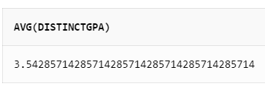

**Q10. Display the total number of application accepted.**  
select count(*) as "no. of accepted application" from apply where decision='Y';

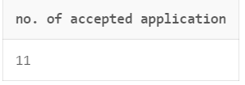

**Q11. Find number of students having GPA>3.4 and coming from high school having size>1000.**

select count(*) as "students" from student where gpa>3.4 and sizeHS>1000;

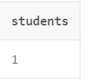

**Q12. Find how many student applied to ‘marine biology’.**

select count(*) as "students" from apply where major='marine biology';

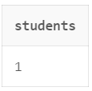

**Q13. Find how many applications were rejected and accepted by the colleges.**  
select decision,count(sid) from apply group by decision;

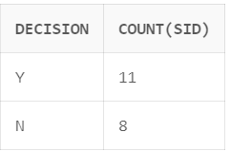

**Q14. Find how many students applied to a particular major. (show count(sid) as No_of_applications).**

select major,count(sid) as "No_of_applications" from apply group by major;

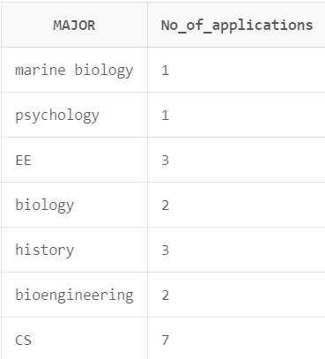

**Q15. Find number of applications received by particular college**

select cname,count(sid) from apply group by cname;

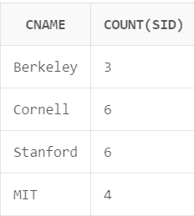

**Q16. Find number of applications received in a particular major at a particular college.**

select cname,major,count(sid) from apply group by cname,major;

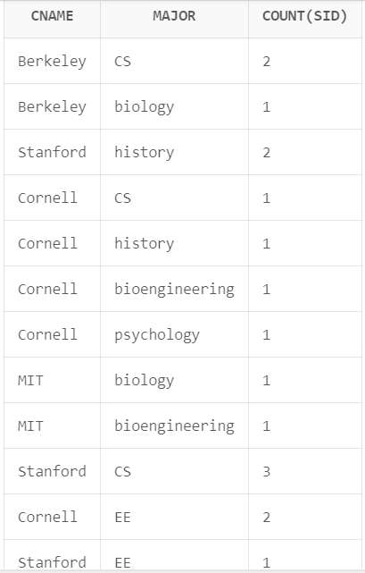

**Q17. Give the college name and major, where number of applications received are greater than or equal to 2.**

select cname,major,count(sid) from apply group by cname,major having count(sid)>=2;

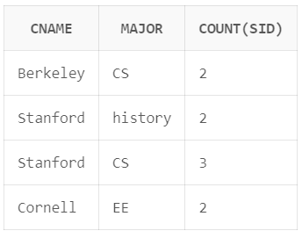

**Q18. Give the name and no of applications of all those colleges which receives applications from 3 or more students.**

select cname,count(sid) from apply group by cname having count(*)>=3;

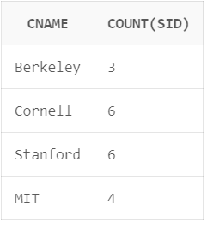

**Q19. Give state and number of colleges of a state that has more than 1 college.**

select state,count(cname) from college group by state having count(cname)>1;

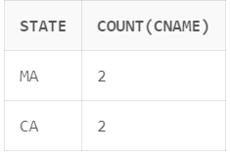

**Q20. Find the name of students that are duplicate.**

select sname,count(sname) from student group by sname having count(sname)>1;

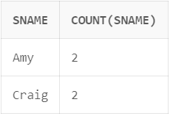

**Q21. Find how many applications are filed by each student. [Hint: use left join as we need information about all 12 students here. If they applied nowhere than show zero in front of them]**

select student.sid,student.sname,count(apply.sid) from student left join apply on student.sid=apply.sid group by student.sid,student.sname;

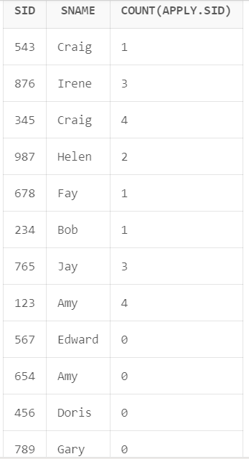

**Q22. Provide name of students that file 3 or more applications.**

select student.sid,student.sname,count(apply.sid) from student left join apply on student.sid=apply.sid

group by student.sid,student.sname

having count(apply.sid)>=3;

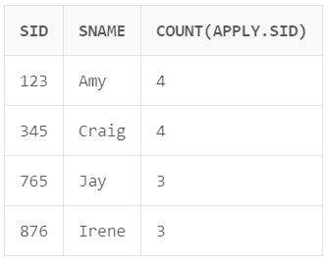

**Q23. Provide name of student who have not applied to any college.**

select student.sid,student.sname,student.gpa,student.sizehs from student join apply on apply.sid=student.sid where apply.sid is null;

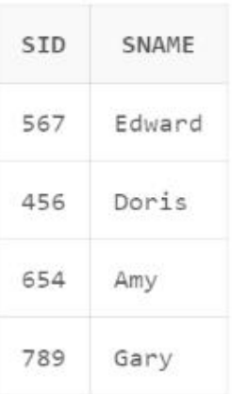

**Q24. Find maximum GPA, Average GPA, and minimum GPA among applicants of each college. (i.e. say sID 123, 324 and 987 had applied to Berkley then compute and display max GPA among these three)**

select apply.cname,max(student.gpa),min(student.gpa),round(avg(student.gpa),3) from student join apply

on student.sid=apply.sid

group by apply.cname;

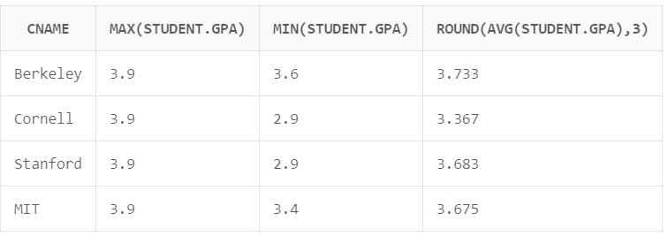

**Q25. Find how many student have same GPA among all students. (provide this frequency in two column table as GPA 3.9 is 4 times, GPA 2.9 is 2 times )**

select gpa,count(gpa) from student group by gpa having count(gpa)>=2;

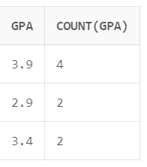

**Q26. Find how many application of each major are rejected and accepted.**

select major,decision,count(sid) as "No_of_Applications" from apply

group by major, decision

order by major,decision;

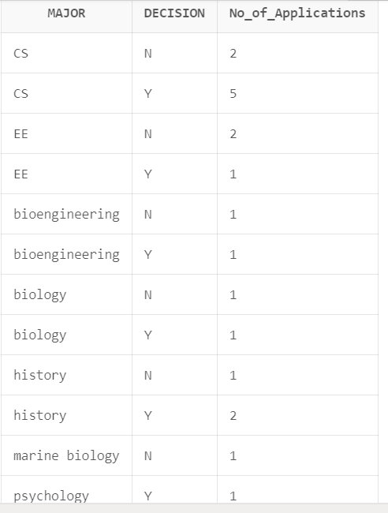

**Q27. Find out the acceptance rate for each college. (Acceptance Rate is percentage of number application accepted w. r. t. number of application received).**

select cname,sum(case when decision='Y' then 1 else 0 end)

accepted_count,count(*) as total_count,

(sum(case when decision='Y' then 1 else 0 end)/count(*))*100

acceptance_rate from apply group by cname;

