DBMS ASSIGNMENT 5

Name- Arpan Agarwal Course- Btech-CS

Section- C

Roll No. 14

Univ. Rollno.- 2215000343

Write SQL Queries for the following:

1. **IDs and names of students who have applied to major in CS at some college.**

select sid,sname from student where sid in (select sid from apply

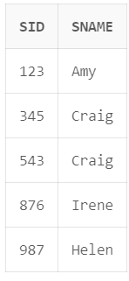where major in('CS'));

1. **Find ID and name of student having same high school size as Jay.**

select sid,sname from student where sizehs in(select sizehs from student where sname in('Jay'));

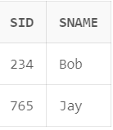

1. **Find ID and name of student having same high school size as Jay but result should not include Jay**

select sid,sname from student where sizehs in(select sizehs from student where sname in('Jay')) and sname<>'Jay';

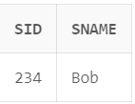

**4. Find the name of student with their GPA and Sid whose GPA not equal to GPA of Irene?**

select sid,sname,gpa from student where gpa not in(select gpa from student where sname in('Irene'));

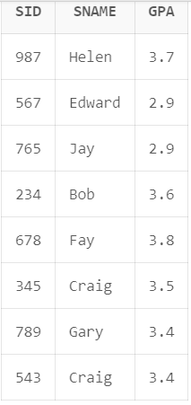

**5.Find college where any student having their name started from J have applied?**

select distinct cname from apply where sid in(select sid from student where sname like 'J%');

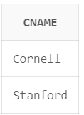

**6. Find all different major where Irene has applied?**

select distinct major from apply where sid in(select sid from student where sname in('Irene'));

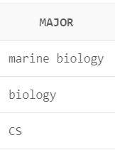

**7. Find IDs of student and major who applied in any of major Irene had applied to?**

select distinct sid,major from apply where major in (select major from apply where sid in (select sid from student where sname in('Irene')));

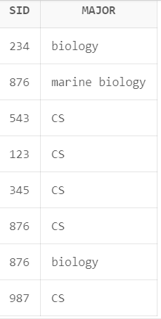

**8. Find IDs of student and major who applied in any of major Irene had applied to? But this time exclude Irene sID from the list**.

select distinct sid,major from apply where major in (select major from apply where sid in (select sid from student where sname in('Irene')))and sid <>(select sid from student where sname='Irene');

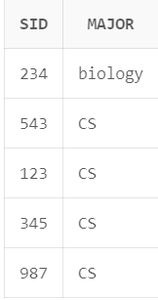

**9. Give the number of colleges Jay applied to?**

select count(distinct cname) from apply where sid in(select sid from student where sname in('Jay'));

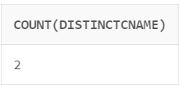

**10. Find sID of student who applied to more or same number of college where Jay has**

**applied?**

select sid from apply where sid <> (select sid from student where sname='Jay') group by sid having count(distinct cname)>=(select count(distinct cname) from apply

where sid in (select sid from student where sname='Jay')) ;

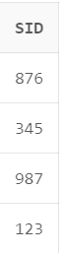

**11. Find details of Students who applied to major CS but not applied to major EE?**

select * from student where sid in (select sid from apply where major='CS') and sid not in(select sid from apply where major = 'EE');

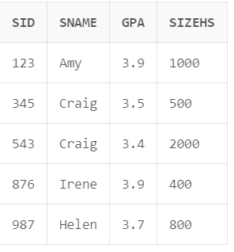

**12. All colleges such that some other college is in same state.**

select cName from College as c1 where EXISTS (select cName from College as c2 where c1.state=c2.state AND c1.cName <> c2.cName);

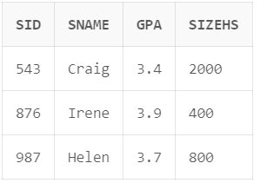

**13. Find the college with highest enrollment**.

select cname from college where enrollment in (select max(enrollment) from college);

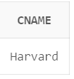

**14. Find name of student having lowest GPA.**

select sname from student where gpa in (select min(gpa) from student);

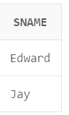

**15. Find the most popular major.**

SELECT major FROM Apply GROUP BY major ORDER BY count(major) DESC LIMIT 1;

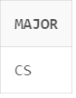

**16. Find sID, sName, sizeHS of all students NOT from smallest HS.**

select sid,sname,sizehs from student where sizehs not in(select min(sizehs) from student);

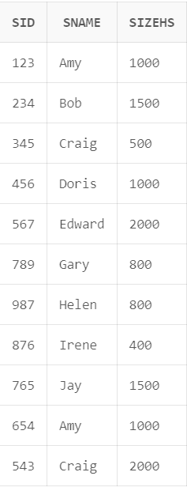

**17. Find the name of student who applies to all the colleges where sID 987 has applied?**

select sName from Student where sid IN (SELECT distinct sID from apply where cName IN (select cName from apply where sID=987));

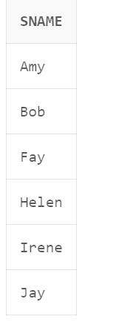

**18. Find college where all the student have applied**.

SELECT a.cName FROM apply a GROUP BY a.cName

HAVING COUNT(DISTINCT a.sID) = (SELECT COUNT(*) FROM student);

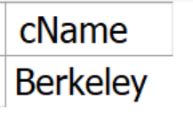

**19. Find sid of student who have not applied to Stanford.**

select sid from apply minus select sid from apply where cname='Stanford';

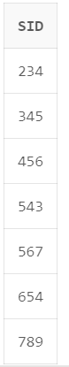

**20. Find sid of Student that applied to both Stanford and Berkeley.**

select sid from apply where cname='Stanford' intersect select sid from apply where cname='Berkeley';

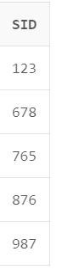

**21. Give list of all names including all names of colleges and students.**

select sname from student union select cname from college;

