DBMS ASSIGNMENT 6

Name- Arpan Agarwal Course- Btech-CS

Section- C

Roll No. 14

Univ. Rollno.- 2215000343

Write SQL Queries for the following:

1. Create a new column DoB in Student table.

alter table student add DOB date;



1. Insert DoB for each Student in corresponding table using above instance of Student table.

update student set dob= TO_DATE('1996-06-26', 'YYYY/MM/DD') where sid=123;

update student set dob= TO_DATE('1995-04-07','YYYY/MM/DD') where sid=234;

update student set dob= TO_DATE('1995-02-04','YYYY/MM/DD') where sid=345;

update student set dob= TO_DATE('1997-07-24','YYYY/MM/DD') where sid=456;

update student set dob= TO_DATE('1996-12-21','YYYY/MM/DD') where sid=567;

update student set dob= TO_DATE('1996-08-27','YYYY/MM/DD') where sid=678;

update student set dob= TO_DATE('1996-10-08','YYYY/MM/DD') where sid=789;

update student set dob= TO_DATE('1997-03-27','YYYY/MM/DD') where sid=987;

update student set dob= TO_DATE('1996-03-07','YYYY/MM/DD') where sid=876;

update student set dob= TO_DATE('1998-08-08','YYYY/MM/DD') where sid=765;

update student set dob= TO_DATE('1996-05-26','YYYY/MM/DD') where sid=654;

update student set dob= TO_DATE('1998-08-27','YYYY/MM/DD') where sid=543;

select * from student;

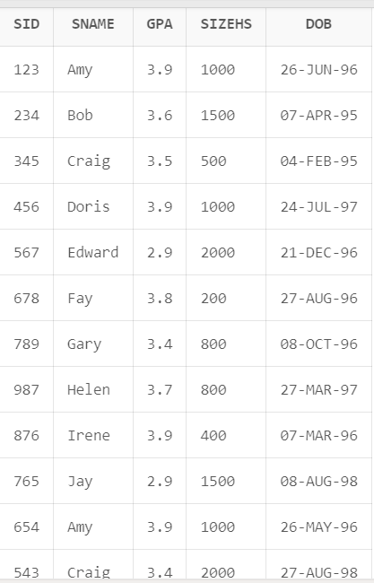

1. Find average of GPA round off to 2 decimal places.

select round(avg(gpa),2) from student;

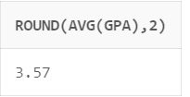

1. Find year of DoB of Student having less than 1000.

SELECT extract(year from DoB)

FROM Student

WHERE sizeHS < 1000;

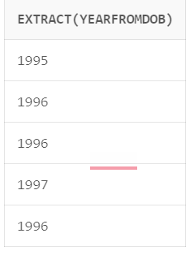

1. Compute Age of each student. (Hint: take difference between year of sysdate and Student’s DoB)

select sid, (extract(year from sysdate) - extract(year from DoB) ) as "age"

FROM Student;

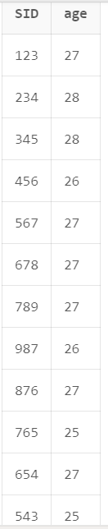

1. Display name of all Students in uppercase and name of college they applied in lower case.

select upper(s.sname), lower(a.cname) from student s join apply a on s.sid=a.sid;

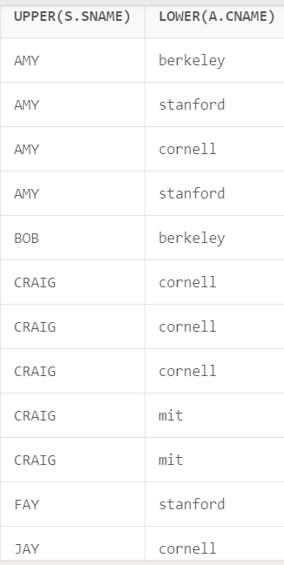**\\**

 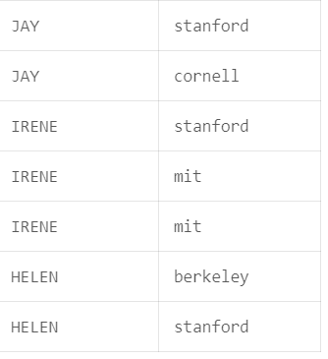

1. Find fourth alphabet of each student. (Hint: use substring)

select substr(sname,4,1) as "fourth letter" from student;

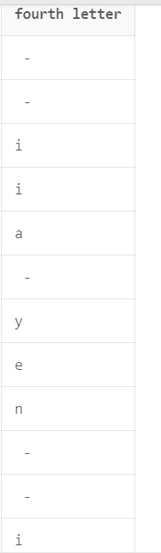

1. Find sID and sName of student whose sName has string length greater than 3.

select sid,sname from student where length(sname)>3;

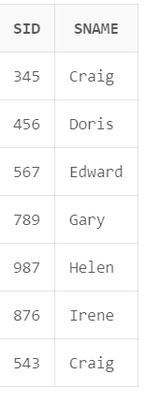

1. Find floor, ceiling and truncate (to one decimal place) value of average GPA.

select floor(avg(gpa)),ceil(avg(gpa)),trunc(avg(gpa),1) from student ;

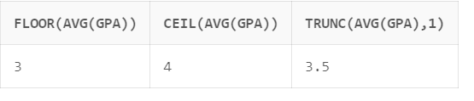

1. Display details of all students whose sID is even.

select * from student where mod(sid,2)=0;

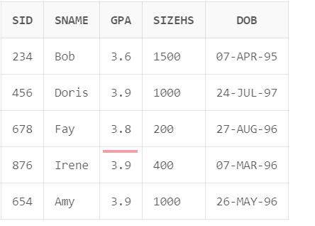

1. Compute Square Root of 900 and 247 .

select sqrt(900),sqrt(247) from dual;

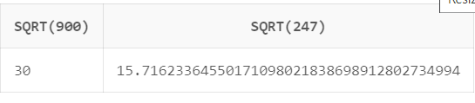

1. Consider the string “Peter Piper picked a peck of pickled peppers. A peck of pickled peppers Peter Piper picked. If Peter Piper picked a peck of pickled peppers, Where the peck of pickled peppers Peter Piper picked?” Find 6th occurrence of string ‘pick’. (Hint: use INSTR)

select instr('Peter Piper picked a peck of pickled peppers. A peck of pickled

peppers Peter Piper picked. If Peter Piper picked a peck of pickled peppers, Where the

peck of pickled peppers Peter Piper picked?', 'pick', 1, 6) as count from dual;

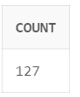

1. Consider String ‘Satya Nadella’ replace this using the key.

SELECT translate('Satya Nadella', 'adelNSTY', '12345678') AS transformed_string FROM dual;

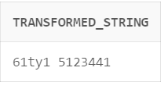

1. Display sID, sname and DoB in this format ‘February 26, 2014’

select sid,sname,to_char(dob,'Month DD, YYYY') from student;

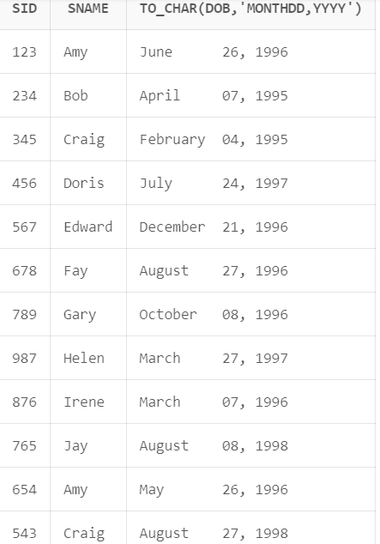

1. Convert the text ’26/02/2014’ to date.

select to_date('26/02/2014','DD-MM-YYYY') from dual;

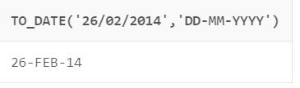

1. Compute on which date is next Saturday and last day of this month?

select sysdate,next_day(sysdate,'saturday'),last_day(sysdate) from dual;

