BANK LOAN REPORT QUERY DOCUMENT

- BANK LOAN REPORT | SUMMARY
KPI’s:
Total Loan Applications
Select count(id) as Total_applications from bank_loan_data
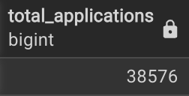

MTD Loan Applications
SELECT COUNT(id) AS mtd_loan_applications
FROM bank_loan_data
WHERE EXTRACT(MONTH FROM TO_DATE(issue_date, 'DD-MM-YYYY')) = 12
AND EXTRACT(YEAR FROM TO_DATE(issue_date, 'DD-MM-YYYY')) = 2021;
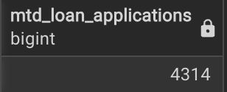

PMTD Loan Applications
SELECT COUNT(id) AS total_applications
FROM bank_loan_data
WHERE EXTRACT(MONTH FROM TO_DATE(issue_date, 'DD-MM-YYYY')) = 11;
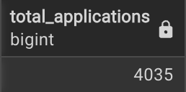
_____________________________________________________________________

Total Funded Amount
SELECT SUM(loan_amount) AS total_funded_amount
FROM bank_loan_data;
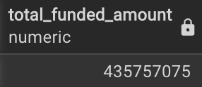
MTD Total Funded Amount
SELECT SUM(loan_amount) AS total_funded_amount
FROM bank_loan_data
WHERE EXTRACT(MONTH FROM TO_DATE(issue_date, 'DD-MM-YYYY')) = 12;
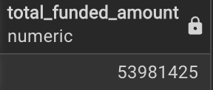

PMTD Total Funded Amount
SELECT SUM(loan_amount) AS total_funded_amount
FROM bank_loan_data
WHERE EXTRACT(MONTH FROM TO_DATE(issue_date, 'DD-MM-YYYY')) = 11;
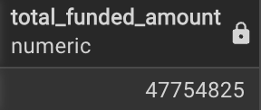
_________________________________________________________________________

Total Amount Received
SELECT SUM(total_payment) AS Total_Amount_Collected FROM bank_loan_data
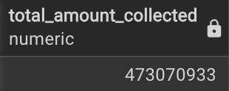
MTD Total Amount Received
SELECT SUM(total_payment) AS total_amount_collected
FROM bank_loan_data
WHERE EXTRACT(MONTH FROM TO_DATE(issue_date, 'DD-MM-YYYY')) = 12;
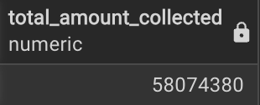

PMTD Total Amount Received
SELECT SUM(total_payment) AS total_amount_collected
FROM bank_loan_data
WHERE EXTRACT(MONTH FROM TO_DATE(issue_date, 'DD-MM-YYYY')) = 11;
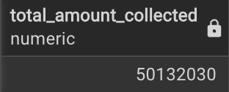_________________________________________________________________________
Average Interest Rate
SELECT AVG(int_rate) * 100 AS avg_int_rate
FROM bank_loan_data;
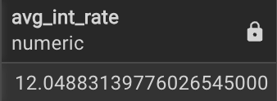
MTD Average Interest
SELECT AVG(int_rate) * 100 AS mtd_avg_int_rate
FROM bank_loan_data
WHERE EXTRACT(MONTH FROM TO_DATE(issue_date, 'DD-MM-YYYY')) = 12;
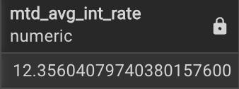
PMTD Average Interest
SELECT AVG(int_rate) * 100 AS pmtd_avg_int_rate
FROM bank_loan_data
WHERE EXTRACT(MONTH FROM TO_DATE(issue_date, 'DD-MM-YYYY')) = 11;
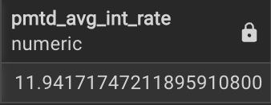__________________________________________________________________
Avg DTI ( Debt-to-Income Ratio - the percentage of a borrower’s income used to pay debts.)
SELECT AVG(dti) * 100 AS avg_dti
FROM bank_loan_data;
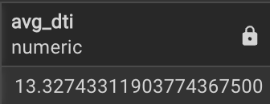
MTD Avg DTI
SELECT AVG(dti) * 100 AS mtd_avg_dti
FROM bank_loan_data
WHERE EXTRACT(MONTH FROM TO_DATE(issue_date, 'DD-MM-YYYY')) = 12;
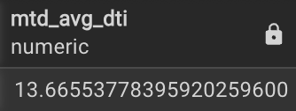
PMTD Avg DTI
SELECT AVG(dti) * 100 AS pmtd_avg_dti
FROM bank_loan_data
WHERE EXTRACT(MONTH FROM TO_DATE(issue_date, 'DD-MM-YYYY')) = 11;
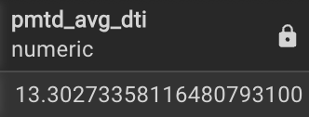

GOOD LOAN ISSUED
Good Loan Percentage
SELECT
(COUNT(CASE WHEN loan_status = 'Fully Paid' OR loan_status = 'Current' THEN id END) * 100.0) /
COUNT(id) AS Good_Loan_Percentage
FROM bank_loan_data
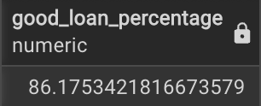
Good Loan Applications
SELECT COUNT(id) AS good_loan_applications
FROM bank_loan_data
WHERE loan_status = 'Fully Paid'
OR loan_status = 'Current';
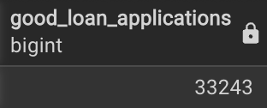
Good Loan Funded Amount
SELECT SUM(loan_amount) AS good_loan_funded_amount
FROM bank_loan_data
WHERE loan_status = 'Fully Paid'
OR loan_status = 'Current';
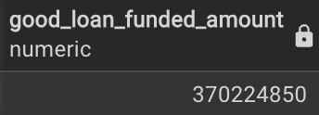
Good Loan Amount Received
SELECT SUM(total_payment) AS good_loan_amount_received
FROM bank_loan_data
WHERE loan_status = 'Fully Paid'
OR loan_status = 'Current';
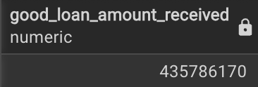

BAD LOAN ISSUED
Bad Loan Percentage
SELECT
(COUNT(CASE WHEN loan_status = 'Charged Off' THEN id END) * 100.0)
/ COUNT(id) AS Bad_Loan_Percentage
FROM bank_loan_data;
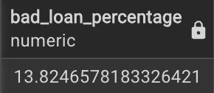
Bad Loan Applications
SELECT COUNT(id) AS Bad_Loan_Applications
FROM bank_loan_data
WHERE loan_status = 'Charged Off';
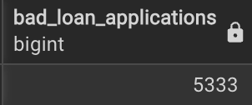
Bad Loan Funded Amount
SELECT SUM(loan_amount) AS Bad_Loan_Funded_amount
FROM bank_loan_data
WHERE loan_status = 'Charged Off';
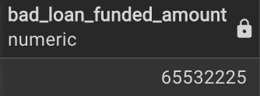
Bad Loan Amount Received
SELECT SUM(total_payment) AS Bad_Loan_amount_received
FROM bank_loan_data
WHERE loan_status = 'Charged Off';
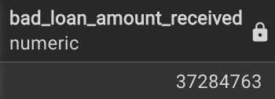

LOAN STATUS
SELECT
loan_status,
COUNT(id) AS LoanCount,
SUM(total_payment) AS Total_Amount_Received,
SUM(loan_amount) AS Total_Funded_Amount,
AVG(int_rate * 100) AS Interest_Rate,
AVG(dti * 100) AS DTI
FROM bank_loan_data
GROUP BY loan_status;
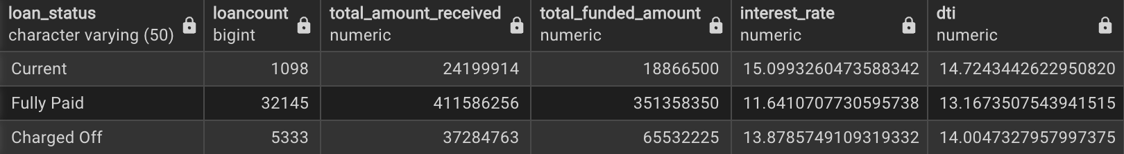
SELECT
loan_status,
SUM(total_payment) AS MTD_Total_Amount_Received,
SUM(loan_amount) AS MTD_Total_Funded_Amount
FROM bank_loan_data
WHERE EXTRACT(MONTH FROM TO_DATE(issue_date, 'DD-MM-YYYY')) = 12
GROUP BY loan_status;
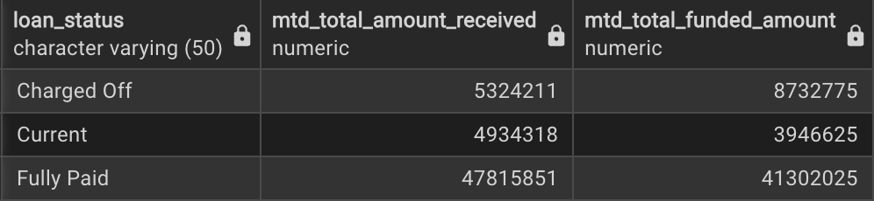
- BANK LOAN REPORT | OVERVIEW
MONTH
SELECT
EXTRACT(MONTH FROM TO_DATE(issue_date, 'DD-MM-YYYY')) AS month_number,
TO_CHAR(TO_DATE(issue_date, 'DD-MM-YYYY'), 'Month') AS month_name,
COUNT(id) AS total_loan_applications,
SUM(loan_amount) AS total_funded_amount,
SUM(total_payment) AS total_amount_received
FROM bank_loan_data
GROUP BY
EXTRACT(MONTH FROM TO_DATE(issue_date, 'DD-MM-YYYY')),
TO_CHAR(TO_DATE(issue_date, 'DD-MM-YYYY'), 'Month')
ORDER BY month_number;
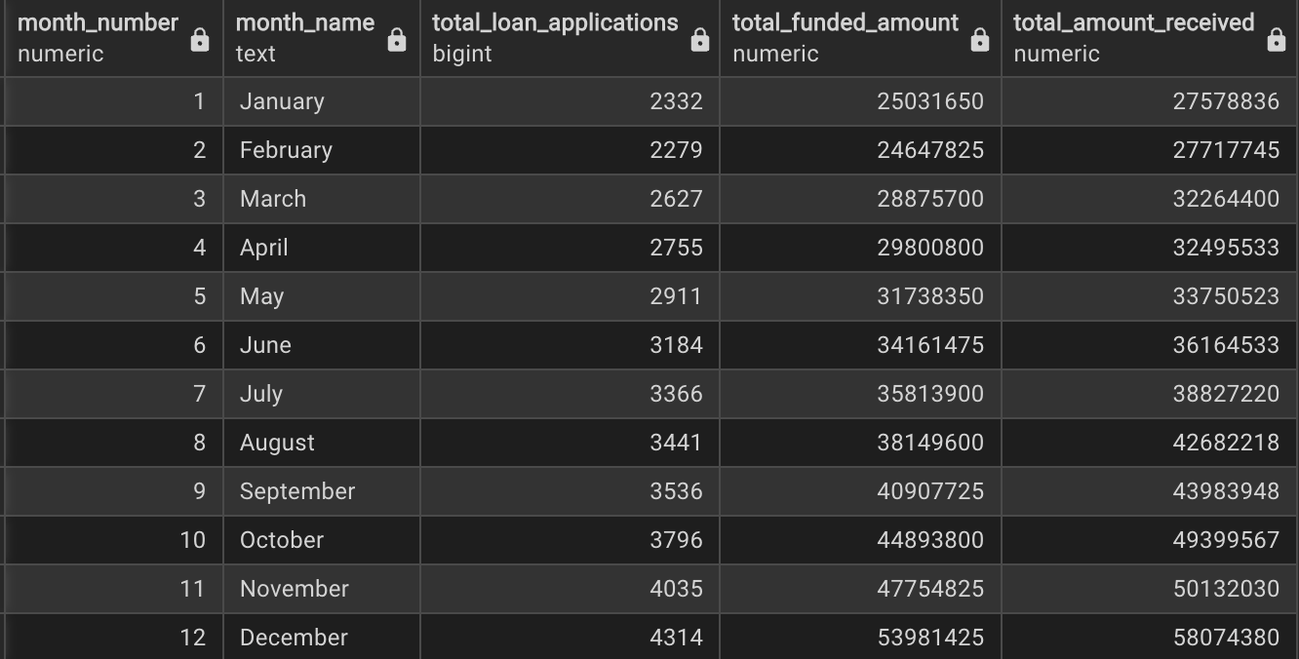
STATE
SELECT
address_state AS State,
COUNT(id) AS Total_Loan_Applications,
SUM(loan_amount) AS Total_Funded_Amount,
SUM(total_payment) AS Total_Amount_Received
FROM bank_loan_data
GROUP BY address_state
ORDER BY address_state;
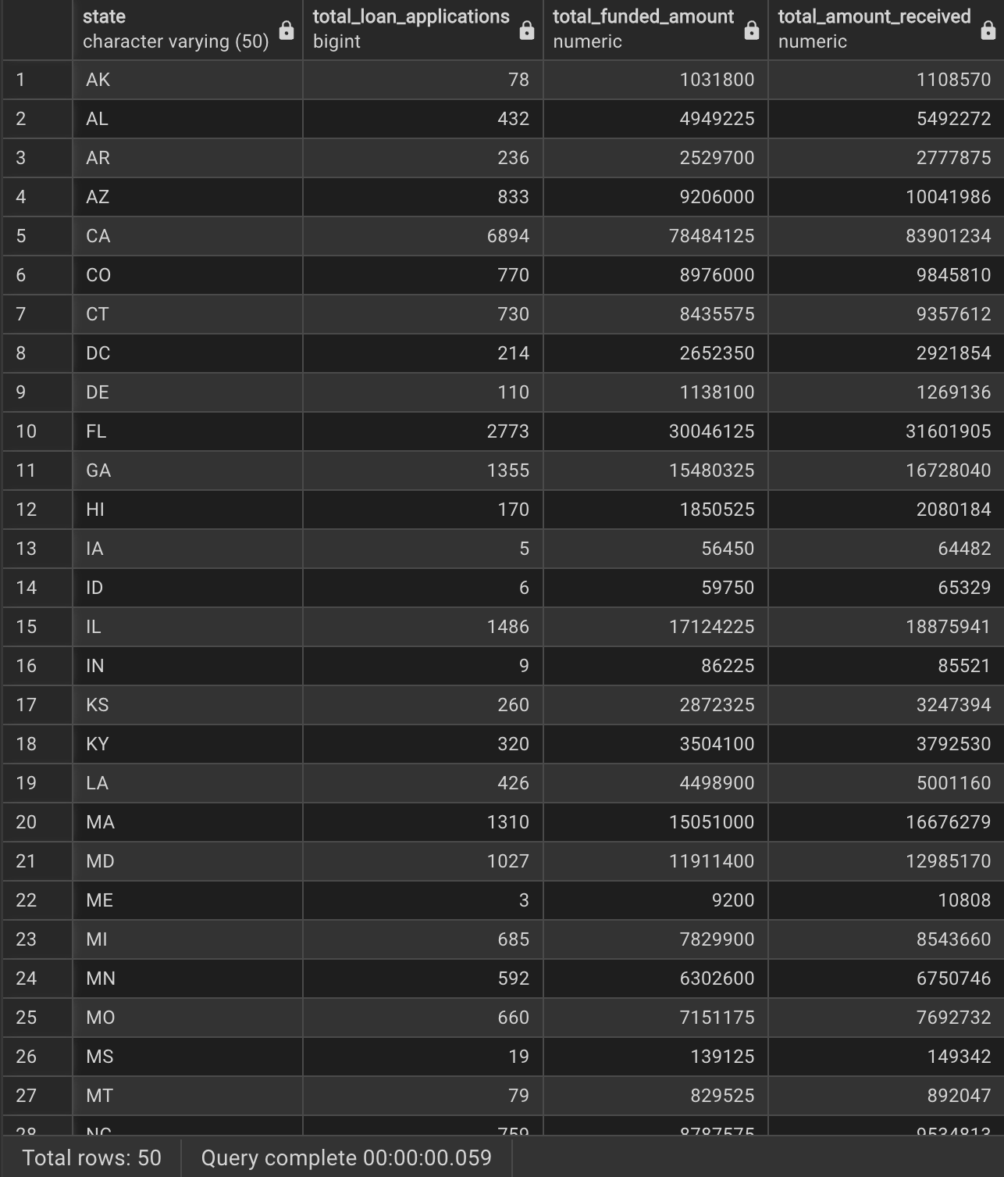
TERM
SELECT
term AS Term,
COUNT(id) AS Total_Loan_Applications,
SUM(loan_amount) AS Total_Funded_Amount,
SUM(total_payment) AS Total_Amount_Received
FROM bank_loan_data
GROUP BY term
ORDER BY term

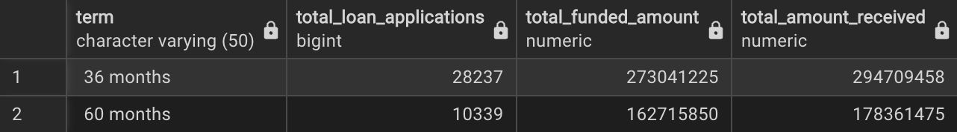
EMPLOYEE LENGTH
SELECT
emp_length AS Employee_Length,
COUNT(id) AS Total_Loan_Applications,
SUM(loan_amount) AS Total_Funded_Amount,
SUM(total_payment) AS Total_Amount_Received
FROM bank_loan_data
GROUP BY emp_length
ORDER BY emp_length
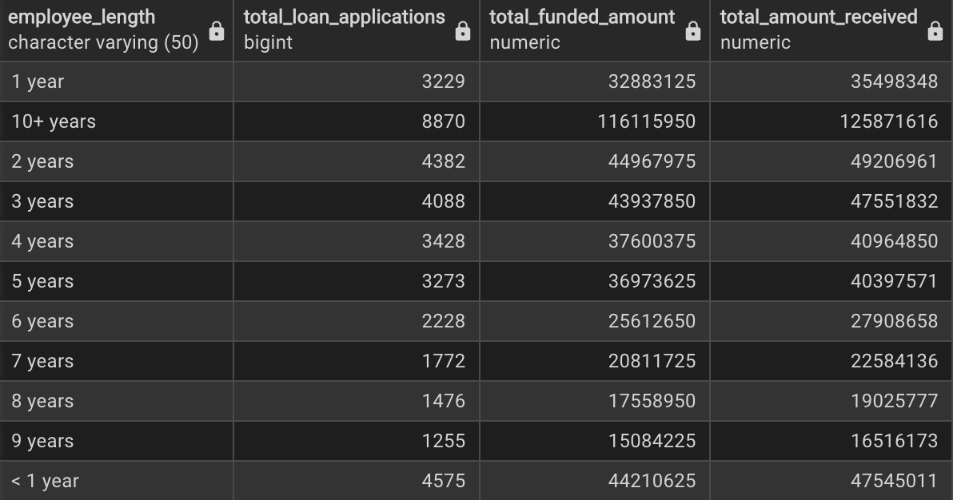
PURPOSE
SELECT
purpose AS PURPOSE,
COUNT(id) AS Total_Loan_Applications,
SUM(loan_amount) AS Total_Funded_Amount,
SUM(total_payment) AS Total_Amount_Received
FROM bank_loan_data
GROUP BY purpose
ORDER BY purpose
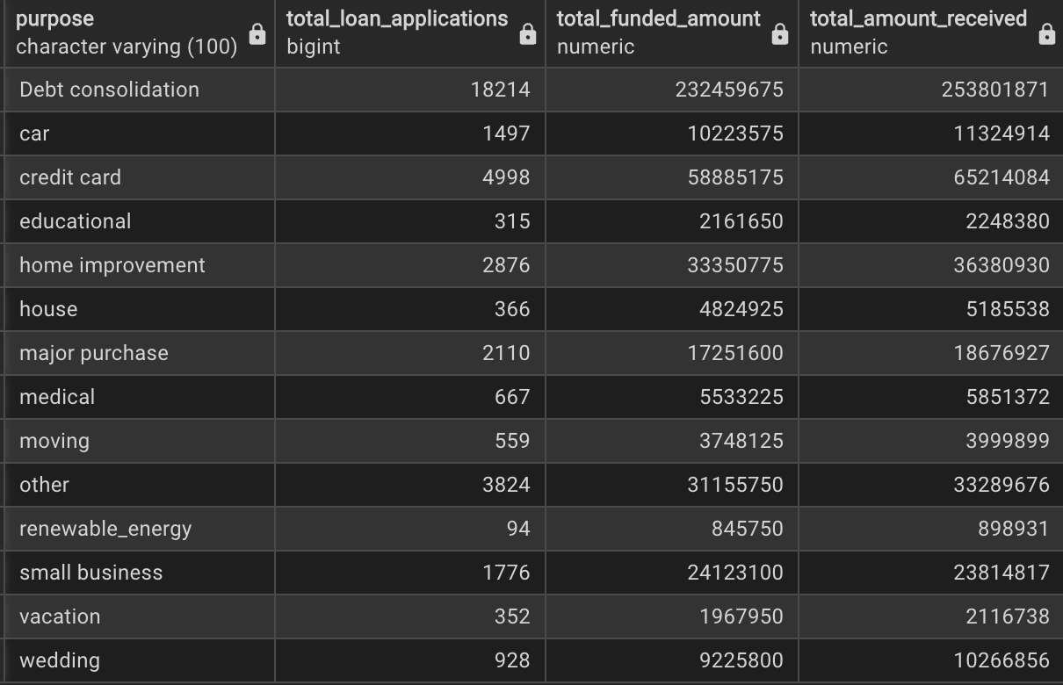
HOME OWNERSHIP
SELECT
home_ownership AS Home_Ownership,
COUNT(id) AS Total_Loan_Applications,
SUM(loan_amount) AS Total_Funded_Amount,
SUM(total_payment) AS Total_Amount_Received
FROM bank_loan_data
GROUP BY home_ownership
ORDER BY home_ownership
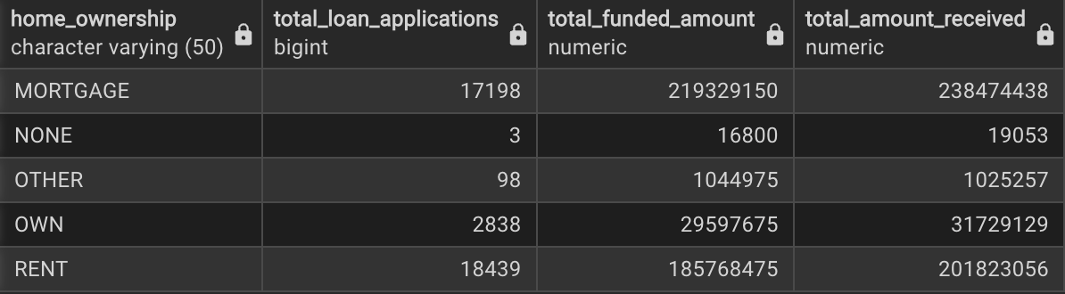

SELECT
purpose AS PURPOSE,
COUNT(id) AS Total_Loan_Applications,
SUM(loan_amount) AS Total_Funded_Amount,
SUM(total_payment) AS Total_Amount_Received
FROM bank_loan_data
WHERE grade = 'A'
GROUP BY purpose
ORDER BY purpose
