A PROJECT REPORT ON

MEDQUEUE
A Smart Clinic Appointment and Live Queue Management System

Submitted in partial fulfilment of the requirements for the award of the degree of
[Course Name, e.g. Bachelor of Computer Applications (BCA)]

Submitted by
[Student Name]
Roll No.: [Roll Number]

Under the guidance of
[Guide Name]
[Designation, Department]

[College Logo]

[Department of Computer Science]
[College Name]
[Affiliated to University Name]
[City]
Academic Year [2025–2026]

[College Name]
[Department of Computer Science]
[College Logo]

CERTIFICATE
This is to certify that the project entitled “MedQueue: A Smart Clinic Appointment and Live Queue Management System” is a bonafide work carried out by [Student Name], Roll No. [Roll Number], a student of [Course Name], in partial fulfilment of the requirements for the award of the degree of [Course Name] of [University Name] during the academic year [2025–2026].
The project has been carried out under my supervision and guidance, and to the best of my knowledge the work embodied in this report has not been submitted elsewhere for the award of any other degree or diploma.

______________________  Project Guide  [Guide Name] | ______________________  Head of Department  [HOD Name]

______________________  External Examiner | ______________________  Principal  [Principal Name]

Date: [DD/MM/YYYY]
Place: [City]
(College Seal)

ACKNOWLEDGEMENT
I take this opportunity to express my sincere gratitude to everyone who supported me in completing this project, “MedQueue: A Smart Clinic Appointment and Live Queue Management System”.
I am deeply grateful to my project guide, [Guide Name], for the constant guidance, valuable suggestions and encouragement throughout the development of this project. Their feedback at every stage helped me improve both the design and the quality of the system.
I sincerely thank [HOD Name], Head of the [Department of Computer Science], and [Principal Name], Principal of [College Name], for providing the facilities and an environment that made this work possible.
I am also thankful to all the faculty members and staff of the department for their support, and to my family and friends, whose encouragement and patience kept me motivated throughout this project.

[Student Name]
Roll No.: [Roll Number]

DECLARATION
I, [Student Name], Roll No. [Roll Number], a student of [Course Name] at [College Name], hereby declare that the project report entitled “MedQueue: A Smart Clinic Appointment and Live Queue Management System” submitted to [University Name] is a record of original work carried out by me under the guidance of [Guide Name].
I further declare that this work has not been submitted, in part or in full, to any other university or institution for the award of any degree or diploma, and that all sources of information used have been duly acknowledged.

Date: [DD/MM/YYYY]
Place: [City]

______________________
[Student Name]
Signature of the Student

INDEX
Sr. No. | Contents | Page No.
1 | INTRODUCTION | 1
1.1 | Overview | 1
1.2 | Problem Statement | 1
1.3 | Objectives | 2
1.4 | Scope of the Project | 2
2 | SYSTEM ANALYSIS | 3
2.1 | Existing System and its Limitations | 3
2.2 | Proposed System | 3
2.3 | Feasibility Study | 4
3 | REQUIREMENT SPECIFICATION | 5
3.1 | Hardware Requirements | 5
3.2 | Software Requirements | 5
3.3 | Functional Requirements | 5
3.4 | Non-Functional Requirements | 6
4 | SYSTEM DESIGN | 7
4.1 | System Architecture | 7
4.2 | Module Description | 7
4.3 | Database Design (ER Diagram) | 8
4.4 | Data Dictionary | 9
4.5 | Appointment Lifecycle | 10
5 | IMPLEMENTATION | 12
5.1 | Technology Stack | 12
5.2 | Project Structure | 12
5.3 | Key Algorithms | 13
5.4 | Security Implementation | 14
5.5 | REST API Summary | 14
6 | TESTING | 16
6.1 | Testing Strategy | 16
6.2 | Unit Test Cases | 16
6.3 | Integration Checks and Results | 17
7 | SCREENSHOTS | 18
8 | CONCLUSION AND FUTURE ENHANCEMENTS | 22
8.1 | Conclusion | 22
8.2 | Limitations | 22
8.3 | Future Enhancements | 22
9 | REFERENCES | 24

CHAPTER 1
INTRODUCTION

1.1 Overview
Waiting rooms in small and medium clinics are often crowded because patients have no reliable way to know when the doctor will actually see them. Appointments are booked by phone or written in a register, token numbers are called out loud, and patients wait for long periods with no information about the queue.
MedQueue is a web-based clinic appointment and live queue management system that addresses this problem. Patients book a fixed time slot online, receive a token number, and follow a live queue tracker that shows how many people are ahead of them and when they are expected to be called. Doctors run their queue from a dashboard, call patients in, write digital prescriptions and see each patient’s earlier visits. An administrator manages doctors, their working hours and the overall clinic statistics.
The system is built as a three-tier web application: a React single-page frontend, a Spring Boot REST backend secured with JSON Web Tokens (JWT), and a MySQL relational database.

1.2 Problem Statement
Traditional appointment handling in clinics suffers from the following problems:
- Patients do not know their position in the queue or the expected waiting time, so they arrive early and wait in crowded rooms.
- Phone or register based booking leads to double bookings and lost appointments.
- Doctors have no quick view of a patient’s previous visits and prescriptions at the time of consultation.
- Prescriptions are handwritten, can be hard to read and are easily lost by patients.
- Clinic owners have no data on waiting times, no-shows or patient satisfaction.
The aim of this project is to replace this manual process with a reliable online system that gives every user accurate, real-time information.

1.3 Objectives
- To allow patients to register, browse doctors and book an appointment in a fixed time slot without double booking.
- To show patients a live queue tracker with their position, expected call time and whether the doctor is running late.
- To provide doctors with a live queue dashboard to call, complete or skip patients, and to add walk-in patients.
- To enable doctors to write digital prescriptions for every visit, reuse templates and repeat earlier prescriptions.
- To let patients view and print their prescriptions and rate their consultations.
- To maintain a complete visit history for patients and doctors.
- To give the administrator tools to manage doctors, their schedules (including night shifts) and clinic statistics.
- To secure the system with role-based access control and encrypted passwords.

1.4 Scope of the Project
MedQueue is designed for a single clinic or a small multi-doctor practice. It covers the full outpatient flow: registration, booking, rescheduling and cancellation, arrival check-in, the live queue, consultation, prescription, rating and history. The system supports day shifts, shifts ending at midnight and overnight shifts that run past midnight.
Online payments, laboratory reports, pharmacy stock management, SMS notifications and multi-branch hospital management are outside the scope of the current version and are listed as future enhancements.

CHAPTER 2
SYSTEM ANALYSIS

2.1 Existing System and its Limitations
In the existing manual system, the receptionist books appointments by phone or in a register and hands out paper tokens on arrival. The doctor calls patients in the order of the tokens. The limitations of this approach are:
- No visibility of the queue for patients; waiting time is unknown.
- The same time can be given to two patients, causing conflicts and delays.
- Late or absent patients hold up the queue because the receptionist does not know who has arrived.
- Patient history and prescriptions are kept on paper and are hard to retrieve.
- There is no feedback mechanism and no reports for the clinic management.

2.2 Proposed System
The proposed system, MedQueue, automates the complete process through three role-based dashboards:
- Patient: books fixed slots, sees the next free slot of every doctor, reschedules or cancels, checks in with “I’ve arrived” or “Running late”, follows the live queue, views and prints prescriptions, and rates completed visits.
- Doctor: runs the live queue (Call Next always picks the first patient who has arrived), sees a running consultation timer, writes prescriptions with templates and medicine suggestions, views patient history, adds walk-in patients and reads patient ratings.
- Administrator: creates, edits, deactivates and reactivates doctors, configures working days and hours with a live slot preview, and views overall statistics.
The waiting time shown to a patient is calculated from the doctor’s real consultation times, the patient currently with the doctor, and the booked slots of everyone ahead, so the estimate improves as the clinic uses the system.

2.3 Feasibility Study

Technical Feasibility
The system uses mature, widely used open-source technologies (Java, Spring Boot, React and MySQL) that run on ordinary computers. The required skills are part of a standard computer science curriculum, so the project is technically feasible.

Economic Feasibility
All software used is free and open source. The application runs on existing clinic computers and patients use their own phones or computers, so the cost of adoption is very low compared with the time saved for staff and patients.

Operational Feasibility
The user interface follows familiar web patterns, uses large readable text and clear status labels, and needs no special training. Walk-in support and automatic closing of unfinished appointments allow the system to fit the way real clinics already work.

CHAPTER 3
REQUIREMENT SPECIFICATION

3.1 Hardware Requirements
Table 3.1: Hardware requirements
Component | Minimum | Recommended
Processor | Dual-core 2 GHz | Quad-core 2.5 GHz or higher
RAM | 4 GB | 8 GB or more
Storage | 2 GB free space | 10 GB free space (SSD)
Network | Local network / Internet | Broadband Internet connection
Client device | Any device with a modern browser | Desktop for staff, smartphone for patients

3.2 Software Requirements
Table 3.2: Software requirements
Category | Software / Version
Operating system | Windows 10/11, Linux or macOS
Backend runtime | Java Development Kit 21
Backend framework | Spring Boot 4.0.8 (Web MVC, Data JPA, Security, Validation)
Database | MySQL Server 8.0
Authentication | JJWT 0.12.6 (JSON Web Tokens), BCrypt password hashing
Frontend | React 19, Vite 8, Bootstrap 5.3
Build tools | Apache Maven (wrapper), Node.js and npm
IDEs used | Eclipse IDE (backend), Visual Studio Code (frontend)
Browser | Google Chrome, Microsoft Edge or Mozilla Firefox (latest)

3.3 Functional Requirements

Patient
- Register and log in; the session expires securely and the user is returned to the login page.
- Search doctors by name or specialization and see each doctor’s rating and next free slot.
- Book an appointment by choosing one of the doctor’s available time slots; receive a token and a confirmation with an “Add to calendar” option.
- Reschedule or cancel a booked appointment.
- Check in with “I’ve arrived” or “Running late” and follow the live queue tracker.
- View, print or save prescriptions as PDF; view visit history; rate completed visits.

Doctor
- View the queue for the current shift (including night shifts) with arrival status of each patient.
- Call the next arrived patient, complete or skip patients, and add walk-in patients.
- Write and edit a prescription for every visit, using templates, medicine suggestions or the patient’s previous prescription.
- View patient history, own consultation history, and patient ratings and reviews.

Administrator
- Create, edit, deactivate and reactivate doctor accounts.
- Set working days, start and end time (including overnight shifts) and consultation duration with a live slot preview.
- View clinic statistics such as total doctors, patients and appointments by status.

3.4 Non-Functional Requirements
- Security: passwords stored with BCrypt; stateless JWT authentication; every endpoint checks the user’s role and ownership of the data.
- Reliability: a database-level unique key and per-doctor row locking prevent double bookings even when two patients book at the same moment.
- Accuracy: all times are stored in the clinic’s timezone (Asia/Kolkata) so call and completion times match appointment times.
- Usability: one consistent colour theme, readable text of at least 12 px, clear status badges and plain-language messages.
- Performance: queue information refreshes every 5 seconds with a locally ticking countdown.
- Maintainability: layered architecture (controller, service, repository), configuration through environment variables and automated unit tests.

CHAPTER 4
SYSTEM DESIGN

4.1 System Architecture
MedQueue follows a three-tier client–server architecture, shown in Figure 4.1. The presentation tier is a React single-page application running in the browser. It communicates with the application tier, a Spring Boot REST API, over HTTP using JSON. Every request after login carries a JWT in the Authorization header. The application tier validates the token, enforces role-based access, applies the business rules and stores data in the MySQL database through Spring Data JPA (Hibernate).
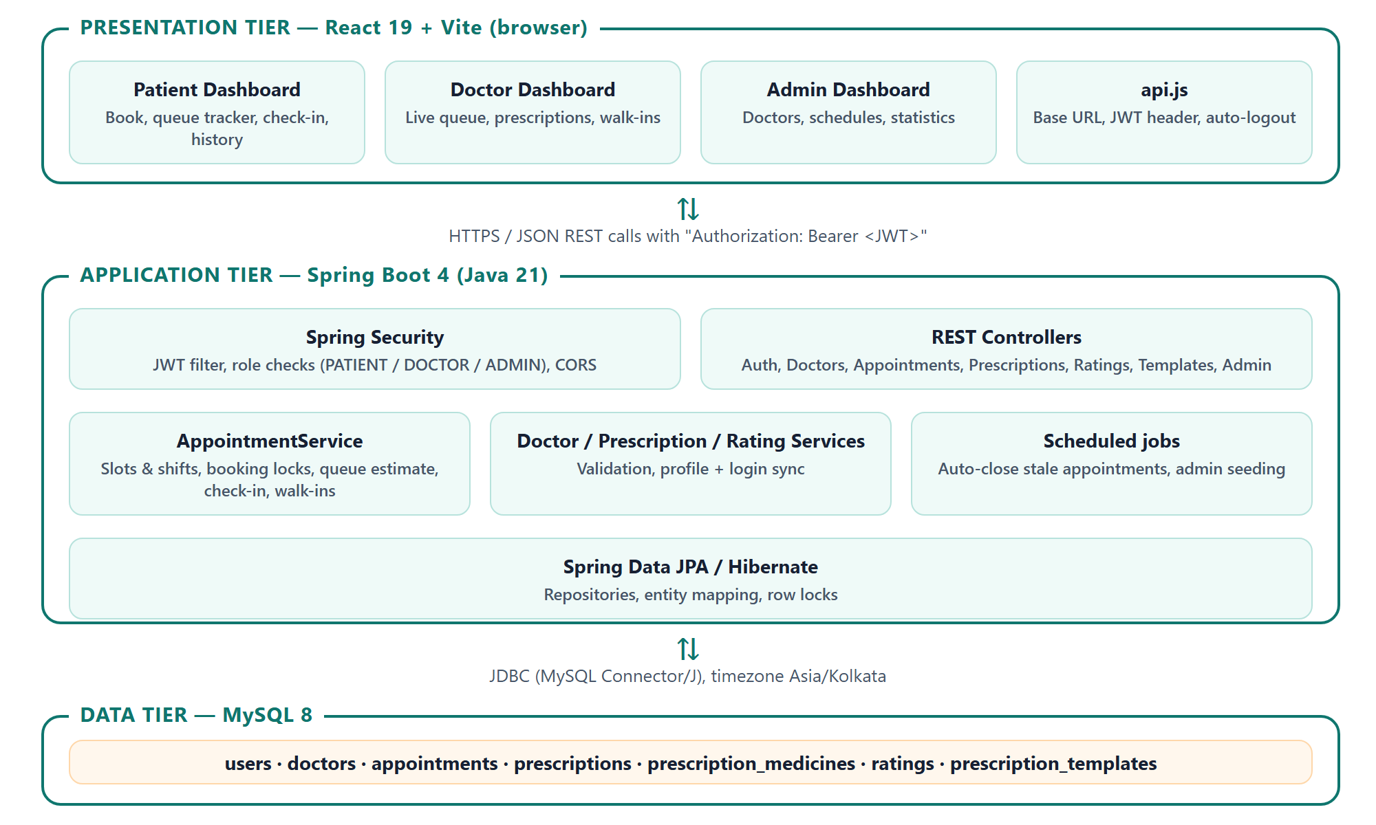
Figure 4.1: System architecture of MedQueue

4.2 Module Description
Table 4.1: Modules of the system
Module | Description
Authentication | Patient self-registration, login for all roles, JWT generation and validation, automatic logout when the session expires.
Doctor Management | Admin creates, edits, deactivates and reactivates doctors; doctor profile and login account are kept in sync in one transaction.
Scheduling & Slots | Generates fixed time slots from each doctor’s working days, hours and consultation length, including overnight shifts.
Appointment Booking | Booking, rescheduling and cancellation with double-booking protection and token assignment.
Live Queue | Doctor’s queue view, Call Next, Complete, Skip, walk-ins and patient check-in (arrived / running late).
Queue Estimation | Learns the doctor’s average consultation time and simulates the queue to estimate each patient’s call time and delay.
Prescription | Digital prescriptions with multiple medicines, templates, medicine suggestions, repeat-last and a printable / PDF view.
Rating & Reviews | Patients rate completed visits (1–5 stars) with an optional review; doctors and admins see averages.
History | Complete visit history with prescriptions and ratings for patients and doctors.
Maintenance Jobs | Seeds the admin account at startup and automatically closes appointments left unfinished.

4.3 Database Design
The database consists of seven main tables. Figure 4.2 shows the entity–relationship diagram. A user with the DOCTOR role is linked one-to-one with a doctor profile. Each appointment links one patient and one doctor, and can have at most one prescription and one rating. Prescription medicines and template medicines are stored as dependent collections.
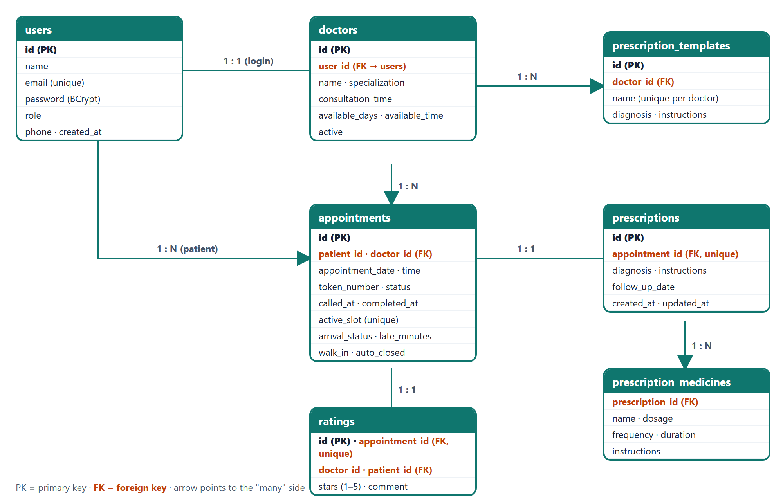
Figure 4.2: Entity–relationship diagram

4.4 Data Dictionary
Table 4.2: users
Field | Type | Description
id | BIGINT (PK) | Unique user identifier
name | VARCHAR | Full name
email | VARCHAR (unique) | Login email address
password | VARCHAR | BCrypt hash of the password
role | ENUM | PATIENT, DOCTOR or ADMIN
phone | VARCHAR | Mobile number
created_at | DATETIME | Registration time

Table 4.3: doctors
Field | Type | Description
id | BIGINT (PK) | Doctor identifier
user_id | BIGINT (FK) | Linked login account in users
name, specialization | VARCHAR | Doctor name and speciality
consultation_time | INT | Minutes per patient (5–60)
available_days | VARCHAR | Working days, e.g. MON,TUE,WED
available_time | VARCHAR | Working hours, e.g. 10:00-14:00 or 23:00-03:00
active | BIT | Inactive doctors cannot log in or be booked

Table 4.4: appointments
Field | Type | Description
id | BIGINT (PK) | Appointment identifier
patient_id, doctor_id | BIGINT (FK) | Patient (users) and doctor (doctors)
appointment_date, appointment_time | DATE, TIME | Booked slot
token_number | INT | Token within the doctor’s session
status | VARCHAR | BOOKED, CALLED, COMPLETED, SKIPPED or CANCELLED
called_at, completed_at | DATETIME | Actual consultation start and end
active_slot | VARCHAR (unique) | Slot key while the booking is live; prevents double booking
arrival_status, checked_in_at, late_minutes | VARCHAR, DATETIME, INT | Patient check-in (ARRIVED / LATE)
walk_in, auto_closed | BIT | Added at the clinic / closed automatically

Table 4.5: prescriptions and prescription_medicines
Field | Type | Description
id | BIGINT (PK) | Prescription identifier
appointment_id | BIGINT (FK, unique) | One prescription per visit
diagnosis, instructions | VARCHAR | Diagnosis and general advice
follow_up_date | DATE | Suggested follow-up
created_at, updated_at | DATETIME | Audit timestamps
medicine: name, dosage, frequency, duration, instructions | VARCHAR | One row per prescribed medicine

Table 4.6: ratings
Field | Type | Description
id | BIGINT (PK) | Rating identifier
appointment_id | BIGINT (FK, unique) | One rating per completed visit
doctor_id, patient_id | BIGINT (FK) | Who rated whom
stars | INT | 1 to 5
comment, created_at | VARCHAR, DATETIME | Optional review and time

Table 4.7: prescription_templates
Field | Type | Description
id | BIGINT (PK) | Template identifier
doctor_id | BIGINT | Owner doctor
name | VARCHAR | Template name, unique per doctor
diagnosis, instructions, medicines | VARCHAR / collection | Saved prescription content

4.5 Appointment Lifecycle
Figure 4.3 shows the states an appointment passes through. A booking (or walk-in) starts as BOOKED; the patient can check in or report that they are running late. When the doctor calls the patient it becomes CALLED, and when the consultation ends it becomes COMPLETED, after which a prescription is written and the patient can rate the visit. A booked appointment can be cancelled or skipped. Appointments that nobody finished are closed automatically twelve hours after the slot and are clearly flagged.
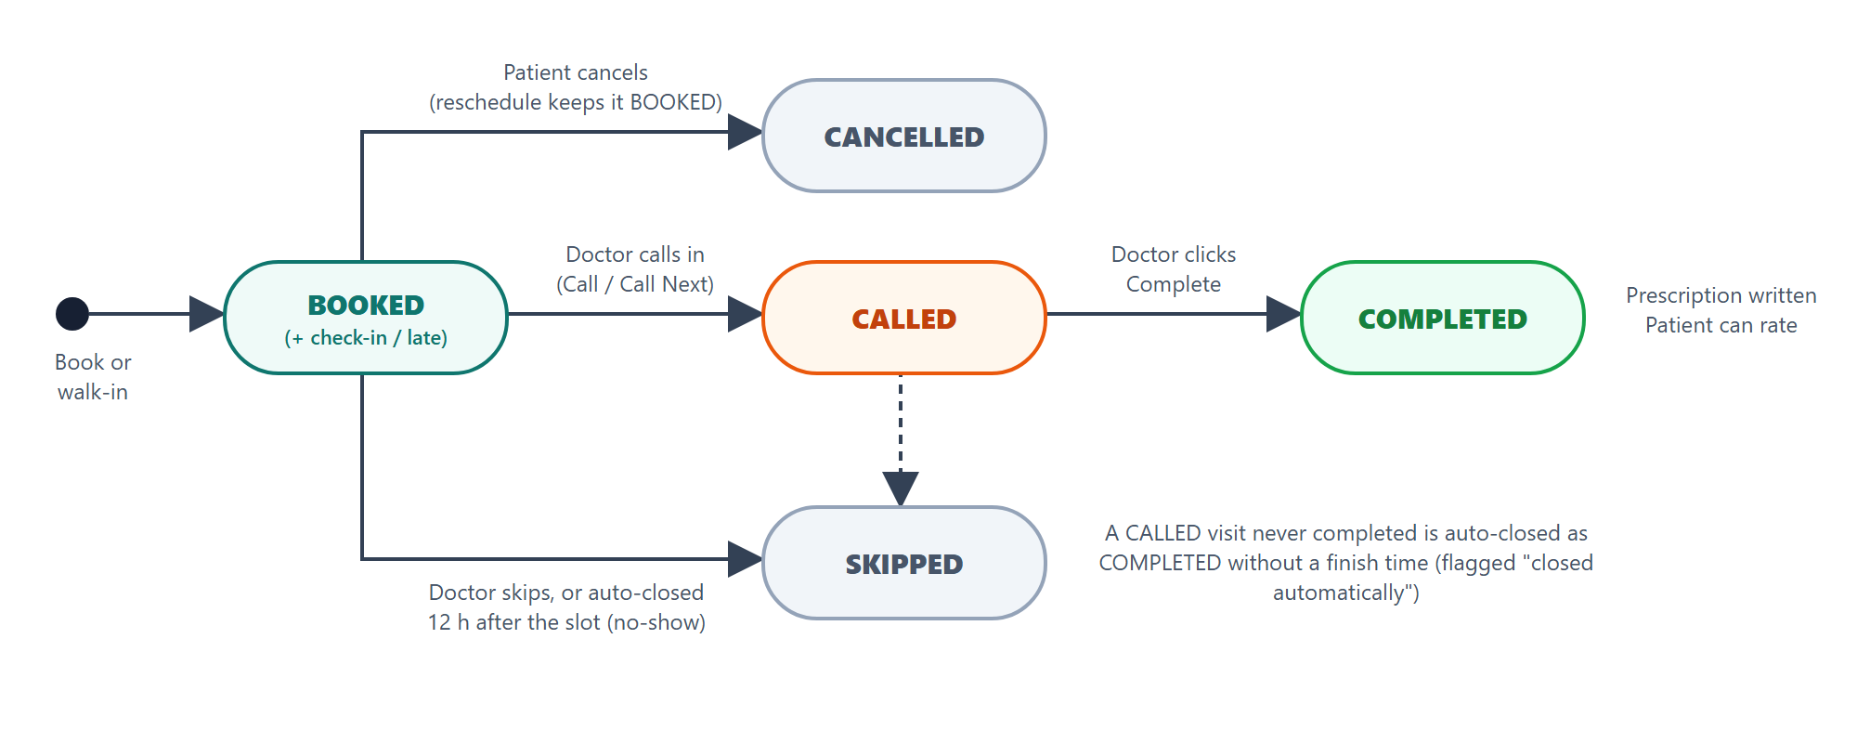
Figure 4.3: Appointment lifecycle (state diagram)

CHAPTER 5
IMPLEMENTATION

5.1 Technology Stack
Table 5.1: Technology stack
Layer | Technology | Purpose
Frontend | React 19 + Vite 8 | Single-page dashboards for patient, doctor and admin
UI | Bootstrap 5.3 + custom CSS theme | Layout and a shared colour theme
Backend | Spring Boot 4.0.8 (Java 21) | REST API and business logic
Security | Spring Security + JJWT 0.12.6 | JWT authentication and role checks
Persistence | Spring Data JPA / Hibernate | Object–relational mapping and locking
Database | MySQL 8.0 | Relational data storage
Testing | JUnit 5 + Mockito | Automated unit tests of business rules

5.2 Project Structure
The backend (folder medqueue/) follows a layered package structure:
- config: security configuration, admin seeding, scheduled maintenance jobs.
- controller: REST controllers and request/response objects (DTOs).
- entity: JPA entities – User, Doctor, Appointment, Prescription, Medicine, Rating, PrescriptionTemplate.
- repository: Spring Data repositories with derived and custom queries.
- service: business logic – appointments and queue, doctors, prescriptions, ratings, authentication.
- security: JWT generation and the authentication filter.
The frontend (folder medqueue-frontend/) contains the three dashboards (PatientDashboard, DoctorDashboard, AdminDashboard), the login and sign-up screen, shared components (QueueTracker, PrescriptionCard, StarRating, StatusBadge) and api.js, which holds the backend address and handles login expiry.

5.3 Key Algorithms

5.3.1 Slot Generation and Overnight Shifts
Each doctor has working days, a start time, an end time and a consultation length. Slots are generated in minutes from midnight: starting at the start time, one consultation apart, as long as the slot ends by the end time. If the end time is at or before the start time, the shift runs past midnight and 1440 minutes are added to the end. For a calendar date, the bookable times are the early-morning part of the previous evening’s night shift plus that day’s own shift. Appointments keep their real calendar date, while queues, tokens and estimates treat the whole night as one session.

5.3.2 Double-Booking Protection
Three layers prevent two patients from getting the same slot:
- The doctor’s database row is locked (pessimistic write lock) for the whole booking transaction, so bookings for the same doctor are processed one at a time and token numbers stay unique.
- The requested time must be one of the generated slots, must not be in the past, and must not be held by another live booking; a patient also cannot hold two live bookings in the same session or at the same time.
- As a last line of defence, each live booking stores an active_slot key (doctor|date|time) with a unique database index. Cancelled or finished bookings clear the key so the slot can be booked again.

5.3.3 Live Queue Waiting-Time Estimation
The estimate is recalculated on every request:
- Learned average: the doctor’s last 30 completed consultations are averaged, with today’s visits weighted twice, blended with the configured consultation time when little history exists; durations under 1 minute or over 2 hours are ignored.
- Current patient: the remaining time is the average minus the time already spent; if the consultation is overrunning, a small buffer is used and the patient behind is told they will be called as soon as the current consultation ends.
- Queue simulation: every waiting patient ahead is processed in order; nobody is seen before their booked slot, or before their reported arrival time if they said they were running late.
- Result: expected call time, remaining seconds (shown as a live countdown), position in line and the delay compared with the booked slot.

5.3.4 Check-in, Walk-ins and Automatic Closing
From three hours before the slot a patient can tap “I’ve arrived” or “Running late (10/15/30 min)”. The doctor’s Call Next button selects the first patient who has arrived, so an absent patient keeps their place without holding up the queue. Doctors can add walk-in patients, who join the current session at the current time, already marked as arrived. A scheduled job runs every 30 minutes and closes appointments still open twelve hours after their slot: BOOKED becomes SKIPPED (no-show) and CALLED becomes COMPLETED without a finish time, both flagged as closed automatically.

5.4 Security Implementation
- Passwords are hashed with BCrypt; public sign-up always creates a PATIENT account and doctors are created only by the administrator.
- After login the server issues a signed JWT valid for 24 hours. A filter validates it on every request; missing or expired tokens receive HTTP 401 and the frontend logs the user out automatically.
- Method-level role checks (PATIENT, DOCTOR, ADMIN) protect every endpoint, and ownership checks ensure patients only access their own appointments and doctors only their own queue.
- Deactivated doctors cannot log in, and their existing tokens stop working.
- Secrets (database password, JWT key, admin password) are read from environment variables or a local file that is not shared; CORS allows only local development origins.
- All user-supplied text on the printable prescription is HTML-escaped to prevent script injection.

5.5 REST API Summary
Table 5.2: Main REST endpoints
Method & Endpoint | Role | Purpose
POST /api/auth/register | Public | Patient sign-up
POST /api/auth/login | Public | Login, returns JWT
GET /api/doctors | Public | List active doctors with ratings
POST, PUT /api/doctors | Admin | Create or edit a doctor
PUT /api/doctors/{id}/deactivate | activate | Admin | Change doctor status
GET /api/appointments/slots | Logged in | Available slots of a doctor for a date
GET /api/appointments/next-free | Logged in | Earliest free slot of every doctor
POST /api/appointments/book | Patient | Book a slot
PUT /api/appointments/{id}/reschedule | Patient | Move to another slot
PUT /api/appointments/{id}/check-in | Patient | Arrived / running late
PUT /api/appointments/{id}/cancel | Patient | Cancel a booking
GET /api/appointments/{id}/queue-status | Owner | Live queue estimate
GET /api/appointments/doctor/{id} | Doctor/Admin | Doctor’s queue for a date
PUT /api/appointments/{id}/status | Doctor/Admin | Call, complete or skip
POST /api/appointments/walk-in | Doctor | Add a walk-in patient
GET /api/appointments/history/… | Owner/Staff | Visit history
POST, PUT /api/prescriptions/appointment/{id} | Doctor | Write or edit a prescription
GET, POST, DELETE /api/prescription-templates | Doctor | Manage templates
POST /api/ratings/appointment/{id} | Patient | Rate a completed visit
GET /api/admin/statistics | Admin | Clinic statistics

CHAPTER 6
TESTING

6.1 Testing Strategy
Testing was carried out at two levels. Unit tests written with JUnit 5 and Mockito check the business rules of the service layer in isolation, using mocked repositories so that each rule (slot generation, booking, rescheduling, check-in, queue estimation, walk-ins and automatic closing) can be tested with exact, repeatable data. Integration checks were then performed against the running MySQL database and backend to confirm database constraints, configuration and security behaviour.

6.2 Unit Test Cases
Table 6.1: Automated unit test cases
No. | Test class | Test case | Result
1 | AppointmentShiftTest | Day shift 10:00–14:00 gives 16 slots; none on non-working days | Pass
2 | AppointmentShiftTest | Shift 18:00–00:00 ends at midnight; last slot 23:45, nothing spills over | Pass
3 | AppointmentShiftTest | Night shift 23:00–03:00: correct slots on each calendar day | Pass
4 | AppointmentShiftTest | Doctor’s night queue contains both dates of the shift in order | Pass
5 | QueueOverrunTest | Consultation of 20 min vs 15 min average is flagged as 5 min over | Pass
6 | QueueOverrunTest | Consultation within the usual time is not flagged; wait ≈ 5 min | Pass
7 | PatientFlowTest | Reschedule within the same session keeps the token | Pass
8 | PatientFlowTest | Reschedule into an already booked slot is refused | Pass
9 | PatientFlowTest | A patient cannot reschedule someone else’s appointment | Pass
10 | PatientFlowTest | Reschedule to a time that is not a slot is refused | Pass
11 | PatientFlowTest | Check-in “arrived” is recorded with time | Pass
12 | PatientFlowTest | Check-in “running late 15 min” is recorded | Pass
13 | PatientFlowTest | Check-in too early, invalid minutes or another user is refused | Pass
14 | PatientFlowTest | A patient 30 min late ahead pushes the next estimate to ≈ 40 min | Pass
15 | PatientFlowTest | Next free slot is the upcoming free slot | Pass
16 | StaleAndWalkInTest | Stale BOOKED → SKIPPED, stale CALLED → COMPLETED (no end time), recent unchanged | Pass
17 | StaleAndWalkInTest | Walk-in joins the queue as arrived with the next token | Pass
18 | StaleAndWalkInTest | Walk-in reuses an existing patient by phone and blocks duplicates | Pass
19 | StaleAndWalkInTest | Walk-in outside the doctor’s session is refused | Pass
20 | StaleAndWalkInTest | Walk-in without a name is refused | Pass

6.3 Integration Checks and Results
Table 6.2: Integration checks performed
Check | Expected result | Observed result
Insert a second live booking for an occupied slot directly in MySQL | Rejected by unique key | Duplicate entry error on uk_appointment_active_slot
Store a timestamp through the application connection | Stored in clinic time (IST) | 23:33 stored as 23:33 (previously shifted to 18:03)
Backend startup with secrets from local-secrets.properties | Connects to MySQL and loads the JWT key | Connection pool started and JPA initialised
Token expiry check used for automatic logout | Expired token detected, valid token accepted | Expired: detected; valid: accepted
“<script>” typed in a patient name, printed prescription | Shown as text, never executed | HTML-escaped and displayed as plain text
Application startup schema update | New columns and tables created | All columns, tables and indexes created successfully

Result: all 20 automated unit tests passed (Tests run: 20, Failures: 0, Errors: 0), and all integration checks produced the expected results.

CHAPTER 7
SCREENSHOTS
The following screenshots show the main screens of MedQueue. Figures marked with a dashed box are to be filled with screenshots taken from the running application.
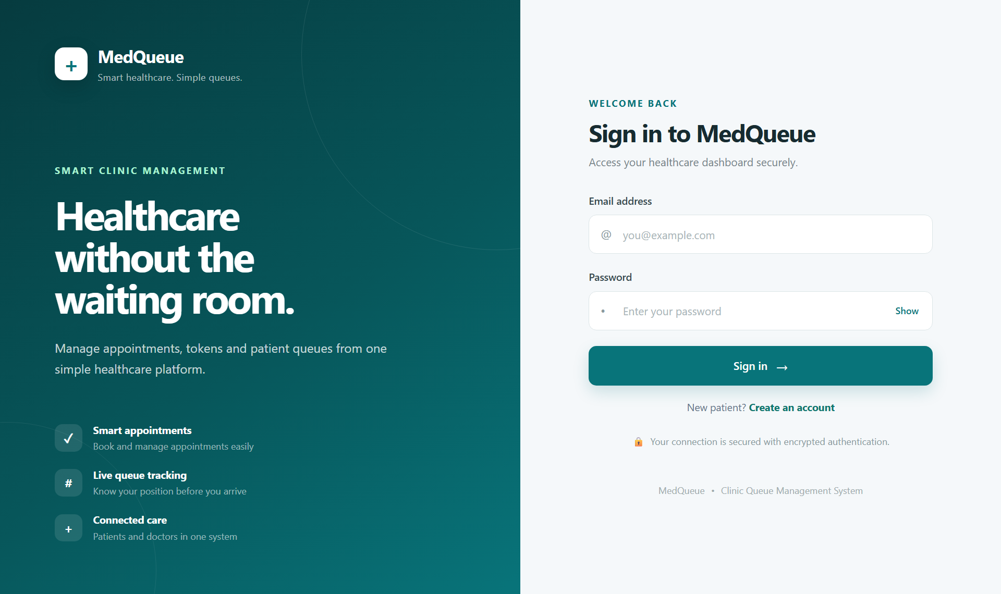
Figure 7.1: Login and patient sign-up screen
[Insert screenshot here]
Log in as a patient with an appointment for today
Figure 7.2: Patient dashboard with live queue tracker and check-in
[Insert screenshot here]
Doctors → Book Appointment → choose a date
Figure 7.3: Booking with doctor’s available time slots
[Insert screenshot here]
Shown right after confirming a booking
Figure 7.4: Booking confirmation with “Add to calendar”
[Insert screenshot here]
Log in as a doctor during a session
Figure 7.5: Doctor dashboard – live queue with arrival status
[Insert screenshot here]
Doctor → Write Prescription
Figure 7.6: Writing a prescription with templates and suggestions
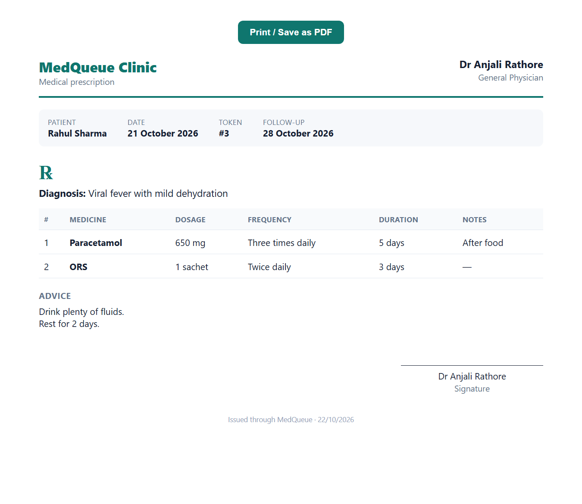
Figure 7.7: Printable prescription (sample data)
[Insert screenshot here]
Patient → History
Figure 7.8: Patient visit history with prescriptions and ratings
[Insert screenshot here]
Admin → Doctors → Add doctor / Edit
Figure 7.9: Admin – doctor management and schedule with slot preview

CHAPTER 8
CONCLUSION AND FUTURE ENHANCEMENTS

8.1 Conclusion
MedQueue successfully replaces the manual appointment and token system of a clinic with an online, role-based application. Patients can book reliable time slots, see exactly where they stand in the queue and when they will be called, check in on arrival, and keep their prescriptions and history in one place. Doctors run their queue efficiently with live arrival information, write complete digital prescriptions quickly using templates and history, and handle walk-in patients. The administrator manages doctors and their schedules, including overnight shifts, with validation that prevents mistakes.
Special attention was given to correctness and security: double bookings are prevented at three levels, waiting times are calculated from real consultation data, time is stored consistently in the clinic’s timezone, and every request is checked for the user’s role and ownership. The business rules are covered by 20 automated unit tests, all of which pass.

8.2 Limitations
- The queue updates by checking the server every 5 seconds rather than receiving instant push updates.
- Notifications are shown only inside the application; there are no SMS or e-mail reminders yet.
- A doctor can have only one working session per day (no separate lunch break or second session), and leave or holiday dates are not yet supported.
- The system is designed for a single clinic and runs on a local server in its current form.

8.3 Future Enhancements
- Real-time push updates using WebSockets or Server-Sent Events.
- SMS / WhatsApp reminders and “your turn is near” browser notifications.
- Doctor breaks, multiple sessions per day and leave management.
- Admin reports: average waiting time per doctor, no-show rate, busiest hours and CSV export.
- Online consultation fee payment and digital receipts.
- Upload of laboratory reports and medical documents to a patient’s history.
- Multi-language support (Hindi and regional languages) and a mobile app.
- Deployment to the cloud with HTTPS, automated backups and database migrations.

CHAPTER 9
REFERENCES
[1] Spring Boot Reference Documentation, VMware / Broadcom. https://docs.spring.io/spring-boot/
[2] Spring Security Reference Documentation. https://docs.spring.io/spring-security/reference/
[3] Spring Data JPA Reference Documentation. https://docs.spring.io/spring-data/jpa/reference/
[4] Hibernate ORM User Guide. https://hibernate.org/orm/documentation/
[5] React Documentation. https://react.dev/
[6] Vite Documentation. https://vite.dev/
[7] MySQL 8.0 Reference Manual, Oracle Corporation. https://dev.mysql.com/doc/refman/8.0/en/
[8] JJWT – Java JWT library. https://github.com/jwtk/jjwt
[9] M. Jones, J. Bradley, N. Sakimura, “JSON Web Token (JWT)”, RFC 7519, IETF, 2015.
[10] B. Desruisseaux, “Internet Calendaring and Scheduling Core Object Specification (iCalendar)”, RFC 5545, IETF, 2009.
[11] MDN Web Docs – HTTP, CORS and Web APIs, Mozilla. https://developer.mozilla.org/
[12] JUnit 5 User Guide. https://junit.org/junit5/docs/current/user-guide/
[13] Mockito Documentation. https://site.mockito.org/

