**hive_class_3_assignment**

**Name – Ayushi Jain**

**Batch – 1st Big data bootcamp**

**Mail Id –** [**ayushijain2277@gmail.com**](mailto:ayushijain2277@gmail.com)

1. -- **Downloaded file and moved to /tmp/Hive_class/ folder in local.**

2. --**Storing raw data into hdfs location**

hadoop fs -put sales_order_data.csv /tmp/hive_data_class2

Hadoop fs -ls /tmp/hive_data_class2

1. --**Creating a internal hive table "sales_order_csv" which will store csv data sales_order_csv and making sure to skip header row while creating table**

use hive_class_b1;

create table sales_order_csv

(

ORDERNUMBER int,

QUANTITYORDERED int,

PRICEEACH float,

ORDERLINENUMBER int,

SALES float,

STATUS string,

QTR_ID int,

MONTH_ID int,

YEAR_ID int,

PRODUCTLINE string,

MSRP int,

PRODUCTCODE string,

PHONE string,

CITY string,

STATE string,

POSTALCODE string,

COUNTRY string,

TERRITORY string,

CONTACTLASTNAME string,

CONTACTFIRSTNAME string,

DEALSIZE string

)

row format delimited

fields terminated by ','

tblproperties("skip.header.line.count"="1")

;

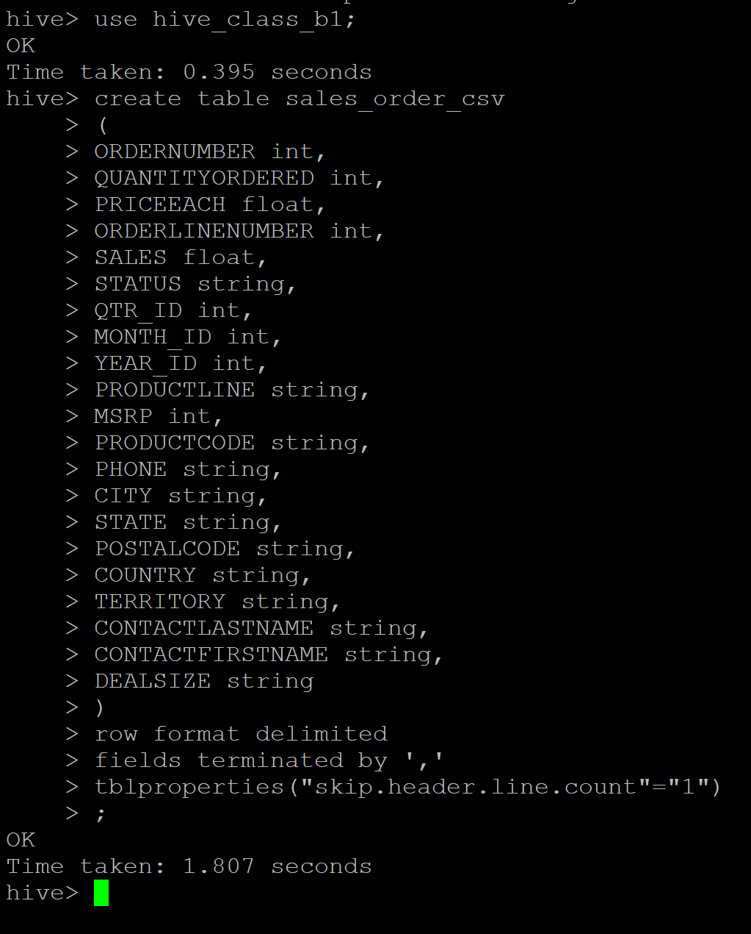

4.--**Loading data from hdfs path into "sales_order_csv" internal table**

Load data inpath ‘/tmp/hive_data_class2/’ into table sales_order_csv;



1. -- **Creating an internal hive table which will store data in ORC format "sales_order_orc"**

create table sales_order_orc

(

ORDERNUMBER int,

QUANTITYORDERED int,

PRICEEACH float,

ORDERLINENUMBER int,

SALES float,

STATUS string,

QTR_ID int,

MONTH_ID int,

YEAR_ID int,

PRODUCTLINE string,

MSRP int,

PRODUCTCODE string,

PHONE string,

CITY string,

STATE string,

POSTALCODE string,

COUNTRY string,

TERRITORY string,

CONTACTLASTNAME string,

CONTACTFIRSTNAME string,

DEALSIZE string

)

stored as orc;

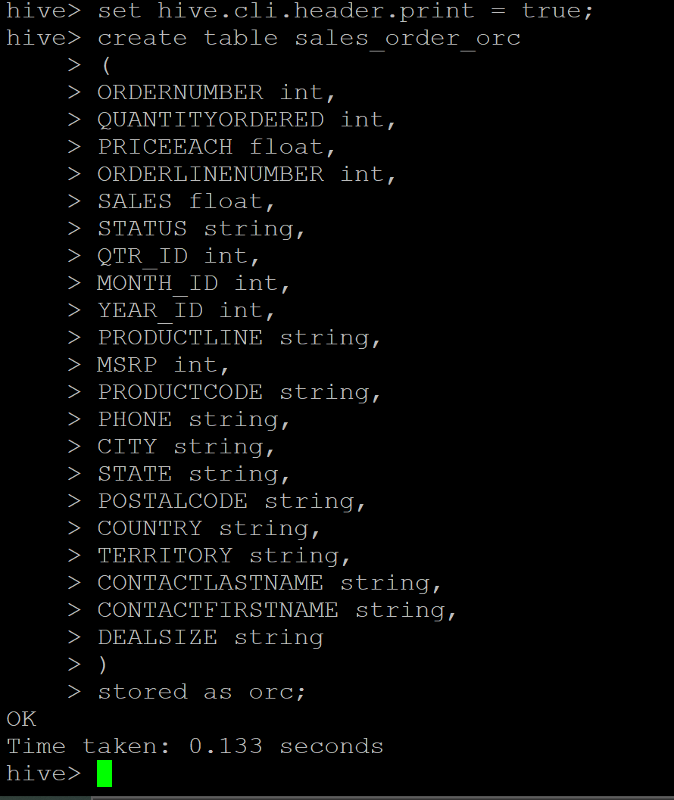

1. --**Loading data from "sales_order_csv" into "sales_order_orc"**

from sales_order_csv insert overwrite table sales_order_orc select *;

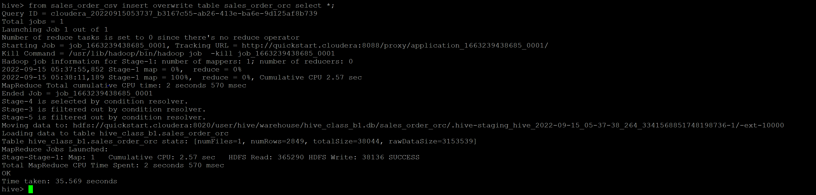

**QUERIES :**

1. **Calculatye total sales per year**

Select year_id ,sum(sales) total_sales from sales_order_orc group by year_id;

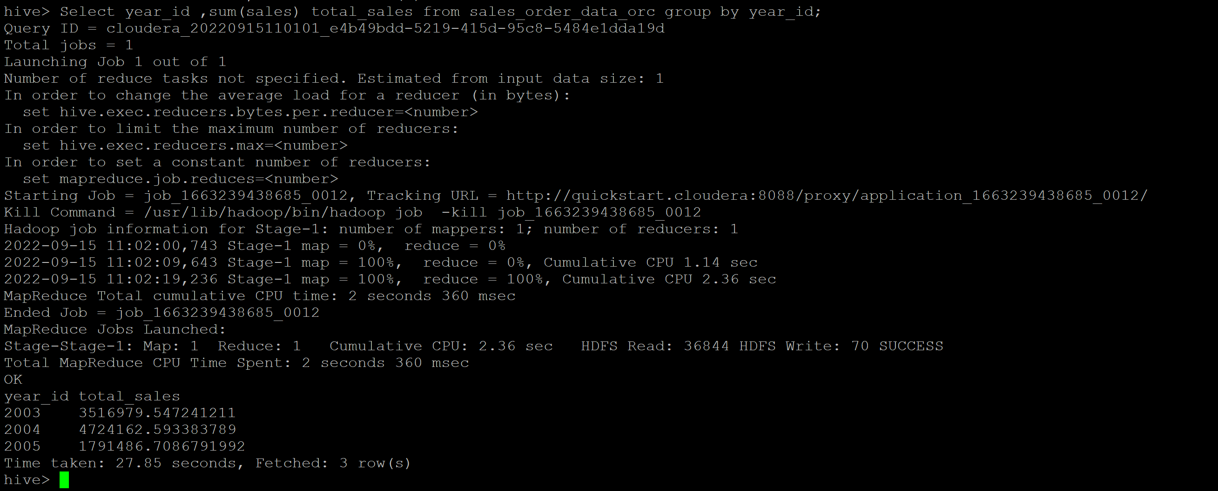

1. **Find a product for which maximum orders were placed**

select PRODUCTLINE as Product ,max(QUANTITYORDERED) as Max_orders from sales_order_orc group by PRODUCTLINE order by max_orders desc;

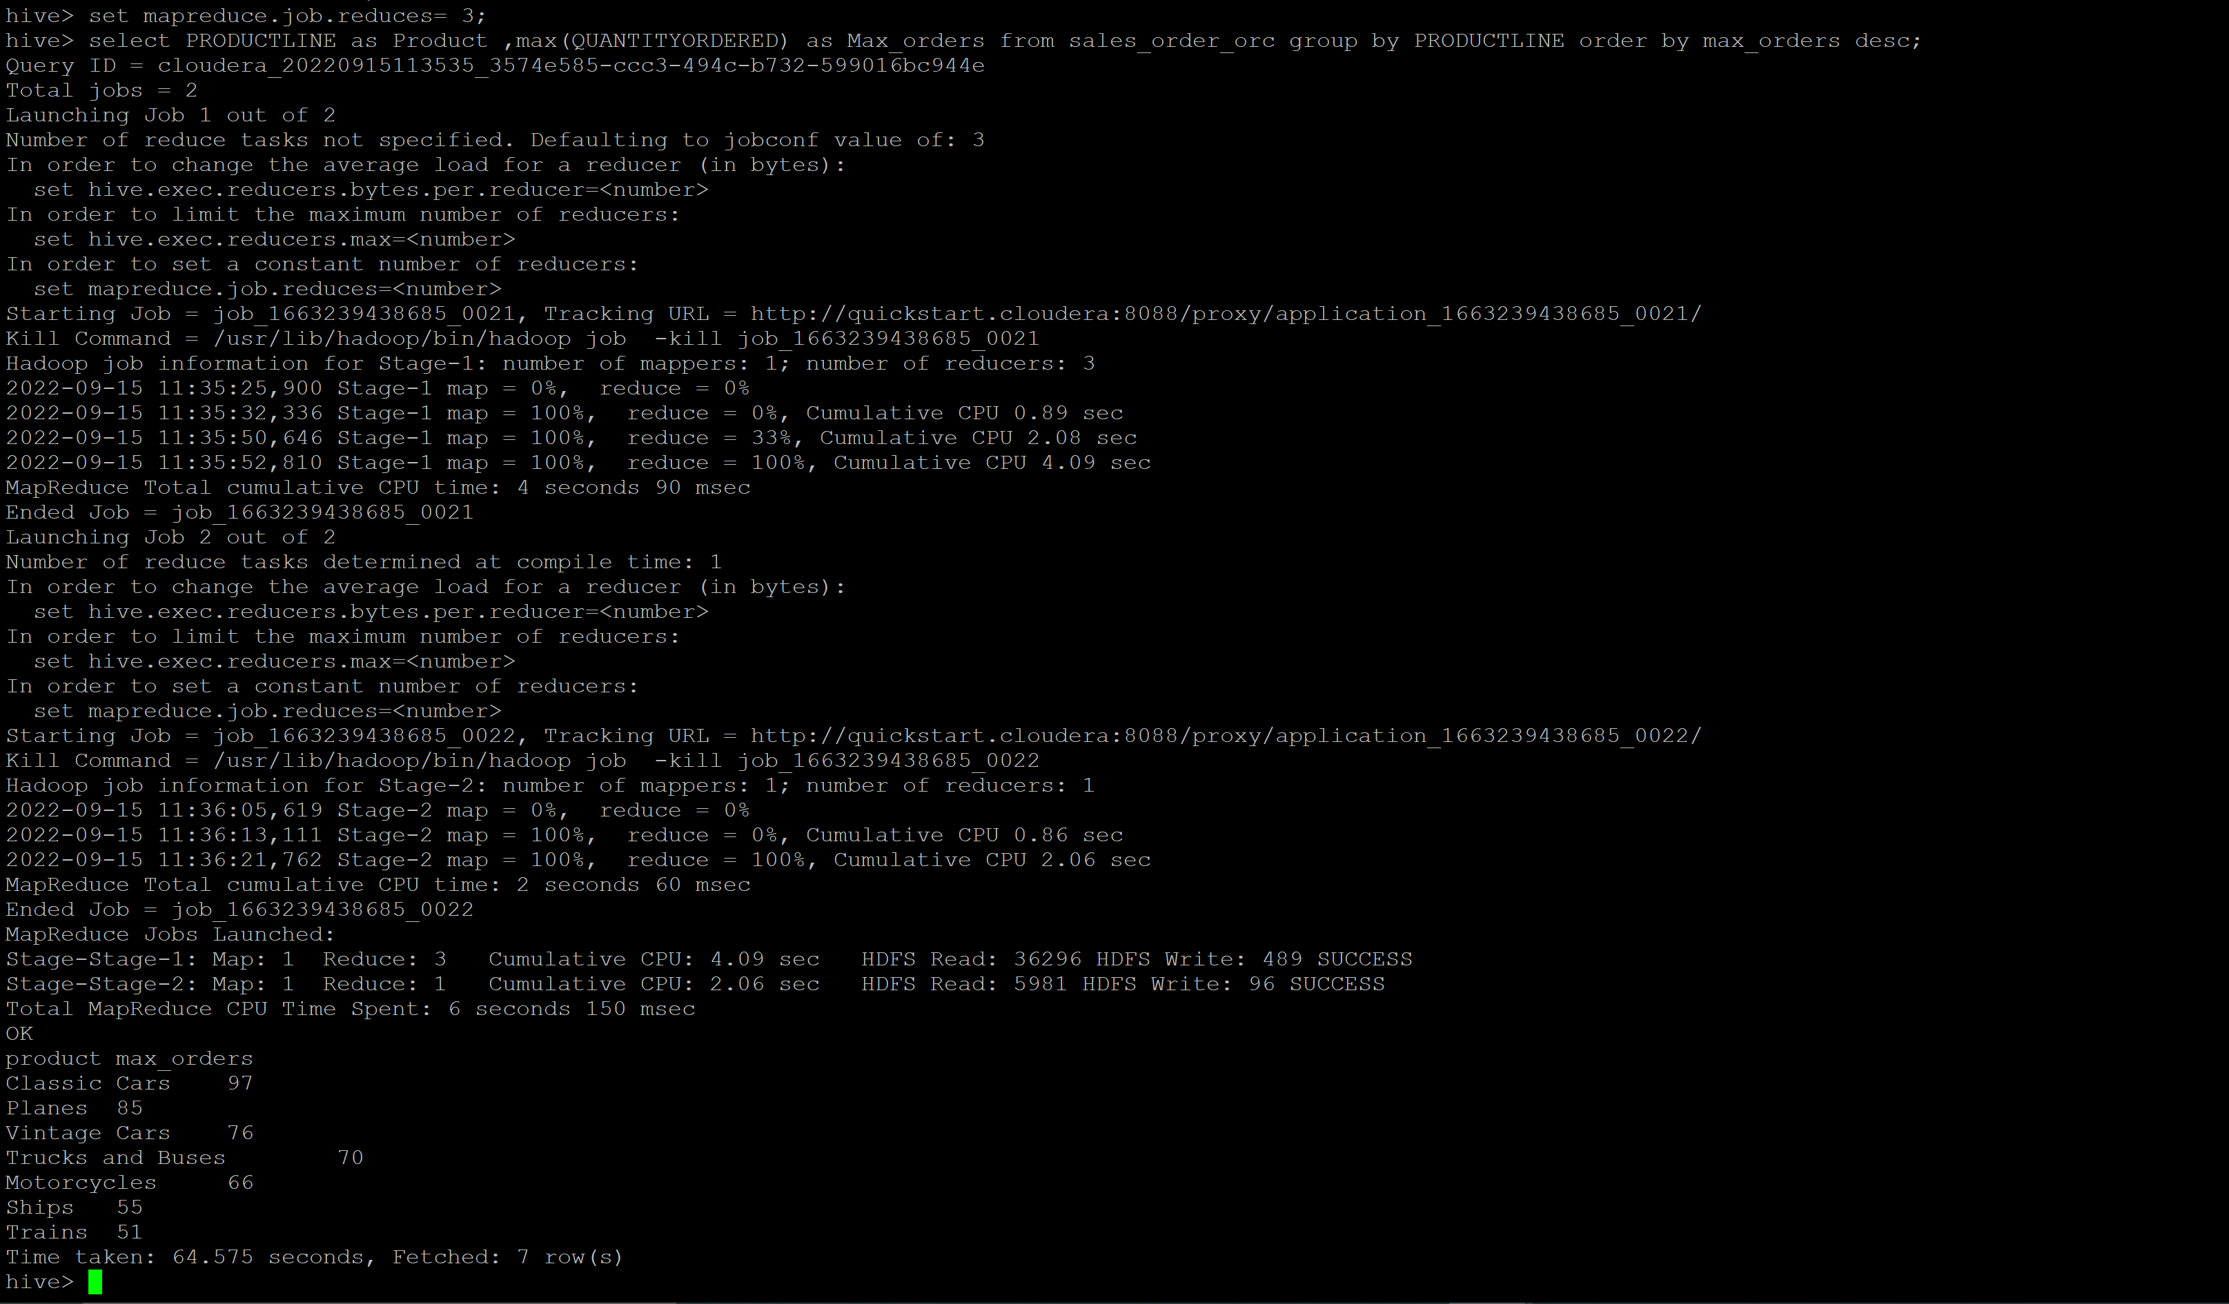

1. **Calculate the total sales for each quarter**

select QTR_ID ,sum(sales) Total_sale_per_quater from sales_order_orc group by QTR_ID order by qtr_id;

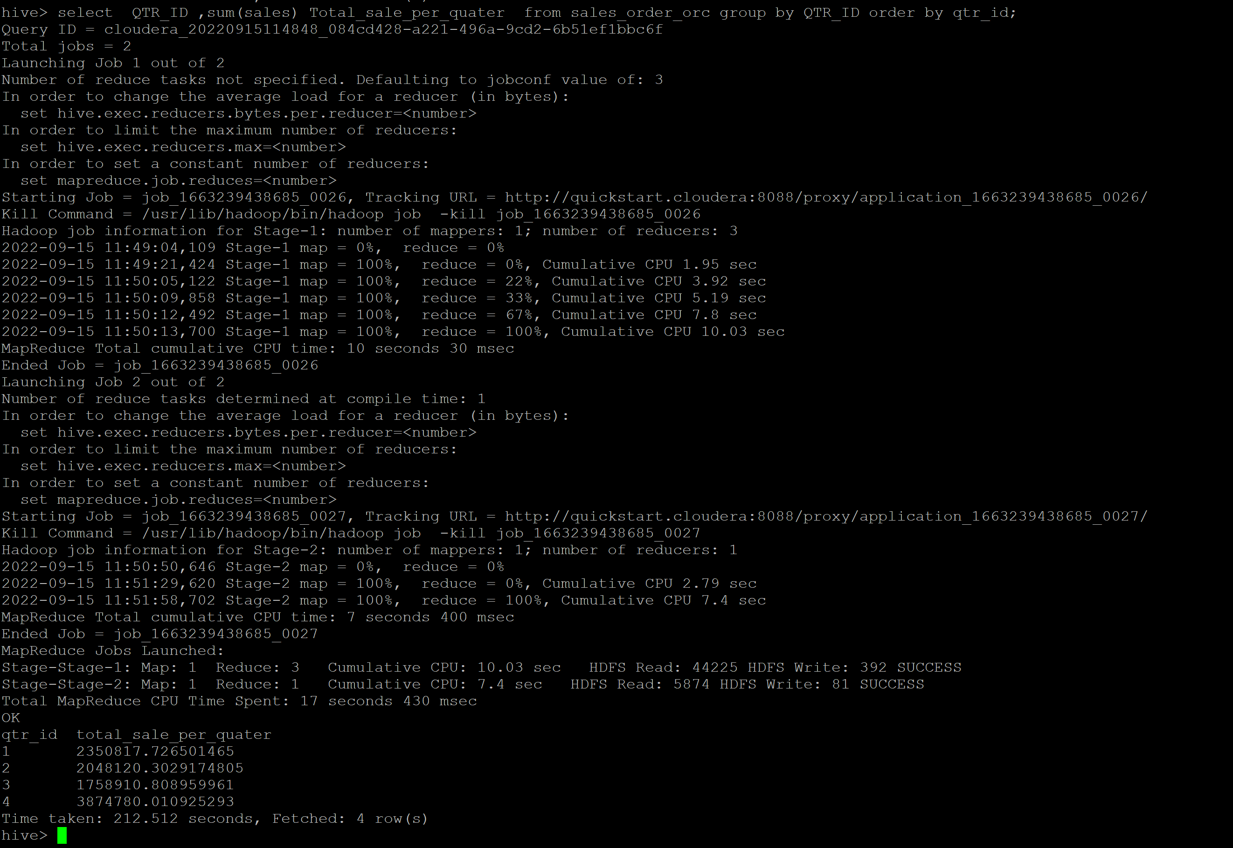

1. **In which quarter sales was minimum**

select QTR_ID , min(sales) Min_sales_per_quater from sales_order_orc group by QTR_ID order by min_sales_per_quater;

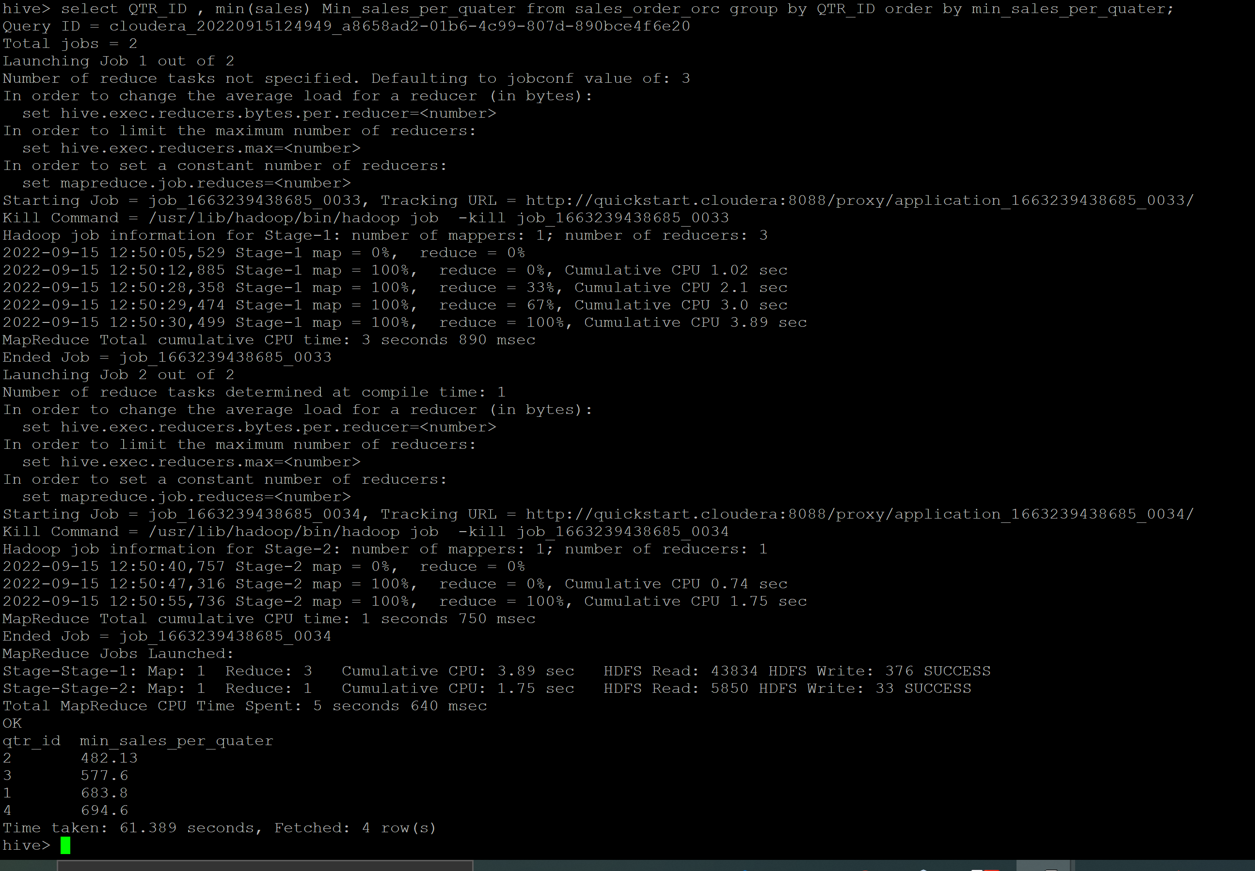

1. **In which country sales was maximum and in which country sales was minimum**

select COUNTRY , min(sales) Min_sales_per_country from sales_order_orc group by COUNTRY order by Min_sales_per_country;

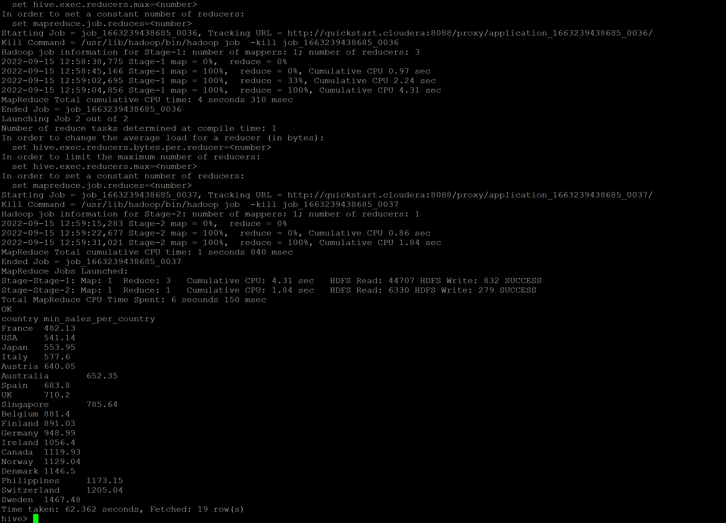

select COUNTRY , max(sales) Max_sales_per_country from sales_order_orc group by COUNTRY order by Max_sales_per_country desc;

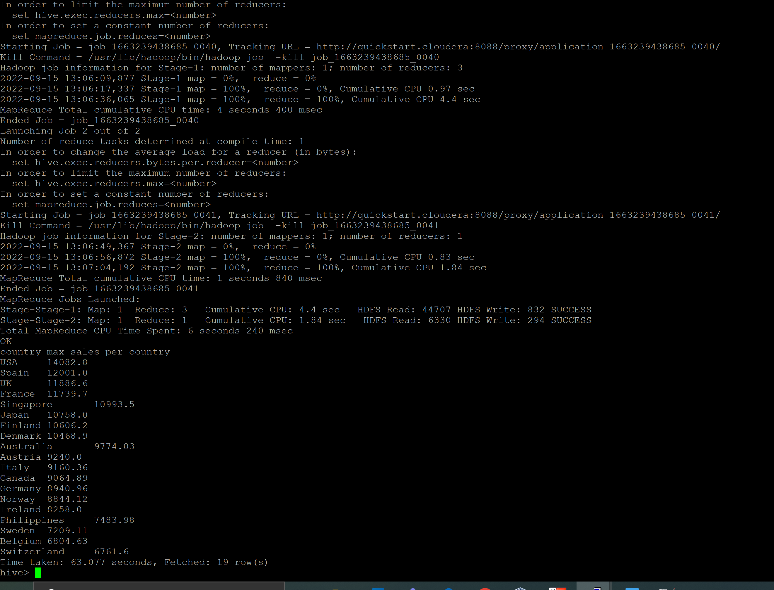

1. **Calculate quartelry sales for each city**

select CITY ,QTR_ID , sum(sales) Quaterly_sales_per_city from sales_order_orc group by QTR_ID ,CITY ORDER BY QTR_ID ,CITY;

1. **Find a month for each year in which maximum number of quantities were sold**

SELECT YEAR_ID , MONTH_ID , MAX(QUANTITYORDERED) FROM sales_order_orc group by MONTH_ID , YEAR_ID order by YEAR_ID , MONTH_ID;

