Program 1:-

Code+Output:-

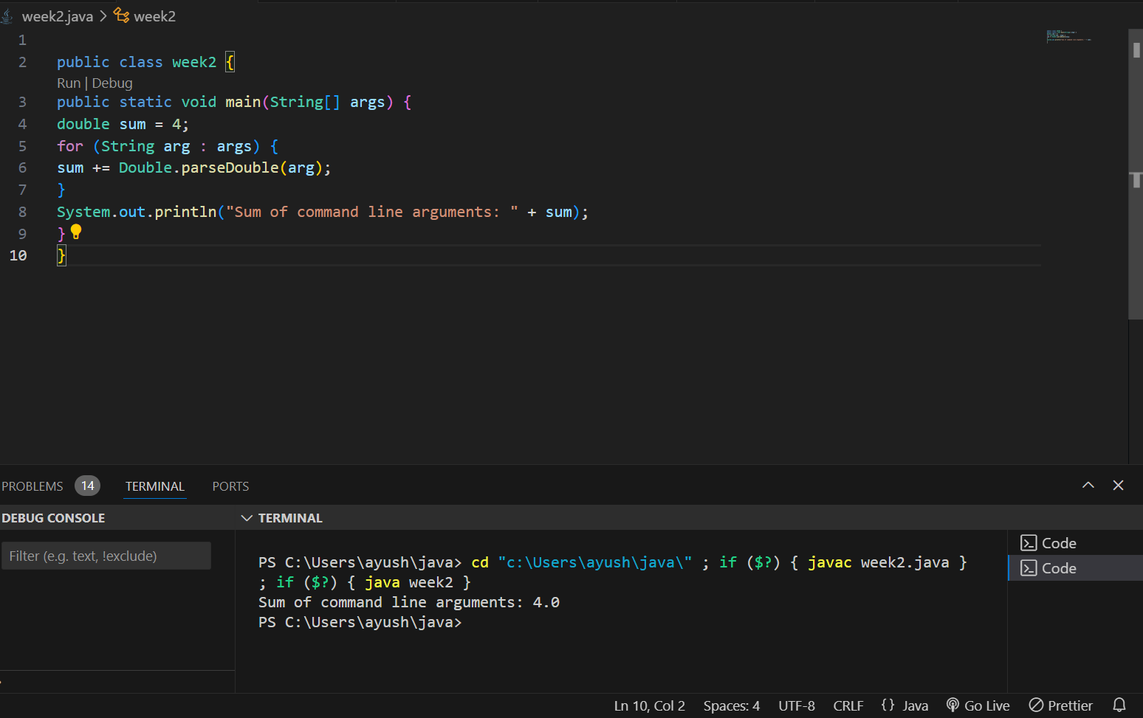

Program 2:-

Code:-

  import java.util.Scanner;

      public class week2 {

          public static void main(String[] args) {

              Scanner scanner = new Scanner(System.in);

              System.out.print("Enter a string: ");

              String inputString = scanner.nextLine();

              int charCount = inputString.length();

              System.out.println("Number of characters in the string: " + charCount);

              String reversedString = reverseString(inputString);

              System.out.println("Reversed string: " + reversedString);

              // Check if the string is a palindrome

              if (inputString.equalsIgnoreCase(reversedString)) {

                  System.out.println("The string is a palindrome.");

              } else {

                  System.out.println("The string is not a palindrome.");

              }

          }

          public static String reverseString(String str) {

              StringBuilder reversed = new StringBuilder();

              for (int i = str.length() - 1; i >= 0; i--) {

                  reversed.append(str.charAt(i));

         }

              return reversed.toString();

          }}

Output:-

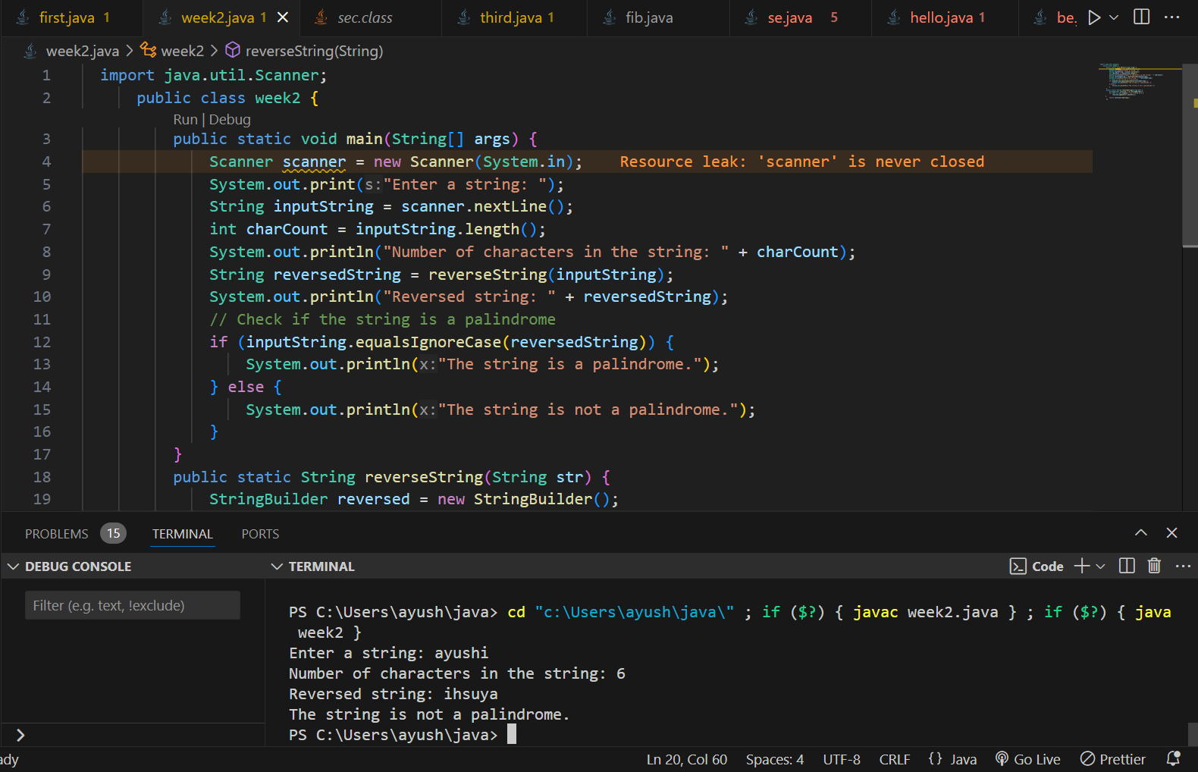

Program -3:-

Code+Output:-

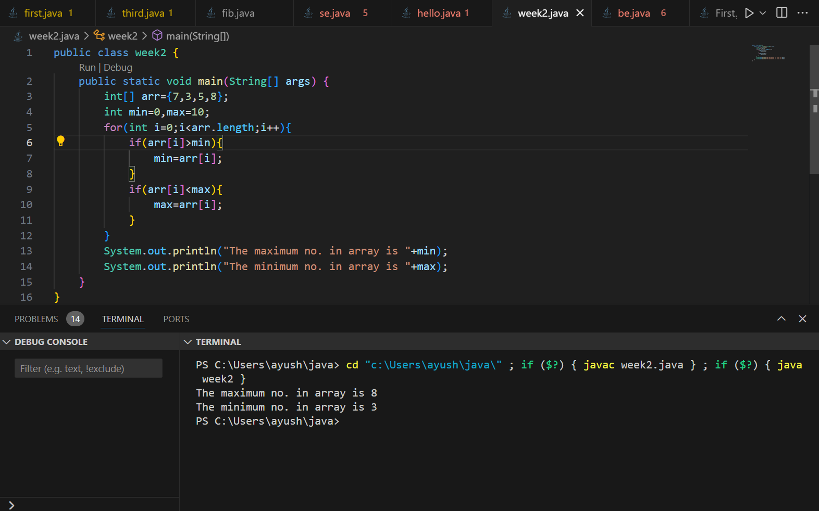

Program 4:-

Code+Output:-

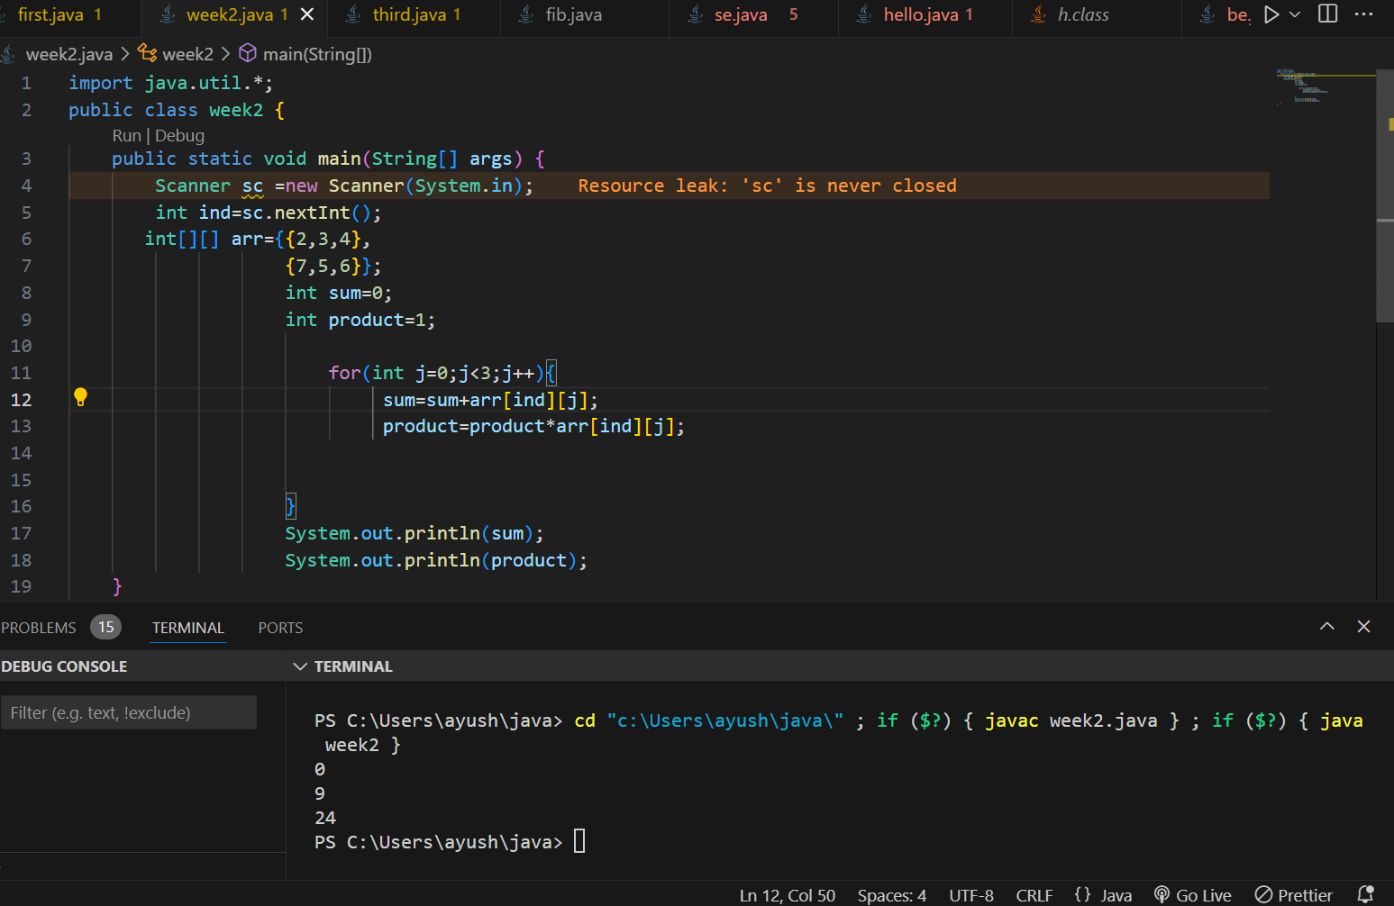

Program 5:-

Code:-

class number{

       public boolean iszero(int n){

        if(n==0){

            return true;

        }

        return false;

       }

       public boolean ispositive(int n){

        if(n>0){

            return true;

        }

        return false;

       }

       public boolean isnegative(int n){

        if(n<0){

            return true;

        }

        return false;

       }

       public boolean iseven(int n){

        if(n%2==0){

            return true;

        }

        return false;

       }

       public boolean isodd(int n){

        if(n%2!=0){

            return true;

        }

        return false;

       }

       public boolean isprime(int n){

        int count=0;

        for(int i=2;i<=n;i++){

            if(n%i==0){

                count++;

            }

        }

        if(count==2){

            return false;

        }

        return true;

       }

}

public class week2 {

    public static void main(String[] args) {

        number a=new number();

        boolean b=a.isprime(9);

        System.out.println("is 9 is prime true or false:-  "+b);

    }

    }

Output:-

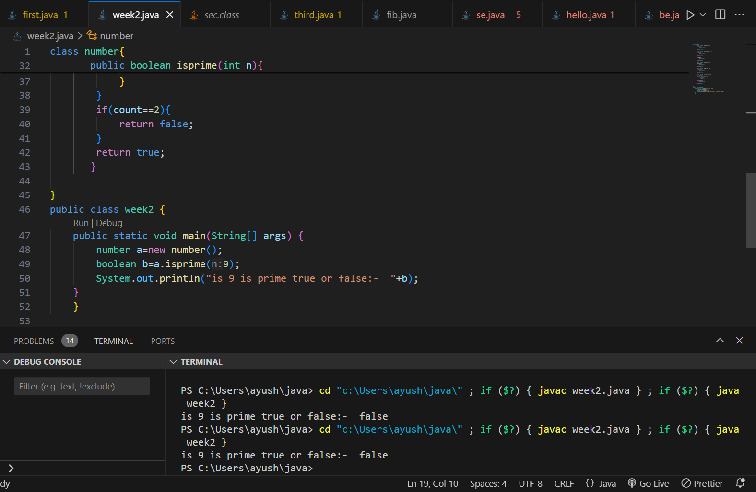

Program 6:-

Code:-

class info{

    int age;

 String name;

    info(int age,String name){

        this.name=name;

        this.age=age;

    }

    info(){

        age=0;

        name="default";

    }

    info(info original) {

        this.age = original.age;

        this.name = original.name;

    }

    info(int age) {

        this(age, "Parameterized");

    }

    void display() {

        System.out.println("Age: " + age + ", Name: " + name);

    }

}

public class week2 {

    public static void main(String[] args) {

        info a=new info();

        a.display();

        info b=new info(16,"arush");

        b.display();

        info c=new info(10);

        c.display();

    }

    }

Output:-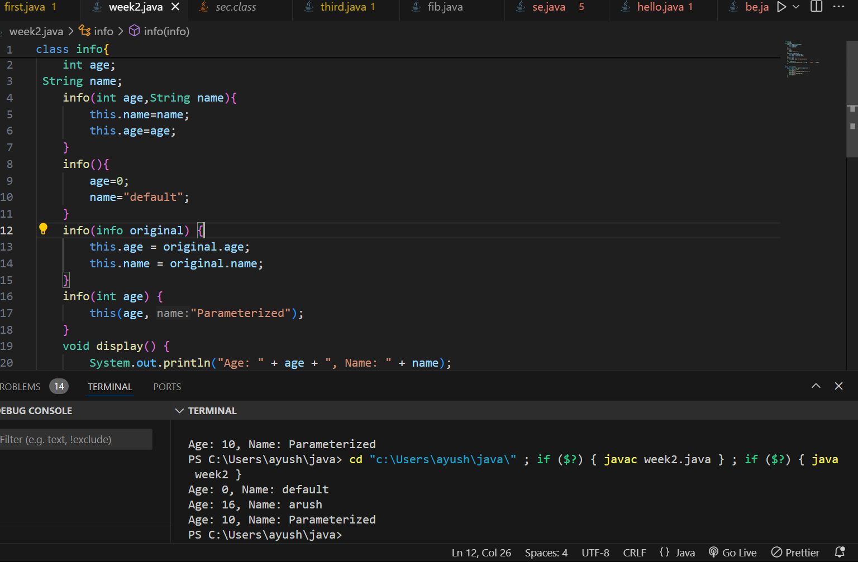

Program 7:-

Code+Output:-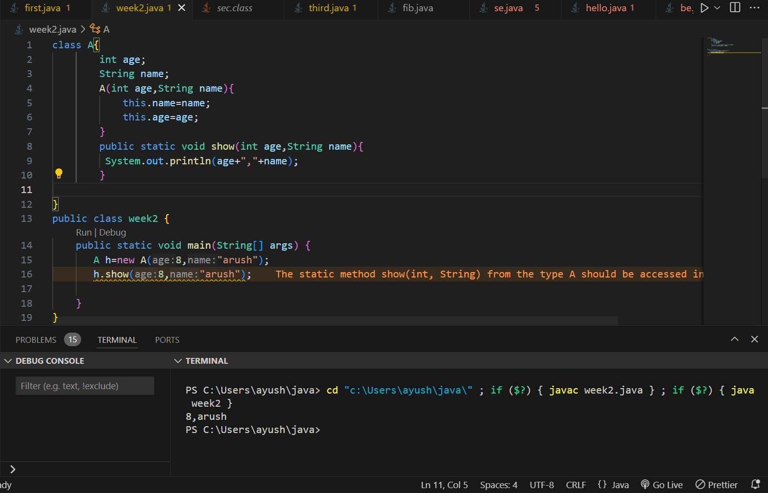

Program 8:-

Code:-

class info{

    public static void add(int n){

        if(n==0){

            System.out.println(0);

        }

        int sum=0;

        for(int i=0;i<=n;i++){

           sum+=i;

        }

        System.out.println("the sum is "+sum);

    }

    public static void display(int n){

        System.out.println("value of n is "+n);

    }

    static int number;

    static {

        System.out.println("Inside static block");

        number = 10;

    }

}

public class week2 {

    public static void main(String[] args) {

      info i=new info();

      i.add(9);

    }

    }

Output:-

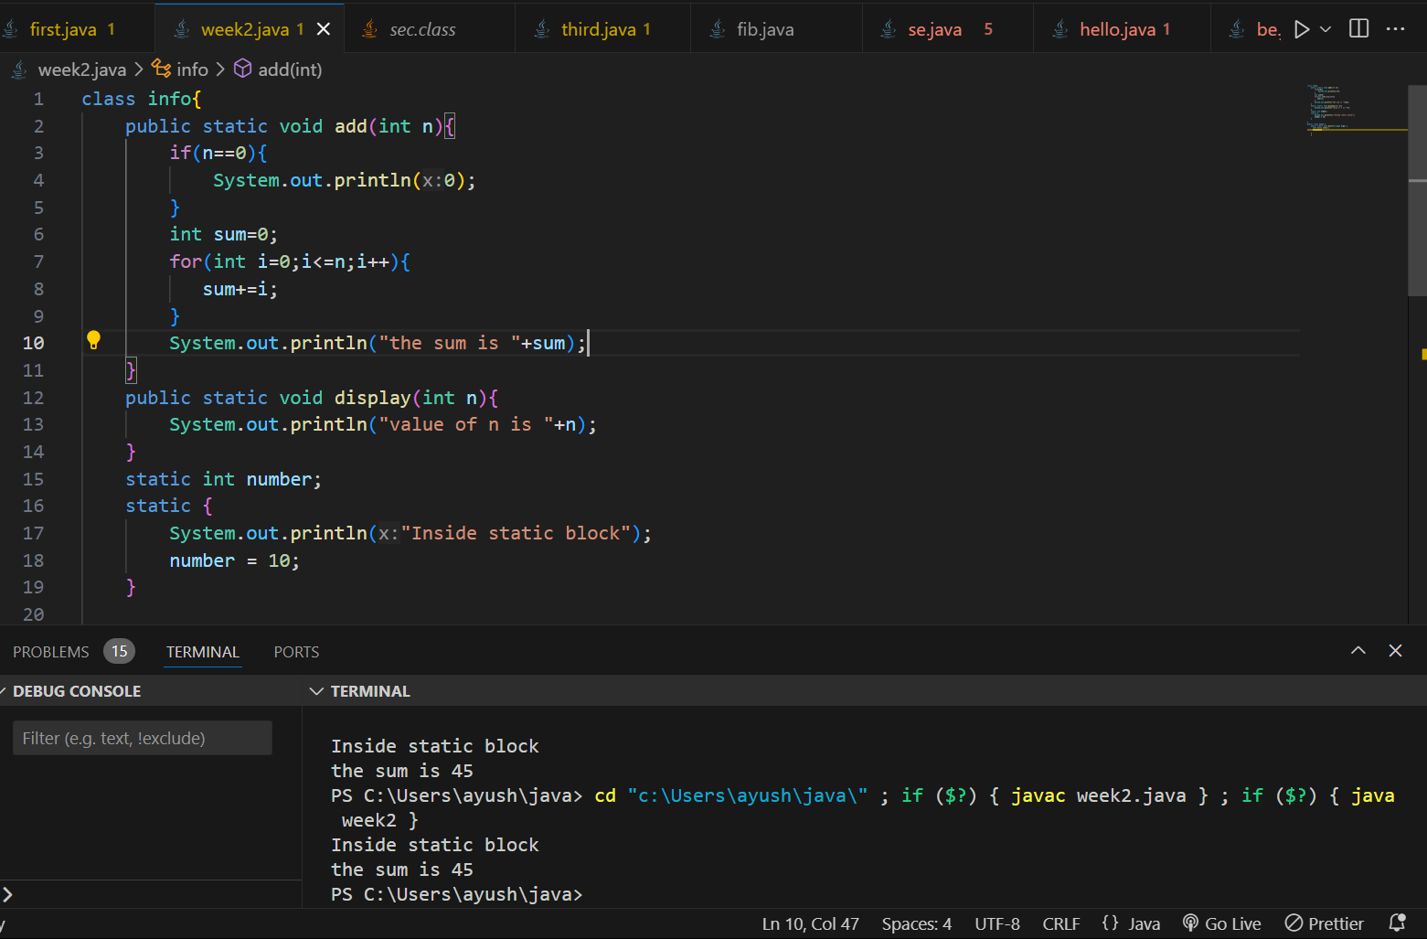

Program 9:-

Code:-w

class shape{

     void draw(){

        System.out.println("Drawing a shape");

    }

     void erase(){

        System.out.println("erasing a shape");

    }

}

class circle extends shape{

   void draw(){

        System.out.println("Drawing a circle");

    }

     void erase(){

        System.out.println("erasing a circle");

    }

}

class triangle extends circle{

    void draw(){

         System.out.println("Drawing a triangle");

     }

      void erase(){

         System.out.println("erasing a triangle");

     }

 }

 class square extends triangle{

    void draw(){

         System.out.println("Drawing a square");

     }

      void erase(){

         System.out.println("erasing a square");

     }

 }

public class week2 {

    public static void main(String[] args) {

        shape circle = new circle();

        shape triangle = new triangle();

        shape square = new square();

        circle.draw();

        circle.erase();

        triangle.draw();

        triangle.erase();

        square.draw();

        square.erase();

    }

    }

Output:-

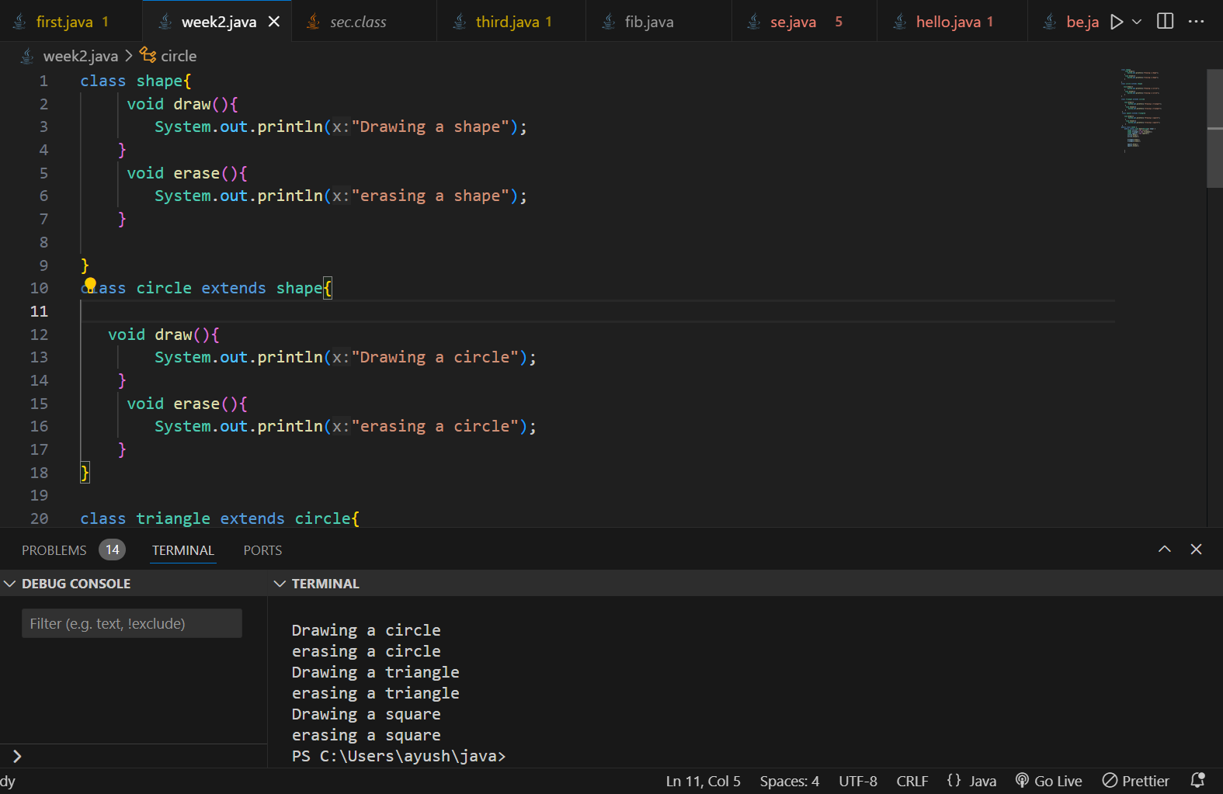

Program 10:-

// Main.java

public class Main {

public static void main(String[] args) {

Employee manager = new Manager();

Employee programmer = new Programmer();

System.out.println("Manager's salary: $" + manager.calculateSalary());

System.out.println("Programmer's salary: $" + programmer.calculateSalary());

}

}

// Employee.java

public class Employee {

public double calculateSalary() {

return 0.0;}}

// Programmer.java

public class Programmer extends Employee {

@Override

public double calculateSalary() {

// Programmer salary calculation logic

return 5000.0;

}

}

// Manager.java

public class Manager extends Employee {

@Override

public double calculateSalary() {

// Manager salary calculation logic

return 10000.0;

}

}

Output:-

