# Docker

Step 1: Create the index.html File

<!DOCTYPE html>

<html lang="en">

<head>

    <meta charset="UTF-8">

    <meta name="viewport" content="width=device-width, initial-scale=1.0">

    <title>Welcome to Nginx</title>

    <style>

        body {

            font-family: Arial, sans-serif;

            text-align: center;

            margin: 0;

            padding: 0;

            background-color: #f4f4f4;

        }

        h1 {

            color: #333;

        }

    </style>

</head>

<body>

    <h1>Welcome to Devops Final Exams!</h1>

    <p>This Ayushi Dhamane Roll no: A012.</p>

</body>

</html>

Step 2: Create the Dockerfile

# Use the official Nginx image as the base image

FROM nginx:latest

# Copy the index.html to the default Nginx HTML directory

COPY index.html /usr/share/nginx/html/index.html

# Expose port 80

EXPOSE 80

# Start Nginx server

CMD ["nginx", "-g", "daemon off;"]

**Step 3: Build and Run the Docker Container**

1. Save both files (index.html and Dockerfile) in the same directory.
2. Open a terminal in that directory.
3. Build the Docker image:

bash

Copy code

docker build -t my-nginx .

1. Run the container:

bash

Copy code

docker run -d -p 8080:80 my-nginx

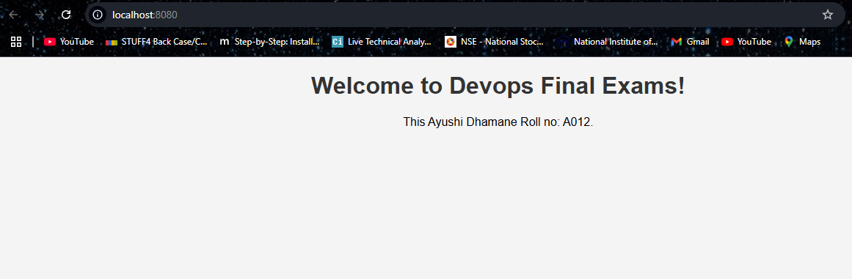



# Kubernetes

SonarCloud

Terraform

Jenkins

Ansible