# KUBERNTES SCALING DEPLOYMENT

Custom Image

Index.html

# Use the official Nginx image FROM nginx:alpine

# Copy the index.html to the appropriate directory in the container COPY index.html /usr/share/nginx/html/index.html

# Expose port 80 to access the web page EXPOSE 80

DockerFile

# Use the official Nginx image FROM nginx:alpine

# Copy the index.html to the appropriate directory in the container COPY index.html /usr/share/nginx/html/index.html

# Expose port 80 to access the web page EXPOSE 80

# DEPLOYMENT.YAML

apiVersion: apps/v1 kind: Deployment metadata:

name: nginx-deployment2 spec:

replicas: 2 # Initial number of replicas selector:

matchLabels: app: nginx

template: metadata:

labels: app: nginx

spec:

containers:

- name: nginx

image: vaibhav1502/custom-depo:latest # Replace with your Docker image name

ports:

- containerPort: 80

SERVICE.YAML

apiVersion: v1 kind: Service metadata:

name: nginx-service2 spec:

selector: app: nginx

ports:

- protocol: TCP

port: 80 # Exposing port 80 targetPort: 80 # Inside the container

type: NodePort # Or you can use NodePort if LoadBalancer isn't available

Docker Login

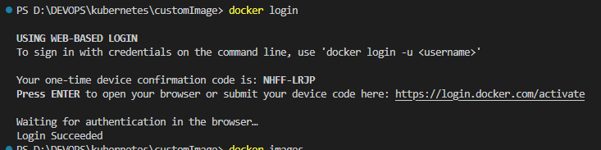

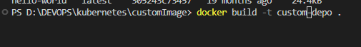

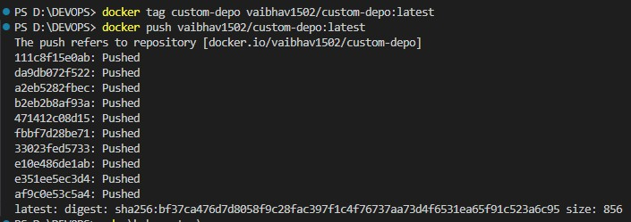

# DEPLOYMENT 2

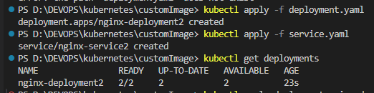

DEPLOYMENT 5

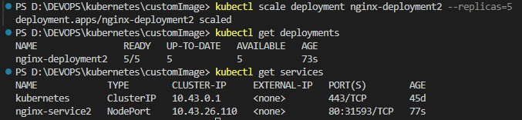

nginx-service2 : localhost:31593

