Q] Scale a running Kubernetes deployment from 2 replicas to 5 replicas, and verify that the scaling was successful

1. Install Kubectl and Minikube along with Docker Desktop. Check the installation: kubectl version

minikube version

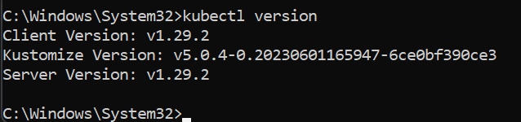

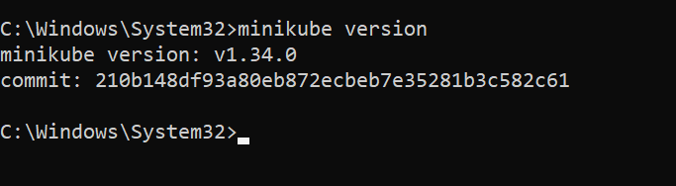

3. Minikube needs to be started with a driver. We use docker driver: minikube start --driver=docker

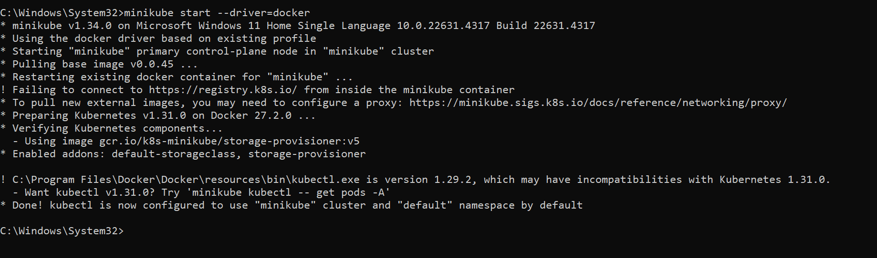

4. Check with docker ps to see if the minikube container is running

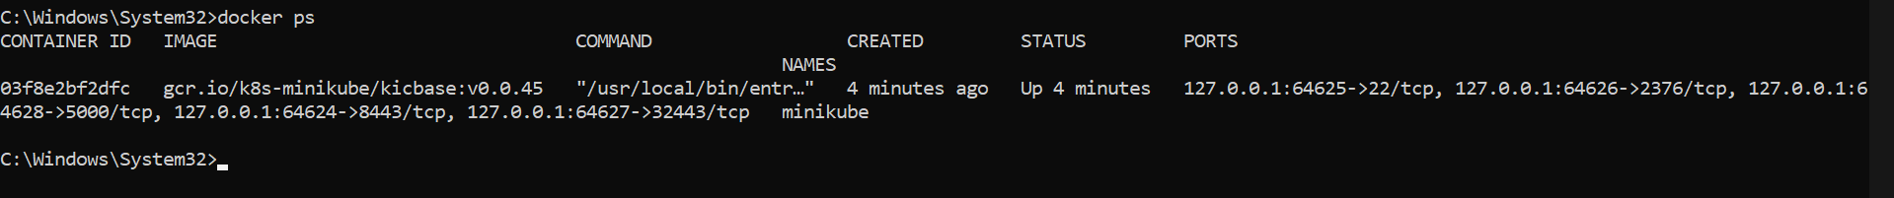

On Docker Desktop: we can see that the minikube container is up and running



5. Check the status of minikube to ensure that it is properly configured

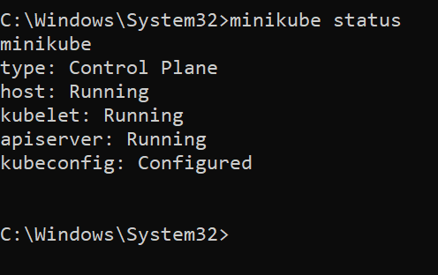

6. Now we need to pull the official image of Nginx from docker hub. In the browser, open docker hub and search for the official image for Nginx server.

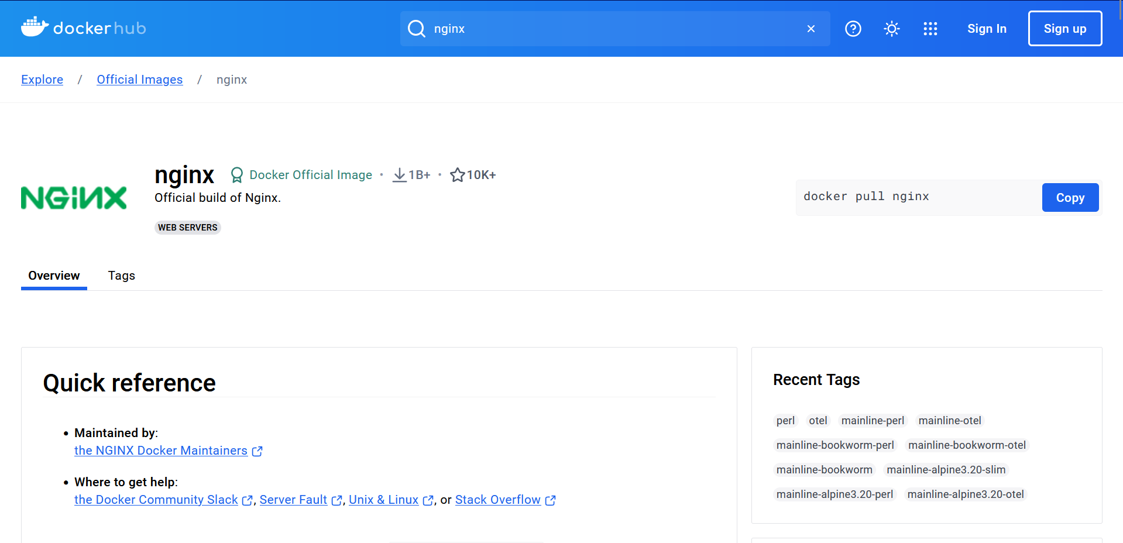

7. Pull the above image using docker pull nginx

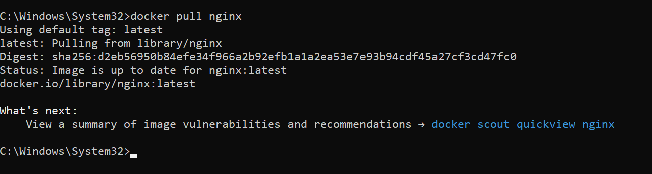

8. Create deployment



9. Check Deploment using kubectl get deployments and kubectl get pods to check the number od pods running

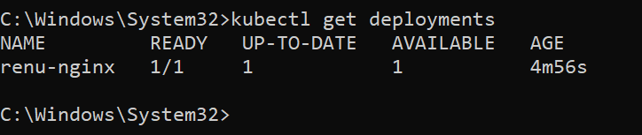

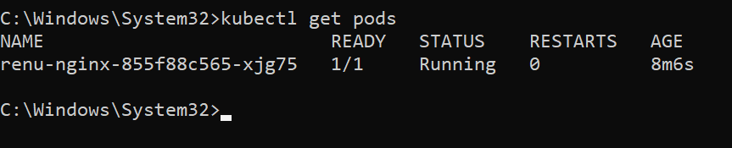

10. Expose deployment so that you can access the homepage of nginx on web browser

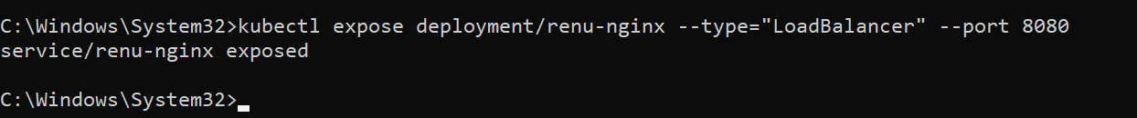

Then do minikube service renu-nginx to open it on browser

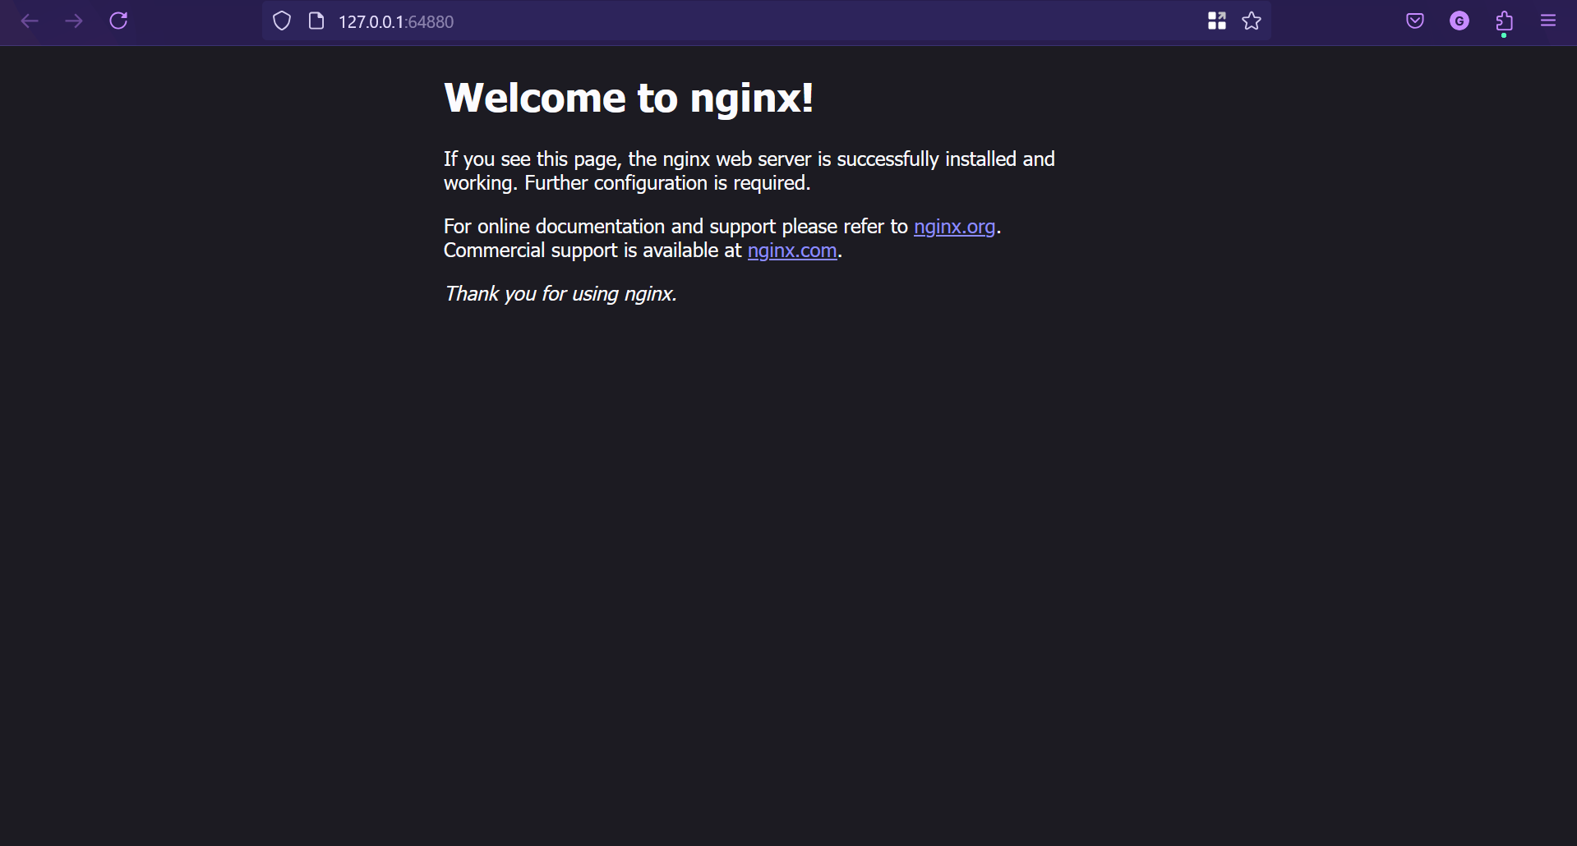

11. Check if nginx is showing in the Kubernetes services

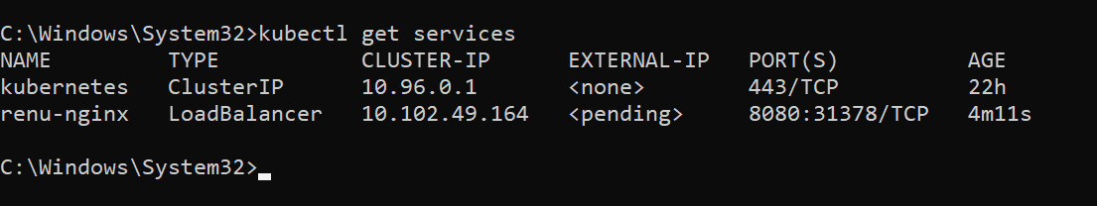

12. Now we can scale up or down the Kubernetes cluster. Scaling with 2 replicas



13. Check the number of deployments in Kubernetes using: kubectl get deployments

kubectl get pods

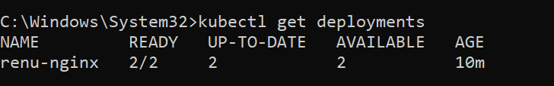

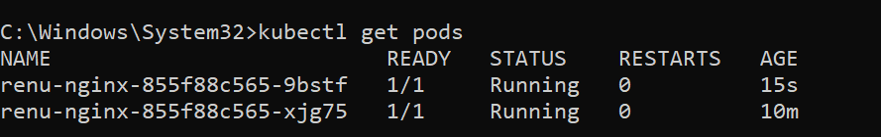

14. Scaling with 5 replicas



15. Again check the number of deployments

kubectl get deployments

kubectl get pods

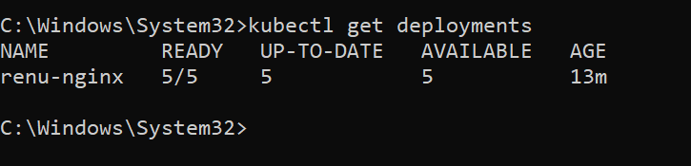

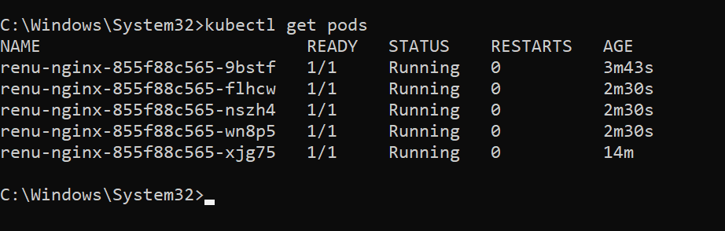

16. Scaling down: kubectl scale deployments/renu-nginx –replicas=2



17. Check if the number of deployments and pods has changed to 2

kubectl get deployments

kubectl get pods

