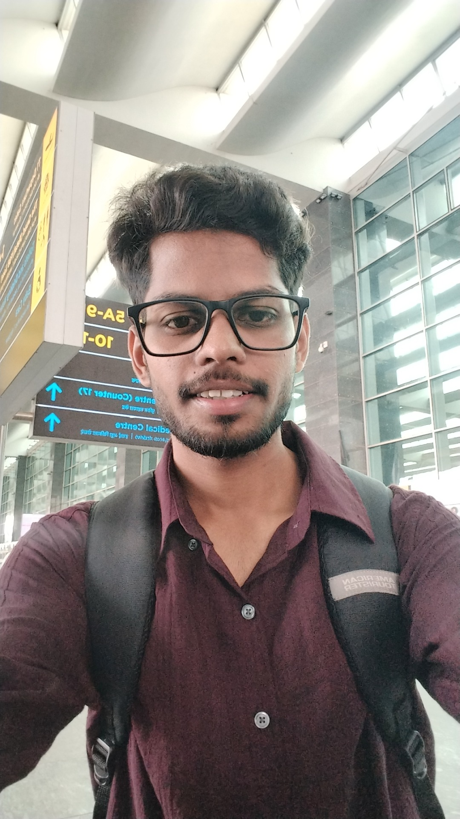 | AYUSH HARSHIT  Final Year | B.Tech Computer Science & Engineering  Siddartha Institute of Science and Technology  Mobile: 9153813123  Email: ayush.harahit2005@gmail.com  LinkedIn: linkedin.com/in/ayush-harshit-982047285  GitHub: github.com/Ayushharshit1/Ayushharshit1
Area of Interest
Full Stack Development, Cybersecurity, Threat Intelligence, AI/ML, Software Development
Education
Year | Degree | Institution | CGPA/%
2027 | B.Tech CSE | Siddartha Institute of Science and Technology | 7.3
2023 | Intermediate (Class XII) | CBSE | 81.8%
2021 | Matriculation (Class X) | CBSE | 61.4%
Internship
Secure Elements (2 Months)
• Built ThreatLens using React, Vite, TypeScript, Tailwind CSS, NestJS, MySQL and TypeORM.
• Implemented CVE Correlation, Threat Intelligence, AbuseIPDB, URLhaus, CIRCL integration.
• Developed SBOM & Binary Analysis modules.
• Integrated RAG, LLM, AI Threat Summarization and PDF Query.
• Used Git, GitHub, pnpm, REST APIs, Swagger, Cloud Deployment.
Projects
ThreatLens – Threat Intelligence, Vulnerability Correlation & Firmware Security Platform
• Interactive dashboard, JWT authentication, CVE feeds, AI-assisted threat summaries, SBOM export.
Skills
Frontend: React, Vite, TypeScript, Tailwind CSS, React Router, TanStack Query/Table, Axios, React Hook Form, Zod, React Flow
Backend: NestJS, Node.js, Express, JWT, bcryptjs, Multer
Database: MySQL, TypeORM
Cybersecurity: CVE Correlation, Threat Intelligence, AbuseIPDB, URLhaus, CIRCL, SBOM, Binary Analysis
AI: RAG, LLM Integration
DevOps: Git, GitHub, pnpm, Cron Jobs, REST APIs, Swagger

