**Q1. Explain the difference between inline, internal, and external CSS.**

**Ans** –

Inline CSS styles are applied **directly inside an HTML element** using the style attribute. E.g. <p style="color: blue; font-size: 18px;">This is an inline-styled paragraph.</p>

Internal CSS is placed **within a <style> tag inside the <head> or in between head and body tags** of the HTML document. E.g.

<!DOCTYPE html>

<html>

<head>

<style>

p {

color: green;

font-size: 18px;

}

</style>

</head>

<body>

<p>This paragraph uses internal CSS.</p>

</body>

</html>

External CSS is written in a **separate .css file** and linked to the HTML document using a <link> tag. E.g. HTML (index.html):

<head>

<link rel="stylesheet" href="styles.css">

</head>

CSS (styles.css): p {

color: red;

font-size: 18px;

}

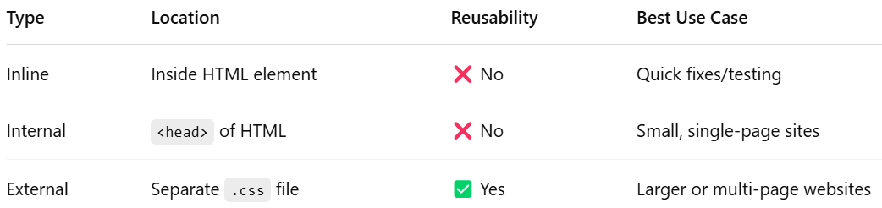

**Q2. Describe CSS selectors and list the types of selectors (e.g., element, class, id).**

**Ans** –

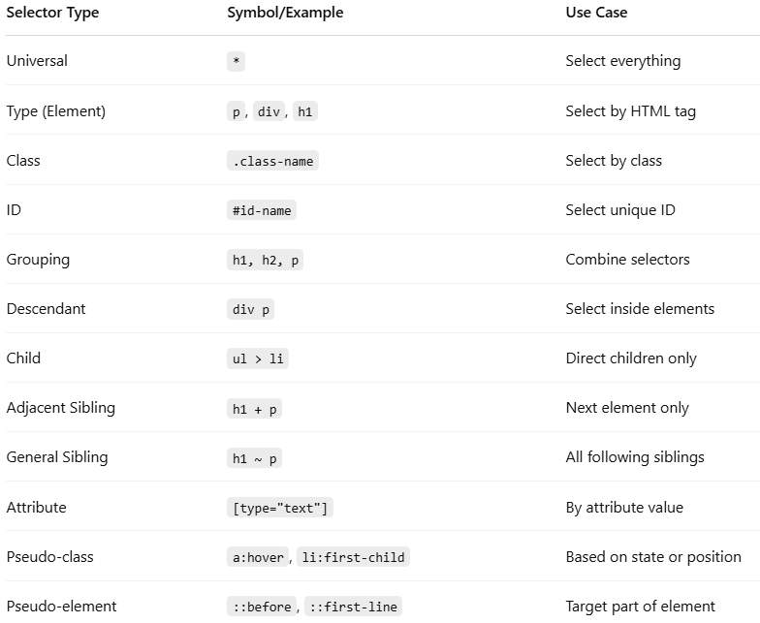

**Q3. Discuss the CSS box model and its components.**

**Ans** - The CSS Box Model is a fundamental concept in web design and layout. It describes how elements are structured and how spacing is applied around them. Every HTML element on a web page is considered as a box, and the box model consists of four main components:

**1. Content**

* This is the **innermost part** of the box.
* It contains the actual content, like text, images, or other elements.
* You can set its dimensions using width and height.

width: 200px;

height: 100px;

**2. Padding**

* Padding is the **space between the content and the border**.
* It creates inner space *inside* the element.
* Increases the size of the box but does not affect the background color (which still shows in the padding area).

padding: 20px; /* adds space inside the element */

**3. Border**

* The border wraps around the padding (if any) and content.
* You can control its thickness, style, and color.

border: 2px solid #333; /* a dark border */

**4. Margin**

* Margin is the **outermost layer**, creating space *outside* the element.
* It separates the element from neighboring elements.

margin: 15px; /* adds space outside the element */

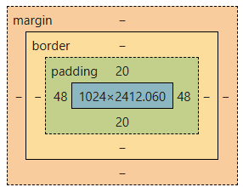

how the box is sized using the box-sizing property: With border-box, the padding and border are included **within** the total width and height, making layout calculations easier. box-sizing: border-box;

--END--