**Q1. What is Bootstrap, and why is it useful for website design?**

A1. Bootstrap is a free front-end framework for faster and easier web development. Bootstrap includes HTML and CSS based design templates for typography, forms, buttons, tables, navigation/navbar, modals, image carousels/slider, hide & show, and many other, as well as optional JavaScript plugins. Bootstrap also gives you the ability to easily create responsive designs.

The advantages of using Bootstrap framework is : it is easy to use (Anybody with just basic knowledge of HTML and CSS can start using Bootstrap), Responsive features (Bootstrap's responsive CSS adjusts to phones, tablets, and desktops), Mobile-first approach( In Bootstrap, mobile-first styles are part of the core framework), Browser compatibility (Bootstrap 5 is compatible with all modern browsers (Chrome, Firefox, Edge, Safari, and Opera)). It makes BS easier to use for website design.

**Q2. Explain the Bootstrap grid system and how it helps create responsive layouts.**

A2. Bootstrap uses a **12-column grid layout** based on **Flexbox**. This system allows you to divide the page into rows and columns that automatically adjust based on the screen size.

• **Container**: The outer wrapper (.container or .container-fluid) that holds rows.

• **Row**: A horizontal group of columns (.row).

• **Column**: The actual content holders (.col, .col-md-6, etc.).

Bootstrap’s grid is responsive and adapts to different screen sizes using **breakpoints**:

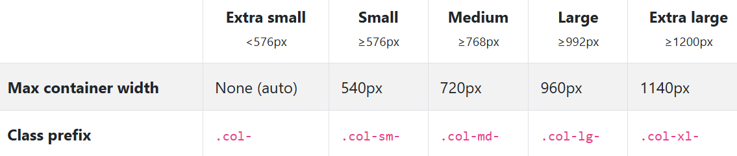

**Q3. List and explain at least three Bootstrap components (e.g., navbar, cards, buttons).**

A3.

1. Navbar

The navbar is a responsive navigation header that adapts to different screen sizes.

* Purpose: Helps users navigate your site with links, dropdowns, brand logos, and toggles.
* Features:
  + Collapses into a hamburger menu on smaller screens.
  + Supports dark/light themes and sticky positioning.

2. Card

The card component is a flexible container for content like text, images, and links.

* Purpose: Great for displaying blog posts, product details, user profiles, etc.
* Features:
  + Supports headers, footers, images, and buttons.
  + Easily customizable with utility classes.

3. Button

Bootstrap buttons are styled elements used for actions like submitting forms or triggering modals.

* Purpose: Provides consistent styles for clickable actions.
* Features:
  + Multiple styles: btn-primary, btn-success, btn-danger, etc.
  + Can be sized (btn-sm, btn-lg) and grouped.

**---END---**