**What is CSS?**

**Ans-** CSS is Cascading Style Sheet.

CSS specifies how the HTML tags will be appear on the screen, in the print or other media.

CSS helps you to save the time and effort to put into styling/designing the web page.

It has the ability to control the layout of numerous web pages at the same time.

**Types of CSS.**

**Ans-** three types 1.Inline 2.Internal (embedded) 3.External

**CSS Syntex.**

**Ans-** 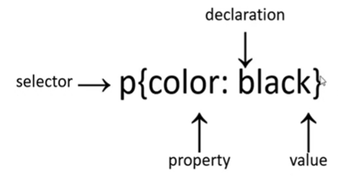

**Ans-** Selector :It indicates the HTML element you want to style. It could be any tag.

Declaration Block

Property

Value

CCS styling

background-color: powderblue;

color: blue

font-family: verdana;

font-size: 300%;

border: 2px solid powderblue;

padding: 30px;

margin: 50px;

Background & Border:

* **Background:**

1. background-color,
2. background-image,
3. background-size,
4. background-position,
5. background-repeat,
6. background-attachment.

* **Border:**

1. border-width,
2. border-style,
3. border-color,
4. border-radius,
5. box-shadow.

* **Gradients**:

1. linear-gradient,
2. radial-gradient

Layout & Positioning:

* **Flexbox:**

1. display: flex,
2. flex-direction,
3. justify-content,
4. align-items.

* **Grid:**

1. display: grid,
2. grid-template-columns,
3. grid-template-rows,
4. grid-gap.

* float, clear

Text & Typography:

* font-size,
* font-family,
* font-weight,
* text-align,
* text-decoration,
* text-transform,
* letter-spacing.
* word-spacing,
* line-height.

Visual Effects:

* **Transitions:**

1. transition-property,
2. transition-duration,
3. transition-timing-function.

* **Animations:**

1. @keyframes,
2. animation-name,
3. animation-duration,
4. animation-timing-function.

* **Transforms:**

1. transform,
2. rotate,
3. scale,
4. translate,
5. skew.

* **Filters:**

1. filter,
2. blur,
3. brightness,
4. contrast,
5. opacity.

Other:

* **Box-Sizing:** box-sizing (border-box, content-box).
* **Pseudo-elements:** ::before, ::after.
* **Pseudo-classes:** :hover, :active, :focus.
* **Custom properties (CSS variables):** --variable-name.
* **Backdrop filter**: backdrop-filter
* **Contain:** contain and container properties for layout isolation
* **List styling:** list-style-type, list-style-image, list-style-position.