#whichever comes in {} brackets, it for
- What is HTML?
Ans – Stands for HyperText Markup Language.
Used to create and structure content on the web.
HTML is a markup language, not a programming language, meaning it annotates text to define how it is structured and displayed by web browsers.
HTML is all about organizing and displaying information on a webpage. We can think of it as the bones or structure of a webpage.
It forms the building blocks of all websites and is complemented by CSS for style and JavaScript for interactivity.
- Why Learn HTML?
Ans –
- Foundation of Web Development.
- Universal Language of the Web.
- Easy to Learn.
- Career Opportunities. ( Web developer, Content manager, UX/UI designer roles)
- Gateway to Advanced Technologies.

- What are the definitions in HTML?
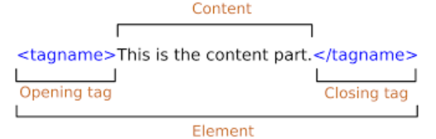
- What is Tag ?
Ans – anything which come into triangular bracket <>.
- What is attribute?
Ans – Attributes which provides extra information on tags.
- What are the types of the tag?
Ans – three types of tags.
- Opening tags
- Closing tags
- Self-closing tags

- Structure of the HTML.
Ans –
<html>
<head>
<title>Hello</title> {to name a tab title}
</head>
<body>
</body>
</html>
- Types of Tags
Ans -
- Heading tags : to give font size h1 to h6
<h1></h1> biggest font size
<h2></h2>
<h3></h3>
<h4></h4>
<h5></h5>
<h6></h6> smallest font size
<br> - to break single line {self-closing tag}
<b></b> : Bold
<i></i> : Italic
<u></u> : Underline
- Paragraph tags
<p></p>
<pre></pre>
- Anchor tag
<a></a>
- Image tag
<img src=“Link()/photos” alt=“if image can’t be load, text can be appeared”></img>
- Image mapping
- List tags
  - Order list - <ol></ol>
  - Unorder list - <ul></ul>
  - Description list - <dl></dl>
- rowspan & colspan attributes
rowspan=“” , colspan=“”
- Caption tag
<caption></caption>
- Marquee tag – to move the title of the table
<marquee></marquee>
- Table tag
<table></table>
- Row tag
<tr></tr>
- Colom tag
<td></td>
- To make head in the table
<th></th>
- To make Nested table
<td>
<table>
<tr>
<td>
</td>
</tr>
</table>
</td>
- Form tag
<form></form>
- Label tag
<label></label>
- Input tag : Self closing tag
<input>
- Select tag
<select> </select>
- Option tag
<option></option>

