AWS-Based Smart Parking Violation Reporting System
Full Project Documentation — Frontend, Backend, and Cloud Infrastructure
This document brings together every part of the project: the React frontend, the serverless AWS backend, and the AWS cloud infrastructure that was set up manually and through code. It covers what was built, how the pieces are meant to fit together, what has actually been verified working so far, and what is still left to connect before the system runs end to end on real AWS infrastructure.
Date: October 2026

1. Project Overview
The Smart Parking Violation Reporting System lets a registered user report a parking violation against a vehicle on campus, attach a photo as evidence, and have a campus admin review the report and either verify or reject it. A verified violation carries a fine based on how severe the category is, and a vehicle with repeated violations is flagged as a repeat offender. Admins get a dashboard with totals, trends, and a location-wise breakdown of where violations happen most.
The project was split across three areas of work:
- Frontend — a React (Vite) web application: the dashboards, forms, and tables a user or admin actually interacts with.
- Cloud infrastructure — the AWS resources the system runs on: DynamoDB tables, an S3 bucket for evidence photos, and IAM roles, set up directly in the AWS console.
- Backend — a serverless API (AWS Lambda + API Gateway) that the frontend is meant to call, written as Node.js handlers and defined as infrastructure-as-code with AWS CDK so it can be deployed without clicking through the console.
Each of these three parts works and has been verified on its own. The section that matters most for a viva or a review is Section 7, which states plainly how far they currently are from being connected to each other, and what specifically is left to do.

2. System Architecture
The system is designed around a simple serverless pattern. The browser never talks to the database or file storage directly; it only calls a REST API, and that API's Lambda functions do all the work.
Intended request flow, step by step:
- 1. The browser (the React app) sends an HTTPS request to API Gateway, for example POST /violations.
- 2. API Gateway routes the request to the matching Lambda function.
- 3. The Lambda function checks the JWT token (for routes that need login), validates the input, and does its job.
- 4. The function reads or writes DynamoDB, and for evidence photos, generates a presigned S3 URL instead of handling the image itself.
- 5. The function returns a JSON response, which API Gateway sends back to the browser.
There is no server running all the time. AWS only runs a Lambda function for the few milliseconds it takes to handle one request, which keeps cost close to zero for a small project like this. Section 7 explains which of these arrows are live today and which are not yet wired up.

3. Cloud Infrastructure Setup
Before any backend code was written, the core AWS resources were created directly in the AWS Management Console. This section documents that work with screenshots taken from the console.

3.1 Region and resources
- Region: Asia Pacific (Mumbai) — ap-south-1
- 3 DynamoDB tables: ParkingUsers, ParkingVehicles, ParkingViolations
- 1 S3 bucket for evidence photos: smart-parking-evidence-vit-2026-xxxxx (kept private, evidence/ folder)
- 1 IAM role: SmartParkingLambdaRole, with AmazonDynamoDBFullAccess, AmazonS3FullAccess, and AWSLambdaBasicExecutionRole attached

3.2 IAM role
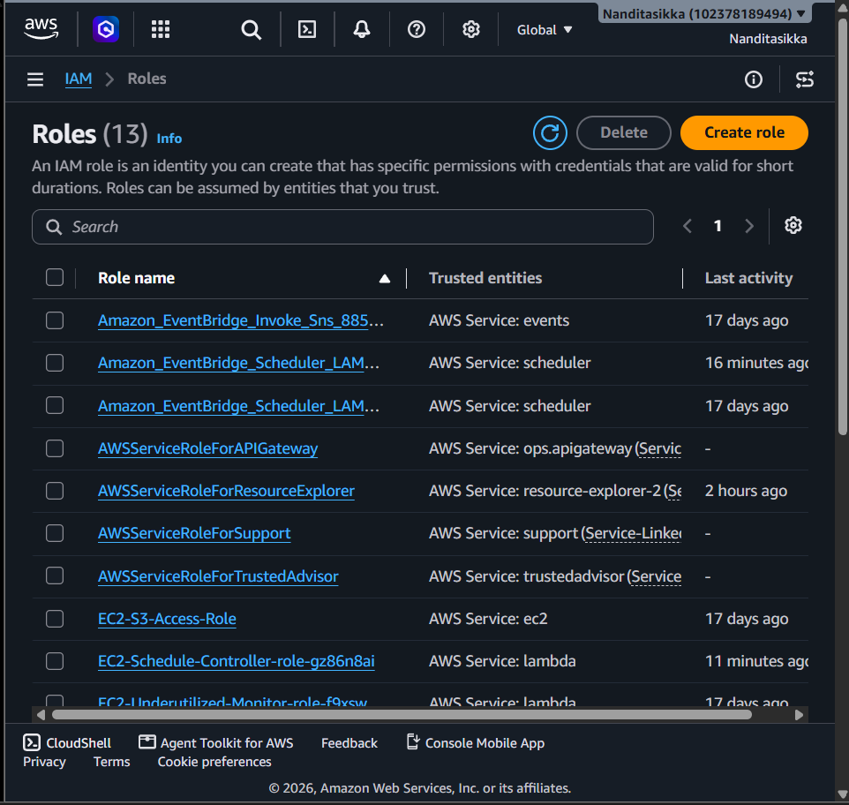
Figure 1: The IAM Roles list in the AWS console, showing SmartParkingLambdaRole alongside other account roles.
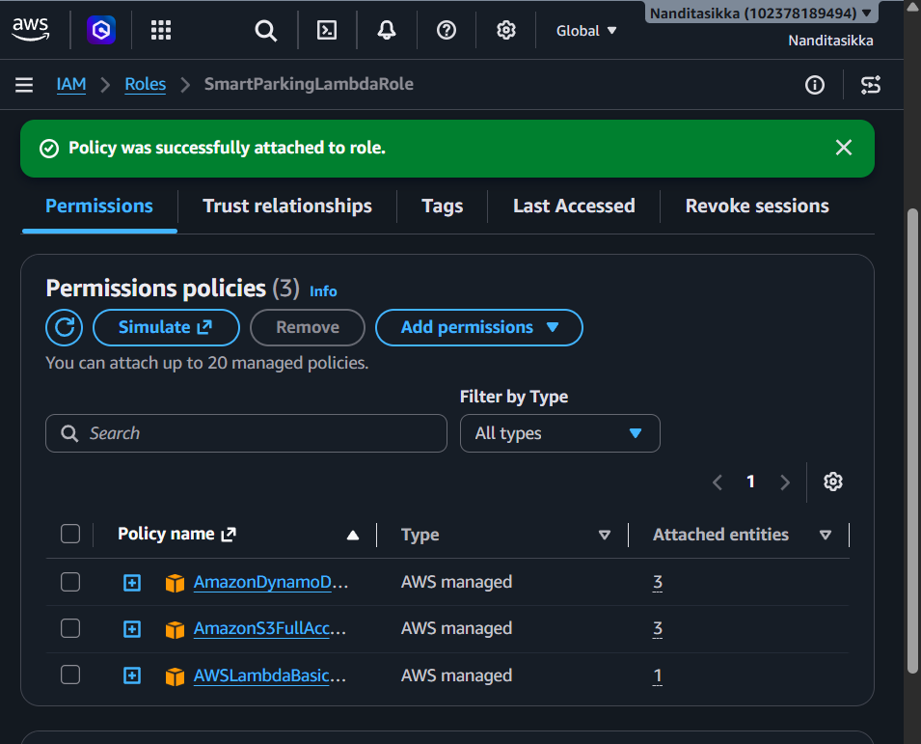
Figure 2: SmartParkingLambdaRole with its three managed policies attached — DynamoDB, S3, and Lambda basic execution (CloudWatch logging).

3.3 S3 bucket
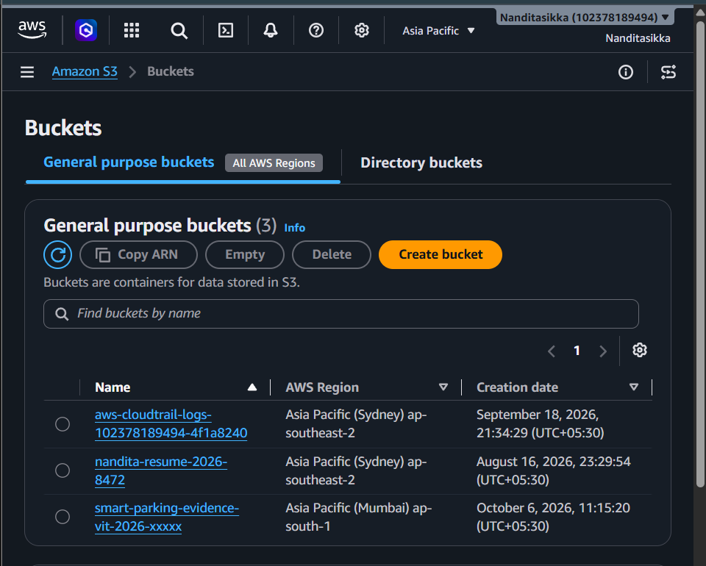
Figure 3: The S3 console showing the smart-parking-evidence-vit-2026-xxxxx bucket created in ap-south-1 for evidence photos.

3.4 DynamoDB tables
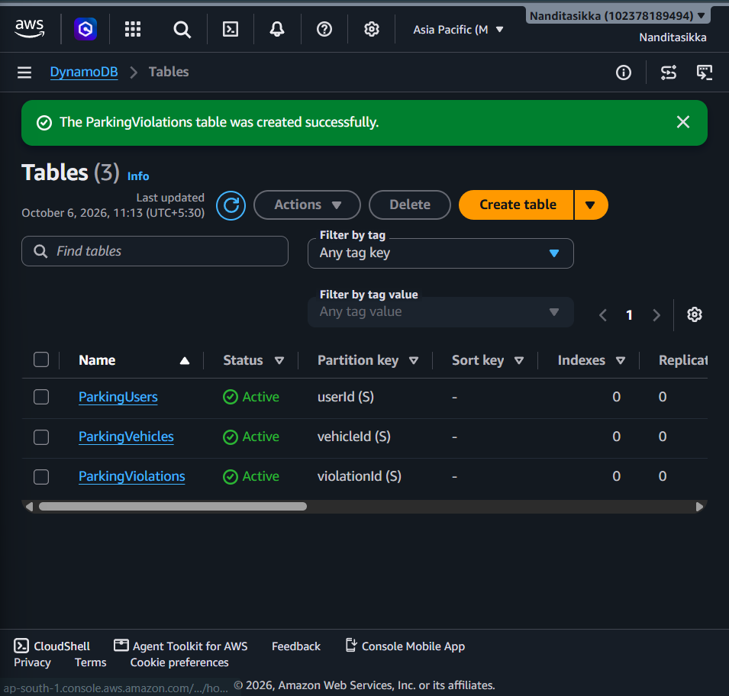
Figure 4: The DynamoDB console showing all 3 tables (ParkingUsers, ParkingVehicles, ParkingViolations) active, each with a simple partition key.
Note: The DynamoDB console shows each table with 0 indexes. The backend code (Section 4.5) is written to use Global Secondary Indexes — EmailIndex, VehicleNumberIndex, UserIndex, VehicleIndex, ReportedByIndex, and StatusIndex — to avoid slow table scans. These indexes have not been created yet. They need to be added to the existing tables before the backend's login, vehicle-lookup, and admin-queue queries will work against real data.

4. Backend Module (Serverless API)
The backend is a set of 21 AWS Lambda functions behind a single API Gateway REST API, written in Node.js. It is organized as handlers (one file per endpoint), repositories (DynamoDB access), services (S3, auth, notifications), and a CDK stack that defines the AWS resources as code.

4.1 Technology stack
Layer | Choice | Why
Compute | AWS Lambda (Node.js 20.x) | Serverless, pay only per request, no server to patch or manage
API layer | Amazon API Gateway (REST API) | Routes HTTP requests to the right Lambda, handles CORS
Database | Amazon DynamoDB | Serverless NoSQL, fast key lookups, scales automatically
File storage | Amazon S3 | Stores evidence photos privately, accessed only via presigned URLs
Auth | Custom JWT (jsonwebtoken + bcryptjs) | Cognito was not used for this project (team decision); a simple JWT layer was built instead
Infrastructure as code | AWS CDK (JavaScript) | Defines Lambda functions, API routes and IAM roles in code instead of clicking through the console
Logging | Amazon CloudWatch | Every Lambda function logs automatically; used for debugging

4.2 Database design
Every table is designed to use Global Secondary Indexes (GSIs) so the backend never needs to run a full table Scan for a normal request. A Scan reads every row in the table, which is slow and expensive as the table grows; a Query using a GSI jumps straight to the rows that matter.

ParkingUsers
- Primary key: userId (UUID)
- EmailIndex (GSI, planned): look up a user by email during login

ParkingVehicles
- Primary key: vehicleId (UUID)
- VehicleNumberIndex, UserIndex (GSIs, planned): look up by plate number, or list a user's vehicles

ParkingViolations
- Primary key: violationId (UUID)
- VehicleIndex, ReportedByIndex, StatusIndex (GSIs, planned): a vehicle's history, violations by reporter, and the admin review queue
- Fields: category, severity, fine, status (PENDING/VERIFIED/REJECTED), paymentStatus, evidenceKey, isRepeatOffender, latitude, longitude
Two admin-only reporting endpoints (location-wise hotspots and monthly stats) deliberately use a full table Scan on ParkingViolations. This is a documented tradeoff: those endpoints are low-frequency, admin-only, and the dataset for a student project is small, so the cost is acceptable.

4.3 Authentication and security
- Passwords are hashed with bcrypt (10 salt rounds) before being stored. The plain password is never saved.
- Login issues a JWT signed with a secret set as an environment variable at deploy time, never written in the source code.
- Every protected route reads the token from the Authorization: Bearer <token> header and verifies it before doing anything else.
- Login returns the same error for a wrong password and a non-existent email, so an attacker cannot tell which emails are registered.
- Routes are split into three levels: public (register/login), authenticated (any logged-in user), and admin-only (verify/reject, dashboard, reports).
- Each Lambda function's IAM role is scoped to only the DynamoDB table(s) and S3 permissions it actually needs, not a blanket admin role.

4.4 Evidence photo upload flow
The S3 bucket is private. No Lambda function ever receives or stores the actual image bytes; the backend hands out short-lived presigned URLs and the client uploads or downloads the photo directly to/from S3.
- 1. The client calls POST /uploads/evidence-url and gets a presigned PUT URL (valid 5 minutes) plus an evidenceKey.
- 2. The client uploads the photo directly to that URL.
- 3. The client includes that evidenceKey when calling POST /violations.
- 4. To view the photo later, GET /violations/{id}/evidence-url returns a presigned GET URL (valid 15 minutes).

4.5 API endpoints (21 total)

Users
Method | Path | Auth | Description
POST | /users/register | Public | Create an account
POST | /users/login | Public | Log in, get a JWT
GET | /users/me | User | Get my own profile
PUT | /users/me | User | Update my name/phone

Vehicles
Method | Path | Auth | Description
POST | /vehicles | User | Register a vehicle
GET | /vehicles | User | List my vehicles
GET | /vehicles/{vehicleId} | User | Get one vehicle
PUT | /vehicles/{vehicleId} | Owner/Admin | Update vehicle type
DELETE | /vehicles/{vehicleId} | Owner/Admin | Remove a vehicle

Violations
Method | Path | Auth | Description
POST | /violations | User | Report a violation
GET | /violations/{violationId} | User | Get one violation
GET | /vehicles/{vehicleId}/violations | User | A vehicle's violation history
GET | /violations/{violationId}/evidence-url | User | Get a viewable link to the evidence photo
POST | /violations/{violationId}/pay | Owner/Admin | Mark a verified fine as paid

Uploads
Method | Path | Auth | Description
POST | /uploads/evidence-url | User | Get a presigned URL to upload a photo

Admin
Method | Path | Auth | Description
GET | /admin/violations/pending | Admin | List violations awaiting review
POST | /admin/violations/{violationId}/verify | Admin | Approve a violation
POST | /admin/violations/{violationId}/reject | Admin | Reject a violation
GET | /admin/dashboard | Admin | Summary counts and totals

Reports
Method | Path | Auth | Description
GET | /reports/location-wise | Admin | Violation hotspots by rounded coordinates
GET | /reports/monthly-stats | Admin | Totals for a given year/month

4.6 Business logic

Fine calculation
Every violation category maps to a severity level, and every severity level maps to a fine amount, defined once in constants.js so a fine amount is never duplicated or hardcoded elsewhere.
Severity | Fine (Rs.) | Example categories
MINOR | 500 | NO_PARKING, PARKING_TIME_EXCEEDED
MODERATE | 750 | WRONG_PARKING, NO_PARKING_ZONE, UNAUTHORIZED_PARKING
MAJOR | 1000 | DISABLED_PARKING
SEVERE | 2000 | EMERGENCY_ACCESS_BLOCK

Repeat offender detection
When a new violation is reported, the backend checks that vehicle's history: 2 or more VERIFIED violations within the last 90 days (both configurable) flags it as a repeat offender. Only verified violations count, since an unproven report should not count against anyone.

Status workflow
A violation always starts as PENDING. An admin can move it to VERIFIED or REJECTED, but only once; re-processing an already-decided violation returns a 409 Conflict instead of silently overwriting the result.

4.7 Backend code and folder structure (screenshots)
Every file built in the backend, with a screenshot of the actual code in VS Code.

Project structure and config
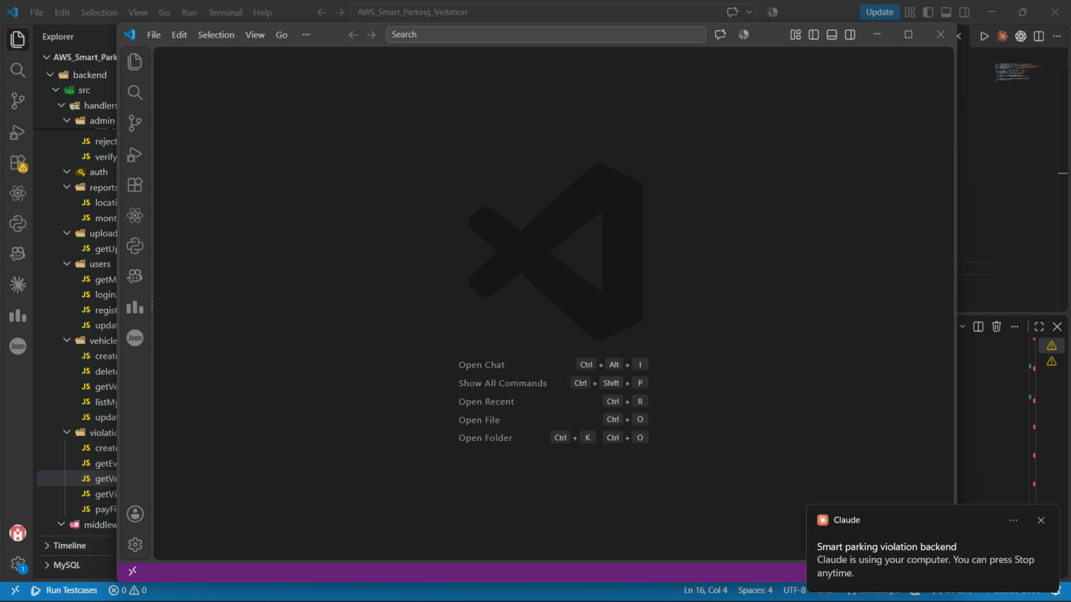
Figure 5: Full backend folder structure in VS Code.
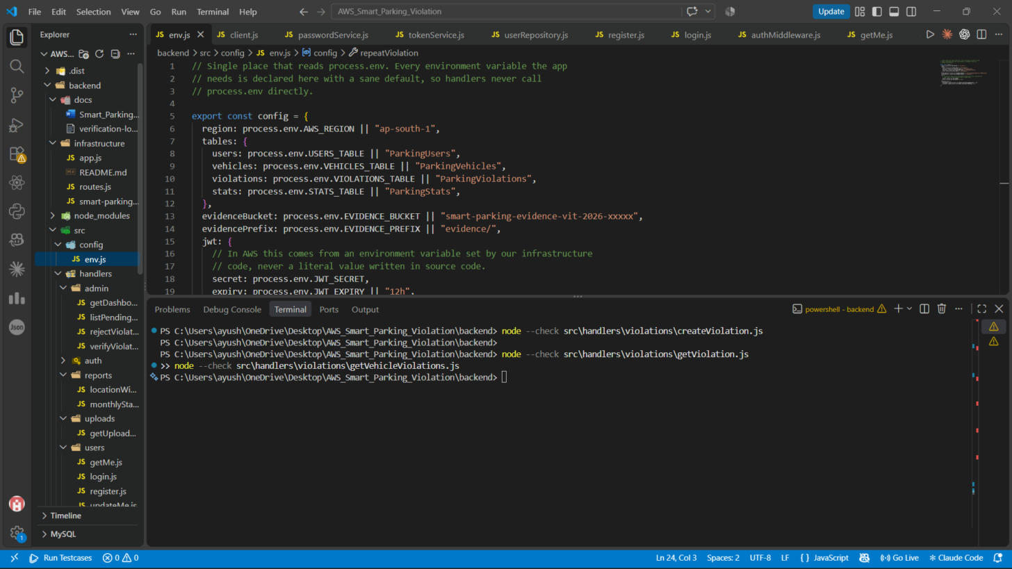
Figure 6: config/env.js — reads process.env, with the team's real DynamoDB table names and S3 bucket name.

Admin handlers
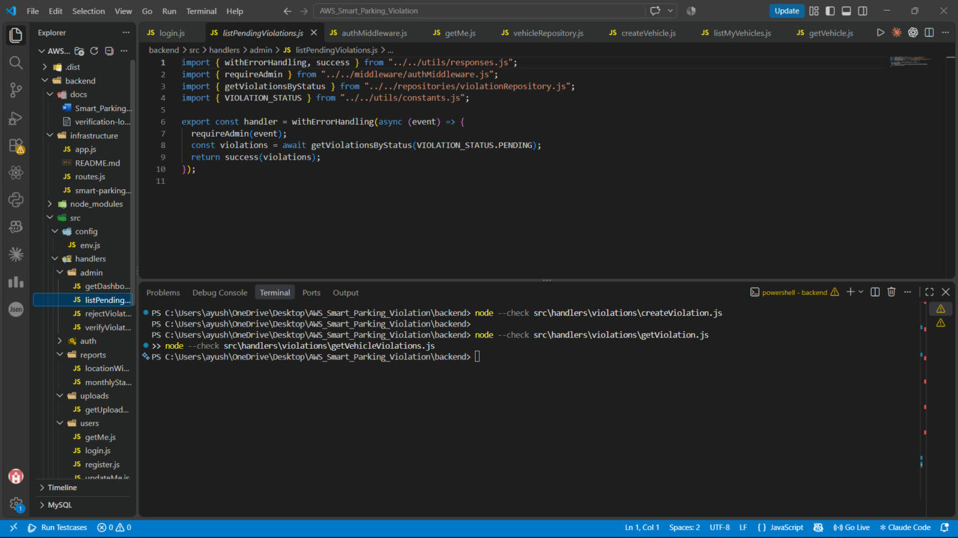
Figure 7: admin/listPendingViolations.js — returns violations waiting for review via the StatusIndex GSI.
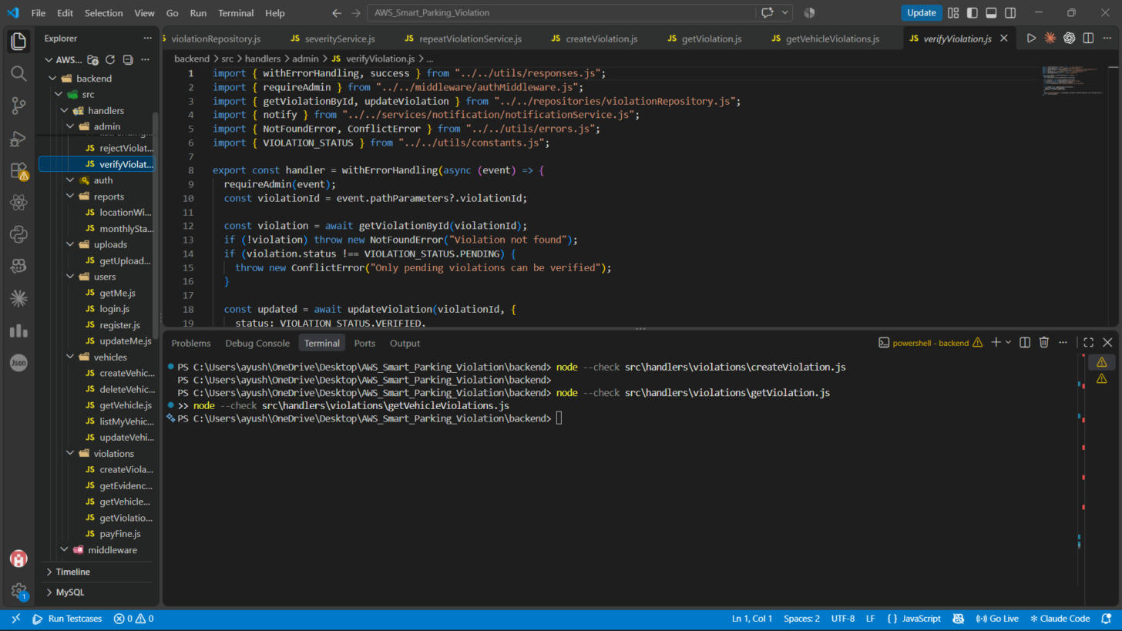
Figure 8: admin/verifyViolation.js — approves a pending violation, with a Conflict check against double-processing.
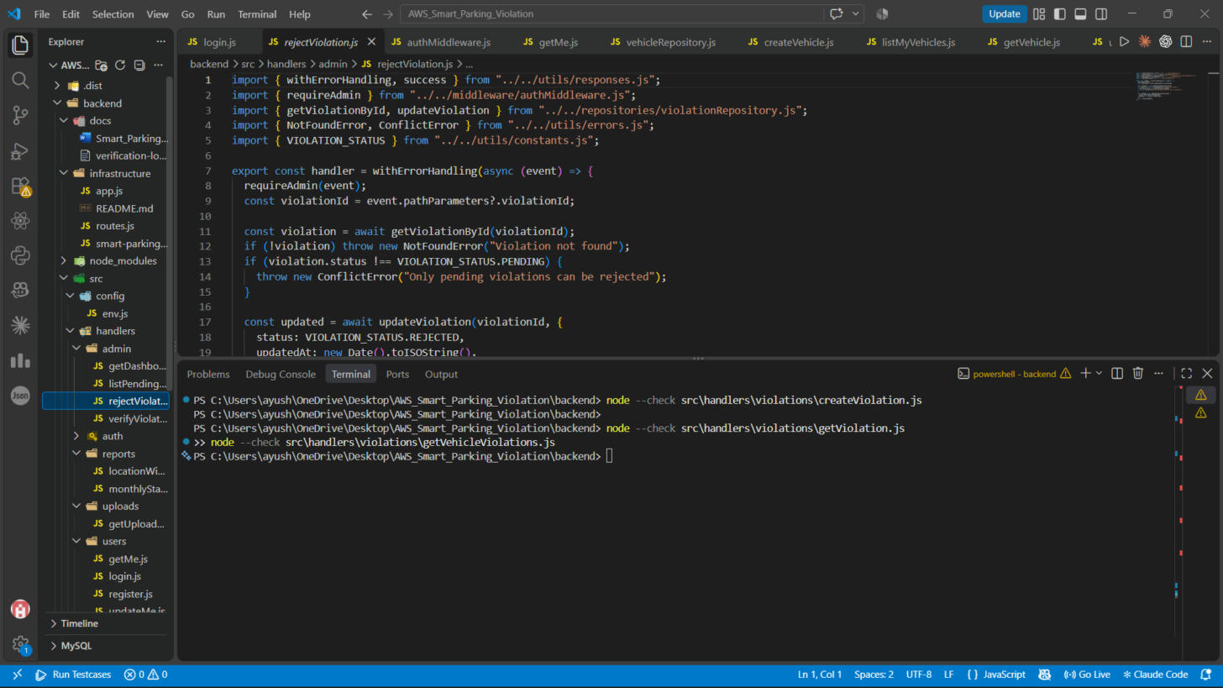
Figure 9: admin/rejectViolation.js — the matching reject path.
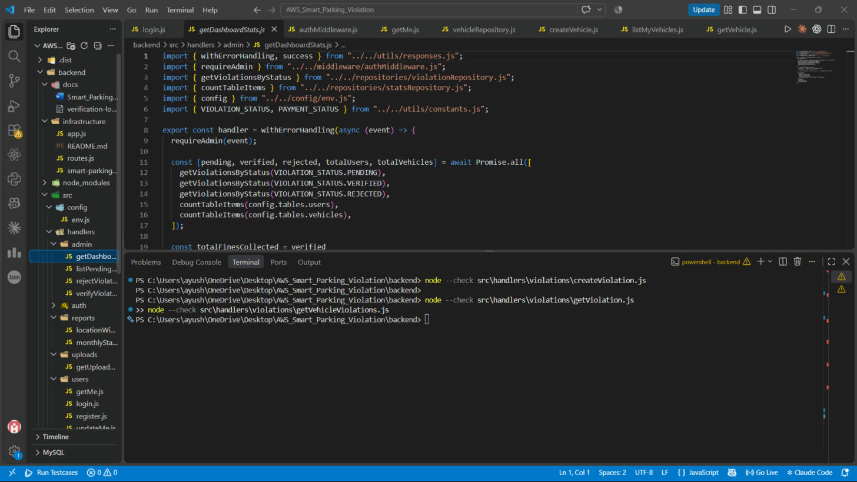
Figure 10: admin/getDashboardStats.js — builds the admin dashboard summary.

Reports
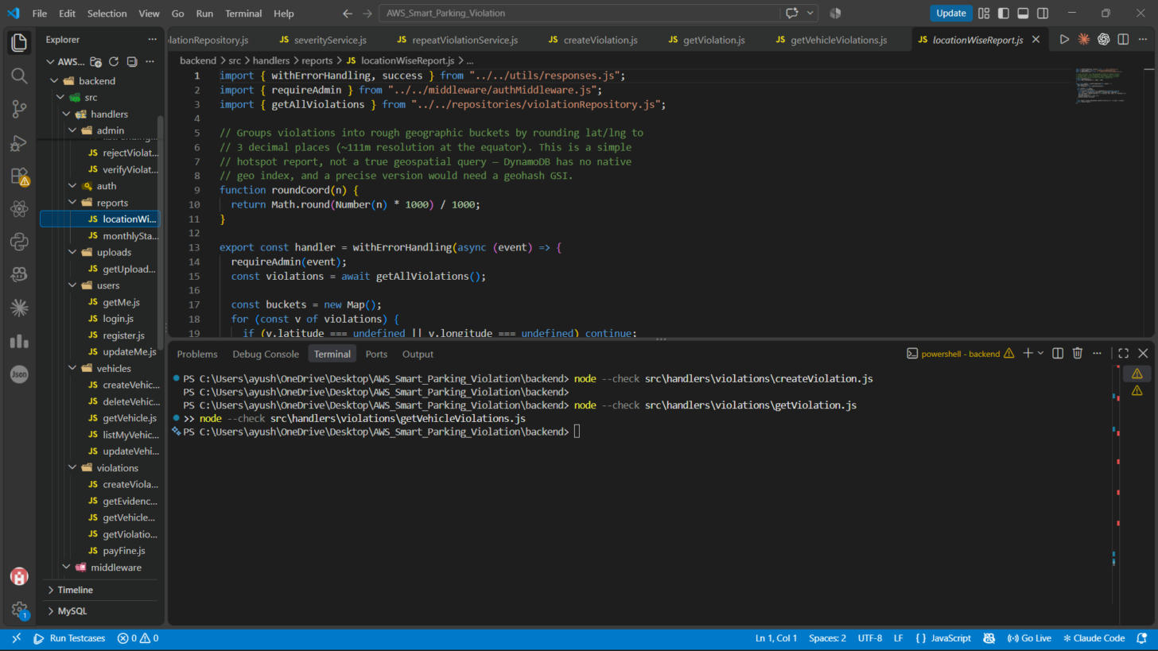
Figure 11: reports/locationWiseReport.js — groups violations into geographic buckets.
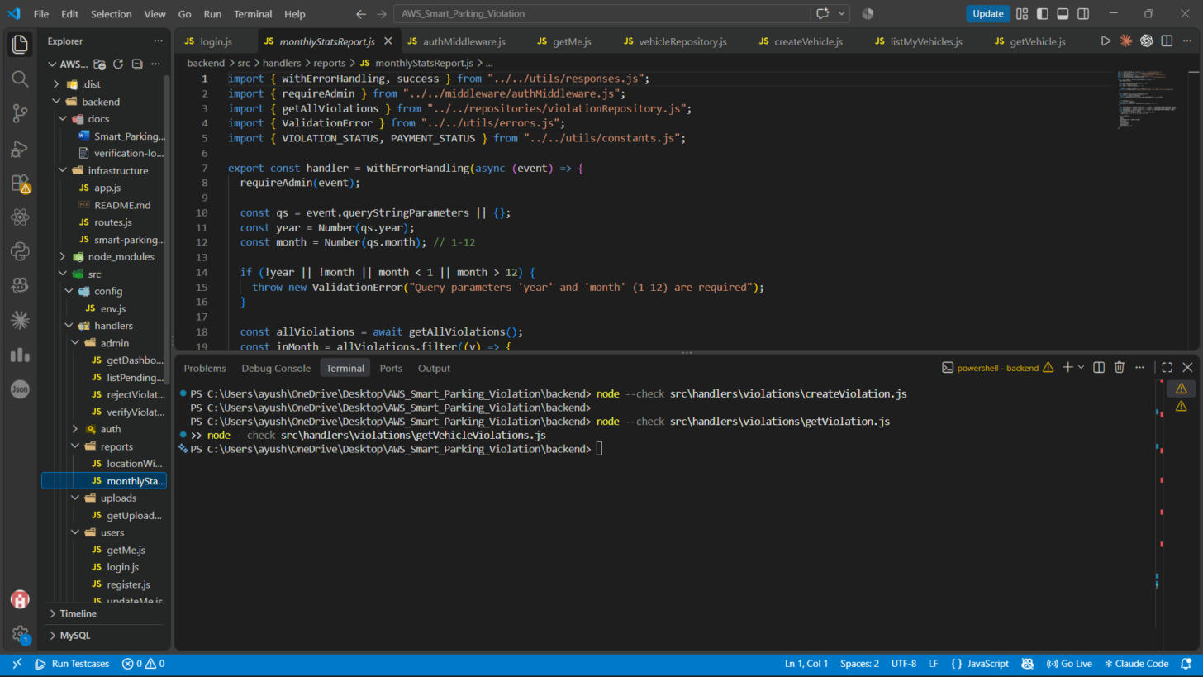
Figure 12: reports/monthlyStatsReport.js — aggregates a given month's violations.

Evidence photo flow (S3)
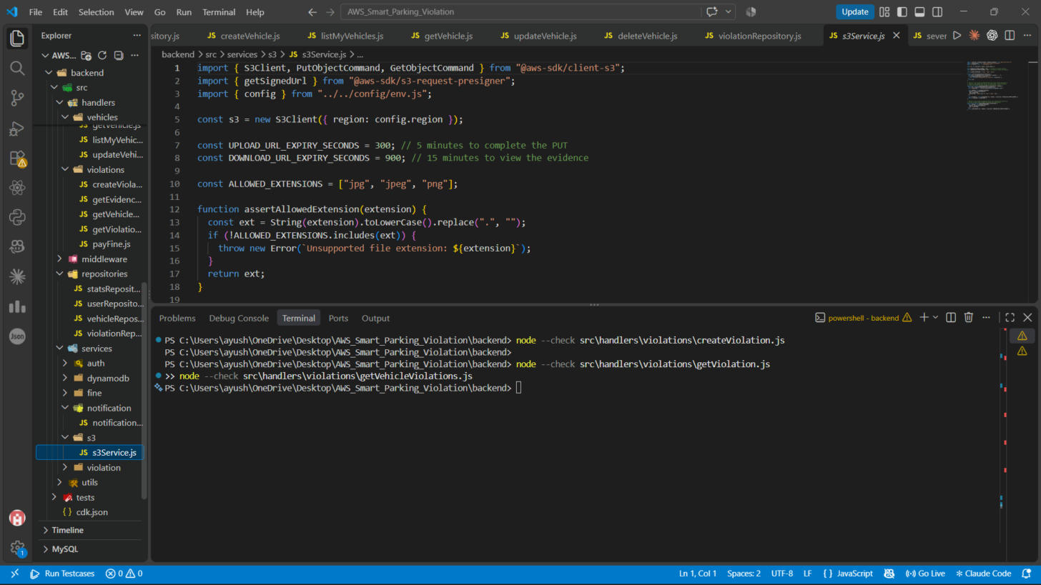
Figure 13: services/s3/s3Service.js — generates presigned PUT and GET URLs.
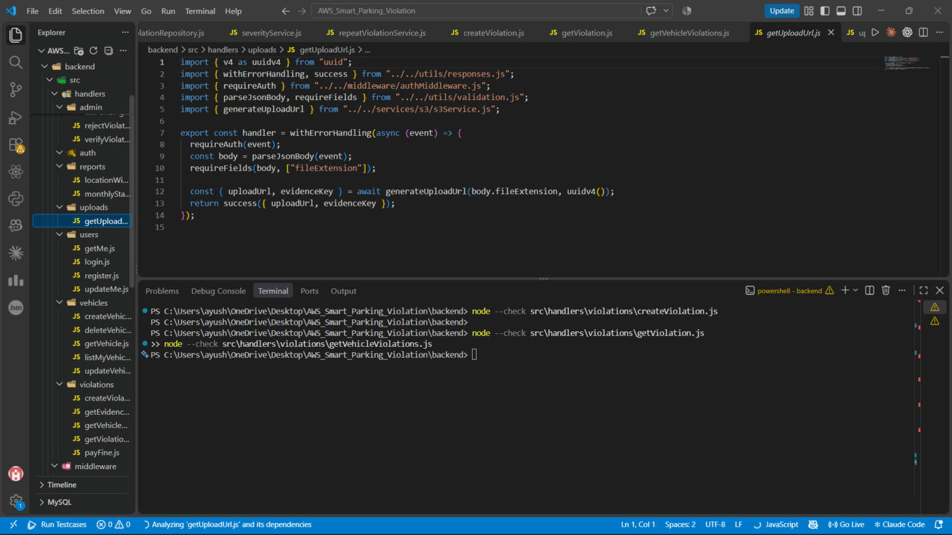
Figure 14: uploads/getUploadUrl.js — hands the client a presigned upload URL.
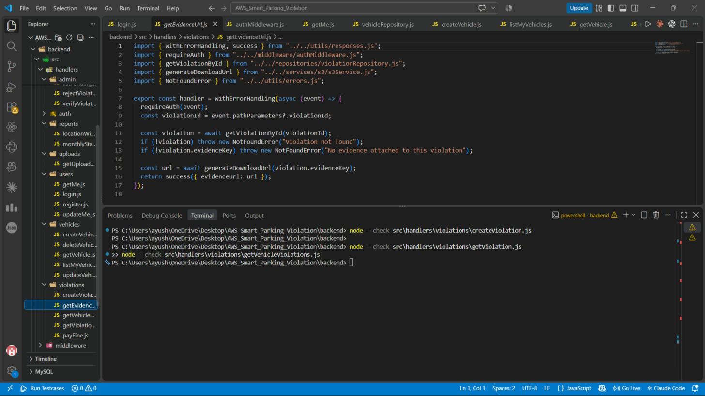
Figure 15: violations/getEvidenceUrl.js — returns a presigned GET URL to view a photo.

Payments and notifications
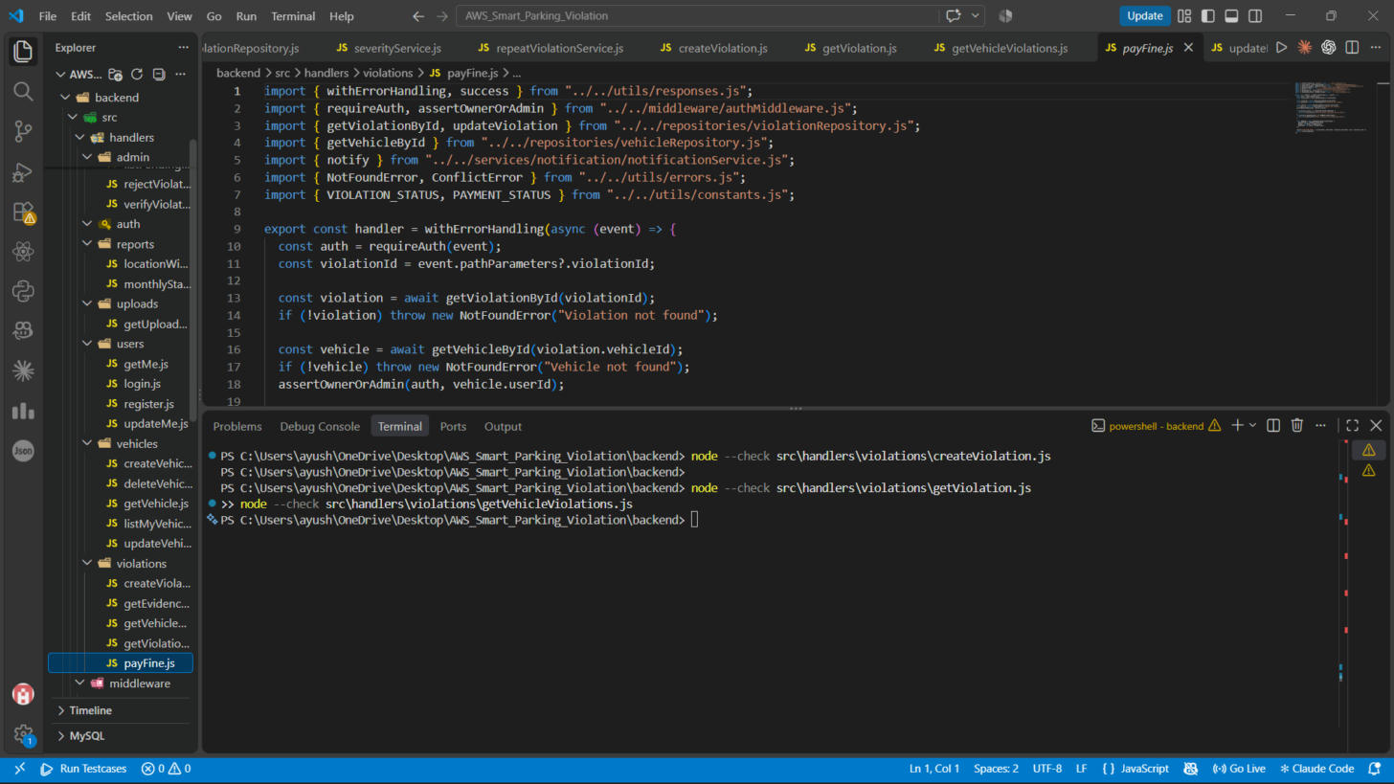
Figure 16: violations/payFine.js — marks a verified violation's fine as paid.
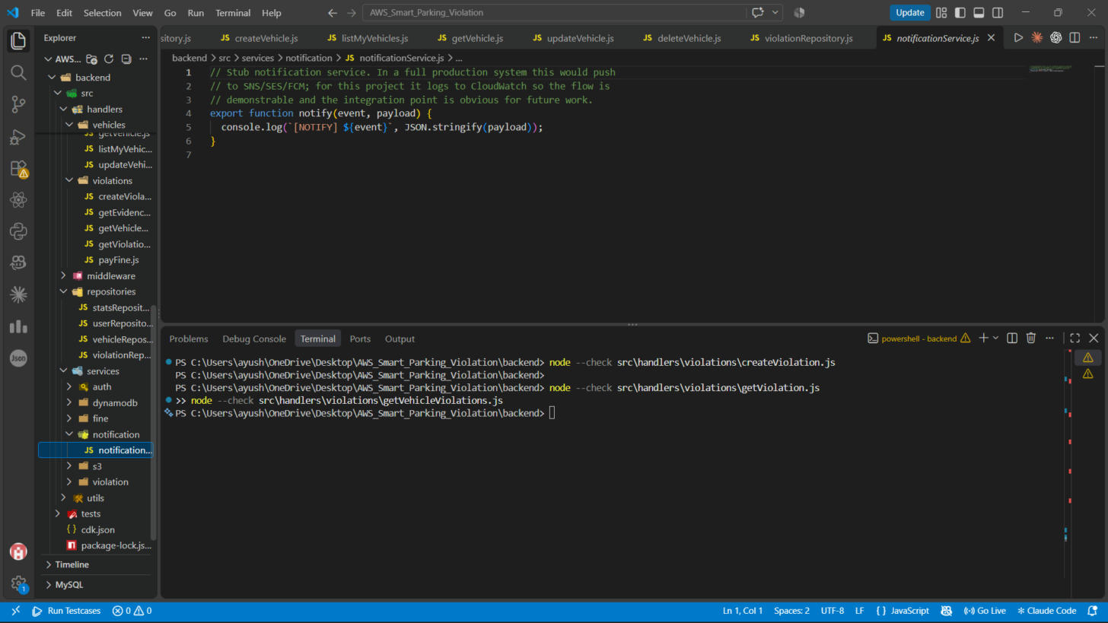
Figure 17: services/notification/notificationService.js — a console.log stub standing in for SNS/SES/FCM.

Repositories
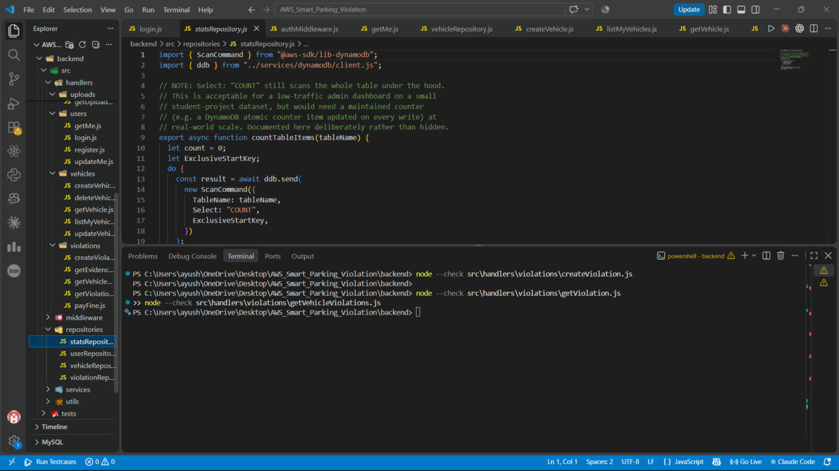
Figure 18: repositories/statsRepository.js — counts items in a table.
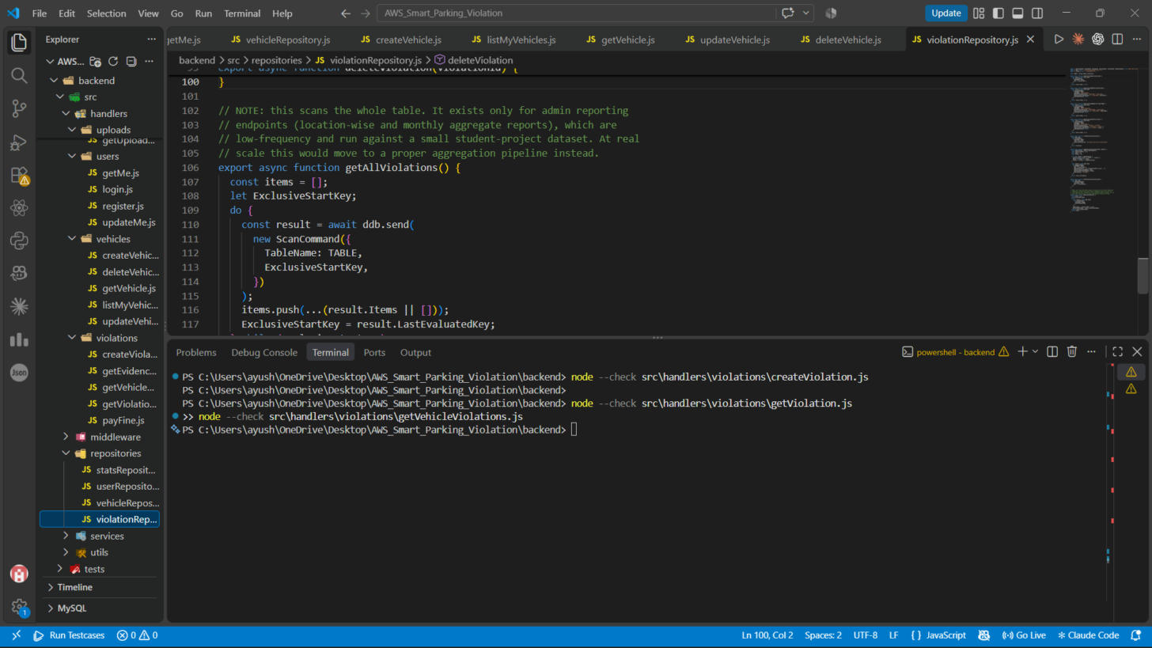
Figure 19: repositories/violationRepository.js — getAllViolations(), with a comment documenting the Scan tradeoff.

Verification
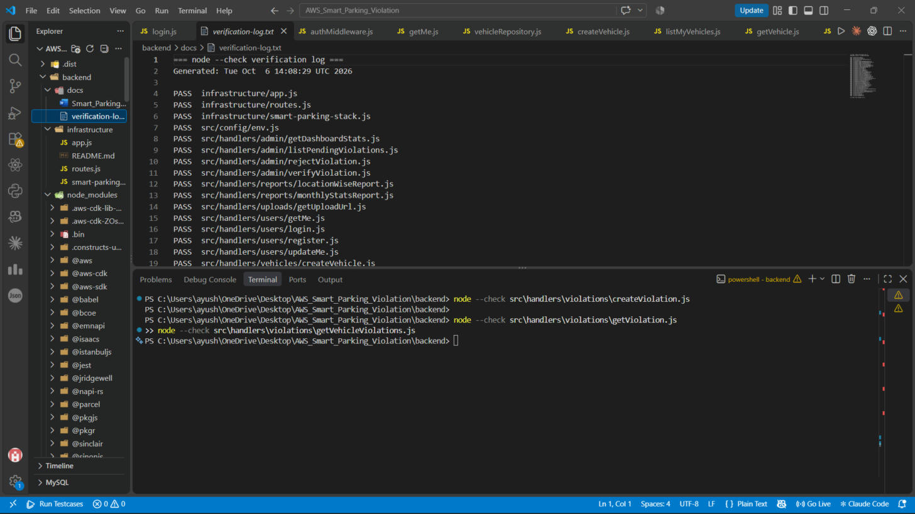
Figure 20: node --check run against all 41 .js files in the project — full PASS list.

AWS CDK infrastructure as code
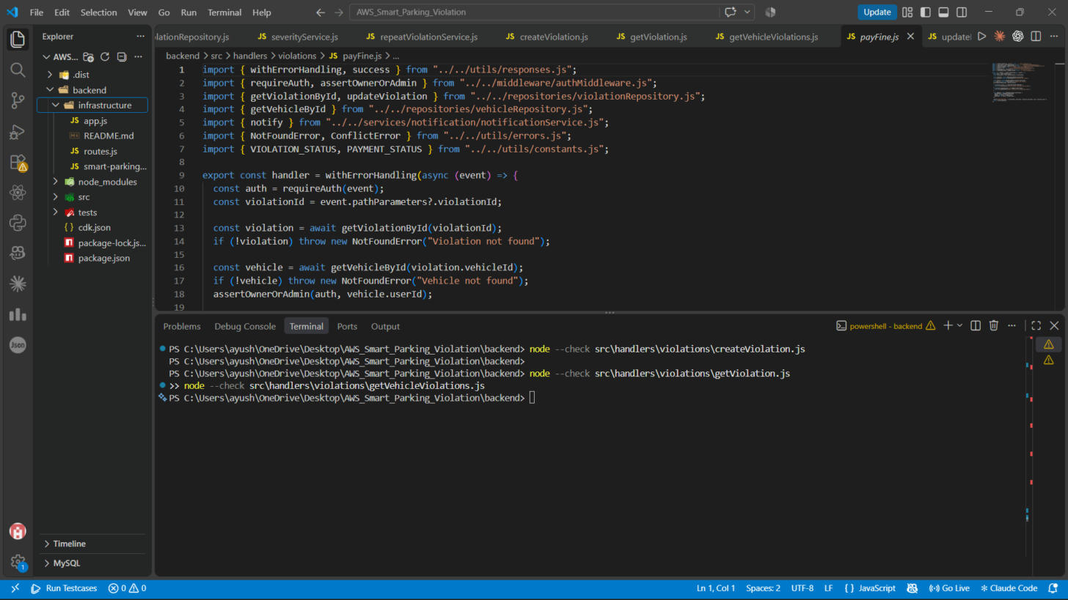
Figure 21: infrastructure/ folder — the CDK app (app.js, smart-parking-stack.js, routes.js, README.md).
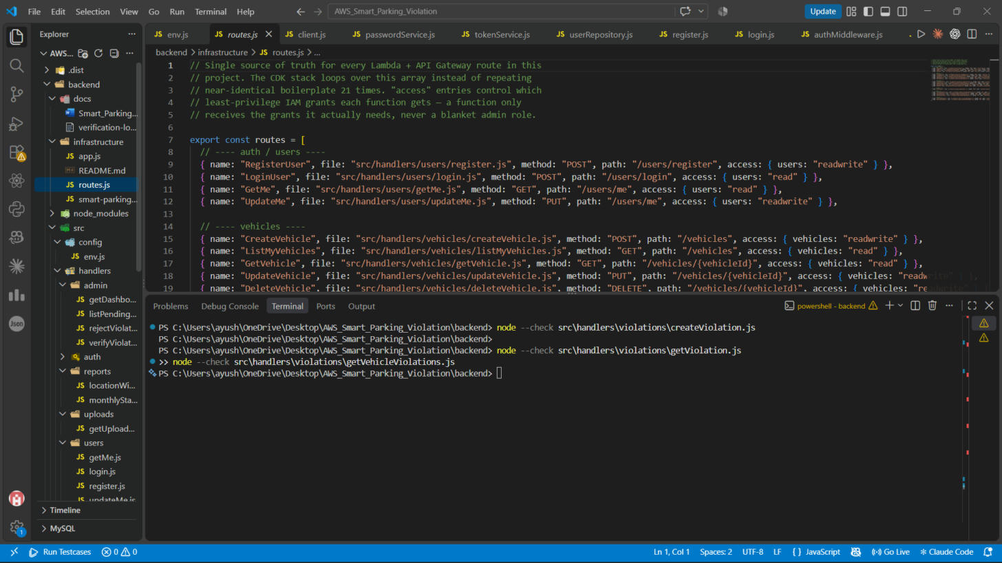
Figure 22: infrastructure/routes.js — all 21 routes and the exact least-privilege access each Lambda needs.
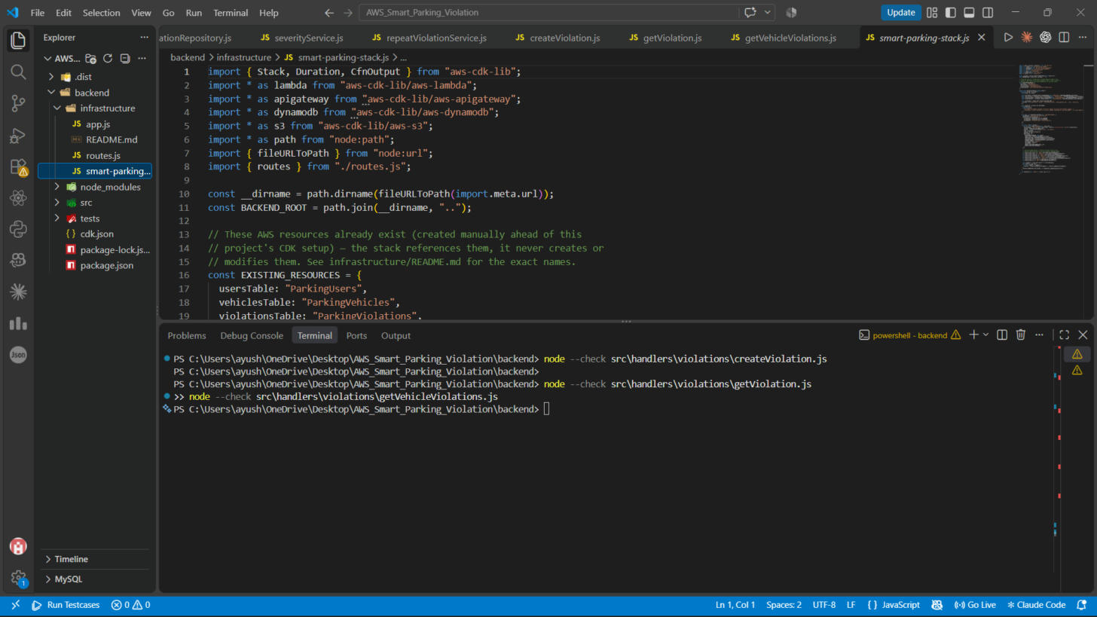
Figure 23: infrastructure/smart-parking-stack.js — references the existing DynamoDB tables and S3 bucket by name.
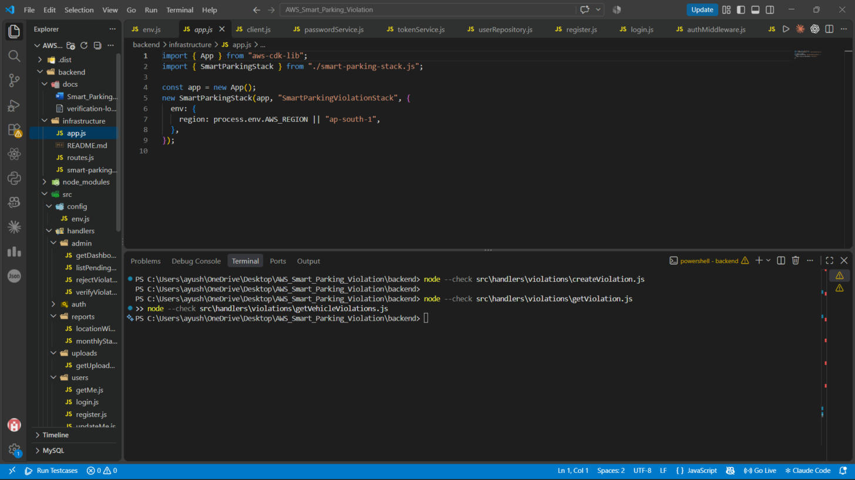
Figure 24: infrastructure/app.js — the CDK app entry point.
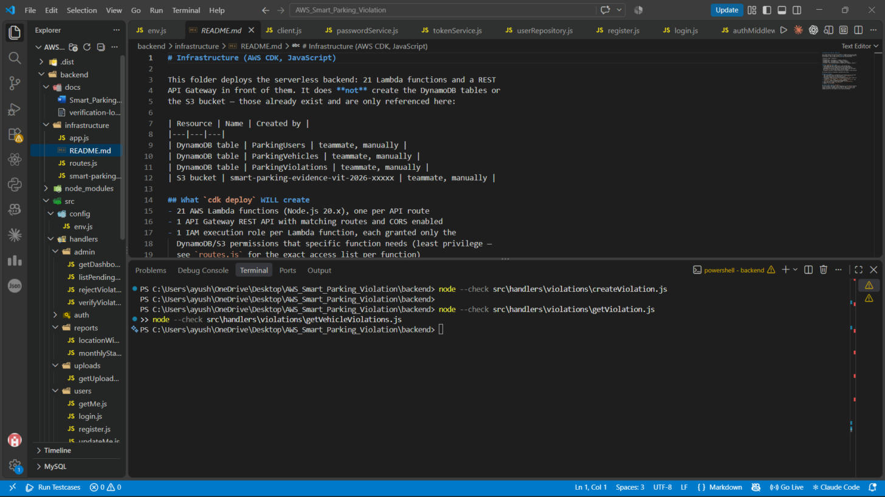
Figure 25: infrastructure/README.md — states what cdk deploy will and will not create.
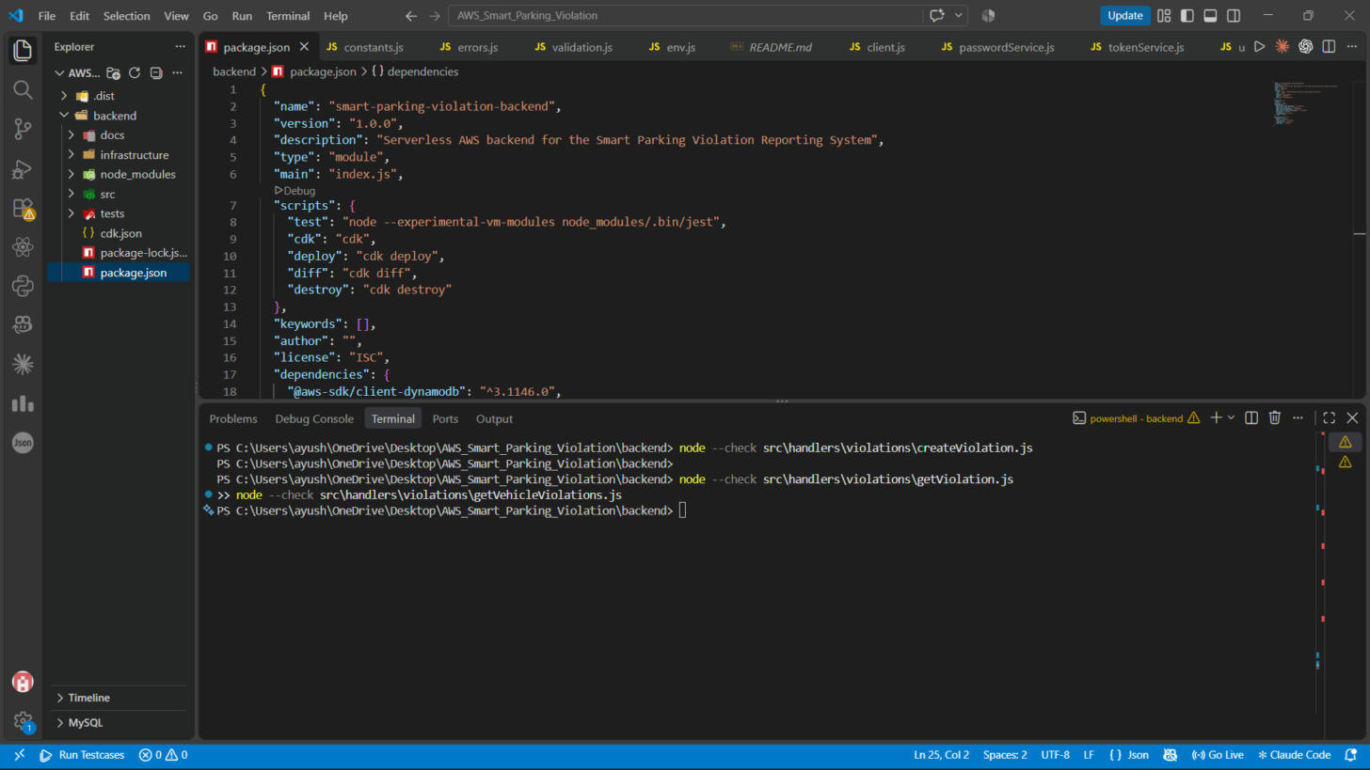
Figure 26: package.json — CDK dependencies and npm scripts.
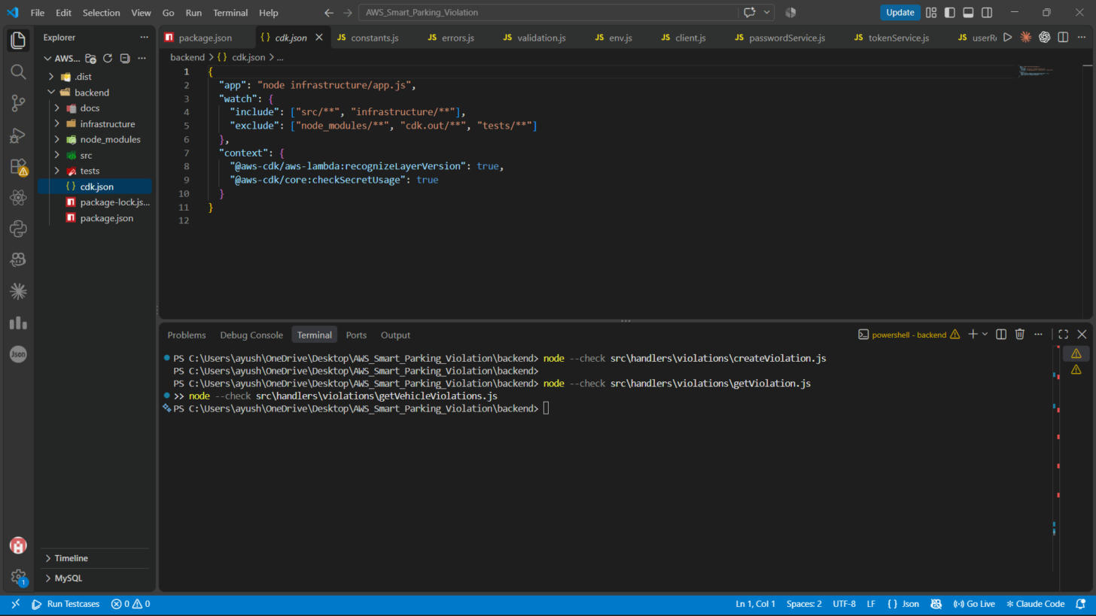
Figure 27: cdk.json — points the CDK CLI at infrastructure/app.js.

5. Frontend Module
The frontend is a React 19 application built with Vite, named "Smart Park" in the UI. It is a single-page app with a user side (dashboard, vehicles, violation history, reports) and an admin side (overview, verification queue, user/vehicle directory), switchable with a "Switch to Admin Mode" button for demo purposes.

5.1 Technology stack
Layer | Choice | Why
Framework | React 19 + Vite | Fast dev server, component-based UI
Charts | Recharts | Monthly violation trend charts on the admin dashboard
Icons | lucide-react | Icon set used across the dashboards and forms
Linting | oxlint | Fast linter configured for the project

5.2 Components
File | Purpose
App.jsx | Root component — holds the logged-in user, the user/admin mode switch, and the active tab
Header.jsx | Top navigation bar — logo, mode switch button, login/account status
AuthModal.jsx | Login and registration modal
UserDashboard.jsx | User's summary view — vehicle count, violation count, pending count, total fine, recent violations
VehiclesTab.jsx | Registered Vehicles tab — lists a user's vehicles with per-vehicle violation counts and fines
ViolationHistoryTab.jsx | Violation History tab — full table of a user's violations with status filters
VehicleReportTab.jsx | Vehicle Reports tab — per-vehicle severity breakdown and status counts
ReportViolationModal.jsx | The form used to report a new violation — vehicle, category, date/time, location, photo evidence
AdminDashboard.jsx | Admin Overview tab — totals, monthly trend chart, location-wise analysis, repeat offenders
AdminViolationManager.jsx | Verify Violations tab — review queue with Verify/Reject actions per violation
UsersDirectoryTab.jsx | Users & Vehicles DB tab — a read-only directory view of registered users and vehicles

5.3 Data layer: mock mode vs. real API
All data access goes through one file, src/services/api.js, behind a single switch:
- USE_MOCK_API = true — the app reads and writes data to the browser's localStorage, seeded with seven mock violations across four vehicles and two users. Every screen in Section 6 was captured in this mode.
- USE_MOCK_API = false — the same functions instead call API_BASE_URL (currently a placeholder) using plain fetch(), expecting a REST API shaped like the one in Section 4.5.
This design means the frontend was built and fully tested on its own, independent of whether the backend was ready yet — and it still is, since the real backend has not been deployed. Section 7 covers exactly what needs to change to flip that switch for real.

6. Full Working Demonstration (Live Screenshots)
The screenshots below were captured by running the frontend's production build in a browser and clicking through it live, not reused from a mock-up. They show the complete user and admin flow working end to end against the frontend's local mock data.
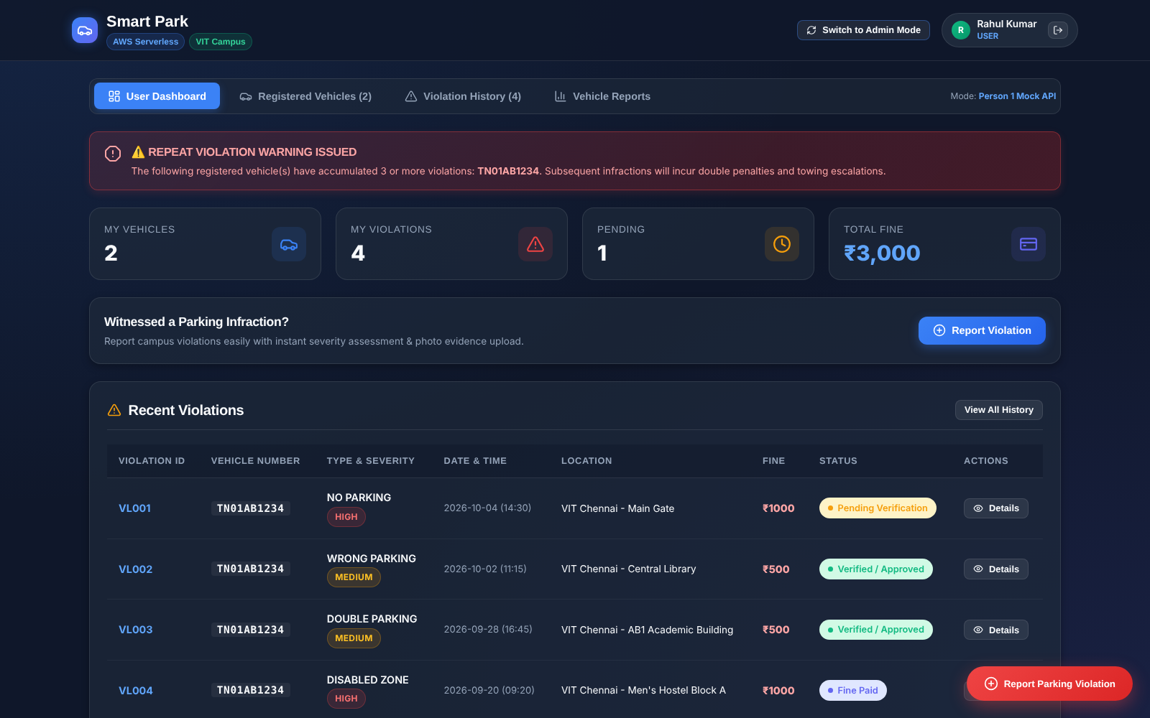
Figure 28: User Dashboard — vehicle count, violation count, pending count, total fine, and a repeat-violation warning banner.
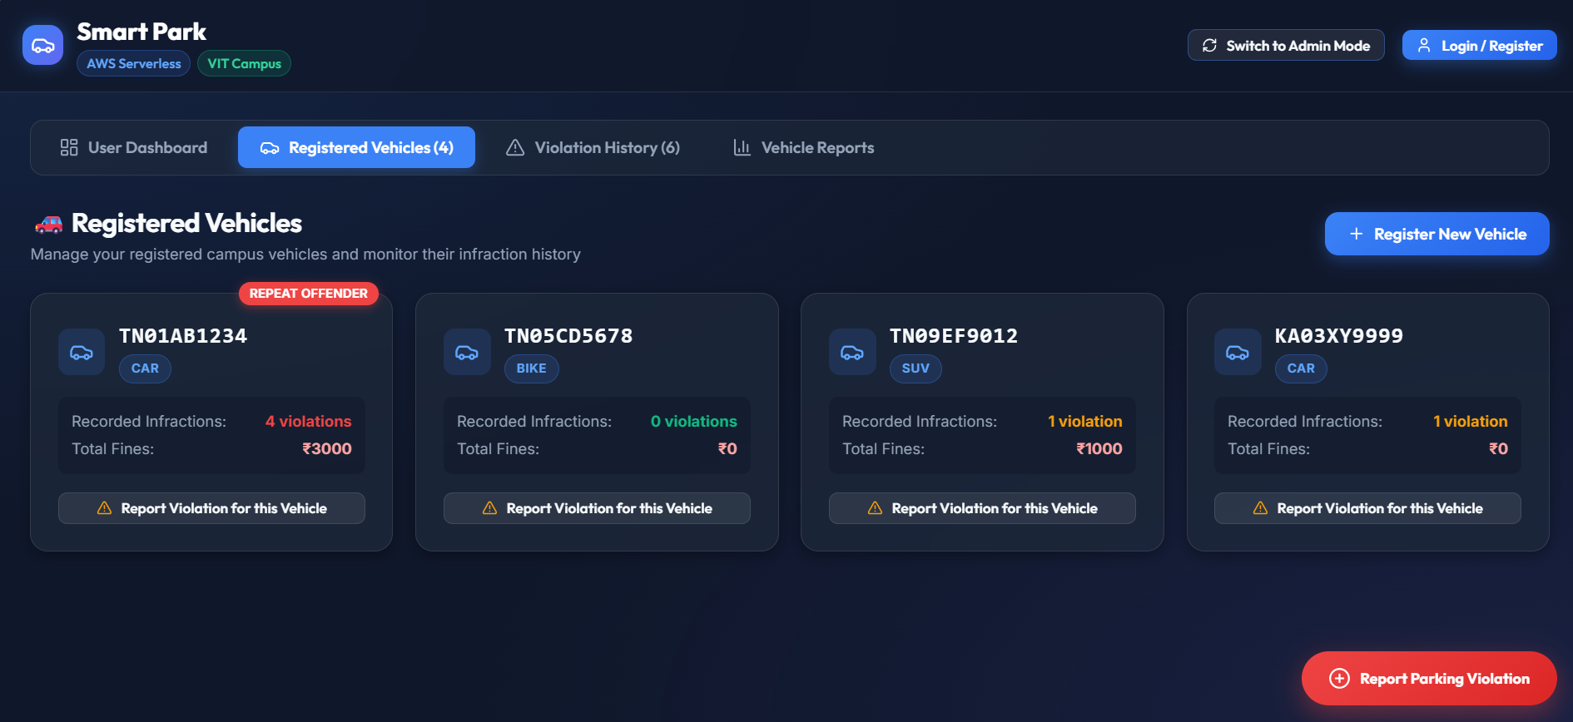
Figure 29: Registered Vehicles tab — each vehicle with its violation count and accumulated fine; one flagged REPEAT OFFENDER.
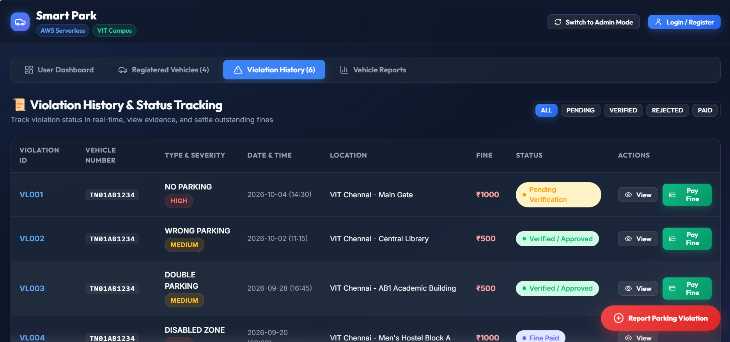
Figure 30: Violation History tab — the full violation table with status filters (All / Pending / Verified / Rejected / Paid).
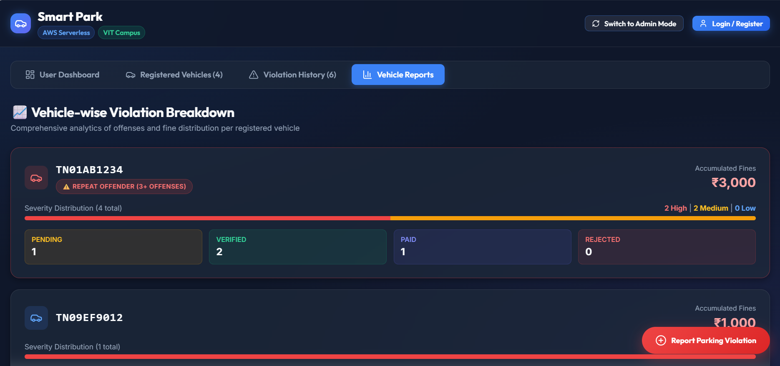
Figure 31: Vehicle Reports tab — per-vehicle severity breakdown and status counts.
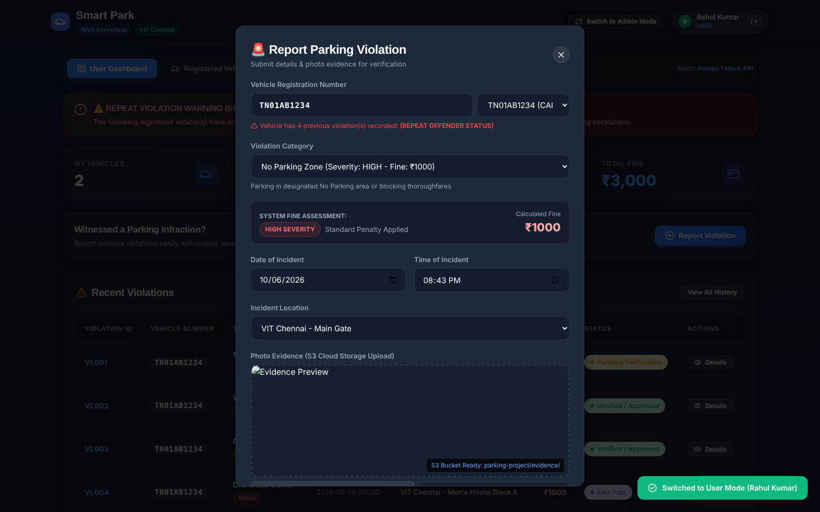
Figure 32: Report Parking Violation form — category, auto-calculated fine, date/time, location, and an S3-bound photo evidence uploader.
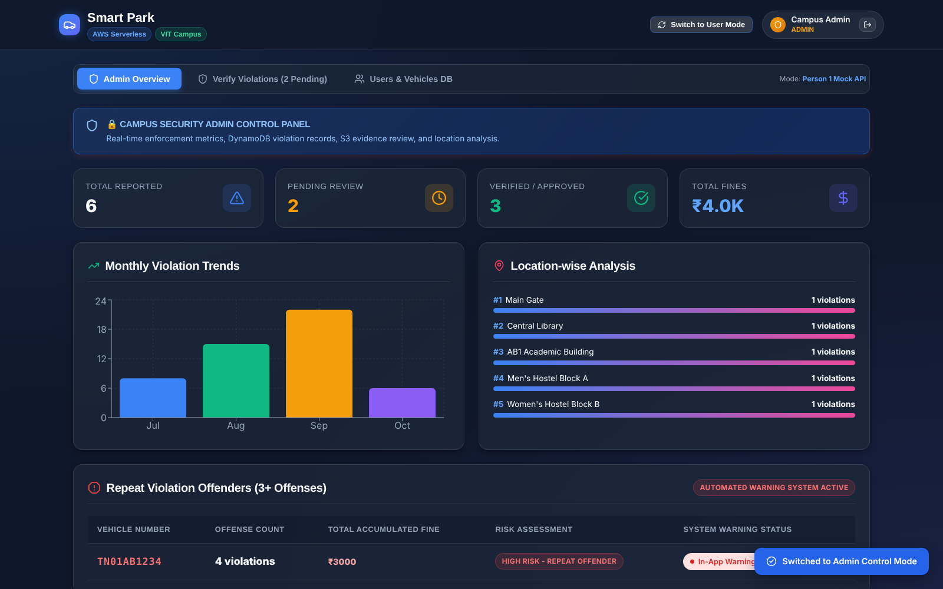
Figure 33: Admin Overview — totals, a monthly violation trend chart, location-wise analysis, and the repeat-offender list.
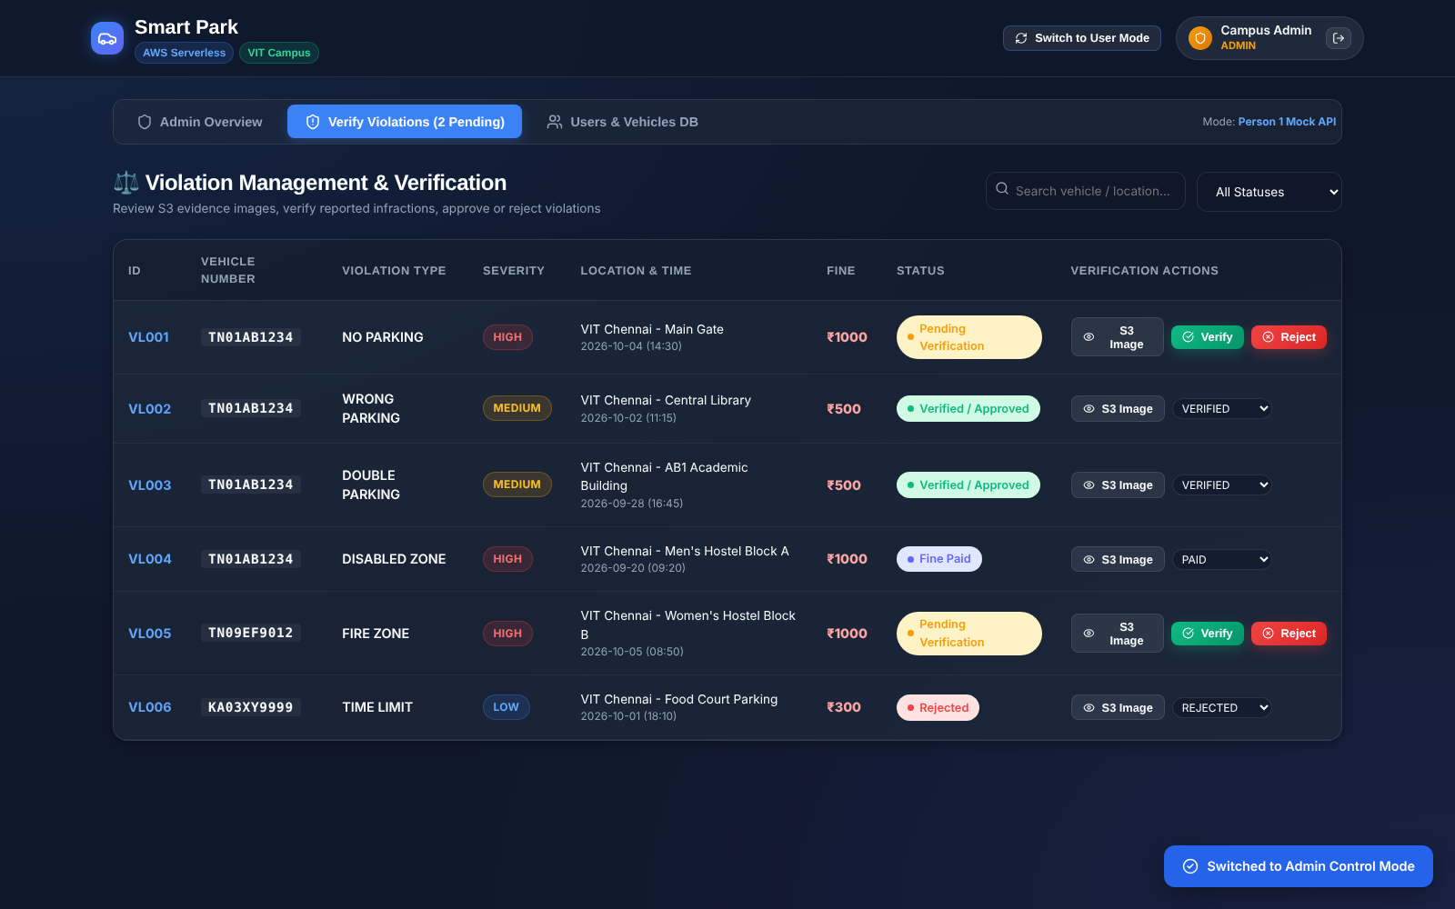
Figure 34: Verify Violations queue — admin can view the S3 evidence image and Verify or Reject each pending report.
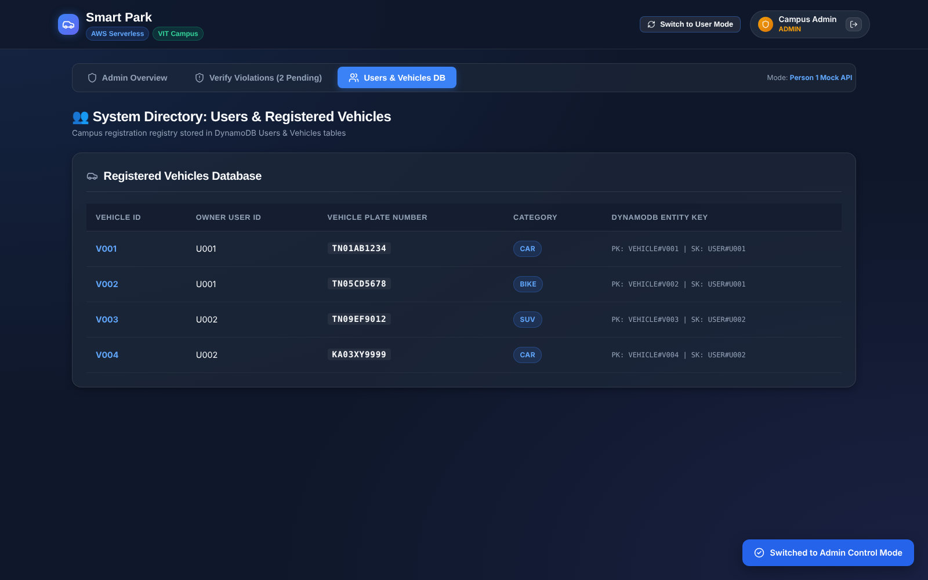
Figure 35: Users & Vehicles DB tab — a directory view of registered vehicles and their owners.
Note: Every screenshot in this section says "Mode: Person 1 Mock API" in the top right corner of the app. That label is accurate: this run used the frontend's built-in mock data (browser localStorage), not the real AWS backend. This is still a legitimate, fully working demonstration of the application logic and UI — it is just not yet proof that the Lambda/API Gateway/DynamoDB path in Section 4 is wired up. Section 7 explains exactly what that would take.

7. Integration Status and Known Gaps
This section is intentionally direct. The three modules (frontend, backend, infrastructure) each work and have been verified independently, but they are not connected yet. Here is exactly what stands between the current state and a real end-to-end system.

7.1 The backend is not deployed yet
The Lambda functions and API Gateway in Section 4 exist only as code (infrastructure/smart-parking-stack.js). cdk deploy has not been run, so there is currently no live API for the frontend to call. Deploying requires AWS CLI credentials under a personal IAM user and a JWT_SECRET environment variable; see Section 8 for the exact steps.

7.2 The frontend runs on mock data
src/services/api.js has USE_MOCK_API = true and a placeholder API_BASE_URL. All of Section 6's screenshots come from this mock mode. Flipping USE_MOCK_API to false will make real fetch() calls, but only once the two gaps below are closed.

7.3 API path mismatch
The frontend's fetch() calls (when not mocked) target different paths than the backend actually exposes. These need to be reconciled, on either side, before real calls will succeed:
Frontend calls | Backend actually exposes
POST /login | POST /users/login
POST /register | POST /users/register
GET /vehicles/{userId} | GET /vehicles (user identified by JWT, not a path param)
GET /violations/{userId} | GET /vehicles/{vehicleId}/violations (per-vehicle, not per-user)
PUT /violation/{id}/status | POST /admin/violations/{id}/verify or /reject
GET /admin/statistics | GET /admin/dashboard
GET /admin/repeat-offenders | no dedicated endpoint — the flag is embedded per violation

7.4 Violation category and fine mismatch
The frontend's own category list (src/config/constants.js) does not match the backend's (src/utils/constants.js). For example the frontend has a flat fine table (HIGH = Rs. 1000, MEDIUM = Rs. 500, LOW = Rs. 300) with categories like FIRE_ZONE and TIME_LIMIT, while the backend uses a four-tier severity system (MINOR/MODERATE/MAJOR/SEVERE, Rs. 500 to Rs. 2000) with categories like NO_PARKING_ZONE and EMERGENCY_ACCESS_BLOCK. One list needs to become the source of truth, and the other side updated to match, before fines shown in the UI will agree with fines calculated by the backend.

7.5 Missing DynamoDB indexes
As noted in Section 3.4, the three DynamoDB tables currently have 0 secondary indexes, while the backend code queries against six GSIs that do not exist yet (EmailIndex, VehicleNumberIndex, UserIndex, VehicleIndex, ReportedByIndex, StatusIndex). These need to be added to the existing tables — this does not require recreating the tables, just adding indexes to them.

7.6 Two different IAM strategies
The AWS console setup (Section 3.2) created one shared role, SmartParkingLambdaRole, with broad AmazonDynamoDBFullAccess and AmazonS3FullAccess policies. The CDK stack (Section 4.7) takes a different, more careful approach: it creates one narrow IAM role per Lambda function, scoped to only the table(s)/bucket that function actually touches. These two approaches should not both be used — the recommendation is to let cdk deploy create and attach its own per-function roles, and leave SmartParkingLambdaRole unused, since least-privilege access is safer and was a deliberate design decision for this project.

7.7 Summary checklist
Item | Status
AWS region, DynamoDB tables, S3 bucket created | Done
IAM role for Lambda created (broad policy) | Done, superseded by CDK's per-function roles
Backend Lambda code written (21 functions) | Done
Backend verified with node --check | Done
CDK infrastructure code written | Done
cdk deploy run (Lambdas + API Gateway actually created) | Not done
DynamoDB GSIs added to existing tables | Not done
Frontend UI built and verified (mock data) | Done
Frontend API paths aligned with backend routes | Not done
Frontend violation categories/fines aligned with backend | Not done
USE_MOCK_API switched to false, API_BASE_URL set to real URL | Not done
End-to-end test against real AWS resources | Not done

8. Deployment (AWS CDK)
The backend infrastructure is defined as code using AWS CDK in JavaScript (infrastructure/ folder), not clicked together manually. Running it creates:
- 21 Lambda functions (Node.js 20.x runtime), one per API route
- 1 API Gateway REST API with all matching routes and CORS enabled
- 1 IAM execution role per Lambda function, scoped to least privilege
- CloudWatch Log Groups (created automatically by Lambda)
It does not create or modify the DynamoDB tables or the S3 bucket, since those already exist (Section 3).
Steps to deploy (run on a machine with AWS CLI configured under a personal IAM user, never the root account):
- 1. Add the missing DynamoDB GSIs listed in Section 7.5 to the existing tables.
- 2. Set the JWT secret: $env:JWT_SECRET = "<a long random string>" (PowerShell)
- 3. npm install (installs aws-cdk-lib and constructs)
- 4. npx cdk bootstrap (first time only, per AWS account/region)
- 5. npx cdk diff (review exactly what will be created before touching AWS)
- 6. npx cdk deploy (creates the resources listed above)
- 7. Copy the API Gateway URL from the deploy output into the frontend's API_BASE_URL, resolve the mismatches in Section 7.3 and 7.4, and set USE_MOCK_API to false.
Step 6 was deliberately left for manual review rather than run automatically, since it creates real AWS resources and billing should always be a conscious decision.

9. Known Limitations
- Auth is a simplified custom JWT layer, not Cognito: no refresh tokens, no MFA, no password reset.
- Two reporting endpoints use a DynamoDB Scan, which does not stay cheap at a very large scale.
- Payment is just a status flag (UNPAID -> PAID); there is no real payment gateway integration.
- Notifications are a console.log stub meant to show where a real SNS/SES/FCM integration would plug in.
- The vehicle-number regex is a loose pattern and will not match every real Indian registration format.
- The frontend and backend were built against two different violation-category schemas (Section 7.4) and need reconciling.
These are documented tradeoffs made consciously for a college project timeline, not oversights.

