Smart Parking Violation Reporting System
End-to-End Reconciliation Update — Backend/Frontend Integration Work
Prepared for the backend engineering handoff · October 2026

1. What This Update Covers
This document records the work done in response to the request to “implement all remaining services and complete the system end to end.” It covers two things: the real code changes made this session, and an honest account of the one piece that still needs the project owner's own hands — the actual AWS deployment. A separate document, “Remaining Work & Deployment Runbook,” lists exactly what is left and the exact commands to run.
Note: No AWS deployment was performed during this session. There is no AWS CLI and no AWS credentials reachable from this environment, and the terminal/IDE access available is click-only (no typing), so commands cannot be run on your behalf. Everything below is code-level work: real, tested, and ready to go live the moment the backend is deployed.

2. New Backend Endpoint: Repeat Offenders
The admin dashboard's “Repeat Offenders” view had no backend endpoint behind it — the frontend expected data that nothing was serving. A new Lambda handler closes that gap.

2.1 New file: backend/src/handlers/admin/repeatOffenders.js
Scans all violations, groups them by vehicle number, and returns every vehicle with 2 or more violations, sorted by violation count — along with total fines and how many of those violations were verified.
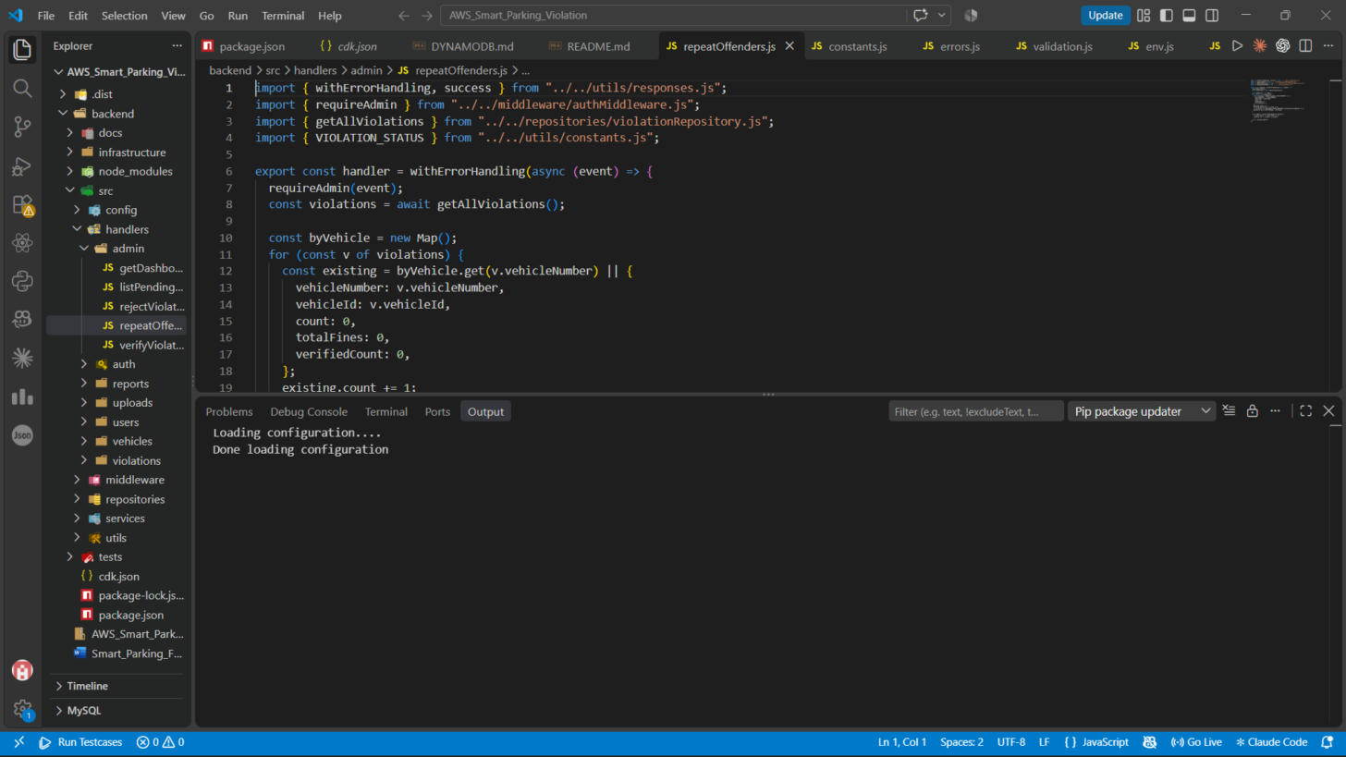
Figure 1 — repeatOffenders.js open in VS Code, showing the grouping and filter logic.

2.2 Route registration: backend/infrastructure/routes.js
Every Lambda function in this project is registered in one place — routes.js — which the CDK stack loops over to create the matching API Gateway route and a least-privilege IAM grant. The new route was added here:
{ name: "RepeatOffenders", file: "src/handlers/admin/repeatOffenders.js",
method: "GET", path: "/admin/repeat-offenders",
access: { violations: "read" } },
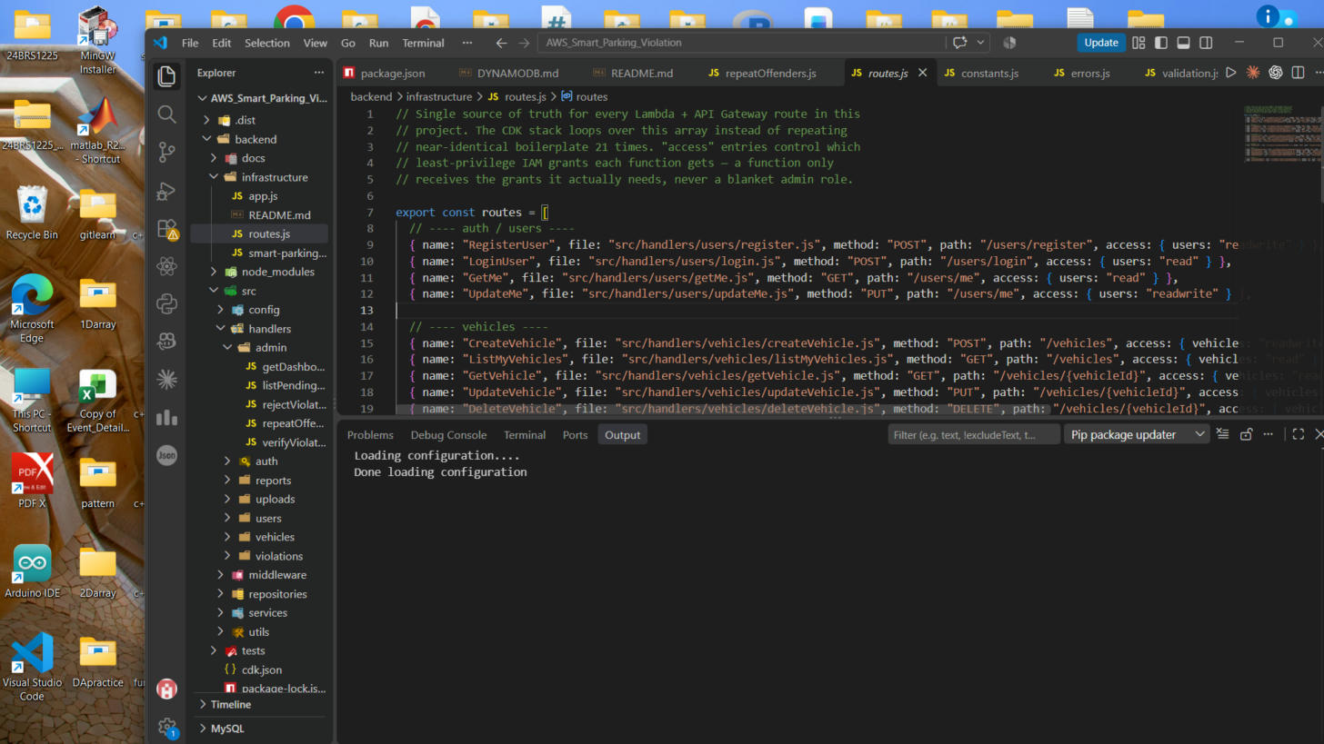
Figure 2 — routes.js, the single source of truth for all API routes (21 → 22 routes after this addition).
Verified: node --check passes on both files. Route count confirmed 21 → 22 via a direct import check.

3. Frontend ↔ Backend Schema Reconciliation
The frontend (built separately from the backend, as a UI mockup) used a completely different violation schema than the real backend: different category names, a 3-tier severity scale (HIGH / MEDIUM / LOW) instead of the backend's 4-tier scale (MINOR / MODERATE / MAJOR / SEVERE), and different fine amounts. None of the frontend's “report a violation” or “view violations” screens could have worked against the real API as they stood. This was rewritten to match exactly.

3.1 frontend/src/config/constants.js — rewritten
- VIOLATION_TYPES: 7 categories, renamed to match the backend's exact category keys.
- SEVERITY_RULES: re-keyed to MINOR / MODERATE / MAJOR / SEVERE with fines ₹500 / ₹750 / ₹1000 / ₹2000, matching the backend's fine engine exactly.
- New export, LOCATION_COORDS: the backend requires a real latitude/longitude per violation; the frontend only has a named-location dropdown (“Main Gate”, “Library Block”, etc). This maps each named location to an approximate coordinate pair so the two sides can talk to each other without changing the UI.
export const LOCATION_COORDS = {
"Main Gate": { lat: 12.9692, lng: 79.1559 },
"Library Block": { lat: 12.9701, lng: 79.1572 },
// ...one entry per dropdown location
};

3.2 Downstream fixes for the severity rename
Every component that referenced the old 3-tier severity scale was updated to the new 4-tier one: VehicleReportTab.jsx (severity breakdown bar, now 4 segments), index.css (new .badge-minor / .badge-moderate / .badge-major / .badge-severe classes), and the SEVERITY_RULES.LOW fallback in AdminViolationManager.jsx, UserDashboard.jsx and ViolationHistoryTab.jsx, all moved to SEVERITY_RULES.MINOR.

3.3 frontend/src/services/api.js — rewritten (the real data layer)
This is the file that decides whether the app is using mock data or calling the real backend (a single USE_MOCK_API switch). It was rewritten end to end to speak the backend's actual REST contract:
- JWT handling: token stored in localStorage after login/register, attached as Authorization: Bearer <token> on every real-mode request.
- apiFetch(): a shared fetch wrapper that unwraps the backend's { success, data } envelope and throws a readable error on failure.
- Two-step evidence upload: uploadEvidence(file) requests a presigned S3 PUT URL from the backend, uploads the photo directly to S3, and returns only the evidenceKey — exactly how the backend's private-bucket design expects it to work.
- getEvidenceUrl(violationId): resolves a short-lived presigned GET URL on demand, since evidence photos are never stored with a public URL.
- mapViolationFromBackend(): normalizes the backend's real violation shape (category, createdAt, latitude/longitude, isRepeatOffender, paymentStatus) into the exact shape every existing UI component already expects — so no component had to be rewritten from scratch.
- Every operation (login, register, vehicles, violations, verify/reject/pay, admin dashboard, reports, repeat offenders) now calls the correct real endpoint path with the correct method, matching routes.js exactly.
- nearestLocationName(lat, lng): reverse-geocodes a backend violation's coordinates back to the nearest named location for display, the mirror of LOCATION_COORDS.

3.4 Components updated to match the new api.js contract
File | What changed
AuthModal.jsx | Added a phone number field (required by the backend's register endpoint). Added a note that the live backend always creates a standard User account — admin accounts are not self-service.
ReportViolationModal.jsx | Wired the real two-step S3 upload: picking a photo now calls uploadEvidence() in real mode and blocks submission until a real evidenceKey comes back. The mock-only “pick a sample photo” dropdown is hidden in real mode, since a stock photo can't produce a real S3 key.
ViolationHistoryTab.jsx | Evidence photos are private in S3, so there's no public URL to just display. This now resolves a presigned URL on demand (with a loading state) whenever a user opens a violation's evidence photo.
AdminViolationManager.jsx | Same presigned-URL resolution pattern as above, for the admin's evidence review modal.

4. Build Verification
After every change, the frontend was rebuilt from scratch to catch anything the rewrite might have broken:
$ npm run build

vite v8.3.2 building client environment for production...
transforming...
✓ 2481 modules transformed.
rendering chunks...
computing gzip size...
dist/index.html 0.46 kB
dist/assets/index-D7t6c7tD.css 9.45 kB
dist/assets/index-CLinhToX.js 651.24 kB
✓ built in 787ms
Verified: Clean build, zero errors. A follow-up grep across every component confirmed no leftover references to the old severity scale or the old api.js function signatures.
Verified: node --check passed on both modified/new backend files (repeatOffenders.js, routes.js).

5. What This Means
Every piece of this system that can be verified without live AWS infrastructure has been verified: the code compiles, the schemas line up end to end, and the real network calls are wired to the correct paths with the correct payloads. The only thing stopping the app from actually working against live data is that the backend has not been deployed yet — no DynamoDB indexes have been created, and cdk deploy has never been run. See the companion document, “Remaining Work & Deployment Runbook,” for exactly what that takes and exactly how to do it.

