AWS-Based Smart Parking Violation Reporting System
Backend Module Documentation
This document covers the backend I built for the Smart Parking Violation Reporting System project: the serverless API, the database design, the file storage flow for evidence photos, and the AWS infrastructure setup. It includes screenshots of the code and folder structure as proof of work.
Date: October 2026

1. Project Overview
The Smart Parking Violation Reporting System lets a user report a parking violation (wrong parking, no-parking zone, blocking emergency access, and so on) against a vehicle, attach a photo as evidence, and have an admin review and either verify or reject the report. A verified violation carries a fine based on how severe the category is. The system also tracks repeat offenders and gives admins a dashboard and a few reports.
My part of the project is the backend: everything that runs on AWS without a server I manage myself. The frontend (mobile or web) talks to this backend only through HTTPS API calls.

2. Architecture
The backend follows a simple serverless pattern. The frontend never talks to the database or file storage directly; it only calls the API, and the API Gateway and Lambda layer does all the work.
Request flow, step by step:
- The client sends an HTTPS request to API Gateway (for example, POST /violations).
- API Gateway routes the request to the matching Lambda function.
- The Lambda function checks the JWT token (if the route needs login), validates the input, and does its job.
- The function reads or writes DynamoDB, and for evidence photos, generates a presigned S3 URL instead of handling the image itself.
- The function returns a JSON response, which API Gateway sends back to the client.
There is no EC2 server running all the time. AWS only runs a Lambda function for the few milliseconds it takes to handle one request, which keeps cost close to zero for a small project like this.

3. Technology Stack
Layer | Choice | Why
Compute | AWS Lambda (Node.js 20.x) | Serverless, pay only per request, no server to patch or manage
API layer | Amazon API Gateway (REST API) | Routes HTTP requests to the right Lambda, handles CORS
Database | Amazon DynamoDB | Serverless NoSQL, fast key lookups, scales automatically
File storage | Amazon S3 | Stores evidence photos privately, accessed only via presigned URLs
Auth | Custom JWT (jsonwebtoken + bcryptjs) | Cognito was not used for this project (team decision); a simple JWT layer was built instead
Infrastructure as code | AWS CDK (JavaScript) | Defines Lambda functions, API routes and IAM roles in code instead of clicking through the console
Logging | Amazon CloudWatch | Every Lambda function logs automatically; used for debugging

4. AWS Resources
Region used: ap-south-1 (Mumbai).
Resource | Name | Notes
DynamoDB table | ParkingUsers | Primary key: userId. GSI: EmailIndex (login lookup)
DynamoDB table | ParkingVehicles | Primary key: vehicleId. GSIs: VehicleNumberIndex, UserIndex
DynamoDB table | ParkingViolations | Primary key: violationId. GSIs: VehicleIndex, ReportedByIndex, StatusIndex
S3 bucket | smart-parking-evidence-vit-2026-xxxxx | Private bucket, evidence/ folder, accessed only through presigned URLs
Lambda functions | 21 functions, one per endpoint | Created by the CDK stack, not manually
API Gateway | smart-parking-violation-api | One REST API fronting all 21 Lambda functions
IAM roles | One per Lambda function | Each function only gets access to the exact table(s)/bucket it uses (least privilege)
The three DynamoDB tables and the S3 bucket were created directly in the AWS console (not by this CDK stack), so the infrastructure code only references them by name and never creates, deletes, or modifies them.

5. Database Design
Every table uses Global Secondary Indexes (GSIs) so the backend never needs to run a full table Scan for a normal request. A Scan reads every row in the table, which is slow and expensive as the table grows; a Query using a GSI jumps straight to the rows that matter.

5.1 ParkingUsers
- Primary key: userId (UUID)
- EmailIndex (GSI): look up a user by email during login
- Fields: name, email, phone, passwordHash, role (USER or ADMIN), createdAt, updatedAt

5.2 ParkingVehicles
- Primary key: vehicleId (UUID)
- VehicleNumberIndex (GSI): look up a vehicle by its plate number
- UserIndex (GSI): list all vehicles owned by one user

5.3 ParkingViolations
- Primary key: violationId (UUID)
- VehicleIndex (GSI): a vehicle's full violation history
- ReportedByIndex (GSI): violations reported by one user
- StatusIndex (GSI): the admin's pending-review queue
- Fields: category, severity, fine, status (PENDING/VERIFIED/REJECTED), paymentStatus, evidenceKey, isRepeatOffender, latitude, longitude
Two admin-only reporting endpoints (location-wise hotspots and monthly stats) do use a full table Scan on ParkingViolations. This is a deliberate, documented tradeoff: those endpoints are low-frequency, admin-only, and the dataset for a student project is small, so the cost is acceptable. At a larger scale this would need a proper aggregation pipeline instead.

6. Authentication and Security
Cognito was intentionally not used for this project. Instead, authentication is a small custom layer:
- Passwords are hashed with bcrypt (10 salt rounds) before being stored. The plain password is never saved.
- Login issues a JWT (JSON Web Token) signed with a secret that is set as an environment variable at deploy time, never written in the source code.
- Every protected route reads the token from the Authorization: Bearer <token> header and verifies it before doing anything else.
- Login returns the exact same error for a wrong password and for a non-existent email, so an attacker cannot tell which emails are registered (this is called account-enumeration prevention).
- Routes are split into three levels: public (register/login), authenticated (any logged-in user), and admin-only (verify/reject violations, dashboard, reports).
- Each Lambda function's IAM role is scoped to only the DynamoDB table(s) and S3 permissions it actually needs, not a blanket admin role.
Known limitation, stated plainly: this custom JWT layer has no refresh-token rotation, no multi-factor authentication, and no password-reset flow. For a college project this is an acceptable, documented simplification; a production system would use Cognito or a more complete auth service.

7. Evidence Photo Upload Flow
The S3 bucket is private. No Lambda function ever receives or stores the actual image bytes; instead, the backend hands out short-lived presigned URLs and the client uploads or downloads the photo directly to/from S3.
- 1. The client calls POST /uploads/evidence-url, and the backend returns a presigned PUT URL (valid 5 minutes) plus an evidenceKey like evidence/<uuid>.jpg.
- 2. The client uploads the photo directly to that URL.
- 3. The client includes that evidenceKey when calling POST /violations.
- 4. To view the photo later, GET /violations/{id}/evidence-url returns a presigned GET URL (valid 15 minutes).
Only the evidenceKey (a short string like evidence/ab12-cd34.jpg) is ever stored in the database, never a public URL, since the bucket is private.

8. API Endpoints (21 total)

8.1 Users
Method | Path | Auth | Description
POST | /users/register | Public | Create an account
POST | /users/login | Public | Log in, get a JWT
GET | /users/me | User | Get my own profile
PUT | /users/me | User | Update my name/phone

8.2 Vehicles
Method | Path | Auth | Description
POST | /vehicles | User | Register a vehicle
GET | /vehicles | User | List my vehicles
GET | /vehicles/{vehicleId} | User | Get one vehicle
PUT | /vehicles/{vehicleId} | Owner/Admin | Update vehicle type
DELETE | /vehicles/{vehicleId} | Owner/Admin | Remove a vehicle

8.3 Violations
Method | Path | Auth | Description
POST | /violations | User | Report a violation
GET | /violations/{violationId} | User | Get one violation
GET | /vehicles/{vehicleId}/violations | User | A vehicle's violation history
GET | /violations/{violationId}/evidence-url | User | Get a viewable link to the evidence photo
POST | /violations/{violationId}/pay | Owner/Admin | Mark a verified fine as paid

8.4 Uploads
Method | Path | Auth | Description
POST | /uploads/evidence-url | User | Get a presigned URL to upload a photo

8.5 Admin
Method | Path | Auth | Description
GET | /admin/violations/pending | Admin | List violations awaiting review
POST | /admin/violations/{violationId}/verify | Admin | Approve a violation
POST | /admin/violations/{violationId}/reject | Admin | Reject a violation
GET | /admin/dashboard | Admin | Summary counts and totals

8.6 Reports
Method | Path | Auth | Description
GET | /reports/location-wise | Admin | Violation hotspots by rounded coordinates
GET | /reports/monthly-stats | Admin | Totals for a given year/month

9. Business Logic

9.1 Fine calculation
Every violation category maps to a severity level, and every severity level maps to a fine amount. Both mappings live in one file (constants.js) so a fine amount is never duplicated or hardcoded anywhere else.
Severity | Fine (Rs.) | Example categories
MINOR | 500 | NO_PARKING, PARKING_TIME_EXCEEDED
MODERATE | 750 | WRONG_PARKING, NO_PARKING_ZONE, UNAUTHORIZED_PARKING
MAJOR | 1000 | DISABLED_PARKING
SEVERE | 2000 | EMERGENCY_ACCESS_BLOCK

9.2 Repeat offender detection
When a new violation is reported, the backend checks that vehicle's history: if it has 2 or more VERIFIED violations within the last 90 days (both numbers are configurable), it gets flagged as a repeat offender at the moment of reporting. Only verified violations count, since an unproven report should not count against anyone.

9.3 Status workflow
A violation always starts as PENDING. An admin can move it to VERIFIED or REJECTED, but only once; trying to verify or reject an already-processed violation returns a 409 Conflict error instead of silently overwriting the result. This keeps the review history trustworthy.

10. Code and Folder Structure (Screenshots)
This section documents every file built in this phase of the backend, with a screenshot of the actual code in VS Code and a short note on what it does.

10.1 Project structure and config
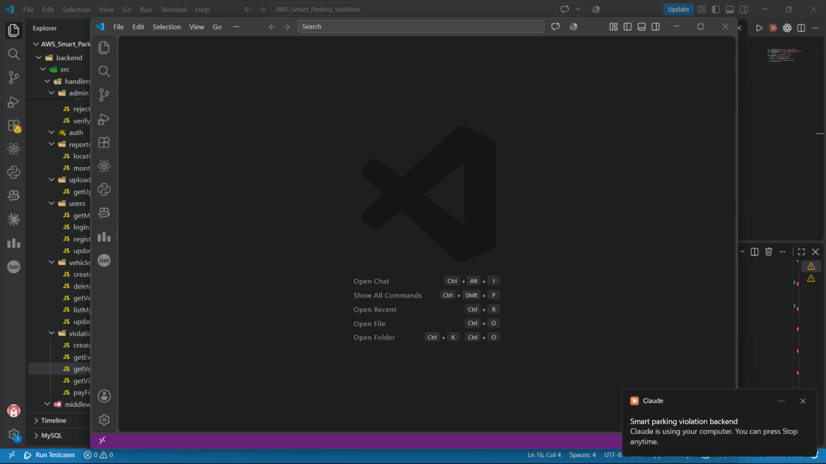
Figure 1: Full backend folder structure in VS Code, showing all handler folders (admin, reports, uploads, users, vehicles, violations).
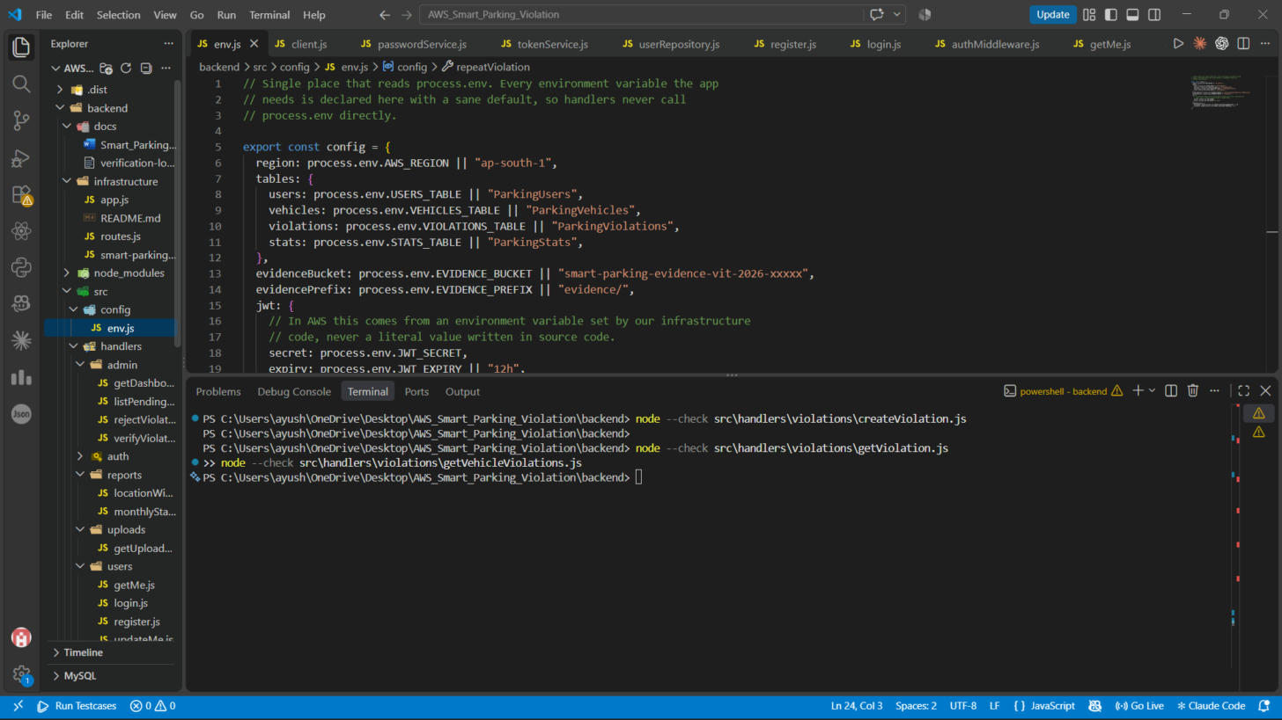
Figure 2: config/env.js — the single place that reads process.env, now updated with the team's real DynamoDB table names and S3 bucket name.

10.2 Admin handlers
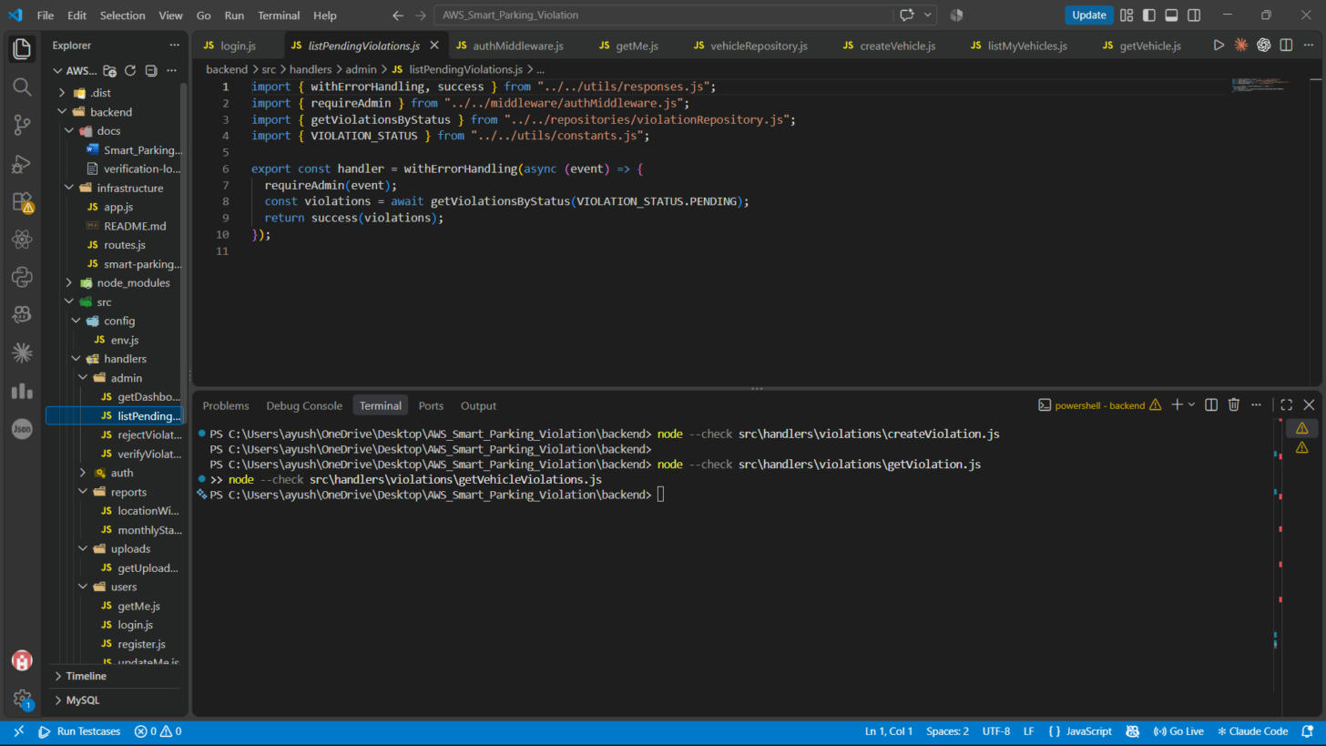
Figure 3: admin/listPendingViolations.js — returns all violations waiting for admin review, using the StatusIndex GSI (no table Scan).
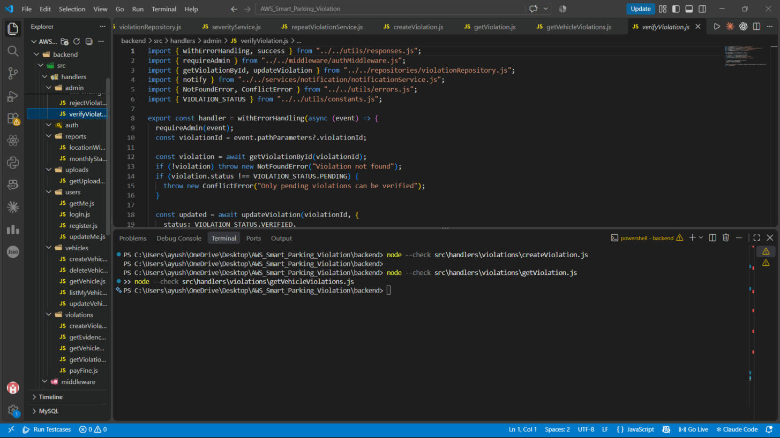
Figure 4: admin/verifyViolation.js — an admin-only endpoint that approves a pending violation, with a Conflict check to stop double-processing.
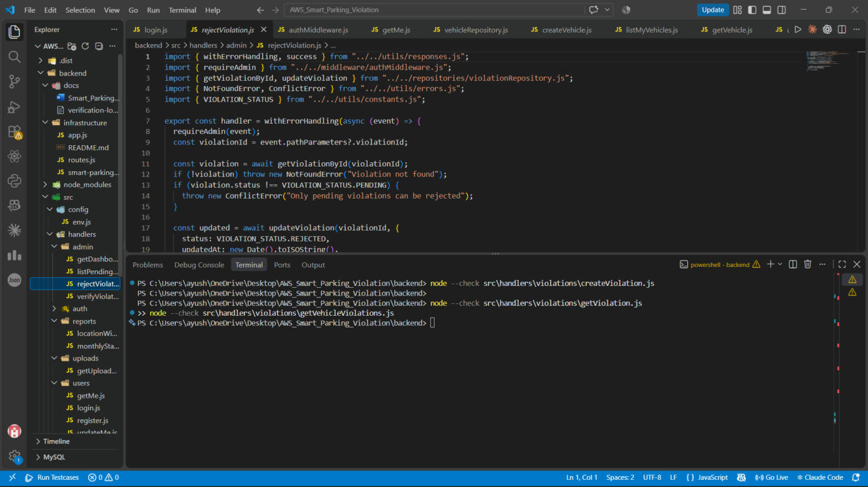
Figure 5: admin/rejectViolation.js — the matching reject path; same ownership and status checks as verify.
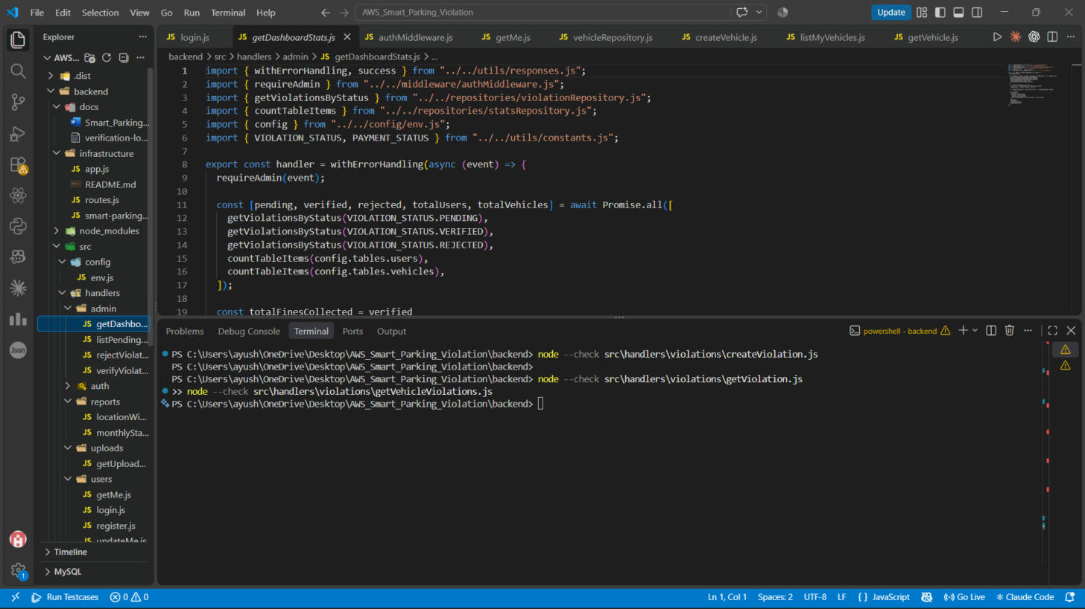
Figure 6: admin/getDashboardStats.js — builds the admin dashboard summary (pending/verified/rejected counts, total fines collected, repeat offender count).

10.3 Reports
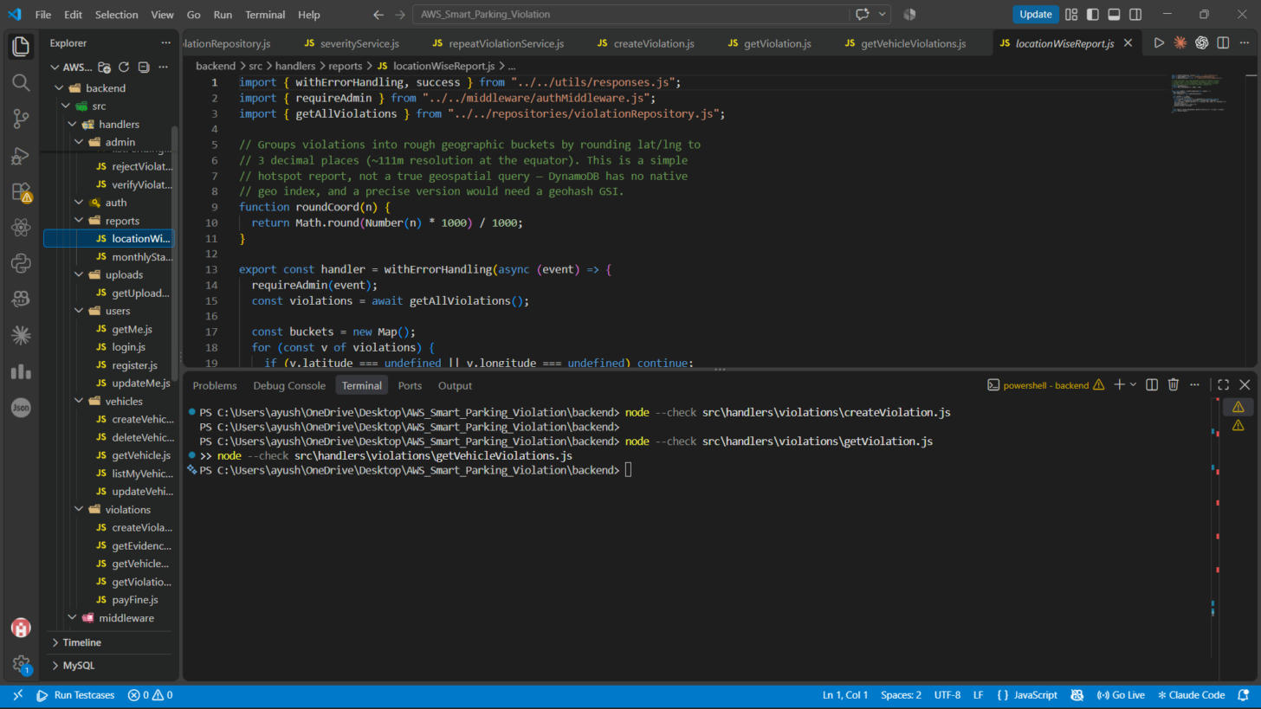
Figure 7: reports/locationWiseReport.js — groups violations into rough geographic buckets for a hotspot report.
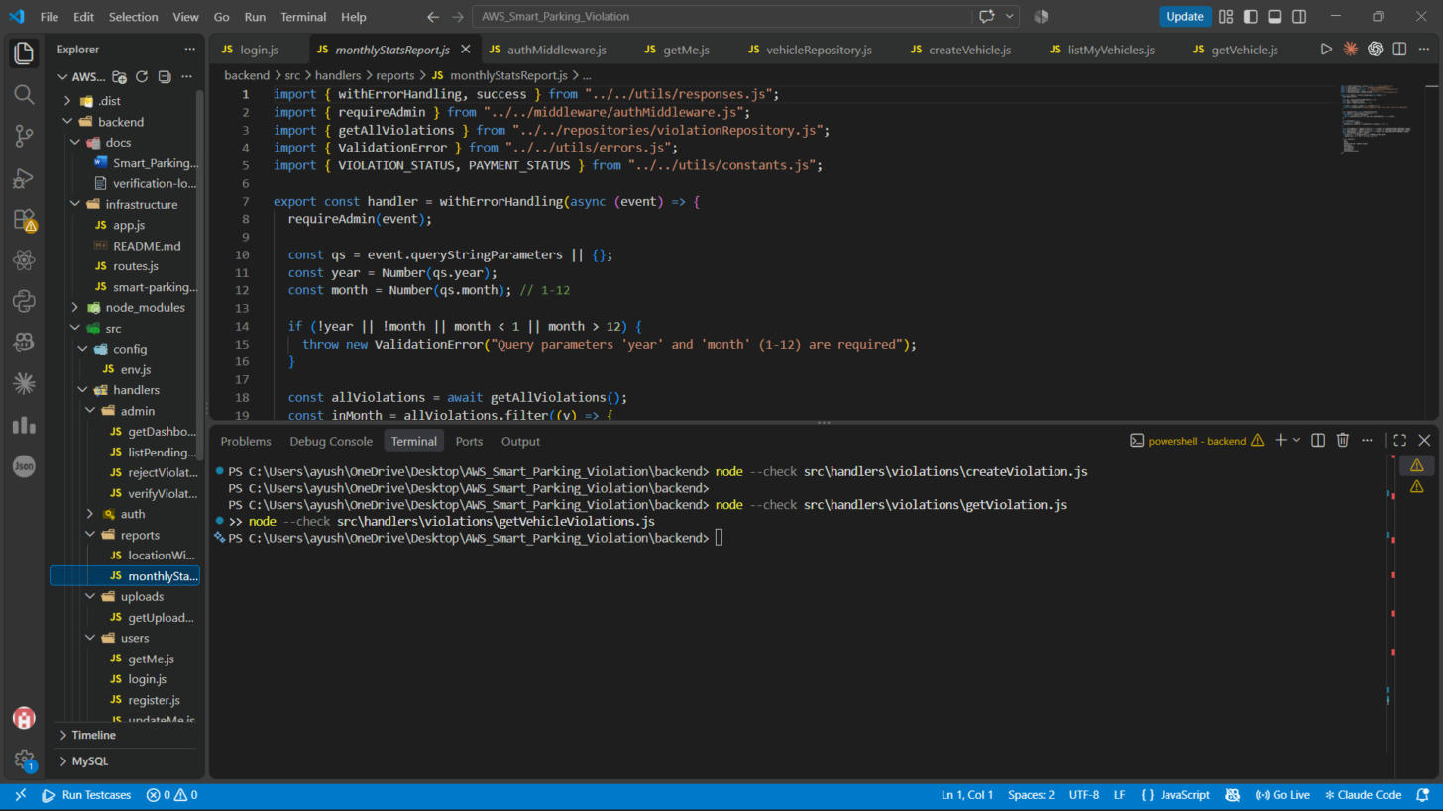
Figure 8: reports/monthlyStatsReport.js — aggregates a given year/month's violations by category and status.

10.4 Evidence photo flow (S3)
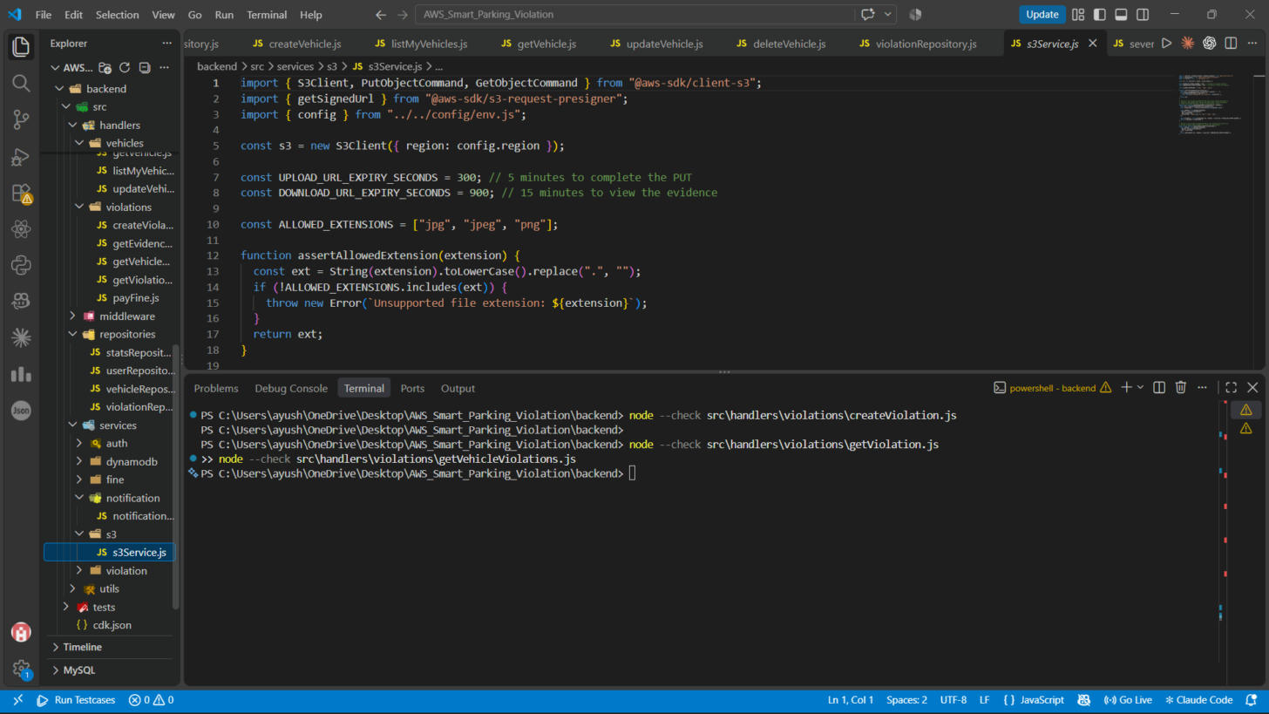
Figure 9: services/s3/s3Service.js — generates presigned PUT and GET URLs for evidence photos, with an allowed-extension check.
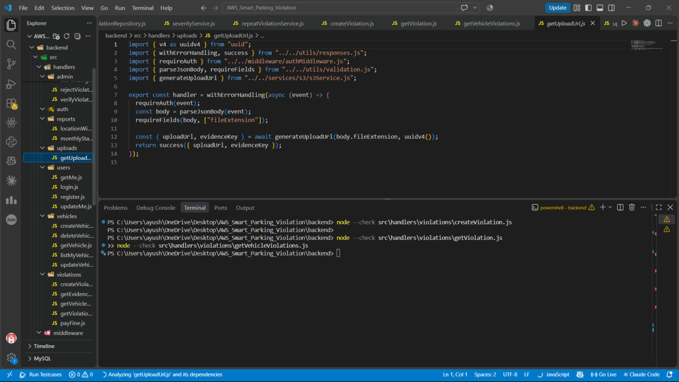
Figure 10: uploads/getUploadUrl.js — the endpoint that calls s3Service to hand the client a presigned upload URL.
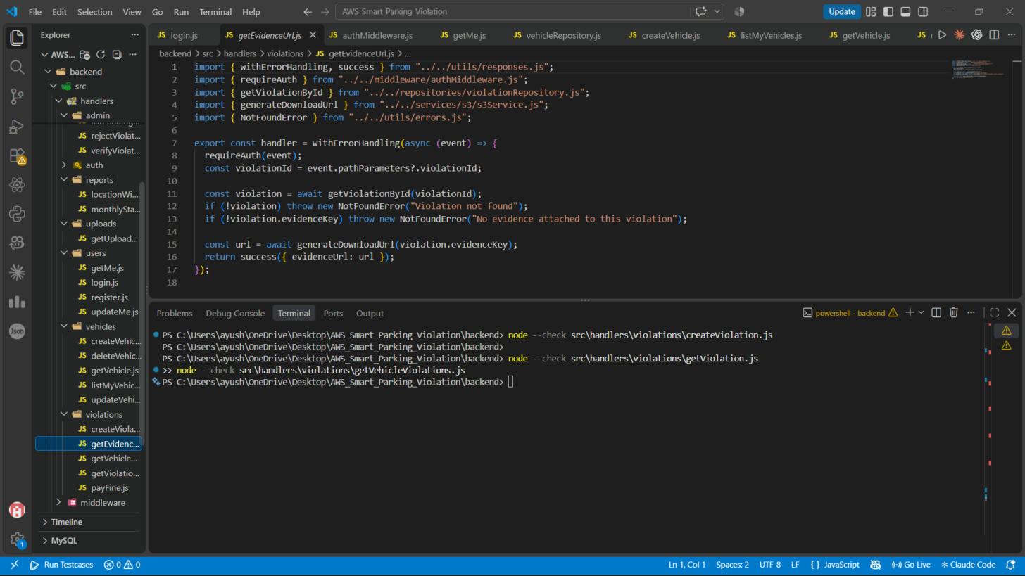
Figure 11: violations/getEvidenceUrl.js — returns a presigned, time-limited GET URL so a client can view an evidence photo.

10.5 Payments and notifications
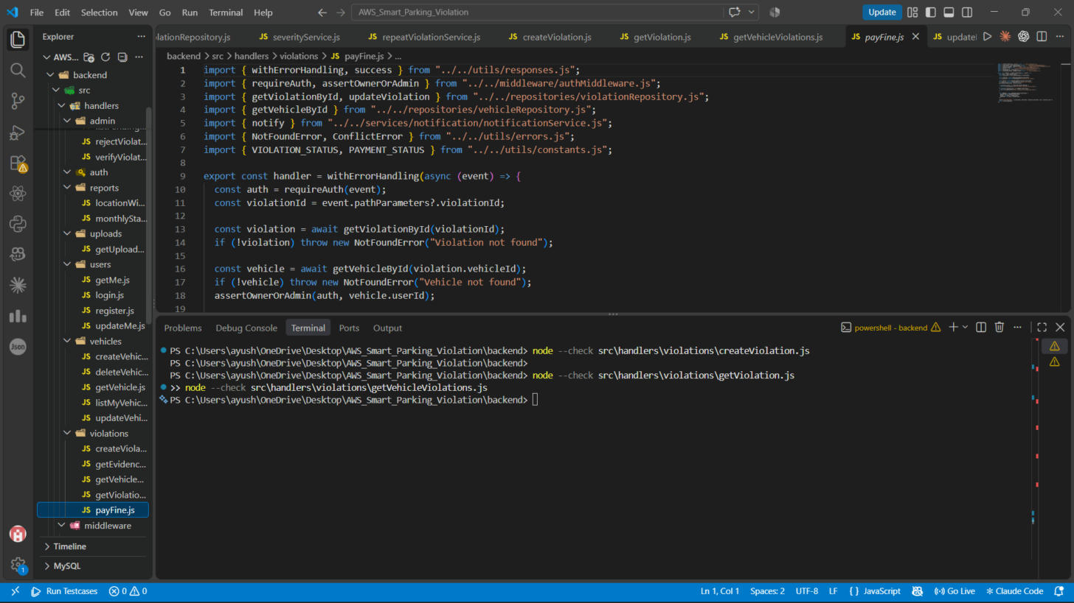
Figure 12: violations/payFine.js — marks a verified violation's fine as paid, with an ownership check.
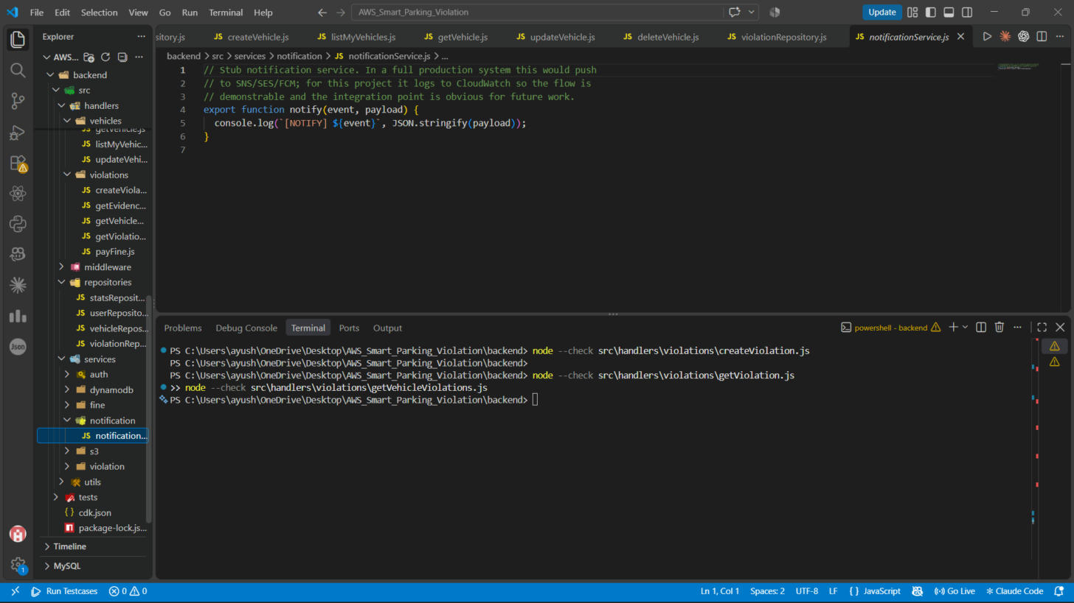
Figure 13: services/notification/notificationService.js — a console.log stub standing in for a real SNS/SES/FCM integration.

10.6 Repositories
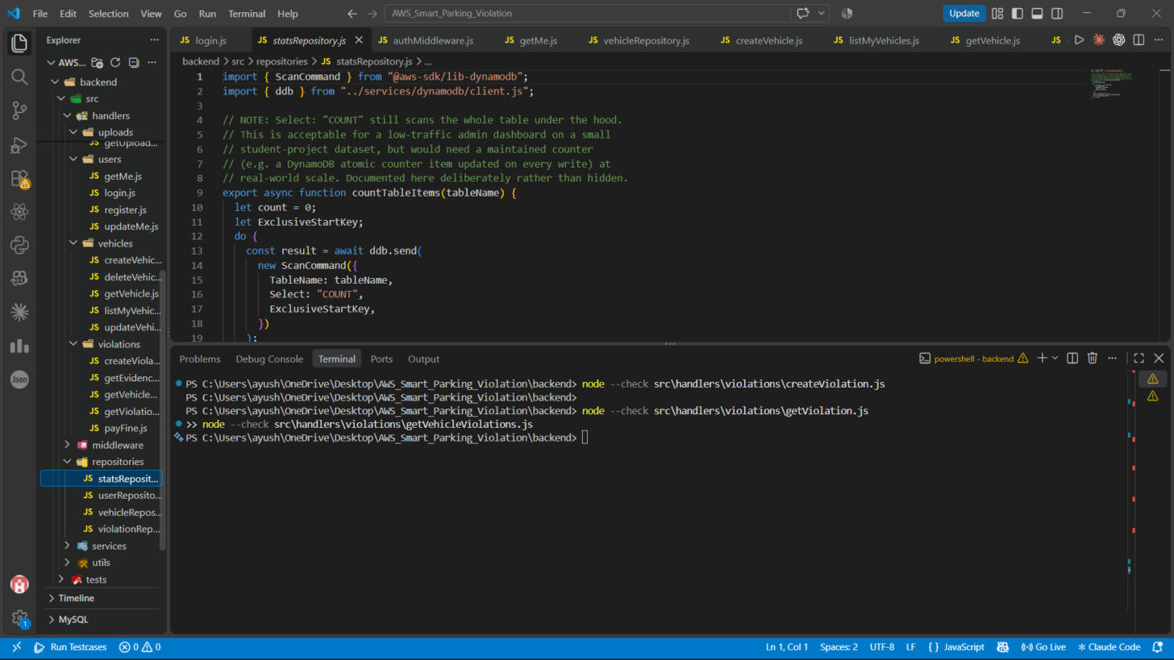
Figure 14: repositories/statsRepository.js — counts items in a table (used for the dashboard's user/vehicle totals).
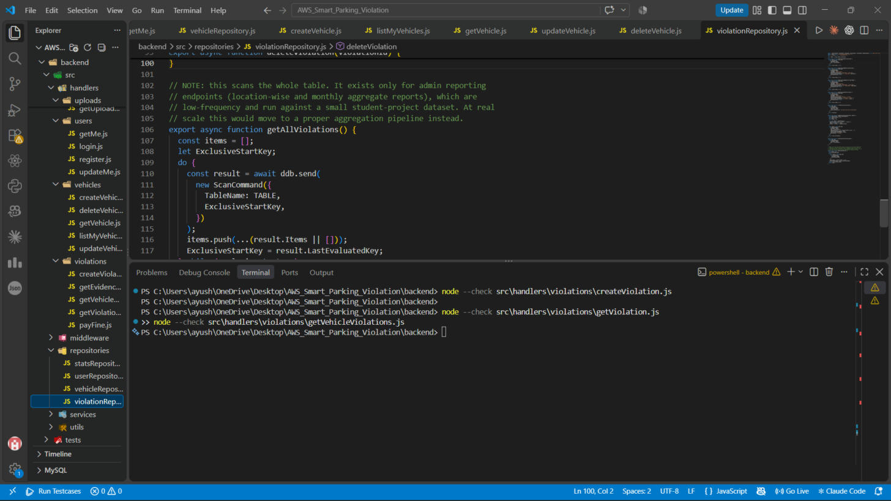
Figure 15: repositories/violationRepository.js — the new getAllViolations() function, with a comment documenting why this one function uses Scan.

10.7 Verification
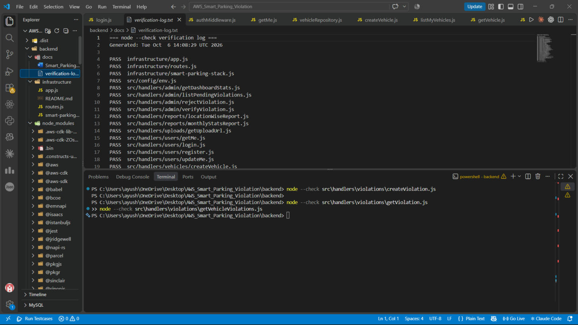
Figure 16: docs/verification-log.txt opened in VS Code — the full PASS list from running node --check against all 41 .js files in the project.

10.8 AWS CDK infrastructure
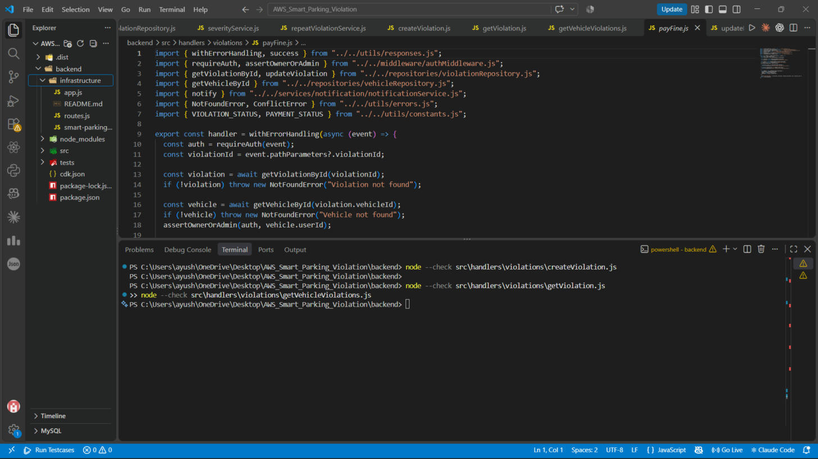
Figure 17: infrastructure/ folder holding the AWS CDK app (app.js, smart-parking-stack.js, routes.js, README.md).
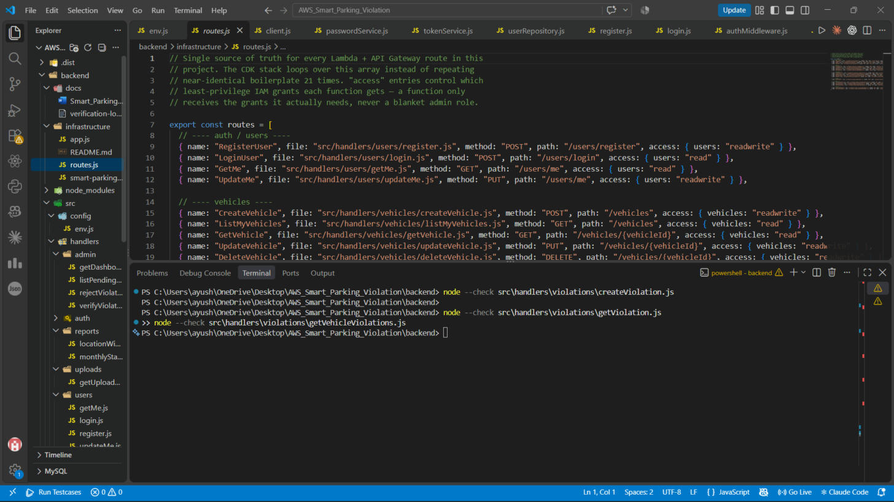
Figure 18: infrastructure/routes.js — the single config array listing all 21 routes and the exact least-privilege access each one's Lambda needs.
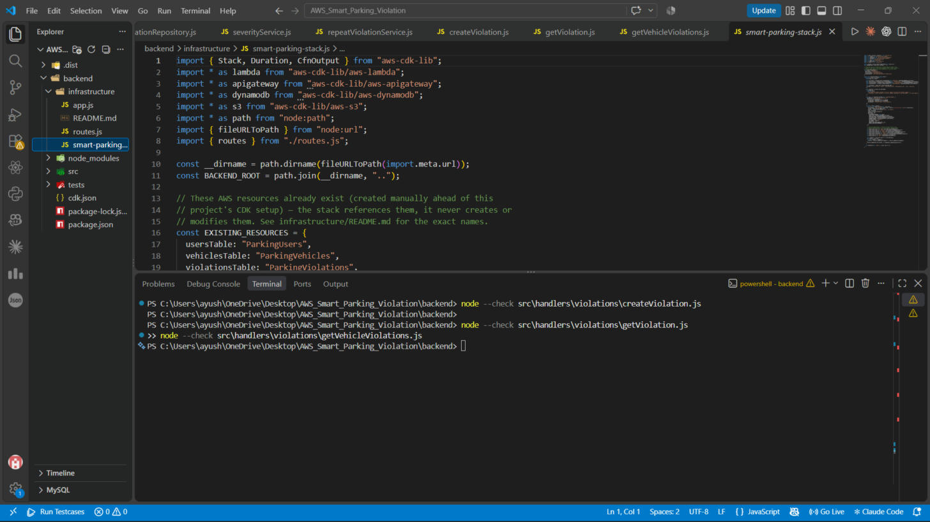
Figure 19: infrastructure/smart-parking-stack.js — the CDK stack referencing the already-existing DynamoDB tables and S3 bucket by name.
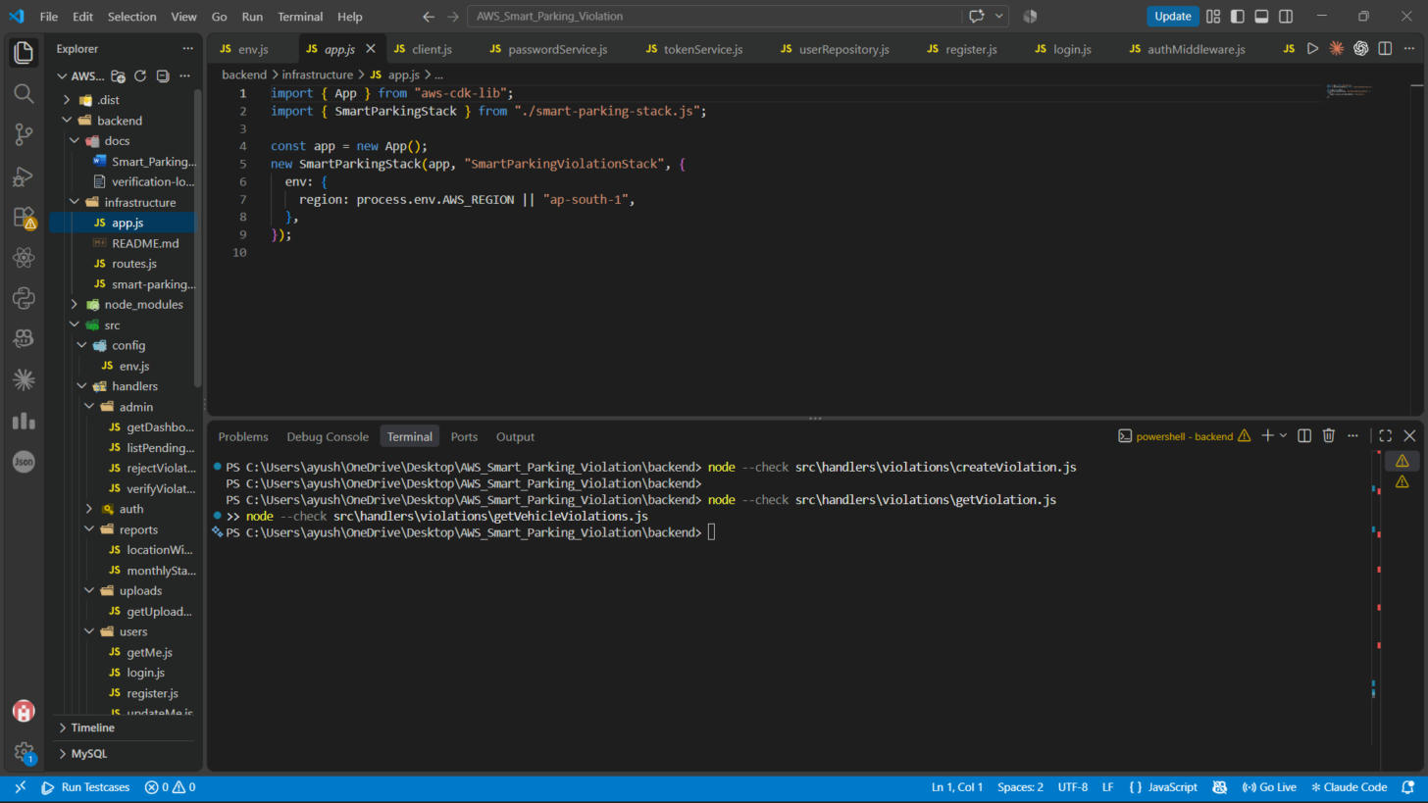
Figure 20: infrastructure/app.js — the CDK app entry point that instantiates the stack.
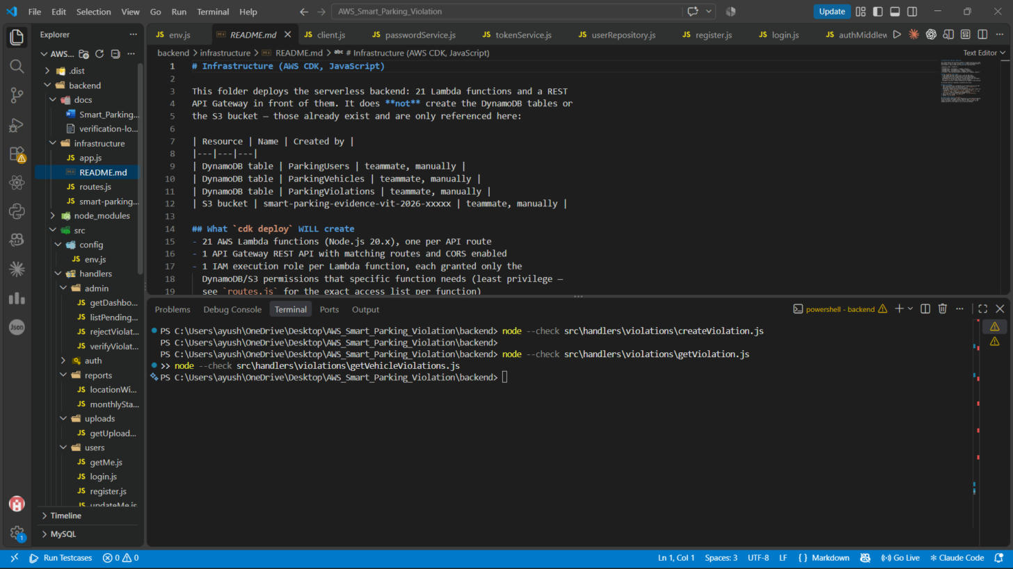
Figure 21: infrastructure/README.md — states plainly what cdk deploy will and will not create, since it must never touch the existing DynamoDB tables or S3 bucket.
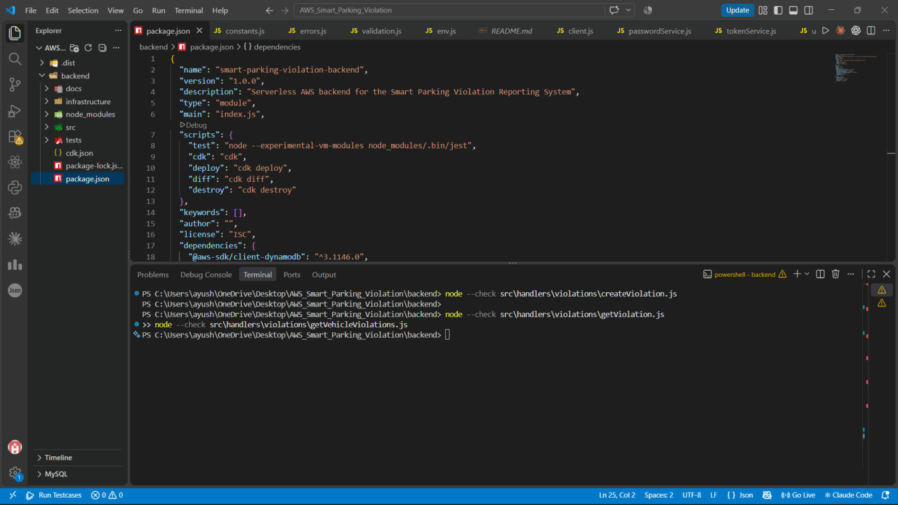
Figure 22: package.json — the added CDK dependencies and the cdk/deploy/diff/destroy npm scripts.
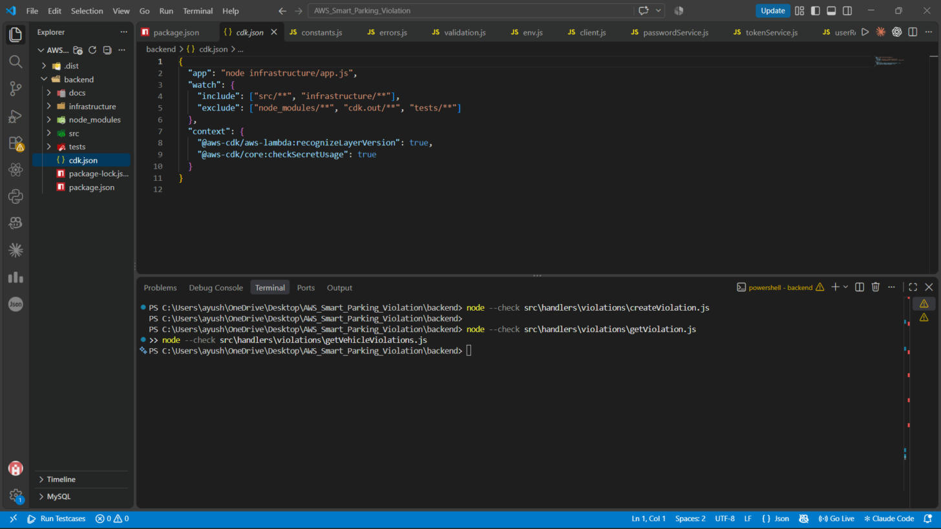
Figure 23: cdk.json — points the CDK CLI at infrastructure/app.js as the entry point.

11. Deployment (AWS CDK)
The infrastructure is defined as code using AWS CDK in JavaScript (infrastructure/ folder), not clicked together manually in the AWS console. Running it creates:
- 21 Lambda functions (Node.js 20.x runtime), one per API route
- 1 API Gateway REST API with all matching routes and CORS enabled
- 1 IAM execution role per Lambda function, scoped to least privilege
- CloudWatch Log Groups (created automatically by Lambda)
It does not create or modify the DynamoDB tables or the S3 bucket, since those already exist.
Steps to deploy (run on a machine with AWS CLI already configured under a personal IAM user, never the root account):
- 1. Set the JWT secret: $env:JWT_SECRET = "<a long random string>" (PowerShell)
- 2. npm install (installs aws-cdk-lib and constructs)
- 3. npx cdk bootstrap (first time only, per AWS account/region)
- 4. npx cdk diff (review exactly what will be created before touching AWS)
- 5. npx cdk deploy (creates the resources listed above)
This last step was deliberately left for manual review rather than run automatically, since it creates real AWS resources and billing should always be a conscious decision.

12. Known Limitations
- Auth is a simplified custom JWT layer, not Cognito: no refresh tokens, no MFA, no password reset.
- Two reporting endpoints use a DynamoDB Scan, which does not stay cheap at a very large scale.
- Payment is just a status flag (UNPAID -> PAID); there is no real payment gateway integration.
- Notifications are a console.log stub meant to show where a real SNS/SES/FCM integration would plug in.
- The vehicle-number regex is a loose pattern and will not match every real Indian registration format.
These are documented tradeoffs made consciously for a college project timeline, not oversights.

