**Dharmsinh Desai University,**

**Nadiad**

**Faculty of Technology**



**Department of Computer Engineering**

B. Tech. CE Semester – VI

**Subject**: System Design Practice

**Project** **Title**: NGO System

**By:**

**Ayushi Tikoo** : ID:17CEUOG130 Roll No:CE-007

**Ashwini Dhandhuki**a : ID:17CEUOS122 Roll No:CE-028

**Guided By:**

Asst. Prof. Sheetal Shah,

Department of Computer Engg.

Faculty of Technology



**Dharmsinh Desai University, Nadiad**

Faculty of Technology, Department of Computer Engineering

**CERTIFICATE**

This is to certify that System Design Practice Project entitled “**NGO System”**

**1)Ayushi Tikoo(17CEUOG130)**

**2)** **Ashwini Dhandhukia (17CEUOS122)**

of Department of Computer Engineering ,Semester VI , academic year 2019-2020, under our supervision and guidance.

|  |  |  |
| --- | --- | --- |
|  |  |  |
| **Guide** |  | **HOD** |
| **Asst.Prof. Sheetal Shah**  Assistant Professor Department of Computer Engineering, Dharmsinh Desai University, Nadiad |  | **Dr. C. K. Bhensdadia**  Head of Department Computer Engineering, Dharmsinh Desai University, Nadiad |

**Contents**

**1) Abstract** --------------------------------------------------------------------------------4

**2) Introduction** - -------------------------------------------------------------------------5

**3) Software Requirement Specifications** -------------------------------------------7

**4) Design** ----------------------------------------------------------------------------------9

* + 1. Use Case Diagrams
    2. Class Diagrams
    3. Sequence Diagrams
    4. Activity Diagrams
    5. State Diagrams
    6. E-R Diagrams
    7. Data Dictionary

**5) Implementation Detail**------------------------------------------------------------21

1. Modules created and brief description of each module
2. Function prototypes which implements major functionality

**6) Testing**---------------------------------------------------------------------------------23

**7) Screen-shots** -------------------------------------------------------------------------24

**8) Conclusion**----------------------------------------------------------------------------32

**9) Limitation and Future Extension** -----------------------------------------------32

**10) Bibliography**------------------------------------------------------------------------32

Abstract

The project report upon the “**NGO System**” will provide various event information and one can donate with this website.

It is a system that enables users to check for different event available at the website and can register his/her self for volunteering on the site. He may even donate through a debit card/credit card. Once the donor makes an effective transaction he gets confirmation of donation. Donor can also donate other things like books, dresses, food etc. for that they can also send pickup request to NGO. One can also get location of our centers through map.

**Introduction**

* 1. **PROJECT OVERVIEW:**

The project comprises the list of available events displayed on different dates. He can even pay through a credit card or debit card. Once the donor makes an effective transaction he gets a confirmation message.

* 1. **PURPOSE: GOALS & OBJECTIVES**

The purpose of this project is to develop the user friendly and interactive website which will allow the user to donate online. user will be able to search and can send request for volunteering and can donate in terms of online Payments through Credit card/debit card and Get the confirmation message.

The main purpose of this project is giving flexibility to the Information as this website plays main role at admin side. Without login or any Customer, who have not idea about event, They easily Find and register themselves. Anyone will be able to open this site and get the information about the event details and can see achievements of NGO.

* 1. **SCOPE**

The aim of the project is to build a simple, effective computerized NGO system along with displaying the information of any types of query of event information in my web application.

**Functions for user**

* Registration
* Login
* Search event date and place wise
* Request for volunteering
* Donate money/other things
* Go For Checkout
* Edit account information
* Add Feedback

**Functions for the Admin**

* Admin Login
* Manage All volunteer
* Manage event details
* View transaction/donated amount
* Reply to feedback
* **Software requirement :**
* Operating System : Microsoft Windows 7/8 or higher
* Language: node js , Express js
* Front End: HTML, CSS, JavaScript , Bootstrap , JQuery
* Back-End : Node.js, Express js, phpMyAdmin
* Designing Tool : Xampp
* Documentation Tool: Ms-Word 2016, ERD Plus,Umlet

**Software Requirement Specification for NGO System**

Types of users:

-Admin

-Client

Client-

R1. Registration

Description: user enters personal details like name, email, phone number, address, Password

Input - Details are entered

Output - Successfully registered message

R2. Login

Description: user enters email and password

Input - Details are entered

Output - Successfully login message

R3. Manage donation

R3.1. Donation

Description: user enters type of donation(money or materialistic item),

Name, email,phone number

Input-details are entered

Output-payment page (if money is donated)

R3.2.Payment

Description: user enters card name, card number, CVV and expiry date

Input-Details are entered

Output- confirmation message: Payment done successfully

R4. Apply as volunteer

Description: user can apply as volunteer in different events organized by ngo

by entering name, email, phone number, address

Input - Details are entered

Output – confirmation message will be displayed

R5.Get Help

Description: description about problem is entered, name, phone number(optional),email

Input-details are entered

Output-Message sent

R6.Write to us

Input-user can give feedback or suggestions

Output-Message sent

ADMIN-

R1.Login

Description: user enters email and password

Input-Details are entered

Output-Successfully login message

R2. Manage event

Description-admin can add, update and delete event details

R2.1.Add event

Input-event details like title,place, date, description, guest name

Output-event added successfully

R2.2.Delete event

Input-User selection

Output-event deleted successfully

R2.3.update event information

Input- event details

Output-event information updated successfully

R3. Manage volunteer

Description-admin can choose and see volunteer details

Input-user selection

Output-confirmation message sent.

R4.display donation

Description-admin can see donor's details and their contribution.

Input-user selection

Output-list of doners.

**Design**

**1) use case diagram Admin side:-**

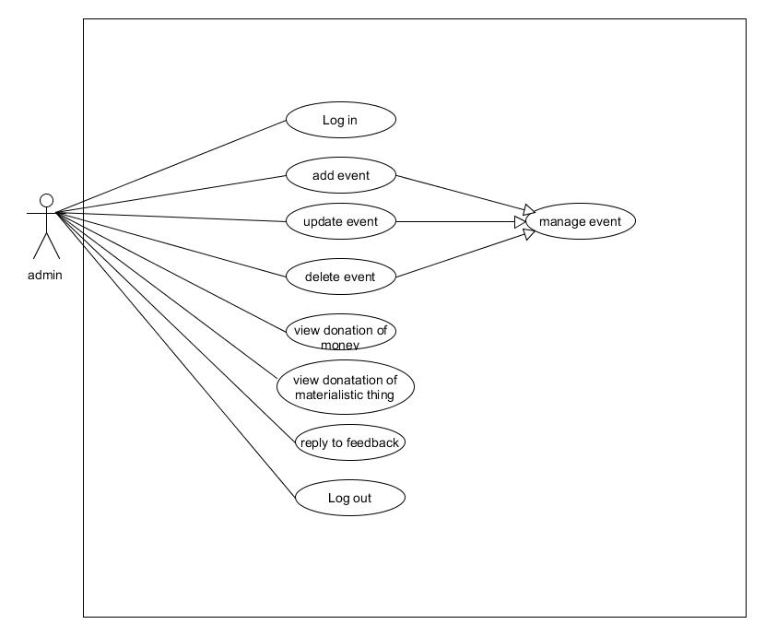

**User side use case diagram:-**

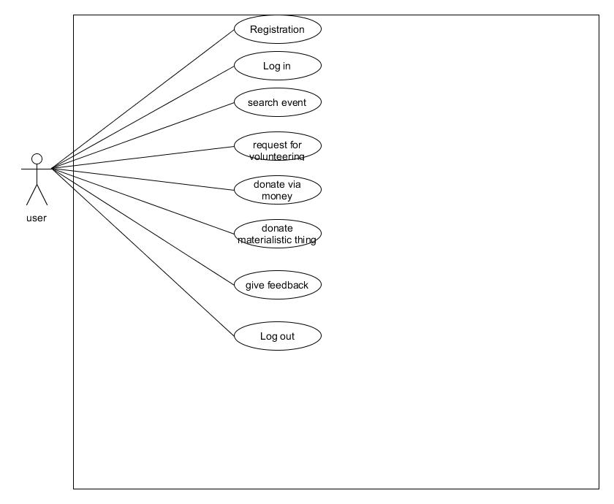

2) **Class Diagram:-**

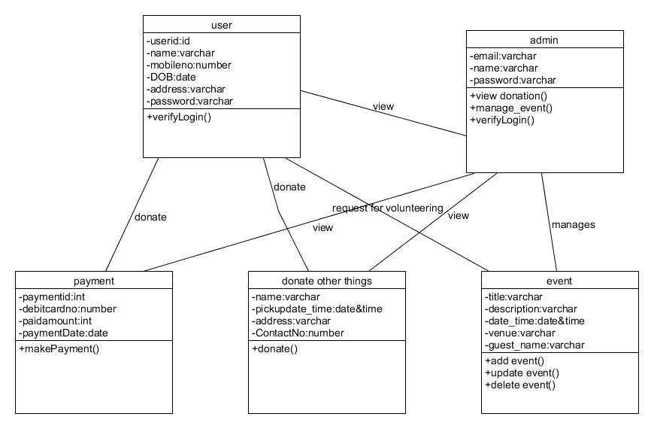

**3) Sequence diagram:-**

## Types of Messages in Sequence Diagrams

**Synchronous Message**  
A synchronous message requires a response before the interaction can continue.

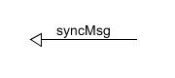

**Asynchronous Message**  
Asynchronous messages don't need a reply for interaction to continue.

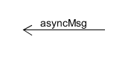

**Reply or Return Message**  
A reply message is drawn with a dotted line and an open arrowhead pointing back to the original lifeline.

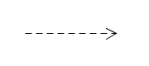

**Self Message**  
A message an object sends to itself, usually shown as a U shaped arrow pointing back to itself.

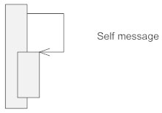

**For login process-**

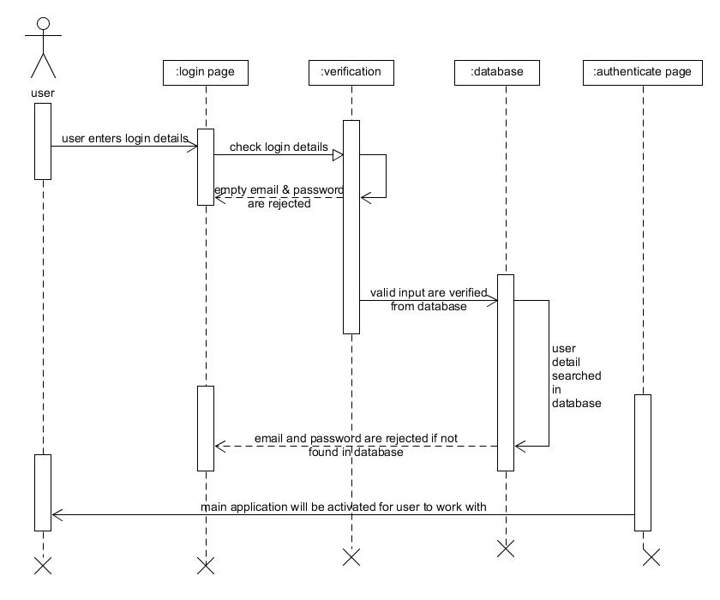

**For donate money(payment)process :**

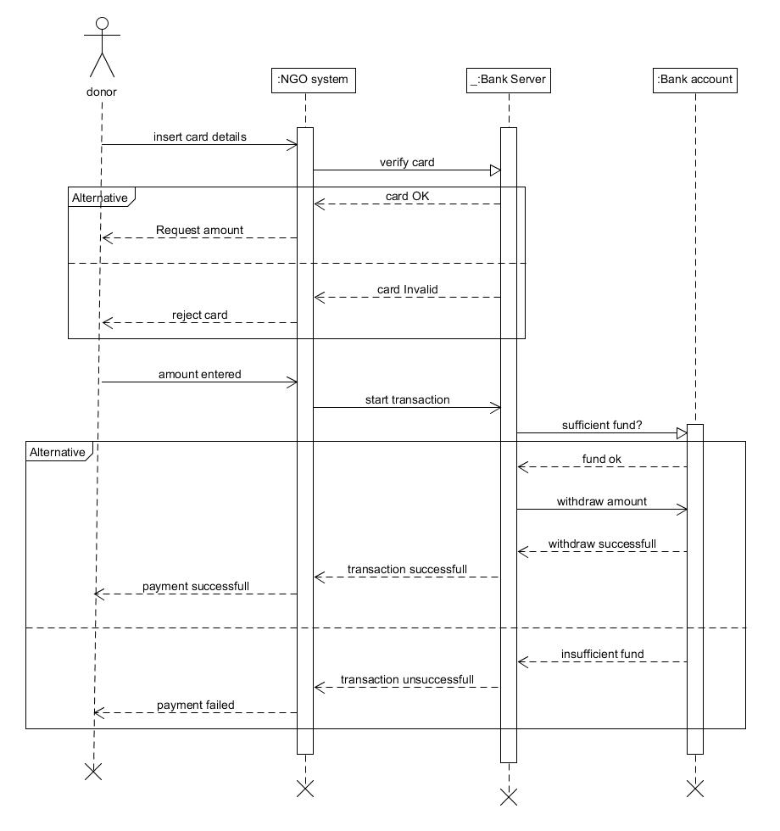

**4) Activity diagram:-**

**Admin side-**

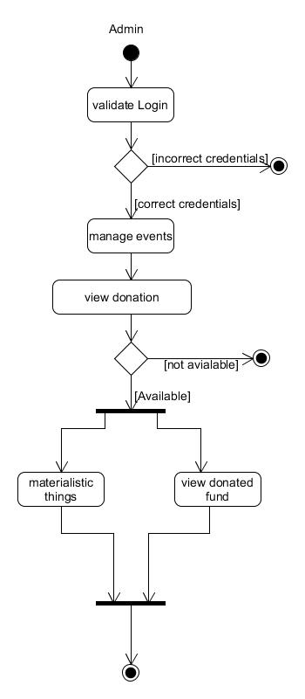

**User side activity diagram-**

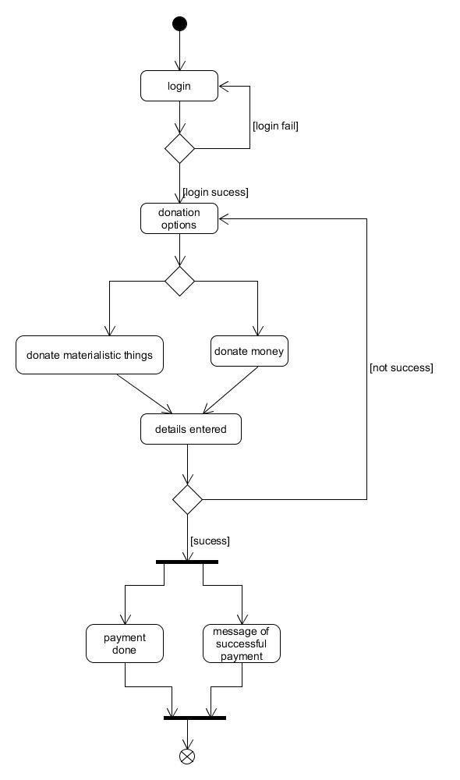

**5) State diagram:-**

**For manage_event-**

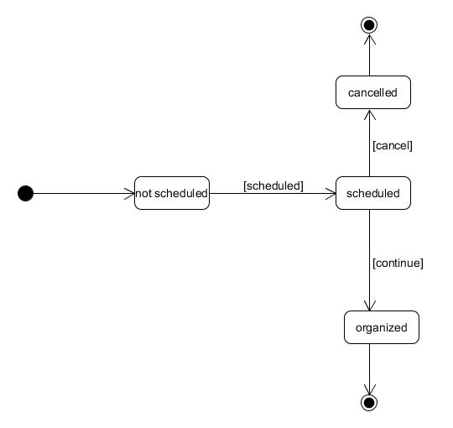

**For volunteering event-**

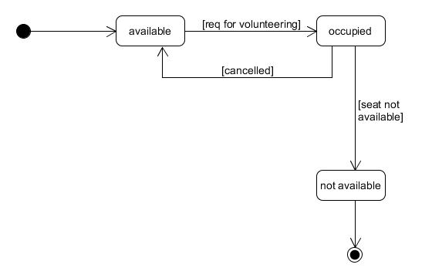

**6)ER-Diagram:-**

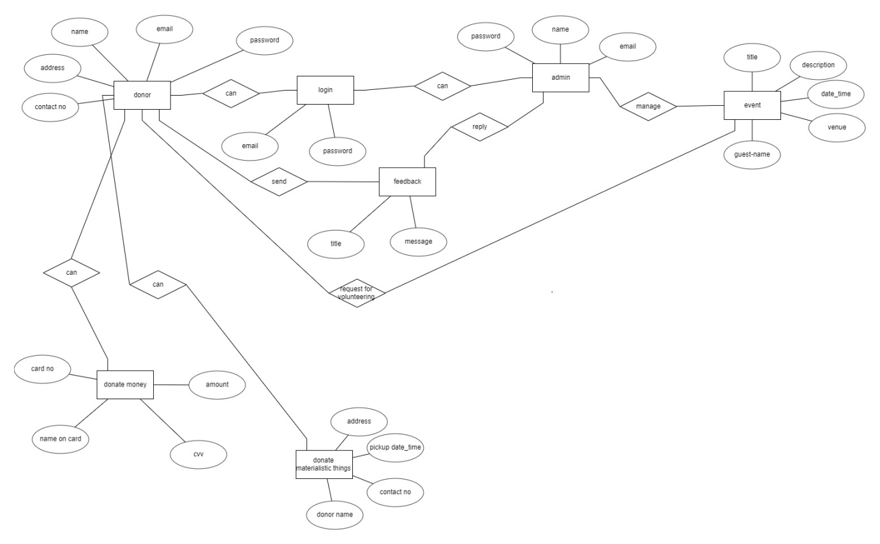

**7)Data Dictionary**

|  |  |  |  |  |  |  |
| --- | --- | --- | --- | --- | --- | --- |
| volunteer | | | | | | |
| Sr no | name | Datatype | size | required | Unique | PK/FK |
| 1 | id | Int | 11 | Auto_increment | yes | Primary key |
| 2 | Name | Varchar | 100 | - |  |  |
| 3 | Mobile | Varchar | 10 | - |  |  |
| 4 | Email | Varchar | 100 | - |  |  |
| 5 | eName | varchar | 200 | - |  | Foreign key |

|  |  |  |  |  |  |  |
| --- | --- | --- | --- | --- | --- | --- |
| mdonar | | | | | | |
| Sr no | name | datatype | size | required | unique | PK/FK |
| 1 | Id | Int | 200 | Auto_increment | yes | primarykey |
| 2 | Email | Varchar | 100 |  |  |  |
| 3 | sName | Varchar | 100 |  |  |  |
| 4 | sMobile | Varchar | 10 |  |  |  |
| 5 | sAddress | Varchar | 300 |  |  |  |
| 6 | sCity | Varchar | 100 |  |  |  |
| 7 | sState | Varchar | 100 |  |  |  |
| 8 | sDate | Date |  |  |  |  |
| 9 | Donationtype | varchar | 200 |  |  |  |

|  |  |  |  |  |  |  |
| --- | --- | --- | --- | --- | --- | --- |
| feedback | | | | | | |
| Sr no | name | dataType | size | required | unique | PK/FK |
| 1 | Id | Int | 100 | Auto increment | yes | primarykey |
| 2 | Email | Varchar | 100 |  |  |  |
| 3 | Category | varchar | 100 |  |  |  |
| 4 | comments | varchar | 200 |  |  |  |

|  |  |  |  |  |  |  |
| --- | --- | --- | --- | --- | --- | --- |
| Event | | | | | | |
| Sr no | name | datatype | size | required | unique | PK/FK |
| 1 | Id | Int | 200 | Auto increment | yes | primarykey |
| 2 | eName | Varchar | 200 |  |  |  |
| 3 | eLocation | Varchar | 200 |  |  |  |
| 4 | eTime | time | 6 |  |  |  |
| 5 | eDate | Date |  |  |  |  |
| 6 | eDescription | varchar | 400 |  |  |  |

|  |  |  |  |  |  |  |
| --- | --- | --- | --- | --- | --- | --- |
| donar | | | | | | |
| Sr no | name | datatype | size | required | unique | PK/FK |
| 1 | Id | Int | 200 | Auto increment | yes | Primary key |
| 2 | cName | Varchar | 200 |  |  |  |
| 3 | cEmail | Varchar | 200 |  |  |  |
| 4 | cMobile | Varchar | 10 |  |  |  |
| 5 | cAddress | Varchar | 200 |  |  |  |
| 6 | cCity | Varchar | 200 |  |  |  |
| 7 | cState | Varchar | 200 |  |  |  |
| 8 | cZip | Int | 6 |  |  |  |
| 9 | Donation type | Varchar | 200 |  |  |  |
| 10 | cAmount | int | 200 |  |  |  |

|  |  |  |  |  |  |  |
| --- | --- | --- | --- | --- | --- | --- |
| customerInfo | | | | | | |
| Sr no | name | datatype | size | required | unique | PK/Fk |
| 1 | Id | Int | 100 | Auto increment | yes | primarykey |
| 2 | Email | varchar | 100 |  |  |  |
| 3 | cName | Varchar | 100 |  |  |  |
| 4 | cMobile | Varchar | 100 |  |  |  |
| 5 | cPassword | varchar | 100 |  |  |  |

**Implementation Details**

**i)Modules created and brief description of each module**

**CLIENT SIDE-**

**Routes and Views**

* **Dashboard-** after user logins into the system then this page is displayed showing all the options available to him. Feedback, Donation and Event Registration.
* **DonarC-** user can donate money by filling up the form and providing details about himself and the money he wants to donate. Donation can only be done via card
* **FeedbackC-** user can give feedback by filling up the form providing email , category in which he wants to give feedback and comments.
* **FrontPage-** It’s the very first page which will be displayed to the user when he starts the application.
* **LoginC-** Display the login and registration form to the user. User needs to register himself first into the system and then login in.
* **EventsC-** All the events that will be organised by the ngo will be displayed and the user can also enrol himself into any of them by registering.
* **DonarMC-** The users who want to donate other materialistic things can donate here in this form . It displays a form asking for users details and the donation type. The material will get picked up from the users home by our agents on the date specifies by him.
* **Thanks-** page for thanking the donar for providing donation(money).
* **ThanksEventRegister-** Thanking the user for participating in the event.
* **ThanksFeedback-** Thanking the user giving us it valuable feedback.

**ADMIN SIDE-**

**Routes and Views**

* **Customer-**handles insertion , deletion and Displaying of users of the system
* **Donar-** Displays all the Donars to the admin.
* **Feedback-** Displays the feedback of the donars, volunteers and users.
* **Index-** Handles admin Login.
* **Index1-** Displays all the options available to the admin after logging in like view feedback , donar, users and manage events.
* **Login-** Form for the admin to login by providing the email and password.
* **Events-** Admin can manage all t.he events. He can insert any new event by providing all its details. Any event can be deleted and edited by him.
* **DonarM-** Displays all the materialistic things donars of the system along with the things they want to donate.
* **Volunteer-** Displays all the volunteers of the ngo of various events. And can also remove them.

**Testing**

Unit and integration testing are used.

* **unit testing** – testing our application code and logic. This is anything that our code actually does and is not reliant upon external services and data to accomplish.
* **integration testing** – testing our application as it connects with services inside of our application. This could include connecting different parts of application, or connecting two different applications in a larger umbrella project.

**Screenshots**

**USER-**

**Front page :**

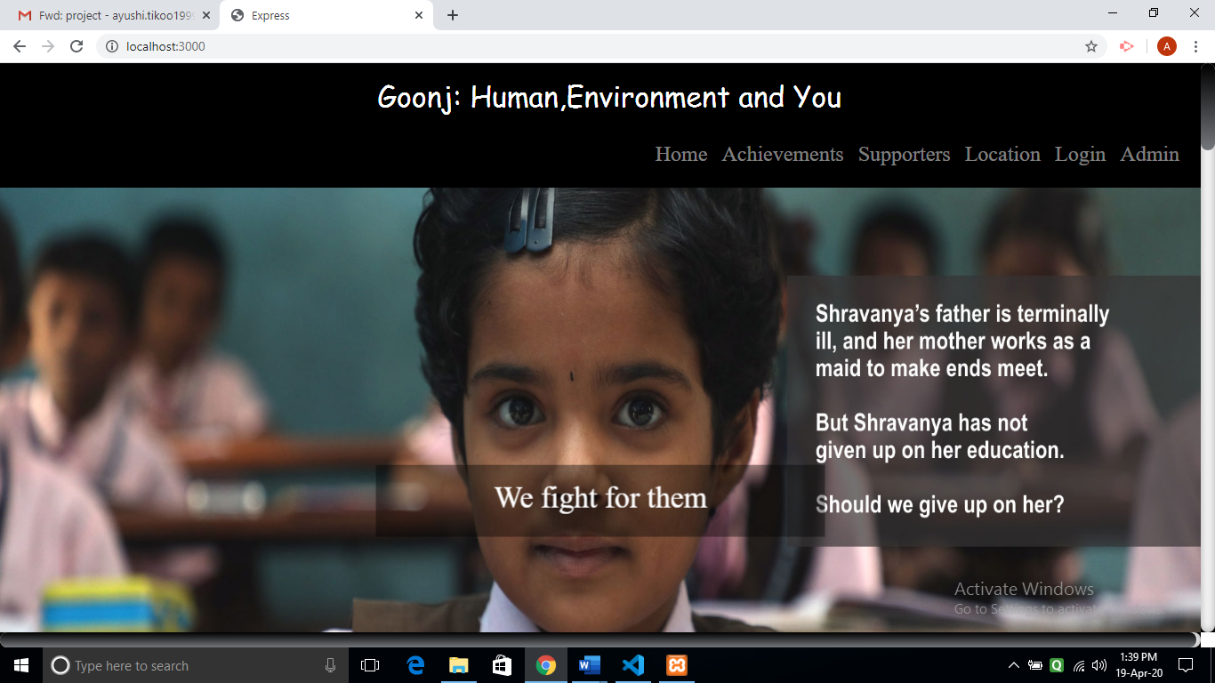

**Login Registration page for user :**

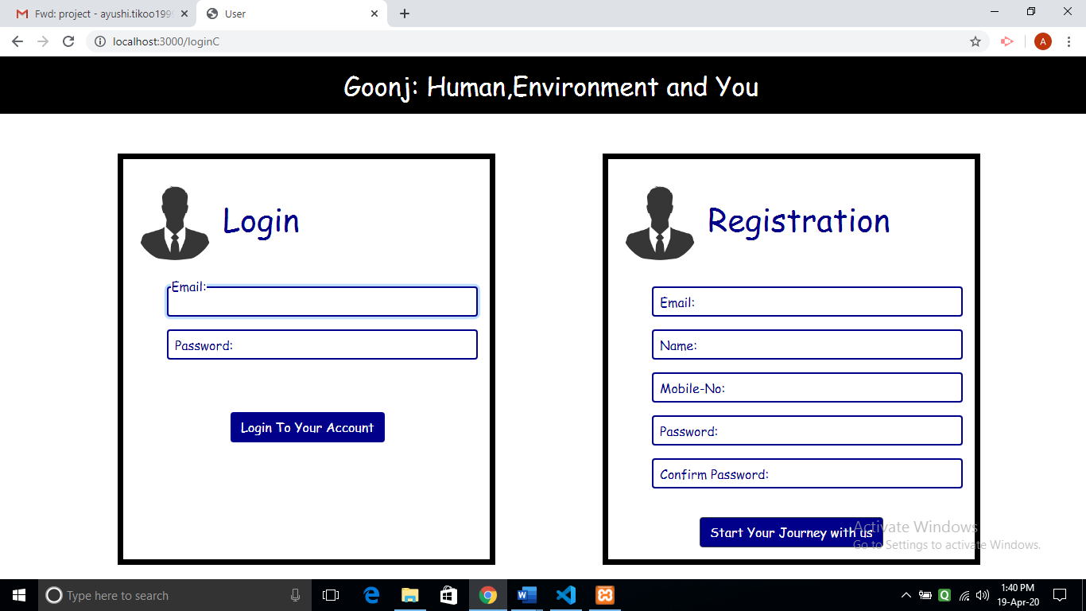

**Money donation :**

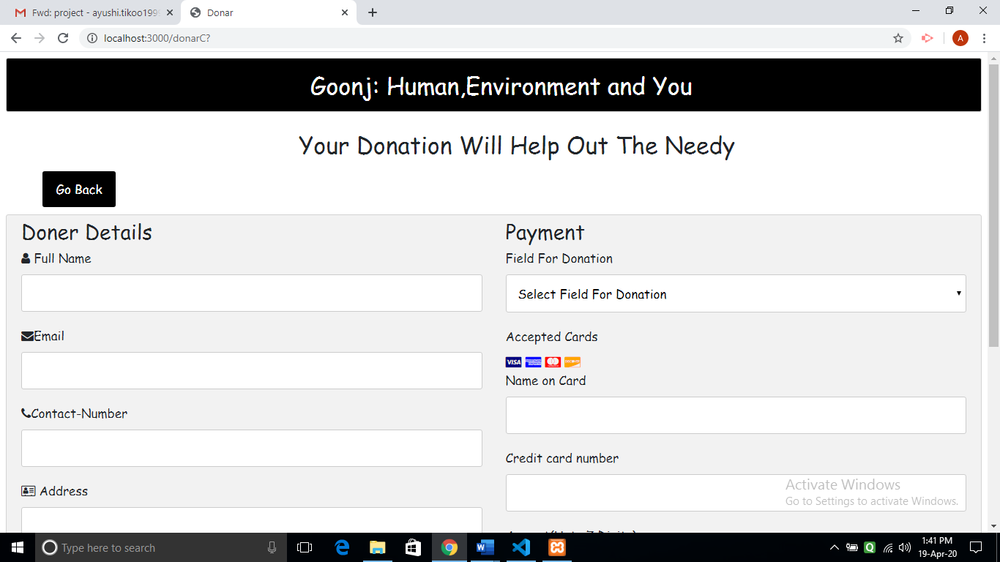

**To donate materialistic things :**

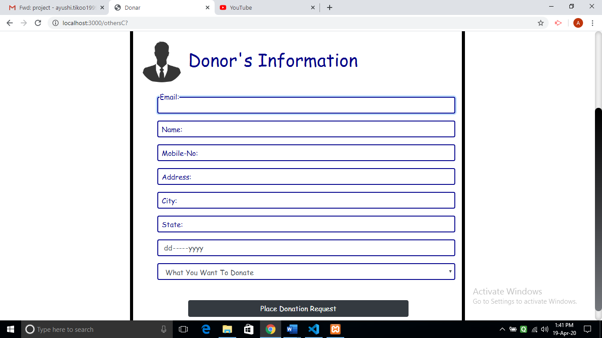

**Feedback form :**

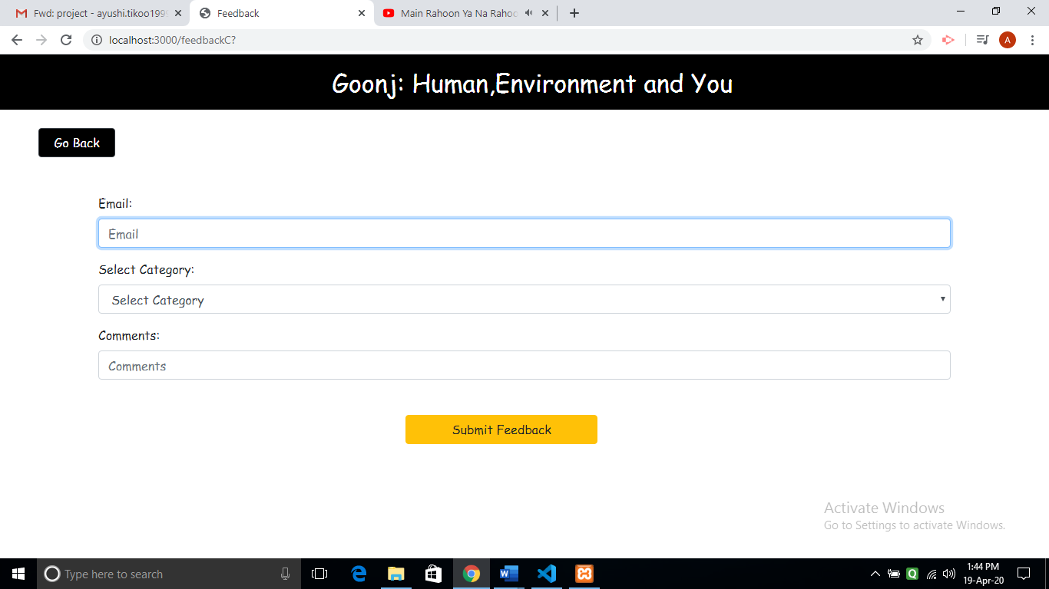

**View Events :**

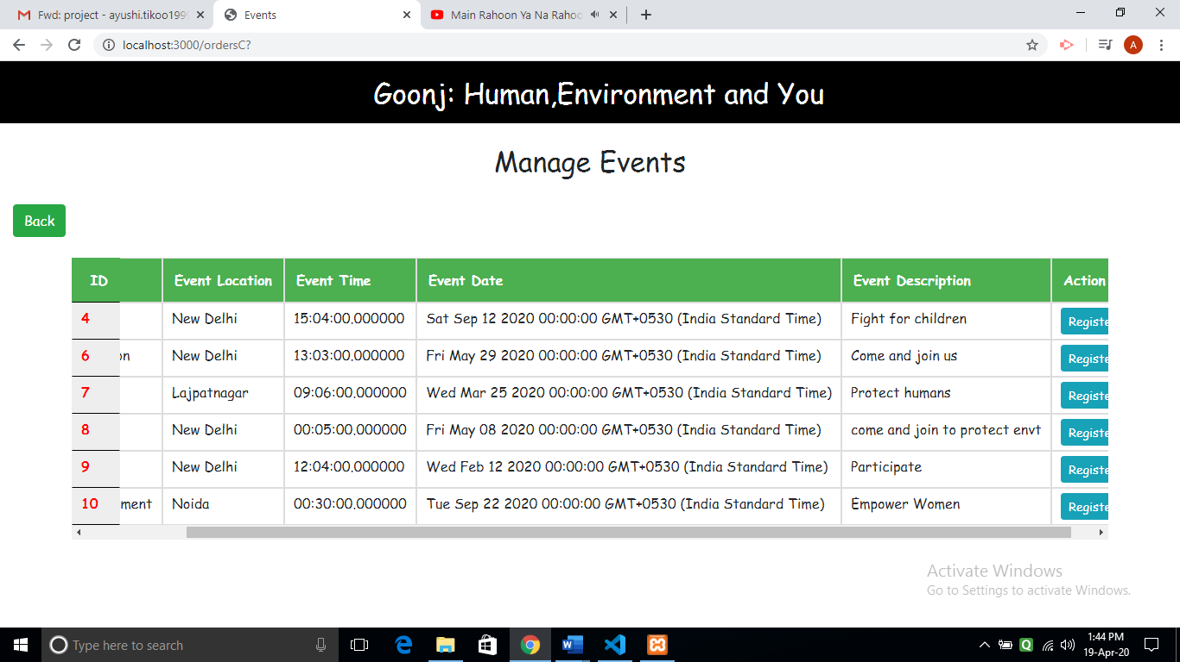

**Participate in event form :**

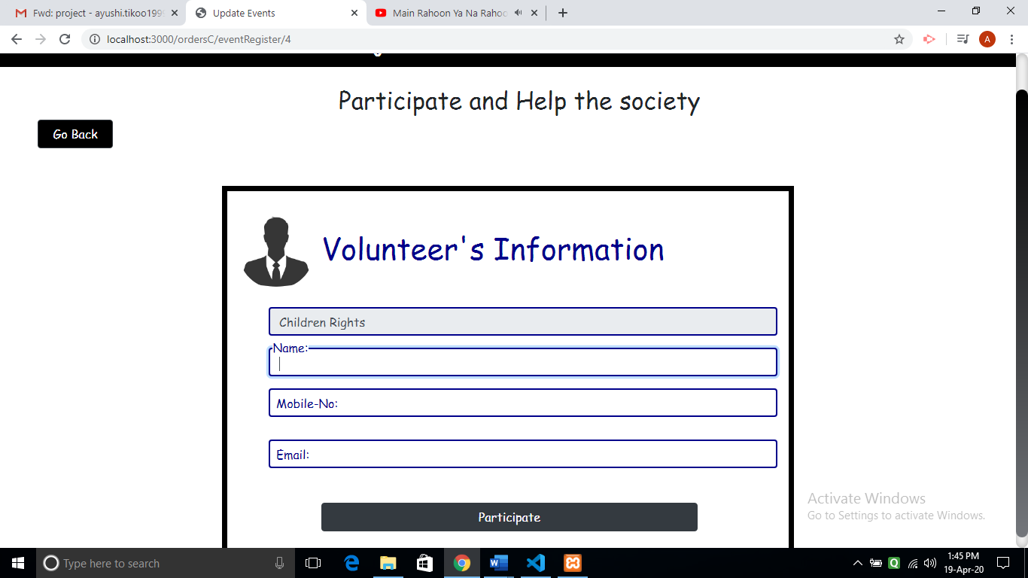

**ADMIN-**

**Welcome Page for admin :**

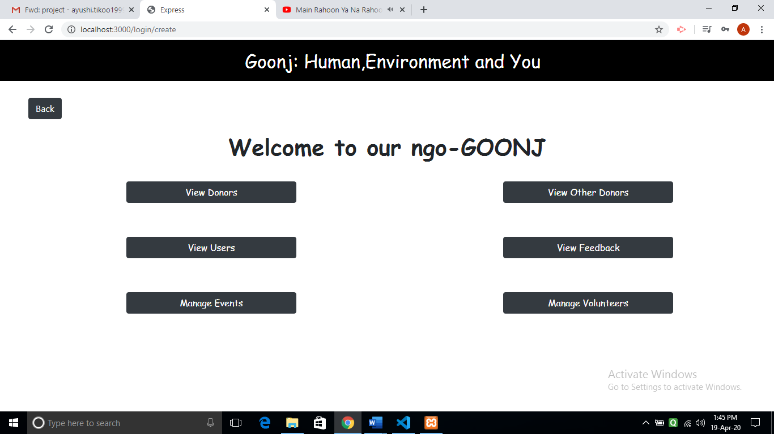

**View Donor :**

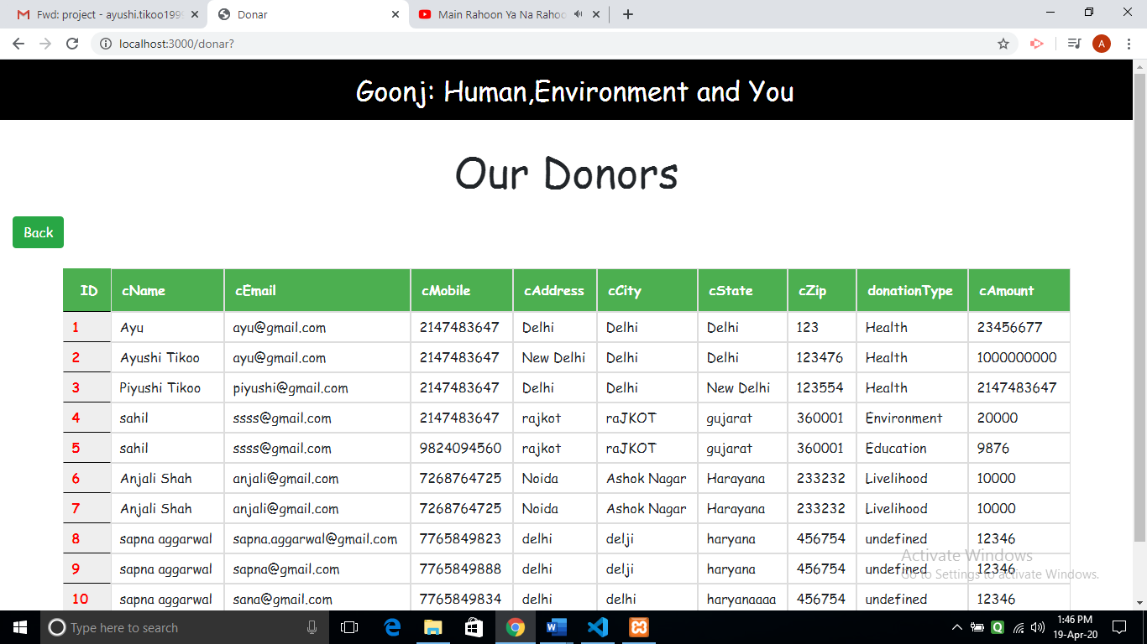

**Manage Users:**

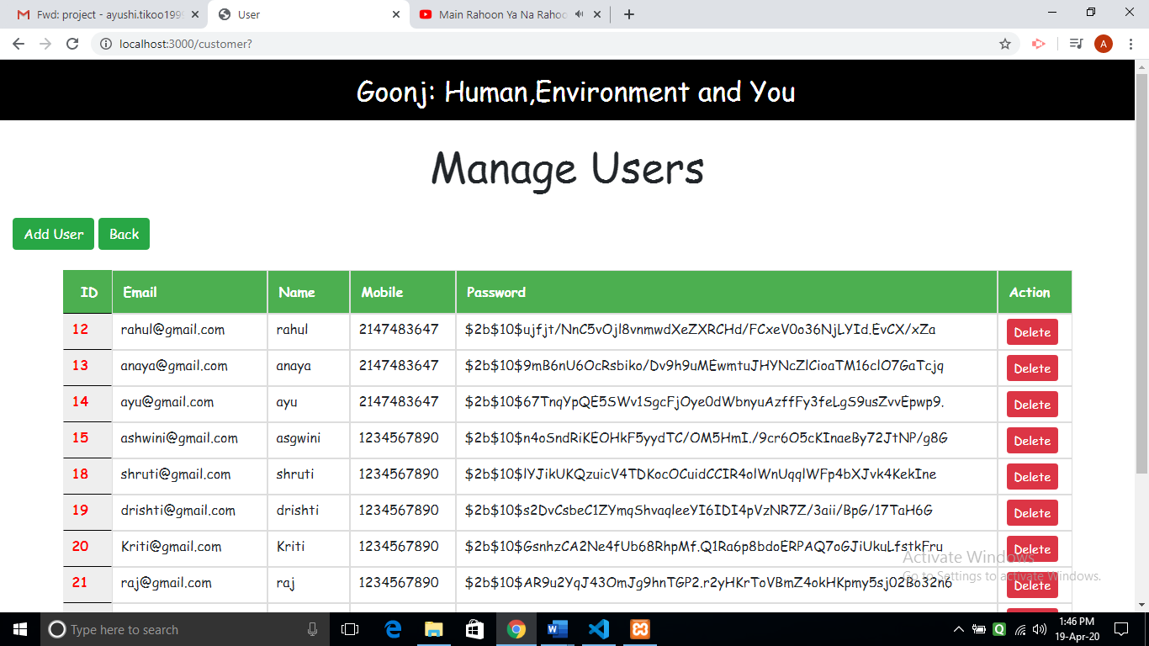

**Manage Events :**

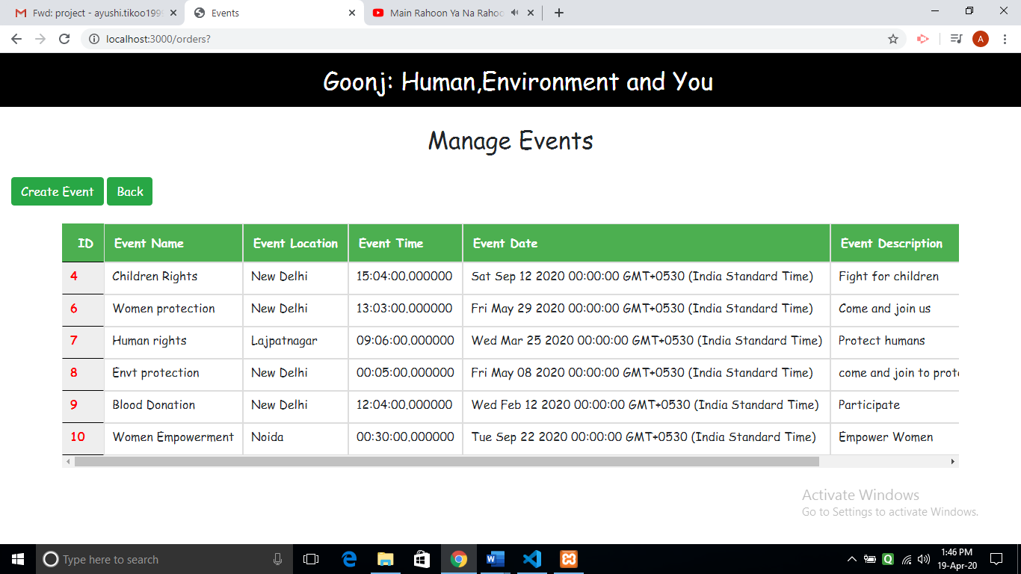

**Insert New Event :**

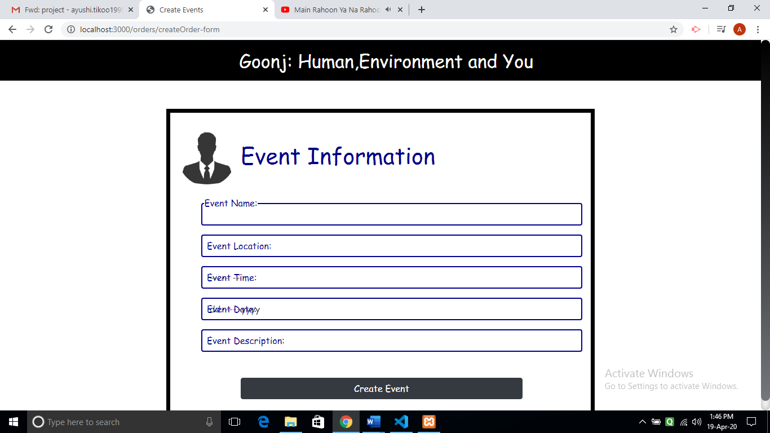

**View Donors (Others) :**

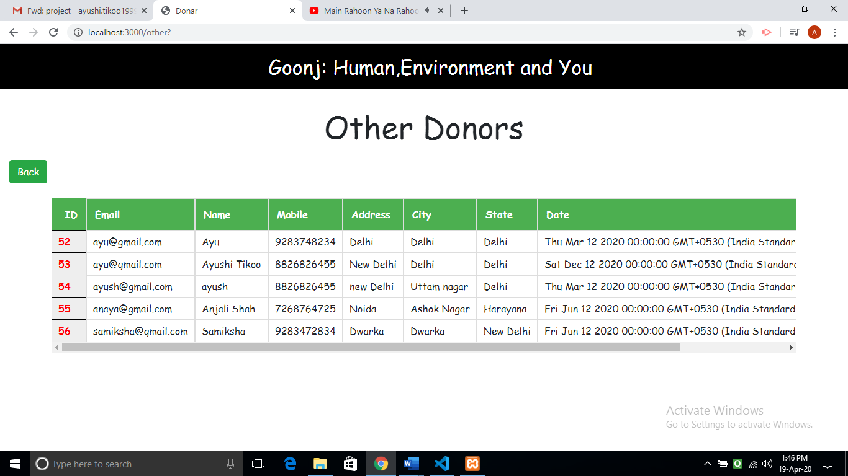

**View Feedback :**

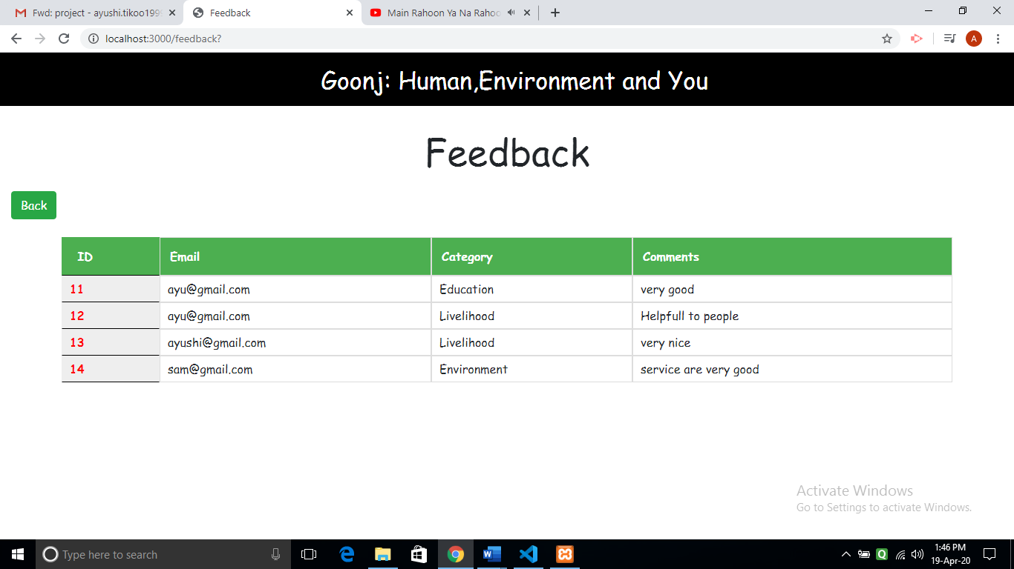

**View Volunteers of event :**

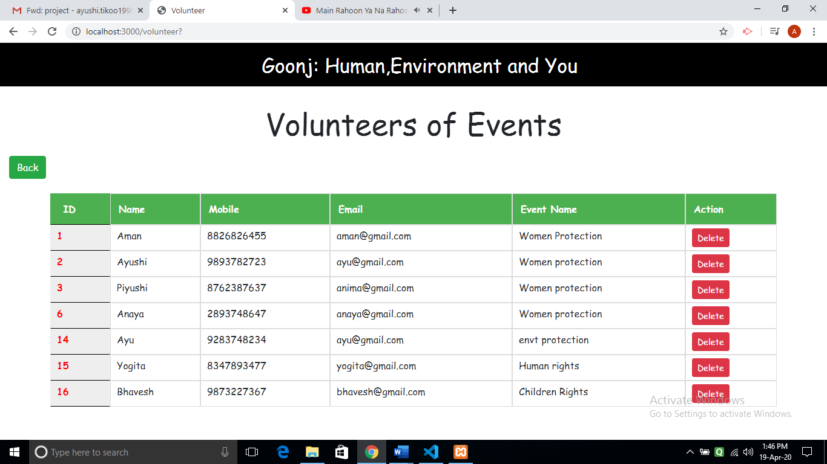

**Conclusion**

We have successfully build the project of NGO System. We are able to build the project with success by fully implementing all the functionalities. First the user will have to register and then login into the system. After logging in he is displayed all the options like donating money or other things, giving feedback and participating in events. User is successfully able to donate money and other things without any problem. He can participate in any event by registering himself. Admin is able to manage user, view feedback, insert any new user, manage events, insert delete and update events and view donors who donated money and other materialistic things.

**Limitation and future extension**

* Users who want to volunteer for event won’t be able to give feedback about that event to admin
* We need to add system in the project in which admin should be able to send confirmation message to the volunteer.
* In future we could also provide tracking system to the donor by which he would be able to track the pickup request for its donation.
* We could also provide platform for the people to help them.

**Bibliography**

**References Used:**

<https://www.google.com/>

[http://stackoverflow.com](http://stackoverflow.com/)/

<https://www.w3schools.com/>

<https://www.tutorialspoint.com/index.htm>

<https://www.geeksforgeeks.org/>