PUSHBUTTON
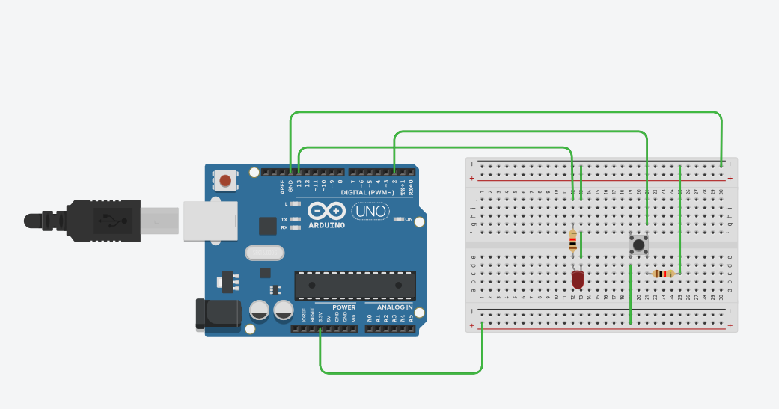

int led = 13;
int pushButton = 2;

void setup() {
Serial.begin(9600);
pinMode(pushButton, INPUT);
pinMode(led, OUTPUT);
}

void loop() {
int buttonState = digitalRead(pushButton);
Serial.println(buttonState);

if (buttonState == 1) {
digitalWrite(led, HIGH); // Turn LED ON
delay(5000); // Stay ON for half a second
digitalWrite(led, LOW); // Turn LED OFF
}
}

