Potentiometer
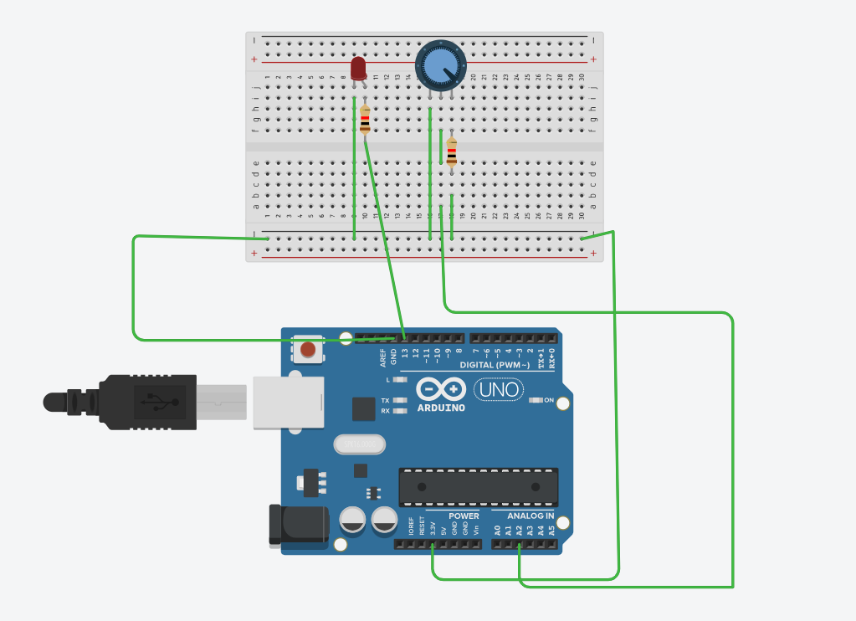
const int ldrPin = A0;
const int ledPin = 13;
int threshold = 500; // adjust: 0 (bright) .. 1023 (dark)

void setup() {
pinMode(ledPin, OUTPUT);
Serial.begin(9600);
}

void loop() {
int val = analogRead(ldrPin);
Serial.println(val);

if (val >= threshold) { // when reading is higher than threshold
digitalWrite(ledPin, HIGH);
} else {
digitalWrite(ledPin, LOW);
}

delay(200);
}

