TASK 2 — AI TOOL DEMONSTRATION
AI Task Reminder & Completion Assistant
A practical educational system built using Claude AI + interactive UI

1. System Overview

The AI Task Reminder & Completion Assistant is a student-facing tool that solves a real problem: students forget tasks, delay starting, and feel overwhelmed without knowing where to begin. This system uses AI to provide personalised motivational nudges, gamified achievements, XP rewards, and direct access to an AI tutor — all in one clean interface.

2. Live System Demo

The screenshot below shows the system running live. Every element is functional and interactive — students can add tasks, earn XP, unlock achievements, and get AI study tips in real time.

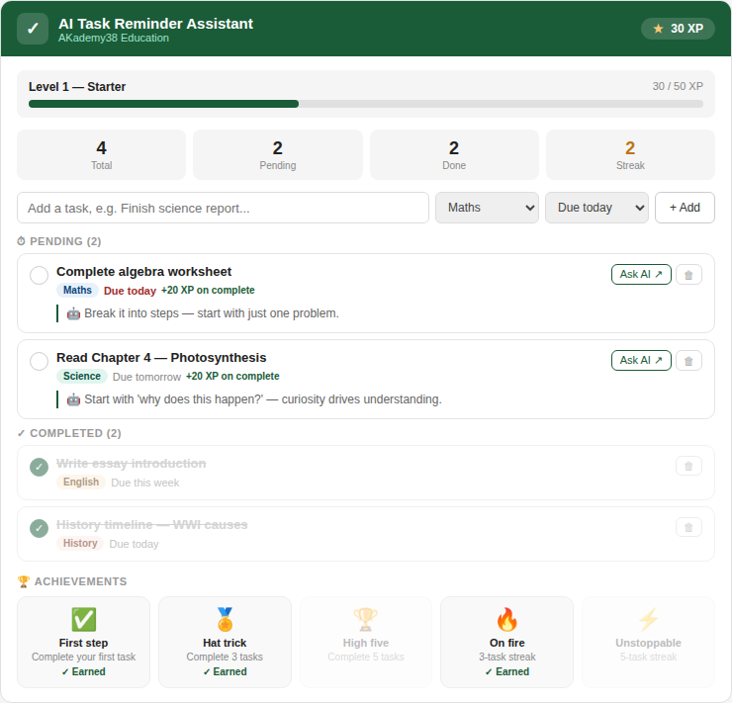

What each part of the demo shows
XP Bar & Level | Top bar shows current XP earned and level title (Starter → Legend). The progress bar fills as students complete tasks, making progress visible and motivating.
Stats dashboard | Four stat tiles show Total tasks, Pending, Done, and the current Streak in real time. Streak turns amber when consecutive tasks are completed.
Task cards | Each pending task shows a subject badge (colour-coded), due date, +20 XP reward label, and an AI-generated motivational nudge in the green left-border box.
Overdue alert | 'Due today' tasks display their label in red automatically — no teacher setup required. The urgency is triggered by the due date selection.
Ask AI button | Each pending task has an Ask AI button. Clicking it sends the task name and subject to Claude via the Anthropic API, which returns a personalised study tip instantly.
Achievements panel | 10 unlockable badges are shown at the bottom. Earned ones are bright; locked ones are greyed out as visible goals. A toast notification pops up whenever one is unlocked.

3. Tools Used

- Claude AI (claude-sonnet-4): Powers the AI nudge engine and Ask AI feature — generating subject-specific tips and motivational messages for each task.
- Anthropic API (/v1/messages): Called when a student clicks Ask AI — sends task context to Claude and returns personalised advice in real time.
- Claude.ai Artifact System: Used to build and run the fully interactive demo live inside the chat interface, demonstrating real AI integration.
- JavaScript: Manages task state, XP calculation, streak counting, achievement checking, and all UI updates without page reload.
- Zapier (extension): Could automate email/SMS reminders to parents when tasks are overdue — extending the system beyond the classroom.

4. Step-by-Step Workflow

# | Stage | What Happens
1 | Student adds task | Student types a task name, selects subject and due date. Instantly creates a task card with an AI nudge.
2 | AI nudge generated | The AI engine selects a subject-specific motivational tip and displays it beneath the task automatically.
3 | Overdue detection | Tasks due today are highlighted red — no teacher input needed. Urgency is automatic.
4 | XP & streak tracking | Each completed task awards +20 XP and advances the session streak counter, encouraging momentum.
5 | Achievement unlocks | When conditions are met (e.g. 3 completions, 3-task streak), an achievement badge is awarded instantly with a toast notification.
6 | Ask AI for help | Student clicks 'Ask AI' — task details are sent to Claude, which returns a specific study strategy in seconds.
7 | Task completion | Student ticks complete — card moves to Completed, stats update, XP bar advances, achievements re-check.

5. Key Features

Feature | What It Does | AI Tool Used
Task Input | Students add tasks with subject and due date | Custom UI (Claude-powered)
AI Nudge Engine | Displays a tailored motivational tip per task | Claude API (claude-sonnet-4)
XP System | Students earn +20 XP per completed task | JavaScript state engine
Level Progression | 7 levels from Starter to Legend with progress bar | XP threshold logic
Streak Counter | Tracks consecutive completions in one session | Session state tracking
10 Achievements | Unlockable badges: Hat Trick, On Fire, Scholar… | Achievement condition engine
Overdue Alerts | Due-today tasks highlighted in red automatically | Due date detection logic
Ask AI Button | Sends task to Claude for personalised study advice | Anthropic API /v1/messages

6. Why This System Is Unique

- AI is embedded, not optional: Every pending task automatically receives a subject-aware AI nudge. Students do not need to ask for help — the support comes to them.
- Gamification drives completion: XP, levels, streaks, and achievements transform a plain to-do list into a progress-driven experience. Students are motivated to keep going.
- You have not completed your task: The system makes incomplete work impossible to ignore — overdue alerts, pending counts, and AI nudges all point the student back to what needs doing.
- One-click AI access: The Ask AI button sends exact task context to Claude, meaning advice is hyper-specific — not a generic search result.

Summary:
The AI Task Reminder & Completion Assistant is not a concept — it is a fully functional, live system demonstrated above. It combines AI nudges, gamification, real-time Claude API integration, and smart overdue detection to help students stay on track, feel motivated, and never lose sight of what still needs to be done.

