JCapture

INDIVIDUAL CONTRIBUTIONS:
- Ayushika Verma (S24CSEU0362) developed the countdown logic, dynamic preview, screenshot capture, and feedback handling.
- Yosita Swarna (S24CSEU0240) integrated the snipping tool, managed file saving with timestamps, and ensured responsiveness using multithreading and a clean layout.
Under the Guidance of: Dr. Susmita Das

JCapture is a Java swing-based desktop program that takes screenshots recorded in full-screen and custom region modes. It offers a seamless, user-friendly experience, including countdowns, live previews, and automatic saving.

JCapture’s Salient Features:
- Modern GUI
The modern graphical user interface of JCapture was developed using the latest GUI Java Swing technology. Its layout gives a visually attractive experience, with a grid-based appearance. The application is user-friendly and easy to use, owing to the well-organized layout of its components, including buttons, labels, and input fields.

- Two Capture Modes
The application supports two screenshot modes:
- Full Screen: Captures a screenshot of the whole screen.
- Snipping Tool: The Snapping Tool allows users to manually select a specific area of the screen to capture by opening a transparent outlined overlay.
Because of this versatility, users can select the capturing method that best suits their needs.

- Delayed Capture
Users can specify a delay (in seconds) before the screenshot is taken. This countdown is particularly useful when preparing the screen or opening specific windows before capturing the screen snip. During the delay, a progress bar and dynamic countdown message keep users informed, adding clarity and control to the process.

- Cancel Option
The cancel feature employs a common isCancelled flag inspected by the background TimerThread. When the user cancels in the middle of the countdown, the thread terminates immediately, bypassing the screenshot and UI update without freezing the interface.

- Live Preview
Once the screenshot is taken, an instant preview is immediately displayed within the application interface. The live preview provides an instant visual screenshot dummy, providing confirmation of the capture success and allowing users to know instantly the result without needing to exit the application.

- Formatted File Paths
Screenshots are automatically saved as .jpg files using timestamp-based filenames to prevent duplicates. The directory structure is well-defined.

Key Components of JCapture:

JFrame, JPanel | Base containers for organizing the GUI layout.
JButton | "Capture Screenshot" and "Cancel Screenshot" buttons.
JTextField | For user to enter the delay before capture.
JLabel | Displays messages and preview of screenshots.
JProgressBar | Shows countdown progress visually
BufferedImage | Stores the captured image data.
Robot | Captures the screen as a raw image.
SnippingTool | Inner class allowing freeform region selection via a transparent overlay.
ImageIO | Saves screenshots to .jpg format.
SimpleDateFormat | Formats timestamp for filenames.
TimerThread | Handles countdown and triggers the capture process.

Step-by-Step Workflow:

User Input: The user causes a delay of seconds and selects a capture mode.
Countdown Timer: The application shows a real-time countdown with a visual progress bar.
Mode Selection:
Full Screen: A Robot class captures the entire screen.
Snipping Tool: A transparent overlay allows users to select a specific area using mouse events.
Saving and Preview: The screenshot is saved in the SAVEDSCREENCAPTURES/<username> directory.
A preview of the screenshot is displayed in the application.

User Input
Countdown Timer
Mode Selection
Saving and Preview
Test Cases:
screenshot_20250318_184238
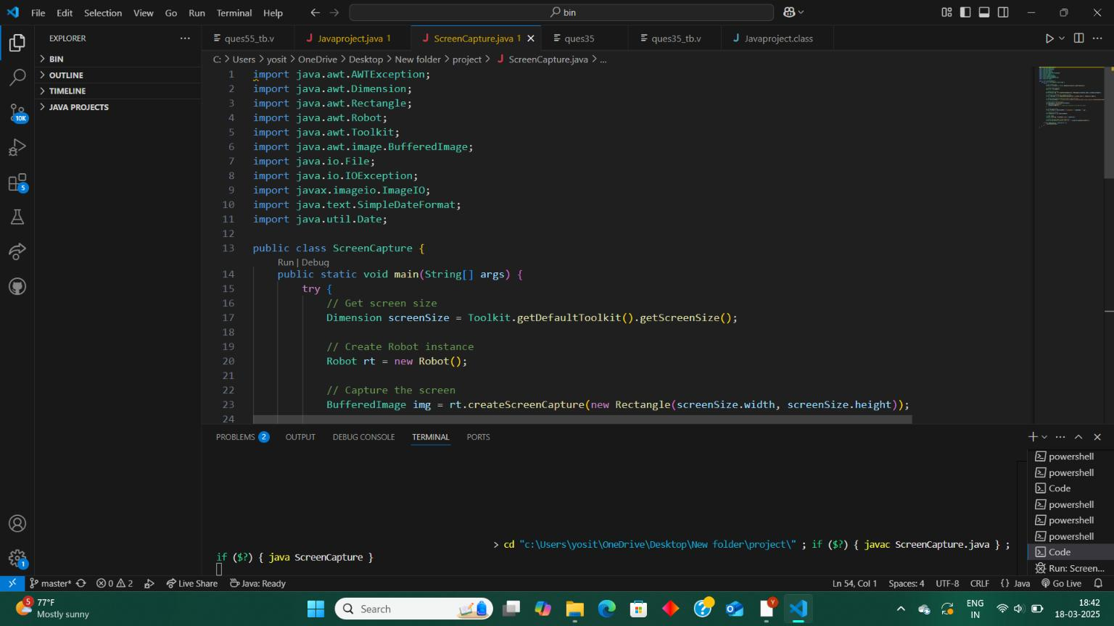

screenshot_20250318_193114
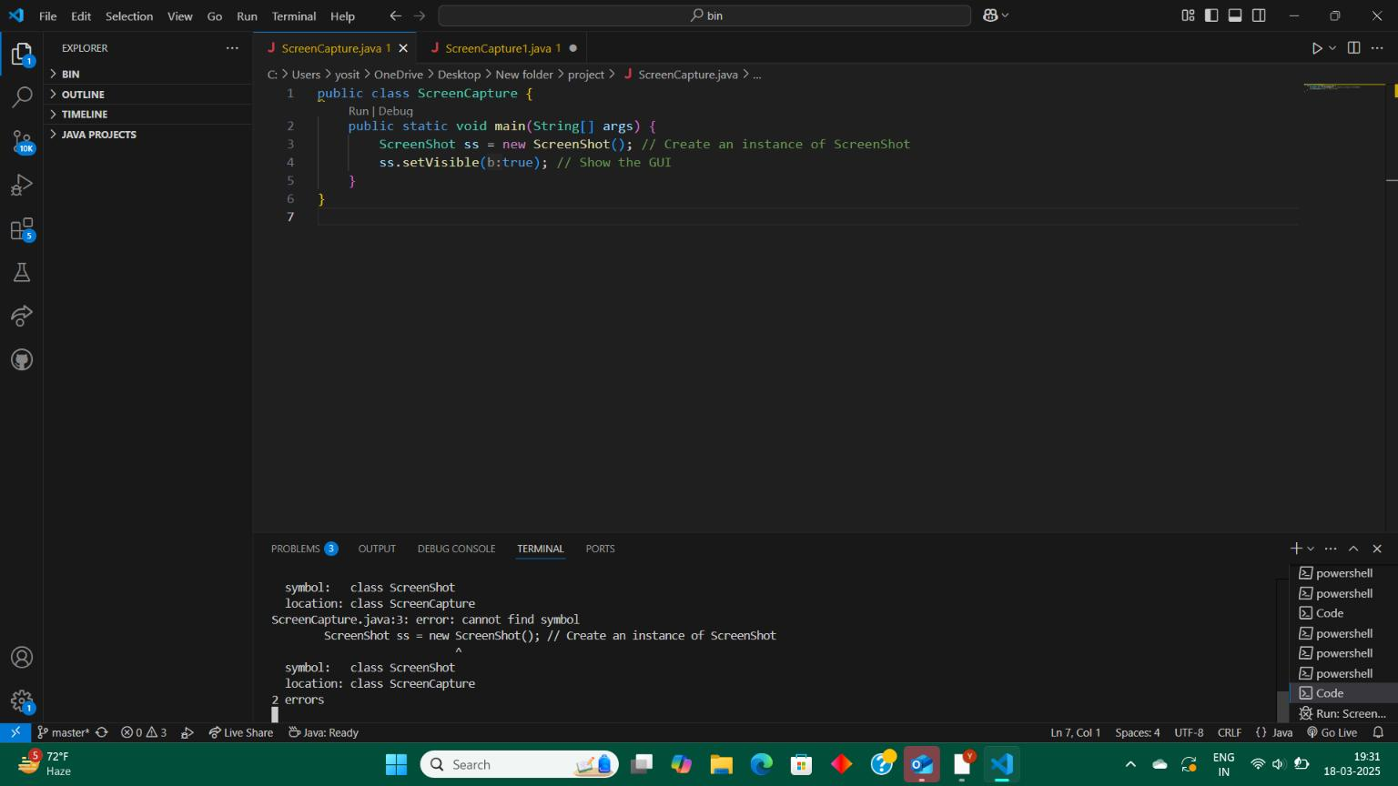

screenshot_20250401_222324
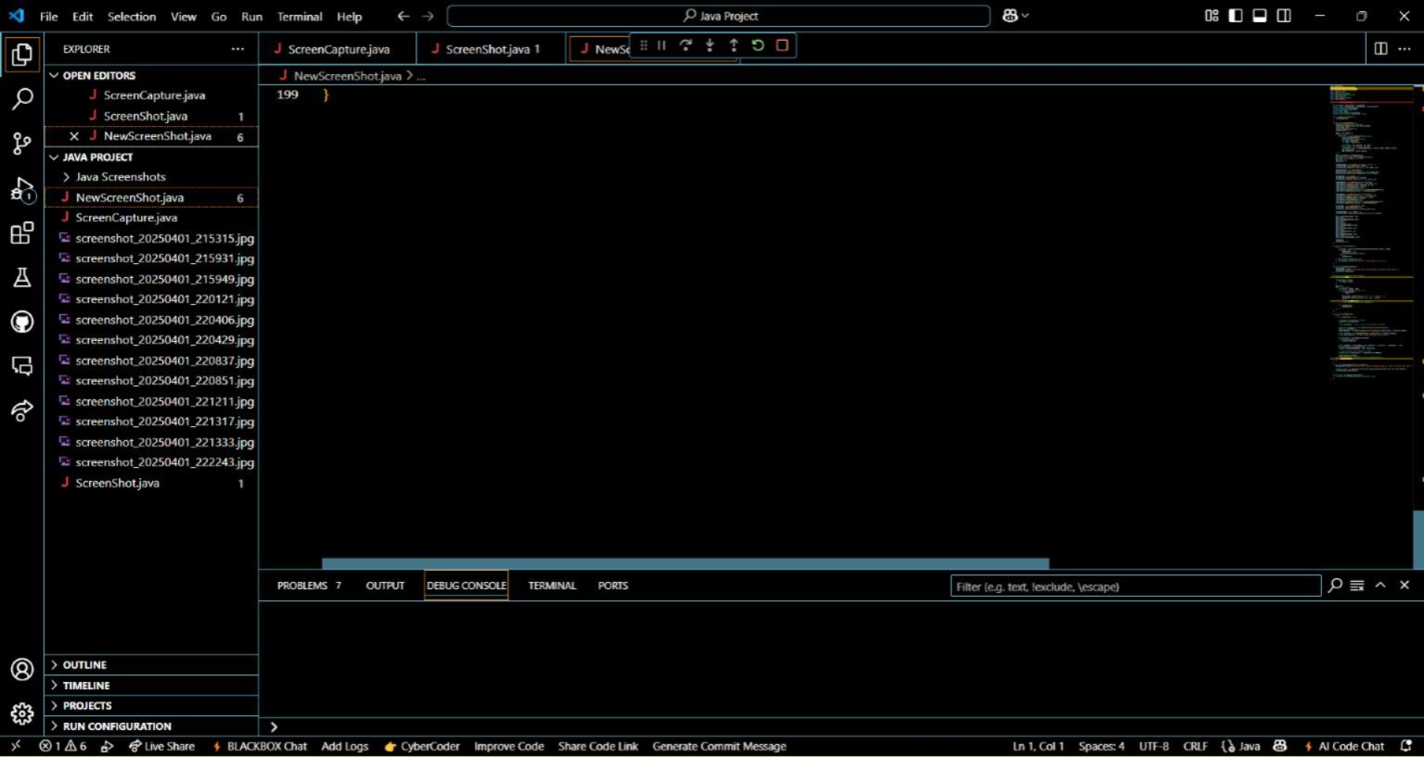

snip_20250421_203743

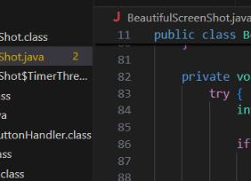

Resources and References:

Java Swing and AWT Documentation: https://docs.oracle.com/javase/8/docs/api/

Java 2D Graphics: https://docs.oracle.com/javase/tutorial/2d/

TutorialsPoint – Java GUI Programming

StackOverflow discussions on screenshot capture and JWindow

GitHub snippets for snipping tool logic (adapted)

