Course Name: | Elements of Electrical and Electronics Engineering | Semester: | I/II
Date of Performance: | 10/12/21 | Batch No: | A2
Faculty Name: | Maruti Zalte | Roll No: | 16010121045
Faculty Sign & Date: |  | Grade/Marks:

Internal Assessment: 1
Brief Report on
1. Electrical power Generation and distribution systems:
List the Electrical power generation methods in India. Explain using block diagram how electricity reaches at your home from generating station. Explain in brief the stages of conversion of Voltages and role of transformer.
2. List the possible electrical Hazards inside a home.
3. Electrical safety essentials: List and brief about Products for a safer home such as Circuit breakers, MCBs, Switch Fuse Unit (SFU, ELCB, MCCB).
(Note: Students can add photographs of safety devices)
4. What are Types of Wires and Cables used for electricity distribution?
5. Importance of Earthing.
6. Explain in brief fluorescent, CFL, LED operations and typical power ratings.

1. Electrical power Generation and distribution systems.
Electricity generation is the process of generating electric power from sources of primary energy. It is the stage prior to its distribution to end users. Electricity is not freely available in nature, so it must be "produced" by transforming other forms of energy to electricity. Production is carried out in power stations by electromechanical generators, primarily driven by heat engines fuelled by combustion or nuclear fission but also by other means such as the kinetic energy of flowing water and wind.
Electrical power is generated by various methods across the world. Few methods which are prominently used in India are listed below:
Types of Power Plant | Installed Capacity (MW) | Percentage Share
1. Thermal power  (i) Coal Gas  (ii) Gas based  (iii) Oil based | 153848  132288  20360  1200 | 68.14  58.59  9.02  0.53
2. Hydro Power | 39623 | 17.55
3. Nuclear Power | 4780 | 2.12
4. Renewable Source Of Energy | 27542 | 12.20
Total Energy | 225793 | 100.00
Source: Jagran Josh
Thermal Power^{[1]}
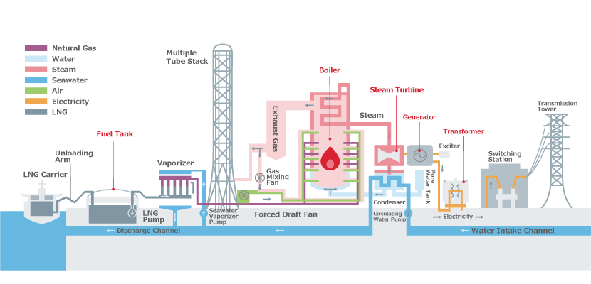
A thermal power station is a power station in which heat energy is converted to electricity. Typically, fuel is used to boil water in a large pressure vessel to produce high-pressure steam, which drives a steam turbine connected to an electrical generator. The low-pressure exhaust from the turbine passes through a steam condenser and is recycled to where it was heated. This is known as a Rankine cycle. Natural gas can also be burnt directly in a gas turbine similarly connected to a generator.
The same above procedure is followed for other heat sources like Coal and Oil. The only difference being that the source of Heat Energy.
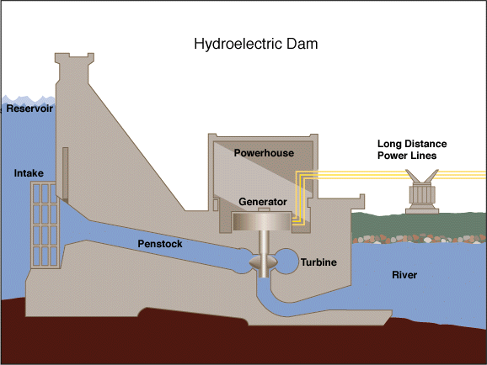
Hydro Power^{[2]}
Hydro-power, also known as water power, is the use of falling or fast-running water to produce electricity or to power machines. This is achieved by converting the gravitational potential or kinetic energy of a water source to produce power. Hydro-power is a method of sustainable energy production.
Since ancient times, hydro-power from watermills has been used as a renewable energy source for irrigation and the operation of mechanical devices, such as gristmills, sawmills, textile mills, trip hammers, dock cranes, domestic lifts, and ore mills.
Hydropower is an attractive alternative to fossil fuels as it does not directly produce carbon dioxide or other atmospheric pollutants and it provides a relatively consistent source of power. Nonetheless, it has economic and environmental downsides and requires a sufficiently energetic source of water, such as a river or elevated lake.

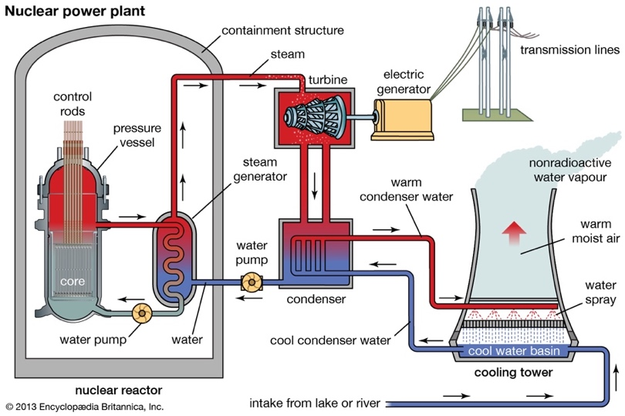
Nuclear Power^{[3]}
Nuclear power, electricity generated by power plants that derive their heat from fission in a nuclear reactor. Except for the reactor, which plays the role of a boiler in a fossil-fuel power plant, a nuclear power plant is similar to a large coal-fired power plant, the difference being this is a low-carbon power source.
Nuclear power can be obtained from nuclear fission, nuclear decay and nuclear fusion reactions. Presently, the vast majority of electricity from nuclear power is produced by nuclear fission of uranium and plutonium in nuclear power plants.
Renewable Energy Sources^{[4]}
Renewable energy, often referred to as clean energy, comes from natural sources or processes that are constantly replenished. For example, sunlight or wind keep shining and blowing, even if their availability depends on time and weather.
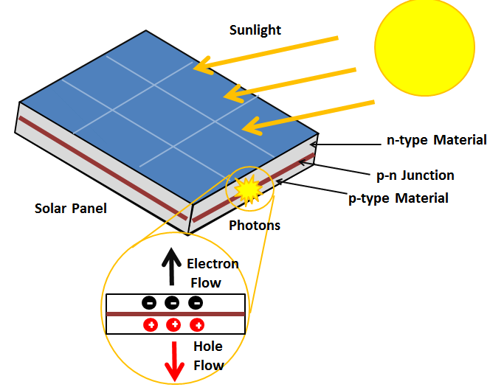
Solar Energy^{[5]}
Solar energy is radiant light and heat from the Sun that is harnessed using a range of technologies such as solar power to generate electricity, solar thermal energy including solar water heating, and solar architecture. Humans have been harnessing solar energy for thousands of years—to grow crops, stay warm, and dry foods.
Solar, or photovoltaic (PV), cells are made from silicon or other materials that transform sunlight directly into electricity. Distributed solar systems generate electricity locally for homes and businesses, either through rooftop panels or community projects that power entire neighbourhoods. Solar farms can generate power for thousands of homes, using mirrors to concentrate sunlight across acres of solar cells.

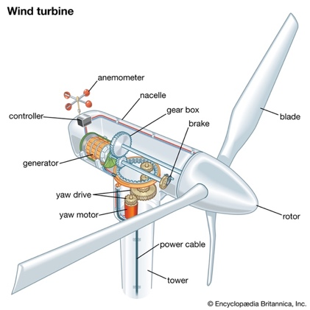
Wind Energy^{[6]}
Wind energy, also known as Wind-power is the use of wind turbines to generate electricity. Wind power is a popular, sustainable, renewable energy source that has a much smaller impact on the environment than burning fossil fuels. Wind farms consist of many individual wind turbines, which are connected to the electric power transmission network.

Electricity is first generated as informed in the above methods to generate electricity. Then this generated electricity is transmitted over transmission lines which facilitate this movement from power plants to electrical substations. It is then distributed to the consumers via electrical substations.

- Power Generating Station^{[7]}
At Power Generating Station the electricity generated is at 11 kV.
- Grid Substation
The alternating voltage is then transmitted to the grid sub-station and stepped up to 132 kV using a step-up transformer. In order to prevent the loss of energy via heat and resistance over long distances.
- Main Sub Station
It is then transmitted to the main sub-station where the voltage is stepped down to 33 kV using a step-down transformer and is then transmitted to the intermediate sub-station.
- Intermediate Sub Station
At the intermediate sub-station, the voltage is stepped down to 11 kV using a step-down transformer and is transmitted to the city sub-station.
- City Sub Station
At the city sub-station, the voltage is further stepped down to 220 V and is supplied to our houses for electricity use.

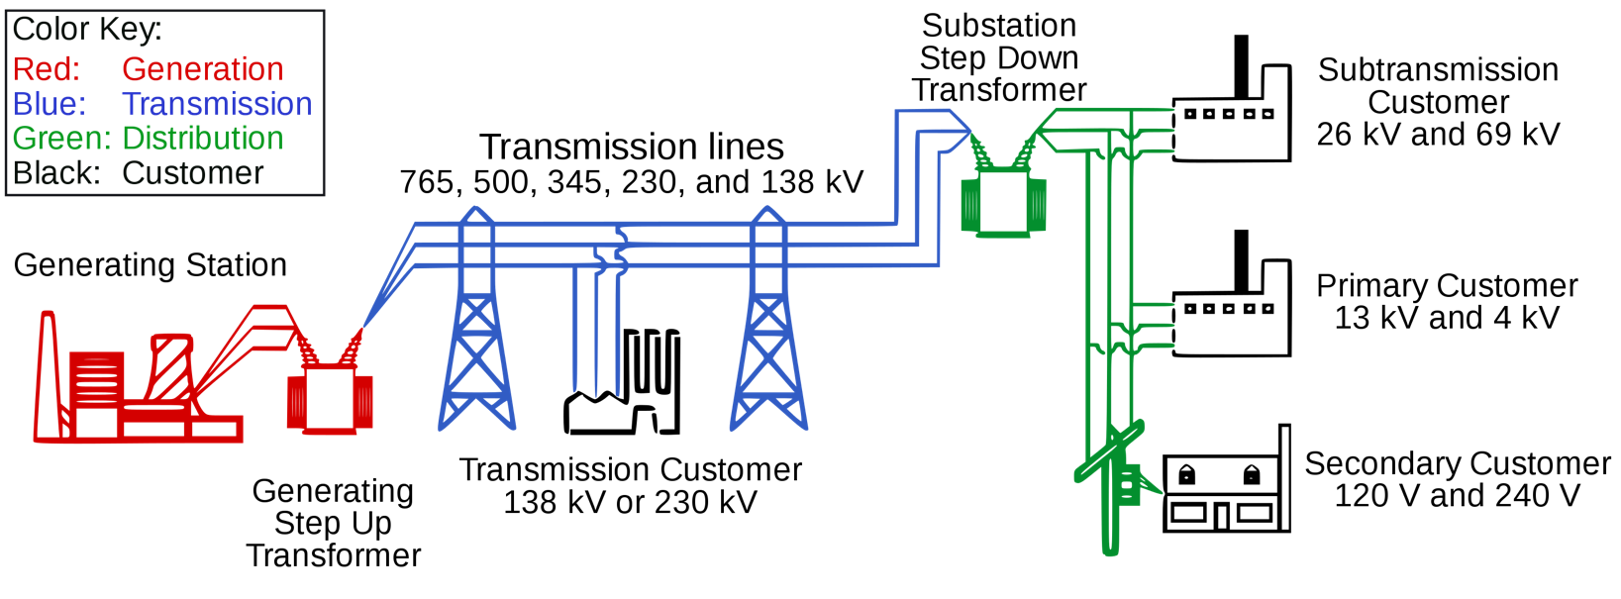

Role of Transformer^{[8]}

A transformer is a device used in the power transmission of electric energy. The transmission current is AC. It is commonly used to increase or decrease the supply voltage without a change in the frequency of AC between circuits. The transformer works on basic principles of electromagnetic induction and mutual induction.
The two main Voltage based Transformers that are utilized in power transmission are:

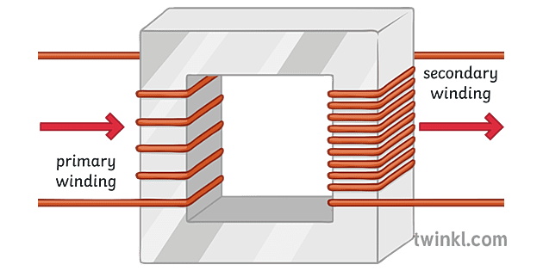
- Step-up Transformer: They are used between the power generator and the power grid. The secondary output voltage is higher than the input voltage. The voltage is stepped up before transmission to reduce current. The power loss in the lines due to resistance is called copper loss or I²R loss. Lesser the current lesser will be the power loss. Hence, we step-up the voltage thereby decreasing the current in the system.

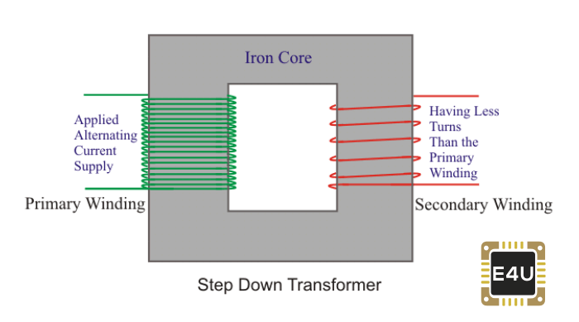
- Step down Transformer: These transformers are used to convert high voltage primary supply to low voltage secondary output. This is used to step-down the high voltages during transmission so that the end user can safely use the electrical appliances.

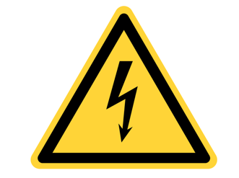
2. List the possible electrical Hazards inside a home.
There are many hazards around any electrical equipment, and at our home which nowadays is filled with various electrical appliances, there are many hazards. Some of them are as follows:
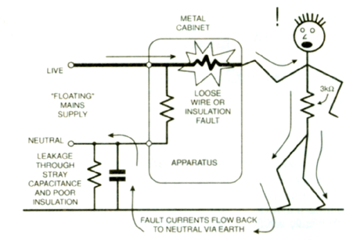
- Poor Earthing
Earthing of electrical appliances like refrigerator, blender, washing machines, etc. is very important poor earthing connection can cause the faulty current to flow through the appliances body to the user which in some cases can be fatal.

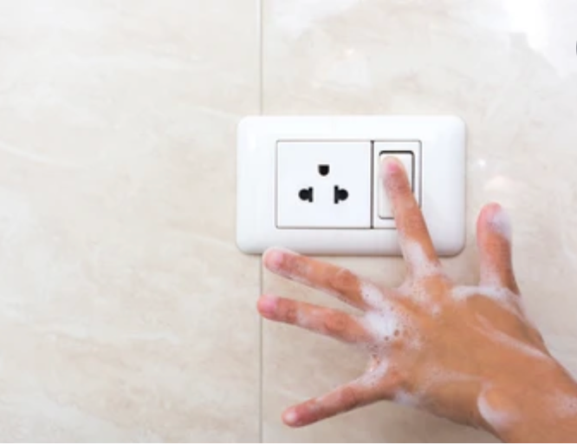
- Wet Hands
As we know, Electricity and water are not good together, and so is the idea of operating them with wet hands. Water is a good conductor of electricity and so is the human body. Operating the appliances with wet hands just increases the probability of getting a shock. Too many of us tend to reach for the hair dryer with wet hands out of the shower. Keep appliances a safe distance away from sinks, bathtubs, showers, and taps.
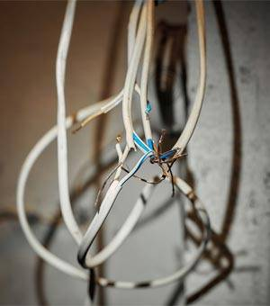
- Bad Wiring
Good quality wiring that conforms to safety standards is very important for safety. Bad wiring can increase the chances of fires, power surges, and other serious consequences. Damaged, worn or torn wires just increases the potential of an electrical accident.

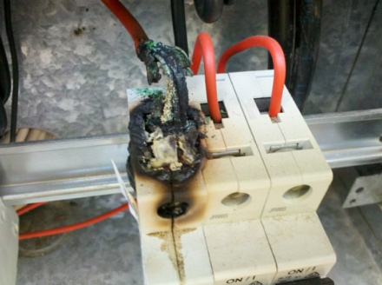
- Lose Connection
A lose connection is nothing but an invitation for an electrical spark. An electrical spark can not only cause the MCB to trip but in some cases can lead up to fire. So, check the connections for a tight and a secure Connection.

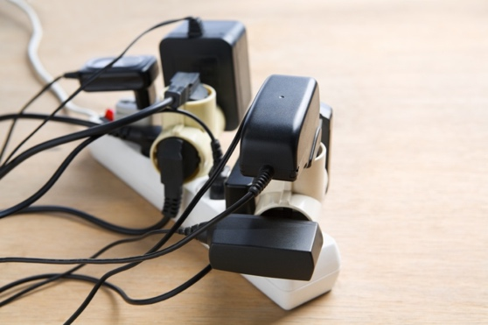
- Extension Cords
Extension cords should be carefully fixed in place, when possible, to reduce the chance of tripping or other accidents. Use plastic socket closures on unused sockets for extra safety.

3. Electrical safety essentials: List and brief about Products for a safer home such as Circuit breakers, MCBs, Switch Fuse Unit (SFU, ELCB, MCCB).
Many of the energy services around the house use electricity. It is extremely important to have various safety devices to protect from fire and electrocution. Some of the products which can be used to ensure safety are as follows:
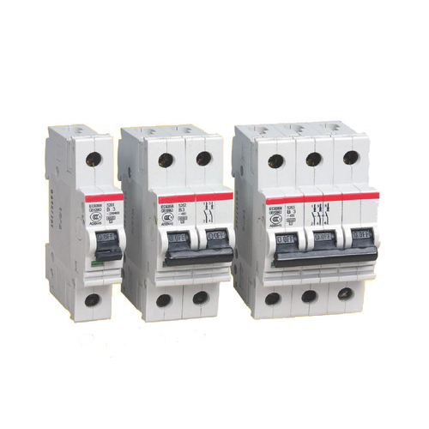
- MCB^{[9]}
MCB stands for Miniature Circuit Breaker. It automatically switches OFF electrical circuit during any abnormal condition in the electrical network such as overload & short circuit conditions. However, fuse may sense these conditions but it has to be replaced though MCB can be reset. The MCB is an electromechanical device which guards the electric wires &electrical load from overcurrent so as to avoid any kind of fire or electrical hazards. Handling MCB is quite safer and it quickly restores the supply. When it comes to house applications, MCB is the most preferred choice for overload and short circuit protection. MCB can be reset very fast & don’t have any maintenance cost. MCB works on bi-metal respective principle which provides protection against overload current & solenoid short circuit current.

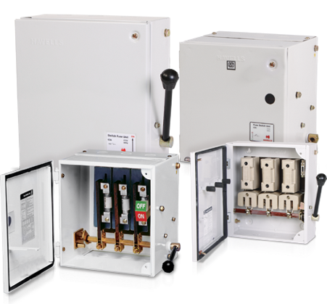
- SFU^{[10]}
SFU is Switch Fuse Unit. It is basically a switch with stationary Fuse. Fuse blows out when the current exceeds limit and protects the equipment from damage. It has one switch unit and one fuse unit. When we operate the breaker, the contacts will get closed through switch and then the supply will pass through the fuse unit to the output. The downside being that the fuse has to be replace after it is blown off.

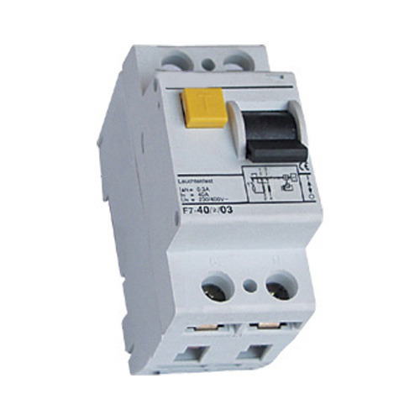
- ELCB^{[11]}
An Earth-leakage circuit breaker (ELCB) is a safety device used in electrical installations with high Earth impedance to prevent shock. It detects small stray voltages on the metal enclosures of electrical equipment, and interrupts the circuit if a dangerous voltage is detected. It directly detects current leakage and directs it to the earth from the circuit and breaks the circuit. However, the ELCB is old technology, and it’s no more in common use. The RCCB has taken center stage since it a current sensitive device, and it has a better advantage over ELCB.

- RCCB^{[12]}
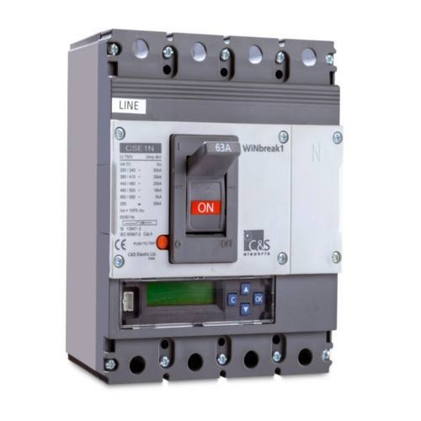
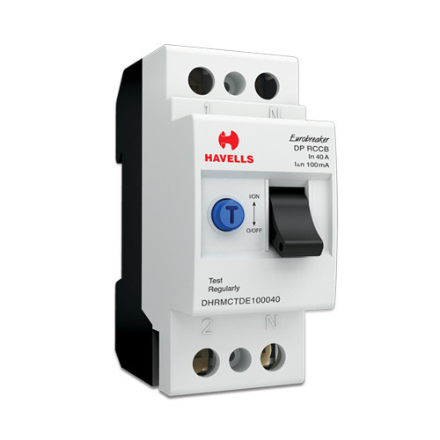
This stands for Residual Current Circuit breaker. This device is basically an electrical wiring device whose function is to disconnect the circuit whenever there is leakage of current flow from the human body, or the current flow is not balanced between the phase conductors. It is the best device for detecting and taking care of electrical leakage currents, so it gives protection against electric shock or electrocution caused by direct contacts. RCCB is usually used in series with an MCB. The MCB protects the RCCB from over-current and short-circuits current. Both neutral and phase wires are connected through an RCCB. The combination of these two devices provides a very effective form of protection from electric shock, and it is widely used for protection against a leakage current of about 30,100 and 200mA.

- MCCB^{[13]}
The Molded Case Circuit Breaker is another type of electrical protection device that is used when the load current exceeds the limit if an MCB. The molded case circuit breaker also provides protection against short circuit faults, overloads and it can also be used for switching circuits. It is also used for higher current rating and fault level in domestic and small commercial applications. But the large current ratings and high breaking capacity of the MCCB are much more useful in industrial applications.

4. What are Types of Wires and Cables used for electricity distribution?
Nowadays the advancement in technology, almost everything is powered by electricity. We need supply of smooth, uninterrupted electricity which is achieved by using suitable type of wires and cables. The electrical sector uses cables and wires for power transmission and distribution to our house and industries some of them are:
- Direct Buried Cable (DBC)^{[14]}
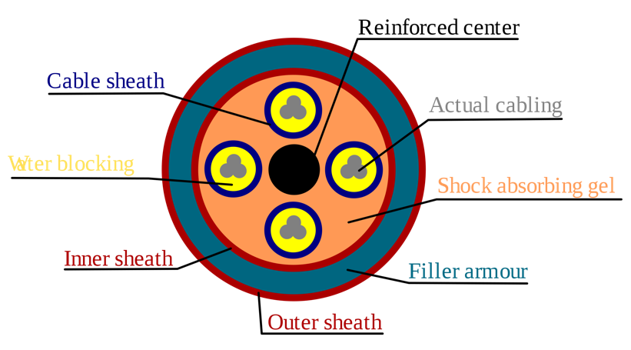
It is a type of cable used for communication and power transmission. Direct-buried cable (DBC) is a kind of communications or transmissions electrical cable which is especially designed to be buried under the ground without any kind of extra covering, sheathing, or piping to protect it. It is made of bundles of fiber optic cables with a thick metal core for stiffness. It has multiple layers of protection such as plastic insulation layer, waterproof layer as well as shock absorbing gel etc. to protect it from heat, moisture and other underground factors. DBC is preferable in some areas since it is more resistant to being the focus of lightning discharges. Some power cabling is also direct-buried. This kind of cabling must follow strict regulatory procedures regarding installation and backfilling. This is usually used for undergrounding in areas where overhead cabling is impractical or dangerous.

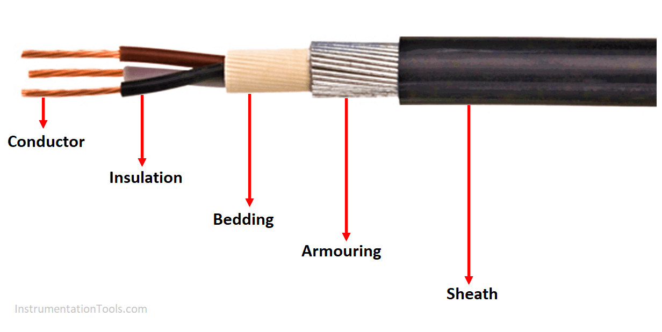
- Armoured Cable^{[15]}
In electrical power distribution, armoured cable usually means steel wire armoured cable (SWA) which is a hard-wearing power cable designed for the supply of mains electricity. It is one of a number of armoured electrical cables – which include 11 kV Cable and 33 kV Cable – and is found in underground systems, power networks and cable ducting. Such type of metallic sheathed cables has a protective twisted or braided metallic layer usually made of steel over its conductor. The external sheath is made of plastic. The metallic layer provides extra mechanical strength against any sort of damage and can also be used for grounding connections. Thus, they are not used in damp or wet location as well as underground. The armoured layer can be wire braid, steel wire or steel tape. The steel wire armored (SWA) cable is most common type of armored cable used for power transmission.
- Overhead Power Line
Overhead power lines are conductors suspended from electrical towers or poles to transmit power over long distance. The conductors used are completely bare and made from aluminum. The electrical and mechanical properties of the conductor depend on its construction. Here are some of the cables used for power transmission:
- All Aluminum Conductor (AAC)^{[16]}
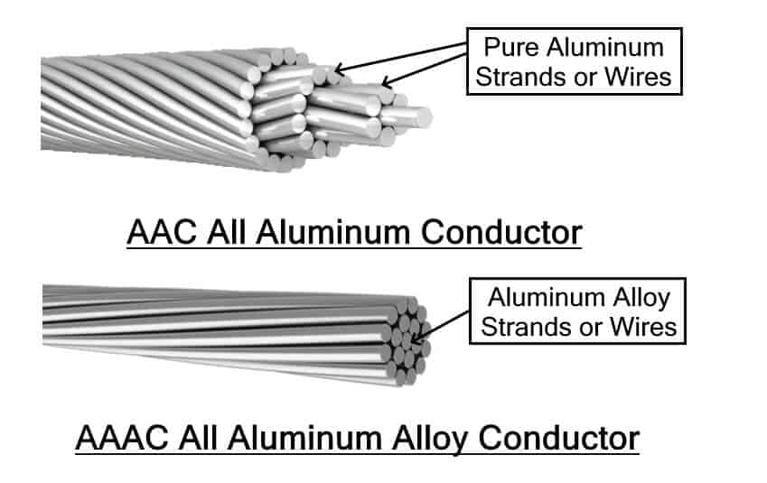
AAC transmission cable, also known as aluminum stranded conductor is made from multiple strands of hard drawn 1350 aluminum alloy which is 99 % pure with a little bit of silicon, iron etc. it has very high conductivity and resistive to corrosion but very poor strength to weight ratio. That is why it is preferred short distances in the stations not for rural power transmission over long distance.

- All Aluminum Alloy Conductor (AAAC)^{[17]}
In order to increase the mechanical strength of the AAC cable, a special aluminum alloy is used made with magnesium and Silicium. It increases the strength to weight ratio while maintaining the corrosion resistivity. However, the conductivity falls a bit short due to resistance.

Aluminum Conductor Steel-Reinforced (ACSR) Cable^{[18]}

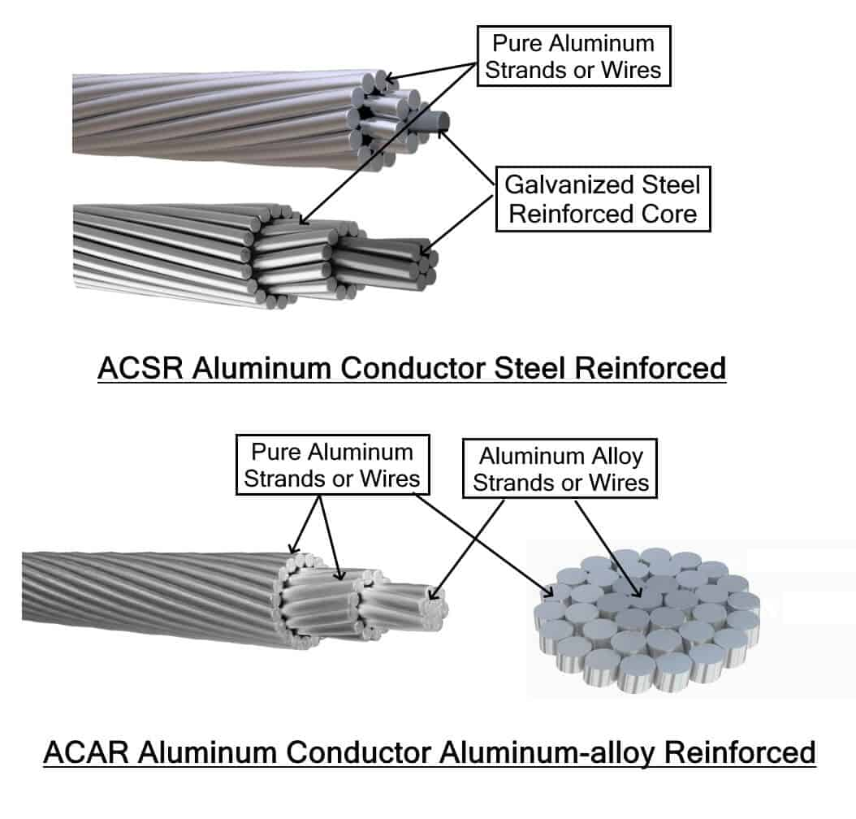
ACSR is also a stranded aluminum cable whose inner strands are made from galvanized steel surrounded by strands of pure aluminum conductors. The steel core increases the tensile strength of cable while the aluminum provides good conductivity and low weight. They are used in long distance transmission line because we can alter the strength of its steel core to meet the requirement.

Aluminum Conductor Aluminum-alloy Reinforced (ACAR)^{[19]}

It is made of pure aluminum conductors surrounding an aluminum core. The structure of ACAR resembles ACSR but instead of its core made from galvanized steel, it is made of aluminum alloy which increase the overall conductivity (ampacity) while maintaining the tensile strength if ACSR.

5. Importance of Earthing.
If there is a fault in your electrical installation you could get an electric shock if you touch a live metal part. This is because the electricity may use your body as a path from the live part to the earth part.
Earthing is used to protect you from an electric shock. It does this by providing a path for a fault current to flow to earth. It also causes the protective device switch off the electric current to the circuit that has the fault.
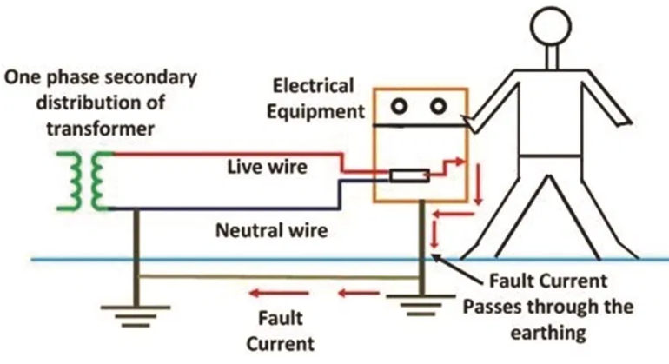
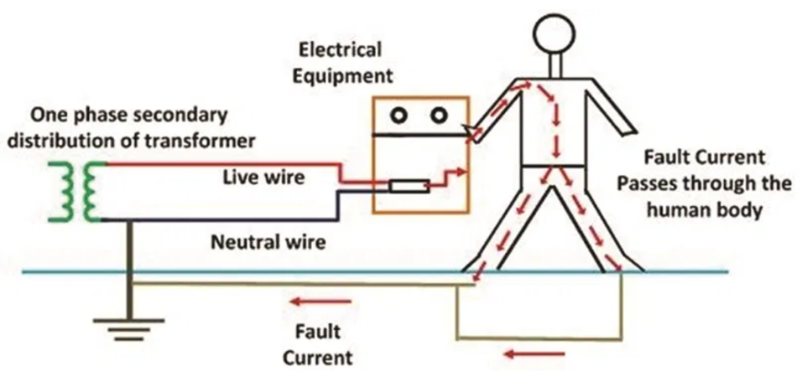
For example, if a refrigerator has a fault, the fault current flows to earth through the earthing conductors. A protective device (fuse or circuit-breaker) in the consumer unit switches off the electrical supply to the cooker. The fridge is now safe from causing an electric shock to anyone who touches it.
Before Earthing After Earthing

Some Advantages of Earthing^{[20]} are:
- Earthing is safe and the best method of offering safety. We know that the earth’s potential is zero and is treated as Neutral. Since low equipment is connected to earth using low resistance wire, balancing is achieved.
- Metal can be used in electrical installations without looking for its conductivity, proper earthing ensures that metal does not transfer current.
- A sudden surge in voltage or overload does not harm the device and person if proper earthing measures are done.
- It prevents the risk of fire hazards that could otherwise be caused by the current leakage.

6. Explain in brief fluorescent, CFL, LED operations and typical power ratings.
The two of the most popular options are CFL (Compact Fluorescent Lamp) and LED (Light Emitting Diode) in the market for light bulbs. Let’s see what they actually are in a brief.

Compact Fluorescent Lamp (CFL)^{[21]}

In CFL bulbs an electric current flows between electrodes at each end of a gas-filled tube. The reaction creates ultraviolet light and heat, which is then changed into light when it hits a phosphor coating on the bulb’s interior. This process takes anywhere from 30 seconds to 3 minutes to complete. Which is why it can seem as if your CFL light takes a while to be fully lit.

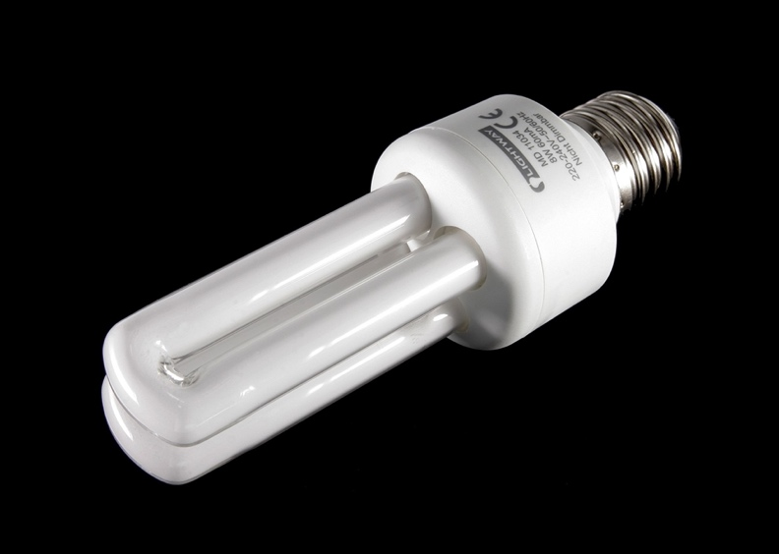
CFLs use 25-35% of the energy used by incandescent bulbs, but if you really want to make the biggest environmental impact on the environment, choosing LEDs is the way to go. CFLs release about 80% of their energy as heat.

The average lifespan of CFLs is about 8,000 hours. CFLs use 1/3rd to 1/5th the electrical power of incandescent lighting and can last 8 to 15 times longer. An average CFL bulb which provides 800 lumens will use only 13 to 15 watts compared to a similar incandescent bulb which uses 60 watts.

Light Emitting Diode (LED)^{[22]}

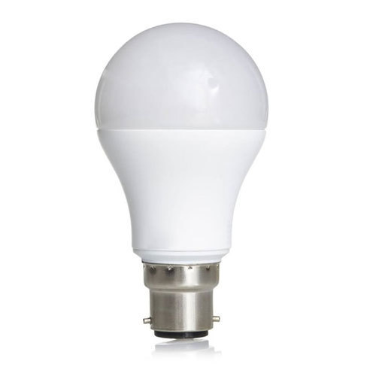
An LED bulb produces light by passing the electric current through a semiconducting material the diode which then emits photons (light) through the principle of electroluminescence. Compared to CFLs this process is way quicker and almost instantaneous.

Residential LEDs, use more than 75% less energy and last 25 times longer than incandescent lighting. LEDs emit very little heat. In contrast, incandescent bulbs release 90% of their energy as heat. Another LED light benefit is that LEDs, because they emit light in a specific direction, do not need diffusers or reflectors that trap lights. This helps increase LED efficiency for uses such as downlights or task lighting.

LEDs have both a great shelf life as well as use case life. LED lights are known to last longer and typically enjoy a lifespan of almost 50,000 hours. An average LED bulb which provides 800 lumens will use only 6 to 8 watts which on in comparison to CFLs, LEDs are power efficient by half the wattage.

The Average Power rating of three most popular alternatives in the market is as follows:

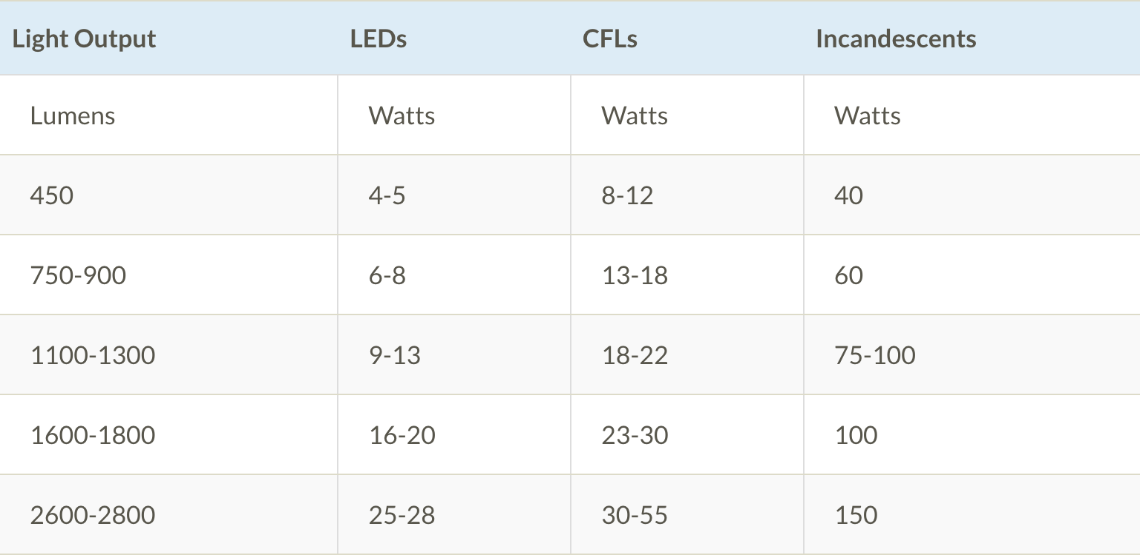
Source: Eartheasy

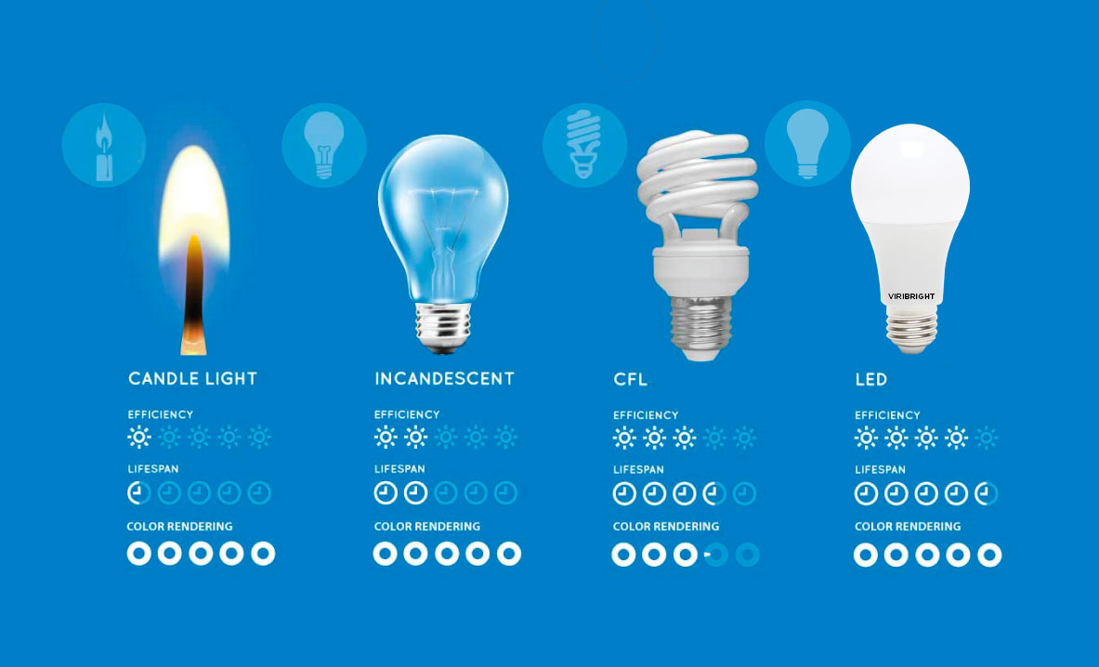
This shows why LEDs is the way to go. Not only they are good for the environment but from a user point of view it also lasts long and is less energy consuming for the same brightness in comparison to CFL and Incandescent.

Sources and References
(Note : All Images and texts are clickable hyperlinks)
- https://en.wikipedia.org/wiki/Thermal_power_station
- https://en.wikipedia.org/wiki/Hydropower
- https://en.wikipedia.org/wiki/Nuclear_power
- https://www.nrdc.org/stories/renewable-energy-clean-facts
- https://en.wikipedia.org/wiki/Solar_energy
- https://www.nrdc.org/stories/renewable-energy-clean-facts
- https://en.wikipedia.org/wiki/Electric_power_transmission
- https://byjus.com/jee/transformer/
- https://cselectric.co.in/blog/difference-mcb-mccb-rccb-elcb/
- https://www.quora.com/What-does-S-F-U-mean-in-electrical-terms
- https://cselectric.co.in/blog/difference-mcb-mccb-rccb-elcb/
- https://cselectric.co.in/blog/difference-mcb-mccb-rccb-elcb/
- https://cselectric.co.in/blog/difference-mcb-mccb-rccb-elcb/
- https://en.wikipedia.org/wiki/Direct-buried_cable
- https://en.wikipedia.org/wiki/Armoured_cable
- https://www.midalcable.com/overhead-line-conductors/aac-all-aluminium-conductors
- https://www.electricaltechnology.org/2020/04/types-wires-cables.html
- https://www.electricaltechnology.org/2020/04/types-wires-cables.html
- https://www.electricaltechnology.org/2020/04/types-wires-cables.html
- https://en.wikipedia.org/wiki/Earthing_system
- https://en.wikipedia.org/wiki/Compact_fluorescent_lamp
- https://en.wikipedia.org/wiki/Light-emitting_diode
Image Sources

- Google Images
- Wikipedia

