Name: Pargat Singh
Batch: A2
Roll No. : 16010121045
Date: 10/11/2021
CO: 1 Understand the importance of water in industry and methods to produce soft water and wastewater treatment

Experiment No. 3
Title: To determine the hardness of water using EDTA titration.

Aim:

To determine the hardness of water using EDTA titration.

Theory:

It is needless to emphasize the importance of water in our life. Without water, there is no life on our planet. We need water for different purposes. We need water for drinking, for industries, for irrigation, for swimming and fishing, etc.
Water for different purposes has its own requirements for composition and purity. Each body of water needs to be analysed on a regular basis to confirm to suitability. The types of analysis could vary from simple field testing for a single analyte to laboratory based multi-component instrumental analysis. The measurement of water quality is a very exacting and time consuming process, and a large number of quantitative analytical methods are used for this purpose.

Total hardness:

Theory:

Hardness in water is that characteristic, which “prevents the lathering of soap”. This is due to presence in water of certain salts of calcium, magnesium and other heavy metals dissolved in it. A sample of hard water, when treated with soap does not produce lather, but on other hand forms a white scum or precipitate. This precipitate is formed, due to the formation of insoluble soaps of calcium and magnesium.

Thus, water which does not produce lather with soap solution readily, but forms a white curd, is called hard water. On the other hand, water which lathers easily on shaking with soap solution, is called soft water. Such water consequently does not contain dissolved calcium and magnesium salts in it.

Temporary or carbonate hardness: It is caused by the presence of dissolved bicarbonates of calcium, magnesium and other heavy metals and the carbonate of iron. Temporary hardness is mostly destroyed by mere boiling of water, when bicarbonates are decomposed, will produce insoluble carbonates or hydroxides, which are deposited as a crust at the bottom of vessel.

Permanent or non-carbonate hardness: It is due to the presence of chlorides and sulphates of calcium, magnesium, iron, and other heavy metals. Unlike temporary hardness, permanent hardness is not destroyed on boiling.

The degree of hardness of drinking water has been classified in terms of the equivalent CaCO₃ concentration as follows:

soft | 0-60mg/L
medium | 60-120mg/L
hard | 120-180mg/L
Very hard | >180mg/L

In a hard water sample, the total hardness can be determined by titrating the Ca²⁺ and Mg²⁺ present in an aliquot of the sample with Na₂EDTA solution, using NH₄Cl-NH₄OH buffer solution of pH 10 and Eriochrome Black-T as the metal indicator.
Na₂H₂Y (Disodium EDTA solution) → 2Na⁺ + H₂Y⁻
Mg²⁺ + HD²⁻ (blue) → MgD (wine red) + H⁺
D (metal-indicator complex, wine red colour) + H₂Y⁻ →Y⁻ (metal EDTA complex colourless) + HD⁻ (blue colour) + H⁺
Ethylenediamine tetra-acetic acid (EDTA) and its sodium salts form a chelated soluble complex when added to a solution of certain metal cations. If a small amount of a dye such as Eriochrome black T is added to an aqueous solution containing calcium and magnesium ions at a pH of 10 ± 0.1, the solution will become wine red. If EDTA is then added as a titrant, the calcium and magnesium will be complexed. After sufficient EDTA has been added to complex all the magnesium and calcium, the solution will turn from wine red to blue. This is the end point of the titration.

Units of Hardness:

1. Parts per million (ppm): Is the parts of calcium carbonate equivalent hardness per 10⁶ parts of water, i.e, 1 ppm = 1 part of CaCO₃ eq hardness in 10⁶ parts of water.

2. Milligram per litre (mg/L): Is the number of milligrams of CaCO₃ equivalent hardness present per litre of water. Thus:
1 mg/L = 1 mg of CaCO₃ eq hardness per L of water.

3. Clarke’s degree (ºCl): Is number of grains (1/7000 lb) of CaCO₃ equivalent hardness per gallon (10 lb) of water. Or it is parts of CaCO₃equivalent hardness per 70,000 parts of water. Thus,
1ºClarke = 1 grain of CaCO₃ eq hardness per gallon of water.

4. Degree French (ºFr): Is the parts of CaCO₃ equivalent hardness per 10⁵ parts of water. Thus,
1º Fr = 1 part of CaCO₃ hardness eq per 10⁵ parts of water.

Relationship Between Various Units of Hardness:

1ppm =1 mg/L=0.1ºFr =0.07ºCl
1mg/L=1 ppm=0.1ºFr =0.07ºCl
1ºCl=1.43ºFr=14.3 ppm=0.7ºmg/L
1ºFr=10 ppm=10 mg/L=0.7ºCl
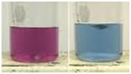

Complexometric Titration:

This type of titration depends upon the combination of ions (other than H⁺ and OH⁻) to form a soluble ion or compound as in the titration of a solution of a cyanide with AgNO₃.

Principle of Complexometric Titration:

Complexometric titrations are particularly useful for determination of a mixture of different metal ions in solution. Ethylene diamine tetra acetic acid (EDTA), is a very important reagent for complex formation titrations. EDTA has been assigned the formula II in preference to I since it has been obtained from measurements of the dissociation constants that two hydrogen atoms are probably held in the form of zwitter ions.
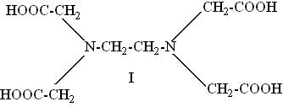

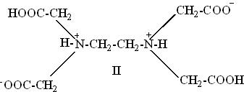

EDTA behaves as a dicarboxylic acid with two strongly acidic groups. For simplicity EDTA may be given the formula H₄Y, the disodium salt is therefore Na₂H₂Y and it has the complex forming ion H₂Y²⁻ in aqueous solution. The reactions with cations may be represented as;

M²⁺ + H₂Y ₂⁻→ MY²⁻ + 2H⁺
M³⁺ + H₂Y ₂⁻→ MY⁻ + 2H⁺
M⁴⁺+ H₂Y ₂⁻→ MY + 2H⁺

One gram ion of the complex-forming ion H₂Y²⁻ reacts in all cases with one gram ion of the metal. EDTA forms complexes with metal ions in basic solutions. In acid-base titrations the end point is detected by a pH sensitive indicator. In the EDTA titration metal ion indicator is used to detect changes of pM. It is the negative logarithm of the free metal ion concentration, i.e., pM = - log [M²⁺]. Metal ion complexes form complexes with specific metal ions. These differ in colour from the free indicator and a sudden colour change occurs at the end point. End point can be detected usually with an indicator or instrumentally by potentiometric or conductometric (electrometric) method.

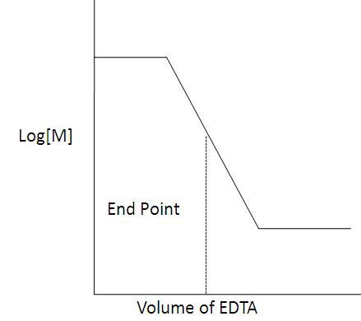

There are three factors that are important in determining the magnitude of break in titration curve at end point.

- The stability of complex formed: The greater the stability constant for complex formed, larger the charge in free metal concentration (pM) at equivalent point and more clear would be the end point.
- The number of steps involved in complex formation: Fewer the number of steps required in the formation of the complex, greater would be the break in titration curve at equivalent point and clearer would be the end point.
- Effect of pH: During a complexometric titration, the pH must be constant by use of a buffer solution. Control of pH is important since the H⁺ ion plays an important role in chelation. Most ligands are basic and bind to H⁺ ions throughout a wide range of pH. Some of these H⁺ ions are frequently displaced from the ligands (chelating agents) by the metal during chelate formation.
- Equation below shows complexation between metal ion and H⁺ ion for ligand:

M₂⁺ + H₂-EDTA → M-EDTA + 2H⁺

Thus, stability of metal complex is pH dependent. Lower the pH of the solution, lesser would be the stability of complex (because more H⁺ ions are available to compete with the metal ions for ligand). Only metals that form very stable complexes can be titrated in acidic solution, and metals forming weak complexes can only be effectively titrated in alkaline solution.

Procedure:

- Under the chemical content, select the tests- Hardness, Alkalinity or COD.

a. Determination of Hardness of Water Sample

- Select the titrant.
- Adjust the speed of the drops from the burette.
- Adjust the molarity of titrant.
- Select a definite volume of water sample.
- Choose the indicator & start the titration.
- When colour changes from wine red to blue click the "stop" button & note the volume of EDTA used.
- Then calculate the hardness of water sample in ppm using the equation as follows.

Self-Evaluation:

  - The hardness of a water sample is usually a measure of
- Na²⁺ and Cl⁻
- Ca²⁺ and Mg²⁺
- Na²⁺ and Mg²⁺
- Ca²⁻ and OH⁻

Assignments:
1. The hardness of 1000 litres of a water sample was completely removed by a zeolites softener. The zeolites had required 30 litres of NaCl solution, containing 1,500mg/L of NaCl for regeneration. Calculate the hardness of the water sample?

1 Litre of NaCl Soln. =1500 mg of NaCl
1000 litres of NaCl Soln. =1000 x 1500 gm of NaCl
= 1500000 gm of NaCl

Quantity of NaCl in terms of CaCO₃ eq. hardness = 1500000 x 5
58.5 gm
= 128205.128 gm of CaCO₃ eq.
= 128.20 x 10⁶ gm
Hardness of 1000 L of water =128.20 x 10⁶ gm
Hardness of 1L of water = 128.20 x 10⁶
1000
= 128200 ppm

2. 1 gm of CaCO3 was dissolved in HCl and the solution was made up to 1 Liter with distilled water. 50 ml of the above solution required 30 ml of EDTA solution for titration. 50 ml of hard water sample required 40 ml of the same solution of EDTA for titration. 50 ml of the hard water after boiling, filtering, etc. required 30 ml of the same EDTA solution for titration. Calculate the temporary hardness of the water.

Concentration of S.H.W. = 1 gm CaCO3/ 1 ml D.W.= 1 mgs in 1 ml water=1mg/ml

50 ml SHW required = 30 ml of EDTA solution

∴ 1 ml EDTA solution = 50/30 mgs CaCO3 equivalent hardness.

50 ml water sample = 40 ml EDTA solution.

∴ hardness of sample = (40 x 50/30) mgs CaCO3 equivalents for 50 ml sample.

Hardness per litre of sample = (40 x 50/30) x 1000/50 mgs/lit.

Total hardness = 1333.33 ppm

50 ml water sample after boiling = 30 ml EDTA solution

Permanent hardness of sample = 30 x 50/30 mgs CaCO3 equivalent for 50 ml.

Permanent hardness of one litre sample = (30 x 50/30)x1000/50 mgs/lit.

Permanent hardness of sample = 1000 ppm

Temporary hardness = total hardness – permanent hardness= 1333.33– = 333.33

3. 0.28g CaCO3 was dissolved in HCl and made upto 1L with distilled water. 100ml of this solution required 28ml EDTA solution. 100ml of hard water sample required 33ml of EDTA solution. After boiling, cooling and filtering, 100ml of the solution required 10ml of EDTA. Calculate hardness.
Solution: Total Hardness= 330ppm; Permanent hardness= 100ppm; Temporary hardness= 230ppm
ANS.

Concentration of S.H.W. = 0.28 gm CaCO3/ 1 ml D.W.= 1 mgs in 1 ml water=1mg/ml

100 ml SHW required = 28 ml of EDTA solution

∴ 1 ml EDTA solution = 100/28 mgs CaCO3 equivalent hardness.

100 ml water sample = 33 ml EDTA solution.

∴ hardness of sample = (33x 100/10) mgs CaCO3 equivalents for 100 ml sample.

Hardness per litre of sample = (33 x 100/10) x 100/100 mgs/lit.

Total hardness = 330 ppm

100 ml water sample after boiling = 10 ml EDTA solution

Permanent hardness of sample = 10 x 100/10 mgs CaCO3 equivalent for 50 ml.

Permanent hardness of one litre sample = (10 x 100/10)x100/100mgs/lit.

Permanent hardness of sample = 100 ppm

Temporary hardness = total hardness – permanent hardness= 330– 100
=230ppm
Observation:

Part-1: Well Water

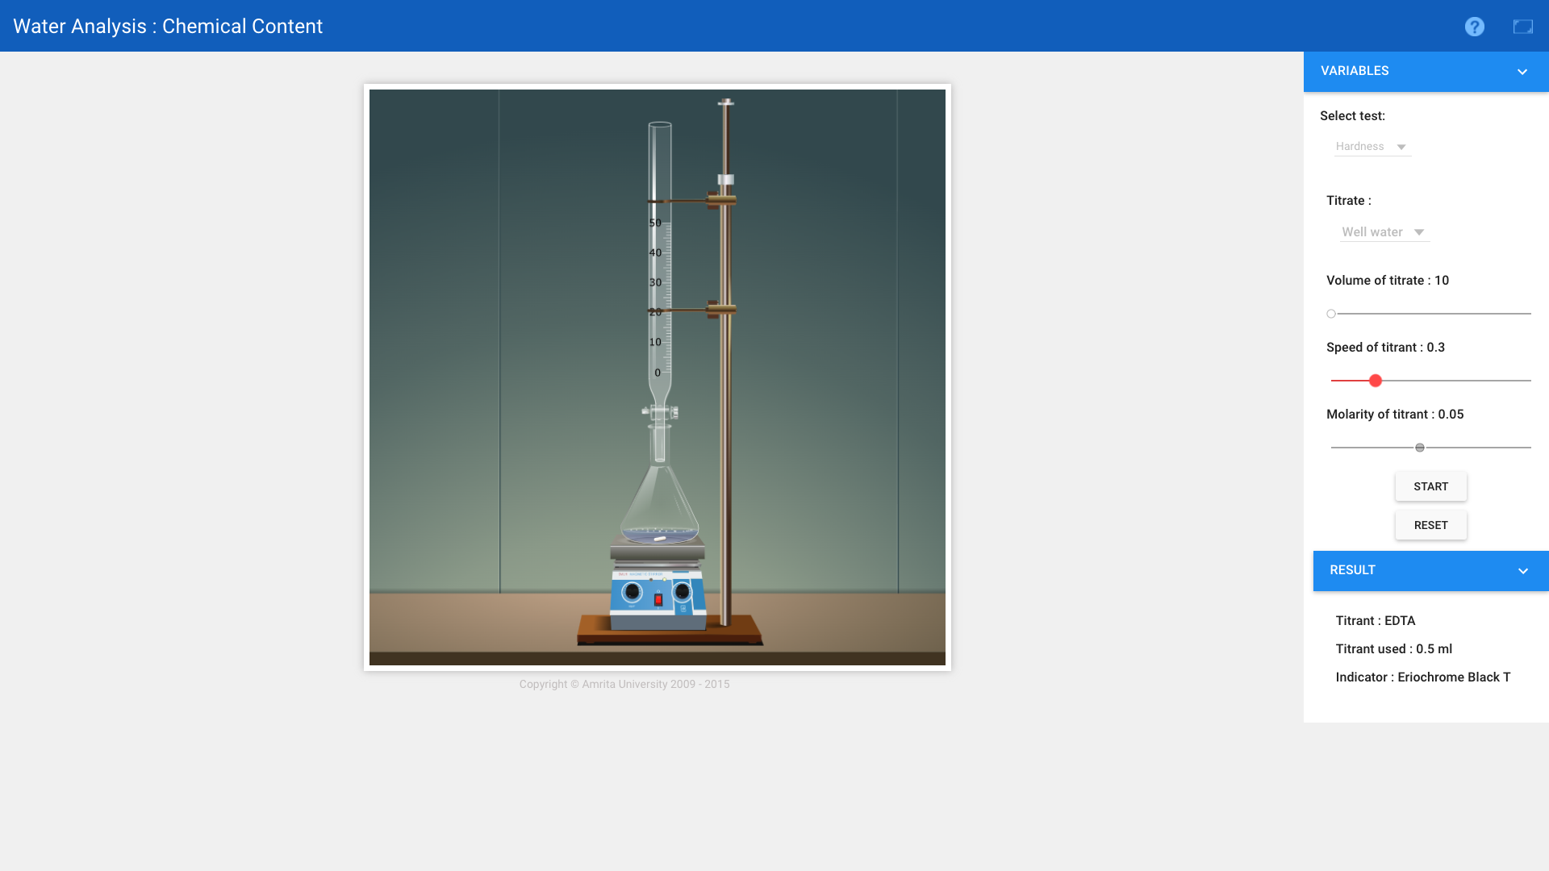
Burette : 0.05 M EDTA solution

Conical flask : 10 mL of sample + Indicator

Indicator : EBT

End point : Wine red to Blue

Reaction:
(Ca⁺² + Mg⁺²) + EBT + Buffer (pH 9-10) → (Ca-EBT + Mg-EBT) complex
(Hard water) (Indicator) (Unstable wine-red complex)

[Ca-EBT + Mg-EBT] complex + EDTA → EBT + [Ca-EDTA + Mg-EDTA] complex
(Unstable wine-red complex) (Blue) (Stable colourless complex)

Pilot Reading : 0.0 (mL) to 1.0 (mL)
Reading | I  (mL) | II  (mL) | III  (mL) | Constant  (mL)
Initial | 0.0 | 0.0 | 0.0 | 0.5  V₁
Final | 0.5 | 0.5 | 0.5
Difference | 0.5 | 0.5 | 0.5

Part-2: Tap Water
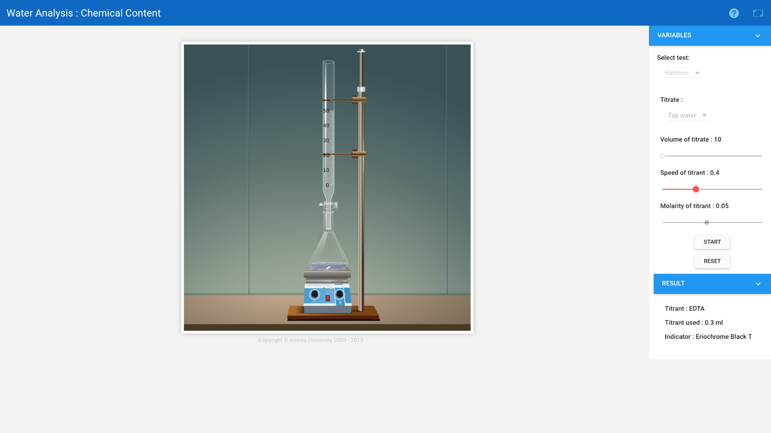
Burette : 0.05 M EDTA solution

Conical flask : 10 mL of sample + Indicator

Indicator : EBT

End point : Wine red to Blue

Reaction:
(Ca⁺² + Mg⁺²) + EBT + Buffer (pH 9-10) → (Ca-EBT + Mg-EBT) complex
(Hard water) (Indicator) (Unstable wine-red complex)

[Ca-EBT + Mg-EBT] complex + EDTA → EBT + [Ca-EDTA + Mg-EDTA] complex
(Unstable wine-red complex) (Blue) (Stable colourless complex)

Pilot Reading : 0.0 (mL) to 1.0 (mL)
Reading | I  (mL) | II  (mL) | III  (mL) | Constant  (mL)
Initial | 0.0 | 0.0 | 0.0 | 0.8  V2
Final | 0.3 | 0.3 | 0.4
Difference | 0.3 | 0.3 | 0.4

Part-3: Sea Water

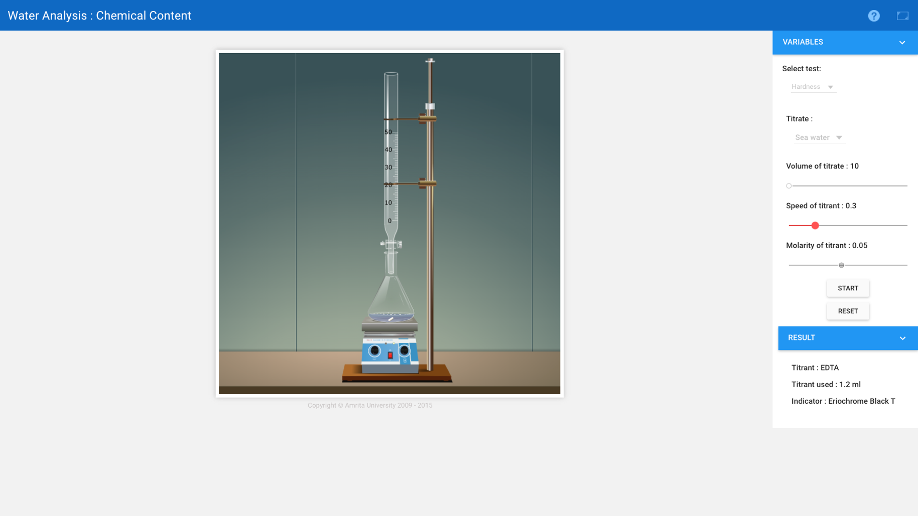
Burette : 0.05 M EDTA solution

Conical flask : 10 mL of sample + Indicator

Indicator : EBT

End point : Wine red to Blue

Reaction:
(Ca⁺² + Mg⁺²) + EBT + Buffer (pH 9-10) → (Ca-EBT + Mg-EBT) complex
(Hard water) (Indicator) (Unstable wine-red complex)

[Ca-EBT + Mg-EBT] complex + EDTA → EBT + [Ca-EDTA + Mg-EDTA] complex
(Unstable wine-red complex) (Blue) (Stable colourless complex)

Pilot Reading : 1.0 (mL) to 2.0 (mL)
Reading | I  (mL) | II  (mL) | III  (mL) | Constant  (mL)
Initial | 0.0 | 0.0 | 0.0 | 1.2  V₃
Final | 1.2 | 1.3 | 1.2
Difference | 1.2 | 1.3 | 1.2

Calculation:

Formula:

Total Hardness (ppm)= Vol. of EDTA (ml) x 0.1 x M_{EDTA} x 10⁶

Vol. of Sample (ml)

Part-1: Well water

Total Hardness (ppm) = Vol. of EDTA (ml) x 0.1 x M_{EDTA} x 10⁶

Vol. of Sample (ml)

= 0.5 x 0.1 x 0.05 x 10⁶

10
= 250.0 ppm

Part-2: Tap water

Total Hardness (ppm) = Vol. of EDTA (ml) x 0.1 x M_{EDTA} x 10⁶

Vol. of Sample (ml)
= 0.3 x 0.1 x 0.05 x 10⁶
10
= 150.0 ppm

Part-3: Sea water

Total Hardness (ppm) = Vol. of EDTA (ml) x 0.1 x M_{EDTA} x 10⁶

Vol. of Sample (ml)

= 1.2 x 0.1 x 0.05 x 10⁶
10
= 600.0ppm

Result:
- The total hardness of well water = 250.0 ppm.

- The total hardness of tap water = 150.0 ppm.

- The total hardness of sea water = 600.0 ppm.

Conclusion:

Total hardness of Well Water is 250.0 ppm , Tap Water is 150.0 ppm and Sea Water is 600.0 ppm is observed.

