CO4. Apply the knowledge of green chemistry and nanotechnology for solving the problems of society in sustainable and greener way.
Name: Pargat Singh
Batch: A2
Roll No. : 16010121045
Date: 17/11/2021

Experiment No. 4
Title: To determine the chemical pollutants in water samples using advanced analytical techniques.

Aim:

To determine chemical parameters such as chemical oxygen demand (COD) of water samples.

Theory:

It is needless to emphasize the importance of water in our life. Without water, there is no life on our planet. We need water for different purposes. We need water for drinking, for industries, for irrigation, for swimming and fishing, etc.
Water for different purposes has its own requirements for composition and purity. Each body of water needs to be analysed on a regular basis to confirm to suitability. The types of analysis could vary from simple field testing for a single analyte to laboratory based multi-component instrumental analysis. The measurement of water quality is a very exacting and time consuming process, and a large number of quantitative analytical methods are used for this purpose.

Chemical Oxygen Demand (COD):

Theory:

COD is used as a measure of oxygen equivalent to organic matter content of a sample that is susceptible to oxidation by a strong chemical oxidant. For samples from a specific source, COD can be related empirically to BOD. COD determination has advantage over BOD determination in that the result can be obtained in about 5 hours as compared to 5 days required for BOD test.

The organic matter gets oxidized completely by K₂Cr₂O₇ in the presence of H₂SO₄ to produce CO₂ and H₂O. The excess of K₂Cr₂O₇ remained after the reaction is titrated with ferrous ammonium sulphate. The dichromate consumed gives the O₂ required for oxidation of organic matter.

DRINKING WATER QUALITY STANDARDS:

Sl. No. | Characteristic/Parameter | BIS | ICMR | WHO
1 | Colour | 5 | 2.5 | -
2 | Odour | Agreeable | Unobjectionable | Unobjectionable
3 | Turbidity | 10 NTU | 5 NTU | 2.5 NTU
4 | pH | 6.5-8.5 | 7.0-85 | 7.0-8.5
5 | TDS | 500 mgl | 500 mgl | 500 mgl
6 | Hardness | 300 mgl | 300 mgl | 200 mgl
7 | Ca | 75 mgl | 75 mgl | 75 mgl
8 | Mg | 30 mgl | 50 mgl | 30 mgl
9 | CL | 250 mgl | 200 mgl | 200 mgl
10 | Sulphate | 200 mgl | 200 mgl | 200 mgl
11 | Fe | 0.3 mgl | 0.1 mgl | 0.1 mgl
12 | Nitrate | 45 mgl | 20 mgl | 45 mgl
13 | Phenolic compounds | 0.001 mgl | 0.001 mgl | 0.001 mgl
14 | Cd, Sc | 0.01 mgl | - | 0.01 mgl
15 | Cu, As | 0.05 mgl | 0.05 mgl | 0.01 mgl
16 | Cyanides | 0.05 mgl | - | 0.01 mgl
17 | Pb | 0.1 mgl | - | 0.01 mgl
18 | Anionic detergents | 0.2 mgl | - | -
19 | PAH | - | - | -
20 | Residual Chlorine | 0.2 mgl | - | -
21 | Pesticides | Absent | - | -

BIS- Beaurau of Indian Standards.
ICMR- Indian Council for Medical Research.
WHO- World Health Organization.

Self-Evaluation:

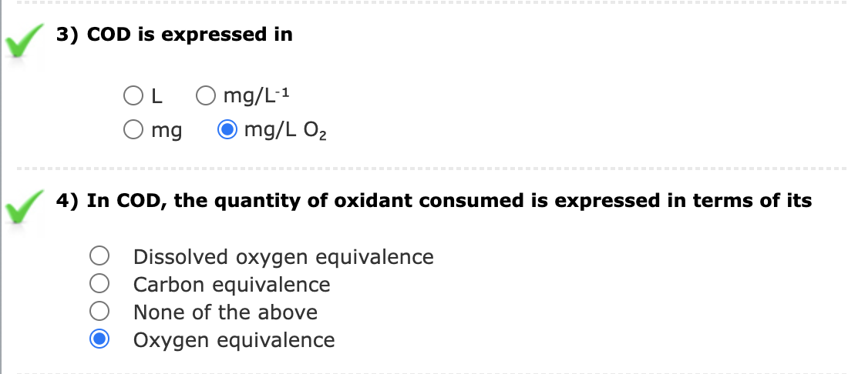

Assignments:

- A 50 ml of sample contains 840 ppm dissolved oxygen. After 5 days the dissolve oxygen value becomes 230 ppm after the sample has been diluted to 80 ml. Calculate the BOD of sample.

Given: (DO)_{blank} = 840 ppm
(DO)_{incubated} = 230 ppm
Volume of sample before dilution = 50 ml
Volume of sample after dilution = 80 ml
To Find : BOD
Formula:
BOD = [(DO)_{Blank} – (DO)_{Incubated} ] x Dilution Factor
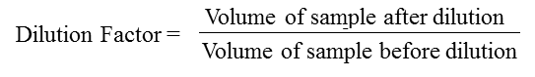

Solution:
Using given formula,
BOD = (840-230)*80/50
= 816 ppm

- A 25 ml of sewage water sample was refluxed with 10 ml of 0.25 N K₂Cr₂O₇ solution of dil. H₂SO₄ . The unreacted dichromate required 6.5 ml of 0.1 N ferrous ammonium sulphate. 10ml of the same K₂Cr₂O₇ solution and 25 ml of distilled water under the same conditions as the sample required 27ml of 0.1 N FAS . Calculate the COD of sewage sample.

Given : Volume of FAS required for blank titration = 27 ml
Volume of FAS required for reaction after mass time = 6.5
Normality of FAS= 0.1 N
Volume of waste water sample taken = 25 ml
To find: COD of sewage sample
Formula:
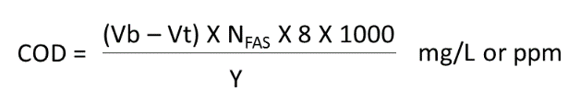
Solution:
Using the given formula,
COD of sewage water = (25 – 6.5) * 0.1*8*1000
25
=656 mg/L

Observation:
Part-1: Blank Water
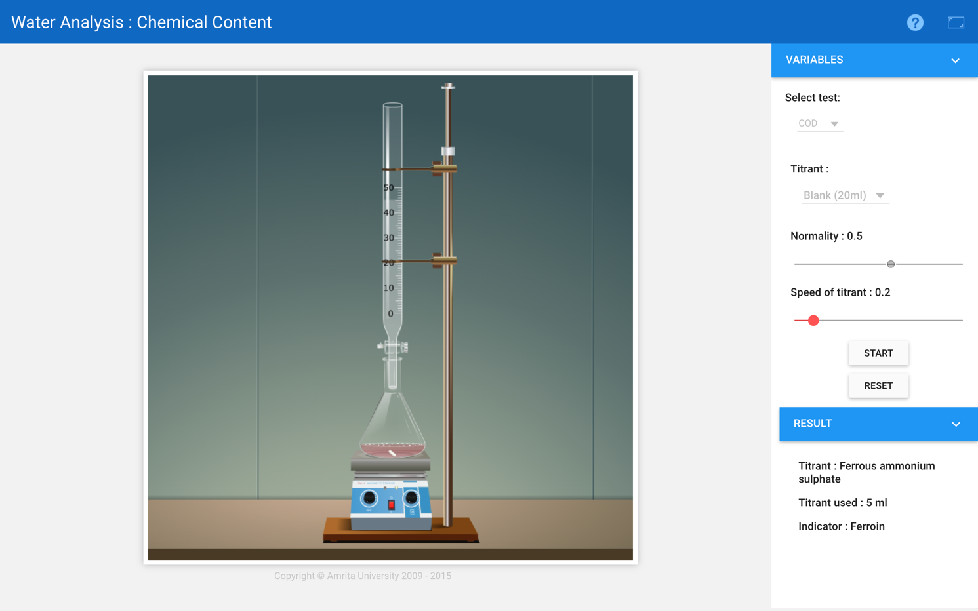
Burette : 0.5 N FAS solution
Conical flask : 20 mL of blank + Indicator
Indicator : Ferroin
End point : Blue to Wine red

Reaction:

C_{x}H_{y}O_{z} + (X + Y/4 – Z/2) O₂ → XCO₂ + Y/2H₂O
Cr₂O₇⁻² + 14H⁺ + 6e⁻_ → 2Cr⁺³ + 7H₂O
[Fe⁺² → Fe⁺³ + e⁻] x 6
Cr₂O₇⁻² + 14H⁺ + 6Fe⁺² → 2Cr⁺³ + 6Fe⁺³ + 7H₂O
Pilot Reading : 4.0 (mL) to 5.0 (mL)
Reading | I  (mL) | II  (mL) | III  (mL) | Constant  (mL)
Initial | 0.0 | 0.0 | 0.0 | 5.0  V₁
Final | 4.9 | 5.0 | 5.0
Difference | 4.9 | 5.0 | 5.0

Part-2: Tap Water
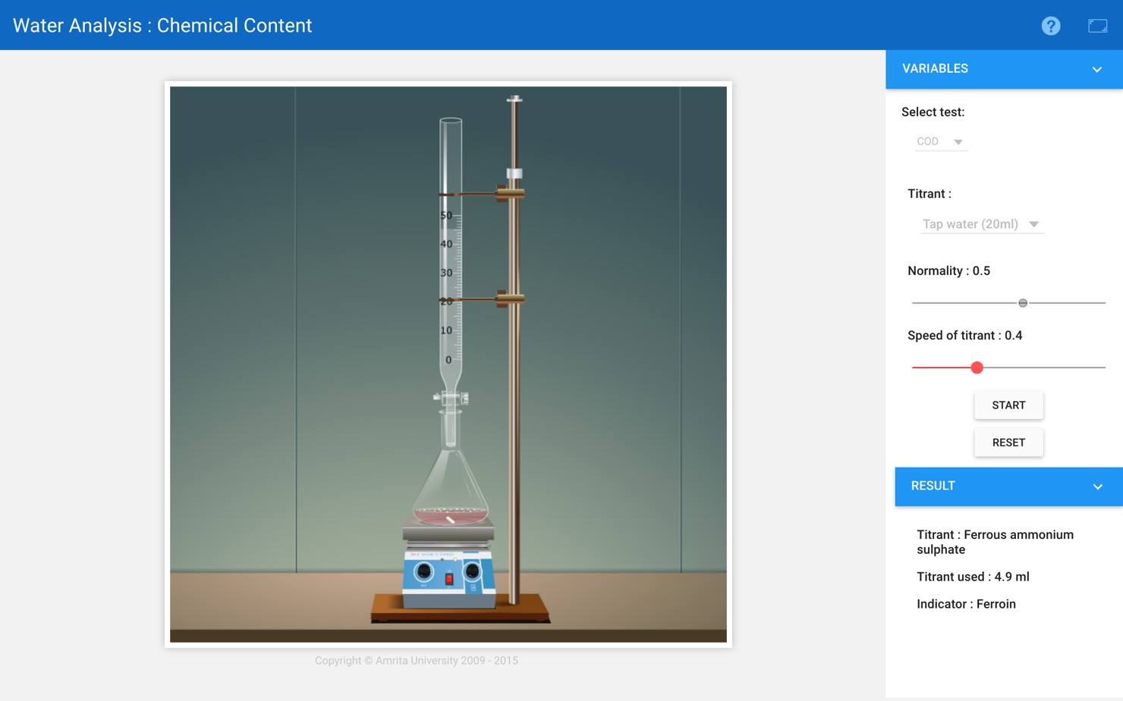
Burette : 0.5 N FAS solution
Conical flask : 20ml of Tap Water + Indicator
Indicator : Ferroin
End point : Blue to Wine red
Reaction:
C_{x}H_{y}O_{z} + (X + Y/4 – Z/2) O₂ → XCO₂ + Y/2H₂O
Cr₂O₇⁻² + 14H⁺ + 6e⁻_ → 2Cr⁺³ + 7H₂O
[Fe⁺² → Fe⁺³ + e⁻] x 6
Cr₂O₇⁻² + 14H⁺ + 6Fe⁺² → 2Cr⁺³ + 6Fe⁺³ + 7H₂O

Pilot Reading : 4.0 (mL) to 5.0 (mL)
Reading | I  (mL) | II  (mL) | III  (mL) | Constant  (mL)
Initial | 0.0 | 0.0 | 0.0 | 4.9  V₂
Final | 4.9 | 4.9 | 4.9
Difference | 4.9 | 4.9 | 4.9

Part-3: Well Water
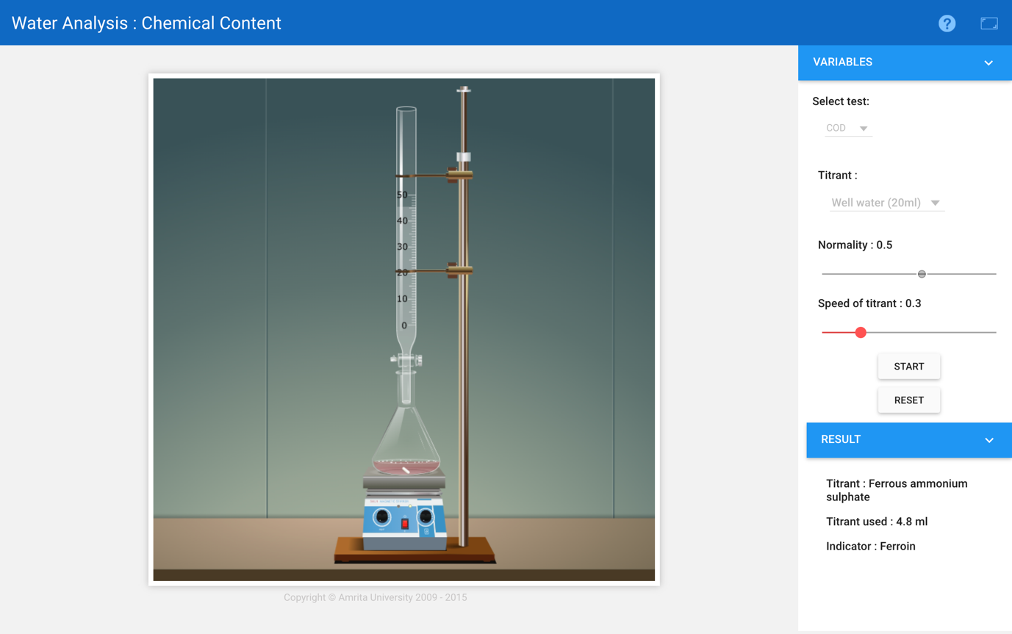
Burette : 0.5 N FAS solution
Conical flask : 20 mL of Well Water + Indicator
Indicator : Ferroin
End point : Blue to Wine red
Reaction:
C_{x}H_{y}O_{z} + (X + Y/4 – Z/2) O₂ → XCO₂ + Y/2H₂O
Cr₂O₇⁻² + 14H⁺ + 6e⁻_ → 2Cr⁺³ + 7H₂O
[Fe⁺² → Fe⁺³ + e⁻] x 6
Cr₂O₇⁻² + 14H⁺ + 6Fe⁺² → 2Cr⁺³ + 6Fe⁺³ + 7H₂O

Pilot Reading : 4.0 (mL) to 5.0 (mL)
Reading | I  (mL) | II  (mL) | III  (mL) | Constant  (mL)
Initial | 0.0 | 0.0 | 0.0 | 4.8  V₃
Final | 4.8 | 4.8 | 4.8
Difference | 4.8 | 4.8 | 4.8

Part-4: Domesticated Water
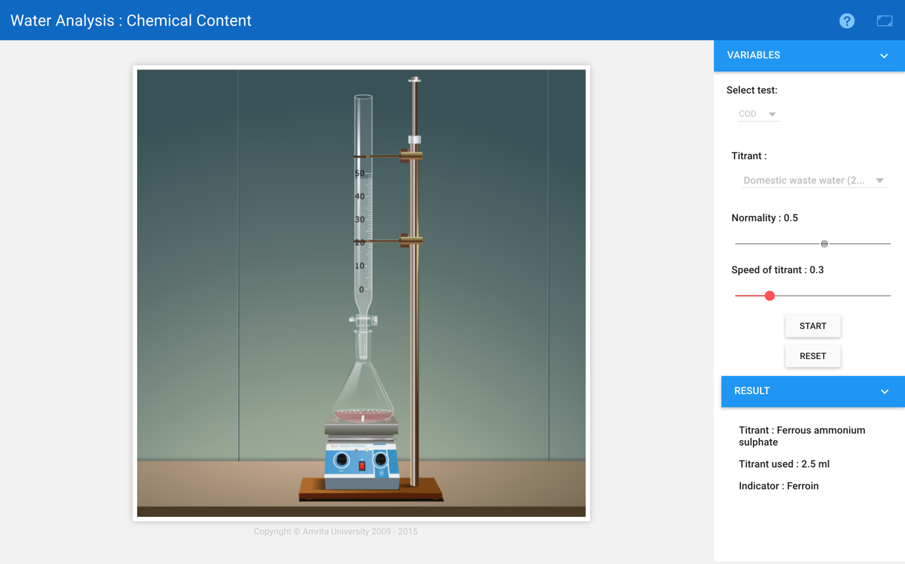

Burette : 0.5 N FAS solution
Conical flask : 20 mL of Domestic Waste Water + Indicator
Indicator : Ferroin
End point : Blue to Wine red
Reaction:
C_{x}H_{y}O_{z} + (X + Y/4 – Z/2) O₂ → XCO₂ + Y/2H₂O
Cr₂O₇⁻² + 14H⁺ + 6e⁻_ → 2Cr⁺³ + 7H₂O
[Fe⁺² → Fe⁺³ + e⁻] x 6
Cr₂O₇⁻² + 14H⁺ + 6Fe⁺² → 2Cr⁺³ + 6Fe⁺³ + 7H₂O

Pilot Reading : 2.0 (mL) to 3.0(mL)
Reading | I  (mL) | II  (mL) | III  (mL) | Constant  (mL)
Initial | 0.0 | 0.0 | 0.0 | 2.5  V₄
Final | 2.5 | 2.5 | 2.5
Difference | 2.5 | 2.5 | 2.5

Calculation:

Formula:

COD (ppm)= Vol. of FAS x Normality of FAS x 8000

Vol. of Sample (ml)

Part-1: Tap water

Vol of FAS= 5ml - 4.9ml = 0.1 ml

Therefore,

COD = $\frac{0.1 x 0.5 x 8000}{20}$

COD = 20 ppm

Part-2: Well water

Vol of FAS= 5ml - 2.5ml = 0.2 ml

Therefore,

COD = $\frac{0.2 x 0.5 x 8000}{20}$

COD = 40 ppm

Part-3: Domestic Waste water

Vol of FAS= 5ml - 2.5ml = 2.5 ml

Therefore,

COD = $\frac{2.5 x 0.5 x 8000}{20}$

COD = 500 ppm

Result:
- The COD of tap water= 20 ppm.

- The COD of well water= 40 ppm.

- The COD of domesticated water = 500 ppm.

Conclusion:

The COD of Well Water is 40.0 ppm , Tap Water is 20.0 ppm and Domesticated Water is 500.0 ppm is observed.

