Name: Pargat Singh
Batch: A2
Roll No.: 16010121045
Date: 24/11/2021
CO2: Demonstrate and analyse the knowledge of polymeric for futuristic engineering applications.

Experiment No. 5
Determine the viscosity average molecular weight of a polymer

Aim: Determine the viscosity average molecular weight of a polymer

Theory:
Viscosity is an internal property of a fluid that offers resistance to flow. It is due to the internal friction of molecules and mainly depends on the nature & temperature of the liquid.
Many methods are available for measuring viscosity of polymer solution. The Ostwald method is a simple method for the measurement of viscosity, in which viscosity of liquid is measured by comparing the viscosity of an unknown liquid with that of liquid whose viscosity is known. In this method viscosity of liquid is measured by comparing the flow times of two liquids of equal volumes using same viscometer.

Consider two liquids are passing through a capillary of same viscometer. Then the coefficient of viscosity of liquid (η₂) is given by equation

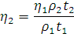

Here t₁ and t₂ are the time of flow of the liquids and ρ₁ and ρ₂ are the respective densities. And η₁ is the coefficient of viscosity of water.
For a given liquid η has a specific value at the same temperature.
Various mixtures of two non-interacting liquids viscosities will lie among the viscosities of those pure components.
The time of flow of liquid depends on the viscosity and composition. In this method the flow times are measured for different known compositions and a graph is plot for time of flow and compositions. The unknown composition can be determined by plotting a graph for the time of flow and compositions.

The molecular weight of the polymer is measured by using viscometer and the molecular weight obtained by this technique is called viscosity average molecular weight. The molecular weight of the polymer solution is very high so the viscosity of polymer solution is very high compared to that of pure solvent.

From the Mark-Houwink equation the relationship among the molecular weight and viscosity are given below

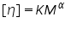

Where is the intrinsic viscosity , is Molecular weight, and are constants for a particular polymer solvent system.
If we know the and values for a given polymer solution the intrinsic viscosity and molecular weight can be calculate using the above equation.

Polymer-solvent system | K x 10³mL/g
PMMA-Acetone | 7.70 | 0.70
PMMA-Benzene | 5.20 | 0.76
PMMA-Toluene | 7.0 | 0.71
Poly vinyl acetate-Acetone | 10.2 | 0.72
Poly vinyl acetate-Benzene | 56.3 | 0.62
Poly vinyl acetate-Acetonitrile | 41.5 | 0.62
Poly vinyl alcohol-Water | 45.3 | 0.64
Poly styrene-Benzene | 10.6 | 0.735
Poly styrene-Toluene | 11.0 | 0.725

Terms Related to Viscosity Measurements:-

Relative Viscosity = 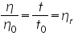

Specific Viscosity =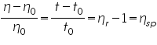
Reduced Viscosity = 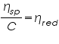
Inherent Viscosity = 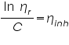
Intrinsic Viscosity = 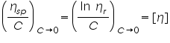

For measuring intrinsic viscosity of polymer sample, solutions of known concentrations are prepared, the flow times of solvent () and the solutions () are measured using viscometer. Double extrapolation plots of reduced viscosity against concentration and inherent viscosity against concentration is plotted by calculating the corresponding reduced viscosity and inherent viscosity. The intrinsic viscosity is given by the common ordinate intercept of these graphs.

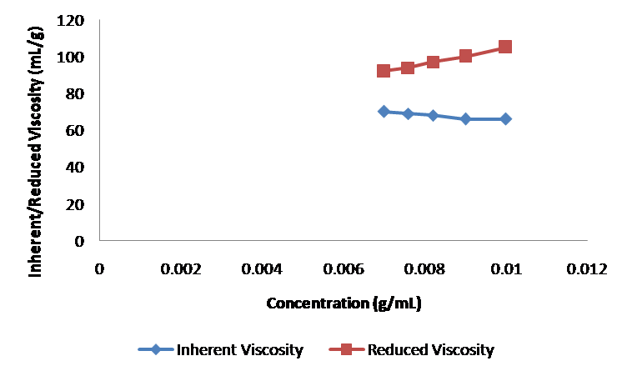

Procedure:

Determining the Intrinsic Viscosity of the Polymer- solvent system:

- Select the Polymer.
- Select the Solvent.
- Determine the Time of flow of the solvent (t₀).
- Determine the time of flow of polymer-solvent system at different concentrations.
- From the concentration and time of flow, the inherent viscosity and reduced viscosity are calculated using the equations; Inherent Viscosity =  , Reduced Viscosity = 
- A graph is drawn by plotting reduced viscosity against concentration and inherent viscosity against concentration.
- Intrinsic viscosity can be obtained by extrapolating the graph to zero concentration.
- From the value of intrinsic viscosity, the viscosity average molecular weight of the polymer can be calculated by using the equation.

Self Evaluation :
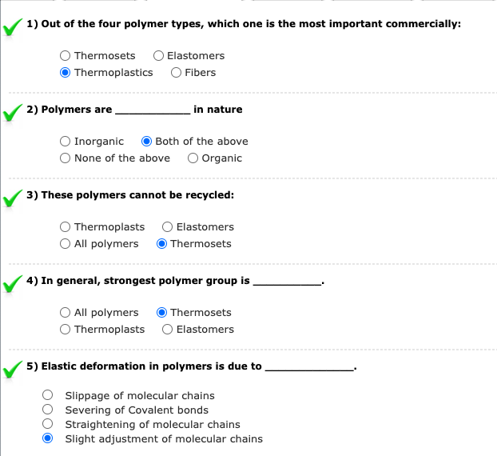

Assignment:

- Viscosity is an important property of a polymer melt in plastics shaping processes. Upon what three parameters does viscosity depend?

Ans) Viscosity of a polymer depends on the following 3 factors:
- Temperature
- Concentration
- Molecular Weight

- How does the viscosity of a polymer melt differ from most fluids that are Newtonian.

Ans)
Polymer Melt | Newtonian Fluid
Viscosity varies with temperature and shear rate. | Viscosity changes with temperature but is constant with change in shear rate.
Viscosity changes if enough pressure is applied | Viscosity will remain constant regardless of pressure applied.
Example: Glue | Example: Water

- What does viscoelasticity mean, when applied to a polymer melt?
Ans) Specifically viscoelasticity is a molecular rearrangement when stress is applied to a polymer melt, parts of the polymer chain change positions. This movement or rearrangement is called creep.

- Which one of the following is the chemical formula for the repeating unit in polyethylene:

(a) CH₂ (b) C₂H₄ (c) C₃H₆ (d) C₅H₈ (e) C₈H₈

- Use of a parison is associated with which one of the following plastic shaping processes:

(a) bi-injection molding (b) blow molding
(c) compression molding (d) pressure thermoforming

Observation:
Solvent System
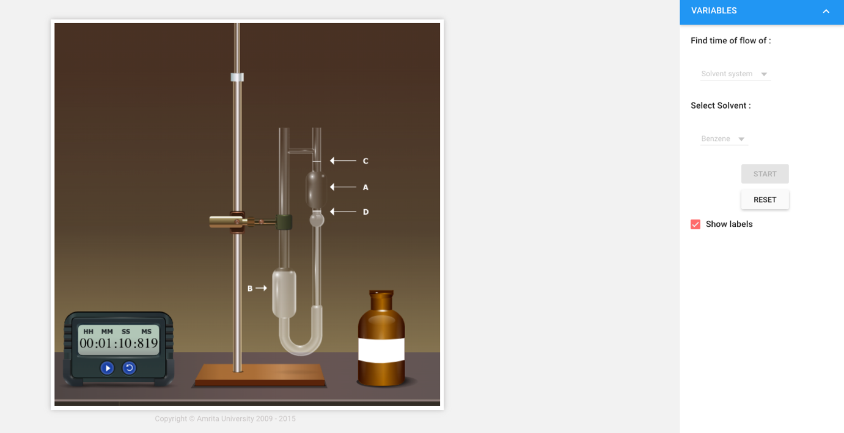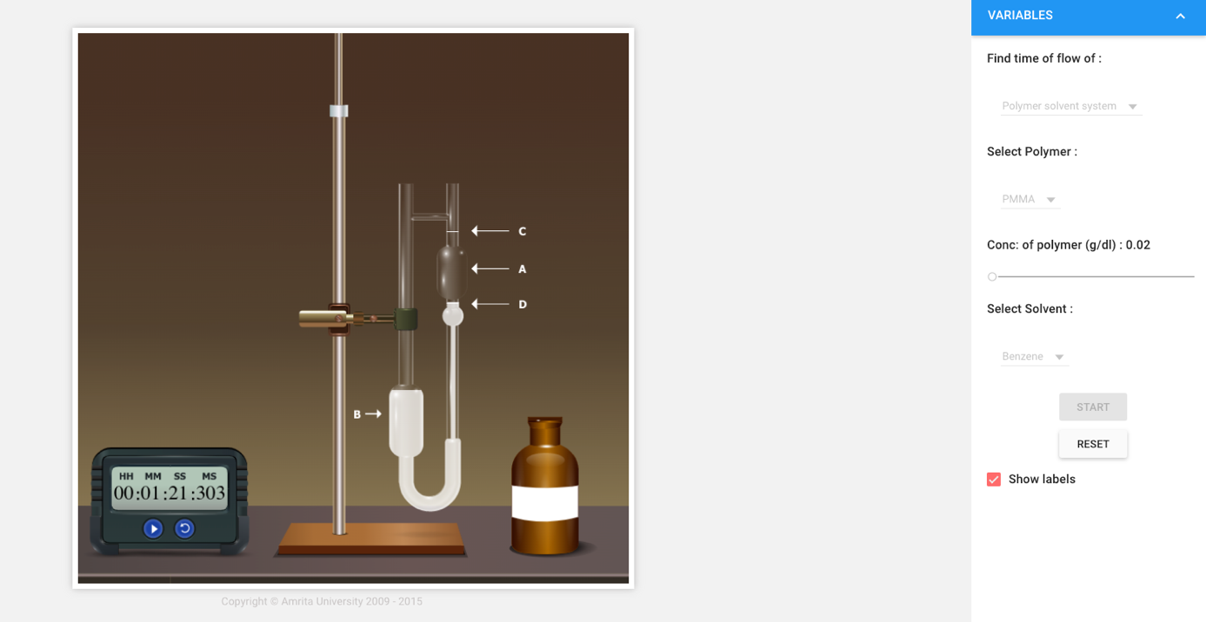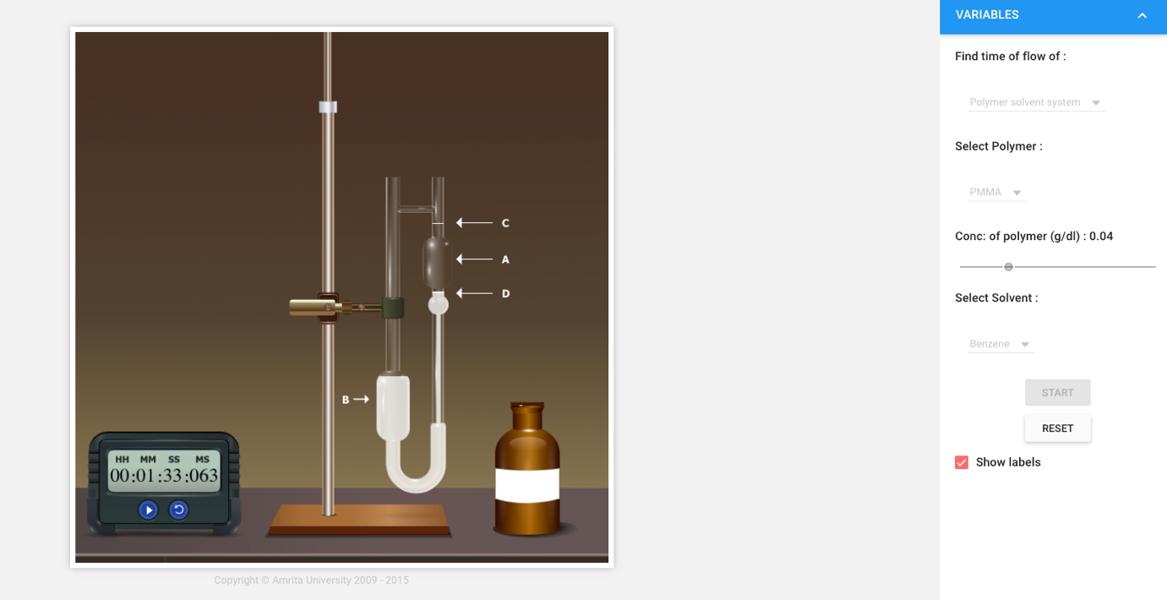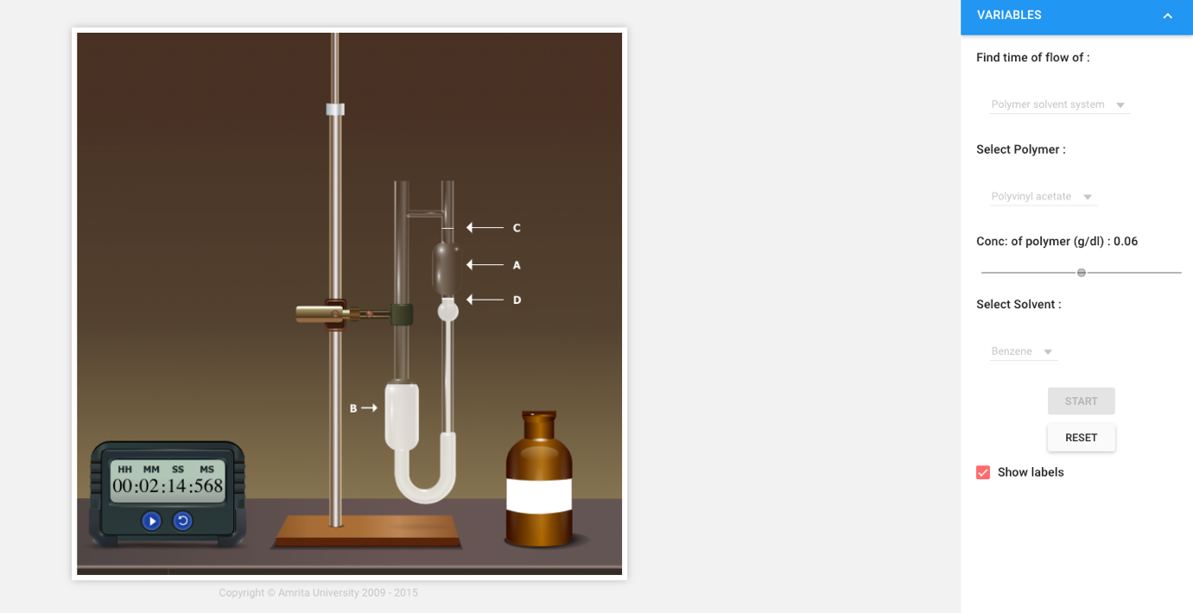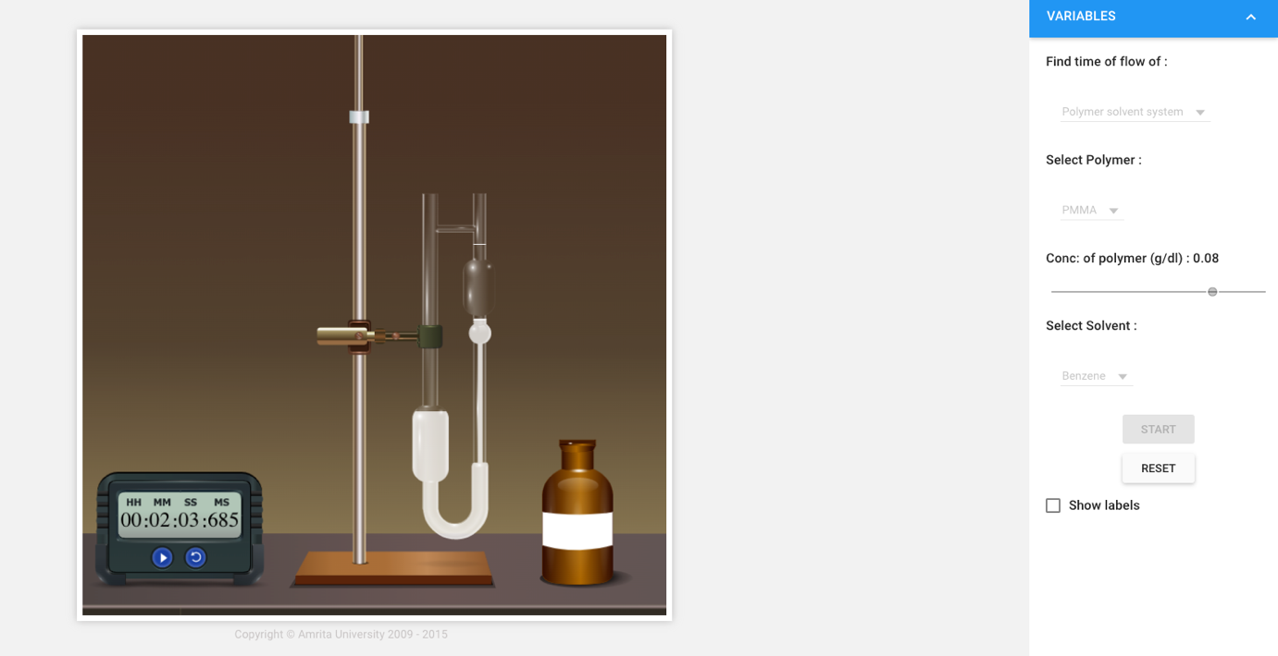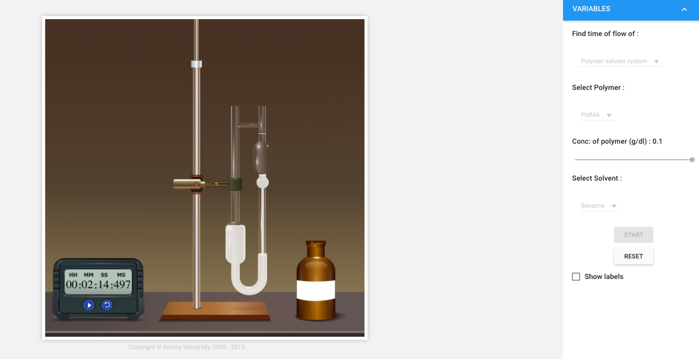

Polymer Solvent System: PMMA-Benzene

Conc:  (g/dl) | Flow Time of Polymer-Solvent system  (t) sec | Flow Time of Solvent  (t₀) sec | 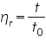 |  | Reduced Viscosity,  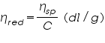 |  | Inherent Viscosity,  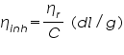
0.02 | 81 s | 70 s | 1.16 | 0.16 | 8 | 0.15 | 7.5
0.04 | 93 s | 70 s | 1.19 | 0.19 | 4.75 | 0.17 | 4.25
0.06 | 134 s | 70 s | 1.91 | 0.91 | 15.17 | 0.65 | 10.83
0.08 | 123 s | 70 s | 1.76 | 0.76 | 9.5 | 0.57 | 7.13
0.1 | 134 s | 70 s | 1.91 | 0.91 | 9.1 | 0.65 | 6.5

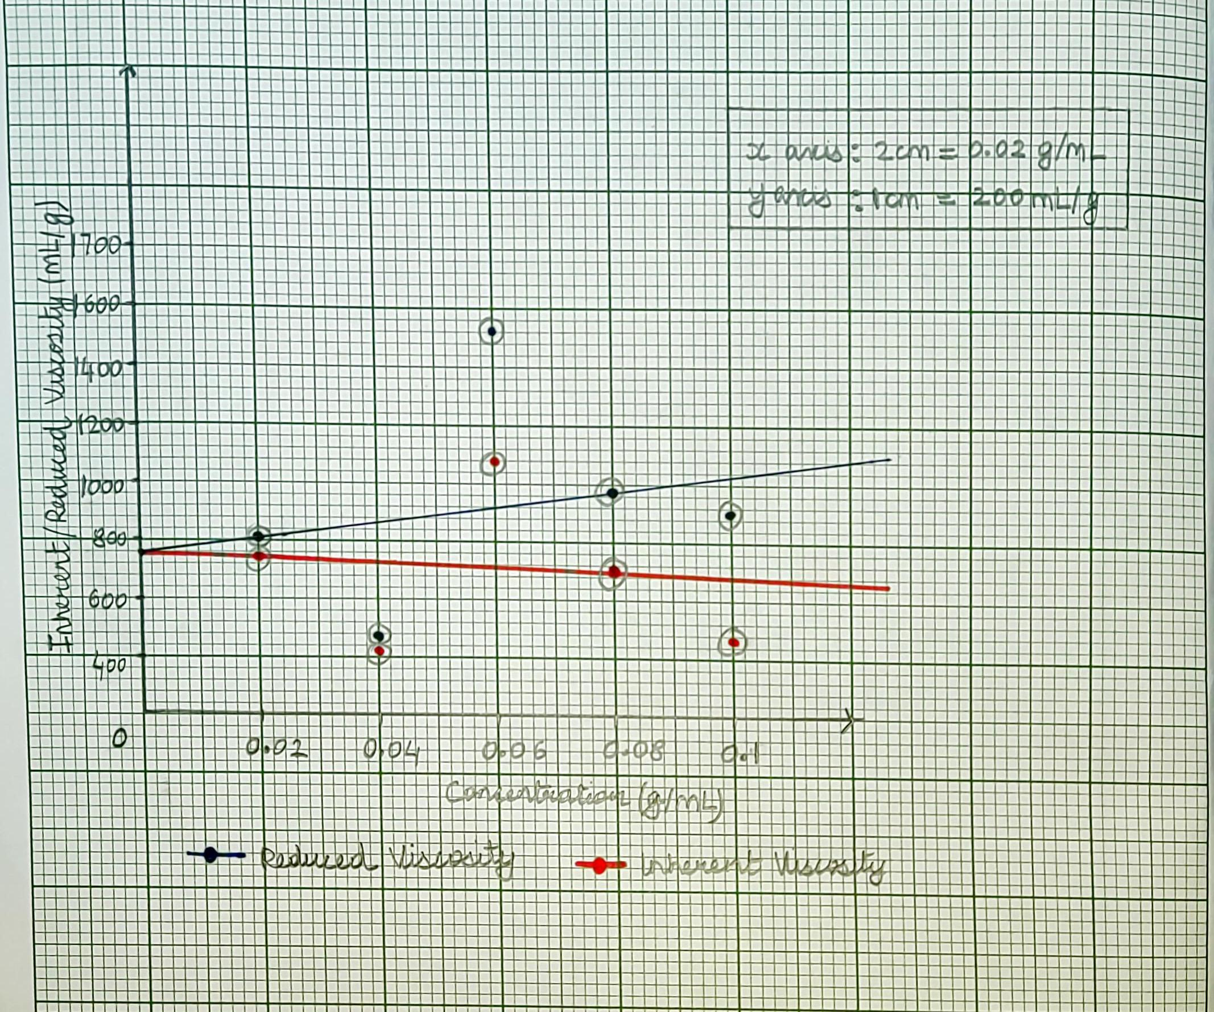
n = 760 mL/g

Calculation:
Formula:

n = 760 mL/g
K=5.20/10³ mL/g
α = 0.76

Therefore,

760 = 5.20/10³ x M^{0.76}

146.15 x 10³ = M^{0.76}

M = 7.05 x 10⁵ gm

Result:

The viscosity average molecular weight of the polymer PMMA-Benzene, M is 7.05 x 10⁵ gm

