Batch: A2 Roll No.: 16010121045

Experiment / assignment / tutorial No. 10

Grade: AA / AB / BB / BC / CC / CD /DD

Signature of the Staff In-charge with date

TITLE: Application Oriented Program

AIM: To develop any application based program.
______________________________________________________________________
Expected OUTCOME of Experiment:
CO1.Formulate a problem statement and develop the logic (algorithm/flowchart) for its solution.
CO2. Apply basic concepts of C programming for problem solving.
CO3. Illustrate the use of derived and structured datatypes such as arrays, strings, structures and unions.
CO4. Design modular programs using functions and demonstrate the concept of pointers and file handling
_____________________________________________________________________
Books/ Journals/ Websites referred:

- Programming in C, second edition, Pradeep Dey and Manas Ghosh, Oxford University Press.
- Programming in ANSI C, fifth edition, E Balagurusamy, Tata McGraw Hill.
- Introduction to programming and problem solving , G. Michael Schneider ,Wiley India edition.
- http://cse.iitkgp.ac.in/~rkumar/pds-vlab/

_____________________________________________________________________

Problem Definition:

Consider the marble rolling toy as shown in figure:
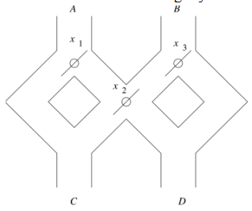
A marble is dropped at A or B. Levers x1,x2 and x3 cause the marble to fall either to the left or to the right. Whenever a marble encounters a lever, it causes the lever to reverse the direction after the marble passes, so the next marble will take the opposite branch. Write a C program to accept an input sequence and generate the appropriate output sequence. Example: input : “BAA” Its equivalent output sequence is “ CCD” i.e. three marbles are dropped sequentially at B, A and A. First marble will find its way through C, second through C and third through D.

Flowchart:
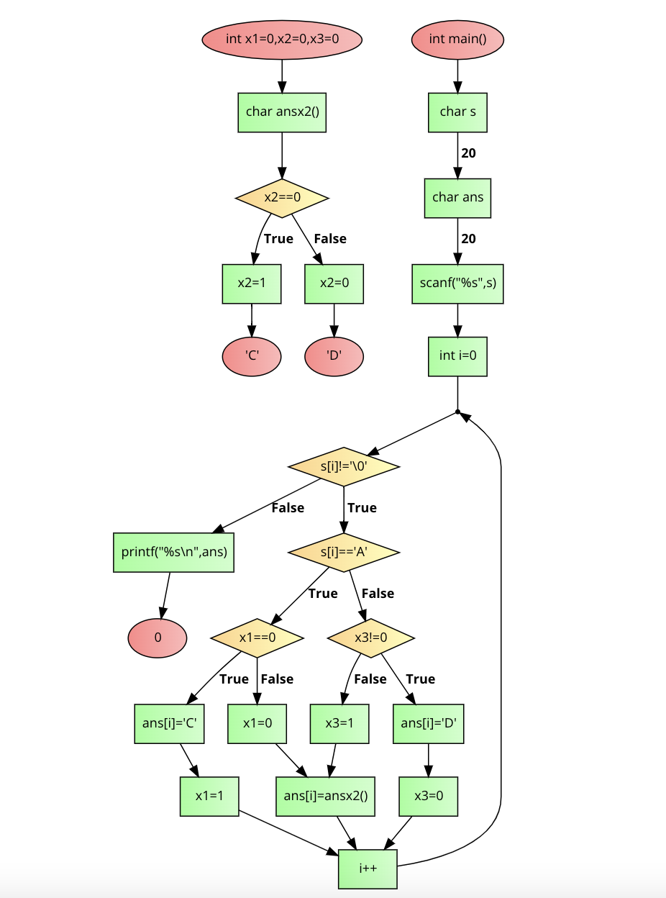

Implementation details:

#include<stdio.h>
int x1=0,x2=0,x3=0;
char ansx2()
{
if(x2==0){
x2=1;
return 'C';}
else
x2=0;
return 'D';
}
int main()
{
char s[20];
char ans[20];
scanf("%s",s);
for(int i=0;s[i]!='\0';i++){
if(s[i]=='A'){
if(x1==0){
ans[i]='C';
x1=1;}
else{
x1=0;
ans[i]=ansx2();}}
else
if(x3!=0){
ans[i]='D';
x3=0;}
else{
x3=1;
ans[i]=ansx2();}
}
printf("%s\n",ans);
return 0;
}

Output(s):
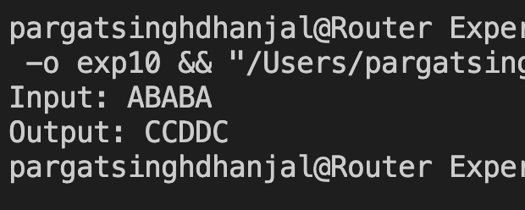
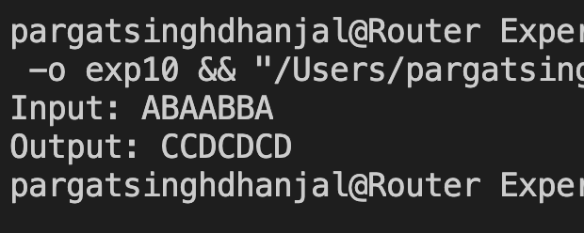

Conclusion:

Successfully executed Experiment 10 based on application oriented program.

Date: _____________ Signature of faculty in-charge

