Batch: A2 Roll No.: 16010121045

Experiment / assignment / tutorial No. 7

Grade: AA / AB / BB / BC / CC / CD /DD

Signature of the Staff In-charge with date

TITLE: Virtual Lab experiment on matrix multiplication

AIM: Virtual Lab experiment on recursion
https://cse02-iiith.vlabs.ac.in/
https://cse02-iiith.vlabs.ac.in/exp/arrays/simulation.html
______________________________________________________________________
Expected OUTCOME of Experiment:
CO3. Illustrate the use of derived and structured datatypes such as arrays, strings, structures and unions.
_____________________________________________________________________
Books/ Journals/ Websites referred:

- Programming in C, second edition, Pradeep Dey and Manas Ghosh, Oxford University Press.
- Programming in ANSI C, fifth edition, E Balagurusamy, Tata McGraw Hill.
- Introduction to programming and problem solving , G. Michael Schneider ,Wiley India edition.
- http://cse.iitkgp.ac.in/~rkumar/pds-vlab/

_____________________________________________________________________

Problem Definition:
The Program implements 1-D and 2-D arrays.
1-D array prompts the user to enter the size of the array and elements. It then sorts the elements.
2-D array prompts the user to enter the order of two matrices and the elements. It then performs matrix multiplication.

Flowchart:
1D:
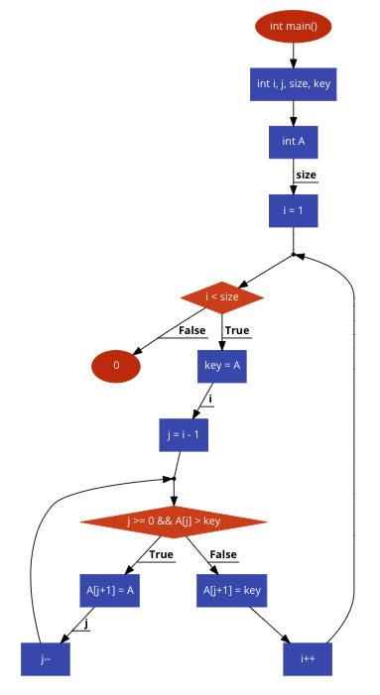
2D:
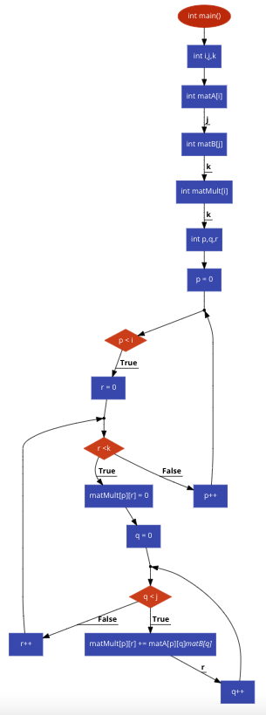

Implementation details:

1D:

int main(){
int i, j, size, key ;
int A[size];
for( i = 1 ; i < size ; i++ )
{
key = A[i];
j = i - 1;
while ( j >= 0 && A[j] > key )
{
A[j+1] = A[j];
j--;
}
A[j+1] = key;
}
return 0 ;}

2D:

int main(){
int i,j,k;
int matA[i][j];
int matB[j][k];
int matMult[i][k];
int p,q,r;
for ( p = 0 ; p < i ;p++ )
{
for ( r = 0 ; r <k ; r++ )
{
matMult[p][r] = 0;
for ( q = 0 ; q < j ; q++ )
{
matMult[p][r] += matA[p][q]*matB[q][r]
}
}
}
}

Output(s):

Pretest
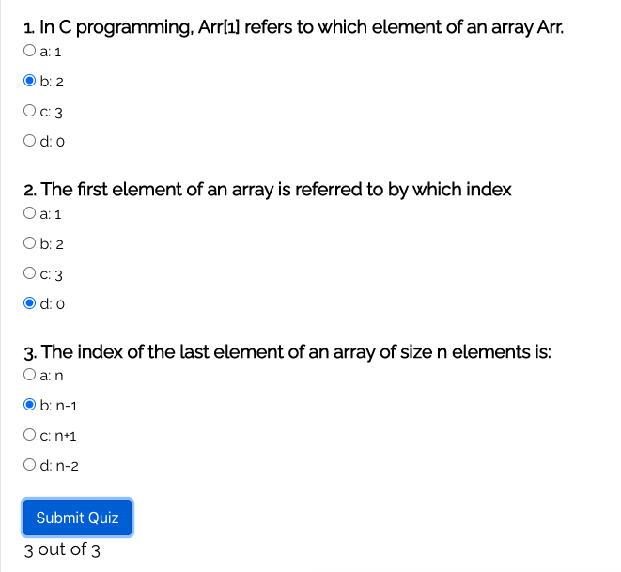
1D:
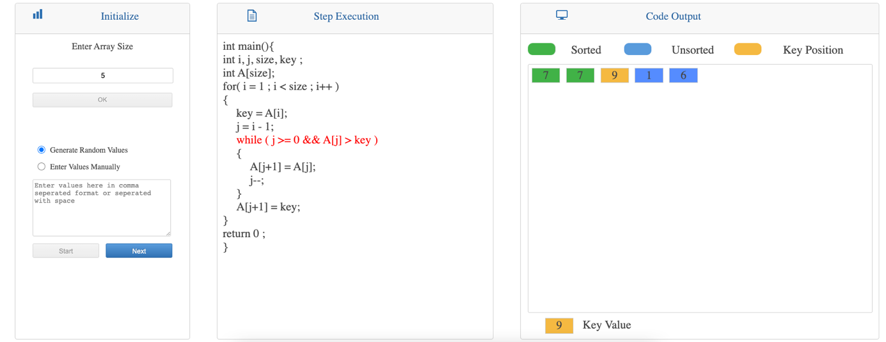

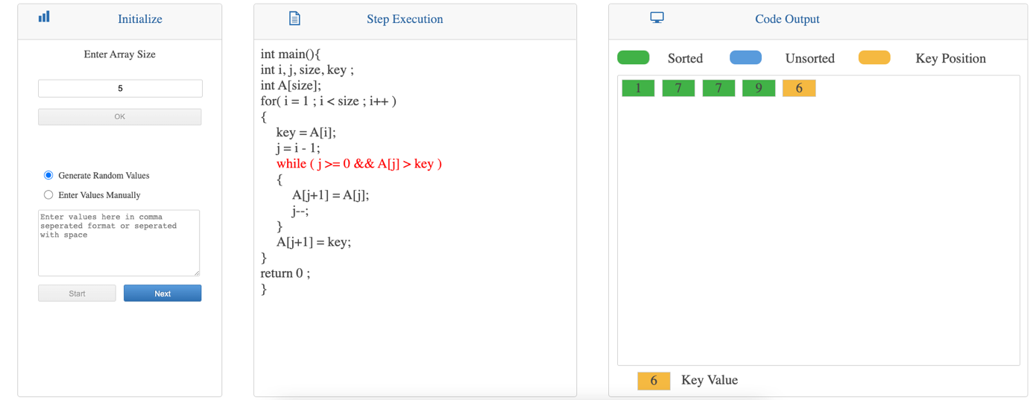

2D:
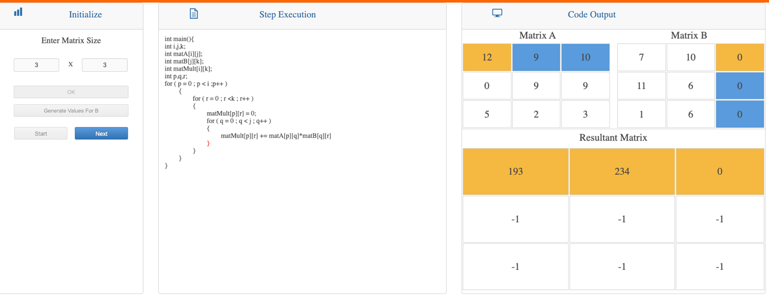

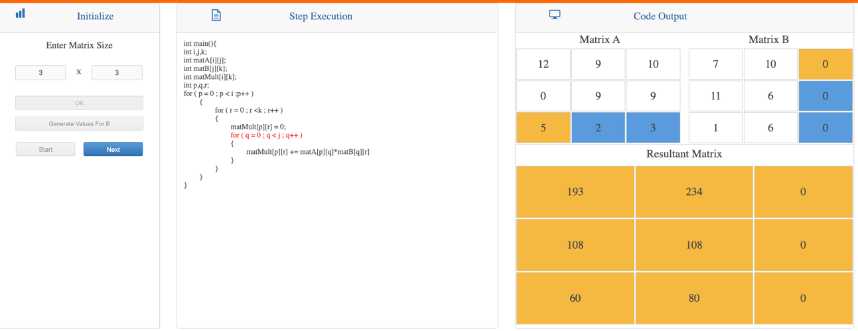

Post-test:
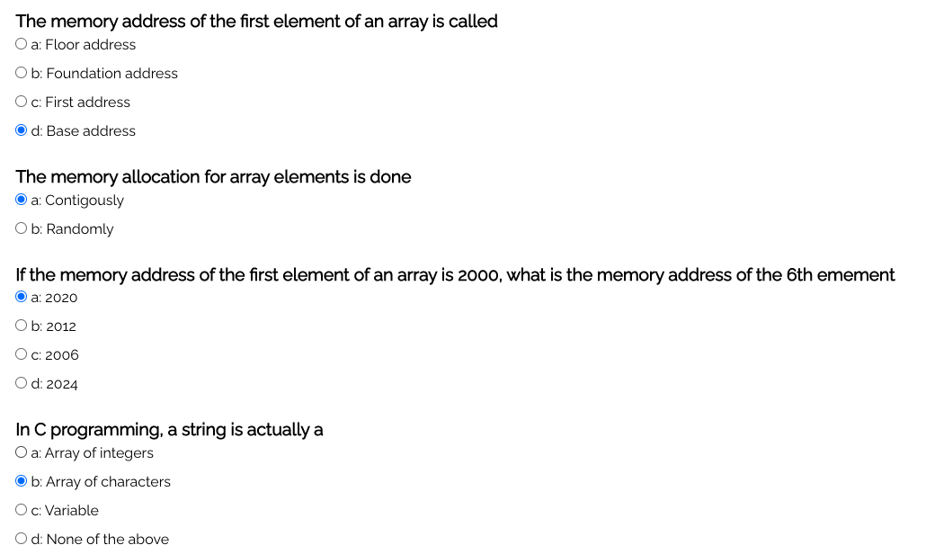

Conclusion:
The programs to sort a 1D array and to multiply two 2D arrays were learnt using online virtual simulation lab. The simulation worked perfectly.

Post Lab Descriptive Questions

- Can we change the size of an array at run time? Why or why not?
The answer is both yes and no. If the array is statically defined then it is impossible to change the size of the array during runtime as the complier requires a value to initialise the array with. The answer is yes because, we can use the free function to redefine an array using free() and realloc() function so an user can can the size of an array during the runtime.

- Can we pass an array as an argument to a function?
There are two possible ways to do so, one by using call by value and other by using call by reference.
We can either have an array as a parameter. Example: int sum (int arr[]);
Or, we can have a pointers in the parameter list, to hold the base address of our array. Example: int sum (int* ptr);

Date: _____________ Signature of faculty in-charge

