Batch: A2 Roll No.: 16010121045

Experiment / assignment / tutorial No. 8

Grade: AA / AB / BB / BC / CC / CD /DD

Signature of the Staff In-charge with date

TITLE: Virtual Lab experiment on Call by reference.

AIM: Virtual Lab experiment on Call by reference
http://cse02-iiith.vlabs.ac.in/
http://cse02-iiith.vlabs.ac.in/exp8/simulation/CallByReferencePointers/index.html
Program to swap two number without using third variable using Call by reference.
______________________________________________________________________
Expected OUTCOME of Experiment:

CO4: Design modular programs using functions and demonstrate the concept of pointers and file handling.

_____________________________________________________________________
Books/ Journals/ Websites referred:

- Programming in C, second edition, Pradeep Dey and Manas Ghosh, Oxford University Press.
- Programming in ANSI C, fifth edition, E Balagurusamy, Tata McGraw Hill.
- Introduction to programming and problem solving , G. Michael Schneider ,Wiley India edition.
- http://cse.iitkgp.ac.in/~rkumar/pds-vlab/

_____________________________________________________________________

Problem Definition:

The call by reference method of passing arguments to a function copies the address of an argument into the formal parameter. Inside the function, the address is used to access the actual argument used in the call.
In the program, a function called swap ( ) is used in which the address is used to access the actual argument.

Algorithm:
1: Start
2: Declare variable A and B as Integer data type and assign value 5 and 9 respectively.
3: Print A
4: Print B
5: Call function swap() and pass A and B as agreements
6: Function call. Local variable type pointer Pa and Pb get assigned the address of A and B respectively.
7: A local variable is declared temp and assigned the value at Address Pa
8: Variable Pa is assigned the value at Address Pb
9: Variable Pb is assigned the value at temp
10: Print A
11: Print B
12: Stop

Implementation details:

#include<stdio.h>
void main(){
int A = 5, B = 9;
printf('Value of A is %d\n',A);
printf('Value of B is %d\n',B);
swap( &A , &B );
printf('Value of A after swapping is %d\n',A);
printf('Value of B after swapping is %d\n',B);
}

void swap( int *Pa , int *Pb){
int temp = *Pa;
*Pa = *Pb;
*Pb = temp;
}
Output(s):

Pretest 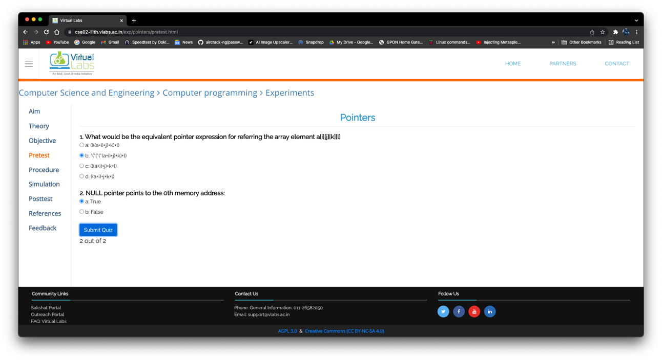

Simulation

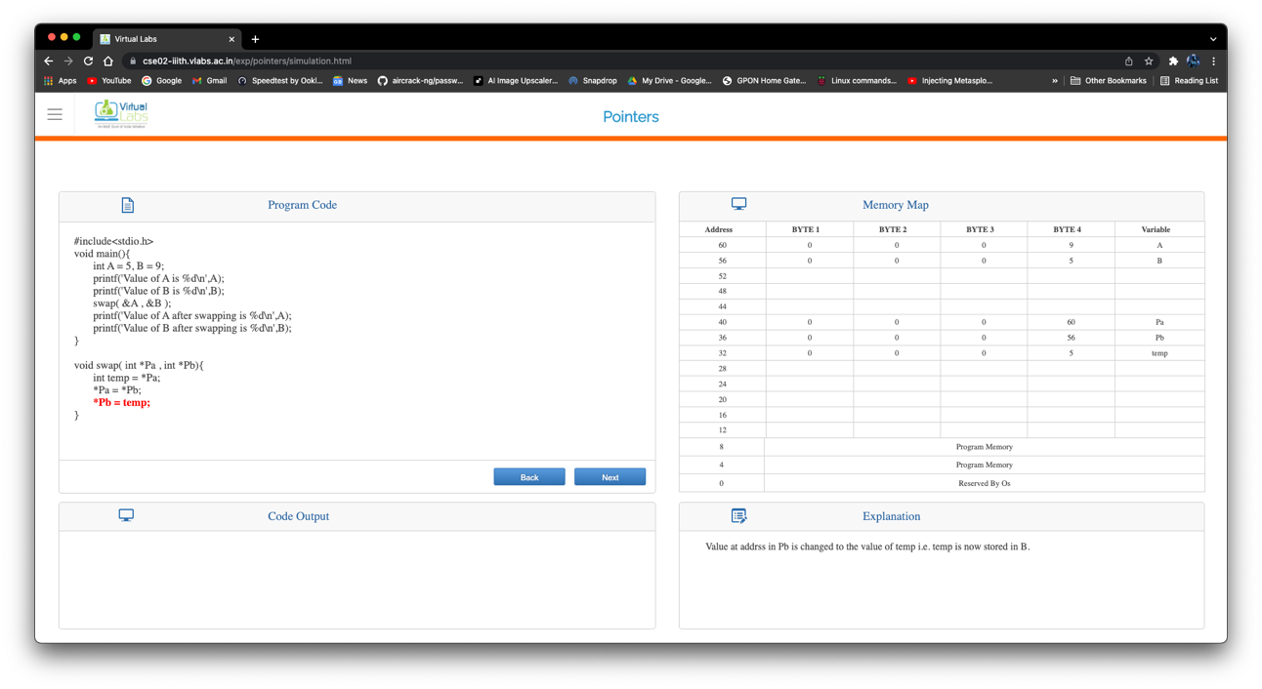

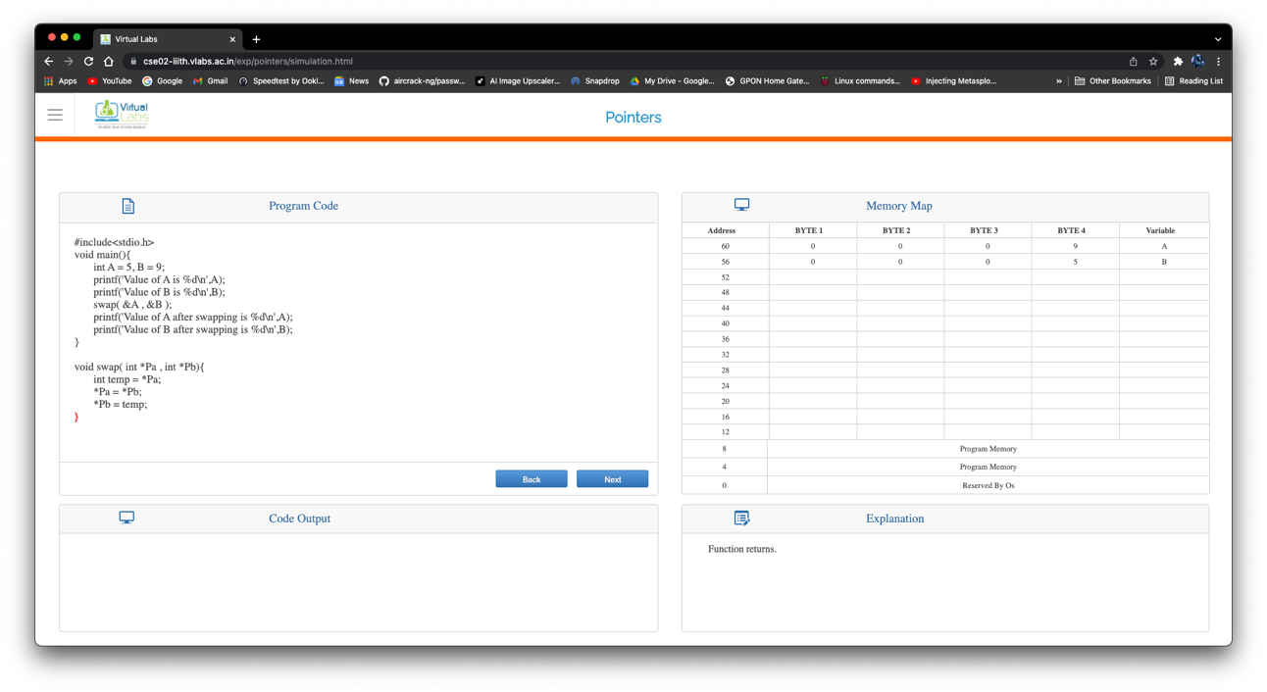

Postest
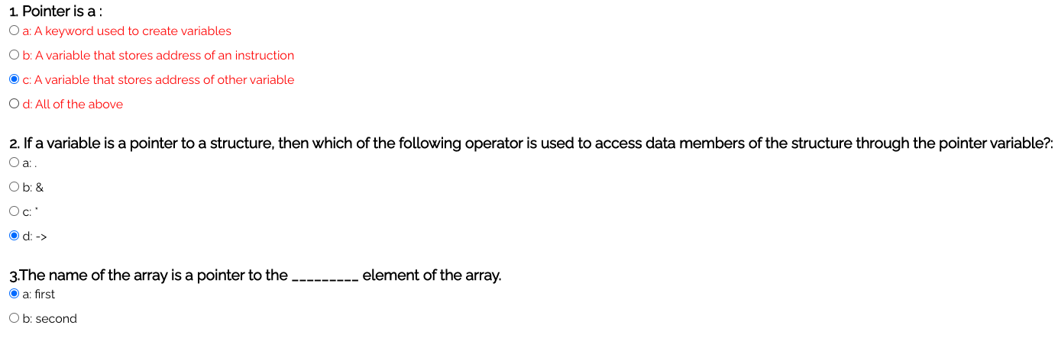

Conclusion:

We learnt the execution of the call by reference program. We were also able to design modular programs using functions and demonstrate the concept of pointers.

Post Lab Descriptive Questions

- Difference between call by value and call by reference in C.
Call By Value | Call By Reference
While calling a function, we pass values of variables to it. Such functions are known as Call By Values. | While calling a function, we pass address of variables to the function known as “Call By References
In this method, the value of each variable in calling function is copied into corresponding dummy variables of the called function. | In this method, the address of actual variables in the calling function are copied into the dummy variables of the called function.
Changes made in a copy of variable never modify the value of variable outside the function | Change in the variable also affects the value of the variable outside the function
In call by values we cannot alter the values of actual variables through function calls. | In call by reference we can alter the values of variables through function calls.

- What would be the output of the following program:

main( )
{
float a = 13.5 ;
float *b, *c ;
b = &a ; /* suppose address of a is 1006 */
c = b ;
printf ( "\n%u %u %u", &a, b, c ) ;
printf ( "\n%f %f %f %f %f", a, *(&a), *&a, *b, *c ) ;
}

Output is:
1006 1006 1006
13.500000 13.500000 13.500000 13.500000 13.500000

Date: _____________ Signature of faculty in-charge

