

K. R Mangalam UNIVERSITY
ASSINGNMENT

SEMESTER— 2

COURSE—
B.TECH CSE-AI & Robotics

Subject:-DATA STRUCTURE

ROLL NO. –2501630003
SECTION:-A

SUBMITTED BY :- Ayushi Thakur
SUBMITTED TO :- AARTI ma’am

Part A: Stack ADT (ADT + Operations)
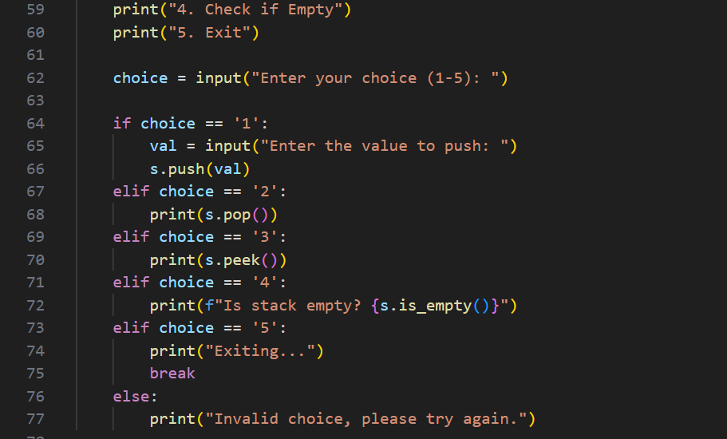
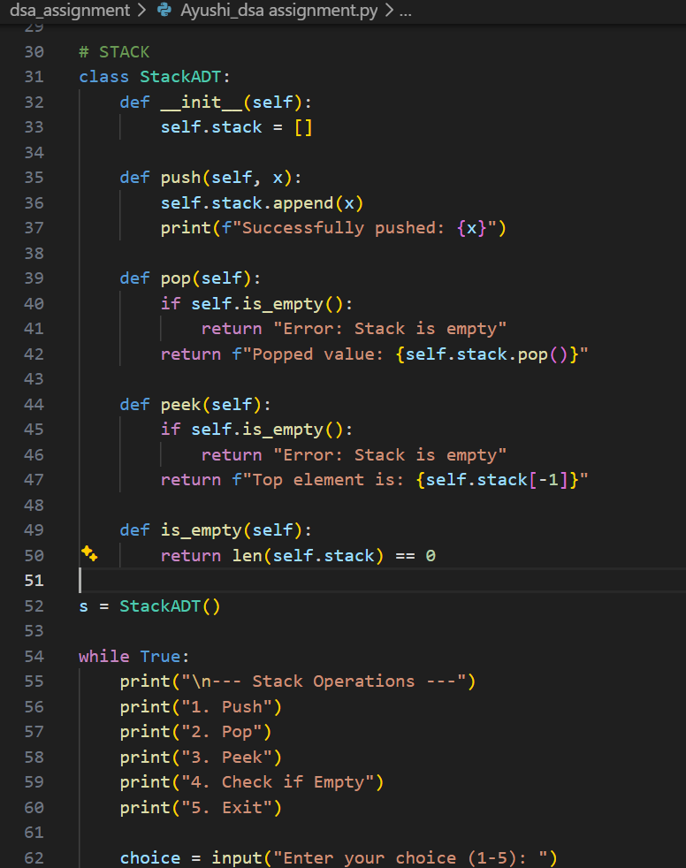

OUTPUT
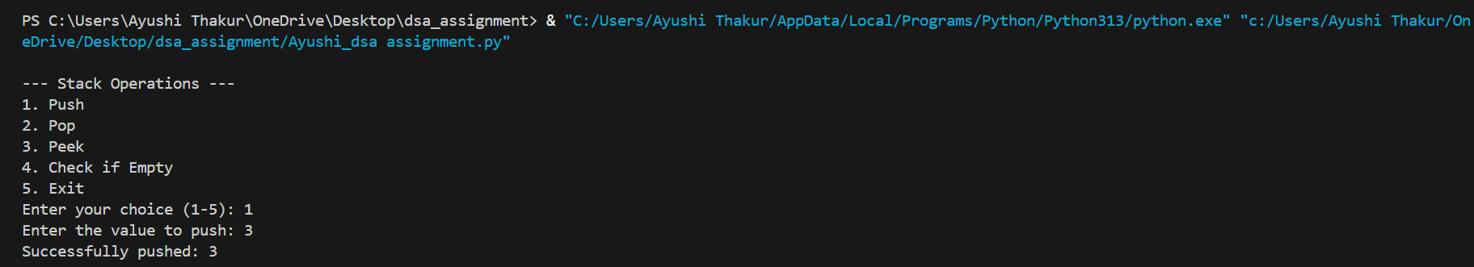

1. What is an ADT?
An Abstract Data Type (ADT) is a logical model of a data structure that defines the operations on data but not the implementation.

2. Why are stack operations usually O(1)?
Stack operations like push, pop, and peek work only on the top element, so they take constant time O(1) without traversing the stack.

Part B: Factorial & Fibonacci (Recursion + Complexity)
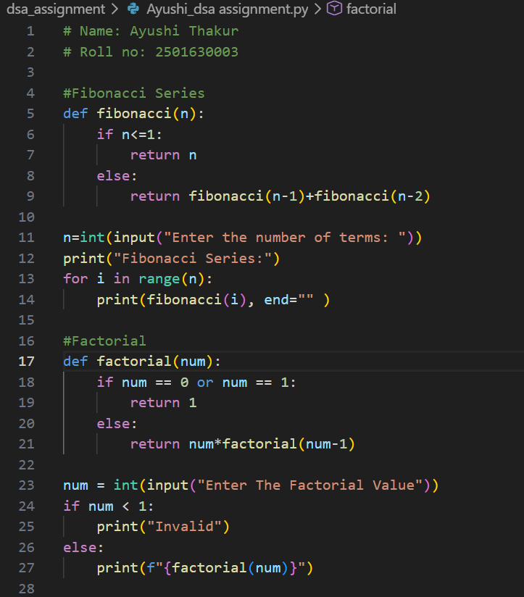

OUTPUT
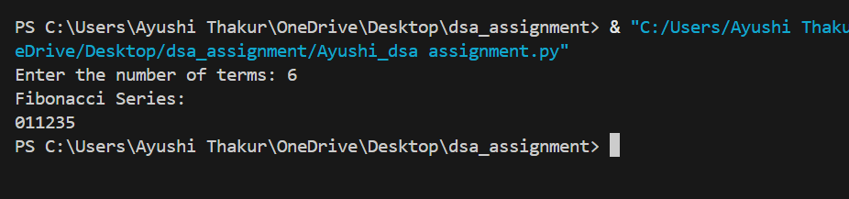
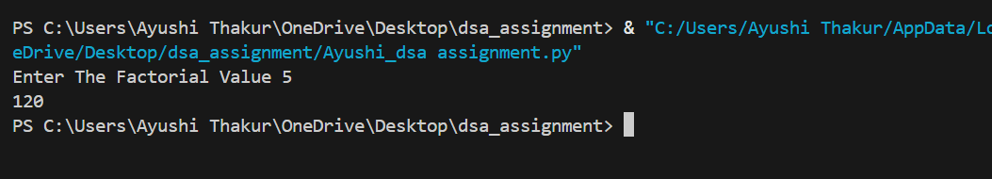
1. Factorial (recursive)
Time Complexity
- Big-O: O(n)
- Big-Θ: Θ(n)
- Big-Ω: Ω(n)
Space Complexity
- O(n) (due to recursive call stack)

2. Fibonacci (naive recursive)
Time Complexity
- Big-O: O(2ⁿ)
- Big-Θ: Θ(2ⁿ)
- Big-Ω: Ω(2ⁿ)
Space Complexity
- O(n) (recursion depth)

3. Why naive Fibonacci becomes slow for large n
Naive Fibonacci is slow because it recalculates the same values many times.
For example, to compute fib(5) it repeatedly computes fib(3) and fib(2) multiple times, causing the number of function calls to grow exponentially (2ⁿ)

Part C: Tower of Hanoi (Recursion + Trace)
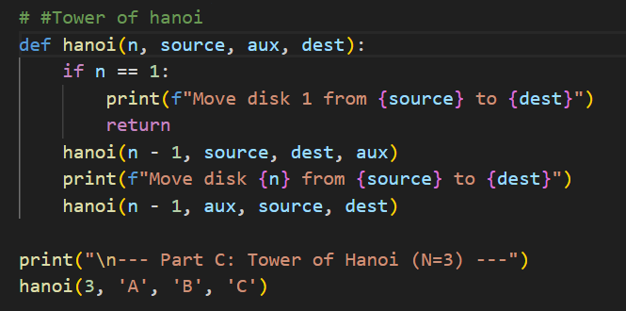
OUTPUT
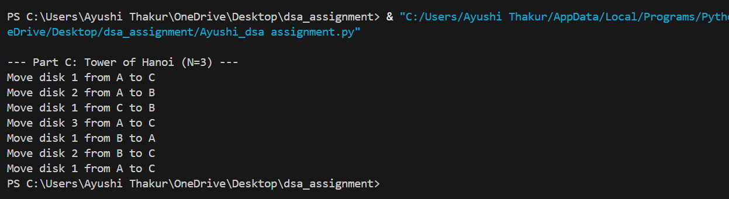
Q) Why number of moves = 2ⁿ − 1
To move n disks:
- Move n−1 disks to the auxiliary rod
- Move 1 largest disk to the destination
- Move n−1 disks again to the destination
So the recurrence is:
T(n) = 2T(n−1) + 1, which solves to 2ⁿ − 1 moves.
Time Complexity: O(2ⁿ)
Space Complexity: O(n) (due to recursion depth)

Part D: Recursive Binary Search (Divide & Conquer + Recurrence)
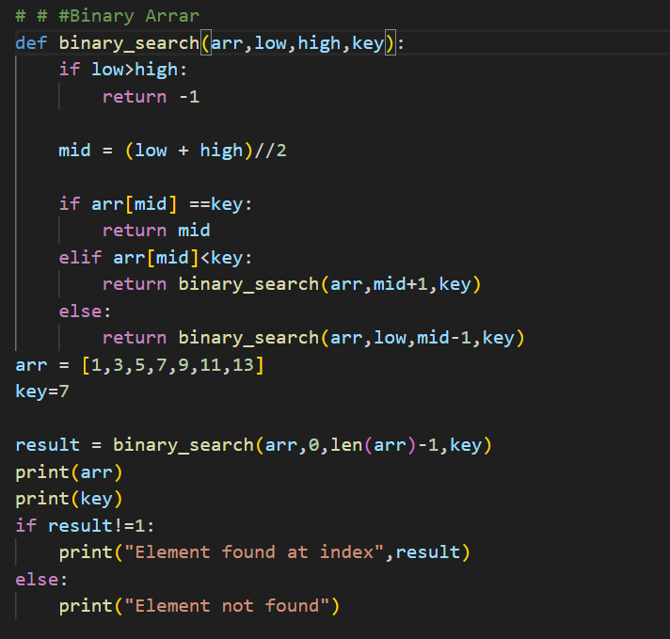
OUTPUT
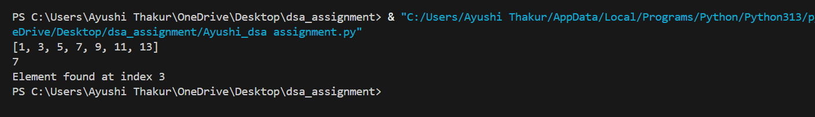

Time Complexity Using Recurrence
For algorithms like binary search, the recurrence relation is:
T(n) = T(n/2) + O(1)
Explanation:
- Each step reduces the problem size to half (n/2).
- The extra work done in each step (comparison, index calculation) is constant O(1).
- Since the input keeps getting halved, the number of steps required is log₂n.

Best, Average, and Worst Case (Simple)
- Best Case: The element is found in the first comparison (middle element).
Time: O(1)
- Average Case: The element is found after a few halvings of the array.
Time: O(log n)
- Worst Case: The element is not present or found after maximum halvings.
Time: O(log n)**.

Part E: Short Paradigm Reflection

Algorithm Design Concepts
1. Binary Search – Divide & Conquer
Binary search follows the Divide & Conquer approach because it repeatedly divides the array into two halves and only searches in the half where the element may exist. This process continues until the element is found or the search space becomes empty.

2. Fibonacci (Memoization) – Dynamic Programming
Memoization stores the previously calculated Fibonacci values so they do not need to be recomputed again. This solves the problem of repeated calculations in naive recursion, making the algorithm much faster.

3. Tower of Hanoi – Recursion
Tower of Hanoi uses recursion by solving smaller subproblems.
- Base case: When there is only 1 disk, move it directly from source to destination.
- Recursive idea: Move n−1 disks to the auxiliary rod, move the largest disk to the destination, then move the n−1 disks to the destination.

Real-Life Examples
Divide & Conquer:
Searching for a word in a dictionary. Instead of checking every page one by one, you open the dictionary roughly in the middle. Based on the first letters, you decide whether the word lies in the first half or second half. Then you again divide that section into halves and repeat the process until the word is found. This is similar to how binary search divides the problem repeatedly.

Dynamic Programming:
Planning travel routes using navigation apps. When finding the shortest route between cities, the system stores the best distances between intermediate locations. If the same sub-route is needed again, it uses the stored result instead of recalculating it. This reuse of previously solved subproblems is the main idea behind dynamic programming.

Greedy:
Giving change in a shop. Suppose you need to return ₹87. The cashier usually gives the largest denomination first (₹50, then ₹20, then ₹10, then smaller coins) until the amount is completed. At each step, the locally best choice (largest denomination) is taken, which is the core idea of greedy algorithms.

GITHUB LINK
https://github.com/Ayushithakur09/DSA.git

