The Agent That Knew When to Stop Learning
We ran two identical trading AIs through 60 collapsing markets. The only difference between them was a safety layer. One finished with zero catastrophic losses. The other was wiped out in 57 of 60.

IN BRIEF
- An unguarded self-improving agent lost 84% of its capital on a market where an otherwise identical agent with safety constraints finished slightly positive.
- The result is not a single lucky run. Across 60 independent markets, the safety-gated agent had a smaller maximum loss in 60 out of 60, and never once lost more than half its capital. The unguarded agent did so 57 times.
- The decisive mechanism is counterintuitive: the agent was built to stop improving itself whenever it was losing money or was uncertain about market conditions. Learning was blocked at 1.96x the volatility at which it was allowed.

Every serious AI system now under construction shares one design question: when should the system be allowed to change itself?
In finance the question is not academic. An agent that continuously re-fits its own strategy to recent market feedback is doing something genuinely useful, because markets change. It is also doing something genuinely dangerous, because market feedback is least reliable at exactly the moment it is most dramatic.
We built a controlled experiment to isolate that single variable. Two trading agents, one market, identical price paths, identical profit-and-loss mechanics, identical underlying trading signal. The only difference: one had a safety layer that could veto its actions and freeze its learning. The other did not.
The gap in outcomes was 87 percentage points.

Finding 1: The same signal produced opposite outcomes
Both agents read the same momentum signal on the same 1,000-step market containing 19 tail events — 13 crashes and 6 volatility spikes. The unguarded agent finished down 84.3%. The safety-gated agent finished up 3.2%.
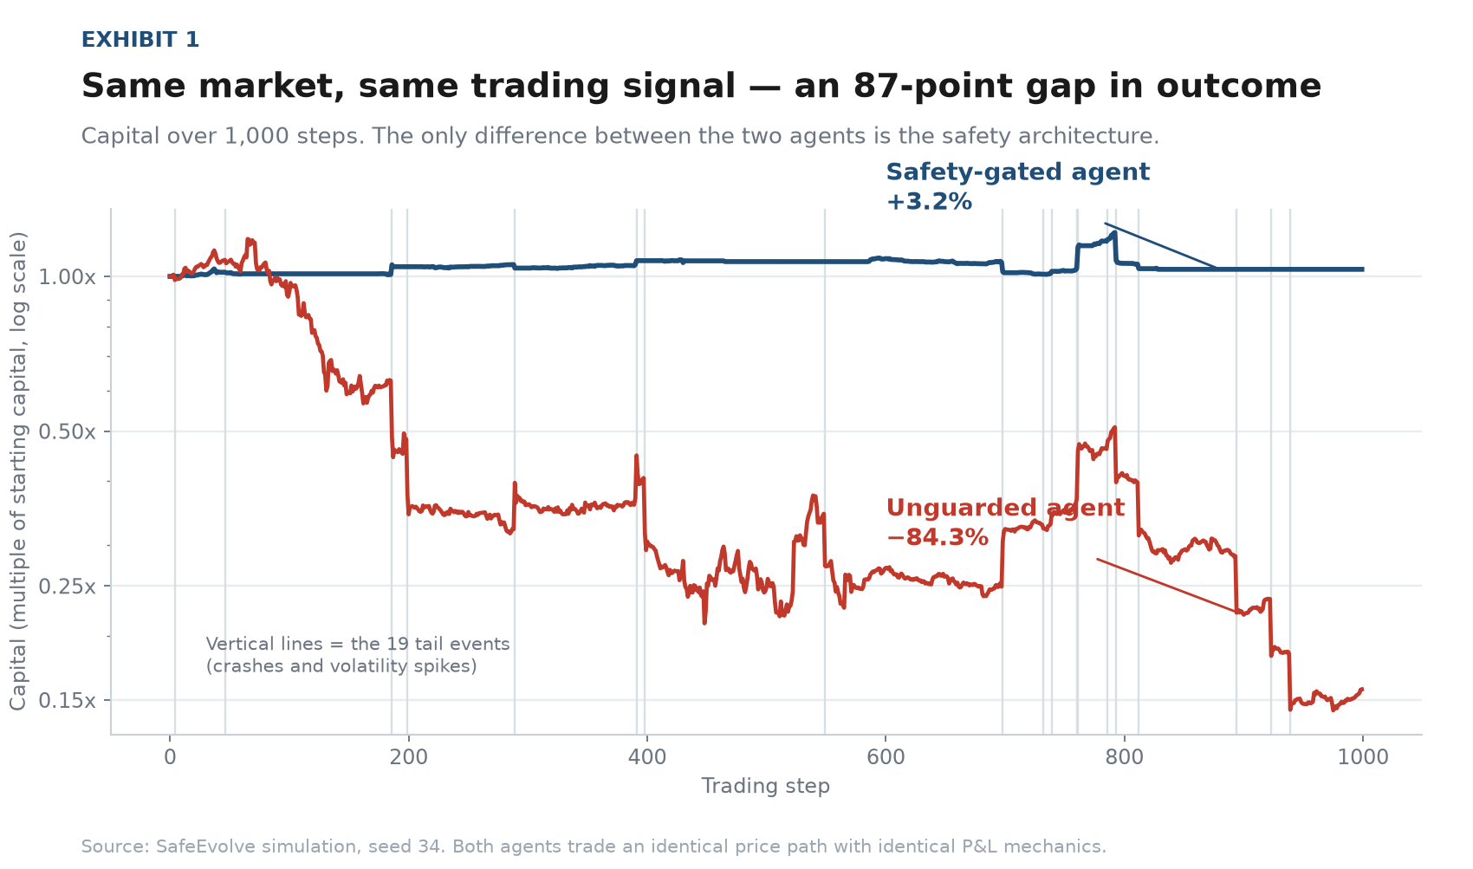
Exhibit 1. Capital over 1,000 steps, log scale. Vertical lines mark tail events. Source: SafeEvolve simulation, seed 34.
The headline number here is not the +3.2%. A 3% return is unremarkable. The number that matters is that the unguarded agent — running the same strategy, on the same prices — destroyed 84% of its capital. Safety was the entire difference.

Why standard models miss this entirely
Most risk systems assume returns follow a normal distribution. Real markets do not. They are fat-tailed: extreme moves occur far more often than the bell curve permits.
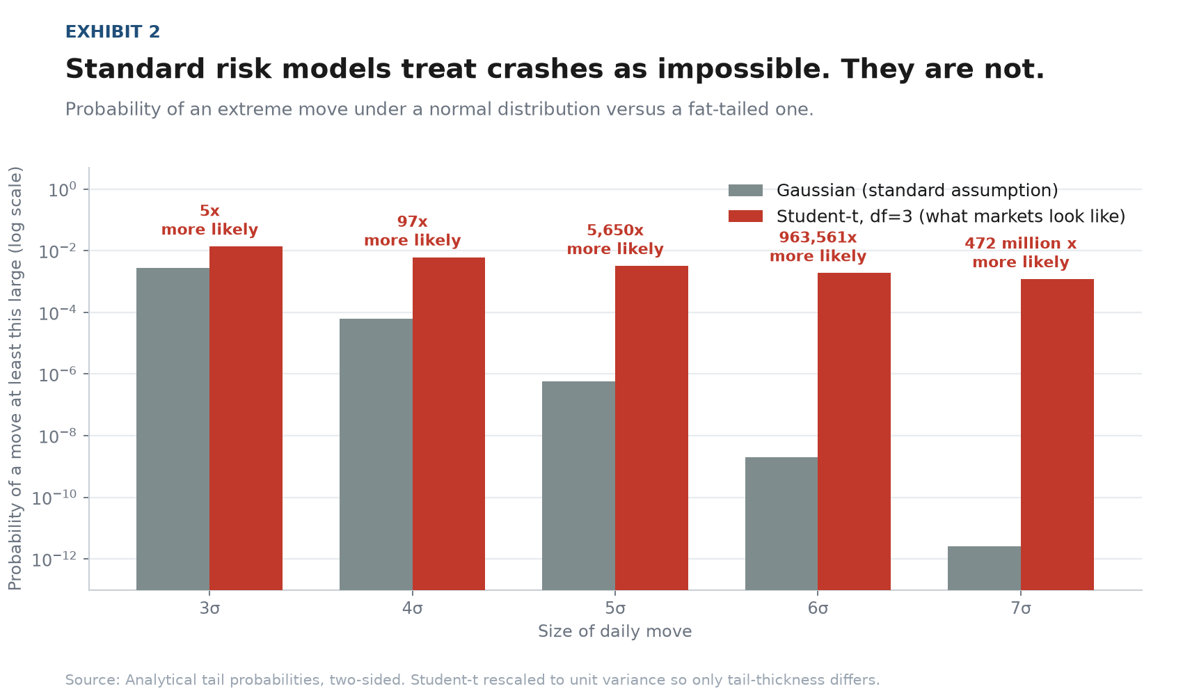
Exhibit 2. Two-sided tail probabilities. The Student-t is rescaled to unit variance, so only tail-thickness differs. Source: analytical calculation.
The distortion compounds violently with severity. A 4-sigma move is 97 times more likely than a normal distribution implies. A 5-sigma move is 5,650 times more likely. A 7-sigma move — the kind that ends funds — is roughly 472 million times more likely.
A model that treats a crash as a one-in-a-quintillion event will size its positions as though crashes never happen. Then one happens.
Our simulated market was built on Student-t innovations with three degrees of freedom precisely so that it would punish this assumption, rather than reward it.

Finding 2: The circuit breaker held
The safety layer contains three hard constraints, applied before any trade reaches the market: a cap of 10% of capital per trade, a position-size reduction when the agent is uncertain, and a circuit breaker that halts trading entirely at a 15% drawdown.
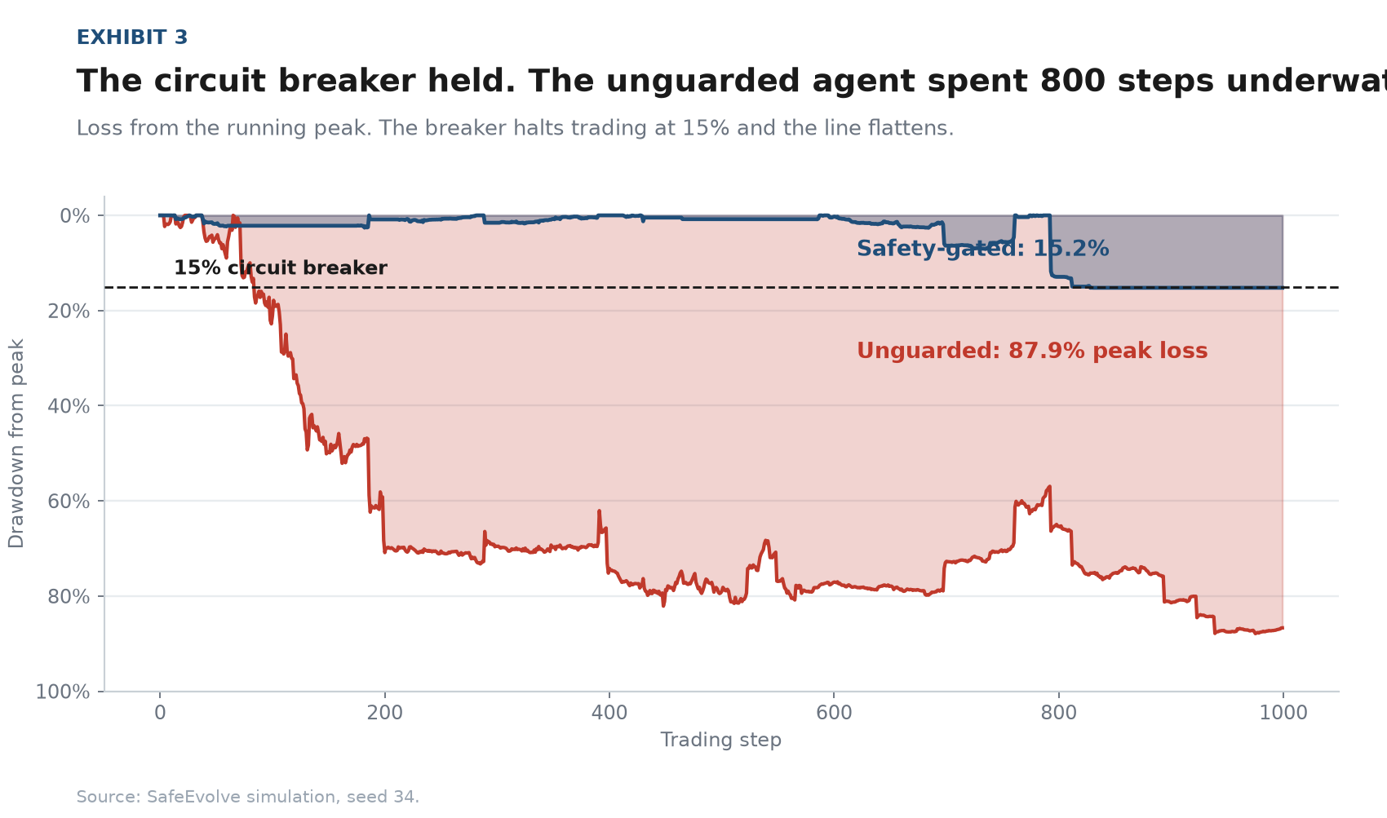
Exhibit 3. Loss from the running peak. Source: SafeEvolve simulation, seed 34.
The unguarded agent spent the majority of the run between 60% and 88% underwater — a position from which no strategy recovers. The safety-gated agent touched its 15% limit once, at which point the breaker halted trading and the loss stopped compounding.

Finding 3: This holds across 60 markets, not one
A single favourable run proves nothing. We re-ran the entire experiment on 60 independently generated markets.
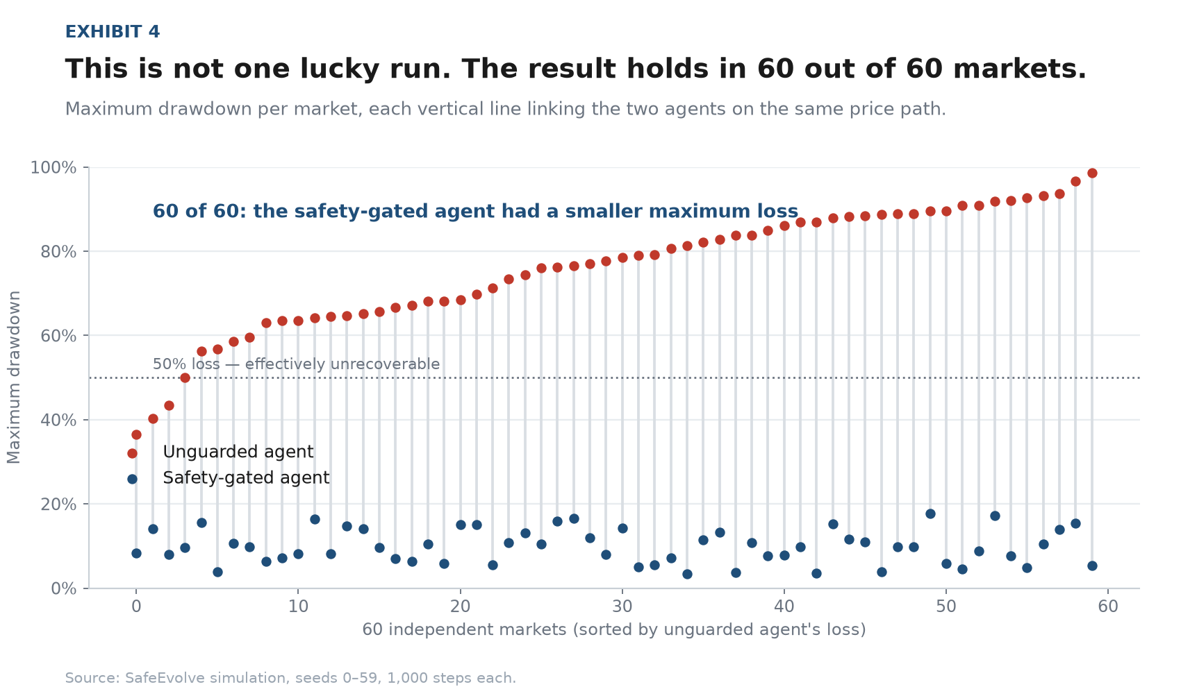
Exhibit 4. Maximum drawdown per market; each line links the two agents on the same price path. Source: SafeEvolve simulation, seeds 0–59.
In 60 markets out of 60, the safety-gated agent's worst loss was smaller. Mean maximum drawdown was 9.9% versus 75.9%. There were no exceptions in either direction.
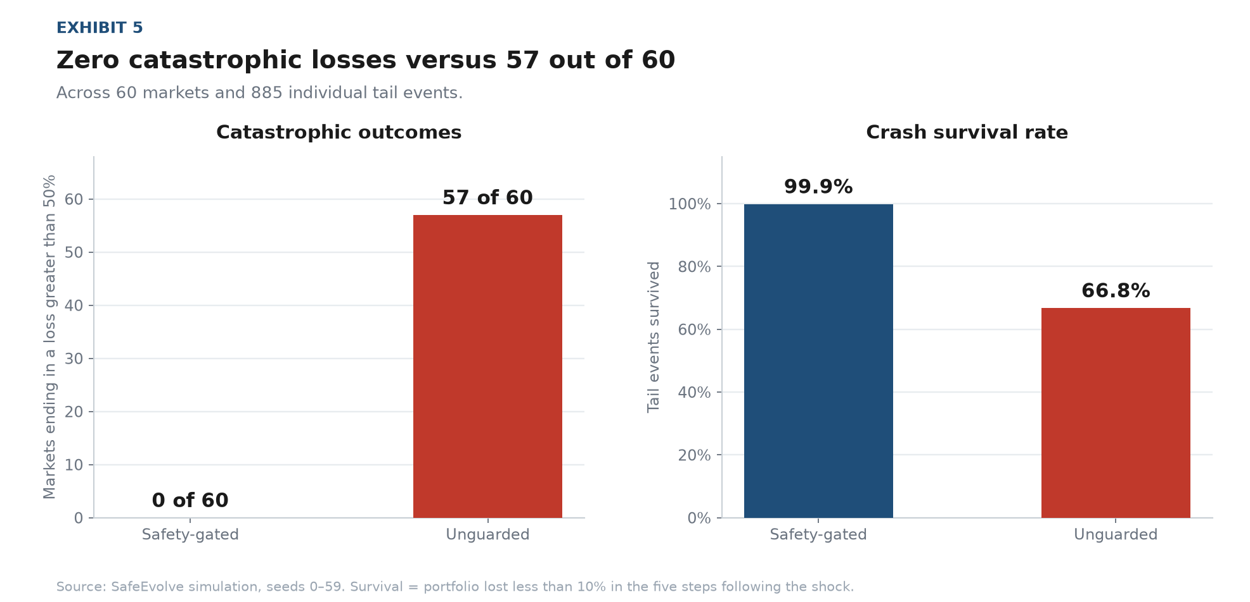
Exhibit 5. Catastrophic outcomes and crash survival across 60 markets and 885 tail events. Source: SafeEvolve simulation, seeds 0–59.
The survival statistics are equally lopsided. Of 885 individual tail events, the safety-gated agent survived 884 — a 99.9% survival rate — against 66.8% for the unguarded agent.
It is worth being precise about the mechanism, because it is not prediction. Neither agent forecast a single crash. The safety-gated agent held an average position of just 6.8% of its capital; the unguarded agent was fully invested at all times. One was simply never standing in front of the bus.

The core idea: learning as a privilege, not a default
This is the part of the design we consider genuinely important, and it inverts the usual instinct in machine learning.
A self-improving agent updates its strategy based on recent performance. But consider what that means during a crash. The agent measures its returns over the recent window, draws a conclusion, and rewrites its own policy — using data generated by a market regime that is about to reverse. It learns the wrong lesson at the worst possible moment, and carries that lesson into the next shock.
Self-evolution requires feedback. Financial feedback is least trustworthy exactly when it is most tempting to act on.
Our resolution was to make self-improvement conditional. Every 50 steps the agent attempts to re-fit its own parameters. Before it can, it checks two conditions: is it solvent, and does it understand the current regime? If either answer is no, the update is blocked and the feedback gathered during that window is discarded rather than banked for later.
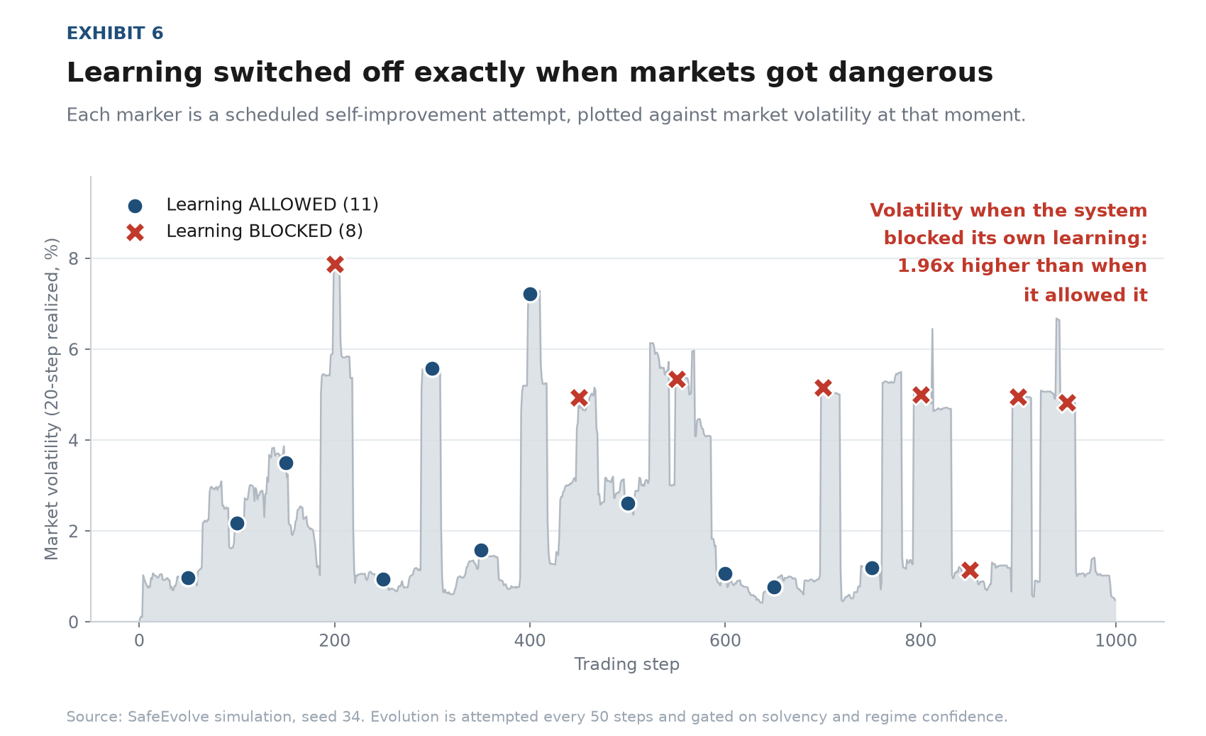
Exhibit 6. Each marker is a scheduled self-improvement attempt, plotted against market volatility at that moment. Source: SafeEvolve simulation, seed 34.
The pattern is unambiguous. Market volatility when the system blocked its own learning was 1.96 times higher than when it permitted it. The system was not told about volatility. It shut itself down as a consequence of not understanding what it was seeing.

How the agent knows it does not know
That behaviour depends on one component: a confidence signal that is honest about uncertainty. We used Bayesian online changepoint detection, which maintains a probability distribution over how long the current market regime has lasted. When the regime shifts, that distribution collapses — and the collapse is measurable in real time.
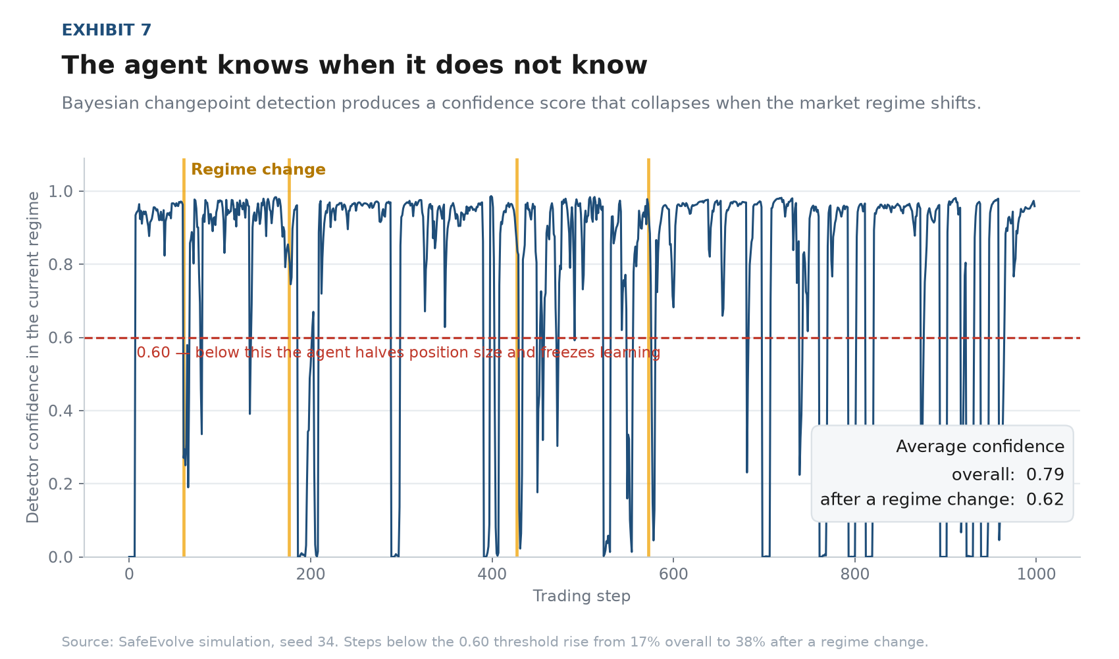
Exhibit 7. Detector confidence with true regime changes marked. Source: SafeEvolve simulation, seed 34.
Average confidence across the run was 0.79. In the ten steps following a regime change it fell to 0.62. The proportion of steps below the 0.60 action threshold rose from 17% to 38%. A conventional moving-average estimator would have produced a stale number with no indication it had become unreliable. This produces a number that says, in effect, stop.

What safety costs
Safety is not free, and any analysis claiming otherwise should be treated with suspicion.
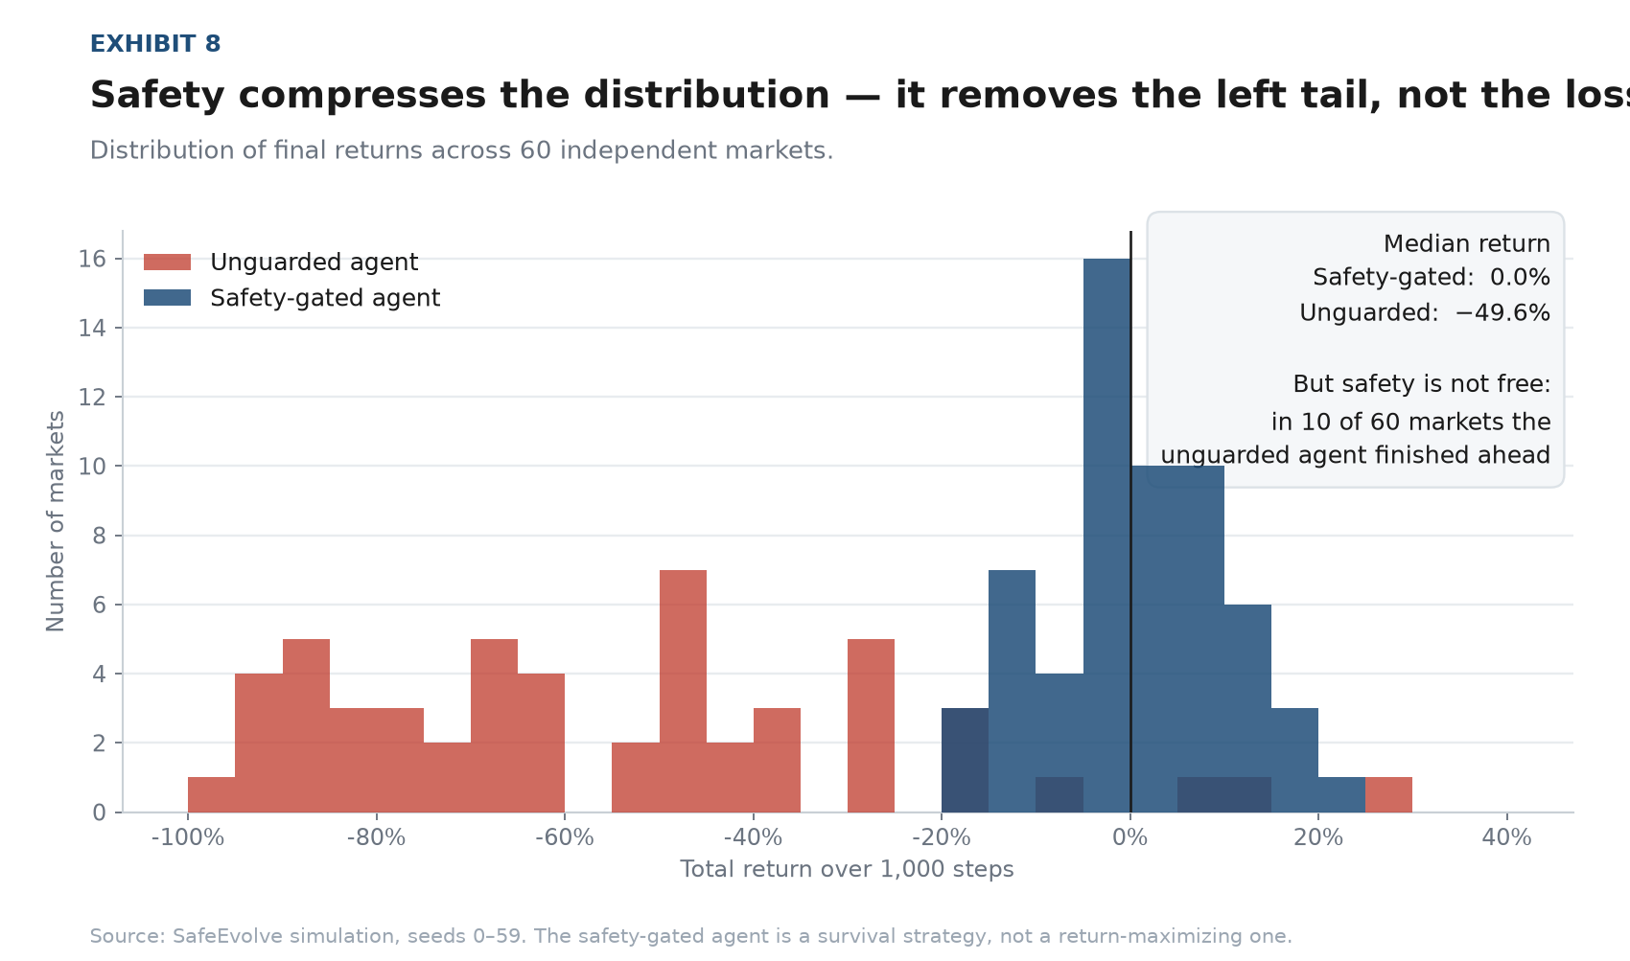
Exhibit 8. Distribution of final returns across 60 independent markets. Source: SafeEvolve simulation, seeds 0–59.
In 10 of the 60 markets, the unguarded agent finished ahead. The safety-gated agent's median return was approximately zero; it is a survival strategy, not a return-maximising one. What the safety layer does is remove the left tail of the distribution. It converts a strategy that occasionally wins big and frequently dies into one that rarely wins big and does not die.
In a business where a single 80% loss is terminal, that trade is heavily favourable. But it is a trade, and it should be stated as one.

How the system is put together
The architecture is deliberately small — roughly 900 lines, no deep-learning framework, every decision logged with a machine-readable reason.
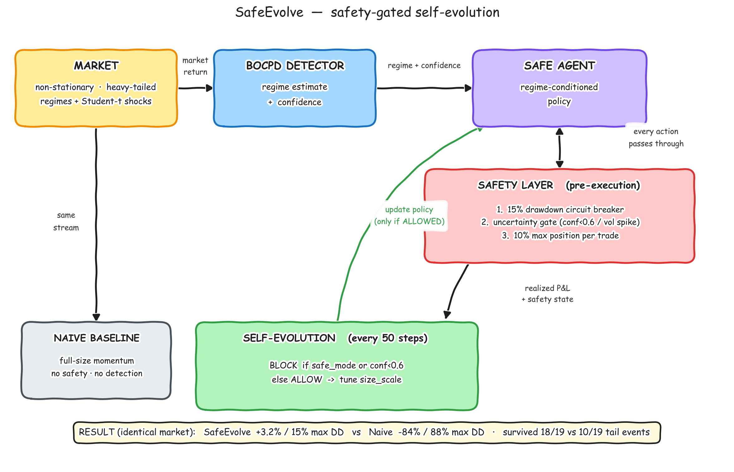
Figure A. System architecture. Market data flows to a regime detector; the agent's proposed action must clear three safety constraints before execution; realized performance feeds a self-improvement module whose updates are gated on safety state.
The trading strategy itself is intentionally simple. That is the point: the safety layer and the learning gate wrap around any policy without modification. They are infrastructure, not strategy.

Implications
- Safety is architecture, not a post-processing step. Safety cannot be a filter applied to a model's output. It has to sit between intent and execution, with the authority to veto. In this experiment the constraints were binding on roughly half of all actions taken.
- Uncertainty is the control surface. An agent that reports a calibrated confidence can be governed. One that reports only a prediction cannot. Uncertainty was the single most useful output in the system.
- Self-modification needs a gate. The question of when an autonomous system may modify itself is answerable, auditable, and testable. Here the answer was: only while solvent and confident, and never using data gathered under distress.
As AI systems take on real financial decisions, the binding constraint will not be how well they predict. It will be whether they know when to stop.

METHOD NOTE
Both agents trade a simulated non-stationary market that switches without warning between trending, mean-reverting and high-volatility regimes, with Student-t (df=3) innovations and injected tail shocks. Agents observe data through step t and are graded on the return at step t+1, so no look-ahead is possible. The two agents share identical P&L mechanics and transaction costs; the only difference is the safety layer and learning gate. Headline figures are from seed 34; robustness figures use seeds 0–59, 1,000 steps each. Every run is deterministic and reproducible from a single command. Results are from a simulated environment, not live trading.

