Quantitative Research · Market-Regime Evaluation
The industry's favourite metric ranked the most dangerous market first
We scored one trading strategy across 2,170 days of real market data two different ways. The two scorecards did not merely disagree on the margin — they produced opposite rankings. The metric almost every desk optimises pointed capital directly at the regime that produced 90% of the worst days.

SOL/USDT daily · August 2020 – July 2026 · 2,150 trading days · Fully reproducible: one command, ~3 seconds, no API key

The finding in 30 seconds
1. Split six years of market data into three regimes — trending, calm, chaotic.
2. Score the identical strategy separately inside each one.
3. Sharpe ranks the chaotic regime BEST of the three: +0.98, against +0.63 and +0.41.
4. Its expected shortfall is 3.1× the calm regime's: −22.26% against −7.08%.
5. That regime is 19.5% of the calendar and 90% of the twenty worst days.
1. The same regime finishes first on both scorecards
Every performance review of a systematic strategy ends in a single number. Usually it is the Sharpe ratio: average return divided by the volatility of that return. It is the number in the tearsheet, the number in the allocation model, and the number a release gate reads before it promotes a strategy to live capital.
We took a deliberately unremarkable momentum rule — buy above the 20-day price, sell below it, one-day execution lag — and ran it across 2,150 trading days of SOL/USDT. Then we scored it twice. Once the conventional way, as one aggregate figure. Once conditioned on the market regime the returns were actually earned in.
The rankings inverted. Sharpe places the high-volatility regime first at +0.98, ahead of trending (+0.63) and calm (+0.41). Expected shortfall places the same regime last, and not narrowly: −22.26% against −7.08% in the calm regime.
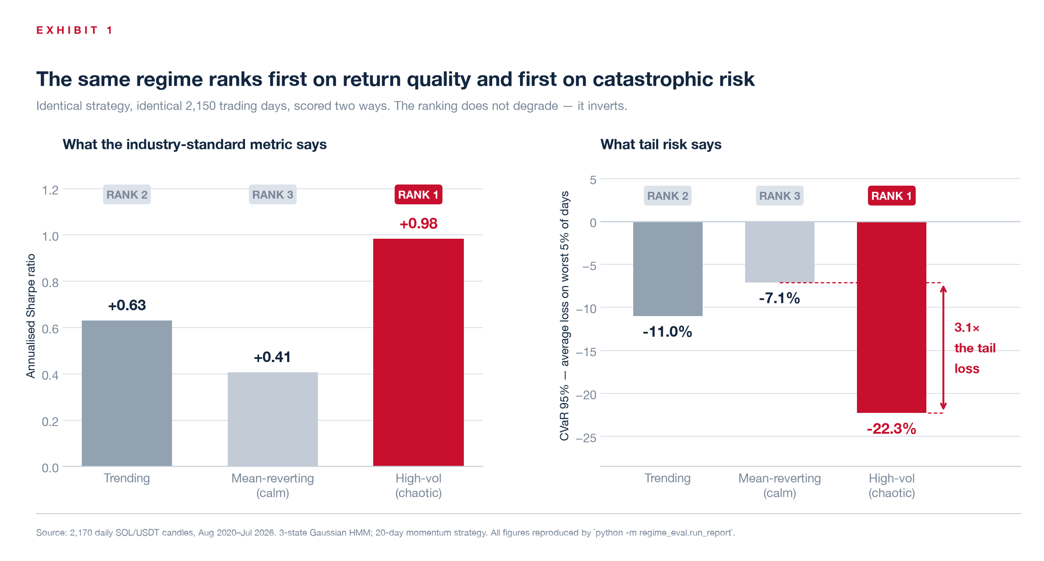
Exhibit 1 — Left: annualised Sharpe by regime. Right: CVaR 95%, the average return on the worst 5% of days. Same strategy, same days, same code path. The ranking flips end to end.
2. The aggregate figure describes a market that never existed
The conventional single number for this strategy is +0.64. It is not wrong so much as it is about nothing. No regime in the sample performed at +0.64. The three actual figures are +0.41, +0.63 and +0.98 — a 2.4× spread that the aggregate silently averages away.
The same holds on the risk side. The aggregate expected shortfall of −12.91% is simultaneously too small to describe the chaotic regime and nearly twice too large to describe the calm one. An allocator sizing against −12.91% is under-hedged in one regime and over-hedged in another, and the number gives no indication of which state it is currently in.
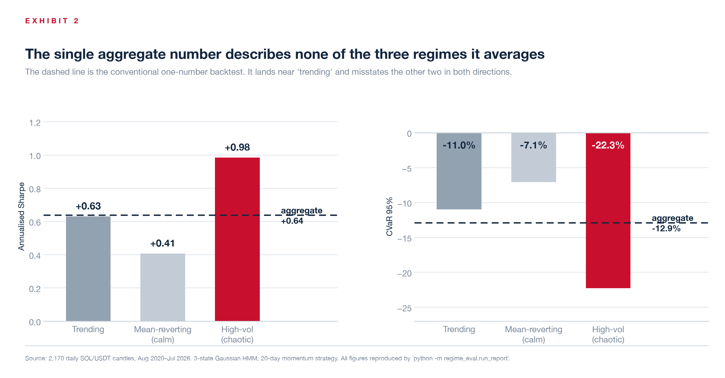
Exhibit 2 — The dashed rule is the aggregate. It sits near the trending regime by coincidence of sample weights and misstates the other two in opposite directions.
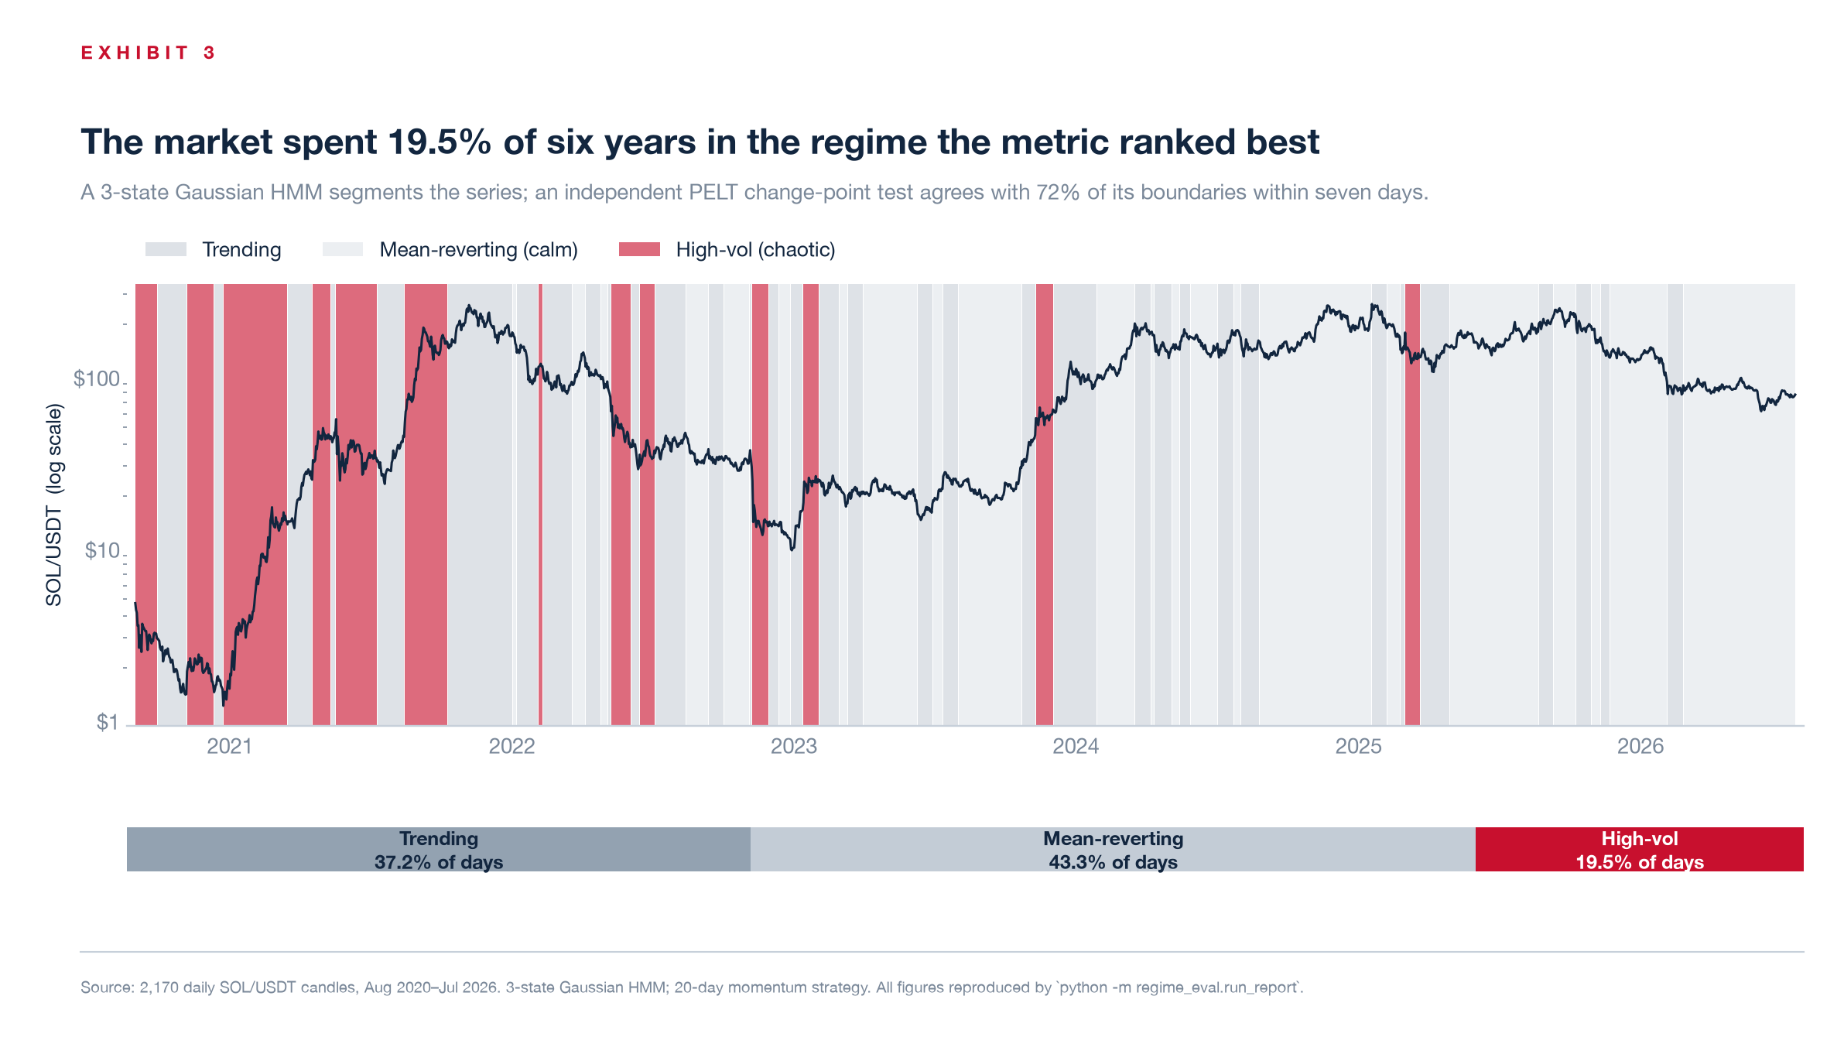
Exhibit 3 — Six years of SOL/USDT, shaded by detected regime. Regimes are assigned by a 3-state Gaussian HMM on return and realised volatility; an independent PELT change-point test corroborates 72% of its boundaries within seven days.
3. One-fifth of the calendar, nine-tenths of the damage
The high-volatility regime accounts for 19.5% of trading days. It also accounts for 90% of the twenty worst days in the sample, 68% of the worst fifty, and 51% of the worst hundred. It is 4.6× over-represented in the extreme left tail relative to its share of the calendar.
The single-day figures are starker still. The worst day inside the calm regime cost 13.6%. The worst day inside the chaotic regime cost 47.0% — three and a half times as much, in a regime the Sharpe ratio had just nominated as the best place to deploy capital.
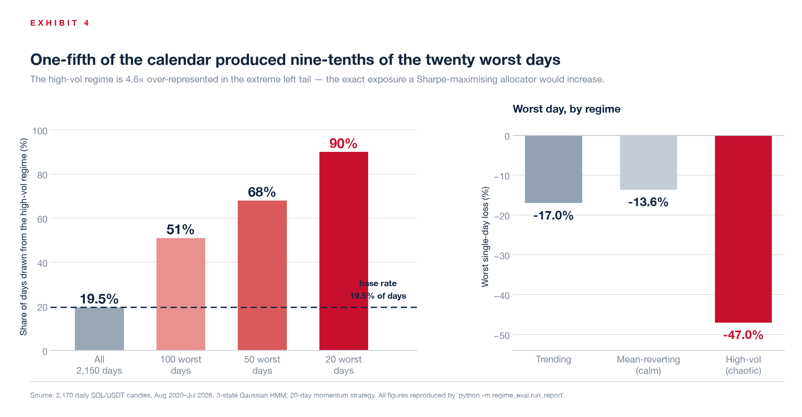
Exhibit 4 — Left: the high-vol regime's share of the worst days, against its 19.5% base rate. Right: worst single-day loss by regime.
4. Why the two scorecards disagree — and why it is systematic
This is not a quirk of one dataset. The disagreement follows a single, predictable fault line: whether a metric preserves the magnitude of a loss or cancels it out.
Sharpe is a ratio. Return sits in the numerator, volatility in the denominator. When a regime's moves get larger, both terms grow, and the size of the loss cancels. The tail ratio behaves identically — it is a gain quantile over a loss quantile. Both metrics rank the chaotic regime first.
CVaR and drawdown are magnitudes. They are denominated in percent, and nothing divides the loss away. Both rank the chaotic regime last.
Sharpe also treats a large gain and a large loss as the same object — volatility — and nets them against each other. Momentum captures some of the large upward moves in a chaotic market, which is what produces the flattering ratio. The equally large downward moves are netted off rather than counted. Expected shortfall counts only the losses, which is why it reaches the opposite verdict from the identical return series.
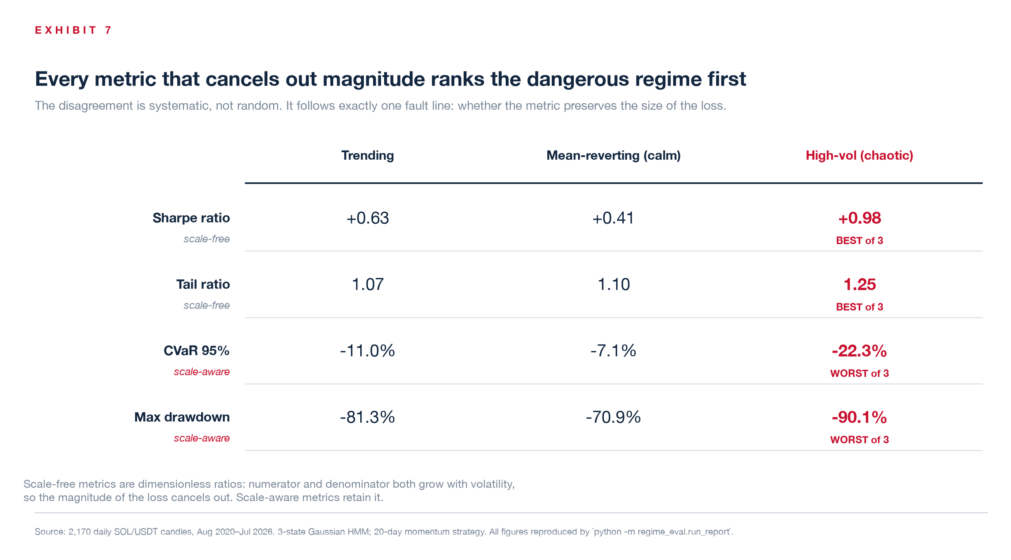
Exhibit 7 — Four metrics, one strategy. The split is exact: every scale-free metric ranks high-vol best; every scale-aware metric ranks it worst.
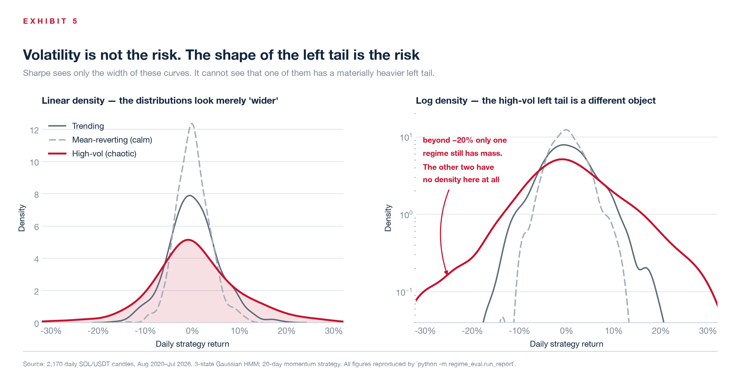
Exhibit 5 — On a linear density the three regimes look like the same distribution at different widths. On a log density the difference is structural: beyond −20% only one regime retains any mass at all.
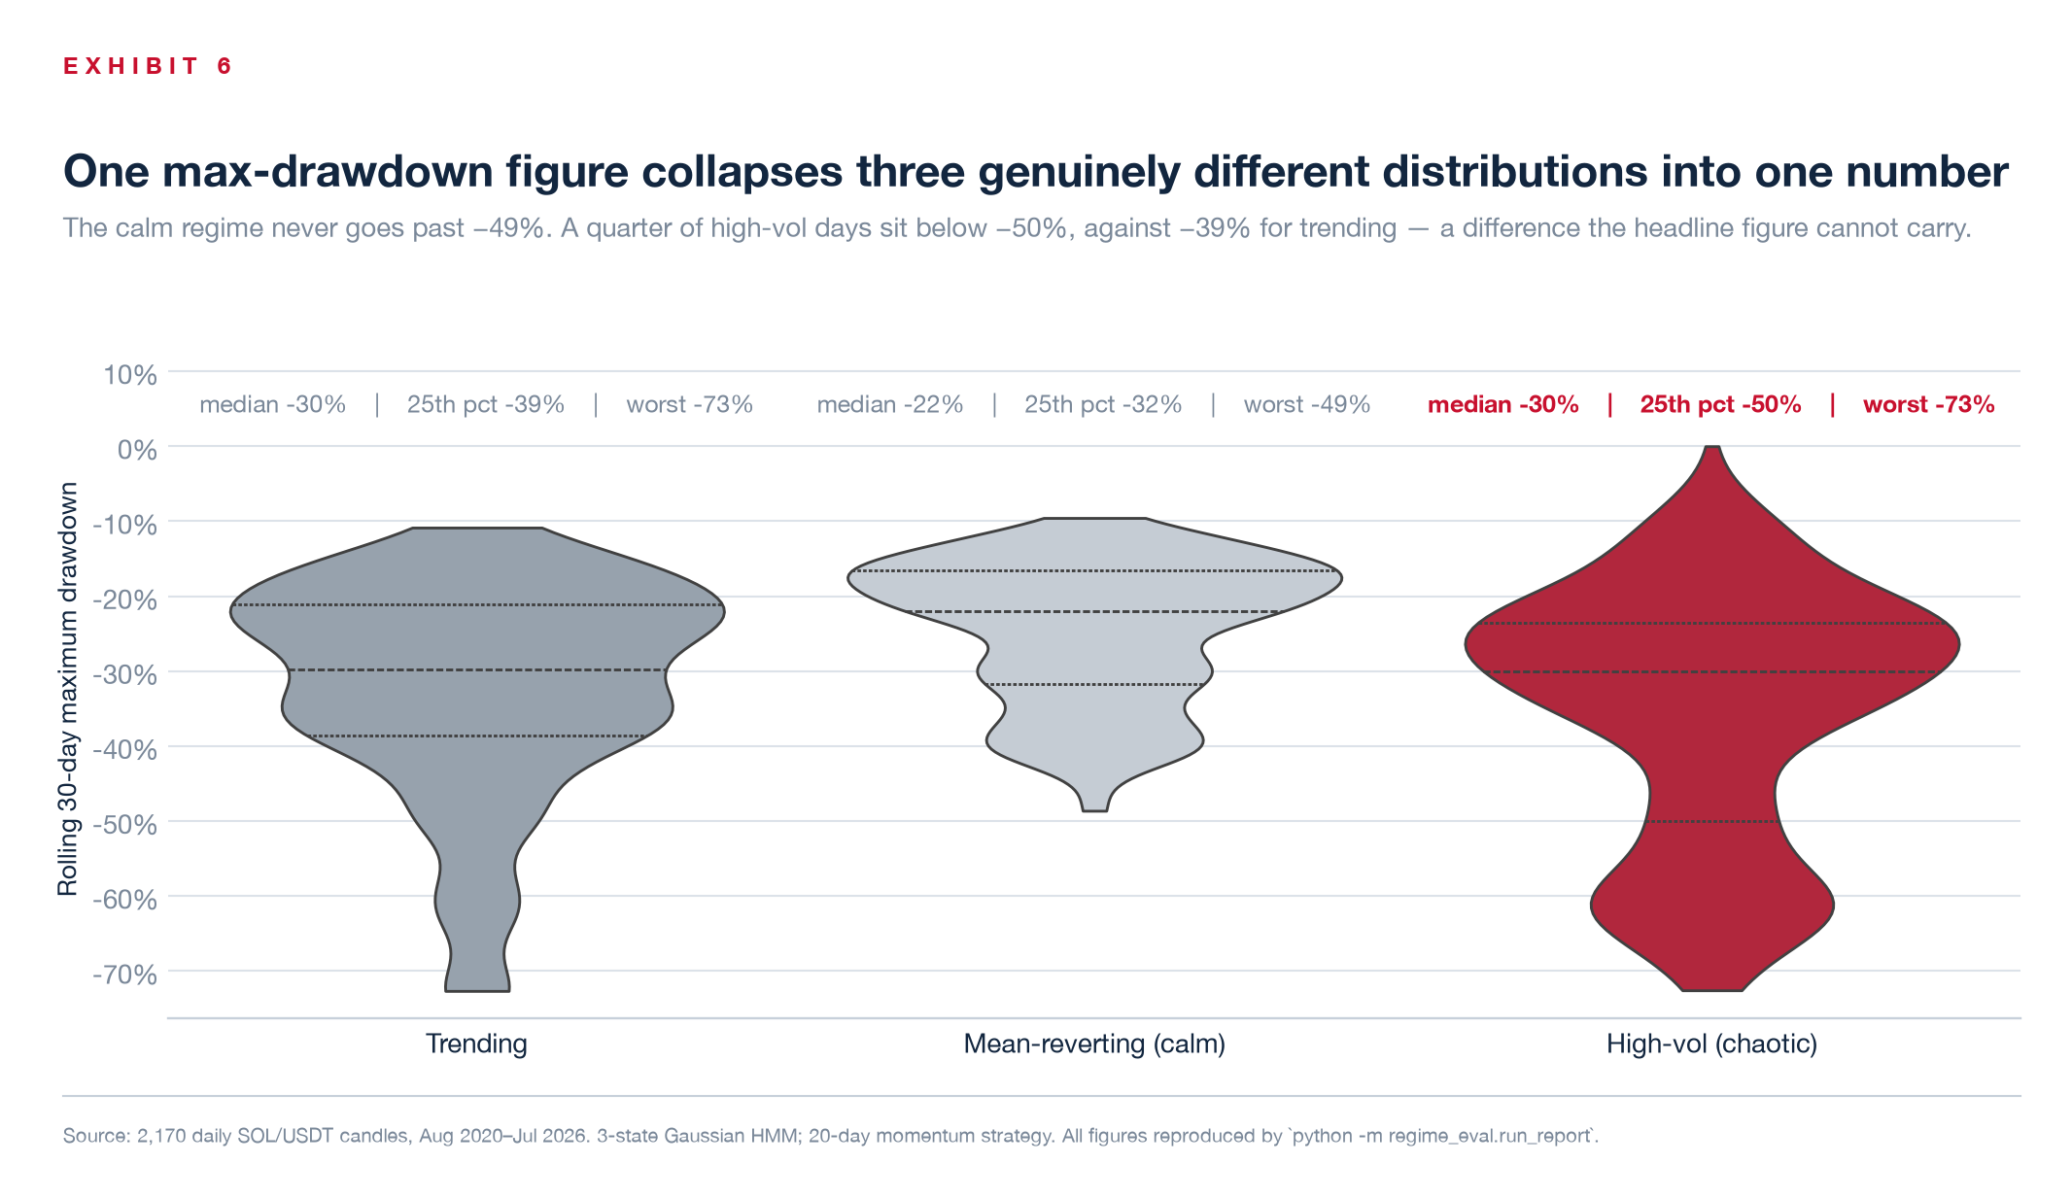
Exhibit 6 — Rolling 30-day maximum drawdown, as a distribution rather than a headline figure.
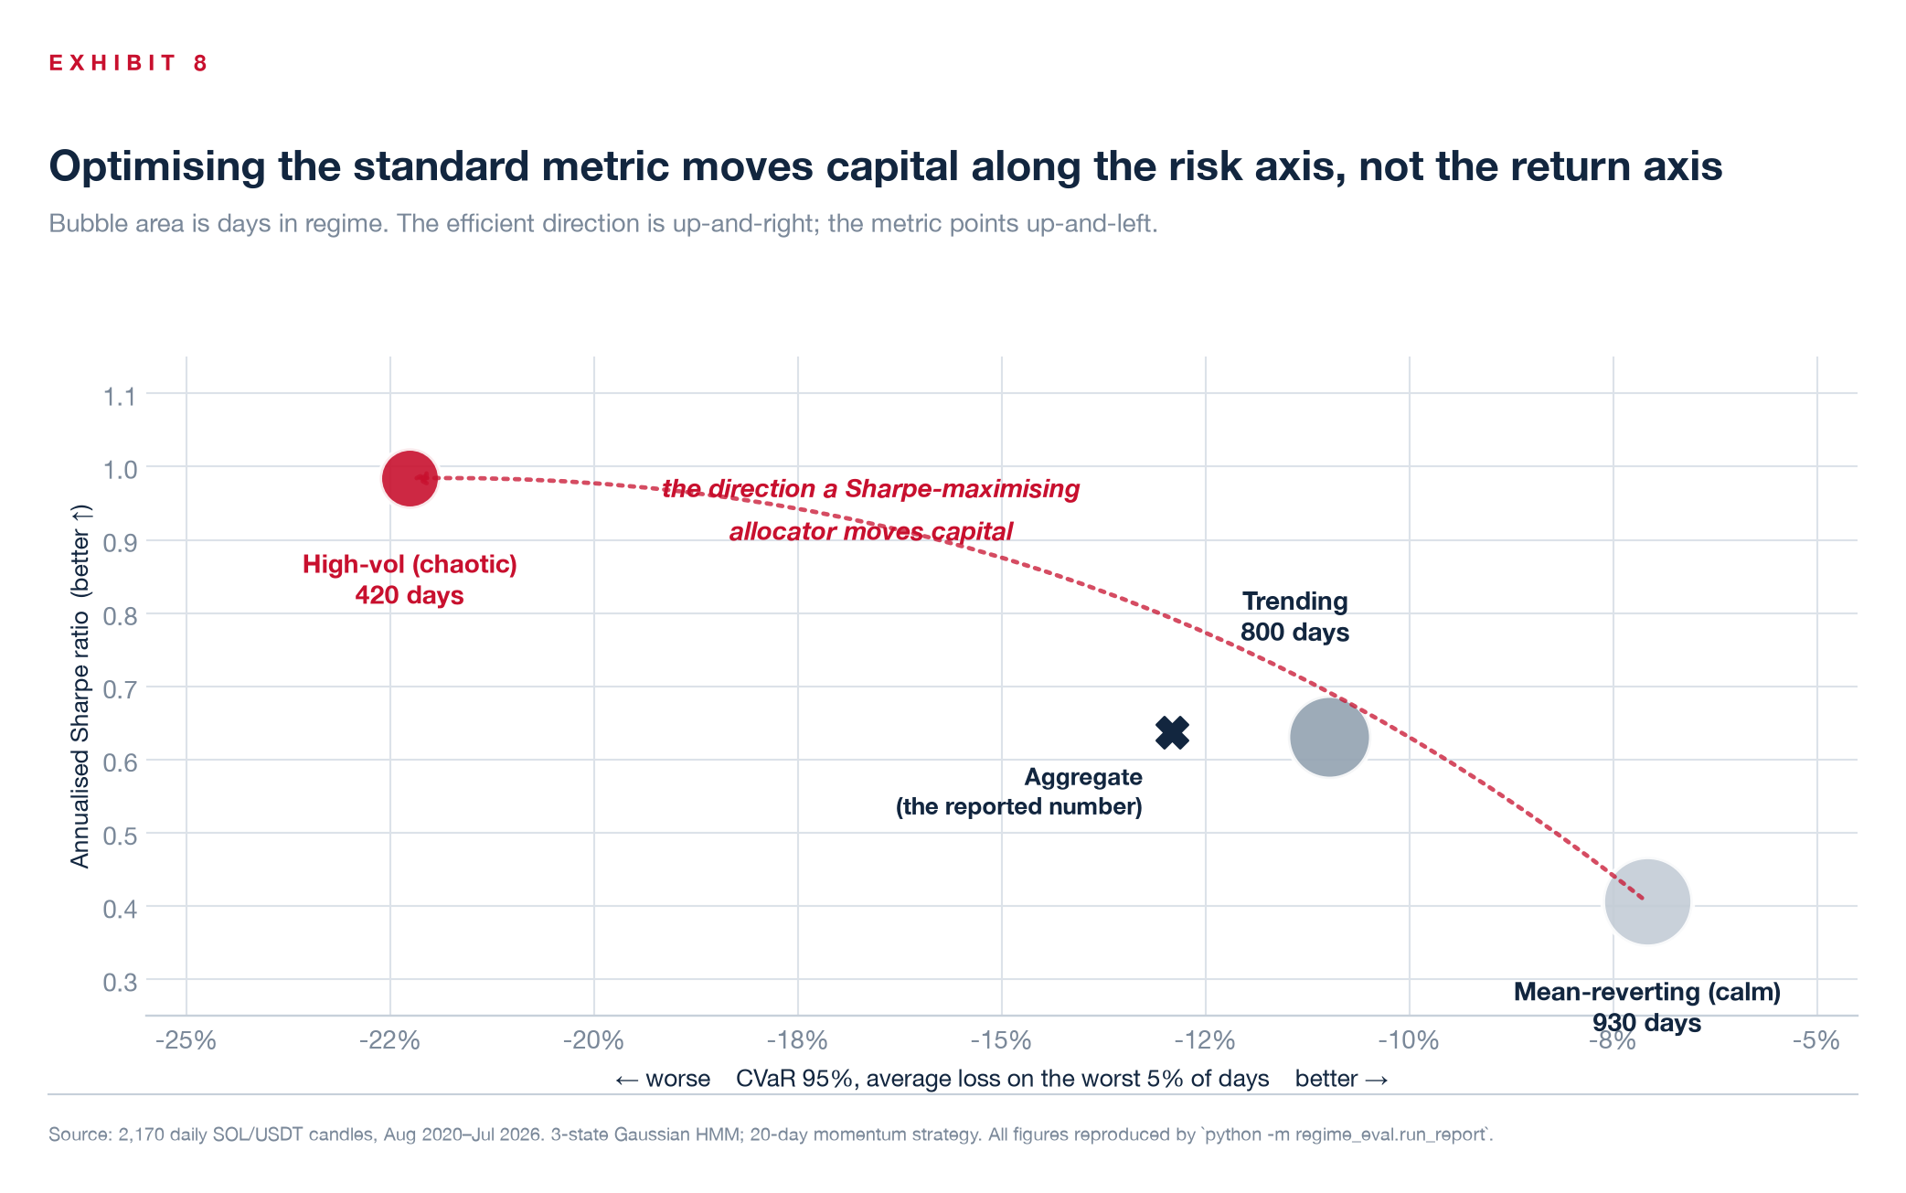
Exhibit 8 — Risk against return, bubble area proportional to days in regime. The efficient direction is up and to the right. Sharpe optimisation travels up and to the left.
5. Turning eval-validity into a live signal
If a backtest is only valid inside the regime it was measured in, the operational question follows immediately: how does a system know when it has left that regime?
We tested a simple answer. A rolling 30-day Kolmogorov–Smirnov test compares the recent return distribution against the calm regime's — the one regime where a backtest's thin-tail assumptions approximately hold. The KS statistic is bounded on [0, 1], so it doubles as a severity score, and it is non-parametric, so there is no density estimate or bin width to tune.
The detector reads prices only. It is never shown the regime labels. It nonetheless fires on 66.7% of days in the chaotic regime and 1.4% of days in the calm one — it recovers the structure it was never given.
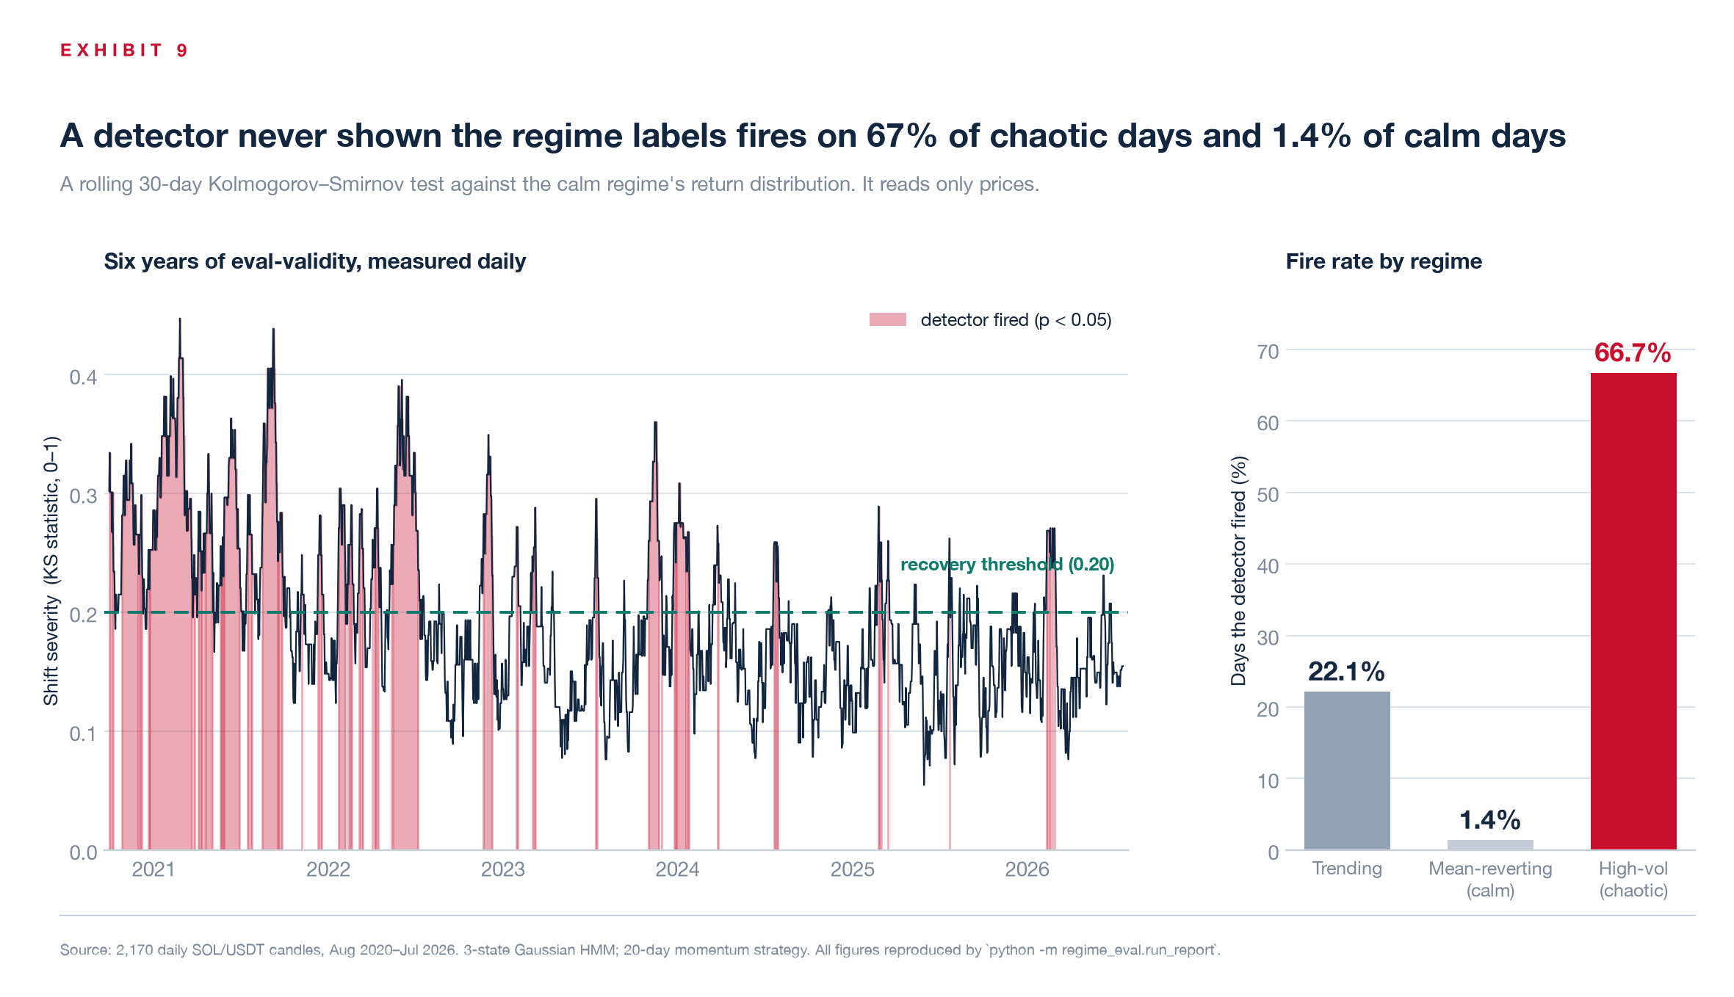
Exhibit 9 — Left: shift severity over six years, with detections shaded. Right: fire rate by regime. Mean severity runs 0.150 in the calm regime, 0.201 in trending and 0.285 in high-vol.
6. The control that nearly killed the result
We then closed the loop: when the detector fires, the agent halves its position; when severity falls back below 0.20, it restores. Fifty-four self-modifications over six years, each written to an audit log with its timestamp, trigger severity and resulting exposure.
Maximum drawdown improved from −85.1% to −76.6%. That result is worthless on its own, and it is worth being explicit about why.
The confound: the adaptive agent spends much of the sample at half size. Its average exposure is 0.86×. Any reduction in exposure reduces drawdown. Measured against the full-size baseline, the comparison establishes only that betting less loses less.
So we added a third arm: constant exposure fixed at 0.86× — the adaptive agent's own average. Both now spend an identical risk budget across the full sample. The only remaining difference is when the risk is taken off.
Targeted de-risking wins by 3.95 drawdown points (−76.63% against −80.58%) and 0.74 points of expected shortfall (−10.37% against −11.11%), at matched average exposure.
A useful internal check sits inside that table. Baseline and uniform report identical Sharpe (0.6371) and identical tail ratio (1.1381), because both metrics are scale-free and constant scaling cannot move them. Had those columns differed, the sizing path would have contained a bug.
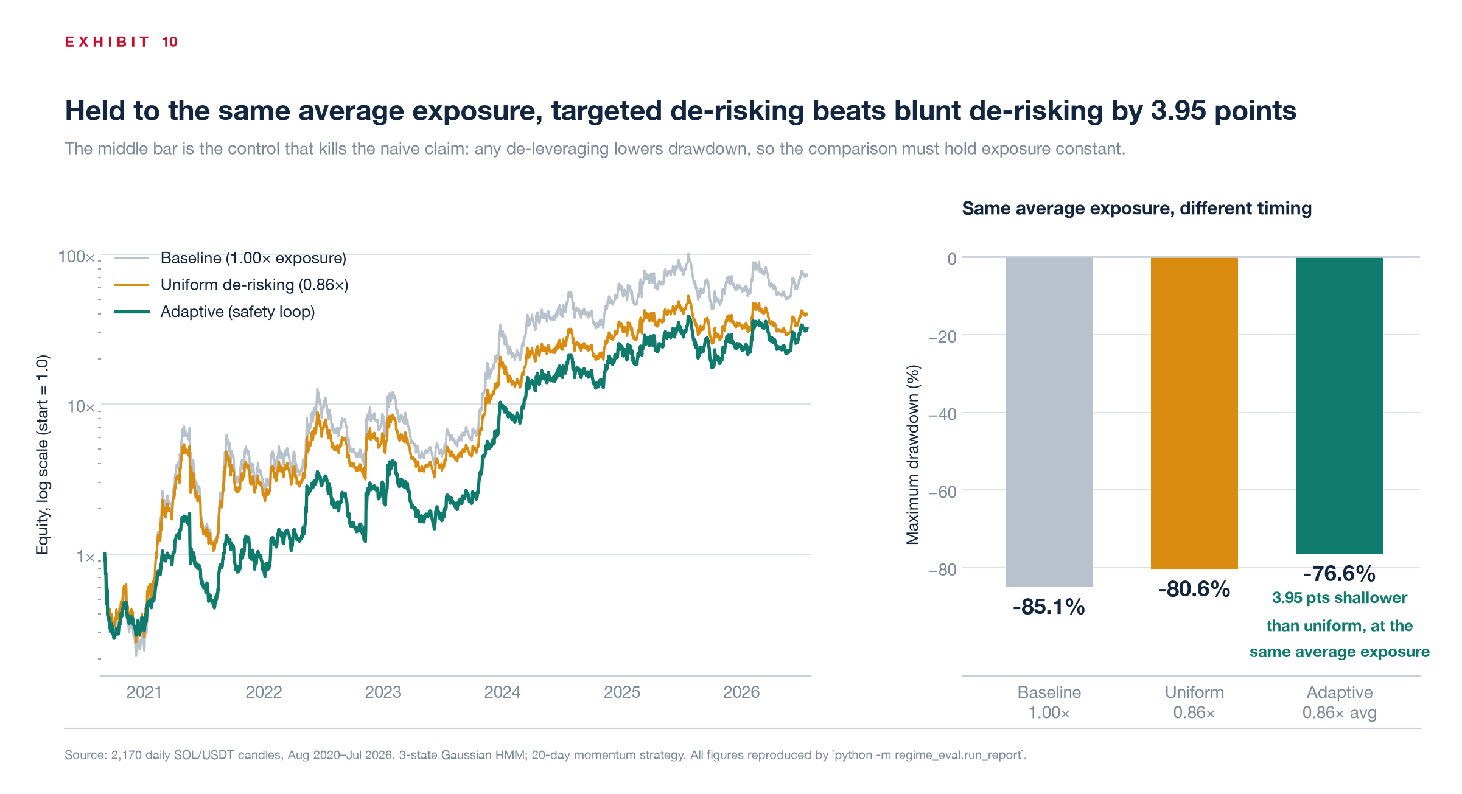
Exhibit 10 — Left: the three equity curves. Right: maximum drawdown at matched average exposure. The middle bar is the control that makes the comparison meaningful.
The cost is reported rather than buried. Terminal wealth falls from 40.2× to 31.9×, roughly a fifth of the compounded return, in exchange for the tail improvement. Safety is purchased, not discovered.
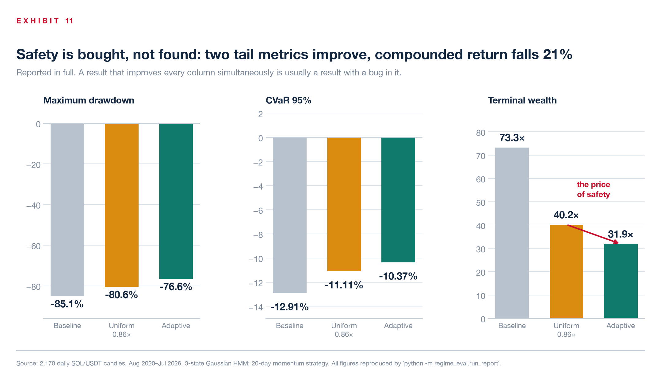
Exhibit 11 — Two tail metrics improve; compounded return declines 21%. A result that improves every column at once is usually a result with an error in it.
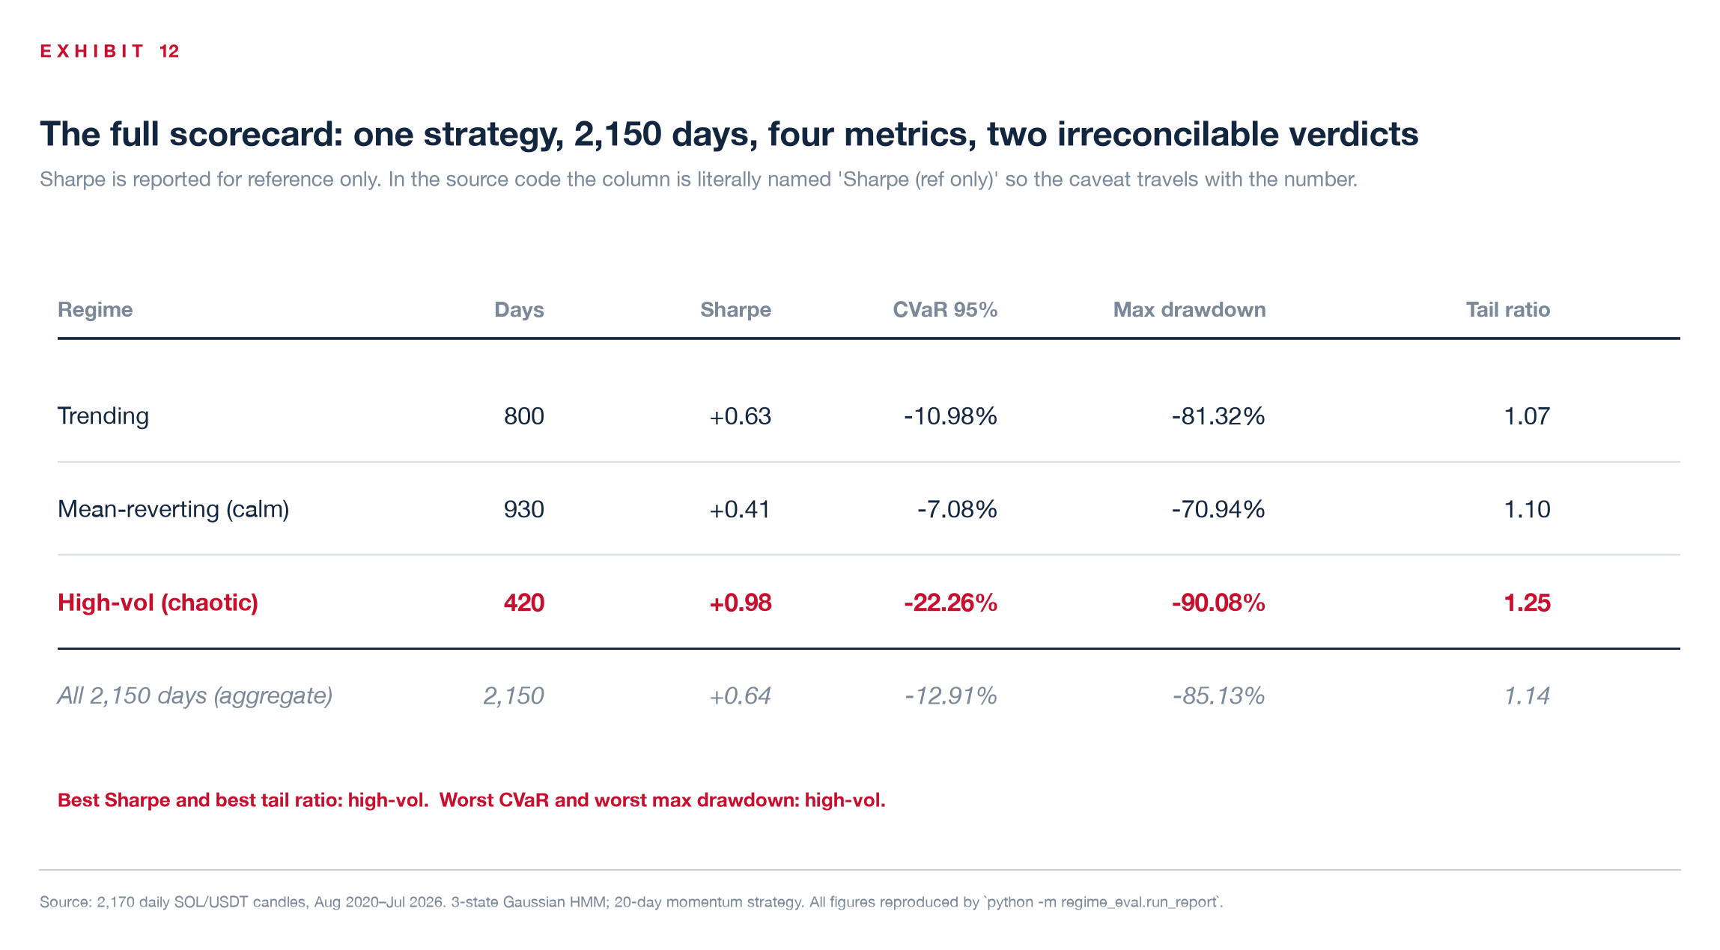
Exhibit 12 — The complete scorecard. In the source code the Sharpe column is literally named 'Sharpe (ref only)', so the caveat travels wherever the table is pasted.
7. What this does not establish
Four limitations, stated plainly, because a result presented without them should not be trusted.
• The regime labels use future information. The HMM is fitted over the full sample and the reference regime is chosen from the full sample. The momentum backtest itself is causal, but the adaptive sizing series is not walk-forward and could not have been reproduced live. The evaluation finding — that conditioning changes the ranking — survives this. The 3.95-point sizing result does not fully, and is presented as the weakest of the three claims.
• The detector's firing rate is not a calibrated error rate. Adjacent 30-day windows share 29 days, so the p-values are strongly dependent. The 22% overall firing rate should not be read as a false-positive rate, and α = 0.05 does not imply that 5% of detections are spurious.
• The strategy is not investable. Drawdowns run 81–90% in every regime and 85% in aggregate. It compounds to 73.3× against 17.5× for buy-and-hold over the same 2,150 days, but no risk desk would fund that profile. This is a study of how a strategy is scored, not evidence that this strategy works.
• The scope is one asset, one strategy, one timeframe. The regime count is fixed at three by configuration rather than selected by an information criterion. Across six random seeds the fit was near-identical and the high-vol regime held both the best Sharpe and the worst CVaR in six of six — which establishes seed stability, not that three is the correct number of states or that the result transfers to another market.
8. The implication
Any system that tunes, gates or allocates against a single backtest number inherits whatever that number gets wrong. On this data, a release gate reading aggregate Sharpe would have promoted a policy on the strength of a regime whose expected shortfall is three times the calm regime's — because the metric ranked that regime first.
The correction is not a better single number. It is refusing to produce one.
One row per regime. Tail metrics alongside ratio metrics, because they disagree and the disagreement is the signal. And a live check on whether the distribution the evidence was gathered under still holds — so that "this passed evaluation" can expire, rather than stand indefinitely.

Method and reproducibility
2,170 daily SOL/USDT candles, 11 Aug 2020 – 20 Jul 2026, cached in-repo so no network access or API key is required. Regimes from a 3-state Gaussian HMM on [log return, 20-day realised volatility], standardised; state labels are derived from each state's own statistics rather than a fixed index map, so re-seeding cannot silently permute them. Boundaries cross-checked against PELT change-point detection with an RBF cost. Strategy: 20-day momentum, long/short, positions lagged one day. Metrics: CVaR 95%, rolling max drawdown, tail ratio, Sharpe (reference only). Shift detection: rolling 30-day two-sample KS against the calm regime, α = 0.05. Every figure in this article is produced by a single command in roughly three seconds, and the output is byte-identical across runs because the pipeline is seeded.
No transaction costs, funding or slippage are modelled.

Appendix · Ready-to-post thread
Companion thread for distribution. Attach the exhibit named in brackets to that post; the bracket text is a note to you, not part of the copy.
1/ I scored one trading strategy two different ways on six years of real market data.
The rankings didn't just differ. They inverted.
The metric almost every desk optimises pointed capital straight at the regime that produced 90% of the worst days.

2/ Setup: 2,170 daily SOL/USDT candles, split into three market regimes by a Hidden Markov Model — trending, calm, chaotic. Then score the identical momentum strategy separately inside each one.
An independent change-point test agrees with 72% of the boundaries.
attach: Exhibit 3
3/ The result.
Sharpe ranking:
1. chaotic +0.98
2. trending +0.63
3. calm +0.41
Tail-risk ranking (CVaR 95%):
1. calm −7.08%
2. trending −10.98%
3. chaotic −22.26%
Same days. Same strategy. Opposite verdict.
attach: Exhibit 1
4/ The regime Sharpe crowned first carries 3.1× the expected shortfall of the calm regime.
An allocator maximising Sharpe levers hardest into the regime most likely to end it.

5/ It gets worse.
That regime is 19.5% of the calendar.
It is 90% of the 20 worst days.
68% of the worst 50.
51% of the worst 100.
Worst single day: −47.0%, against −13.6% in the calm regime.
attach: Exhibit 4
6/ Also: the aggregate number everyone reports (+0.64) describes no regime in the sample.
The three real figures are +0.41, +0.63 and +0.98 — a 2.4× spread averaged into a number that describes a market which never existed.
attach: Exhibit 2
7/ Why do the metrics disagree? It is systematic, not noise.
Sharpe is a RATIO — return ÷ volatility. When moves get bigger, both terms grow and the size of the loss cancels out.
CVaR is a MAGNITUDE. Nothing divides the loss away.
Every scale-free metric ranked chaos best. Every scale-aware metric ranked it worst.
attach: Exhibit 7
8/ So I built a detector: a rolling KS test that fires when the live return distribution drifts off the regime the backtest was valid in.
It reads prices only. It never sees the regime labels.
It fires on 66.7% of chaotic days and 1.4% of calm days — it recovers the structure it was never given.
attach: Exhibit 9
9/ When it fires, the agent halves its position. Drawdown improved from −85.1% to −76.6%.
That result is worthless on its own, and it is worth saying why: the adaptive agent averages 0.86× exposure. Betting less loses less. Confounded.

10/ So I added a control — constant 0.86× exposure. Same risk budget; only the timing differs.
Targeted de-risking still wins by 3.95 drawdown points.
Cost, stated plainly: terminal wealth falls 40.2× → 31.9×. Safety is bought, not found.
attach: Exhibit 10
11/ The honest caveats:
• Regime labels use full-sample information — not walk-forward
• Overlapping windows mean the firing rate is not a calibrated error rate
• The strategy itself is unfundable (81–90% drawdowns)
• One asset, one timeframe
The evaluation finding survives all four.

12/ The takeaway is not “use a better single number.”
It is: stop producing one.
One row per regime. Tail metrics beside ratio metrics — because they disagree, and the disagreement is the signal.
Full write-up, code, and every number reproducible in three seconds: [link]
attach: Exhibit 12

Post copy for the link tweet
“The Sharpe ratio ranked the most dangerous regime in the sample first. Not by a little — it inverted the entire ranking. 2,170 days of data, every number reproducible in three seconds. Write-up below.”

