B. Tech CSE 3rd

SEMESTER: 5th

Mini Project –II

**Final Report**



**Department of Computer Science and Application**

**Institute of Engineering and Technology**

**Submitted To: Submitted By:**

Md. Amir Khan Pop Singh (201500475)

(Technical Trainer) Aryan Pokhriyal(201500155)

Ayush Kumar (201500179)

Anuj Verma (201500122)

Kushpreet Singh (201500366)

Door Security System using



**Acknowledgement**

We thank the almighty for giving us the courage and perseverance in completing the project. This project itself is an acknowledgement for all those people who have given us their heartfelt co-operation in making this project a grand success. We extend our sincere thanks to Mohd. Amir Khan, Technical Trainer at “GLA University, Mathura” for providing his valuable guidance at every stage of this project work. We are profoundly grateful towards the unmatched services rendered by him. And last but not least, we would like to express our deep sense of gratitude and earnest thanks giving to our dear parents for their moral support and heartfelt cooperation in doing the main project.

**Declaration**

We hereby declare that the work which is being presented in the MINI Project “**Door Security System using RFID”,** in partial fulfilment of the requirements for MINI Project viva voce, is an authentic record of our own work carried by the team members under the supervision of our mentor Md. Amir Khan.

Group Members: Pop Singh (201500155)

Aryan Pokhriyal (201500155)

Anuj Verma (201500122)

Kushpreet Singh (201500366)

Ayush kumar (201500179)

Course: B. Tech (Computer Science and Engineering)

Year: 3rd

Semester: 5th

Supervised By: Mr. Mandeep Singh, Technical Trainer

**Introduction**

Today, people want their everyday life to be completely automated. The doors in our houses are also some of the things that are being modernized and automatized.

Our project “Door Security System using RFID” is based on this aspect. We want to show that how our conventional doors can be better automated and can be cheap for better security and access to a better life. We have used our knowledge that we gained during our studies to put together this project. The project uses RFID and NodeMCU module to automate the working of a conventional door.

**Problem with traditional doors?**

The door is an important component in a building as security. It is used as access in and out of a room. But the traditional doors are way too insecure right now. Reasons: Duplicate key, Weak lock mechanism and Rust issues.

**What is in need right now?**

People in the Modern Era now want everyday life that is completely automated, so that the work can be done easily without wasting energy and can shorten the time.

Along with the rapid development, the need for effectiveness and efficiency is prioritized in various fields. The purpose of this project is to design an automatic door that only detects an authorized Radio Frequency Identification (RFID) card to open.

The use of RFID systems can strengthen the security level of building access. This study uses a data processing method in the form of an ID number generated from a tag.

How does our mini project do what it is supposed to?

The answer is: RFID Technology!

Every Big Tech company is now using RFID identification for its employees, shopping malls use RFID to keep check on theft and toll gates use Long-Range RFID to scan car for toll taxes.

What profits do we gain from it?

* Saves Time
* Faster access
* Precise Logged information
* Unauthorized or Unwanted access are blocked



The RFID Reader send electromagnetic waves to the RFID Tag, which induces current in the tag and activates it. The tag transmits its data back to the reader for authorization.



Then, the user information (Tag UID, User name, phone number, etc.) is send to the reader which goes into the ESP8266 module (with authorization code) integrated with Blynk to check if the tag is an authorized tag.

If there is any unwanted access with the user’s RFID tag, then the user will get a notification and an email on their Gmail ID so that they can know about the situation & block their card.

**Resources used:**

**Software/Platforms used**:

1. **Arduino IDE:** Arduino IDE contains a text editor for writing code, a message area, a text console, a toolbar with buttons for common functions.

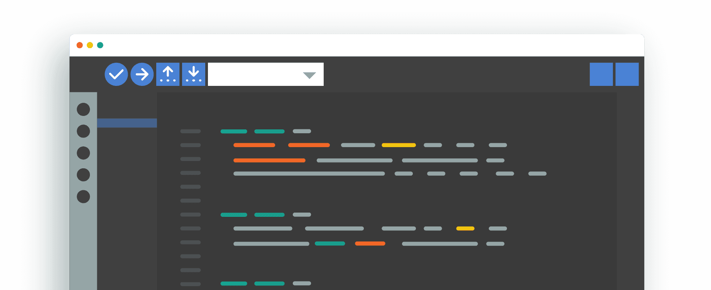

1. **BLYNK IoT platform:** It is an IoT platform for iOS and Android smartphones that is used to control Arduino, Raspberry Pi and NodeMCU via the Internet. It is used to create a GUI by compiling and providing the appropriate address on the available widgets.



**Hardware used:**

1. ESP8266 NodeMCU module
2. MFRC522 RFID reader and RFID Tags/Card.
3. Servo motor
4. Breadboard
5. Jumper wires

**ESP8266 NodeMCU module**

The ESP8266 Wi-Fi Module is a self-contained SOC with integrated TCP/IP protocol stack that can give any microcontroller access to your Wi-Fi network.

Why did we used ESP8266 in our project?

* The voltage of operation of the ESP microprocessors is 3.3 V compared to the Arduino operating voltage of 5V.
* ESP8266 NodeMCU has 16 digital I/O pins whereas Arduino has 14 digital I/O pins
* ESP826 NodeMCU module has 13 PWM pins whereas Arduino has only 6 PWM pins.
* It can be used for Network based project whereas Arduino can’t be used if we don’t integrate it with NodeMCU since NodeMCU has Wi-fi and Bluetooth capabilities.

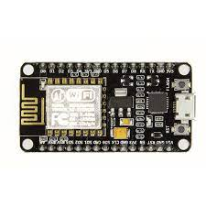

MFRC522 RFID Reader and tags/cards

It is a low-cost RFID reader module which is based on the principle of Electromagnetic Induction. It is easy to use and can be used in a wide range of applications.

We have used a Low frequency RFID system, which ranges from 30KHz to 500KHz. Its transmission ranges generally from few inches to less than a foot.

This system used a passive RFID tag, which receives its power from the reading antenna, whose electromagnetic wave induces a current in the RFID tag's antenna.

RFID tags used in this project typically hold less than 2,000 KB of data, including a unique identifier/serial number.

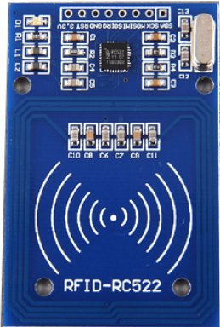 

Servo Motor

A Servo consists of a Motor (DC or AC), a potentiometer, gear assembly, and a controlling circuit. First of all, we use gear assembly to reduce RPM and to increase torque of the motor.

**Servo we used in our project have three wires coming out of it**. Out of which two will be used for Supply (positive and negative) and one will be used for the signal that is to be sent from the MCU.

Servo motor is controlled by PWM (Pulse Width Modulation) which is provided by the control wires. There is a minimum pulse, a maximum pulse and a repetition rate. Servo motor can turn 90 degrees from either direction form its neutral position.

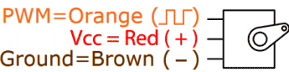



**Source Code:**

/*

* MFRC522 Interfacing with NodeMCU

*

* Typical pin layout used:

* ----------------------------------

* MFRC522 Node

* Reader/PCD MCU

* Signal Pin Pin

* ----------------------------------

* RST/Reset RST D1 (GPIO5)

* SPI SS SDA(SS) D2 (GPIO4)

* SPI MOSI MOSI D7 (GPIO13)

* SPI MISO MISO D6 (GPIO12)

* SPI SCK SCK D5 (GPIO14)

* 3.3V 3.3V 3.3V

* GND GND GND

*/

#define BLYNK_TEMPLATE_ID "TMPL1_b8IfVm"

#define BLYNK_DEVICE_NAME "rfid"

#define BLYNK_AUTH_TOKEN "9KhpD7iqAJBG2aslCMAxywuHHVmluS9R"

#include<SPI.h>

#include<MFRC522.h>

#include<ESP8266WiFi.h>

#include<BlynkSimpleEsp8266.h>

#include <Servo.h>

#define BLYNK_PRINT Serial

Servo servo;

char auth[] = BLYNK_AUTH_TOKEN;

char ssid[] = "Realme";

char pass[] = "pratapsingh24";

WidgetTerminal terminal(V2);

String str1 = "793DF94E";

String str2 = "32635B1A";

String str3 = "A936F84E";

String str4 = "793DF94E";

#define SS_PIN 4 //D2

#define RST_PIN 5 //D1

MFRC522 mfrc522(SS_PIN,RST_PIN); // Instance of the class

void setup() {

Serial.begin(9600); // Start the Serial communication to send messages to the computer

delay(10);

Serial.println('\n');

servo.attach(15); //D8

servo.write(0); //servo at O

Blynk.begin(auth, ssid, pass);

// Connect to the network // Send the IP address of the ESP8266 to the computer

SPI.begin(); // Initiate SPI bus

mfrc522.PCD_Init(); // Initiate MFRC522

}

void loop() {

Serial.println(".............................................................");

Serial.println(".............................................................");

Serial.println(".............................................................");

Serial.println(" UID tag :");

String content= "";

byte letter;

if ( mfrc522.PICC_IsNewCardPresent()){

if ( mfrc522.PICC_ReadCardSerial()){

for (byte i = 0; i < mfrc522.uid.size; i++)

{

Serial.print(mfrc522.uid.uidByte[i] < 0x10 ? "0":"");

Serial.print(mfrc522.uid.uidByte[i],HEX);

content.concat(String(mfrc522.uid.uidByte[i] < 0x10 ? "0":""));

content.concat(String(mfrc522.uid.uidByte[i],HEX));

}

}

}

delay(1000);

content.toUpperCase();

Serial.println();

if( content.equals(str1) )

{

Serial.println("Aryan"); //Enter User1 Name

Blynk.virtualWrite(V2, "Aryan" ); //Enter User1 Name

Blynk.logEvent("e1");

servo.write(90);

delay(2000);

servo.write(0);

delay(1000);

}

else if( content.equals(str2) )

{

Serial.println("Ayush"); //Enter User2 Name

Blynk.virtualWrite(V2, "Ayush" );//Enter User2 Name

Blynk.logEvent("e2");

servo.write(90);

delay(2000);

servo.write(0);

delay(1000);

}

else if( content.equals(str3) )

{

Serial.println("Anuj"); //Enter User3 Name

Blynk.virtualWrite(V2, "Anuj" ); //Enter User3 Name

Blynk.logEvent("e3");

servo.write(90);

delay(2000);

servo.write(0);

delay(1000);

}

else {

Serial.println("Unregistered User");

delay(3000);

} Serial.println();

Serial.println();

Serial.println();

Serial.println();

Serial.println(".............................................................");

Serial.println(".............................................................");

Serial.println(".............................................................");

Serial.println(); Serial.println(); Serial.println(); Serial.println();

      }

**Feasibility Study**

A feasibility study is a high-level capsule version of the entire System analysis and Design Process. The study begins by classifying the problem definition. Feasibility is to determine if it’s worth doing. Once an acceptance problem definition has been generated, the analyst develops a logical model of the system. A search for alternatives is analysed carefully. There are 3 parts in feasibility study.

1) Operational Feasibility

2) Technical Feasibility

3) Economical Feasibility

**Operational Feasibility:**

Operational feasibility is the measure of how well a proposed system solves the problems, and takes advantage of the opportunities identified during scope definition and how it satisfies the requirements identified in the requirements analysis phase of system development. The operational feasibility assessment focuses on the degree to which the proposed development projects fits in with the existing business environment and objectives with regard to development schedule, delivery date, corporate culture and existing business processes. To ensure success, desired operational outcomes must be imparted during design and development.

**Technical Feasibility:**

Establishing the cost-effectiveness of the proposed system i.e. if the benefits do not outweigh the costs then it is not worth going ahead. In the fast paced world today there is a great need of online social networking facilities. Thus the benefits of this project in the current scenario make it economically feasible. The purpose of the economic feasibility assessment is to determine the positive economic benefits to the organization that the proposed system will provide.

It includes quantification and identification of all the benefits expected. This assessment typically involves a cost/benefits analysis.

Pre-requisite:

Hands-on knowledge of Arduino, NodeMCU, Blynk IoT platform and development board connection is essential before working on the concepts for making of RFID door security system. Make sure that you have the browser or chrome installed and running before opening web.

Main Objectives:

* Improvisation of traditional home security systems with the aid of modern IOT-based components.
* Making use of Industrial IOT technologies accessible to the common masses in a feasible and acceptable way.
* Real-Time surveillance and Theft control
* The User can also block its RFID card/tag if there is any unwanted access from the card.

What can we append in future?

* Implement the project with Face Scanner/ Fingerprint Scanner (Two-Factor Authentication)
* Include a physical security feature: Enter a pin unique to the user
* To make RFID identification available to common masses in cheaper and acceptable price
* Implementing RFID tags in cars for toll gates and security entrances
* Messaging facility for the user to inform them of any unwanted access

Bibliography

1. [www.google.com](http://www.google.com)
2. www.Blynk.io
3. [www.arduino.cc](http://www.arduino.cc)
4. [www.youtube.com](http://www.youtube.com)

Thank you!