# B.TECH CSE IIIrd year

# SEMESTER: Vth

# Door Security System using RFID

## MINI PROJECT

## SYNOPSIS



Department of Computer Science & Application

## Institute of Engineering & Technology

SUBMITTED TO: - SUBMITTED BY: -

Md. Amir Khan Aryan Pokhriyal(201500155)

(Technical Trainer ) Pop Singh (201500475)

Anuj Verma (201500122)

Ayush Kumar (201500179)

Kushpreet Singh(201500366)

# Acknowledgement

It gives us a great sense of pleasure to present the synopsis of the B. Tech mini project undertaken during B. Tech III Year. This project is going to be an acknowledgement to the inspiration, drive and technical assistance will be contributed to it by many individuals. We owe special debt of gratitude to Md. Amir Khan, Technical Trainer, for providing us with an encouraging platform to develop this project, which thus helped us in shaping our abilities towards a constructive goal and for his constant support and guidance to our work.

His sincerity, thoroughness and perseverance has been a constant source of inspiration for us. We believe that he will shower us with all his extensively experienced ideas and insightful comments at different stages of the project & also taught us about the latest industry-oriented technologies. We also do not like miss the opportunity to acknowledge the contribution of all faculty members of the department for their kind guidance and co-operation.

Aryan Pokhriyal

Pop Singh

Anuj Verma

Ayush Kumar

Kushpreet Singh

# Declaration

We hereby declare that the project entitled “**Door Security System using RFID”,** which is being submitted as Mini Project of 5th semester in Computer Science & Engineering to **GLA University**, Mathura is authentic record of our genuine work done under the guidance of

**Md. Amir Khan**, Dept. of Computer Science and Engineering, GLA University, Mathura.

Date: 21/11/2022 Aryan Pokhriyal

Place: Mathura Pop Singh

Anuj Verma

Ayush Kumar

Kushpreet Singh

## ABSTRACT

The door is an important component in a building as security. It is used as access in and out of a room. People in the modern era now want everyday life that is completely automated, so that the work can be done easily without wasting energy and can shorten the time. Along with the rapid development, the need for effectiveness and efficiency is prioritized in various fields. The purpose of this paper is to design an automatic sliding door that only detects one Radio Frequency Identification (RFID) card to open and close. The use of RFID systems can strengthen the security level of building access. This study uses a data processing method in the form of an ID number generated from a tag.

# Contents

Abstract Declaration Acknowledgement

1. Introduction
   1. Objective
2. Hardware and software requirements
3. Technical Details
4. Working and Implementation
5. Future Scope
6. References

# INTRODUCTION

Today, people want an everyday life that is completely automated. Along with the increasingly rapid development, it

encourages people to innovate by creating a tool that is more effective and efficient. The sliding door is one type of door used

in a building as access in and out. This door has a function for home security in a building. People use sliding doors for

spaces that are narrow enough to look more comfortable.

The problems discussed in this paper are the absence of applications to open and close sliding doors using one RFID card, and

the absence of a conventional door security system that can strengthen building security. The existing sliding door application is

now applied conventionally and automatically. Conventional sliding doors are done by sliding the door when you want to enter

or exit. The automatic sliding door does not require human power to open or close the door, because it is equipped with an

infrared sensor, so the door will open and close immediately. The Smartcard system for opening and locking doors uses

based RFID technology, which replaces the manual lock.

In previous studies, RFID technology was used to control microcontroller-based classrooms. In this study, RFID is only used

to open or lock doors, turn on, or turn off devices in a room. Weaknesses in the study are, the door does not open automatically

when the RFID tag scan process, and to turn on the device must still scan RFID with different access.

## Objective: -

1. Improvisation of traditional home security systems with the aid of modern IOT-based components.
2. Making use of Industrial IOT technologies accessible to the common masses in a feasible and acceptable way.
3. Real-time surveillance and Theft-control.

**HARDWARE USED:**

* ESP8266
* SERVO MOTOR
* RFID MODULE(MFRC522)
* RFID READERS
* BREADBOARD
* CONNECTING WIRES.

**SOFTWARE USED:**

* ARUIDINO IDE
* BLYNK CLOUD
* BLYNK IOT

# Technical Details

**ESP8266 NodeMCU:**

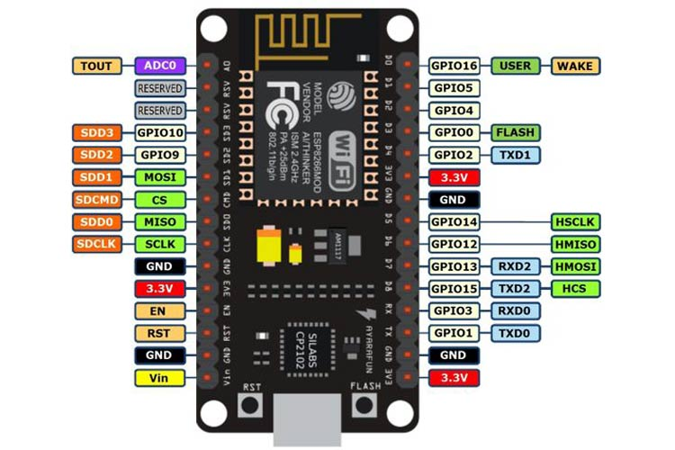

* NodeMCU is an open-source LUA based firmware developed for the ESP8266 WIFI chip. By exploring functionality with the ESP8266 chip, NodeMCU firmware comes with the ESP8266 Development board/kit i.e., NodeMCU Development board.
* NodeMCU Dev Kit has **Arduino like** Analog (i.e., A0) and Digital (D0-D8) pins on its board.
* It supports serial communication protocols i.e., UART, SPI, I2C, etc.
* NodeMCU Development board is featured with WIFI capability, analog pin, digital pins, and serial communication protocols.

## MFRC522 Reader and Tag

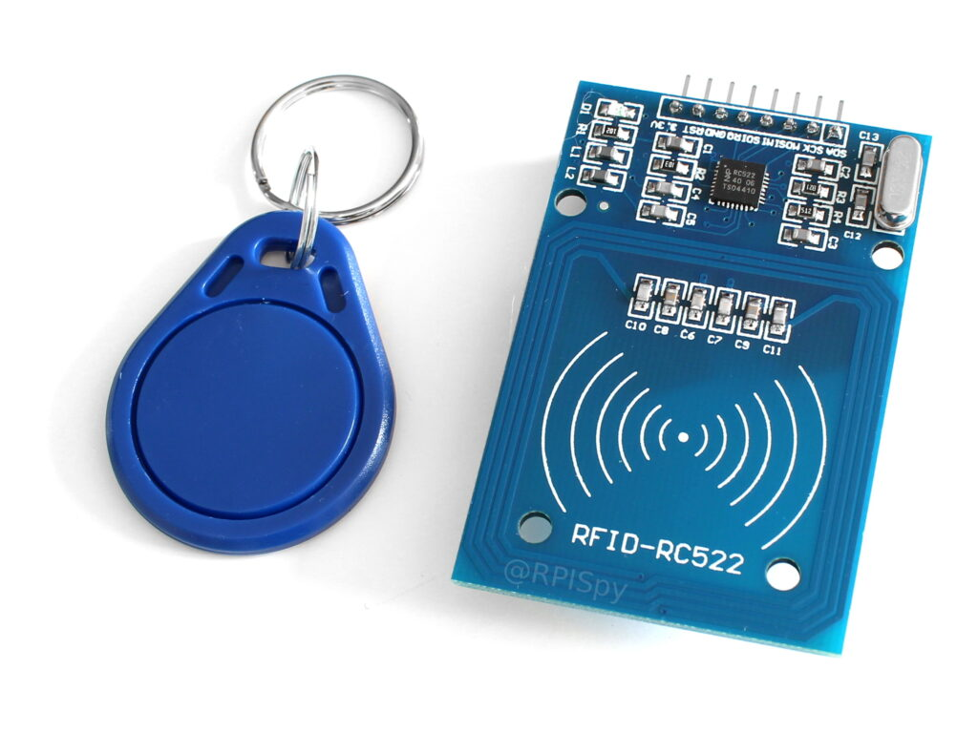

1. **RFID (radio frequency identification)** is a form of wireless communication that incorporates the use of electromagnetic or electrostatic coupling in the radio frequency portion of the electromagnetic spectrum to uniquely identify an object, animal or person.
2. Every RFID system consists of three components: a scanning antenna, a transceiver and a transponder. When the scanning antenna and transceiver are combined, they are referred to as an RFID reader or interrogator. There are two types of RFID readers -- fixed readers and mobile readers. The RFID reader is a network-connected device that can be portable or permanently attached. It uses radio waves to transmit signals that activate the tag. Once activated, the tag sends a wave back to the antenna, where it is translated into data.

### **Blynk IOT:**



Blynk is an IoT platform for iOS or Android smartphones that is used to control Arduino, Raspberry Pi and NodeMCU via the Internet. This application is used to create a graphical interface or human machine interface (HMI) by compiling and providing the appropriate address on the available widgets.

Blynk was designed for the Internet of Things. It can control hardware remotely, it can display sensor data, it can store data, visualize it and do many other cool things.

There are three major components in the platform:

* **Blynk App** - allows to you create amazing interfaces for your projects using various widgets we provide.
* **Blynk Server** - responsible for all the communications between the smartphone and hardware. You can use our Blynk Cloud or run your [private Blynk server](https://docs.blynk.cc/#blynk-server) locally. It’s open-source, could easily handle thousands of devices and can even be launched on a Raspberry Pi.
* **Blynk Libraries** - for all the popular hardware platforms - enable communication with the server and process all the incoming and outcoming commands.

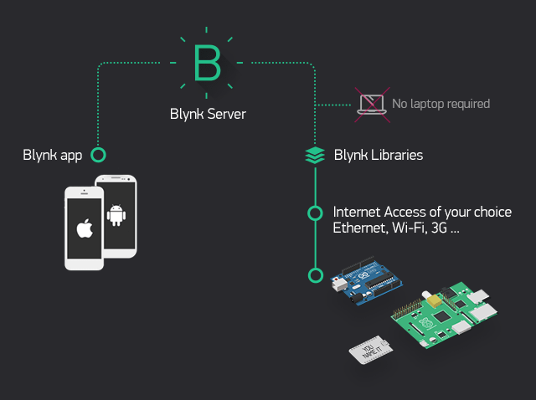

**Steps:**

* Making Template and initializing DataStream.
* Making a connection of widgets and data streams in web dashboard.
* Making automations and enabling notification system.
* Adding a device using template.
* Selecting widgets in blink IOT app and connecting data streams.

**SERVO MOTOR:**

* A servomotor (or servo motor) is a [rotary actuator](https://en.wikipedia.org/wiki/Rotary_actuator) or [linear actuator](https://en.wikipedia.org/wiki/Linear_actuator) that allows for precise control of angular or linear position, velocity and acceleration.[[1]](https://en.wikipedia.org/wiki/Servomotor#cite_note-1) It consists of a suitable motor coupled to a sensor for position feedback. It also requires a relatively sophisticated controller, often a dedicated module designed specifically for use with servomotors.
* Servomotors are not a specific class of motor, although the term *servomotor* is often used to refer to a motor suitable for use in a [closed-loop control](https://en.wikipedia.org/wiki/Closed-loop_control) system.

# Working And Implementation

**Step 1:** Designing the Circuit



**Step 2:** Writing the code

1. Enabling the SPI
2. Installing the packages
3. Adding Read.py

**Step 3:** Running the code

1. Getting the UID
2. Running the final script

**Step 4:** Logging the data in Blynk IOT.

1. Data logging with Date and Time.

**Step 5:** Designing the Mashup for the User interface

**Future Scope**

1. Interfacing with AI Face Scanner.
2. Efficient energy saving.
3. Alarming system for security
4. Adding GSM Module for better Secondary Security.

# References

1. Wikipedia
2. Blynk IOT
3. MFRC522 RFID reader and Tag documentations
4. SPI libraries and documentation
5. Arduino & Blynk IOT documentation