Design Document: School Vaccination Portal

# 1. System Overview

The School Vaccination Portal is a full-stack web application designed for school coordinators to manage vaccination drives for students. The portal will allow authenticated access to student data, vaccination schedules, vaccination status tracking, and report generation, following modern web development standards.

# 2. Technology Stack

|  |  |
| --- | --- |
| Component | Technology Used |
| Frontend | React.js (with Bootstrap for styling) |
| Backend | Python Flask |
| Database | PostgreSQL |
| File Handling | Flask file handling |
| Authentication | hardcoded login |
| API Documentation | Postman Collection |
| Version Control | Git & GitHub |

# 3. Application Architecture

## 3.1 High-Level Architecture

Frontend (React)  
 |  
 | REST API calls  
 ↓  
Backend (Flask)  
 |  
 | Query builder  
 ↓  
Database (PostgreSQL)

## 3.2 Modules

- Authentication Module  
- Dashboard Module  
- Student Management  
- Vaccination Drive Management  
- Reporting Module

# 4. Database Schema (Sample Tables/Collections)

## 4.1 Student Table

|  |  |  |
| --- | --- | --- |
| Field Name | Type | Description |
| id | UUID / ObjectId | Primary Key |
| name | String | Student name |
| student_class | String | Class |
| vaccination_status | String | Vaccination Status |
| vaccination_date | Date | Date of vaccination |
| vaccine_name | String | Vaccine Name |

## 4.2 vaccination_drive

|  |  |  |
| --- | --- | --- |
| Field Name | Type | Description |
| id | UUID / ObjectId | Primary Key |
| vaccine_name | String | Name of vaccine |
| vaccination_date | Date | Date of drive |
| available_doses | Number | No. of doses available |
| applicable_classes | String | Class Eligible |

# 5. Frontend-Backend Interaction

API Endpoints:

|  |  |  |
| --- | --- | --- |
| Method | Endpoint | Description |
| POST | /api/students | Get students data |
| POST | /api/studentdata | Insert Student Data |
| POST | /api/vaccination_upload | Add build student data |
| GET | /api/metrics | All dashboard metrics |
| POST | /api/adddrives | Schedule new drive |
| GET | /api/drives | View drives data |
| PUT | /api/drives/<int:id> | Edit vaccination drive |
| GET | /api/reports/vaccinations | Generate report |

# 6. Business Logic & Validations

* Prevent a student from being vaccinated twice with the same vaccine.
* Drives must be scheduled at least 15 days ahead.
* Editing of vaccination drives disabled after the scheduled date.
* Handle empty states gracefully in the UI

# 7. Running the Application

* Backend:  
  pip install -r requirements.txt  
  python app.py
* Frontend:  
  npm install  
  npm start
* Tools Used: Postman for API testing

# 8. Output Snapshots

* Dashboard view with counts
* Student list and vaccination status
* Vaccination drive creation form
* Report generation with filter

# 9. ScreenShots :

Dashboard view counts:

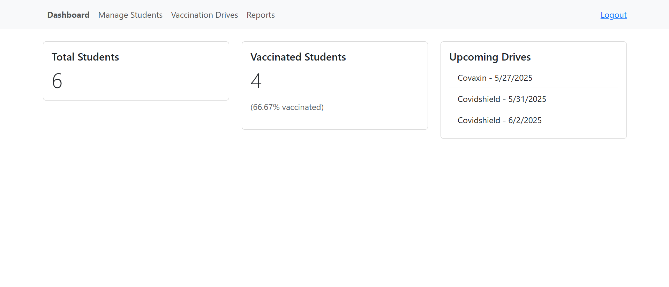

Student List and vaccination status:

Vaccination Drive creation form:

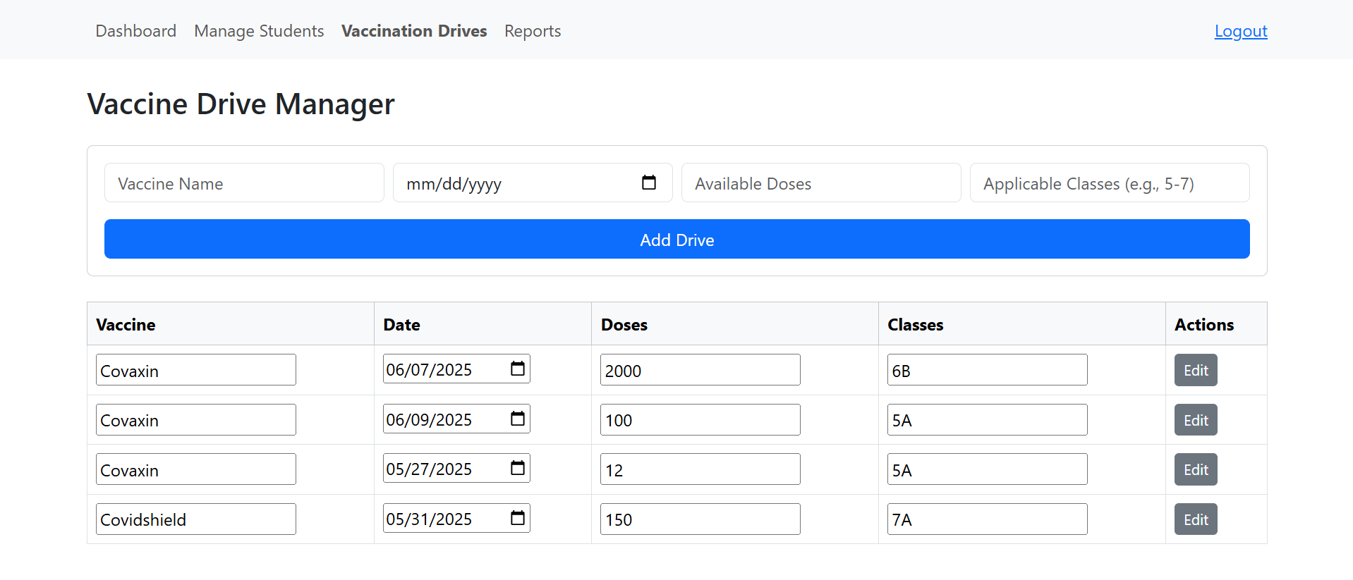

Report generation with filter:

# 10. GitHub & Demo Video

* GitHub Repo:

UI: <https://github.com/Ayushlokki/Vaccination_Portal_UI.git>  
Api backend : <https://github.com/Ayushlokki/Vaccination_Portal_api.git>

* Demo Video Link: