COGNIZANT DN - 4.0 DEEP SKILLING

HANDS ON WEEK-2

NUnit and Moq

**Write Testable Code with Moq**

**Code:**

**CoustomerComm.cs**

using System.Net;

using System.Net.Mail;

namespace CustomerCommLib

{

public interface IMailSender

{

bool SendMail(string toAddress, string message);

}

}

namespace CustomerCommLib

{

public class MailSender : IMailSender

{

public bool SendMail(string toAddress, string message)

{

MailMessage mail = new MailMessage();

SmtpClient smtpServer = new SmtpClient("smtp.gmail.com");

mail.From = new MailAddress("email_address@gmail.com");

mail.To.Add(toAddress);

mail.Subject = "Test Mail";

mail.Body = message;

smtpServer.Port = 587;

smtpServer.Credentials = new NetworkCredential("username", "password");

smtpServer.EnableSsl = true;

smtpServer.Send(mail);

return true;

}

}

}

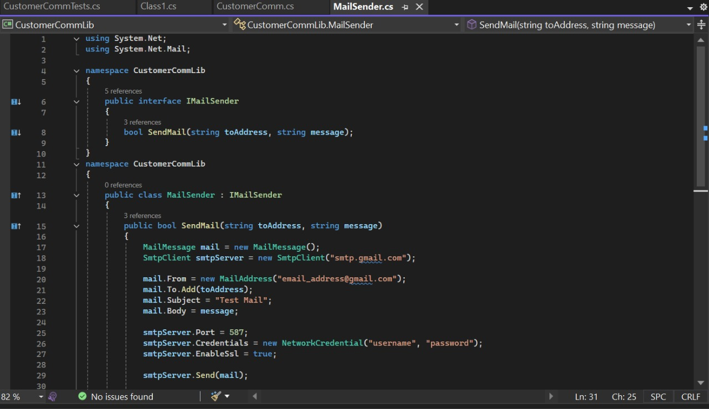

**CoustomerComm.cs**

namespace CustomerCommLib

{

public class CustomerComm

{

private IMailSender _mailSender;

public CustomerComm(IMailSender mailSender)

{

_mailSender = mailSender;

}

public bool SendMailToCustomer()

{

return _mailSender.SendMail("cust123@abc.com", "Some Message");

}

}

}

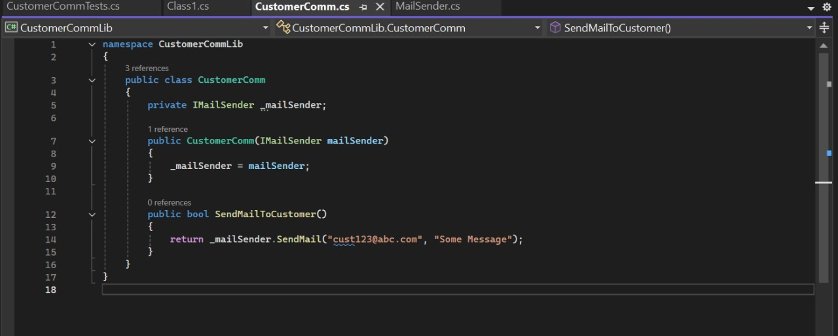

**CoustomerCommTests.cs**

using NUnit.Framework;

using Moq;

using CustomerCommLib;

using System;

namespace CustomerCommTests.Tests

{

[TestFixture]

public class CustomerCommTests

{

private Mock<IMailSender> mockMailSender;

private CustomerCommTests customerComm;

[OneTimeSetUp]

public void Setup()

{

mockMailSender = new Mock<IMailSender>();

mockMailSender.Setup(m => m.SendMail(It.IsAny<string>(), It.IsAny<string>())).Returns(true);

customerComm = new CustomerComm(mockMailSender.Object);

}

[TestCase]

public void SendMailToCustomer_ShouldReturnTrue_WhenMocked()

{

var result = customerComm.SendMailToCustomer();

object value = IsTrue(result);

}

private object IsTrue(object result)

{

throw new NotImplementedException();

}

private object SendMailToCustomer()

{

throw new NotImplementedException();

}

public static implicit operator CustomerCommTests(CustomerComm v)

{

throw new NotImplementedException();

}

}

}

