**Problem Statement**

In this assignment, we will be working on classifying Facial Images as either belonging to the Male or the Female class. For the same, data have been provided with the Train and the Test dataset.

**About Dataset**

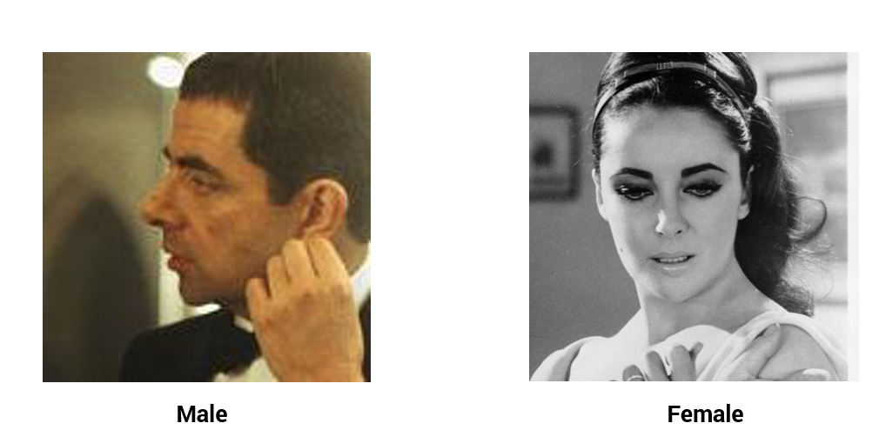

Data has been divided into two parts, the train dataset and the test dataset. We will train our model on the train dataset and check its performance on the test dataset. Below is the description of these two datasets.

**Train Dataset**

Number of Images = 12196 (70%)

Image Size = 224 X 224 X 3

**Test Dataset**

Number of Images = 5227 (30%)

Image Size = 224 X 224 X 3

**Data Download**

You can download the dataset from our [Datahack Platform](https://datahack.analyticsvidhya.com/contest/gender-classification/). Several Machine Learning and Deep Learning competitions are hosted on this platform.