ASSIGNMENT-2
1)Add 5 student records
a) Insert 1 record using insertOne()
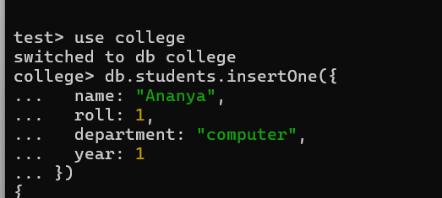
b) Insert 4 records using insertMany()
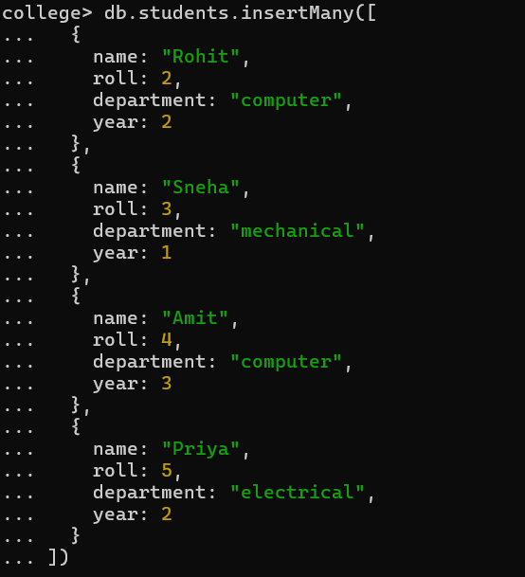
2) remove the 1st record
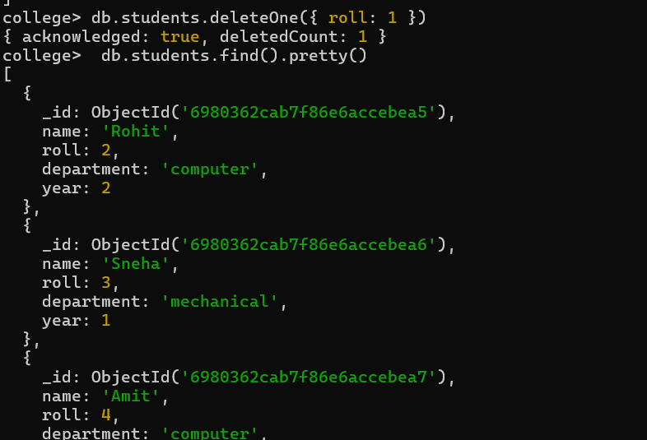

3)Query all students in "computer" department
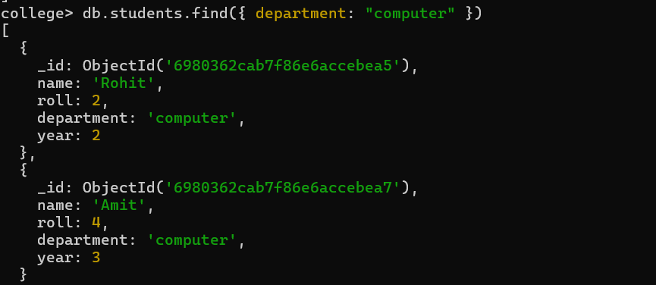
4)Update department from "computer" → "BCA"
