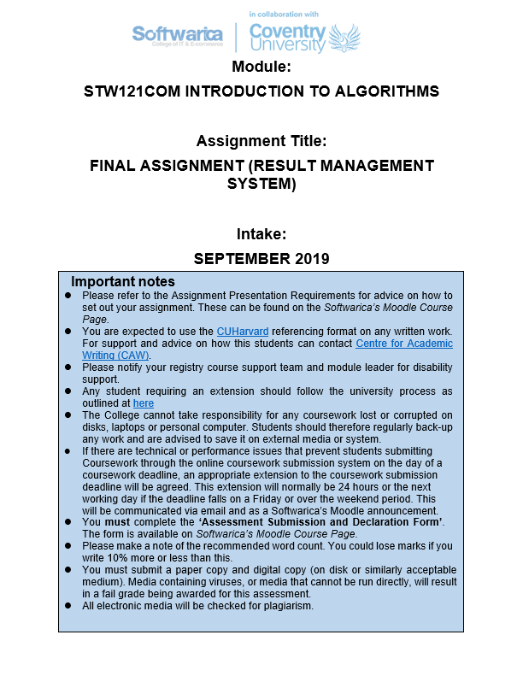

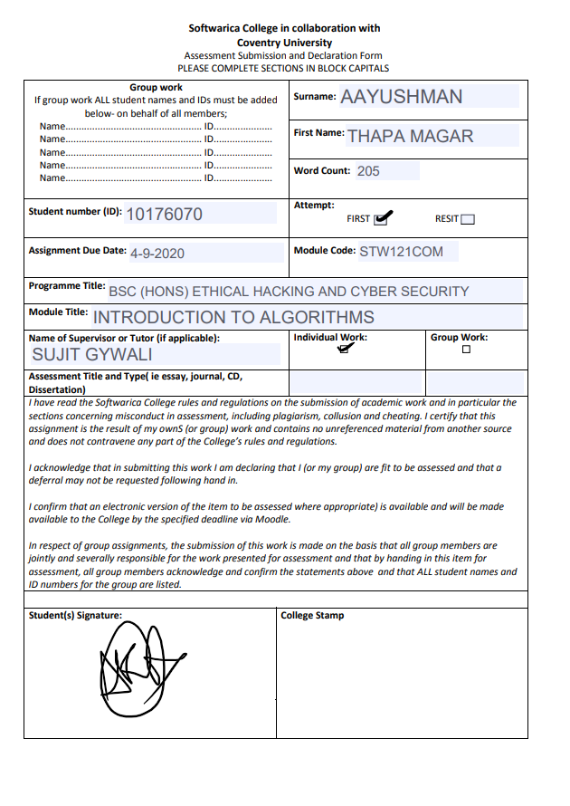

Contents
Introduction 1
Features include 1
Screenshots 1
User interface 1
Login page 2
Registration page 2
Teacher page 3
Student page 3
Classes and methods 4
Exception handling 12
Unit testing 13
DBMS table structure 14
Conclusion 14

Introduction

Result management system is a desktop application intended for distribution of results. It is useful to teachers as they can conveniently publish results and students can access their results respectively. Problems like not being able to access one’s results and difficulty in publishing results are solved by this application.
The application was developed using python. Tkinter module was used to create the GUI. Xampp was used to create a mysql database and an external library, mysql-connector, was used to establish connection. Pycharm professional IDE was used.
Features include:
- Registration for teacher or student user.
- Teacher users can add results for multiple students.
- Student users can view their results.

Screenshots

User interface
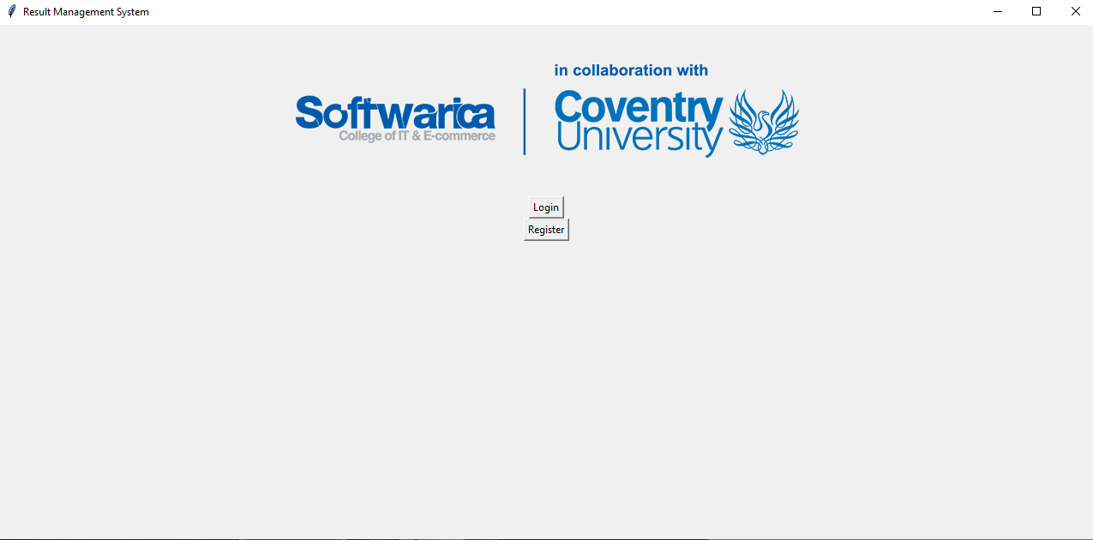

Login page
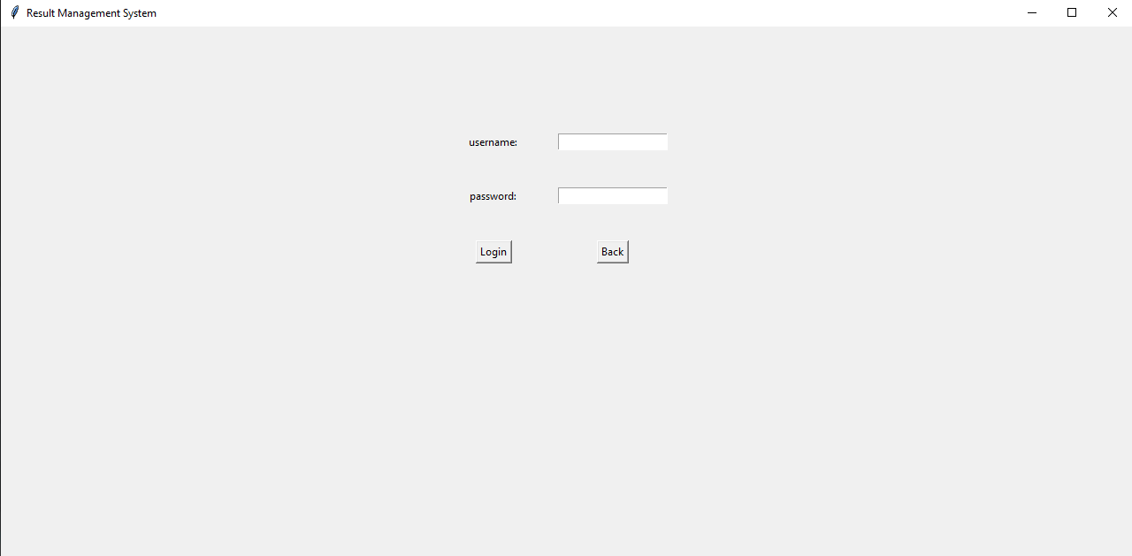

Registration page
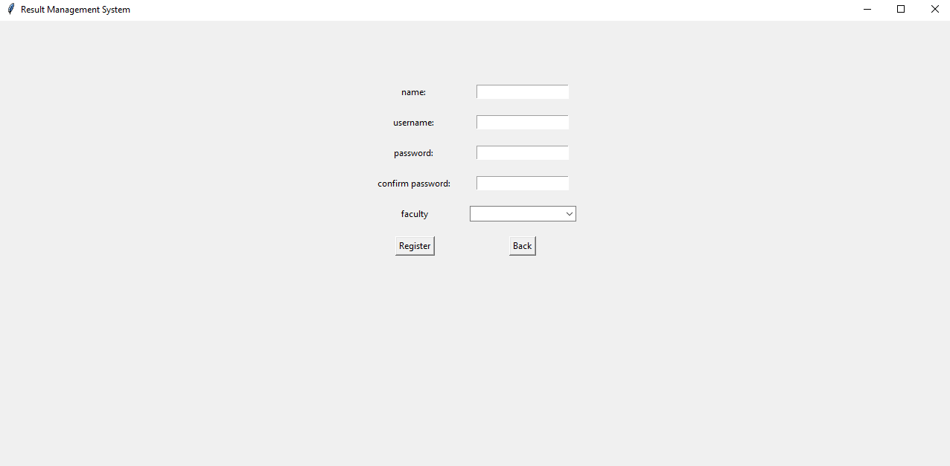

Teacher page

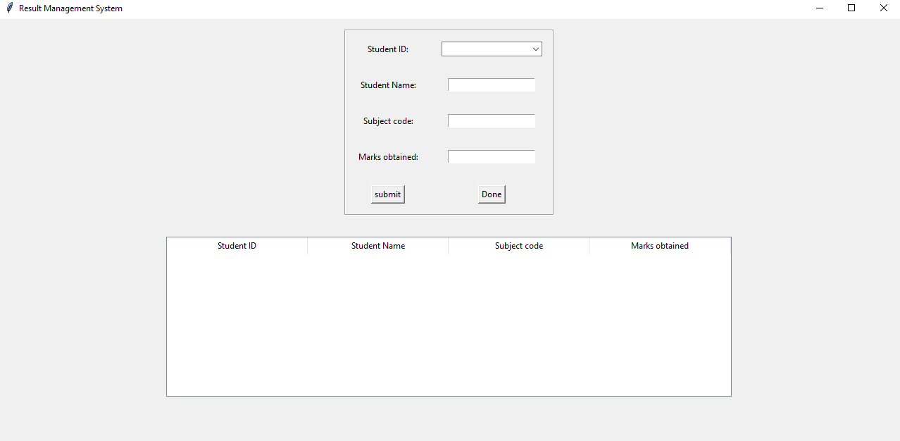

Student page
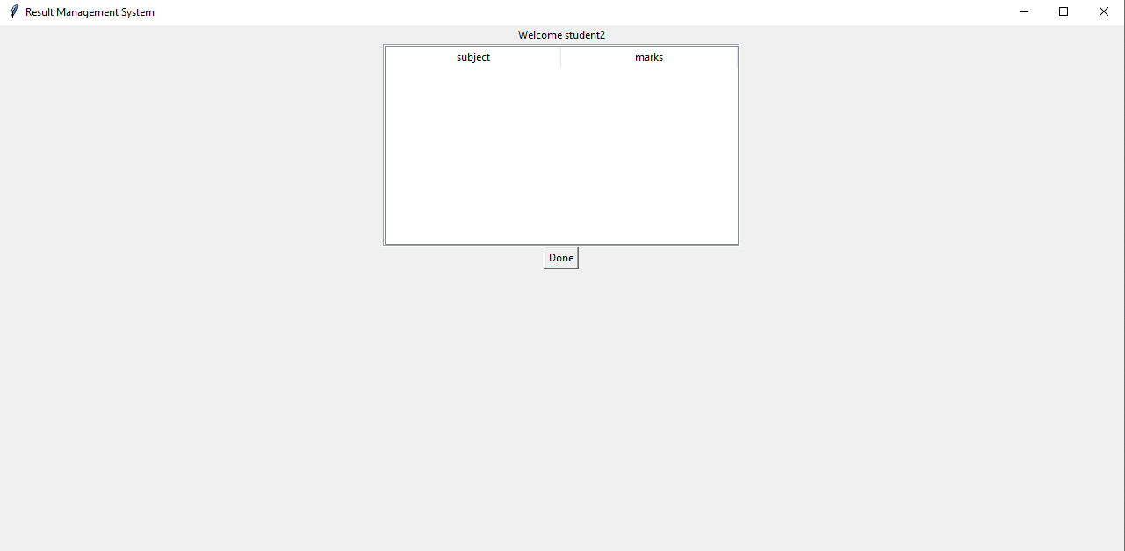

Classes and methods

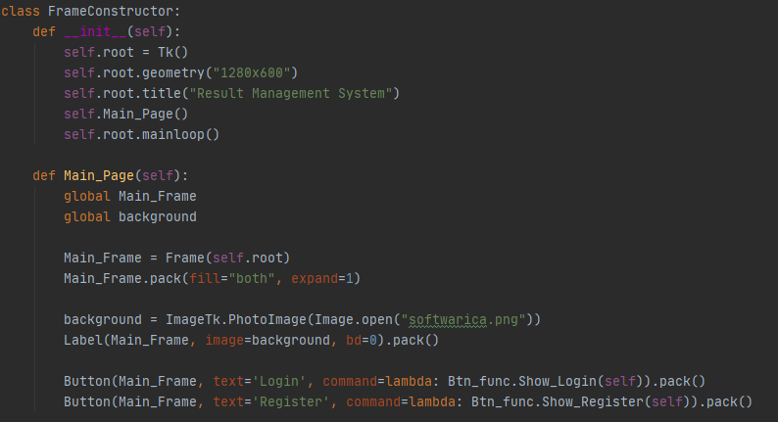

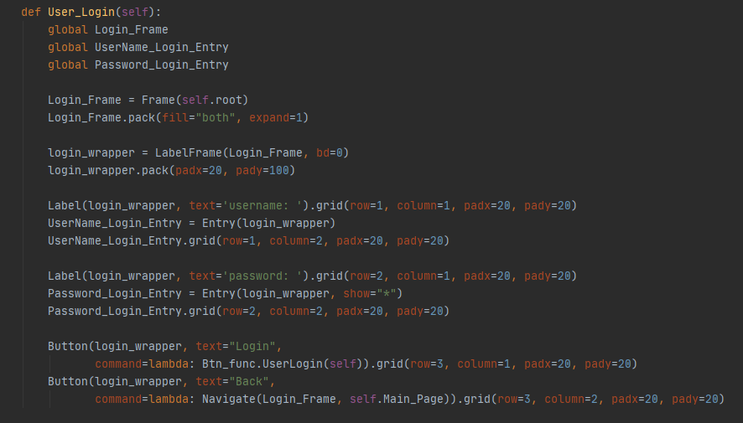
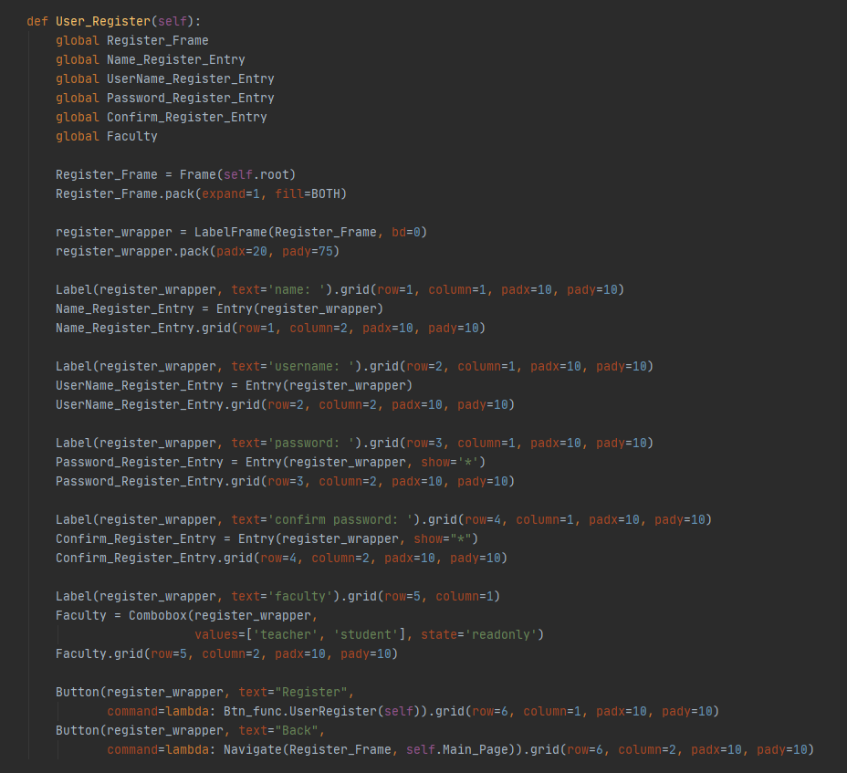

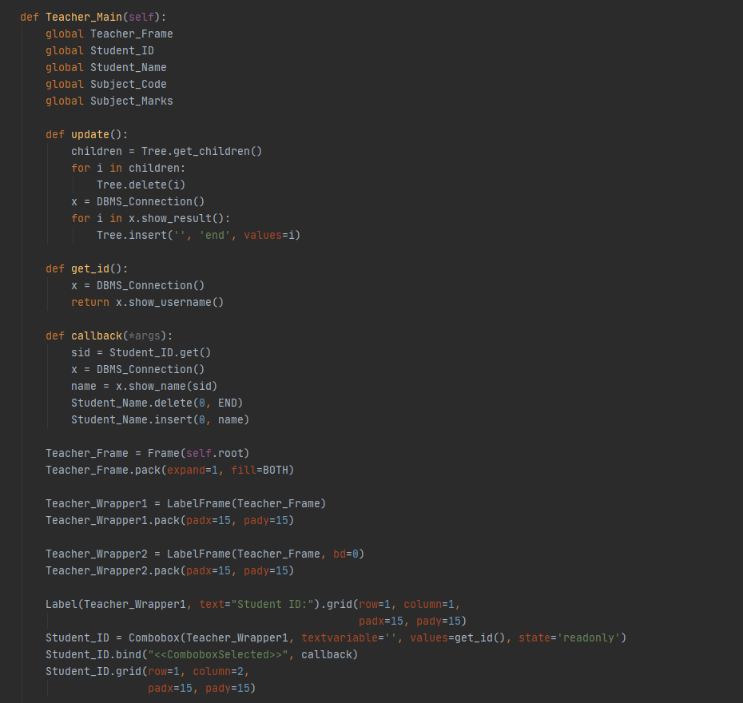
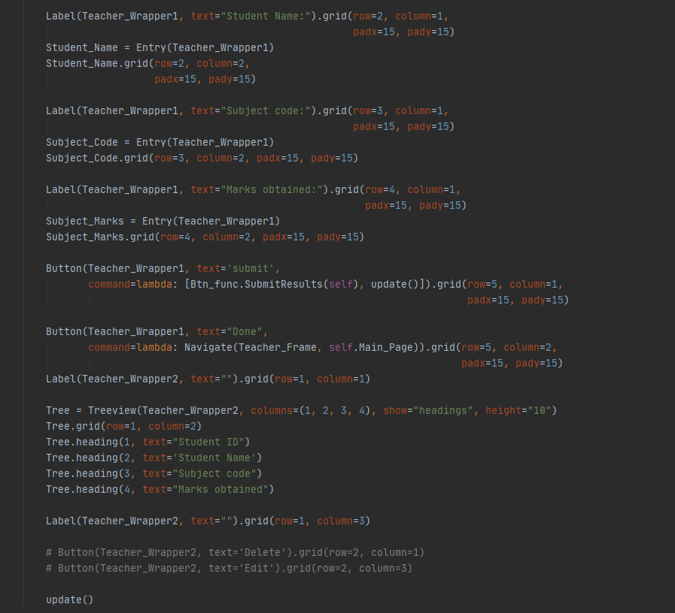
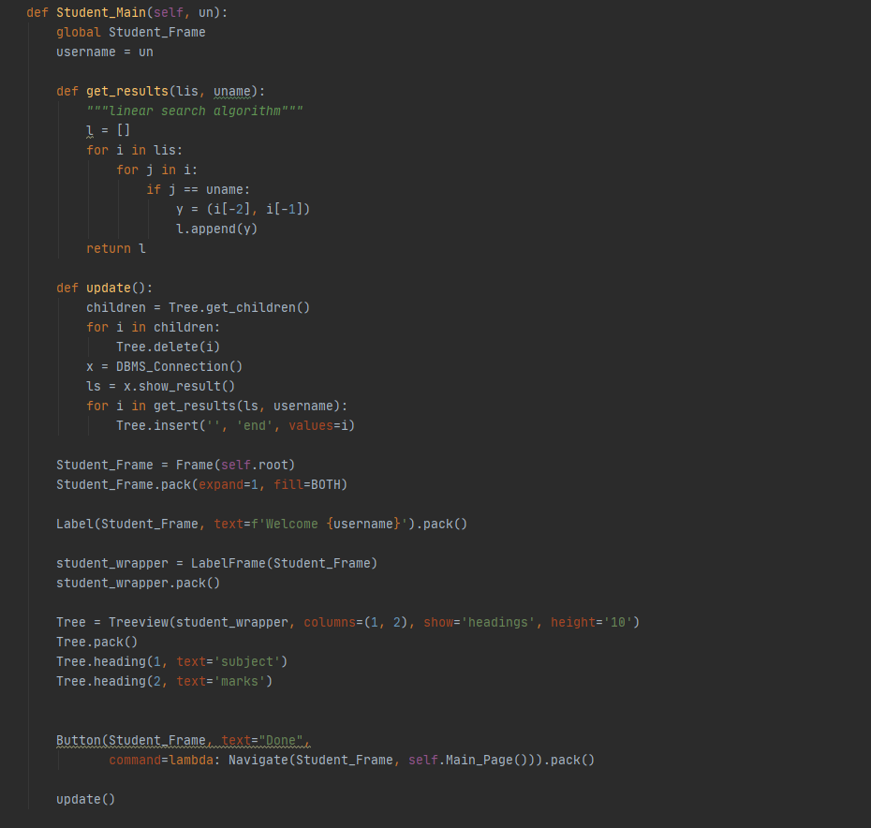

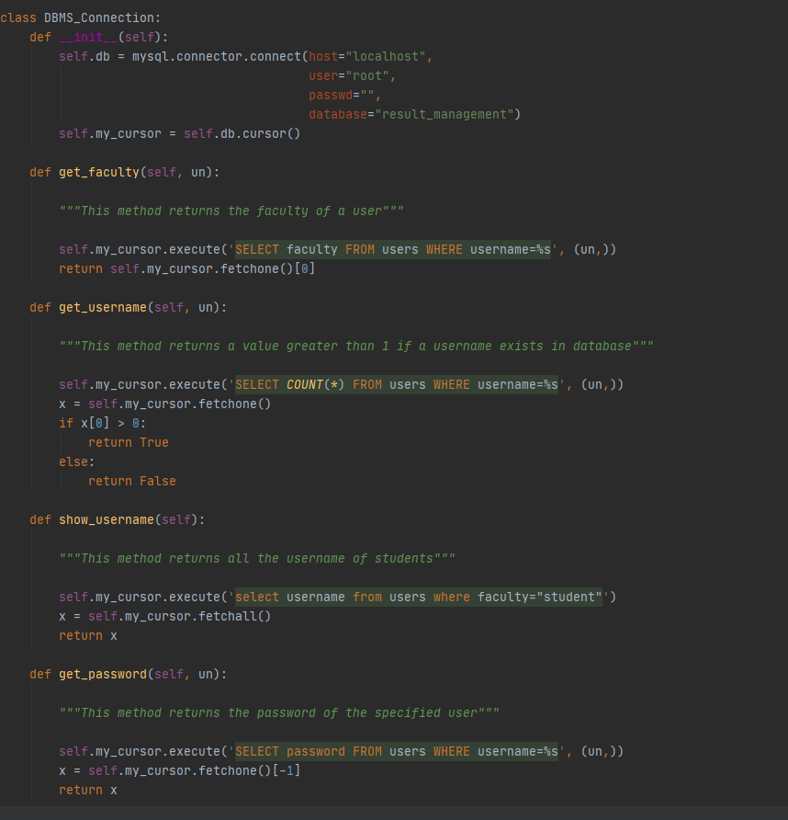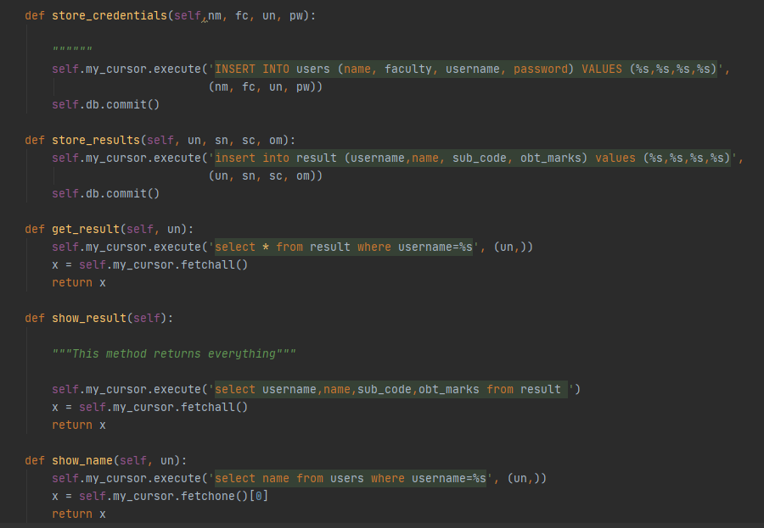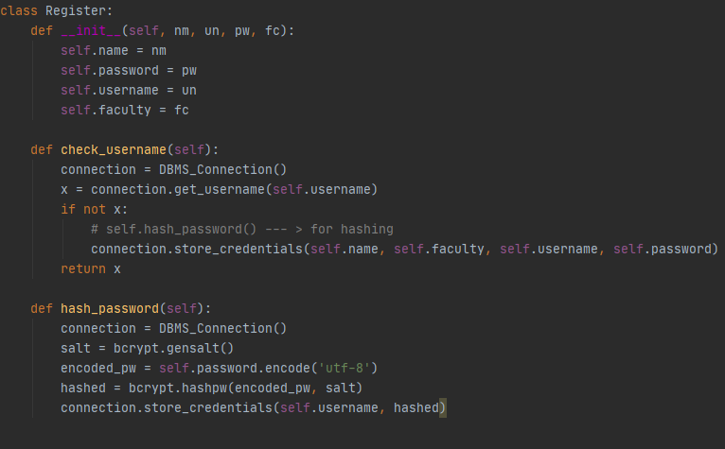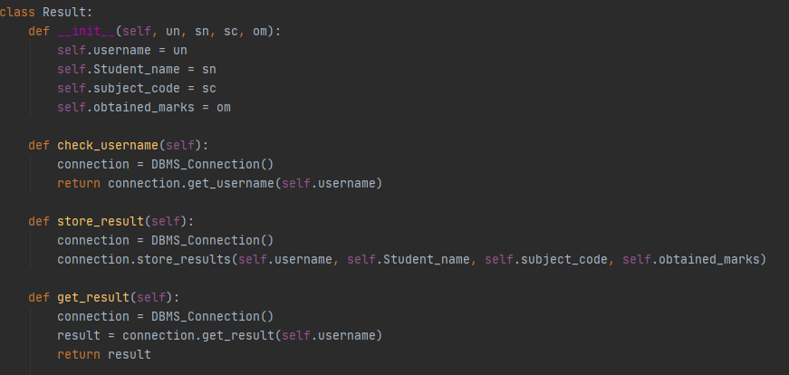
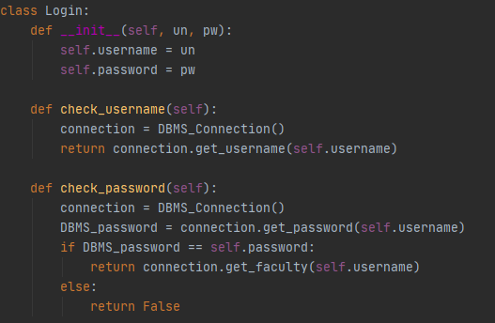

Exception handling
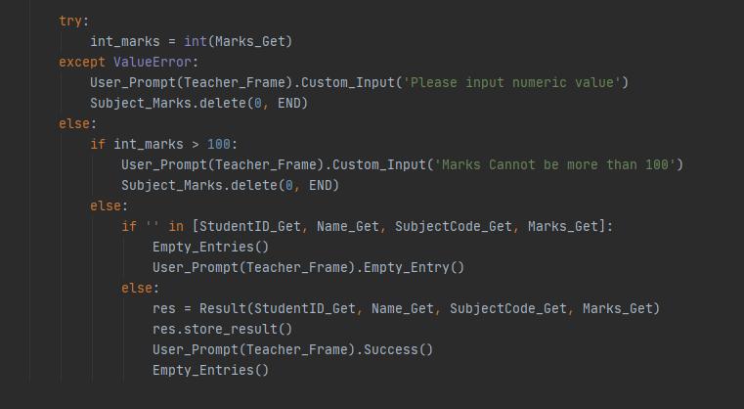

Unit testing
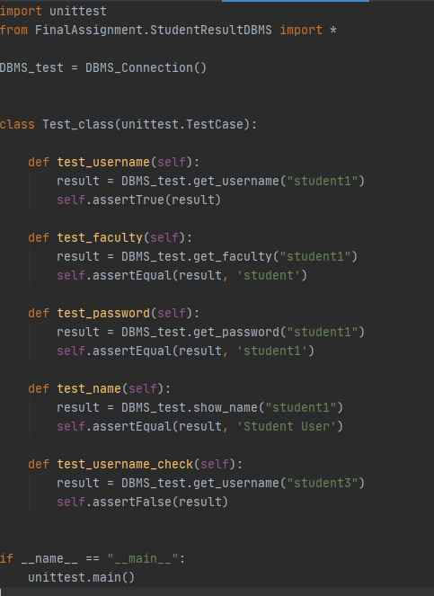
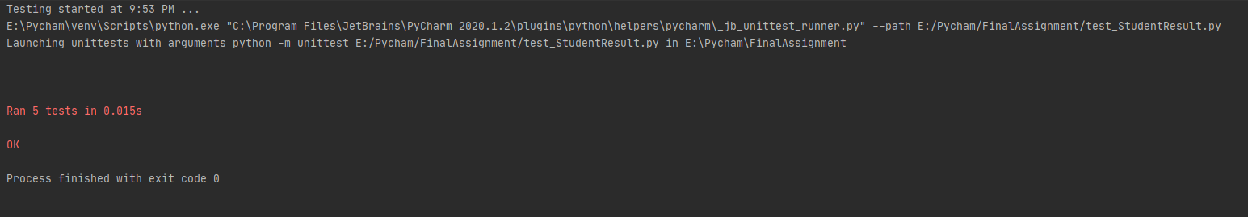

DBMS table structure
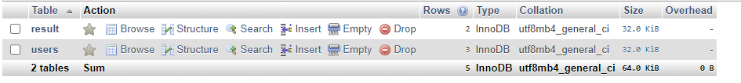

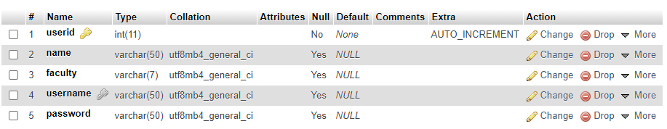
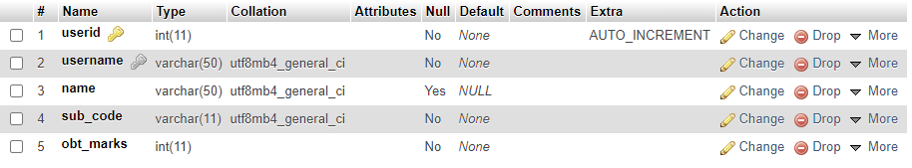

Conclusion

Result management system makes use of database management systems and graphical user interfaces to make the task store user credentials and results convenient for the user. Although the functionality of the application is complete and works as intended, there are still prospects for future upgrades. Currently, sensitive information like user passwords are stored in plain text. Hashing with salt could be used to increase system security. Custom assets could also be used for buttons to improve user experience. Current version is feature complete and as such application could be deployed in the real world.

