Name Of the Group: WEBWING

Group Member Name:

1.Minakshi Sahu

2.kamal Lochan Padhi

3.Ayushman Acharya

4.Laxmi Patra

5.Srikant Raita

6.R. Neel Madhava Aachari

CONCEPT:  
 A start-ups is an entrepreneurial venture in the early stages of operations, typically created for resolving real-life problems. As many start-ups solve society's needs, they attract investors and funders because of the tremendous growth opportunities. If you have an interest in working in a start-up understanding everything about a start-up can be beneficial to make an informed decision.

Start-ups begin with high costs and have limited revenue. Also, they do not have a developed business model and lacks adequate capital to move to the next phase. As a result, these companies seek funding from various sources, such as venture capitalists, angel investors and banks. Investors or lenders might offer additional funds for a share of future profits and partial ownership. Often, these companies use seed capital for investing in research and developing business plans. Research helps them determine the demand for a specific product and a business plan outlines the company's goals and marketing strategies.

Types of Start-ups:

1.scalable

2.small-business

3.social entrepreneurship

4.Large company

5.Lifestyle

6.Buyable

1. Agility: Start-ups are smaller and less structured and also innovative and keep improving them business models, processes, and portfolio. These allow them to adapt to disruptive technologies and changes in market conditions.

2. Efficiency: Established companies have high administrative overheads. Start-up offer their services in most efficient, cost-effective and competitive manner to be aware of their limitations and tend to focus on their core strengths. This causes them to partner with other small organizations so that customer often get benefits with a superior value proposition.

3. Team culture: Employees of large corporations get attracted by prestige and big salaries. They easily lose sight of the company's vision, mission and values and the success of its customers. So, Start-up employees form a close-knit community that shares passion, beliefs and values. They must work together for the good company, its customers and the world at large.

4. Personalization: Start-ups deliver their products and services with a personal touch. This creates a uniquely personal experience for their customers. Start-ups also take time to study and understand their customers’ business requirements. This allows them to build lasting relationships with specific offerings and responsive solutions.

5. Versatility: Start-up employees multitask and the salesperson could double up as the relationship manager. This adds continuity to customer relationships and enables start-ups to respond to emergencies. Most start-ups support learning and have a higher tolerance for mistakes. Both factors enhance the versatility of start-ups employees.

6. Flexibility: Your organization could have rather unique needs and demands for products and services. These might not be met by established service providers operating in a rigid manner. Start-ups are very flexible and are more likely to work at the hours, the place and in the manner that suits you.

7. Having Fun: Last but now least, working with a start-up could be a lot more fun. A start-up doesn’t have to please everyone and may decide to select clients that are fun to work with. Spontaneous fun activities after work are a lot easier to organize in a start-up. Your colleagues could become your best friends.

DISADVANTAGES:

1. Risk of failure:

Most start-ups fail within their first year of operations, so the risk of failure is Working under such high risk can blur a start-ups strategic vision. So, they either fail to seize market opportunities or overestimate their sales projections. High risk also hinders a start-up’s ability to attract experienced and competent staff.

2. Low compensation: It takes blood, sweat, and tears to build a company, and long working hours are the norm for start-ups. The rewards might be low since it takes time to generate revenue and make profits. Some start-ups give up since it’s demotivating to work without proper compensation.

3. Poor Market Access: Many customers prefer a business that they have worked with over a new start-up. Besides it is more expensive to acquire new customers than to retain old ones. Without a customer base, understanding market needs also becomes a real struggle. All these factors combined increase the cost of business development for start-ups.

4. Team Conflicts:

Some start-ups are born out of desperation since the founder could not find or hold on to a job. Such founders often struggle to build a team that the business needs to succeed. A successful start-up requires founders/co-directors with complementary personalities and competencies. Even then disagreements can creep in when the going gets tough.

5. Lack of Resources: Growth hacking, cloud computing, and venture capitalism allow start-ups to gain market entry. Most start-ups operate on a shoestring budget, against competitors that are well-resourced. It gives the competitors an edge in product development, sales, and marketing. They use that edge to push start-ups out of the market when they become a threat.

6. Process:

Start-ups are flat organizations that lack defined business processes and operational procedures. This exposes them to poor customer service, legal liability, and financial losses. Startups might thus opt to outsource non-core business processes to external service providers. But the high associated costs could form a barrier.

7. Stressed out: We did mention that working for a start-up is fun, but it could also become very stressful. Low compensation, many responsibilities and long working hours are more or less expected. Add legal prosecution, imminent business failure, and screaming customers and work becomes unbearable.

SCOPE: (Why we chose IT company website)

IT services play a vital role in the daily routine of a modern company. Regardless of what they are, everything regarding IT is critical for the success of a company relying on tech in some way. Often, this IT encompasses a variety of subjects and fields. At times it’s handled in-house, other times a third-party service provider offers external services to help facilitate smooth IT operations.

Main Highlights:

1. Services:

Graphics Designing: it offers customer to do with graphic designing.

Branding: it offers to create logo for company.

Consultancy/ Out-sourcing

2. Products:

Hosting & Domain

Web designing: This product is for web designing for subscribed customer.

3. Packages:

We have following 3 packages.

Low: in this, we provide only basics like demo model.

Medium: in this, we provide some basics software tools

Premium: in this, we provide all software tools and services.

Main Area of Work: (Highlight)

Types Of Pages:

1. Home:

This is the main page of our website where we can see all little details of every pages.

2. About:

It demonstrates the profile of our website / company

3. Services/product:

It describes the what services / products we provide.

4. technologies:

All tech languages are there in this page.

5. portfolio:

This page has resume, videos and pictures.

6.contact us:

This page has contain information of our company.

Advantages and features of BOOTSTRAP:

BOOTSTRAP 4.6:

-> Bootstrap is a free front-end framework for faster and easier web development.

-> Bootstrap includes HTML and CSS based design templates for typography, forms,

buttons, tables, navigation, modals, image carousels and many other, as well as optional JavaScript plugins.

-> Bootstrap also gives you the ability to easily create responsive designs

ADVANTAGES:

-> Easy to use: Anybody with just basic knowledge of HTML and CSS can start using Bootstrap

-> Responsive features: Bootstrap's responsive CSS adjusts to phones, tablets, and desktops

-> Mobile-first approach: In Bootstrap, mobile-first styles are part of the core framework

-> Browser compatibility: Bootstrap 4 is compatible with all modern browsers

(Chrome, Firefox, Internet Explorer 10+, Edge, Safari, and Opera)

conclusion (Share your experience):

In today's world, Information Technology is most important thing in our everyday life coz it helps in improving & developing. It also offers some various tools to boost development. so, we came up an idea to create a website which provide IT services to our customer so that can learn & create websites or can design so that by this they can improve themselves & also can get benefit by creating for others. Main thing is Our teamwork, in every ups & downs we didn't give up, if there is some error or one couldn't understand than we discuss each other & try to get solution for that problem. Also, if one member feels down, we all try to motivate him/her so that he/she can feel comfortable. While creating this we have lot of fun, everyone co-operates well so that we can manage to create a very efficient website for our customer. we learn lot of stuffs & using bootstrap 4, html, css we create this website.

Scope: (scope for further development)

One of the most commonly used acronyms in the world of education is IT; still very few actually know what this field is all about. In a layman’s word, this is a study which covers the use of computer systems. Perhaps that is why IT has become a synonym of computers for a common man. However, IT has many more things to offer and is not just confined to the boundaries of the computer system and is used to study the use of varied systems, such as telecommunications. So we planned with in next five year to grow our customers and to provide services as much as possible for development of our next generation technology.

----------------------------------------------------------------------------------------------------------------

Typography:

Typography is **the art of arranging letters and text in a way that makes the copy legible, clear, and visually appealing to the reader**. It involves font style, appearance, and structure, which aims to elicit certain emotions and convey specific messages. In short, typography is what brings the text to life

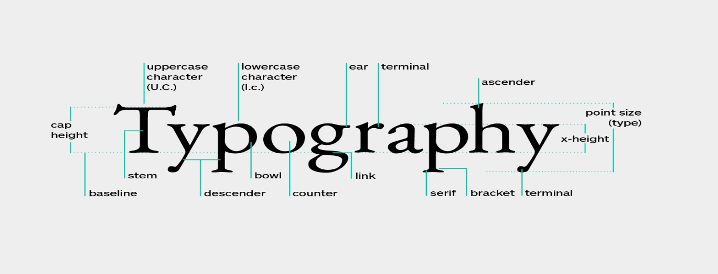

Grid:

The CSS **Grid** Layout Module offers a **grid**-based layout system, with rows and columns, making it easier to design web pages without having to use floats .



Buttons:

Use **Bootstrap's** custom **button** styles for actions in forms, dialogs, and more with support for multiple sizes, states, and more.

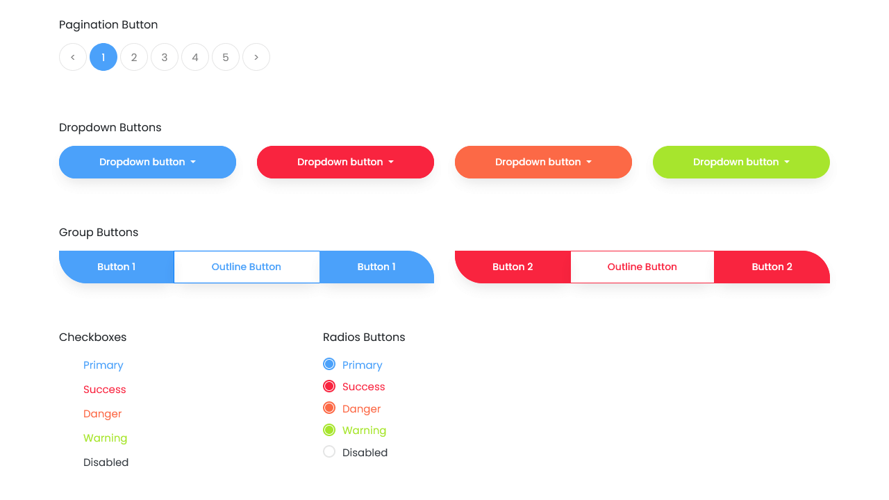

Button Group:

Group a series of buttons together on a single line with the **button group**, and super- power them with JavaScript

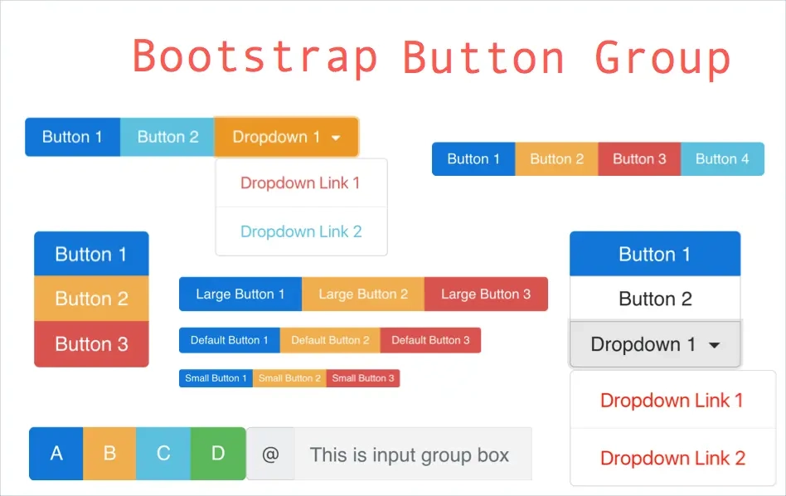

Card:

A **card** is a flexible and extensible content container. It includes options for headers and footers, a wide variety of content, contextual background colours.

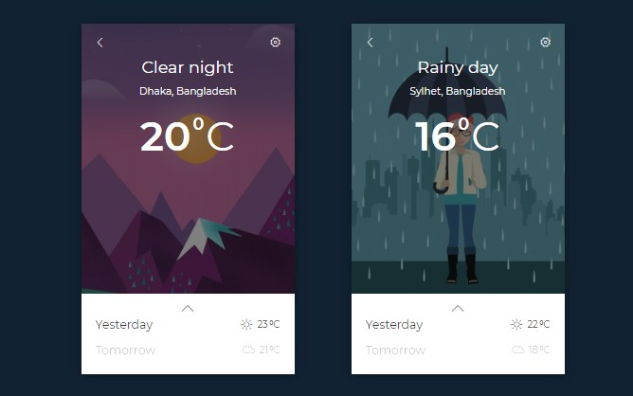

Carousel:

The **carousel** is a slideshow for cycling through a series of content, built with CSS 3D transforms and a bit of JavaScript. It works with a series of images.



Collapse:

The **collapse** JavaScript plugin is used to show and hide content. Buttons or anchors are used as triggers that are mapped to specific elements you toggle

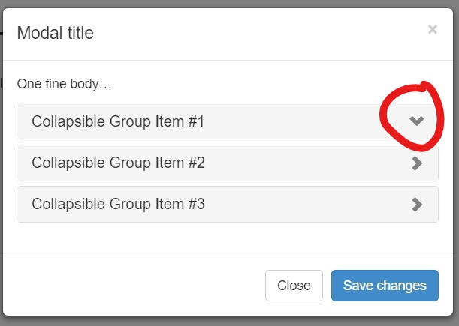

Dropdown:

The. dropdown class uses position: relative, which is needed when we want the **dropdown** content to be placed right below the **dropdown** button

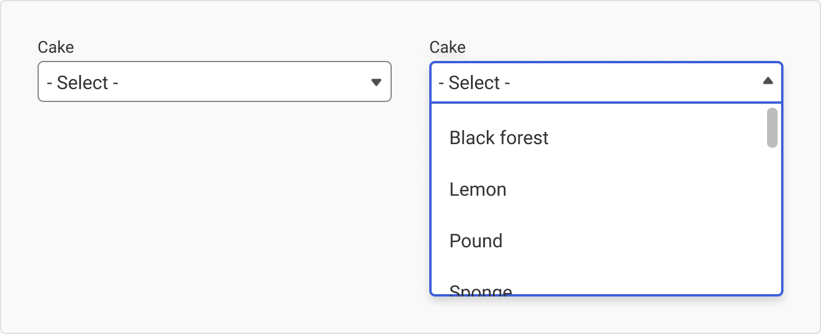

Media Object: Media objects are **non-Hypertext Markup Language (HTML) files or applications that can be displayed or executed as part of an HTML document**. Examples include graphic, audio and video files, and Java applets.

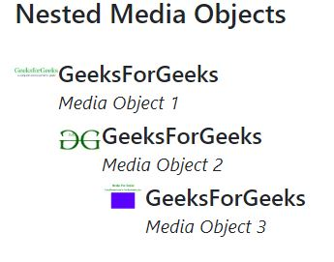

Modal:

**Modal**. Use **Bootstrap's** JavaScript **modal** plugin to add dialogs to your site for lightboxes, user notifications, or completely custom content.

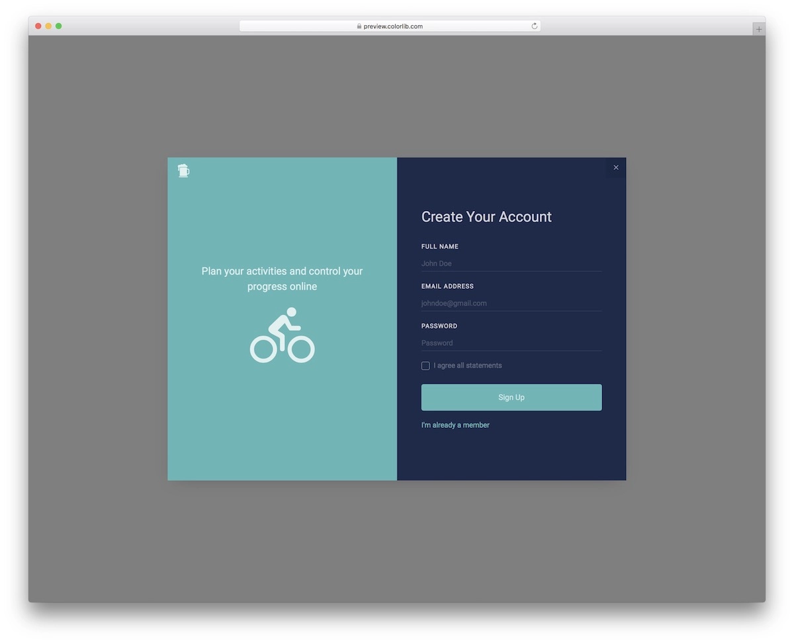

Navs:

Takes the basic **nav** from above and adds the .**nav**-**tabs** class to generate a tabbed interface. Use them to create Tabb able regions with our tab JavaScript plugin.

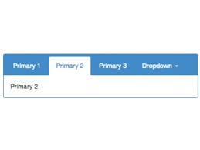

Navbar:

**Navbar**. Documentation and examples for **Bootstrap's** powerful, responsive navigation header, the **navbar**. Includes support for branding, navigation

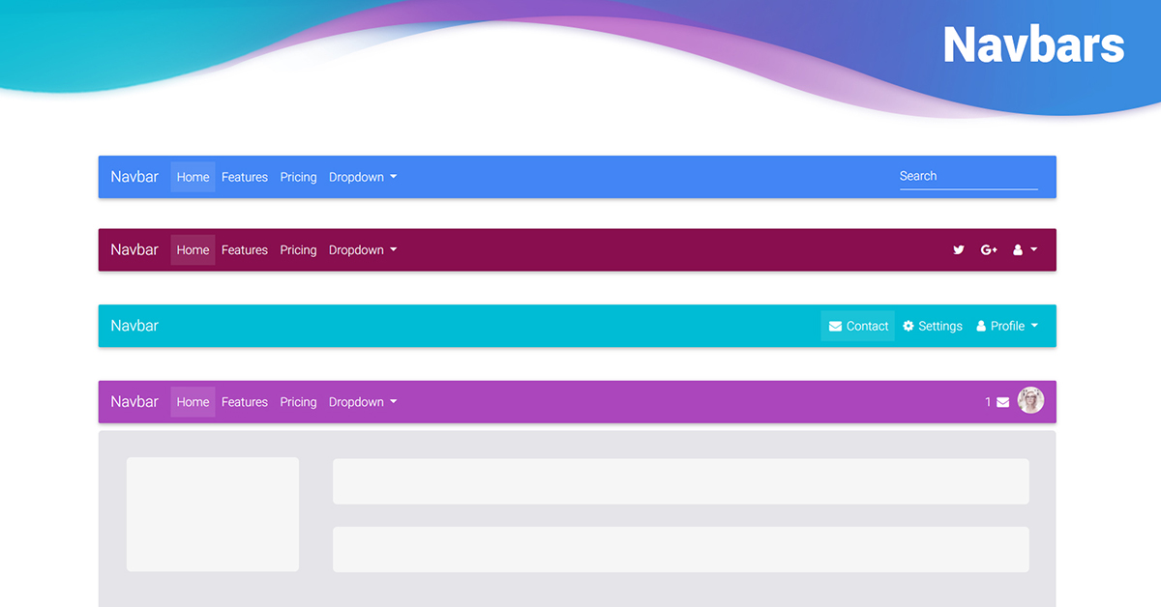

Progress:

**Progress components are built with two HTML elements, some CSS to set the width, and a few attributes**. We don't use the HTML5 <progress> element, ensuring you can stack progress bars, animate them, and place text labels over them. We use the. progress as a wrapper to indicate the max value of the progress bar.

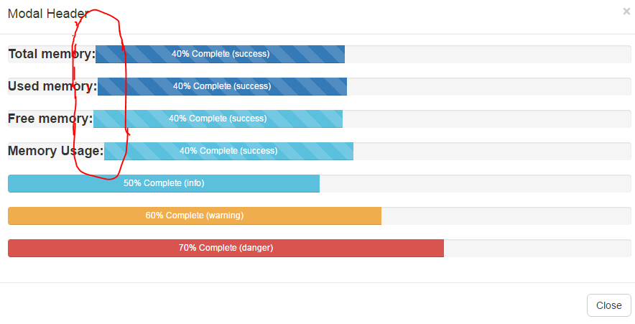

Tooltips:

Tooltips are **opt-in for performance reasons**, so you must initialize them yourself. Tooltips with zero-length titles are never displayed. Specify container: 'body' to avoid rendering problems in more complex components (like our input groups, button groups, etc). Triggering tooltips on hidden elements will not work.

