Google Site Analytics

Ayushman Mittal-500094600

Site Link: [BREWSMITH](https://sites.google.com/view/brewsmiths/home)

At Brewsmiths, we are passionate about crafting exceptional coffee experiences. Our cozy café nestled in the heart of the city is the perfect spot for coffee connoisseurs, casual coffee drinkers, and everyone in between. With our commitment to quality, sustainability, and community, we strive to provide a warm and inviting atmosphere where you can relax, connect, and indulge in the finest brews.

Our skilled baristas are true coffee artisans, meticulously handcrafting each cup using only the freshest, ethically-sourced beans. From classic espresso-based beverages to specialty pour-overs, we take pride in our dedication to delivering the perfect cup of coffee, every time. Our menu also features a delectable selection of teas, pastries, and light bites to complement your coffee experience.

Beyond our passion for coffee, we are also committed to sustainability. We source our beans from local farmers who share our values of environmental and social responsibility. Our café is designed with eco-friendly practices in mind, from our energy-efficient equipment to our composting and recycling programs. We believe in giving back to our community and supporting local initiatives, and we're proud to be a gathering place for like-minded coffee lovers.

Whether you're starting your day with a morning pick-me-up, catching up with friends over a cup of joe, or looking for a quiet spot to work, Brewsmiths is the perfect destination. Come join us for a memorable coffee experience that will awaken your senses and leave you craving more.

*This is how the site looks like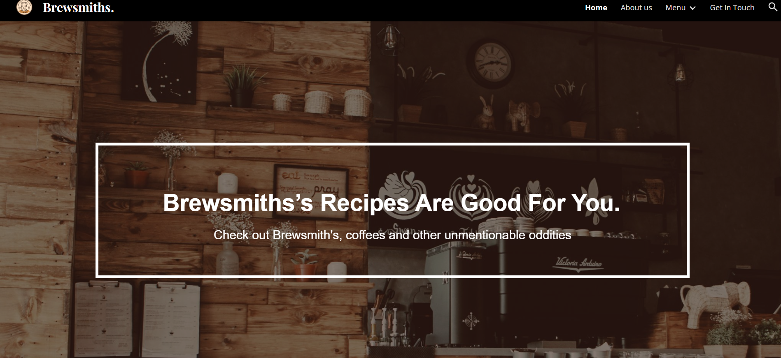*

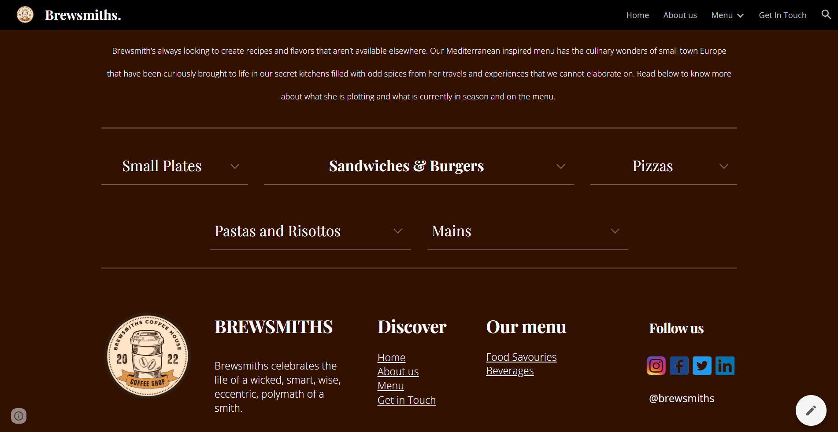

**WHAT IS GOOGLE ANALYTICS?**

Google Analytics is a powerful web analytics tool that helps website owners track and analyze website traffic and user behavior. It provides insights on website performance, user engagement, conversion rates, and other key metrics. Through the use of tracking codes embedded in website pages, Google Analytics collects data on visitor demographics, behavior, and interactions, which is then presented in easy-to-understand reports and visualizations. Website owners can use this data to make data-driven decisions to optimize their website, improve user experience, and achieve their business goals. Google Analytics is widely used by businesses, marketers, and website owners to gain valuable insights into their online presence and improve their digital marketing efforts.  
  
  
SITE ANALYSIS

Demographic details by city

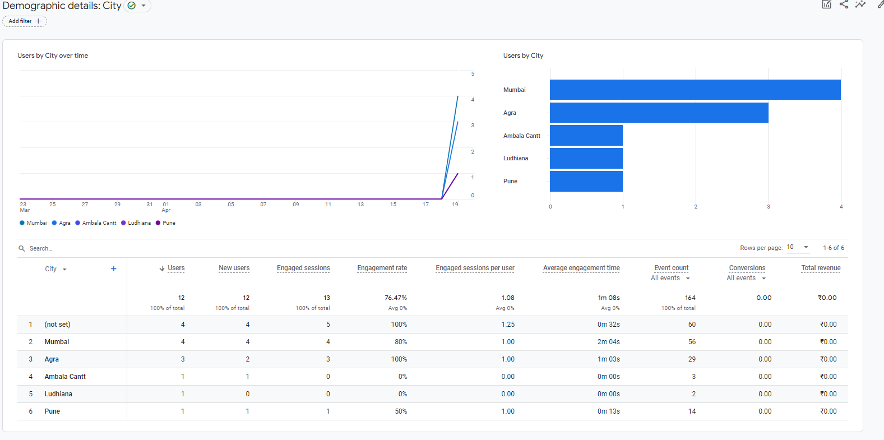

This screenshot is of the demographic by city. This shows a total of 12 users for the site which are spread across the 6 cities, where PUNE, LUDHIANA, AMBALA CANTT has only 1 user. Agra has 3, Mumbai has 4. The average engagement rate is 1m08sec and an engagement rate of 76%.

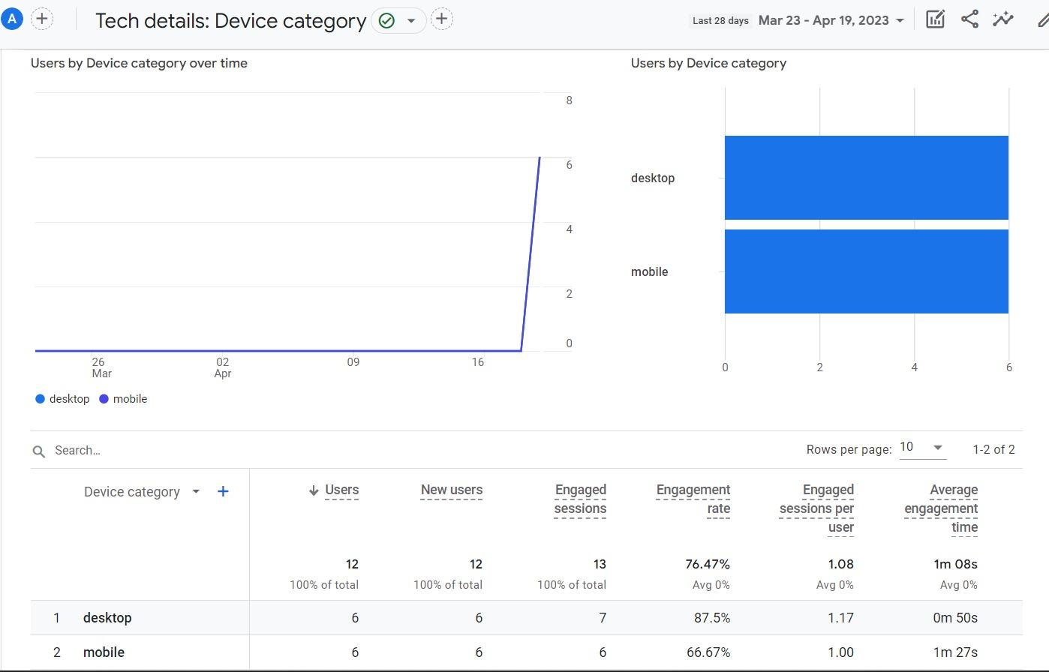

The report above talks about the tech details and furthermore explains the device category and here there is a ratio of 1:1 between mobile and desktop.

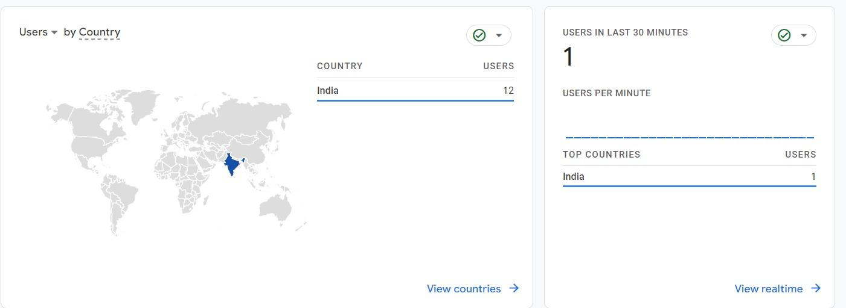

The geomap shows a total of 12 users on the site and 1 in the past 30 minutes from India.

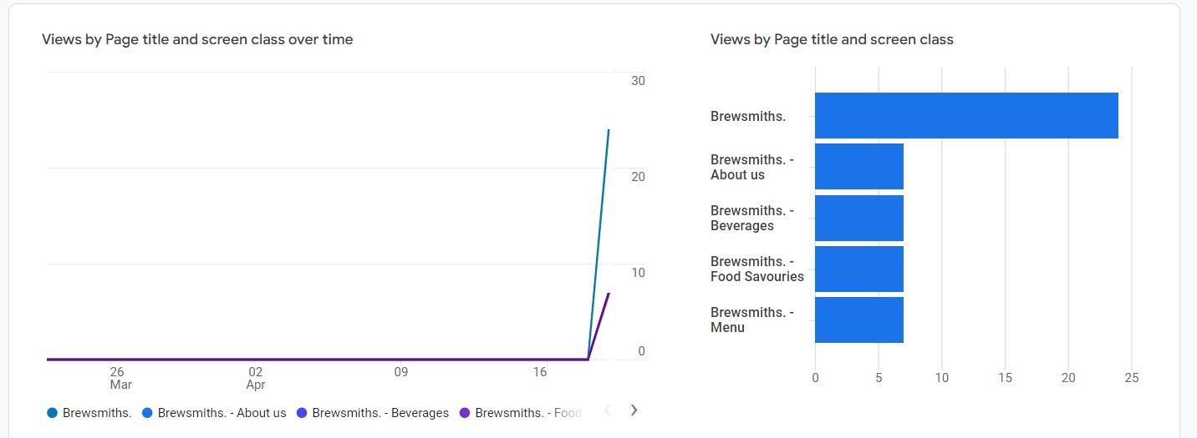

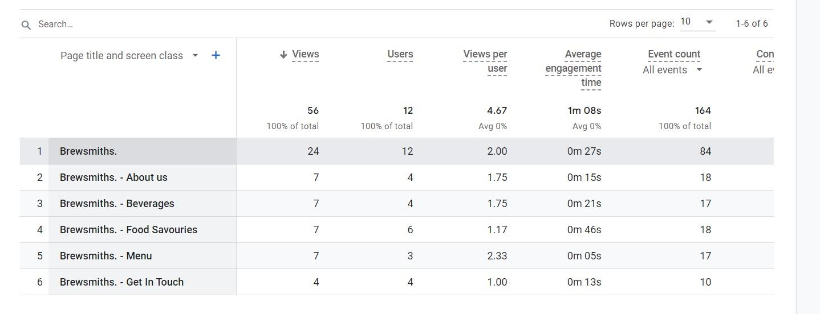The ss above talks about the total engagement to the page and the options in the page. A total of 24 views on the home page, 7 for about us, beverages, food savories, menu and 4 views on get in touch page. The average engagement time is 1m08s. The event counts have been 164.

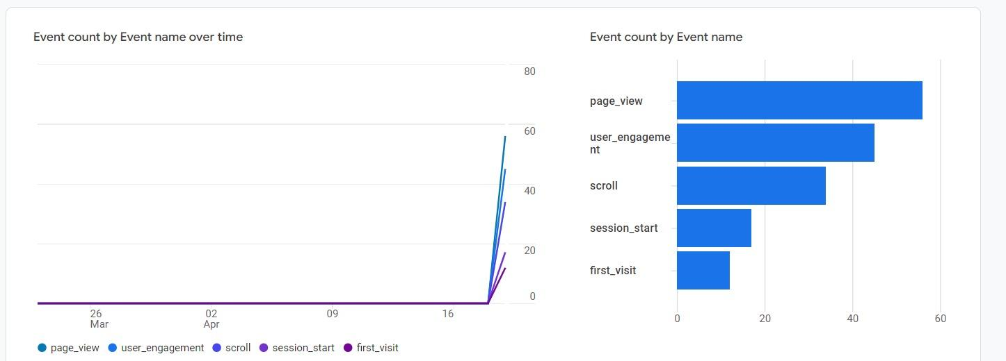

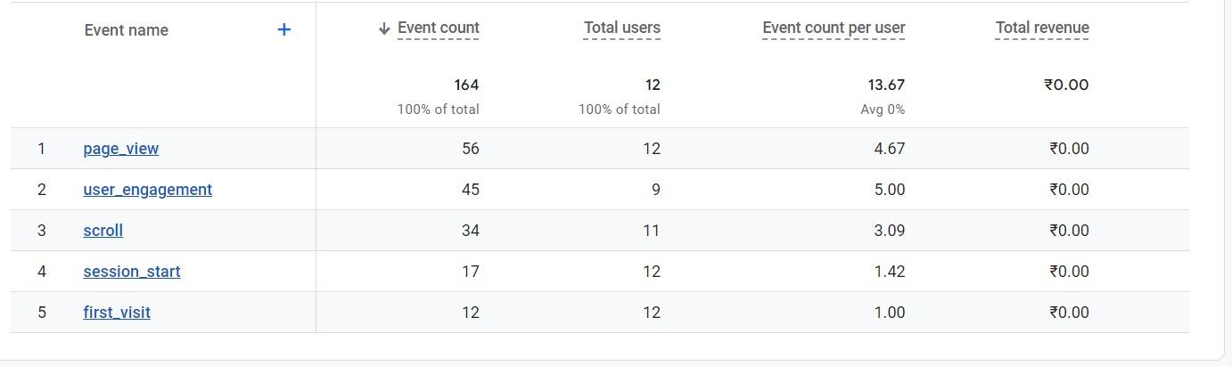

In total of 164 event counts, there are 12 total users and event count per user is 13.67.

first visit have been 12, user engagement 45, scroll 34, page view 56, total revenue has been 0

As a conclusion we can say that, our focus should be more returning users and a higher engagement rate to enable the best possible outcome for our salon.