**Final set**

1) Print the following pattern: 1

1

1 2 1

1 2 3 2 1

1 2 3 4 3 2 1

2) To find a number’s ASCII value.

3) Write a program to implement linear search.

4) Write a program to find LCM of two given numbers.

5) Write program to check Armstrong Number.

6) write a program to find all the prime numbers before the given value.

7) write a program to sort an array using any kind of sorting algorithm.

8) Calculate sum of natural numbers using Recursion.

9) Write a program to find Transpose of a matrix.

10)print following pattern:

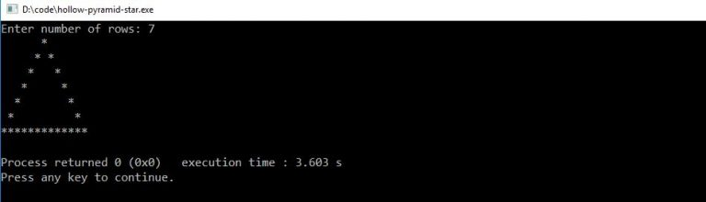

11)

12)

13)