**NAME:- AYUSHMAN VOHRA**

**ROLL NO:- 2022A6R059**

**DEPART.:- CSE**

**SEMESTER:- 5TH SEM**

**Q1. Write a program to display the array element.**

#include<bits/stdc++.h>

using namespace std;

int main()

{

int n;

cout<<"Enter the number of elements: ";

cin>>n;

int arr[n];

for(int i=0;i<n;i++)

{

cin>>arr[i];

}

cout<<"The array is ";

for(int i:arr)

{

cout<<i<<" ";

}

}

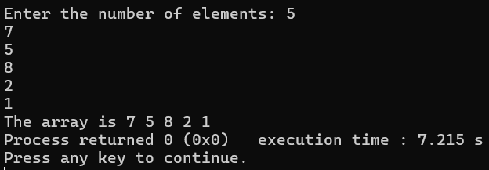

**Q2. Write a progam to find the max element from the list.**

#include<bits/stdc++.h>

using namespace std;

int maximum(list<int> l)

{

int maxx = l.front();

for(int i:l)

{

if(i>maxx)

{

maxx=i;

}

}

return maxx;

}

int main()

{

list<int> l;

cout<<"Enter the size of the list: ";

int n;

cin>>n;

for(int i=0;i<n;i++)

{

int x;

cin>>x;

l.push_back(x);

}

cout<<endl;

cout<<"The maximum element in the list is "<<maximum(l)<<endl;

}

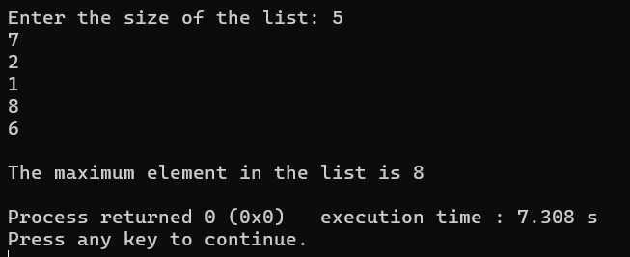

**Q4. Given an array of integers nums and an integer target, return indices of the two numbers such that they add up to target. You may assume that each input would have exactly one solution, and you may not use the same element twice. You can return the answer in any order.**

class Solution {public: vector<int> twoSum(vector<int>& nums, int target) { for(int i=0;i<nums.size();i++) { for(int j=i+1;j<nums.size();j++) { if(nums[i]+nums[j] == target) { return{i,j}; } } } return {}; }};

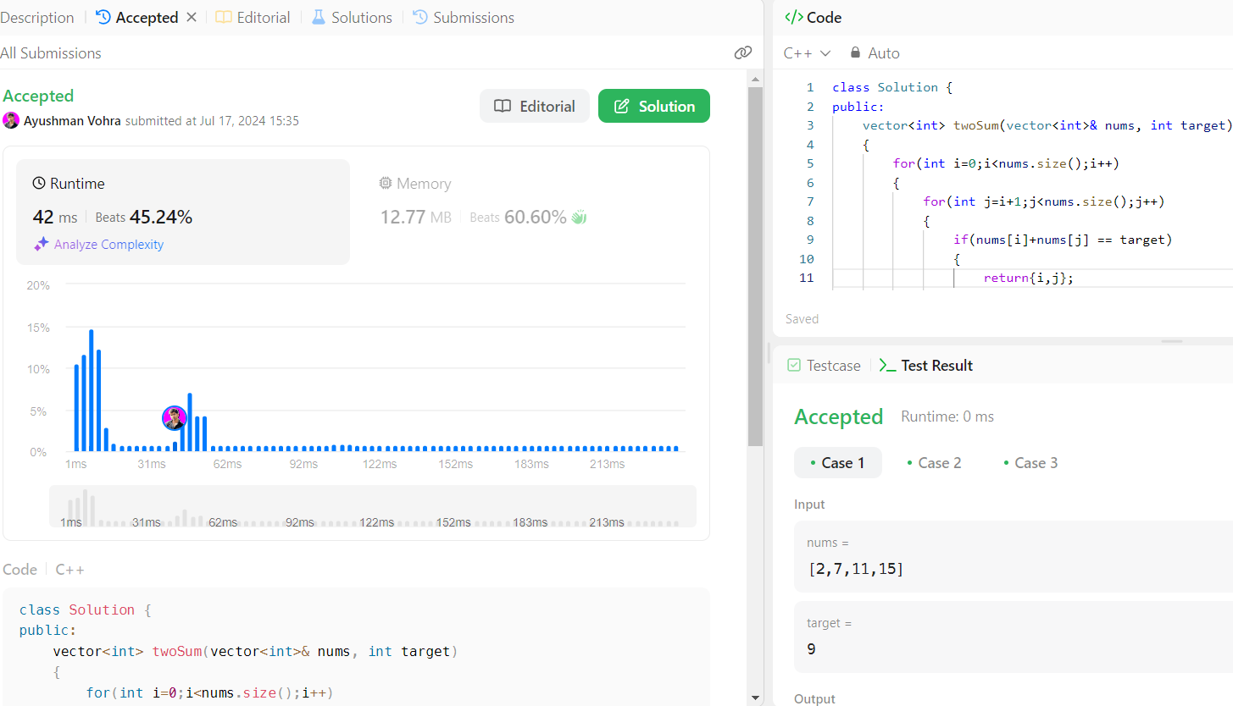

**Q5. Given a string s containing just the characters '(', ')', '{', '}', '[' and ']', determine if the input string is valid.An input string is valid if:Open brackets must be closed by the same type of brackets.Open brackets must be closed in the correct order.Every close bracket has a corresponding open bracket of the same type.**

class Solution {public: bool isValid(string s) { stack<char> st; for(char c:s) { if (c == '(' || c == '{' || c == '[') { st.push(c); } else { if (st.empty() || (c==')' && st.top() != '(') || (c=='}' && st.top() != '{') || (c==']' && st.top() != '[')) { return false; } st.pop(); } } return st.empty(); }};

