
Copilot Readiness Assessment

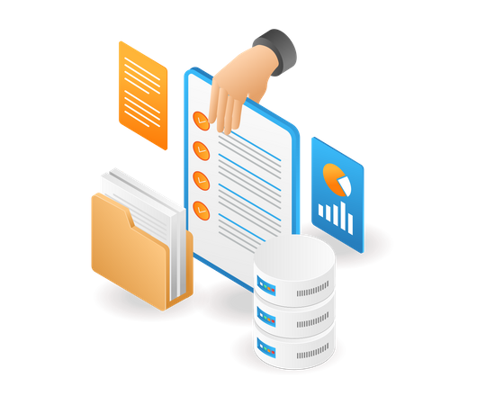

Prepared for:
.
April 20, 2026
Executive Summary 5
Purpose 5
Evaluation Summary 6
3 Pillars of Microsoft 365 Copilot Readiness Assessment 6
M365 Services assessed in CRA 6
Risk Category of Parameters Assessed 7
Summary of Assessment 8
Key Observations: 9
Risks of Immediate Deployment: 12
Recommendations: 12
Detailed Assessment 13
ENTRA ID 13
01: Custom Banned BCword List 15
02: Restricted Access to Microsoft Entra Admin Centre 15
03: Emergency Access Accounts 16
04: Device without Compliance Policies 16
05: Authentication Methods Enabled 17
06: Entra - Tenant creation by non-admins 17
07: Global Administrator Accounts 18
08: Self-Service BCword Reset Authentication Method 18
09: Tenant Collaboration Invitation 19
10: Administrator Consent Workflows 19
11: CAP Policies for Risky Sign -Ins 20
12: Conditional Access Policies (Exclusion) 20
13: User Consent for Applications 21
14: Entra - Third-Party App Integrations 21
15: Users without MFA 22
16: Auto-expiration policy for M365 Groups 22
17: Customer Lockbox 23
18: Guest Invite Settings 23
19: Guest Users count 24
20: User Information 24
21: Number of accounts enabled 25
EXCHANGE ONLINE 26
01: Mailbox Status (Active/Inactive) 27
02: External Storage providers in OWA 27
03: Mailbox Storage usage 28
04: Full Calendar Schedules able to be shared Externally 28
05: Number of Emails read/received 29
06: Number of emails sent 29
MICROSOFT PURVIEW 30
01: Audit Logs Enabled 31
02: Secure Score Percentage 31
03: Sensitivity Labels configured and applied 32
04: Sensitivity Labels applied to Teams 32
05: Compliance Score Overview 33
06: Information Protection Labels applied 33
07: DLP Rules configured 34
08: Audit Log Retention Duration 34
MICROSOFT TEAMS 35
01: Copilot Integration Enabled 36
02: Third Party apps allowed 36
03: Active/Inactive Teams 37
04: Minimum number of Owners 37
05: Teams with External Users 38
06: Meeting Policies Configuration 38
07: Orphan Teams 39
08: Teams with external guest as owner 39
09: Meeting Transcription enabled 40
10: Guest access enabled/disabled 40
11: Teams - Lobby ByBC 41
12: Teams - File Storage Option 41
13: Active/Inactive Teams Users 42
14: Teams - Meeting Chat 42
15: Meeting Recording Retention Policies 43
16: Teams - Channel Email Addresses 43
ONEDRIVE FOR BUSINESS 44
01: External Sharing Settings 45
02: Days to retain a deleted user’s OneDrive 45
03: Total Active users on OneDrive 46
SHAREPOINT ONLINE 47
01: Permission Settings for anyone links 48
02: Sensitive SharePoint sites excluded from Copilot 48
03: Sharing Settings (External/Internal) 49
04: SharePoint and OneDrive Guest Access Expiry 49
05: Expiration Policy for Anyone links 50
06: Inactive site policies 50
07: Active Sites count 51
08: Site Ownership policies 51
09: Active Users on SharePoint 52
10: SharePoint - Modern Authentication 52
11: Storage Quota Consumption 53
Conclusion 54

Executive Summary
As part of its digital transformation strategy, {{ company_name }}. engaged {{ company_name }} for a Copilot Readiness Assessment. The purpose of this engagement was to evaluate the Client’s Microsoft 365 environment across areas including security, governance, and best practices to determine readiness for the secure and responsible adoption of Microsoft 365 Copilot.
The assessment covered critical services including Entra ID, Exchange Online, Microsoft Teams, SharePoint Online, OneDrive for Business, and Microsoft Purview. It aimed to identify configuration gaps, policy misalignments, and potential vulnerabilities that could impact the responsible use of AI-powered tools like Copilot. By benchmarking the current environment against industry standards and Microsoft’s Copilot deployment criteria, the assessment provides a clear roadmap for remediation and optimization.
The findings serve as a strategic foundation for {{ company_name }} to enhance its digital workplace, mitigate operational and compliance risks, and unlock the full potential of Microsoft 365 Copilot. With targeted improvements, the organization can ensure a secure and scalable AI integration that aligns with its long-term business goals.

Purpose
- Evaluate the {{ company_name }} environment for alignment with industry best practices.
- Assess the environment across Microsoft 365 products and services like SharePoint, Teams, OneDrive for business etc.
- Identify gaps that could pose security or compliance risks upon integrating Copilot.
- Establish a baseline for future audits and compliance tracking related to AI usage within Microsoft 365.
- Highlight licensing readiness and user eligibility for Microsoft 365 Copilot deployment.
- Provide a risk-based prioritization of remediation efforts to guide Copilot enablement planning.
- Offer actionable insights to strengthen governance, data protection, and identity management in preparation for AI integration.
- Support strategic decision-making by outlining Copilot deployment prerequisites and dependencies.

Evaluation Summary

3 Pillars of Microsoft 365 Copilot Readiness Assessment

- Governance
- Security
- Best Practices

M365 Services assessed in CRA
- Entra ID
- Exchange Online
- Microsoft Purview
- Microsoft Teams
- OneDrive for Business
- SharePoint Online

Risk Score Matrix
The findings presented in this report are graded according to the following levels of severity:

Risk Category of Parameters Assessed
The following chart provides consolidated parameters based on risk category assessed during the engagement:

Summary of Assessment
The Copilot Readiness Assessment uncovered several configuration gaps and policy deficiencies that could impact the secure and compliant adoption of Microsoft Copilot. Each finding has been categorized by severity and mapped to specific areas of risk within the Microsoft 365 environment.
Overall Readiness:
Based on the findings, the Client’s current readiness level for Copilot integration is assessed as:
Readiness Level: {{ readiness_level }}
Readiness Gaps: {{ fail_count }} out of {{ total_count }}
Significant remediation is required prior to enabling Copilot in the production environment.

46.15%

Key Observations:
- A total of gaps {{ fail_count }} out of {{ total_count }} parameters were identified, distributed across Security, Governance, and Best Practice categories.
- Medium to Critical severity issues make up most of the findings, indicating substantial exposure to operational and compliance risks.
- Gap findings reveal that the percentage of failed parameters is Security ({{ security_pct }}%), Governance ({{ governance_pct }}%), and Best Practices ({{ bestpractice_pct }}%) pillars, indicating a critical need for immediate remediation in those areas.
- There are {{ eligible_users }} user accounts out of {{ total_users }} that are eligible for a M365 Copilot license. Copilot requires a base Microsoft 365 subscription, such as Microsoft 365 E3, E5, Business Standard, or Business Premium.
- There are no users with full user information; assigning User information such as department or role, must be completed to establish an accurate organizational hierarchy and maintain proper records.

- In the past 60 days, {{ onedrive_active_pct }}% of OneDrive users, {{ teams_active_pct }}% of Microsoft Teams users, {{ outlook_active_pct }}% of outlook users and {{ sharepoint_active_pct }}% of SharePoint users have been active, indicating strong engagement across Microsoft 365 core services.
100%

0%
100%

Risks of Immediate Deployment:
Proceeding with Copilot activation in the current state may lead to:

Recommendations:

- Remediation of identified gaps: Address all findings regardless of severity to meet cybersecurity baseline standards.
- Postpone Deployment: Due to the current maturity level of the environment, it is recommended to adopt Copilot deployment after all critical and high-priority gaps are resolved.
- Futureproofing: Implementing the recommendations provided will reduce security risks and ensure regulatory compliance during and after Copilot integration.

Detailed Assessment

The following tables provides a summary of all findings discovered during the course of this engagement:

ENTRA ID

S. No | Parameter | CRA Pillar | Finding | Severity
01 | Custom Banned Password List | Best Practice | {{ entra_f01 }} | Critical
02 | Restricted Access to Microsoft Entra Admin Centre | Best Practice | {{ entra_f02 }} | Critical
03 | Emergency Access Account | Best Practice | {{ entra_f03 }} | Critical
04 | Device without Compliance Policies | Best Practice | {{ entra_f04 }} | Critical
05 | Authentication Methods Enabled | Security | {{ entra_f05 }} | Critical
06 | Entra – Tenant Creation by Non-Admins | Best Practice | {{ entra_f06 }} | Critical
07 | Global Administrator Accounts | Security | {{ entra_f07 }} | Critical
08 | Self-Service Password Reset Authentication Method | Security | {{ entra_f08 }} | Critical
09 | Tenant Collaboration Invitation | Security | {{ entra_f09 }} | High
10 | Administrator Consent Workflows | Best Practice | {{ entra_f10 }} | High
11 | CAP Policies for Risky Sign-Ins | Governance | {{ entra_f11 }} | High
12 | Conditional Access Policies (Exclusion) | Best Practice | {{ entra_f12 }} | High
13 | User Consent for Applications | Security | {{ entra_f13 }} | High
14 | Entra - Third-Party App Integrations | Governance | {{ entra_f14 }} | High
15 | Users without MFA | Security | {{ entra_f15 }} | High
16 | Auto-expiration policy for inactive m365 groups | Security | {{ entra_f16 }} | Medium
17 | Customer Lockbox | Security | {{ entra_f17 }} | Medium
18 | Guest Invite Settings | Security | {{ entra_f18 }} | Medium
19 | Guest Users count | Governance | {{ entra_f19 }} | Medium
20 | User Information | Best Practice | {{ entra_f20 }} | Low
21 | Number of accounts enabled | Security | {{ entra_f21 }} | Low

01: Custom Banned BCword List

Risk Rating: Critical - {{ entra_r01 }}

Description:
Custom-banned Password list is currently not enforced.
Risk:
Weak or commonly used Passwords increase the risk of account compromise. In the absence of a robust, customized banned Password list, attackers may hijack accounts and exploit Copilot features to access sensitive data or impersonate users.
Microsoft Documentation

02: Restricted Access to Microsoft Entra Admin Centre
\

Risk Rating: Critical - {{ entra_r02 }}

Description:
Access to the Microsoft Entra Admin Center is not restricted.
Risk:
Without strict access controls, unauthorised administrators may alter configurations that influence Copilot’s data access across the tenant. This elevates the risk of misconfigurations or unintended over-permission of Copilot.
Microsoft Documentation

03: Emergency Access Accounts

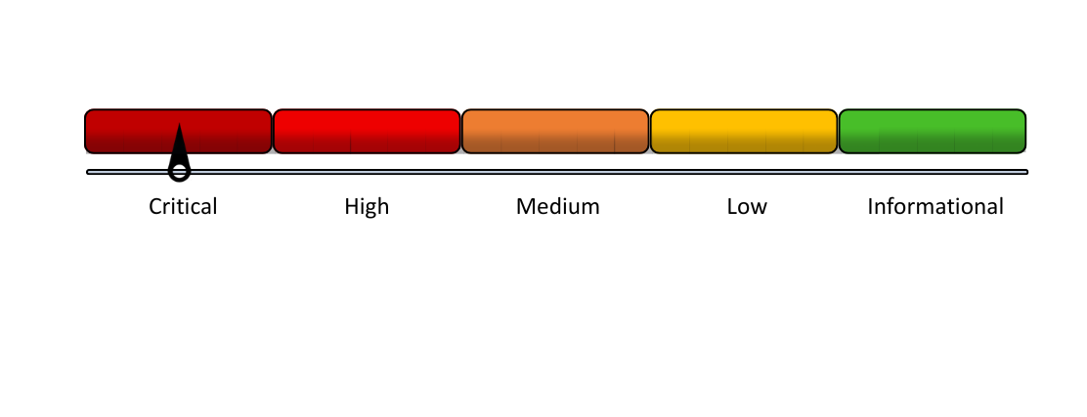
Risk Rating: Critical –

Description:
No Break glass accounts are present.
Risk:
If emergency access accounts are not properly monitored or restricted, they can be exploited to bypass security controls and access Copilot-generated insights. This creates a potential backdoor to sensitive information, circumventing standard identity protection measures.
Microsoft Documentation

04: Device without Compliance Policies

Risk Rating: Critical - {{ entra_r04 }}

Description:
Intune is not being utilized.
Risk:
Devices that are not governed by compliance policies pose a significant security risk when accessing Copilot features. In the absence of essential protections such as encryption and threat detection, data surfaced by Copilot may be exposed to theft, loss, or unauthorised disclosure.

05: Authentication Methods Enabled

Risk Rating: Critical - {{ entra_r05 }}

Description:
All authentication methods are enabled.
Risk:
Copilot depends on robust user identity verification to ensure secure data access. Weak or outdated authentication mechanisms increase the risk of account compromise, potentially allowing malicious actors to exploit Copilot and access sensitive organisational information.

06: Entra - Tenant creation by non-admins

Risk Rating: Critical - {{ entra_r06 }}

Description:
Non-Admin Users are not allowed to create tenants.

Risk:
Allowing non-administrators to create tenants can lead to unmanaged environments where Copilot may be enabled by default. This increases the risk of uncontrolled data exposure and inconsistent security configurations across shadow tenants.

07: Global Administrator Accounts

Risk Rating: Critical - {{ entra_r07 }}

Description:
There are a total of 3 Global Administrator accounts.
Risk:
An excessive number of unmonitored global admin accounts presents a significant security risk. If compromised, these accounts can exploit Copilot’s capabilities to access extensive organizational data, circumventing standard user restrictions and controls.
Microsoft Documentation

08: Self-Service BCword Reset Authentication Method


Risk Rating: Critical – BC

Description:
Self-Service Password Reset Authentication is enabled.
Risk:
Weak or poorly monitored self-service Password reset (SSPR) methods increase the risk of account takeovers. If compromised accounts retain access to Copilot, sensitive data may be exposed or manipulated through AI-driven interactions.
Microsoft Documentation

09: Tenant Collaboration Invitation

Risk Rating: High - {{ entra_r09 }}

Description:
Set to ‘Allow invitation to be sent to any domain’ (Most inclusive).
Risk:
Uncontrolled collaboration invitations can cause tenant sprawl and broaden external access. Copilot may inadvertently access or generate responses using external content introduced through these collaborations, increasing the risk of data leakage and diminishing control over the information Copilot references or exposes.
Microsoft Documentation

10: Administrator Consent Workflows

Risk Rating: High - {{ entra_r10 }}

Description:
User cannot request admin consent.
Risk:
Without an admin consent workflow, users may inadvertently grant permissions to malicious or risky applications, potentially exposing sensitive data and enabling unauthorised access to Copilot-integrated services.
Microsoft Documentation

11: CAP Policies for Risky Sign -Ins

Risk Rating: High - {{ entra_r11 }}

Description:
CAP policy for risky sign-ins is not enabled.
Risk:
Conditional Access Policies (CAP) are critical for mitigating risky sign-ins. In the absence of stringent CAP enforcement, Copilot may be accessed during compromised sessions, heightening the risk of data leakage via AI-assisted functionalities.

12: Conditional Access Policies (Exclusion)

Risk Rating: High - {{ entra_r12 }}

Description:
Conditional Access Polices have one excluded user (Gadmin@aaalegalprocess.onmicrosoft.com).
Risk:
Excluding users or applications from Conditional Access policies compromises identity security. Granting Copilot access to these excluded users can permit access to sensitive data without the enforcement of essential security measures like multi-factor authentication (MFA), thereby elevating the risk of misuse.

13: User Consent for Applications

Risk Rating: High - {{ entra_r13 }}

Description:
User consent for applications is not set.
Risk:
Permissive user consent settings can lead to widespread access to third-party applications, increasing the risk of data leakage and unauthorised use of Copilot features.
Microsoft Documentation

14: Entra - Third-Party App Integrations

Risk Rating: High - {{ entra_r14 }}

Description:
Users are allowed to register third-party applications.
Risk:
Integrating with inadequately managed third-party applications can expose sensitive user data and permissions accessible to Copilot. These applications may interact with Microsoft 365 services—either contributing or extracting content—which Copilot could process without oversight. This increases the risk of data leakage, compromised data integrity, and diminished control over the information Copilot accesses and shares.

15: Users without MFA

Risk Rating: High - {{ entra_r15 }}

Description:
All MFA-capable users have MFA registered.
Risk:
The absence of MFA significantly weakens account security, increasing the risk of unauthorised access to user accounts. As Copilot can surface and interact with sensitive content across Microsoft 365 applications, accounts without MFA represent a heightened security vulnerability and may lead to unintentional data exposure.

16: Auto-expiration policy for M365 Groups

Risk Rating: Medium - {{ entra_r16 }}
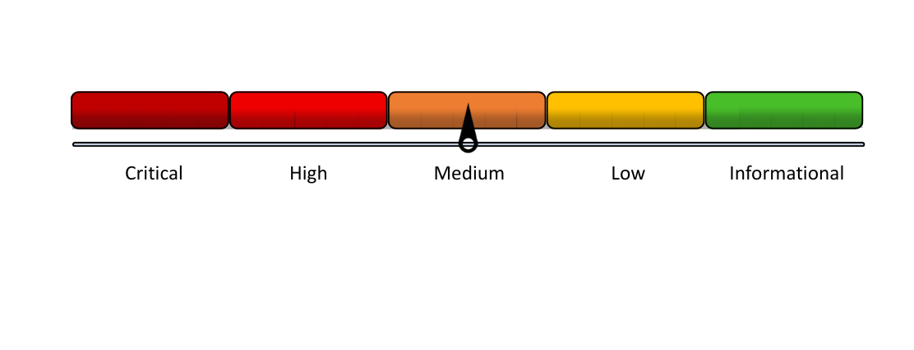
Description:
Auto-expiration policy for inactive groups is not configured.
Risk:
Inactive M365 Groups may retain sensitive data unnecessarily, increasing exposure risk. Copilot may surface outdated or irrelevant content from these teams.
Microsoft Documentation

17: Customer Lockbox

Risk Rating: Medium - {{ entra_r17 }}

Description:
Customer Lockbox is not enabled.
Risk:
Without Customer Lockbox, Microsoft support engineers may access tenant data during troubleshooting without explicit approval. In a Copilot-enabled environment, this increases the risk of unintentionally exposing AI-accessible content to external personnel.
Microsoft Documentation

18: Guest Invite Settings

Risk Rating: Medium - {{ entra_r18 }}


Description:
Anyone in the organisation can invite guest users, including guests and non-admins (most inclusive).
Risk:
Permissive invitation settings may permit unintended guests to join the tenant. Once inside, these guests could access content surfaced by Copilot features, thereby increasing the risk of internal data leakage or misuse.
Microsoft Documentation

19: Guest Users count

Risk Rating: Medium - {{ entra_r19 }}

Description:
There are 0 guest users out of 14 total users.
Risk:
Many guest users increase the risk that Copilot may inadvertently expose sensitive data to unintended recipients. In the absence of clear segmentation and strict data access controls, AI tools may treat guests as internal users, potentially revealing critical information.

20: User Information

Risk Rating: Low - {{ entra_r20 }}
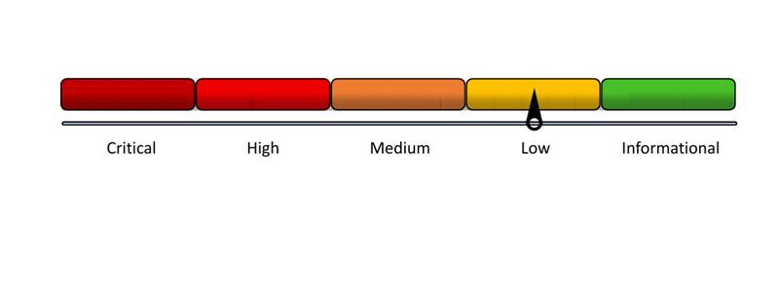

Description:
User information details are not complete for all users.
Risk:
User profiles lacking accurate details such as department or role may compromise the relevance and precision of insights generated by Copilot. This misalignment can result in inappropriate content suggestions or accidental access to data outside a user’s intended scope.

21: Number of accounts enabled

Risk Rating: Low - {{ entra_r21 }}

Description:
9 accounts are enabled out of 14 accounts.
Risk:
Copilot engages with all active accounts to deliver AI-driven insights. If inactive or unauthorised accounts remain enabled, there is a potential risk that Copilot may inadvertently expose sensitive organisational data to individuals who should no longer have access.

EXCHANGE ONLINE

S. No | Parameter | CRA Pillar | Finding | Severity
01 | Mailbox status (Active/Inactive) | Governance | BC | Critical
02 | External Storage providers in OWA | Security | AB | High
03 | Mailbox Storage usage | Best Practice | BC | Medium
04 | Full Calendar Schedules able to be shared Externally | Security | BC | Medium
05 | Number of Emails read/received | Best Practice | BC | Informational
06 | Number of emails sent | Best Practice | BC | Informational

01: Mailbox Status (Active/Inactive)

Risk Rating: Critical - {{ exchange_r01 }}

Description:
{{ exchange_d01 }}
Risk:
Copilot retrieves data from active mailboxes to support features like email summarisation and task extraction; however, unused or poorly monitored mailboxes can increase the risk of exposing outdated, sensitive, or non-critical business data through its outputs.

02: External Storage providers in OWA

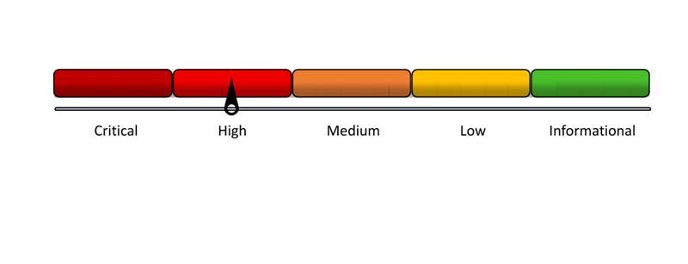
Risk Rating: High – AB

Description:
{{ exchange_d02 }}
Risk:
Enabling third-party storage services in Outlook Web App may allow Copilot to access or recommend content stored outside the Microsoft 365 environment. This reduces control over data governance and increases the risk of exposing unsanctioned or non-compliant information through AI-generated insights.

03: Mailbox Storage usage

Risk Rating: Medium - {{ exchange_r01 }}

Description:
{{ exchange_d03 }}
Risk:
Excessive mailbox storage in the absence of appropriate retention policies may lead Copilot to surface outdated or irrelevant content. Additionally, it increases processing overhead and the likelihood of sensitive legacy data being included in AI-generated responses.

04: Full Calendar Schedules able to be shared Externally

Risk Rating: Medium - {{ exchange_r01 }}

Description:
{{ exchange_d04 }}
Risk:
Sharing full calendar access externally may enable Copilot to include sensitive scheduling information in its responses or meeting suggestions. This raises privacy concerns and increases the risk of organizational exposure through automated content summaries.

05: Number of Emails read/received

Risk Rating: Informational - {{ exchange_r01 }}
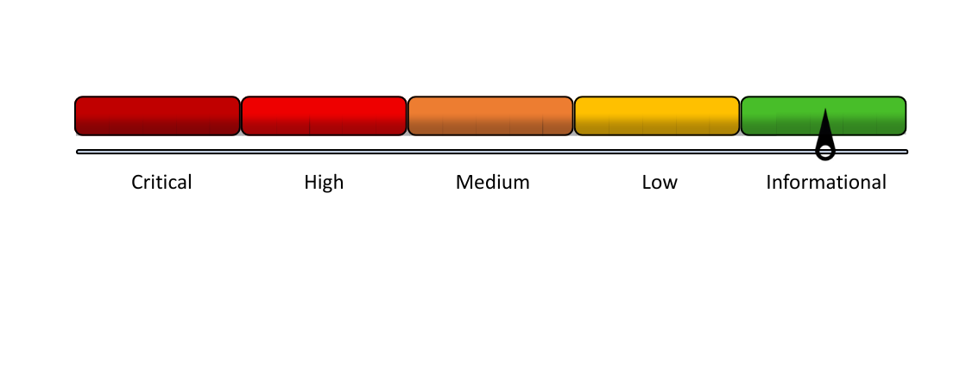

Description:
{{ exchange_d05 }}
Risk:
Copilot may analyse read emails to generate context-aware suggestions and insights. If these emails contain sensitive information, there is a risk of data exposure in the absence of adequate classification, retention, and monitoring controls.

06: Number of emails sent

Risk Rating: Informational - {{ exchange_r01 }}

Description:
{{ exchange_d06 }}
Risk:
Sent emails are included in the dataset accessible to Copilot for analysing communication patterns. Without strong governance, Copilot may inadvertently reuse sensitive or private correspondence in its suggestions, summaries, or generated responses.

MICROSOFT PURVIEW

S. No | Parameter | CRA Pillar | Finding | Severity
01 | Audit Logs Enabled | Security |  | Critical
02 | Secure Score Percentage | Security |  | Critical
03 | Sensitivity Labels configured and applied | Security |  | Critical
04 | Sensitivity Labels applied to Teams | Security |  | Critical
05 | Compliance Score Overview | Governance |  | Critical
06 | Information Protection Labels applied | Security |  | Critical
07 | DLP Rules configured | Security |  | Critical
08 | Audit Log Retention Duration | Governance |  | Medium

01: Audit Logs Enabled

Risk Rating: Critical - {{ purview_r01 }}

Description:
{{ purview_d01 }}
Risk:
Audit logs play a crucial role in monitoring and tracing AI interactions. Disabling audit logging prevents the review and tracking of Copilot activities, thereby hindering incident response capabilities and increasing the likelihood of undetected data misuse or unauthorized behaviour.
Microsoft Documentation

02: Secure Score Percentage

Risk Rating: Critical - {{ purview_r01 }}

Description:
{{ purview_d02 }}
Risk:
A low secure score reflects weak security practices, heightening the risk of data leakage or misuse when Copilot accesses tenant data. It indicates potential misconfigurations or policy gaps that may impact Copilot’s security posture.

03: Sensitivity Labels configured and applied

Risk Rating: Critical - {{ purview_r01 }}

Description:
{{ purview_d03 }}
Risk:
Even when labels are configured, inconsistent application may prevent Copilot from respecting intended data boundaries. This can lead to partial or unintended access to confidential information during content generation.
Microsoft Documentation

04: Sensitivity Labels applied to Teams

Risk Rating: Critical - {{ purview_r01 }}

Description:
{{ purview_d04 }}
Risk:
Without proper labelling of Teams, Copilot may access or surface sensitive content without the necessary controls. This elevates the risk of data leakage, particularly in cross-team suggestions or summaries.

05: Compliance Score Overview

Risk Rating: Critical - {{ purview_r01 }}

Description:
{{ purview_d05 }}
Risk:
A low compliance score may signal inadequate policy enforcement, indicating weak controls over the data accessible to Copilot. This can result in the inadvertent exposure of non-compliant or unprotected content through AI-driven recommendations.

06: Information Protection Labels applied

Risk Rating: Critical - {{ purview_r01 }}

Description:
{{ purview_d06 }}
Risk:
Without the consistent application of sensitivity and protection labels, Copilot may inadvertently expose unclassified sensitive data through search, summarization, or recommendations. These labels establish critical boundaries for AI processing, and their absence undermines the organization’s overall data protection posture.

07: DLP Rules configured

Risk Rating: Critical - {{ purview_r01 }}

Description:
{{ purview_d07 }}
Risk:
Copilot has the capability to access and present sensitive content across Microsoft 365 applications. In the absence of well-defined Data Loss Prevention (DLP) policies, it may inadvertently expose or share sensitive information, potentially violating data protection and compliance requirements.
Microsoft Documentation

08: Audit Log Retention Duration

Risk Rating: Medium - {{ purview_r01 }}

Description:
{{ purview_d08 }}
Risk:
Copilot relies on extended retention of user activity logs to derive behavioural insights. Retaining audit logs for insufficient durations may result in the loss of critical risk signals and contextual history, whereas excessively long retention periods can increase the risk of data exposure if adequate safeguards are not in place.
Microsoft Documentation

MICROSOFT TEAMS

S. No | Parameter | CRA Pillar | Finding | Severity
01 | Copilot Integration Enabled | Governance | BC | Critical
02 | Third Party Apps allowed | Governance | AB | High
03 | Active/Inactive teams | Security | BC | High
04 | Minimum number of Owners | Governance | BC | High
05 | Teams with External Users | Governance | BC | High
06 | Meeting Policies Configuration | Governance | BC | High
07 | Orphan Teams | Governance | BC | High
08 | Teams with guest as owner | Security | BC | High
09 | Meeting Transcription enabled | Governance | BC | High
10 | Guest access Enabled/Disabled | Security | AB | Medium
11 | Teams - Lobby Bypass | Governance | AB | Medium
12 | Teams - File Storage Option | Security | AB | Medium
13 | Active/Inactive Teams Users | Best Practice | AB | Medium
14 | Teams - Meeting Chat | Governance | BC | Medium
15 | Meeting Recording Retention Policies | Best Practice | BC | Medium
16 | Teams - Channel Email Addresses | Governance | AB | Low

01: Copilot Integration Enabled

Risk Rating: Critical - {{ teams_r01 }}

Description:
{{ teams_d01 }}
Risk:
If Copilot is not fully enabled across core workloads like Teams, Word, or Outlook, it signals incomplete readiness and limits Copilot’s utility. Gaps in licensing, onboarding, or workload configuration can reduce Copilot’s effectiveness and may lead to inconsistent user experiences or missed productivity gains.

02: Third Party apps allowed

Risk Rating: High - {{ teams_r01 }}

Description:
{{ teams_d02 }}
Risk:
Allowing third-party applications in Teams can increase the attack surface if these apps are not properly vetted. Such applications may gain access to Copilot-generated content or underlying data, potentially introducing security and compliance risks.
Microsoft Documentation

03: Active/Inactive Teams

Risk Rating: High - {{ teams_r01 }}

Description:
{{ teams_d03 }}
Risk:
Many active Teams expands the data pool that Copilot interacts with. Without effective classification and access controls, this broad surface area increases the likelihood of irrelevant or sensitive information being exposed to unintended users.

04: Minimum number of Owners

Risk Rating: High - {{ teams_r01 }}

Description:
{{ teams_d04 }}

Risk:
Teams or groups lacking a minimum number of designated owners risk becoming orphaned, complicating the management and oversight of data surfaced by Copilot. This absence of ownership can lead to unmanaged access to legacy or sensitive information.

05: Teams with External Users

Risk Rating: High - {{ teams_r01 }}

Description:
{{ teams_d05 }}
Risk:
External users in Teams have access to shared files, chats, and meeting content that Copilot can process. This increases the risk of sensitive or proprietary information being included in AI-generated outputs. Without strict controls, external collaboration can blur tenant boundaries and compromise organisational data privacy.

06: Meeting Policies Configuration

Risk Rating: High - {{ teams_r01 }}

Description:
{{ teams_d06 }}
Risk:
Inadequate or inconsistent meeting policies may allow Copilot to access recordings, chats, or transcriptions from meetings that were not intended for retention. This elevates the risk of private or confidential discussions being inadvertently surfaced in the future.

07: Orphan Teams

Risk Rating: High - {{ teams_r01 }}

Description:
{{ teams_d07 }}
Risk:
Orphaned Teams without owners may still hold sensitive content accessible by Copilot. Without proper oversight, these Teams become unmanaged data sources, raising the risk of outdated or confidential information being surfaced unintentionally.

08: Teams with external guest as owner

Risk Rating: High - {{ teams_r01 }}

Description:
{{ teams_d08 }}
Risk:
Proper ownership control reduces the risk of external manipulation of team settings or misuse of Copilot features within Microsoft Teams.

09: Meeting Transcription enabled

Risk Rating: High - {{ teams_r01 }}

Description:
{{ teams_d09 }}
Risk:
Enabled transcriptions create accessible content that Copilot can process. Without appropriate governance, this heightens the risk of confidential spoken information being incorporated into Copilot’s suggestions, potentially violating privacy boundaries.

10: Guest access enabled/disabled

Risk Rating: Medium - {{ teams_r01 }}

Description:
{{ teams_d10 }}
Risk:
When guest access is enabled, Copilot may unintentionally expose internal content to guest users if adequate restrictions are not enforced. This can result in unauthorised data disclosure and potential violations of internal or regulatory data policies.

11: Teams - Lobby ByBC

Risk Rating: Medium - {{ teams_r01 }}

Description:
{{ teams_d11 }}

Risk:
Allowing participants to bypass the lobby without restrictions can lead to unauthorised access to meetings. If those meetings are recorded or transcribed, Copilot may process and reference sensitive discussions, increasing the risk of privacy violations and breaching governance standards by exposing content not intended for wider access.

12: Teams - File Storage Option

Risk Rating: Medium - {{ teams_r01 }}

Description:
{{ teams_d12 }}

Risk:
Improper configuration of file storage in Teams can route content to non-compliant or insecure locations. Copilot may then access incomplete, outdated, or unprotected files for summarization and insights, increasing the risk of compliance violations and inaccurate or unauthorized data exposure in its responses.

13: Active/Inactive Teams Users

Risk Rating: Medium - {{ teams_r01 }}

Description:
{{ teams_d13 }}
Risk:
Inactive users who maintain access may have their content surfaced by Copilot within collaborative environments. This raises the risk of reintroducing outdated or irrelevant information and, more critically, the potential malicious exploitation of their accounts to misuse AI capabilities.

14: Teams - Meeting Chat

Risk Rating: Medium - {{ teams_r01 }}

Description:
{{ teams_d14 }}
Risk
Meeting chat messages frequently include important contextual information and follow-up actions. When retained and accessible, Copilot may utilize this data to generate summaries or recommendations. Without adequate governance controls, there is a risk that sensitive information casually shared in these chats could be inadvertently exposed by Copilot.

15: Meeting Recording Retention Policies

Risk Rating: Medium - {{ teams_r01 }}

Description:
{{ teams_d15 }}
Risk:
Without strict enforcement of retention policies, Copilot may continuously process and reference outdated recordings. This poses a risk of inappropriate reuse of sensitive historical meeting data, potentially resulting in violations of organisational compliance standards.

Rating: Low - AB

16: Teams - Channel Email Addresses

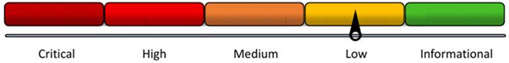

Description:
{{ teams_d16 }}
Risk:
Publicly exposed or mismanaged Teams channel email addresses can be exploited to inject unauthorised content into conversations. As Copilot interacts with Teams content, it may inadvertently process or reference these unvalidated inputs, potentially compromising content integrity, generating misleading insights, or introducing compliance risks.

ONEDRIVE FOR BUSINESS

S. No | Parameter | CRA Pillar | Finding | Severity
01 | External Sharing Settings | Security |  | High
02 | Days to retain a deleted user’s OneDrive | Governance |  | Low
03 | Total Active users on OneDrive | Governance |  | Informational

01: External Sharing Settings

Risk Rating: High - {{ teams_r01 }}

Description:
{{ onedrive_d01 }}
Risk:
When external sharing is broadly enabled, Copilot may unintentionally expose sensitive content to external collaborators during content generation. Misconfigured settings can result in unintended data exposure and potential non-compliance with organizational data sharing policies.
Microsoft Documentation

02: Days to retain a deleted user’s OneDrive

Risk Rating: Low - {{ onedrive_r01 }}

Description:
{{ onedrive_d02 }}
Risk:
Short retention periods may hinder data recovery and audit capabilities, especially if Copilot references deleted user content.
Microsoft Documentation

03: Total Active users on OneDrive
Risk Rating: Informational - {{ onedrive_r01 }}

Description:
{{ onedrive_d03 }}
Risk:
Significant user activity in OneDrive increases the volume and diversity of content Copilot may access. Without strong data governance in place, there is a greater likelihood that outdated, sensitive, or irrelevant files may be surfaced, elevating the risk of inadvertent data exposure.

SHAREPOINT ONLINE

S. No | Parameter | CRA Pillar | Finding | Severity
01 | Permission Settings for anyone links | Security |  | Critical
02 | Sensitive SharePoint sites excluded from Copilot | Security |  | Critical
03 | Sharing Settings (External/Internal) | Security |  | Critical
04 | SharePoint and OneDrive Guest Access Expiry | Security |  | Critical
05 | Expiration Policy for Anyone links | Security |  | High
06 | Inactive Site Policies | Best Practice |  | Medium
07 | Active Sites count | Governance |  | Medium
08 | Site Ownership policies | Governance |  | Medium
09 | Active Users on SharePoint | Governance |  | Medium
10 | SharePoint - Modern Authentication | Best Practice |  | Medium
11 | Storage Quota Consumption | Governance |  | Informational

01: Permission Settings for anyone links

Risk Rating: Critical - {{ sharepoint_r01 }}

Description:
{{ sharepoint_d01 }}
Risk:
Edit permissions on public links can lead to unauthorised changes and data manipulation, which Copilot may process or expose.
Microsoft Documentation

02: Sensitive SharePoint sites excluded from Copilot

Risk Rating: Critical - {{ sharepoint_r02 }}

Description:
{{ sharepoint_d02 }}
Risk:
Time-bound access helps mitigate long-term exposure risks, ensuring Copilot does not reference outdated or overly accessible content.

03: Sharing Settings (External/Internal)

Risk Rating: Critical - {{ sharepoint_r03 }}

Description:
{{ sharepoint_d03 }}
Risk:
Excessively permissive sharing settings can expose sensitive files to external users. Copilot may incorporate this exposed data in its contextual processing, potentially violating data privacy and compliance requirements.
Microsoft Documentation

04: SharePoint and OneDrive Guest Access Expiry

Risk Rating: Critical - {{ sharepoint_r04 }}

Description:
{{ sharepoint_d04 }}
Risk:
The absence of expiry settings permits indefinite guest access, leaving shared content vulnerable to misuse. Consequently, Copilot may continue to process and surface guest-accessible content well beyond its intended relevance or security period.
Microsoft Documentation

05: Expiration Policy for Anyone links

Risk Rating: High - {{ sharepoint_r05 }}

Description:
{{ sharepoint_d05 }}
Risk:
Time-bound access helps mitigate long-term exposure risks, ensuring Copilot does not reference outdated or overly accessible content.
Microsoft Documentation

06: Inactive site policies

Risk Rating: Medium - {{ sharepoint_r06 }}

Description:
{{ sharepoint_d06 }}
Risk:
Lack of ownership policies can result in unmanaged sites, increasing the risk of data mismanagement and improper Copilot indexing.
Microsoft Documentation

07: Active Sites count

Risk Rating: Medium - {{ sharepoint_r07 }}

Description:
{{ sharepoint_d07 }}
Risk:
Copilot indexes content from all active sites to deliver recommendations and contextual support. However, if these sites are outdated or not properly governed, they may expose irrelevant or unsecured information, introducing potential compliance risks.

08: Site Ownership policies

Risk Rating: Medium - {{ sharepoint_r08 }}

Description:
{{ sharepoint_d08 }}
Risk:
Lack of ownership policies can result in unmanaged sites, increasing the risk of data mismanagement and improper Copilot indexing.

09: Active Users on SharePoint

Risk Rating: Medium - {{ sharepoint_r09 }}

Description:
{{ sharepoint_d09 }}
Risk:
Copilot leverages user interaction data to prioritize content recommendations. When user activity is low or activity logs are inaccurate, Copilot may surface irrelevant or low-value content, potentially impacting productivity and diminishing the relevance of delivered insights.

10: SharePoint - Modern Authentication

Risk Rating: Medium - {{ sharepoint_r10 }}

Description:
{{ sharepoint_d10 }}
Risk:
Disabling modern authentication forces reliance on legacy protocols, which may expose data accessed by Copilot to unauthorized users. This weakens the overall security posture and increases the risk of misuse or data breaches.

11: Storage Quota Consumption

Risk Rating: Informational - {{ sharepoint_r11 }}

Description:
{{ sharepoint_d11 }}
Risk:
When storage quotas near their limits, Copilot may be unable to retrieve or process critical files from OneDrive or SharePoint. This can impair its ability to deliver complete responses, accurately summarise content, or perform contextual analysis. Additionally, storage constraints increase the risk of data being missed or omitted during Copilot’s indexing process.

Conclusion
The Copilot Readiness Assessment for {{ company_name }} reveals that the current Microsoft 365 environment is not yet prepared for the secure and compliant deployment of Microsoft 365 Copilot. With 35 {{ fail_count }} out of {{ total_count }} parameters failing to meet readiness standards, many of which fall under critical and high-risk categories, there is a clear need for immediate and comprehensive remediation.
Key gaps were identified across all three foundational pillars: Security, Governance, and Best Practices. Notably, critical vulnerabilities such as the absence of sensitivity labels, permissive external sharing configurations, and insufficient audit logging significantly elevate the risk of data exposure and non-compliance. Furthermore, the lack of complete user profile information and inconsistent policy enforcement could impair Copilot’s ability to deliver accurate, context-aware insights.
To mitigate these risks and ensure a successful Copilot rollout, {{ partner_name }} strongly recommends a phased remediation strategy. This should prioritise the resolution of critical and high-severity issues, followed by medium and low-risk items. Only after these gaps are addressed should the organisation consider enabling Copilot in the production environment.
By aligning with the recommendations outlined in this report, {{ company_name }} can enhance its security posture, ensure regulatory compliance, and fully leverage the transformative potential of Microsoft 365 Copilot.

