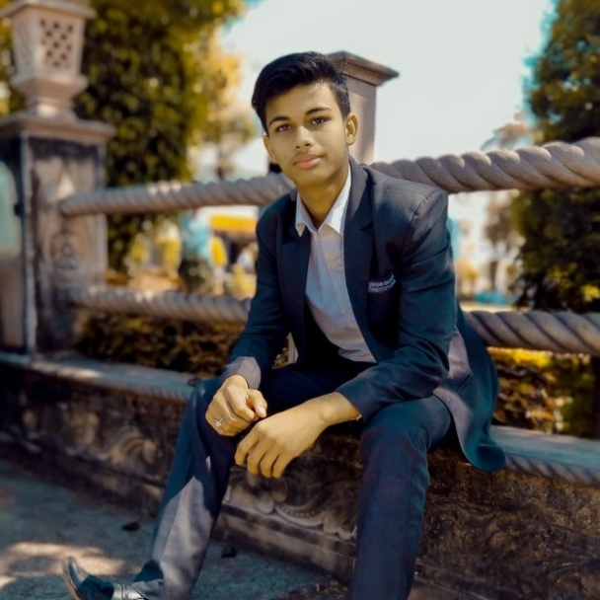;

**12th - 87 percentage from MP Board**

**B.tech 1st sem -**

**B.tech 2nd sem -**

**B.tech 3rd sem -**

**10th - 94 percentage from MP Board**

**B.tech 1st sem -**

**B.tech 2nd sem -**

**B.tech 3rd sem -**

Hello! My name is Ayush and I am obsessed with making things and even more obsessed with making things better. My interests, however, extend beyond the web and I love helping people with print design. I am a CS student looking for opportunities to help develop.

**Book Reading**

**Music**

**🎜**

**🖊**

**Coding**

**Photography**

**🖭**

**🕮**

**https://ayushnigam.netlify.app/**

**Chhatarpur ,MP INDIA**

**+91 9755807634**

**Ayush27nigam02@gmail.com**

**🖂**

**🕻**

**🏛**

**🛢**

**HOBBIES**

**CONTACT**

**PROJECT AND COURSES**

**EDUCATION**

**PROFILE**

**AYUSH NIGAM**

CURICULUM VITAE