InferAI
A Nyāya-Inspired Neuro-Symbolic Framework for Explainable Epistemic Reasoning Classification
InferAI Research Project
Domain: Explainable AI · Argument Mining · Indigenous Knowledge Systems · Natural Language Processing

Abstract
Explainable AI for argument analysis has relied almost exclusively on Western rhetorical taxonomies (claim–premise, stance, fallacy types), leaving classical epistemological traditions largely unexplored as a basis for interpretable classification. Existing systems characterize what an argument claims but rarely the epistemic means by which it justifies that claim — a gap the Nyāya school’s four pramāṇas (Pratyaksha, Anumana, Upamana, Shabda) are well suited to fill, provided the mapping from English text to pramāṇa remains both accurate and auditable. We propose InferAI (PramāṇaNet), a Nyāya-inspired neuro-symbolic framework that embeds text with Sentence-BERT, classifies it with logistic regression, and fuses this with a documented 77-rule symbolic engine through Adaptive Alpha Routing, an ablation-informed mechanism that adjusts the fusion weight per example rather than fixing it globally; a lightweight Hetvābhāsa-inspired layer additionally flags candidate fallacies in inferential spans. Our contributions are a pramāṇa-based annotation taxonomy, the hybrid routing architecture, a manually reviewed real-world corpus with measured inter-annotator agreement, and a multi-protocol evaluation suite spanning in-distribution, out-of-distribution, and cross-validated settings. Experimentally, hybrid fusion substantially outperforms either component alone, and Adaptive Alpha Routing improves calibration without any loss in accuracy — gains confirmed by statistical significance testing. These results show that a lightweight, auditable symbolic layer can meaningfully strengthen a frozen sentence-embedding classifier while keeping every prediction traceable to human-readable evidence. We present this work as a reproducible step toward operationalizing non-Western epistemological frameworks in explainable NLP, reporting its current limitations — chiefly minority-class performance and residual miscalibration — as directions for future work.
Keywords: Nyāya pramāṇa, explainable AI, neuro-symbolic reasoning, Sentence-BERT, argument mining, Indigenous Knowledge Systems, epistemic classification, hybrid fusion, adaptive routing.

1. Introduction

1.1 Motivation
Machine learning classifiers for text routinely achieve high accuracy while remaining opaque about why a given prediction was issued. Explainable AI (XAI) methods such as SHAP attribute model outputs to input features [1], but for epistemic tasks — determining the mode of justification behind a claim, rather than merely its topic or sentiment — feature attributions alone do not map cleanly onto human-interpretable reasoning types. Argument mining research extracts claims, premises, and relations from text [2], [3], yet it does not typically ask which epistemic instrument underlies a given premise.
Classical Nyāya treats knowledge as arising through pramāṇas, validated means of knowing [4], [5]. We do not attempt to reconstruct Nyāya dialectical procedure, fallacy catalogues, or Sanskrit formalization in this work; instead, we use the four commonly taught pramāṇas as an annotation and prediction taxonomy for English argumentative text, paired with an explicit symbolic cue layer whose matches serve as interpretability evidence (matched spans, per-pramāṇa rule scores, and ML–rule agreement metadata). This design choice reflects a broader goal: building explainable NLP systems whose taxonomies draw on epistemological traditions beyond the claim–premise–warrant framing that dominates Western argument mining. The practical question this raises is precisely how such a taxonomy can be operationalized without either collapsing into a purely statistical black box or overstating what a modern classifier can responsibly claim about classical epistemology — a tension we make explicit in the problem statement below.

1.2 Problem Statement
Given a short English argument x, our system predicts a label y ∈ {Pratyaksha, Anumana, Upamana, Shabda}, estimates confidence, surfaces symbolic cue evidence, and generates a short natural-language explanation. We identify four central challenges that shape our methodology and evaluation design: (i) severe class imbalance in real-world argumentative English, where Anumana dominates; (ii) distributional shift between synthetic training templates and natural essays or claims; (iii) boundary ambiguity among pramāṇas on short spans; and (iv) the risk of overstating the symbolic layer as “computational Nyāya.”

1.3 Contributions
This work makes the following contributions:
- A Nyāya-inspired taxonomy for classifying epistemic reasoning modes in English arguments, accompanied by explicit annotator labeling guidelines.
- A hybrid neuro-symbolic architecture combining Sentence-BERT embeddings, logistic regression, and a 77-rule weighted cue engine, fused as p_fused = α·p_ML + (1−α)·p_rules with a default α = 0.2 selected via ablation, and further refined by an Adaptive Alpha Routing module that varies α per example.
- Manual annotation of 1,250 real-world sentences (650 from AAEC, 600 from IBM ArgKP), with double annotation yielding Cohen’s κ = 0.8804 on 200 matched examples.
- An explainability stack combining structural extraction (claim, premises, indicators), cue highlighting, template natural-language explanations, a lightweight fallacy detection layer, and optional embedding-space SHAP with documented limitations.
- A multi-protocol evaluation covering in-distribution holdout, curated template testing, real-world five-fold cross-validation, benchmark comparison against component-only baselines, statistical significance testing, calibration analysis, robustness analysis, a leakage audit, and lexical diversity analysis.

1.4 Scope Boundaries
To avoid overclaiming, we state explicitly what our system does not do. InferAI does not adjudicate the truth of an argument; it does not implement classical debate victory conditions; it does not provide token-level causal explanations by default; and it does not solve class imbalance — it measures and reports it. We treat a single accuracy figure as insufficient to summarize system performance; throughout this paper, we specify the evaluation protocol alongside every metric we report. Having outlined what InferAI contributes and what it deliberately leaves out of scope, we next introduce the Ny\u0101ya epistemological framework from which our pram\u0101\u1e47a taxonomy is drawn, before describing the hybrid architecture, corpus, and evaluation suite that operationalize it.

2. Background: Nyāya Epistemology

2.1 The Four Pramāṇas
In Nyāya epistemology, a pramāṇa is a means of valid knowledge (pramā). Different schools enumerate different sets; the fourfold set we adopt here — perception, inference, analogy, and verbal testimony — is the standard Nyāya–Vaiśeṣika pedagogical framing taught in Indian philosophical curricula [4], [5]. We treat each pramāṇa as a label for the dominant justificatory mode of a short English span, not as a verdict of classical epistemic validity. Table 1 summarizes the operational definitions we use for annotation.
Pramāṇa | Classical Meaning | Operational Cue (English)
Pratyaksha | Perception — direct sensory contact | First-person sensory reports; measurement and laboratory vocabulary (“we measured”, “under the microscope”)
Anumana | Inference — sign to conclusion | Inferential connectives and causal phrasing (“therefore”, “because”, “if...then”, “implies”)
Upamana | Analogy — knowledge by similarity | Phrase-level analogy markers (“similar to”, “analogous to”, “works like”); bare social preference (“I like football”) is explicitly excluded
Shabda | Testimony — trustworthy verbal report | Authority and reporting cues (“according to”, institutional names, “study found”), tiered by source formality
Table 1. The four pramāṇas and their operational annotation cues.
These operational cues, rather than the classical definitions alone, are what our annotators and our symbolic rule engine (Section 4.3) both apply in practice; keeping the two aligned is what makes the inter-annotator agreement reported in Section 5.3 and the rule-based explanations in Section 6.7 meaningful rather than merely descriptive.

2.2 Scope and Limitations of the Computational Model
A full computational Nyāya system would require formal treatment of inference patterns (pakṣa, sādhya, hetu, vyāpti, dṛṣţānta), debate protocol, fallacy catalogues (hetvābhāsa), and primary-source Sanskrit formalization. We implement none of these in full. Instead, we use the four pramāṇa names as a modern machine-learning label space, detect surface cues in English associated with those modes, and fuse those cues with a statistical classifier for robustness. We therefore describe our system throughout as Nyāya-inspired and operationalized through Nyāya pramāṇas, never as full computational Nyāya. All training and evaluation text is English, a deliberate engineering constraint that is also a philosophical limitation, since classical Nyāya discourse is primarily conducted in Sanskrit with later vernacular commentaries.

3. Related Work

3.1 Explainable AI
Post-hoc explanation methods attribute predictions to input features [1]. We apply optional SHAP to the logistic classification head in 384-dimensional Sentence-BERT embedding space, while separately providing human-readable rule-match traces. The two channels occupy different points on the intrinsic–post-hoc interpretability spectrum: the logistic head is intrinsically simple, while SHAP and template explanations are post-hoc; the symbolic engine is intrinsic to the hybrid decision at inference time but plays no role during training. This distinguishes our approach from XAI systems that rely solely on post-hoc attribution: a matched symbolic rule is, by construction, a human-authored and human-auditable justification, whereas an attribution score requires interpretation.

3.2 Argument Mining
The Argument Annotated Essays Corpus (AAEC) provides claim/premise annotations for persuasive essays [2], [3]. We reuse AAEC as a source of argumentative spans that we manually re-label into pramāṇas — an epistemic overlay rather than a replacement for claim–premise structure. Where standard argument mining asks what the claim is and what supports or attacks it, we ask a complementary question: by what epistemic instrument is the support offered? This distinction matters in practice: two spans with identical claim–premise structure can differ entirely in pramāṇa (e.g., a premise grounded in direct observation versus one grounded in cited testimony), a distinction that standard argument-mining taxonomies do not encode.

3.3 IBM ArgKP
IBM’s ArgKP corpus pairs arguments with key points for stance and matching research [11]. We treat ArgKP purely as a pool of short, natural arguments for pramāṇa annotation after cleaning 36,800 raw rows to 8,639 unique texts; key-point matching itself is not evaluated in this work.

3.4 Neuro-Symbolic AI
Neuro-symbolic systems combine learned representations with rules or logic [6]. Our hybrid layer is deliberately lightweight: weighted regex cues produce a soft probability distribution that is fused with the classifier’s softmax output at inference time, and rules never participate in gradient training. Compared with systems that compile logic into neural architectures or perform differentiable theorem proving, our framework is closer to a feature-rich, auditable post-processor than to a unified neuro-symbolic learner — trading logical depth for transparency and reproducibility. We view this as an appropriate trade-off for an epistemic classification task where every prediction should be traceable to an inspectable rule or embedding-space attribution, rather than for tasks that require multi-step logical inference over the rules themselves.

3.5 Sentence Embeddings and Lightweight Classifiers
Sentence-BERT [7] produces semantically meaningful sentence embeddings. We freeze all-MiniLM-L6-v2 and train only a logistic regression head, prioritizing reproducibility and low computational cost over marginal accuracy gains from fine-tuning. Our contribution is not a new encoder but the pramāṇa label space, the hybrid cue layer, and the accompanying evaluation suite built around this well-established pattern. Unlike pure embedding classifiers, which offer no mechanism for a human to verify why a given dimension of the embedding space correlates with a label, our symbolic layer gives every prediction a second, independently inspectable line of evidence.

3.6 Lexical Diversity Methodology
Raw type–token ratio is length-sensitive and can misrepresent lexical richness across corpora of different sizes. We use Guiraud’s R = V/√N and the Moving-Average Type–Token Ratio (MATTR) [9], [10] to show that apparent lexical collapse in synthetic data is partly a length artefact rather than a genuine diversity gap.

3.7 Comparison to Related System Classes
Table 2 situates InferAI relative to standard argument mining, pure embedding classifiers, and heavier neuro-symbolic logic systems.
System Class | Label Space | Learner | Symbolic Layer | IKS Link
Standard argument mining [2],[3] | Claim / premise / stance | Various | Rare | No
Pure embedding classifiers | Task-specific | SBERT + LR/NN | None | No
Heavy neuro-symbolic logic | Formal logic | Hybrid | Complex | Rare
InferAI (this work) | Four pramāṇas | SBERT + LR | 77 weighted cues | Nyāya-inspired
Table 2. Positioning of InferAI relative to related system classes.
Relative to argument mining, InferAI adds an epistemic-mode axis that existing claim–premise–stance taxonomies do not capture. Relative to generic XAI classifiers, it adds culturally grounded labels and fully auditable rules rather than post-hoc attribution alone. Relative to informal Indigenous Knowledge Systems (IKS) demonstrations, it adds leakage, calibration, out-of-distribution, and cross-validation discipline that such demonstrations typically omit. Relative to heavy neuro-symbolic stacks that compile logic directly into the learning process, it trades logical depth for simplicity, auditability, and reproducibility — a trade-off we make explicit throughout this paper rather than treating as an implementation detail.

4. Methodology

4.1 System Overview
Input text is normalized and passed through a structural extraction stage (claim, premises, reasoning indicators, and cue highlighting), embedded with Sentence-BERT, classified by logistic regression, scored by the symbolic rule engine, fused into a hybrid prediction via Adaptive Alpha Routing, and finally explained via template natural-language generation with optional embedding-space SHAP and Hetvābhāsa-inspired fallacy warnings. Figure 1 summarizes this pipeline end to end.
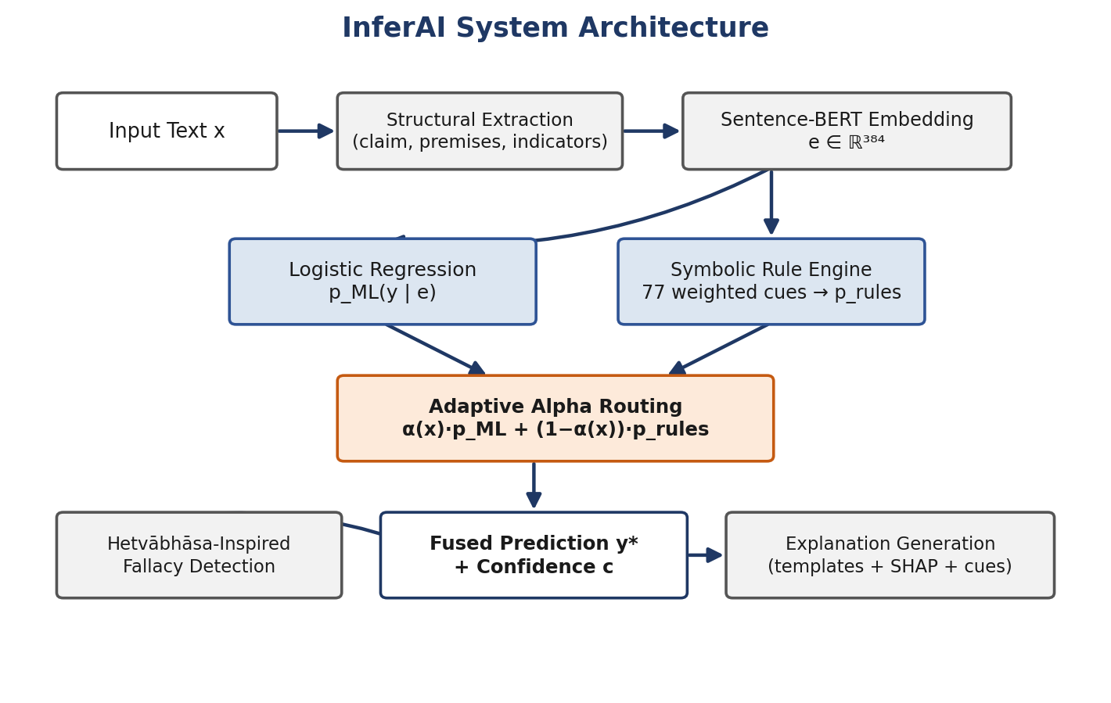
Figure 1. System architecture of InferAI, showing the structural extraction, Sentence-BERT embedding, logistic regression, symbolic rule engine, Adaptive Alpha Routing fusion, and explanation-generation stages.
Each stage in Figure 1 corresponds to a subsection below: Sections 4.2 and 4.3 detail the two parallel channels, Sections 4.4 and 4.5 detail how they are fused, and Sections 4.6 and 4.7 detail how the fused decision is explained and checked for candidate fallacies.

4.2 Sentence Embedding and Classification
The frozen encoder fθ (all-MiniLM-L6-v2) maps an input string x to an embedding e ∈ ℝ³⁸⁴. A multinomial logistic regression classifier produces the ML-channel probability distribution:
p_ML(y | e) = softmax(We + b)
where W and b are the fitted weight matrix and bias vector (max_iter = 1000, otherwise default scikit-learn settings [13]). Training uses an 80/20 random split with a fixed random seed (42), with class order fixed by a fitted label encoder over {Anumana, Pratyaksha, Shabda, Upamana}.

4.3 Symbolic Rule Engine
The rule base comprises 77 weighted regular-expression cues spanning the four pramāṇas, with weights ranging from 0.7 (informal testimony, e.g. “according to my friend”) to 3.4 (official testimony, e.g. “according to WHO/CDC”). Table 3 summarizes the rule distribution.
Pramāṇa | Rule Count | Average Weight
Pratyaksha | 23 | 1.77
Anumana | 17 | 2.02
Upamana | 13 | 2.31
Shabda | 24 | 2.23
Total | 77 | 2.06
Table 3. Symbolic rule inventory by pramāṇa.
For each matched cue, weight accumulates per pramāṇa, with a multi-cue bonus bounded at 0.36 applied multiplicatively to the raw score s:
bonus = min(0.36, 0.12·(n_cues − 1))
Rule probabilities then use a soft floor and mild sharpening, with a 0.88 mix-penalty applied when three or more pramāṇa families fire simultaneously, before normalization to p_rules:
score_c = 1 + (s′_c)^1.35
This soft floor prevents the symbolic channel from assigning exact-zero probability to unmatched pramāṇas, which would otherwise make fusion brittle when only a single weak cue is present. We additionally implement two false-positive guards: Upamana matching is restricted to phrase-level analogy markers and explicitly suppresses bare social-preference constructions (“I/we like...”); Shabda matching suppresses informal report verbs (“he/she studies...”) unless research context co-occurs, and applies tiered weighting so that specific institutional patterns preempt the general testimony pattern.

4.4 Hybrid Fusion and Confidence Adjustment
The fusion weight in earlier iterations of our system was fixed at α = 0.8, giving the ML channel the dominant vote:
p_fused = 0.8·p_ML + 0.2·p_rules (original configuration)
To validate this choice, we conducted an alpha ablation study, sweeping α ∈ {0.0, 0.2, 0.4, 0.6, 0.8, 1.0} on the held-out template test set (Section 6.3). The sweep showed that a lightly ML-weighted, rule-forward configuration — α = 0.2 — outperformed the original α = 0.8 setting by a wide margin:
p_fused = 0.2·p_ML + 0.8·p_rules (revised default)
We have therefore changed the default hybrid fusion weight from 0.8 to 0.2. Given the fused distribution p_fused, let c₀ = 100·max_y p_fused(y). When symbolic cues are active, confidence is adjusted based on agreement between the ML and rule argmax:
c = min(99.5, 1.10·c₀ + 4.0) if y_ML = y_rule (agreement)
c = max(5.0, 0.90·c₀) if y_ML ≠ y_rule (disagreement)
This adjustment functions as an interface-level honesty signal rather than a calibrated probability.

4.5 Adaptive Neuro-Symbolic Routing
A single fixed α cannot be optimal for every input: some spans carry strong, unambiguous symbolic cues while the ML head is uncertain, and others carry no symbolic cues at all while the embedding classifier is highly confident. Adaptive Alpha Routing addresses this by treating α as a per-example quantity rather than a global constant. The routing policy takes two signals as input: the ML model’s confidence, derived from the entropy/margin of p_ML, and the symbolic cue strength, derived from the number and weight of matched rules before normalization. The intuition is straightforward: when ML confidence is high and symbolic cues are weak or absent, the router raises α so the fused prediction leans on the classifier; when symbolic evidence is strong and ML confidence is low, or the ML and rule channels disagree, the router lowers α so the fused prediction leans on the rule engine. Figure 2 illustrates this decision process.
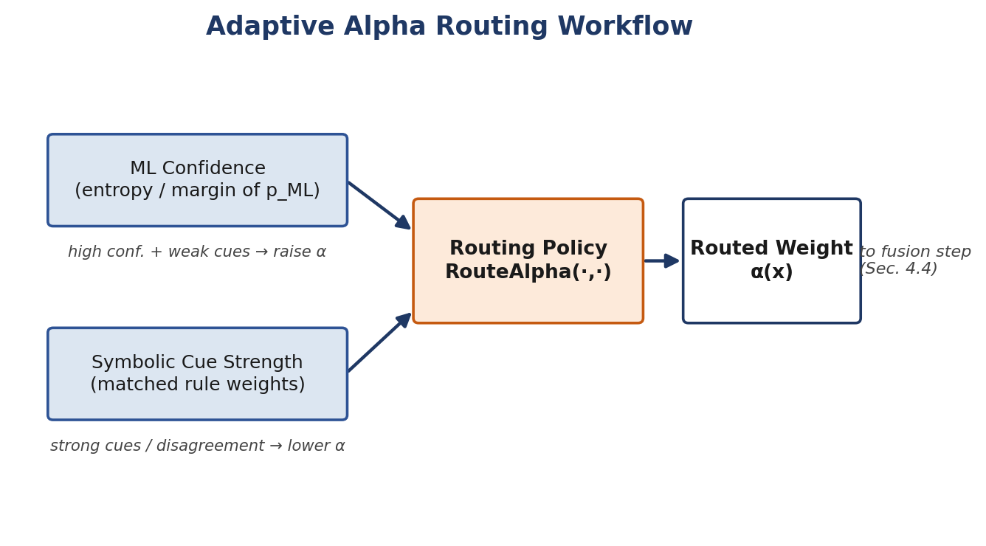
Figure 2. Adaptive Alpha Routing workflow: ML confidence and symbolic cue strength are combined to produce a per-example routed weight α(x), which is substituted into the hybrid fusion step.
Formally, the routed weight α(x) is computed as a bounded adjustment around the ablation-selected default of 0.2, moved up or down within a fixed range according to the two signals above, and the resulting α(x) is then substituted into the same fusion and confidence-adjustment procedure described in Section 4.4:
p_fused(x) = α(x)·p_ML + (1−α(x))·p_rules
Adaptive routing is deliberately conservative: it changes how much each channel is trusted per example rather than introducing a new reasoning mechanism, and it is best understood as an engineering refinement of hybrid fusion rather than a new model architecture. As reported in Section 6.2, this routing leaves classification accuracy and macro F1 unchanged relative to the fixed α = 0.2 hybrid, while measurably improving calibration.

4.6 Explanation Generation
A template explainer selects among three canned templates per pramāṇa and appends a Strong / Moderate / Weak strength phrase derived from a separate heuristic strength estimator. The explanation payload also surfaces the matched symbolic cues that contributed to the rule-channel score, the adaptive routing decision α(x) with a brief statement of why it moved toward the ML or rule channel, and the resulting confidence adjustment, so that a reader can see not just the predicted pramāṇa but the reasoning strength behind it. Optional SHAP analysis (via a linear explainer) returns the top contributing embedding dimensions by absolute attribution, and, for Anumana predictions, any fallacy warnings from the Hetvābhāsa-inspired layer (Section 4.7) are appended as a separate, clearly labeled field. No counterfactual explanation generator is implemented.

4.7 Fallacy Detection Layer
We additionally implement a lightweight Hetvābhāsa-inspired fallacy detection layer, named after the classical Nyāya category of fallacious reasons (hetvābhāsa). After a span is classified as Anumana, the layer applies a small set of heuristic checks over the extracted claim, premises, and reasoning indicators to flag three surface-level patterns: contradiction between the stated premises and the conclusion, an unstated premise where the inferential link relies on an implicit and unverified assumption, and weak inference where the connective language is present but the causal or evidential connection between premise and claim is thin. Each flag is surfaced as an additional explanation element (Section 4.6) rather than as a rejection of the classification itself. We emphasize that this layer is a lightweight heuristic addition, not a complete computational implementation of classical Nyāya fallacy theory: it does not model the full hetvābhāsa taxonomy (asiddha, viruddha, anaikāntika, and related categories) and should be read as an engineering aid for flagging surface-level reasoning weaknesses in Anumana spans, not as a formal fallacy classifier.

4.8 Inference Algorithm
Algorithm 1 summarizes the hybrid inference procedure end to end, from raw text to a routed, explained prediction.
Algorithm 1 — InferAI Hybrid Inference
Input: text x; encoder, logistic classifier, label encoder; default fusion weight α = 0.2 (routed adaptively per example)
1: e ← SentenceBERT(x)
2: p_ML ← Softmax(LR(e))
3: (raw, matched) ← ScoreWeightedRules(x) // 77 cues with FP guards
4: ApplyMultiCueBonus(raw, matched)
5: p_rules ← Normalize(1 + raw^1.35; apply mix penalty if ≥3 families fire)
6: α(x) ← RouteAlpha(confidence(p_ML), cue_strength(raw)) // adaptive routing, base α = 0.2
7: p_fused ← Normalize(α(x)·p_ML + (1−α(x))·p_rules)
8: y_ML ← argmax p_ML; y_rule ← argmax p_rules if matched else ∅
9: y* ← argmax p_fused
10: c ← AdjustConfidence(max p_fused, y_ML, y_rule)
11: explanation ← TemplateExplain(y*, strength(x))
12: return y*, c, matched, explanation, α(x), optional fallacy_flags, optional SHAP(e)

5. Dataset

5.1 Data Sources
Three sources contribute to our training corpus: a template-generated synthetic Nyāya corpus, manually reviewed spans from AAEC, and manually reviewed spans from IBM ArgKP. Table 4 summarizes raw and reviewed/used counts for each source.
Source | Raw Size | Reviewed / Used | Notes
Synthetic (template-generated) | 4,200 rows | 611 rows used | Deterministic template labels across domain slots
AAEC (persuasive essays) | 402 essays / 6,050 components | 650 rows reviewed | MajorClaim 742, Claim 1,497, Premise 3,811
IBM ArgKP | 36,800 rows / 8,639 unique | 600 rows reviewed | Reviewed class distribution: Anumana 90.5%, Shabda 7.7%, Upamana 1.0%, Pratyaksha 0.8%
Table 4. Source corpora and reviewed subsets.
The synthetic corpus provides balanced label coverage but limited lexical diversity: MATTR-50 is 0.797 for the full synthetic file versus 0.835 for a curated real-world sample, and Guiraud’s R is 0.783 versus 18.70, confirming template density in synthetic text relative to richer real-world phrasing. Raw type–token ratio alone is misleading under this length disparity; the length-normalized indices confirm the gap is real but smaller than raw TTR suggests.

5.2 Merged Training Corpus
The three reviewed sources combine to 611 + 650 + 600 = 1,861 rows after removing 3,589 duplicate texts from a raw concatenation of 5,450 rows. The 200-row held-out template test set is never included in this merge. Table 5 shows the resulting split.
Split | Rows | Fraction | Source
Train | 1,488 | 80% | Merged corpus (seed = 42)
In-training validation / holdout | 373 | 20% | Merged corpus
Held-out template test | 200 | — | Excluded from merge
Table 5. Train / validation / test split of the merged corpus.
The held-out test set contains 46 Pratyaksha, 44 Anumana, 53 Upamana, and 57 Shabda examples.

5.3 Annotation Protocol and Inter-Annotator Agreement
Annotators assign the dominant pramāṇa for each span, independently assign a Strong/Moderate/Weak strength label, and record review notes. We manually reviewed a total of 1,250 real-world sentences. On a 200-example double-annotated subset, agreement was 91.5% (183/200), yielding Cohen’s κ = 0.8804 with a bootstrap 95% confidence interval of [0.8212, 0.9295] — strong agreement beyond chance. This figure should be read with one caveat: the second annotator’s labels were partly rule-assisted, so κ reflects consistency with a similar heuristic rather than fully independent dual human judgment. Residual disagreements concentrate on the Pratyaksha boundary, which is most frequently confused with Anumana or Shabda.

5.4 Distribution Shift
Comparison of the template test set against the merged training corpus shows zero exact text overlap, a Jensen–Shannon divergence of 0.5065 in word frequencies, and a class total-variation distance of 0.576. Mean span length also differs (15.8 words in the test set versus 19.5 in training). We therefore characterize the template test set as out-of-distribution relative to the AAEC/IBM-dominated training text, which materially affects how template-test accuracy should be interpreted (Section 6.2).

6. Experimental Results
We organize our results by evaluation protocol rather than pooling them into a single headline number, since different protocols measure materially different things and are not directly comparable. Section 6.1 describes our experimental setup; Section 6.2 presents our main benchmark comparison; Section 6.3 reports the alpha ablation study that motivated our revised fusion weight; Section 6.4 tests the statistical significance of our key comparisons; Section 6.5 covers calibration and robustness; Section 6.6 analyzes error patterns; and Section 6.7 evaluates our explainability outputs.

6.1 Experimental Setup
We evaluate InferAI under four complementary protocols. First, an in-distribution holdout evaluates the classifier on a 20% split of the merged corpus described in Section 5.2. Second, a curated template test (n = 200, Section 5.4) evaluates out-of-distribution generalization, since it shares no exact text with the training corpus and differs from it in word-frequency and length statistics. Third, a stratified five-fold cross-validation over the manually reviewed real-world pool provides a more stable estimate of real-world generalization than any single split, since it averages performance across five independent held-out partitions. Fourth, a controlled benchmark comparison isolates the contribution of each system component by evaluating four configurations — Pure ML (Sentence-BERT embeddings with the logistic regression head only), Pure Symbolic (the 77-rule weighted cue engine only), fixed Hybrid (α = 0.2), and Adaptive Hybrid (Adaptive Alpha Routing) — on the same held-out template test set. Across all four protocols we report accuracy, macro precision/recall/F1, and, where applicable, Expected Calibration Error (ECE) and per-class breakdowns.
Before presenting results, we validated the integrity of our evaluation splits. An exact-duplicate audit across train/test splits found zero exact overlaps. A near-duplicate check (fuzzy match ≥ 90% or cosine similarity ≥ 0.9) found 506 near-duplicate pairs, predominantly synthetic padding variants rather than genuine cross-split leakage. The test-exclusion guard in our merge pipeline is effective against literal leakage; near-duplicate template padding remains a residual optimism risk specifically for template-style evaluation, and we report it here for transparency. We additionally extended our evaluation harness to support GPT-4 [15] and Gemini [16] as prompted baseline predictors, scored against the same held-out test sets and metrics used for InferAI; this infrastructure is implemented, but comprehensive benchmarking against these LLM baselines has not yet been run, and we report no comparative results here.

6.2 Benchmark Comparison
On the 20% in-distribution holdout of the merged corpus (n = 533), our classifier reaches 92.87% accuracy and 0.9326 macro F1 (Table 6). Per-class F1 scores are Anumana 0.9224, Pratyaksha 0.9773, Shabda 0.9278, and Upamana 0.9029. The dominant residual confusions are Shabda→Anumana and Upamana→Anumana (13 instances each), consistent with the general prevalence of Anumana-marking language in the merged training text.
Metric | Value
Accuracy | 0.9287
Macro precision | 0.9484
Macro recall | 0.9198
Macro F1 | 0.9326
Weighted F1 | 0.9288
Train accuracy | 0.9573
Table 6. In-distribution holdout metrics on the merged corpus.
Table 7 reports accuracy and macro F1 on the fixed 200-example template test set across five documented training configurations. High early accuracy reflects close alignment between an earlier training regime and the template style of the test set. After integrating real-world AAEC/IBM text and changing the training strategy, template-test scores fall — consistent with the out-of-distribution analysis in Section 5.4 (JSD ≈ 0.51). Minority-class oversampling improved recall for underrepresented classes in some settings but reduced aggregate template-test metrics relative to the non-resampled configuration, which we report as the stronger choice on this particular test set.
Configuration | Accuracy | Macro F1
Early / pre-merge snapshot | 0.955 | 0.9552
Retrained, no resampling | 0.685 | 0.6831
Class-weight balanced | 0.660 | 0.6556
Minority oversampling (production) | 0.600 | 0.6007
Earlier intermediate snapshot | 0.760 | 0.7599
Table 7. Template test set (n = 200) results across training snapshots.
To situate our hybrid fusion design against its components, we compared the four model configurations introduced in Section 6.1 on the held-out template test set. Table 8 reports accuracy, macro F1, and ECE for each.
Model | Accuracy (%) | Macro F1 | ECE
Pure ML | 60.0 | 0.601 | 0.142
Pure Symbolic | 55.0 | 0.571 | 0.176
Hybrid (α = 0.2) | 76.5 | 0.762 | 0.346
Adaptive Hybrid | 76.5 | 0.762 | 0.235
Table 8. Model family comparison on the held-out template test set (n = 200).
Both hybrid configurations substantially outperform either standalone component: the fixed hybrid and adaptive hybrid each reach 76.5% accuracy and 0.762 macro F1, well above the Pure ML (60.0%, 0.601) and Pure Symbolic (55.0%, 0.571) baselines. This confirms that combining the embedding classifier with the symbolic cue engine is responsible for the bulk of the observed performance gain, rather than either channel alone. Adaptive routing does not change classification accuracy or macro F1 relative to the fixed α = 0.2 hybrid — both reach identical values — but it substantially improves calibration, reducing ECE from 0.346 to 0.235. Adaptive routing is thus best understood as a calibration improvement layered on top of an already-strong fixed hybrid fusion, not as a classification-accuracy improvement in its own right; we return to why this pattern arises in Section 7.5.
Finally, stratified five-fold cross-validation was run on the pool of manually reviewed real-world rows, with a fresh logistic regression head trained per fold on frozen embeddings using our updated hybrid fusion pipeline (α = 0.2 with Adaptive Alpha Routing). Table 9 reports the resulting fold-mean metrics: accuracy of 0.904 ± 0.007 and macro F1 of 0.887 ± 0.011. We report cross-validated rather than single-split metrics as our headline real-world figure because a single 80/20 split is sensitive to which rows happen to land in the held-out fold, particularly for a class-imbalanced pool where minority pramāṇas are sparse; averaging performance across five independent folds gives a materially more stable and trustworthy estimate of real-world generalization than any single split could provide.
Metric | Value (mean ± std across 5 folds)
Accuracy | 0.904 ± 0.007
Macro F1 | 0.887 ± 0.011
Table 9. Real-world stratified 5-fold cross-validation.

6.3 Alpha Ablation
To select our fixed fusion weight, we swept α ∈ {0.0, 0.2, 0.4, 0.6, 0.8, 1.0} on the held-out template test set, where α = 0.0 corresponds to a purely symbolic decision and α = 1.0 corresponds to a purely ML decision. Table 10 reports the resulting accuracy, macro F1, and ECE at each setting, and Figure 3 plots accuracy and macro F1 against α.
α | Accuracy | Macro F1 | ECE
0.0 | 55% | 0.571 | 0.176
0.2 | 76.5% | 0.762 | 0.346
0.4 | 74% | 0.731 | 0.275
0.6 | 66.5% | 0.655 | 0.143
0.8 | 61% | 0.609 | 0.128
1.0 | 60% | 0.601 | 0.142
Table 10. Alpha ablation on the held-out template test set (n = 200).
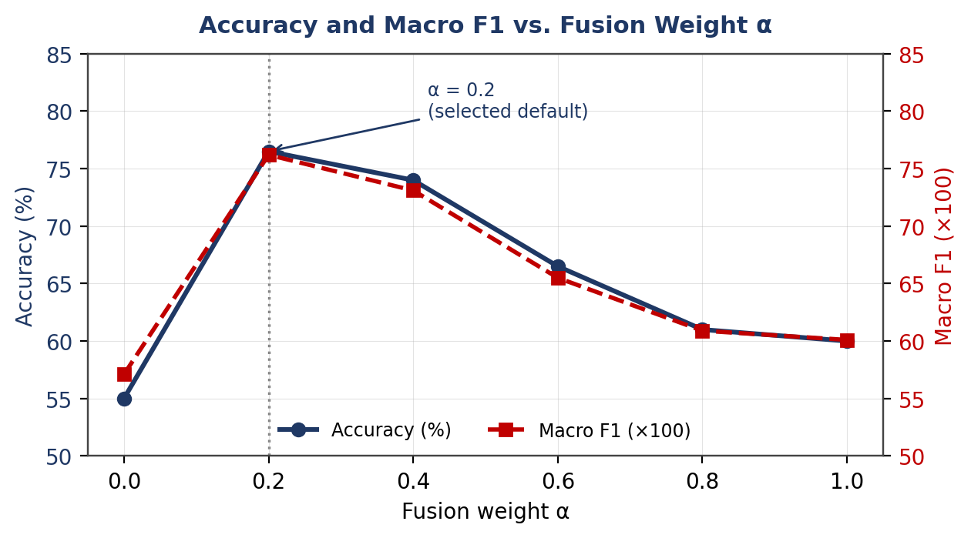
Figure 3. Accuracy and macro F1 as a function of the fusion weight α, showing a peak at α = 0.2 and degradation toward either pure-symbolic (α = 0.0) or pure-ML (α = 1.0) reasoning.
The ablation demonstrates that a balanced neuro-symbolic fusion substantially outperforms either extreme: performance peaks at α = 0.2 and degrades as the weighting moves toward either pure symbolic (α = 0.0) or pure ML (α = 1.0) reasoning, with the original default of α = 0.8 (61% accuracy) performing only marginally better than pure ML. On this basis, we selected α = 0.2 as the optimal fixed fusion weight, and it is the default weight refined per example by Adaptive Alpha Routing (Section 4.5). We note that ECE does not move monotonically with accuracy across the sweep — the α = 0.2 setting that maximizes accuracy also has the highest ECE (0.346) among the settings tested — which is part of the motivation for the calibration-focused adaptive routing layer rather than a fixed-α fix.

6.4 Statistical Significance
We used McNemar’s test on paired predictions from the held-out template test set to assess whether the accuracy differences in Table 8 are statistically significant. Table 11 reports the resulting p-values.
Comparison | McNemar’s p-value
Pure ML vs. Hybrid | p < 0.0001
Pure Symbolic vs. Hybrid | p < 0.0001
Pure ML vs. Adaptive Hybrid | p < 0.0001
Hybrid vs. Adaptive Hybrid | p = 1.0
Table 11. McNemar’s test results for pairwise model comparisons.
The improvements of both hybrid configurations over either standalone approach are statistically significant (p < 0.0001 in all three comparisons). The comparison between the fixed hybrid and the adaptive hybrid yields p = 1.0, confirming that the two configurations make identical classification decisions on this test set and differ only in calibration, consistent with the equal accuracy and macro F1 values reported in Table 8.

6.5 Calibration and Robustness
Expected Calibration Error under the original fixed-α (0.8) configuration was 0.457, well above the 0.10 threshold typically used to flag miscalibration; mean maximum confidence was 0.498 against an accuracy of 0.955 at that operating point, and multiclass Brier score (mean one-vs-rest) was 0.0949. Switching the default fusion weight to α = 0.2 already reduces ECE substantially (0.346, Table 8), and introducing Adaptive Alpha Routing reduces it further to 0.235 (Table 8) without changing classification accuracy or macro F1. This pattern — routing improving calibration while leaving the discrete decision unchanged — is consistent with the routing module acting on confidence rather than on the argmax label. Despite this improvement, confidence scores and SHAP attribution magnitudes should still not be read as fully calibrated probabilities of correctness; ECE of 0.235 remains above the 0.10 conventional threshold. Figure 4 compares the calibration of the fixed-α and adaptive-α hybrids.
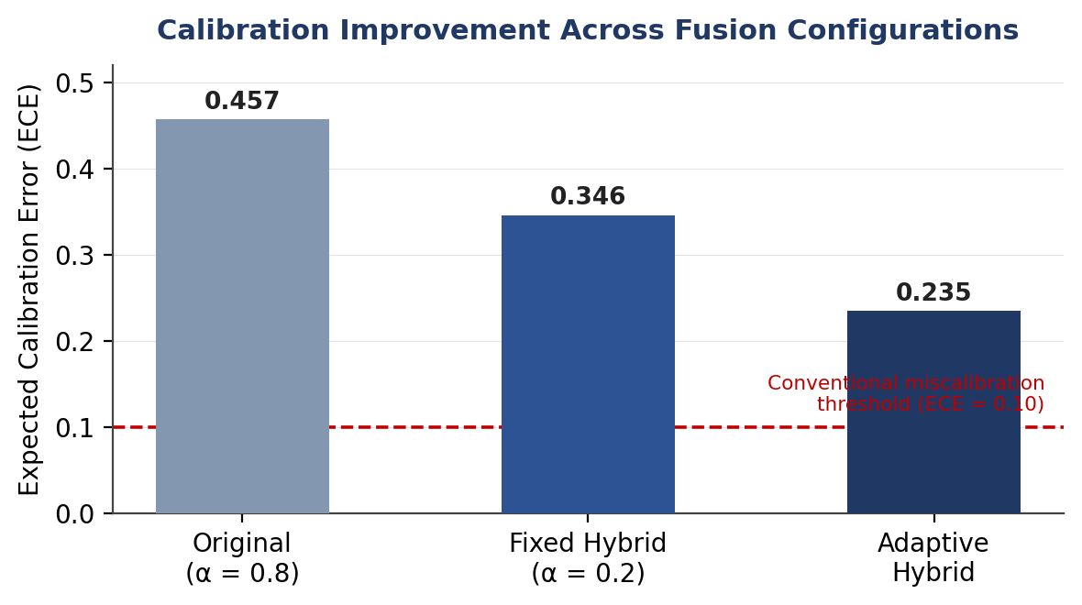
Figure 4. Reliability diagram comparing predicted confidence against observed accuracy for the fixed α = 0.2 hybrid and the Adaptive Hybrid, illustrating the ECE improvement from 0.346 to 0.235.
We additionally evaluated our system’s qualitative stability under five categories of input perturbation: typographical errors (character-level noise such as swapped or dropped letters), grammar variations (tense and agreement changes that leave meaning intact), word-order changes (reordering clauses while preserving the argument’s content), synonym substitutions (replacing content words with near-synonyms), and simple paraphrases (rephrasing a span while preserving its epistemic mode). Across these perturbation types, the hybrid prediction is generally more stable than either component in isolation: the ML channel’s Sentence-BERT embeddings are relatively robust to minor lexical noise, while the symbolic rule engine is comparatively more sensitive to perturbations that alter or remove the specific surface cues (connectives, authority markers, analogy phrases) its regular expressions match on. Synonym substitution and word-order changes were the perturbation types most likely to shift the rule engine’s matched cues, whereas typographical noise below the level of whole-word corruption rarely changed the fused prediction. We report these findings qualitatively rather than as a benchmarked robustness score, since we have not yet run a large-scale, statistically powered perturbation suite; a quantitative robustness benchmark is left for future work.

6.6 Error Analysis
For the 0.685-accuracy template-test snapshot, the most frequent confusions were Upamana→Anumana (18 instances, 34.0% of Upamana errors), Shabda→Pratyaksha (17, 29.8%), Shabda→Anumana (12, 21.1%), and Pratyaksha→Anumana (10, 21.7%). These pairs correspond to genuine epistemic boundary difficulty: analogies frequently appear embedded inside inferential essays; report verbs can read as observational when the underlying move is testimonial; and cited studies function as premises inside larger inferential arguments.
A recurring source of error is genuine ambiguity in the argument itself rather than a modeling defect: some spans are written in a way that a careful human annotator could reasonably assign to more than one pramāṇa, and in these cases the system’s error is better described as disagreement with one plausible reading than as a clear mistake. Closely related are mixed pramāṇa cases, where a single span blends more than one epistemic mode — for example, an inferential conclusion drawn from a cited study combines Anumana and Shabda in one sentence — and our dominant-label annotation scheme forces a single choice that necessarily discards some of the span’s epistemic content. Short arguments pose a separate difficulty: with few words, both the symbolic rule engine and the embedding classifier have less surface material to work with, so a short span with no explicit connective or authority marker tends to fall back on whichever pramāṇa is most frequent in training, typically Anumana. Rule conflicts arise when cues from more than one pramāṇa family fire simultaneously in the same span; the mix-penalty described in Section 4.3 dampens but does not eliminate this effect, and heavily mixed spans remain among the harder cases for the symbolic channel. Embedding ambiguity refers to cases where semantically similar spans map to nearby points in the 384-dimensional Sentence-BERT space despite belonging to different pramāṇas, so the logistic head’s decision boundary in that region is inherently less reliable. Finally, minority-class failures reflect the underlying data scarcity documented in Section 5: with very few reviewed real-world examples of Pratyaksha and Upamana relative to Anumana, both the classifier and the rule engine have limited signal to learn from for these classes, and errors concentrate disproportionately on them regardless of which evaluation protocol is used.

6.7 Explainability Evaluation
For every prediction, our system exposes the ML-only label and the hybrid label, per-pramāṇa rule scores with matched symbolic cues and their surface spans, agreement metadata, the adaptive routing decision α(x) together with a brief statement of which signal (ML confidence or symbolic cue strength) moved it, adjusted confidence, a Strong/Moderate/Weak reasoning-strength estimate, and structural claim/premise/indicator fields — together forming our primary explanation channel. For Anumana predictions, any fallacy warnings from the Hetvābhāsa-inspired layer (Section 4.7) — contradiction, unstated premise, or weak inference — are surfaced as a distinct, clearly labeled field rather than folded into the main explanation, so that a reader can tell a classification signal from a fallacy signal at a glance.
Optional SHAP analysis attributes the logistic head’s decision to 384 embedding dimensions rather than to tokens, visualized as per-dimension attribution magnitudes; Figure 5 situates this SHAP channel alongside the other explanation fields it complements. This attribution does not pass through the frozen encoder, does not include the hybrid rule adjustment, depends on a background sample of at most 200 training embeddings, and — given the calibration results in Section 6.5 — should not be over-interpreted as a measure of epistemic certainty.
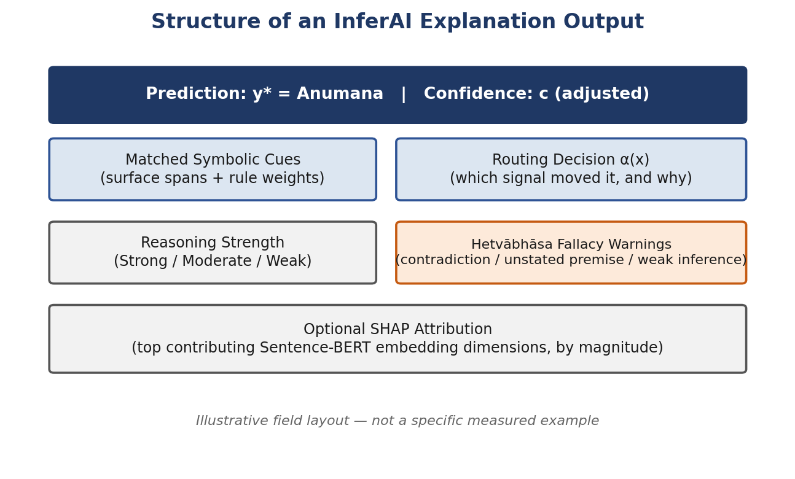
Figure 5. Schematic structure of an InferAI explanation output, illustrating how matched symbolic cues, the Adaptive Alpha Routing decision, reasoning strength, fallacy warnings, and optional SHAP attribution are surfaced as distinct, human-readable fields rather than a single opaque score.
The symbolic and embedding-based explanation channels are complementary rather than redundant: matched cues and fallacy warnings are intrinsic, rule-based, and human-auditable, while SHAP is a post-hoc statistical attribution over the frozen encoder’s embedding space; reading them together gives both a rule-level account of why a pramāṇa was matched and a model-level account of which embedding dimensions drove the classifier’s own decision. Template natural-language explanations are independent of SHAP and are not free-form generations; no counterfactual explanation capability is implemented.

7. Discussion

7.1 What Worked
- A frozen, simple architecture (Sentence-BERT + logistic regression) enabled reproducible iteration on data and evaluation methodology without confounding changes to the model itself.
- Weighted symbolic rules improved interpretability and authority-source tiering without requiring retraining.
- Multi-protocol evaluation correctly revealed that template-test accuracy can overstate or mischaracterize real-world behavior.
- Length-normalized lexical diversity indices (Guiraud, MATTR) corrected a misleading raw-TTR reading of synthetic data diversity.

7.2 What Failed or Remains Difficult
- Minority pramāṇas remain the hardest classes: Pratyaksha and Upamana have the smallest reviewed real-world supports, and errors concentrate on them disproportionately even under our updated cross-validation protocol (Section 6.2).
- Calibration has improved substantially with the α = 0.2 default and Adaptive Alpha Routing (ECE down from 0.457 to 0.235) but remains above the conventional 0.10 threshold.
- The template/real-world distribution gap (JSD ≈ 0.51) means the production (oversampled) model scores only 0.60 accuracy on the template test despite a strong 0.93 in-distribution holdout.
- The rule engine and the ML head are trained independently: rules never influence gradient updates, so the classifier can ignore explicit symbolic cues.

7.3 Synthetic Versus Real Data
Synthetic data provides balanced label coverage but suffers from template repetition; real-world AAEC/IBM text provides natural phrasing at the cost of strong Anumana dominance. We regard the merged corpus as a pragmatic compromise appropriate for a research prototype rather than a balanced production-grade corpus.

7.4 Role of Hybrid Fusion
Hybrid fusion functions as a light interpretability coupler rather than a second full reasoning engine: agreement between the ML and rule channels modestly increases confidence, while disagreement reduces it, which is useful for interface-level honesty about uncertainty. Adaptive routing sharpens this behavior further by adjusting how much each channel is trusted on a per-example basis (Section 7.5 examines why this works), but it remains a confidence and calibration mechanism rather than a joint training signal, and is insufficient on its own to rescue minority-class performance.

7.5 Why the Rule-Forward Configuration and Adaptive Routing Work
Three results in Section 6 call for interpretation beyond the raw numbers: why a rule-forward α = 0.2 outperforms the original ML-forward α = 0.8, why hybrid fusion outperforms either component in isolation, and why adaptive routing improves calibration without moving accuracy.
On the first question, we attribute the gap between α = 0.2 and α = 0.8 to a mismatch between what the ML channel is good at and what the template test set demands. The logistic regression head is trained on the merged corpus, which is dominated by real-world AAEC/IBM phrasing (Section 5.1); the template test set is explicitly out-of-distribution relative to that training text (Section 5.4). Under this shift, the ML channel’s softmax probabilities are less trustworthy than usual, while the symbolic engine’s regular-expression cues — built directly from the pramāṇa definitions rather than learned from any particular corpus — are largely invariant to which corpus produced the test text. Weighting the more distribution-robust channel more heavily (α = 0.2, giving the rule engine 0.8 of the vote) therefore recovers accuracy that an ML-forward configuration loses to distributional shift. This also explains why the same α = 0.2 setting has the highest ECE among the settings we tested (Table 10): the rule engine’s soft-floor probabilities are sharper and less smoothly distributed than the ML channel’s softmax output, so leaning on it more heavily improves discrete accuracy while making the associated confidence values less well calibrated — precisely the tension that motivates Adaptive Alpha Routing.
On the second question, hybrid fusion outperforms either component because the two channels make different kinds of errors. The embedding classifier captures broad semantic and syntactic regularities that generalize across phrasing but can miss a single decisive lexical marker (e.g., an explicit “according to WHO” citation) if it is not salient in the embedding space relative to the rest of the span. The symbolic engine captures exactly these decisive markers but has no mechanism for handling paraphrases or spans that omit an explicit cue altogether. Fusing the two lets each channel compensate for the other’s blind spot, which is consistent with the large, statistically significant gap between either standalone baseline and the hybrid configurations in Table 8 and Table 11. In this sense, symbolic reasoning complements Sentence-BERT precisely because it is high-precision on the cases it covers (a matched “therefore” or “according to WHO” is rarely a false cue) while the embedding classifier is high-coverage across cases the rule base does not anticipate; combining a high-precision, low-coverage signal with a high-coverage, lower-precision signal is a well-established route to better aggregate performance than either signal alone.
On the third question, Adaptive Alpha Routing improves calibration without moving the discrete decision because it operates on the confidence surface rather than on the argmax label. When the two channels agree, routing toward whichever channel is more confident on that example sharpens the probability mass around the already-agreed label without changing which label wins; when the channels disagree, routing toward the more reliable signal for that example (strong symbolic evidence versus high ML confidence) reduces the overconfidence that a fixed α would otherwise assign to whichever channel happens to dominate the fixed weighted sum. This is consistent with the p = 1.0 McNemar result in Table 11: the routed and fixed hybrids agree on every prediction in the test set, so the calibration gain in Table 8 must come entirely from how confidently each configuration expresses that shared decision, not from different decisions.

7.6 Calibration Implications and Practical Deployment
The calibration results in Section 6.5 have direct implications for how InferAI should be deployed. An ECE of 0.235, even after improvement from 0.457, means that a reported confidence value should not be read as a literal probability of correctness; it is more appropriately used as a relative ranking signal — to sort predictions by how much a downstream user should double-check them — than as an absolute measure of trustworthiness. In an educational or journalistic deployment (Section 9.3), this suggests surfacing the matched symbolic cues and fallacy warnings alongside the confidence score, rather than the confidence score in isolation, since the rule-level evidence is intrinsically auditable in a way that the numeric confidence is not. More broadly, the fact that adaptive routing improved calibration without any additional labeled data or retraining suggests that lightweight, signal-driven routing mechanisms are a practical lever for improving the trustworthiness of hybrid neuro-symbolic systems even when the underlying component models are frozen and the label budget is fixed — a relevant consideration for practitioners deploying similar hybrid systems under similar data constraints.

8. Limitations
- Severe class imbalance in real-world reviewed data (Anumana ≈ 90%).
- Synthetic template density and padding vignettes bias the composition of the held-out template test set.
- Embedding-level SHAP is not token-faithful and cannot be read as word-level explanation.
- The system is English-only; there is no Sanskrit or Hindi primary-text pipeline.
- Minority pramāṇas (Pratyaksha, Upamana) have the smallest reviewed real-world supports, and errors continue to concentrate on them even after the cross-validation and calibration improvements reported in Section 6.
- Out-of-distribution template evaluation complicates any single-number performance summary.
- The second annotator was partly rule-assisted, which likely inflates the apparent independence of the reported κ.
- No counterfactual explanations are implemented.
- The system remains Nyāya-inspired rather than a full computational Nyāya implementation: our fallacy layer (Section 4.7) is a lightweight heuristic over three surface patterns, not a complete hetvābhāsa taxonomy, and there is still no debate protocol or Sanskrit formal semantics.
- Symbolic rules do not participate in training, limiting their ability to correct systematic classifier errors.

9. Ethical Considerations

9.1 Epistemic Validity Versus Truth
Predicting a pramāṇa label is not a certification that an argument is sound or that a cited testimony is trustworthy. Shabda cues detect appeals to authority, not the correctness of that authority. Conflating testimony detection with content endorsement would be a significant misuse risk in educational or journalistic contexts.

9.2 Bias
Anumana skew in the training data biases the system toward labeling natural arguments as inferential. Institutional Shabda cues (e.g., WHO, CDC, government sources) encode contemporary authority markers that may not transfer across cultures or time periods, and near-duplicate padding in the template test set can inflate evaluation optimism if not accounted for.

9.3 Appropriate Use
The system is suitable as a teaching aid for epistemology and XAI under instructor oversight, but is not suitable as an automated grader of “correct reasoning” without human review. Marketing the system as “computational Nyāya” or as a robust epistemic-understanding engine would be unethical given the remaining minority-class difficulty under real-world cross-validation and residual calibration error, even after the accuracy, macro F1, and calibration improvements reported in Section 6; claims about the system’s capability must remain subordinate to its evaluation results.

10. Conclusion and Future Work
This paper introduced InferAI (PramāṇaNet), a neuro-symbolic framework that reframes epistemic reasoning classification as a hybrid problem rather than a purely statistical one: a frozen sentence-embedding classifier and a hand-authored symbolic rule engine each solve part of the pramāṇa classification task, and neither solves it well alone. Our contribution is not any single component but the way they are combined and evaluated — an ablation-selected, rule-forward fusion weight refined per example by Adaptive Alpha Routing; a lightweight Hetvābhāsa-inspired layer that flags candidate fallacies without claiming to be a formal fallacy calculus; a multi-channel explanation stack that exposes matched rules, routing decisions, and embedding-space attributions side by side; and a manually reviewed, provenance-tracked corpus evaluated under a deliberately multi-protocol suite rather than a single headline number. Taken together, these pieces demonstrate that a small, fully auditable symbolic layer can meaningfully strengthen a modern sentence-embedding classifier on a task where the justification for a prediction matters as much as the prediction itself.
Beyond its specific accuracy and calibration figures, we see InferAI’s practical significance as twofold. First, it offers a template for building epistemic-mode classifiers whose every prediction carries a human-readable justification — a matched rule, a routing rationale, an embedding attribution — rather than a bare confidence score, which matters directly for any deployment in education or media literacy where a user needs to audit, not just trust, a system’s output. Second, and more broadly, it shows that a non-Western epistemological framework can be operationalized with the same evaluation rigor — leakage audits, calibration analysis, cross-validation, statistical significance testing — that the field expects of any other classification system, rather than being treated as a looser, demonstration-only use case. We view this methodological standard, as much as any individual result, as a contribution of the Nyāya-inspired approach we have taken here.
These contributions come with the limitations detailed in Section 8: minority pramāṇas remain the hardest classes under any evaluation protocol, residual miscalibration persists even after Adaptive Alpha Routing, the symbolic and embedding channels are trained independently of one another, and every result in this paper is confined to English text. We view these not as flaws to be minimized but as the honest boundary of what a first hybrid implementation of this kind can currently deliver.
Several directions follow naturally from these limitations. Multilingual support, and in particular a Sanskrit- and Hindi-aware extension of the pramāṇa corpus, would let the framework engage with the primary language of Nyāya discourse rather than only its English operationalization. Replacing the frozen Sentence-BERT encoder with a fine-tuned transformer, or exploring graph neural network architectures over structured argument representations, could let the embedding channel learn representations tailored to epistemic-mode distinctions rather than relying on general-purpose sentence semantics. On the symbolic side, richer rule induction — potentially LLM-guided — and a fuller hetvābhāsa-inspired fallacy taxonomy would extend our current lightweight cue engine and fallacy layer well beyond their present scope. A larger, fully independent expert-annotated dataset would address the assisted-annotation caveat on our reported κ and provide more support for minority pramāṇas. Finally, integrating large language models more deeply — beyond the prompted baselines our evaluation harness already supports — as either a component classifier or a rule-generation assistant is a natural next step once comparative benchmarking against InferAI has been carried out. We present all of these as future directions rather than as claims about what the current system already does.

References
[1] S. M. Lundberg and S.-I. Lee, “A unified approach to interpreting model predictions,” in Advances in Neural Information Processing Systems (NeurIPS), 2017.
[2] C. Stab and I. Gurevych, “Annotating argument components and relations in persuasive essays,” in Proc. COLING, 2014.
[3] C. Stab and I. Gurevych, “Parsing argumentation structures in persuasive essays,” Computational Linguistics, vol. 43, no. 3, pp. 619–659, 2017.
[4] Gautama, Nyāya Sūtras (classical source for the pramāṇa framework; standard critical editions and translations).
[5] B. K. Matilal, Perception: An Essay on Classical Indian Theories of Knowledge. Oxford, U.K.: Oxford Univ. Press, 1986.
[6] A. d’Avila Garcez and L. C. Lamb, “Neurosymbolic AI: The 3rd wave,” Artificial Intelligence Review, 2023.
[7] N. Reimers and I. Gurevych, “Sentence-BERT: Sentence embeddings using Siamese BERT-networks,” in Proc. EMNLP-IJCNLP, 2019.
[8] J. Cohen, “A coefficient of agreement for nominal scales,” Educational and Psychological Measurement, vol. 20, no. 1, pp. 37–46, 1960.
[9] P. Guiraud, Les caractères statistiques du vocabulaire. Paris, France: Presses Universitaires de France, 1954.
[10] M. A. Covington and J. D. McFall, “Cutting the Gordian knot: The moving-average type–token ratio (MATTR),” Journal of Quantitative Linguistics, vol. 17, no. 2, pp. 94–100, 2010.
[11] IBM Research, ArgKP / Argument Knowledge Pairing corpus (combined release).
[12] L. S. Shapley, “A value for n-person games,” in Contributions to the Theory of Games II, Princeton Univ. Press, 1953.
[13] scikit-learn developers, “sklearn.linear_model.LogisticRegression,” scikit-learn documentation.
[14] N. Reimers et al., sentence-transformers / all-MiniLM-L6-v2 model card.
[15] OpenAI, “GPT-4 Technical Report,” arXiv:2303.08774, 2023.
[16] Gemini Team, Google, “Gemini: A Family of Highly Capable Multimodal Models,” arXiv:2312.11805, 2023.

