Campus Placement and Internship Pipeline
Lab 3 | Architecture justification
Name: Ayush Ravindra Paithankar
SRN: PES1UG24CS104

Architecture selection
We chose Layered Architecture for the Campus Placement & Internship Pipeline System. The presentation layer contains the Placement Portal, the application layer contains the Pipeline Manager, and the infrastructure layer contains the Placement Repository, Interview Scheduler and Notification Service. Students apply for placement or internship opportunities, while authorized placement staff manage eligibility, interview rounds and offers.

Architectural style analysis
Layered architecture separates the portal, workflow rules and integrations, making a campus application straightforward to maintain. Its tradeoffs include calls across layers and limited independent scaling within one deployment. Microservices support independent scaling and releases, but introduce distributed consistency, network failure and operational complexity. Client-server architecture supports shared access and centralized records, but a single server can become a bottleneck or failure point. It can coexist with the chosen layered design: browsers access an application server organized into layers.

Two scenario specific reasons
1. Consistent placement rules. The Pipeline Manager checks eligibility and controls application transitions from applied to shortlisted, interview and offered, with rejection or withdrawal where allowed. Centralizing these rules ensures that portal actions follow the same process for both placements and internships. Opportunity-specific criteria can change without redesigning the portal.
2. Maintainable component boundaries. The Placement Repository hides storage details, the Interview Scheduler handles slots and conflicts, and the Notification Service handles updates and reminders. Defined interfaces allow a calendar or email provider to be replaced without rewriting application eligibility or offer workflows.

Security advantage
The application layer enforces authenticated roles and record ownership before accessing data: students can view their own applications, while authorized staff can update recruitment stages. The portal cannot query the repository directly. This limits exposure of student profiles and offer details. Access checks, encrypted connections and audit records must be implemented; layering alone does not secure the system.

Performance benefit
The repository can use indexed queries and pagination for opportunity lists and application tracking. Internal component calls avoid the network overhead of separate microservices. Calendar synchronization and email delivery can run asynchronously after application changes are saved, keeping the portal responsive during recruitment deadlines. Failed deliveries can be retried without repeating the application update.

Pipeline Component Diagram
Five internal components connect through four internal interfaces. Calendar and email providers are external systems.
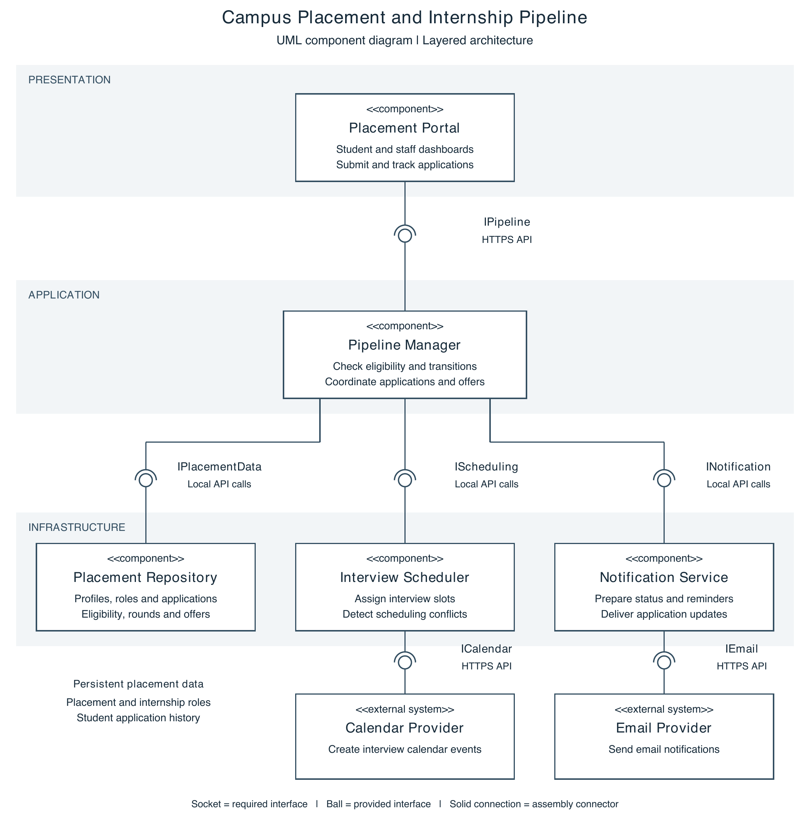

Interaction and data flow
1. Placement Portal calls IPipeline to browse roles, apply or view status. Pipeline Manager uses IPlacementData to read profiles and criteria, check eligibility and save valid applications.
2. Authorized staff request an interview through IPipeline. Pipeline Manager calls IScheduling with the candidate, panel and time. Interview Scheduler checks conflicts and uses ICalendar to create the event; confirmed details are saved through IPlacementData.
3. Pipeline Manager saves authorized shortlist, rejection or offer updates, then calls INotification with the recipient and event details. Notification Service uses IEmail to send the message and returns delivery status.
Responses return through the same interfaces. Scheduling conflicts return an error for rescheduling. Calendar or email failures remain pending for retry; they do not undo saved applications or create duplicate submissions.

