Lab 4 Vibe Coding Submission
  - Climber Game Repair and Feature Implementation
Name Ayush Paithankar
SRN PES1UG24CS104
Assigned project 37_climber | Date 7 October 2026
This submission contains the repaired Pygame Climber game and all three requested features. The work is available in the Lab-4 folder of my personal GitHub repository, with separate commits for each task, before and after gameplay videos, and the AI chat record.

Objective
Use an AI coding assistant to identify and fix the height-score bug, implement the feature hooks in the assigned repository, and verify the resulting gameplay.

Completed tasks

1 Preserve the highest height
The HUD now retains the greatest height reached during the current run. Game.update uses max(self.height, current_height), so descending or losing a life does not reduce the recorded peak. Starting a new run resets it to zero.

2 Add platform colors
platform_color(index, total) returns an RGB gradient from green at ground level to violet at the top. The interpolation is clamped and handles a zero or small total without dividing by zero.

3 Add moving platforms
Every third non-ground platform oscillates horizontally at 1 to 3 pixels per frame, with faster movement higher in the level. The ground remains static. Boundary movement returns the actual displacement so a standing player is carried accurately.

4 Add coin pickup feedback
Collecting a coin adds 50 points, removes the coin, and creates 12 sparkles with a score popup. The effect lasts 45 frames and is retained separately from the removed coin. Restarting clears all effects.

Verification and gameplay evidence
All 16 regression checks passed. They cover height retention, reset, scoring, camera movement, platform colors, moving-platform bounds and carrying, coin effects, collision direction, falling, lives, and reaching the top.
Measurement | Before | After
Video duration | 10.0 seconds | 10.0 seconds
Frames at 60 FPS | 600 | 600
Frames where height decreases | 131 | 0
Highest height observed | 83 m | 83 m
Coins collected | 1 | 1
Frames with pickup effects | 0 | 45

Both videos show actual game-rendered frames with repeatable keyboard inputs and random seed 37. They are labeled as automated gameplay demonstrations. The before clip uses the untouched source code; the after clip uses the repaired version.
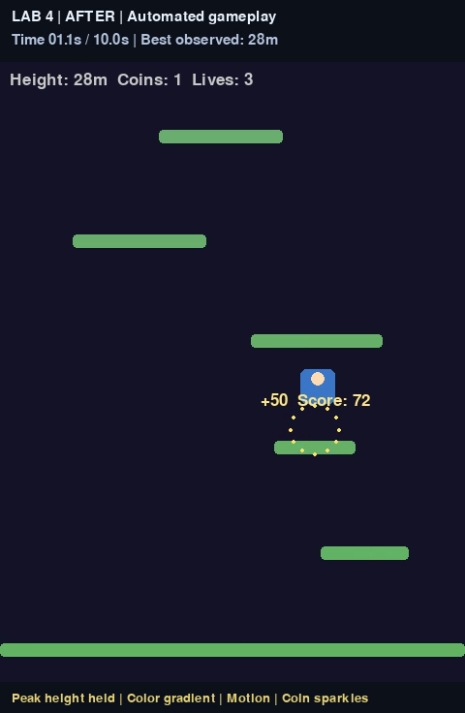
After gameplay showing the coin pickup effect

Submission links
Submission repository
https://github.com/Ayushpaithankar/SE_lab_1/tree/main/Lab-4
Updated game code
Before gameplay video
After gameplay video
Chat history PDF
Shared AI chat
Verification report and test results
Assigned source repository

Separate task commits
Task | GitHub commit
1 Preserve peak height | 9e038e0
2 Add platform colors | d2a63e8
3 Add moving platforms | ec87e3c
4 Add coin effects | 54072f8
View the Lab 4 commit history

Run the game
Use Python 3.10 or newer. Open the Lab-4 folder, install the dependency, and start the game:
python -m pip install -r requirements.txt
python game.py
Controls: A or Left and D or Right move; Space, W, or Up jumps; R starts a new run.
Run the regression checks with:
python -m unittest discover -s tests -v

AI assistance
Codex assisted with code changes, automated checks, recordings, and GitHub uploads. The repository includes the chat export and assistant-written task briefs, with the recording method documented in the README.

