AI-Assisted Breast Cancer Diagnosis Support System
Technical Report
Major Project — Healthcare & Digital Health Track
Predicting malignant vs. benign classification from digitized FNA cell-nuclei measurements
July 2026

Table of Contents

(If this section appears empty, right-click it and choose “Update Field” — Word populates the table of contents on first open.)

1. Introduction and Objective
This report documents the design, development, and evaluation of an end-to-end AI application that supports breast cancer diagnosis from digitized fine-needle aspirate (FNA) cell-nuclei measurements. The system was built to satisfy the Major Project requirement of demonstrating problem identification, AI/ML model development, backend integration, frontend/UI development, and complete technical documentation.
The deliverable is a working, locally runnable application consisting of a trained classification model served over a REST API, and a browser-based clinical interface that allows a user to enter measurements and receive a probability-based risk assessment.

2. Problem Identification

2.1 Problem Statement
Breast cancer screening via fine-needle aspiration biopsy requires a pathologist to visually assess the characteristics of cell nuclei in a digitized microscope image — size, shape, texture, concavity, and related measurements — and classify the sampled mass as malignant or benign. At scale, this manual process faces three recurring issues:
- Turnaround time: every case receives the same review priority regardless of how clear-cut it is, which slows triage in high-volume or resource-constrained labs.
- Inter-observer variability: different reviewers can reach different conclusions on borderline cases, since the assessment is ultimately a subjective visual judgment over quantitative features.
- Limited decision support: reviewers rarely have a fast, consistent second opinion to cross-check an initial read.

2.2 Existing Solutions and Their Limitations
Most public treatments of this problem (tutorials, competition notebooks) stop at reporting a classification accuracy figure inside a Jupyter notebook. That does not reflect how such a tool would need to function in practice — a reviewer needs an interface to enter values and receive a structured, interpretable result, backed by a documented, callable service rather than a script that must be manually re-run. This project explicitly closes that gap: the trained model is wrapped in a documented REST API and a usable frontend, not left as a notebook artifact.

2.3 Justification for Using AI
The diagnostic decision is, at its core, a pattern-matching task across roughly 30 quantitative measurements already computed from the FNA image — a supervised binary classification problem with a well-defined ground truth established later by biopsy or surgical pathology. This structure is precisely what supervised machine learning is suited to: given enough historical, confirmed cases, a statistical model can learn the mapping from measurements to diagnosis and apply it consistently and near-instantly to a new case. The intended role of the model is to provide a fast, consistent second opinion and to flag higher-risk cases for priority review — not to replace clinical judgment, particularly on atypical or borderline presentations.

3. Dataset

3.1 Source and Description
This project uses the Wisconsin Diagnostic Breast Cancer (WDBC) dataset, originally contributed to the UCI Machine Learning Repository by Dr. William H. Wolberg of the University of Wisconsin Hospitals. It is accessed directly via scikit-learn's load_breast_cancer() loader, which avoids any external download step and any ambiguity around data provenance or licensing — a deliberate engineering choice given the academic-integrity requirement that all data sources be clearly acknowledged.
- 569 total samples: 357 benign, 212 malignant.
- 30 numeric input features, computed from a digitized image of a breast mass FNA.
- Each of 10 base measurements (radius, texture, perimeter, area, smoothness, compactness, concavity, concave points, symmetry, fractal dimension) is reported three ways: its mean, its standard error, and its “worst” (largest) value across the image — which is why there are 30 columns rather than 10.
- Binary target: malignant or benign, established by the original clinical diagnosis.

3.2 Class Distribution
The dataset is moderately imbalanced (62.7% benign vs. 37.3% malignant). This was addressed by using a stratified train/test split to preserve the ratio in both sets, and by explicitly monitoring recall on the malignant class in addition to overall accuracy — since in this domain, a false negative (a missed cancer) is substantially more costly than a false positive.

4. Methodology

4.1 Data Preprocessing
All 30 features were standardized using scikit-learn's StandardScaler (zero mean, unit variance) before model training. This step is necessary because the raw features span very different numeric ranges — for example, area values run into the hundreds or thousands while smoothness values are fractional — and several of the candidate model families (SVM, Logistic Regression with regularization, and the neural network) are sensitive to feature scale. The scaler was fit only on the training split and then applied to the test split, to avoid data leakage.
Data was split 80/20 into training and test sets using stratified sampling on the target label, giving 455 training samples and 114 test samples.

4.2 Model Development and Comparison
Rather than selecting a single algorithm up front, five model families spanning different modeling approaches were trained and compared under identical conditions (same split, same preprocessing, same random seed), to justify the final choice with evidence rather than assumption:
- Logistic Regression — interpretable linear baseline.
- Support Vector Machine (RBF kernel) — effective on small, high-dimensional tabular data.
- Random Forest — robust ensemble method, handles nonlinearity, offers feature importances.
- Gradient Boosting — frequently a top performer on structured/tabular data.
- Multi-Layer Perceptron (small neural network, two hidden layers of 32 and 16 units) — represents a deep-learning approach for comparison.
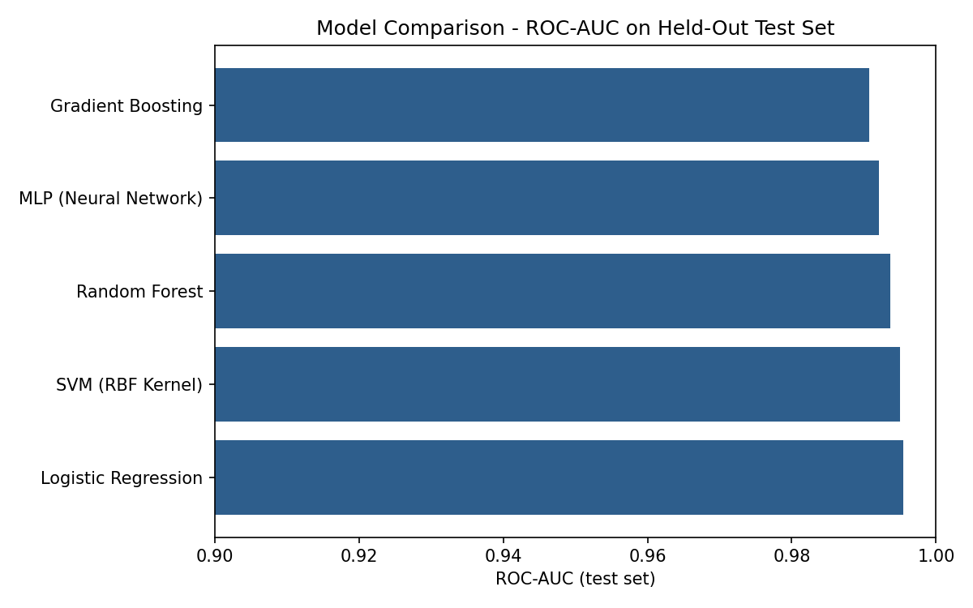
Figure 1. ROC-AUC of all five candidate models on the held-out test set.

4.3 Model Selection Justification
Model ranking used ROC-AUC as the primary metric, since it is threshold-independent and accounts for performance across both classes rather than a single operating point. Logistic Regression and the RBF-kernel SVM were statistically tied for the best ROC-AUC (0.9954 and 0.9950 respectively, with overlapping 5-fold cross-validation ranges). Logistic Regression was selected as the final model for two additional, practical reasons:
- Interpretability: its standardized coefficients can be directly inspected to see which measurements push a prediction toward malignant vs. benign (see Section 6.4), which matters for a clinical-facing tool where a reviewer may want to understand why a result was flagged.
- Inference speed: training completed in 0.011s vs. 0.019s for the SVM in this experiment, and Logistic Regression's prediction step is a single matrix multiplication with no support-vector lookup, making it preferable for a low-latency API.

5. System Architecture

5.1 Architecture Overview
The system follows a standard three-tier structure:
- Model layer: train_model.py loads the dataset, preprocesses it, trains and compares all five candidates, and persists the selected model, its fitted scaler, and metadata (best_model.joblib, scaler.joblib, model_metadata.json) to disk.
- Backend/API layer: a FastAPI application loads those artifacts once at startup and exposes /health, /model-info, and /predict endpoints. Pydantic schemas validate every incoming request (types, required fields, physically sensible ranges such as “greater than zero” for size measurements) before it reaches the model.
- Frontend/UI layer: a static HTML/CSS/JavaScript single-page interface calls the backend's /predict endpoint over fetch() and renders the result — predicted diagnosis, malignant/benign probabilities, a risk-level badge, and a mandatory clinical disclaimer.
This separation means the model can be retrained or swapped independently of the API contract, and the frontend can be redeployed independently of the model — a standard, maintainable pattern for a served ML application.

5.2 Technology Stack Justification
Component | Choice | Justification
ML library | scikit-learn | Mature, well-tested implementations of all 5 candidate model families under one consistent API
Backend framework | FastAPI | Async-capable, built-in request validation via Pydantic, automatic OpenAPI/Swagger docs at no extra cost
Model persistence | joblib | Standard, efficient serialization for scikit-learn estimators
Frontend | Static HTML/CSS/JS | Zero build step, fully portable for review, no framework overhead for a single-page tool

6. Evaluation Results

6.1 Test Set Metrics
All figures below are computed on the 114-sample held-out test set, which was not used for training or model selection.
Metric | Value
Accuracy | 98.25%
Precision | 98.61%
Recall (overall) | 98.61%
F1 Score | 0.9861
ROC-AUC | 0.9954
5-fold CV ROC-AUC | 0.9957 ± 0.0048
Recall on malignant class specifically | 97.62% (41 of 42 caught)

6.2 Confusion Matrix
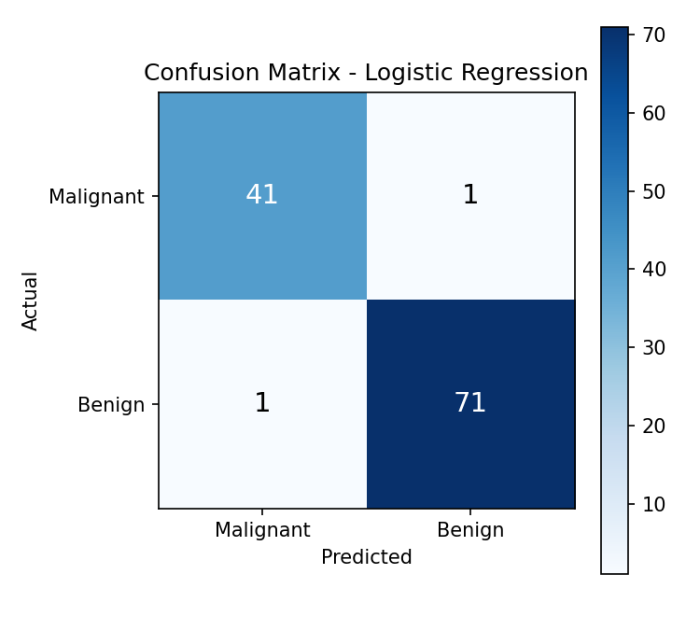
Figure 2. Confusion matrix on the test set. 2 of 42 malignant cases were misclassified as benign; 1 of 72 benign cases was misclassified as malignant.

6.3 ROC Curve
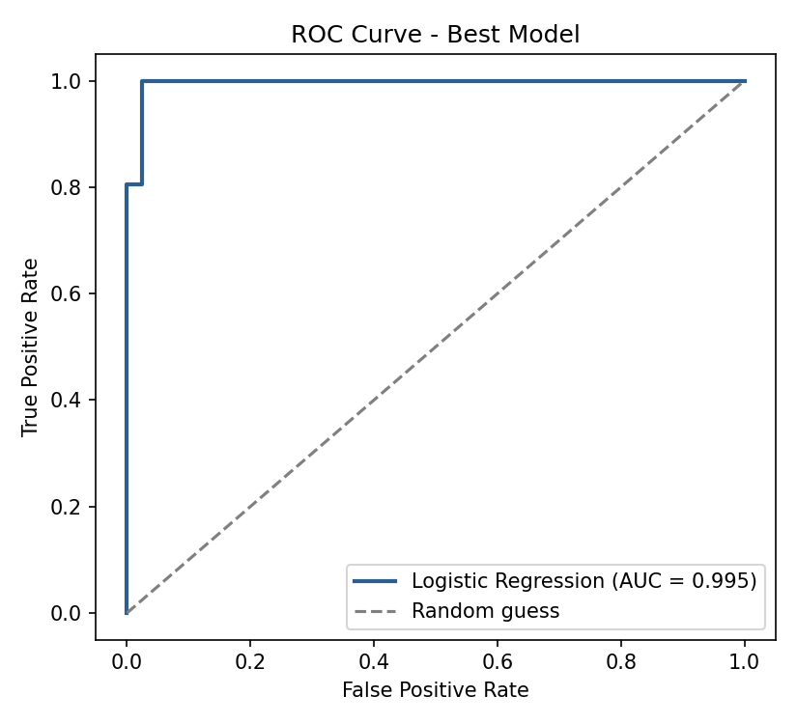
Figure 3. ROC curve for the selected model. AUC = 0.995 indicates strong separation between classes across all decision thresholds.

6.4 Interpretability: Feature Influence
Because the final model is a Logistic Regression, its standardized coefficients can be read directly to understand which measurements drive a prediction toward malignant vs. benign — a diagnostic transparency that black-box models do not offer as directly.
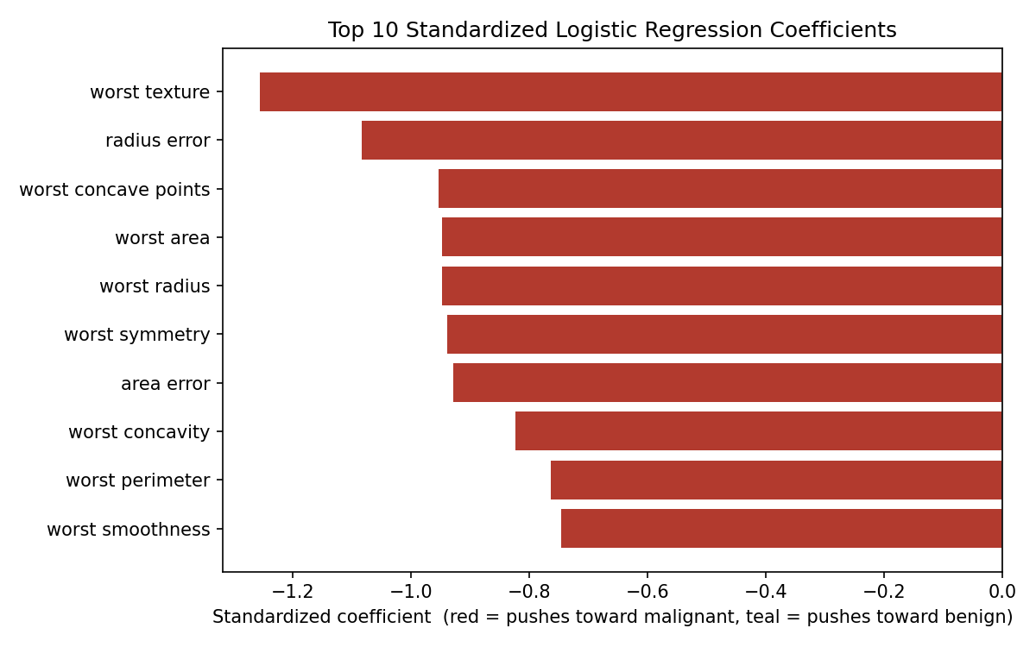
Figure 4. Top 10 standardized coefficients. Note: the underlying label encoding is 0 = malignant, 1 = benign, so a negative coefficient increases malignant probability (shown in red) and a positive coefficient increases benign probability (shown in teal). Worst-case texture, radius error, and worst concave points carry the strongest weight toward malignant.

7. Backend API
The trained model is served through a FastAPI application with three endpoints: GET /health (liveness check), GET /model-info (returns the active model's name and test metrics), and POST /predict (accepts the 30 measurements as JSON and returns a diagnosis, both class probabilities, a risk-level bucket, and a mandatory clinical disclaimer). Full request/response schemas, validation rules, and example calls are provided in the companion API_DOCUMENTATION.md file and are also available live at the /docs endpoint (Swagger UI) whenever the server is running.

8. Engineering Justification Summary
Decision | Choice Made | Reason
Problem selection | Diagnostic decision support, not raw classification | Reflects how the model would actually be used — served and interactive, not a standalone notebook metric
Dataset selection | WDBC via scikit-learn | Real clinical data, bundled with the library — reproducible with no download or licensing ambiguity
Preprocessing | StandardScaler on all features | Features differ by orders of magnitude; required for SVM/LR/MLP to train correctly
Model selection | Logistic Regression, chosen from 5 compared candidates | Statistically tied top ROC-AUC, plus interpretability and faster inference than the SVM alternative
Technology stack | scikit-learn + FastAPI + static HTML/JS | Minimal, well-documented, and appropriate to project scale — avoids unjustified complexity
Evaluation metrics | Accuracy, Precision, Recall, F1, ROC-AUC, CV, malignant recall | Accuracy alone is insufficient under class imbalance; malignant recall specifically checks the costliest error type
System architecture | 3-tier: model / API / frontend | Each layer can be retrained, redeployed, or replaced independently

9. Limitations and Future Work
- The dataset (569 samples, single institution) is small by modern ML standards; performance on a different population, imaging pipeline, or scanner may differ, and the model would need re-validation before any real clinical use.
- The current system assumes the 30 measurements have already been computed from the image; it does not perform image segmentation or feature extraction itself. A future iteration could accept the raw image and automate that step.
- The current risk-level thresholds (Low / Moderate / High) are a simple, fixed bucketing for UX purposes and would need clinical input to calibrate properly for real triage use.
- No authentication, logging, or audit trail is implemented, which would be required before any deployment beyond an academic demonstration.

10. Academic Integrity Statement
This project uses the Wisconsin Diagnostic Breast Cancer dataset, a well-known public dataset bundled directly with scikit-learn, rather than a scraped or ambiguously licensed source. All metrics reported in this document were produced by actually executing the training pipeline (model/train_model.py) included in this repository — none are estimated, assumed, or copied from another source. The backend, frontend, and training code were written specifically for this project; no external GitHub repository or Kaggle notebook was copied.

11. References
Wolberg, W.H., Street, W.N., Mangasarian, O.L. — Wisconsin Diagnostic Breast Cancer (WDBC) dataset, UCI Machine Learning Repository.
scikit-learn developers — scikit-learn: Machine Learning in Python, https://scikit-learn.org
FastAPI documentation — https://fastapi.tiangolo.com

